2022

Sushant Bisht

Namandeep Singh

Ankit

Anushka

Vaani

Chandigarh University

11/6/2022

Low Level Design



1. **CLASS DIAGRAM**

app: it a component that contains the main function which imports all the other components.

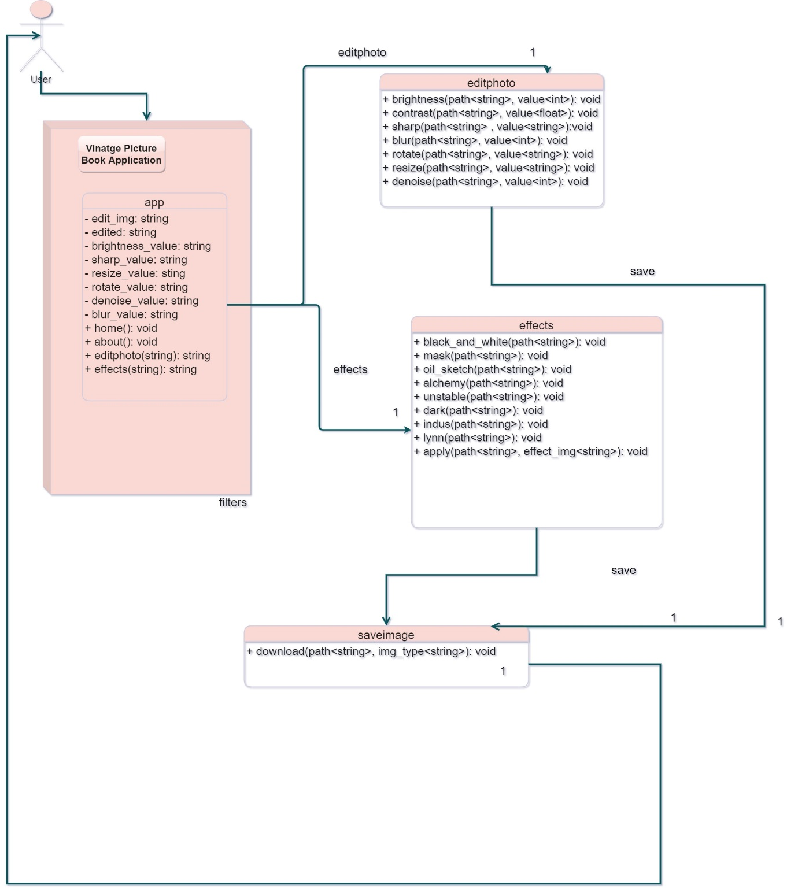

1. **ER Diagram**

