ANDROID CALL DURATION CONTROL
System Design & Phased Implementation Plan
Android-only • Kotlin • Telecom Framework • Default Dialer

Field | Value
Status | Proposed / Engineering Planning
Platform | Android only
Primary language | Kotlin
Core platform | android.telecom / InCallService
First milestone | Proof-of-concept: validate call lifecycle + disconnect behavior
Production strategy | Become the user's default dialer; implement required dialer UI and InCallService
Critical gate | Do not build full product until real-device disconnect tests pass

1. Executive Summary
The product is a call-duration control application. A user configures a maximum allowed duration for a phone call. When an active call reaches the configured threshold, the app alerts and vibrates. The user must explicitly confirm that they are still present; otherwise the system attempts to end the call.
The first build should be a deliberately small Proof of Concept (POC). Its purpose is not to look like a finished phone app. Its purpose is to answer the highest-risk engineering question: whether the chosen Android Telecom integration can observe an active cellular call and reliably terminate it on the target devices.
Android's current documentation states that a default dialer must handle ACTION_DIAL and fully implement InCallService, including incoming and ongoing call UI. Android also exposes the ROLE_DIALER role through RoleManager. cite references omitted from artifact text; see Sources section.

2. Design Decision
Decision | Recommendation | Reason
Platform | Native Android/Kotlin | Direct access to Android Telecom APIs and lifecycle.
Call integration | Default dialer + InCallService | Required for a full in-call experience and the strongest supported integration boundary.
Timer | In-memory call session state + monotonic timing | Avoid timer drift and isolate active-call state.
Persistence | Room for settings/history | Reliable local configuration and optional audit/history.
Alert | High-priority notification / full-screen call UI where permitted | The alert must be visible during an active call.
Call termination | POC first; production only after device validation | Exact behavior must be validated across Android versions/OEMs.
Backend | None for MVP | The core feature is local and does not require a server.

3. Goals and Non-Goals
Goals | Non-goals for initial release
Detect active cellular calls through supported Telecom integration. | Replacing every feature of Google Phone/Samsung Phone.
Track call duration accurately. | Cloud synchronization.
Trigger an alert when the configured limit is reached. | AI call analysis or call recording.
Require an explicit user confirmation to continue. | Managing emergency calls differently from the platform.
Safely end the call after the confirmation window expires, if supported by the tested configuration. | Bypassing Android security restrictions/rooting devices.
Work predictably on a defined Android/OEM test matrix. | Guaranteeing identical behavior on every OEM without testing.

4. Phase 0 — Technical Feasibility / POC
Build only the minimum required to prove the core capability.
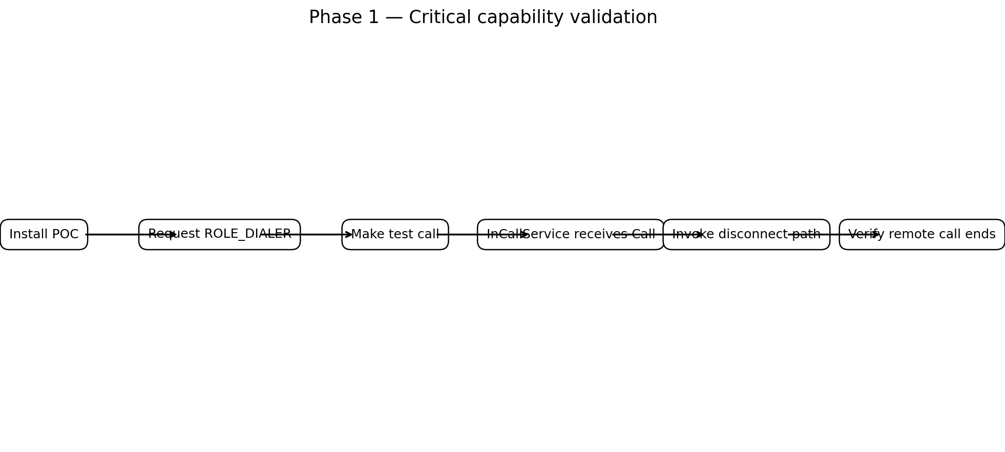

4.1 POC Scope
- Create a minimal Kotlin Android application.
- Declare the services/components required for default-dialer eligibility.
- Request the ROLE_DIALER role using RoleManager.
- Implement a minimal InCallService.
- Log onCallAdded() and onCallRemoved() events.
- Expose the currently active Call object to a simple test screen.
- Add a manual 'Disconnect Test Call' button.
- Test the disconnect operation against real cellular calls.
- Repeat the test for incoming and outgoing calls and across target devices.
- Record the result in a compatibility matrix.

4.2 POC UI
Screen | Controls | Purpose
POC Home | Default dialer status; active call status | Shows whether the app is correctly integrated.
Active Call Test | Call state; elapsed time; Disconnect Test button | Directly validates the critical capability.
Test Result | PASS / FAIL + device/API/OEM notes | Creates evidence for the go/no-go decision.

4.3 POC Success Criteria
- App can successfully request and hold ROLE_DIALER on supported test devices.
- InCallService receives the test call lifecycle.
- Active cellular calls are represented as expected in the app.
- The tested disconnect path actually ends the live cellular call—not merely updates local UI state.
- The behavior is reproducible for both outgoing and incoming calls.
- The result is documented separately for each Android version and OEM.
- Failure modes are captured rather than hidden.

4.4 POC Failure Decision
If the required disconnect behavior cannot be reliably achieved for the target devices through the supported default-dialer/Telecom path, stop before building the production UI. Re-evaluate the product requirement, supported-device scope, or a managed-device/system-app strategy. Do not design the product around an unverified hack.

5. POC Folder Structure
call-duration-poc/
├── app/
│ ├── src/main/
│ │ ├── AndroidManifest.xml
│ │ ├── java/com/example/callguard/
│ │ │ ├── MainActivity.kt
│ │ │ ├── POCInCallService.kt
│ │ │ ├── DialerRoleManager.kt
│ │ │ ├── ActiveCallStore.kt
│ │ │ └── CallStateLogger.kt
│ │ └── res/
│ │ ├── layout/
│ │ ├── values/
│ │ └── drawable/
│ └── build.gradle.kts
├── build.gradle.kts
├── settings.gradle.kts
└── README.md

5.1 POC Core Class Responsibilities
Class | Responsibility
MainActivity | Minimal POC screen and manual test controls.
DialerRoleManager | Checks/request ROLE_DIALER.
POCInCallService | Receives Telecom call lifecycle callbacks.
ActiveCallStore | Keeps a reference to the currently tested call session.
CallStateLogger | Logs state transitions, disconnect attempts and results.

6. Phase 1 — Production Foundation
Only begin this phase after the POC passes on the minimum supported device matrix.
- Convert the POC into a proper default-dialer application.
- Implement the dial pad and ACTION_DIAL handling.
- Implement incoming-call UI.
- Implement ongoing-call UI.
- Implement call lifecycle/state management.
- Introduce a durable settings model using Room/DataStore as appropriate.
- Add configurable maximum duration and confirmation window.
- Add vibration and alert policy.
- Add safe handling for call removal, remote hang-up, hold, multi-call states and lifecycle changes.
- Create automated unit tests for timing/policy logic and instrumented tests for Telecom integration.

7. Production Architecture
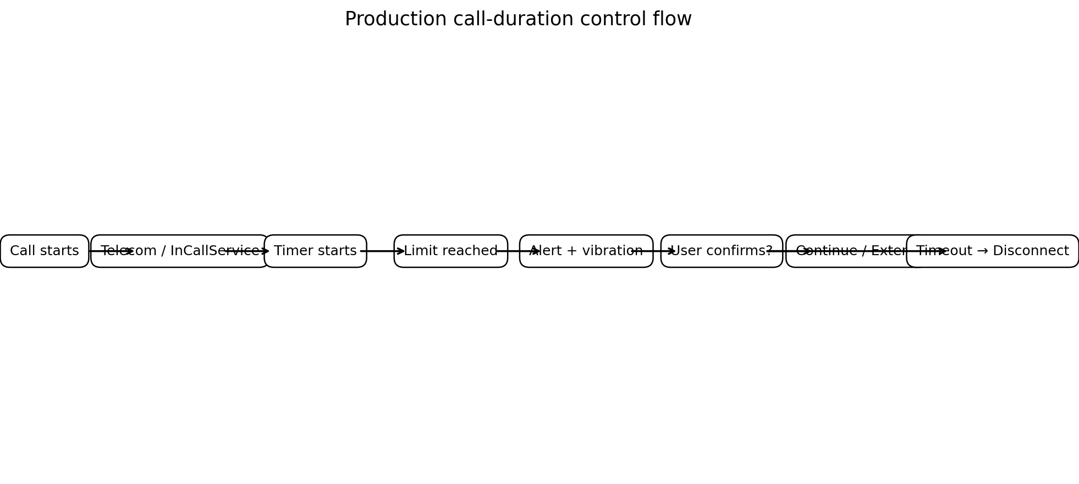

7.1 Component Architecture
Component | Responsibility | Primary state
Dialer UI | Dial pad, incoming call UI, active call UI. | UI state / ViewModel
DialerRoleManager | Requests and verifies default-dialer role. | Role state
CallGuardInCallService | Entry point for active call lifecycle. | Telecom Call objects
CallController | Single place for answer/reject/disconnect actions. | Active session
CallTimer | Tracks elapsed time using a monotonic clock. | Session timing
LimitPolicy | Determines threshold and confirmation behavior. | Settings
AlertController | Shows the threshold warning and confirmation action. | Alert state
VibrationController | Runs user-configured vibration pattern. | Ephemeral
SettingsRepository | Persists global/default policies. | Room/DataStore
CallRepository | Optional call history/audit records. | Room

8. Production Folder Structure
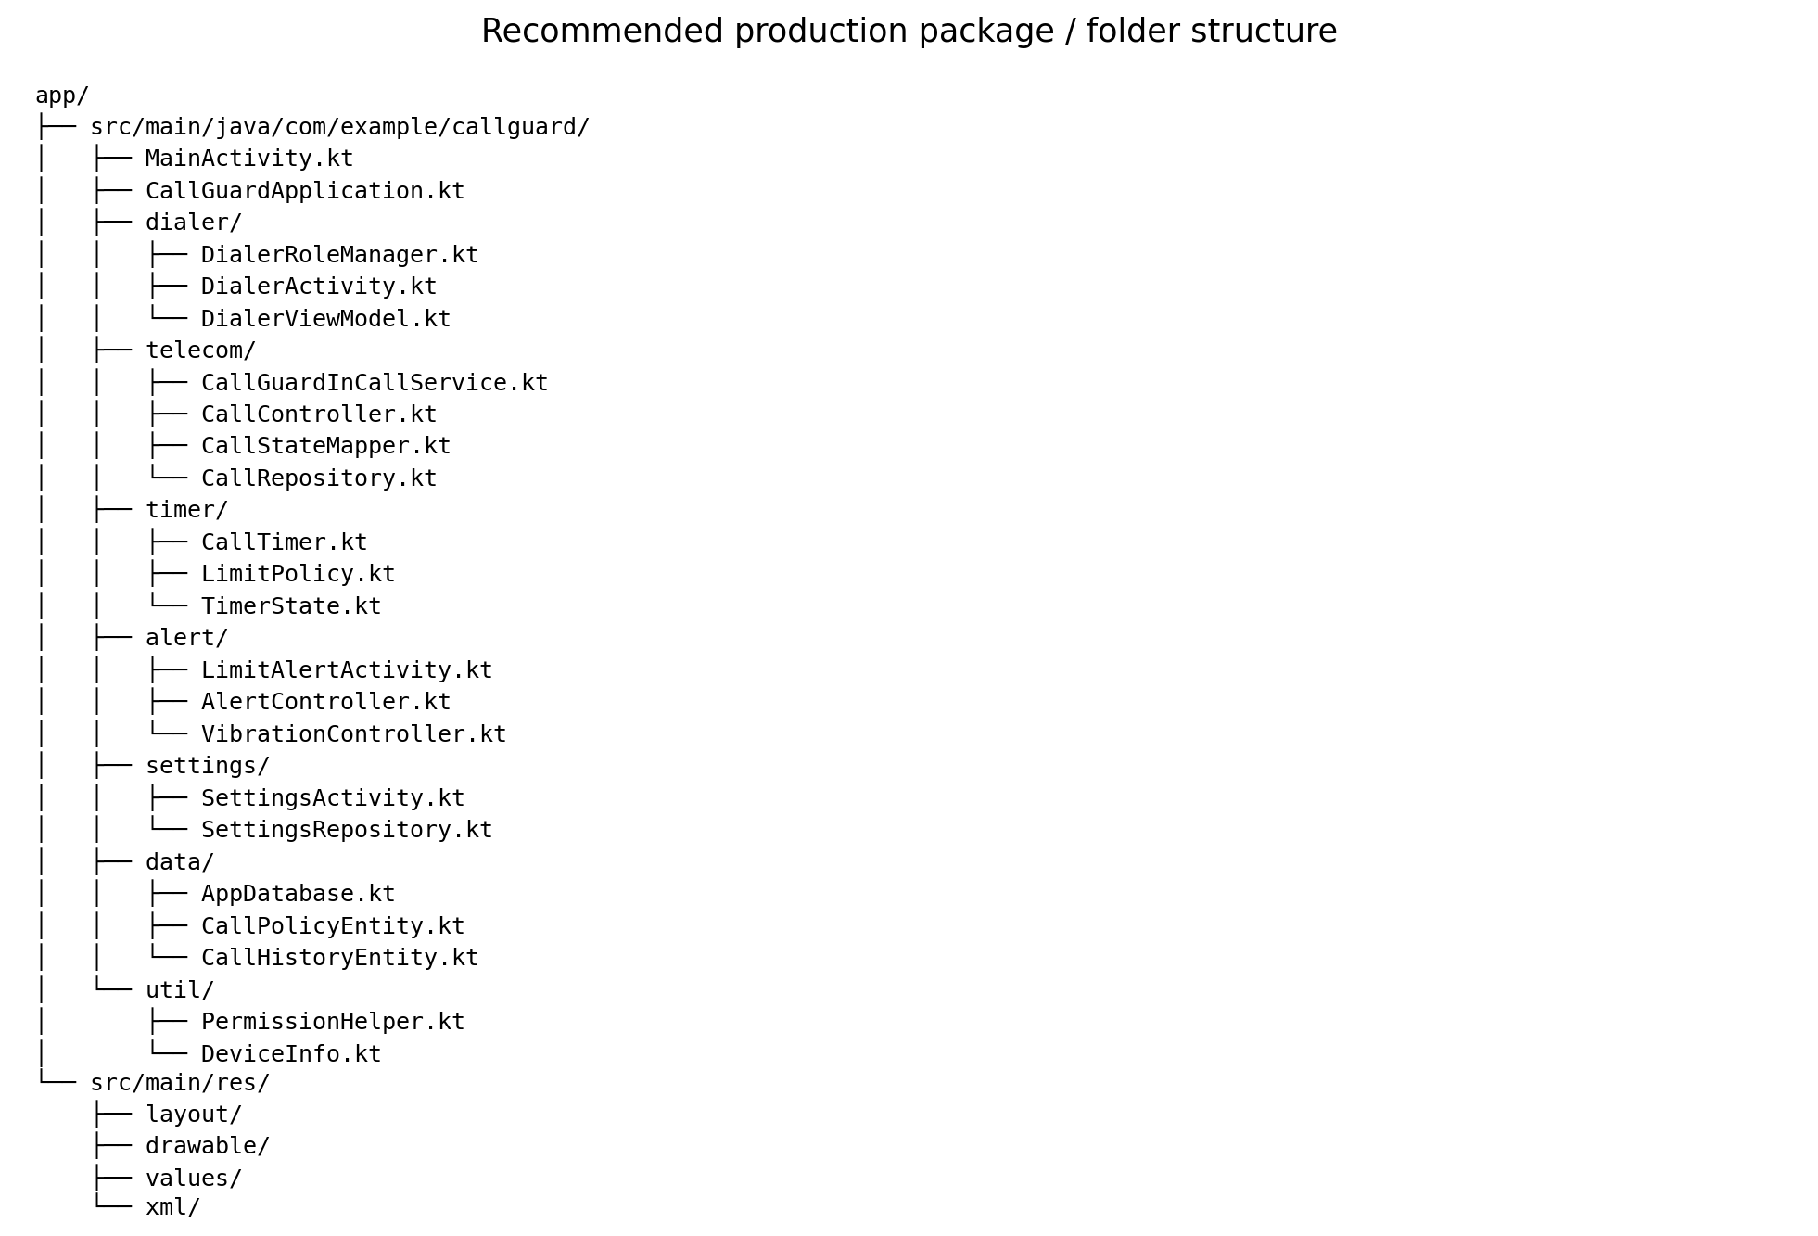

8.1 Expanded Package Responsibilities
Package | Key classes | Purpose
dialer | DialerActivity, DialerViewModel, DialerRoleManager | Default dialer entry and role management.
telecom | CallGuardInCallService, CallController, CallStateMapper | Android Telecom integration.
timer | CallTimer, LimitPolicy, TimerState | Duration tracking and threshold decisions.
alert | LimitAlertActivity, AlertController, VibrationController | User confirmation and alerting.
settings | SettingsActivity, SettingsViewModel, SettingsRepository | User-configurable limits and policies.
data | AppDatabase, CallPolicyEntity, CallHistoryEntity | Local persistence.
util | PermissionHelper, DeviceInfo | Shared platform helpers.

9. Detailed Runtime Flow

9.1 Outgoing Call
- User enters a number and initiates a call.
- The default dialer routes the call through Android Telecom.
- The in-call service receives the call session.
- CallController maps the Telecom call to an internal CallSession.
- When the call becomes active, CallTimer starts using a monotonic time source.
- LimitPolicy resolves the applicable maximum duration.
- The timer continuously evaluates the session against the threshold without relying on exact one-second UI ticks.
- At the threshold, AlertController displays the confirmation UI and VibrationController alerts the user.
- If the user confirms, the session enters EXTENDED/CONTINUED state and the next threshold is calculated.
- If the confirmation window expires, CallController invokes the tested disconnect path.
- When Telecom reports call removal, the session is closed and timers/listeners are released.

9.2 Incoming Call
- Telecom delivers the incoming call to the default dialer/in-call experience.
- The user answers the call.
- The service receives the active call state.
- The timer starts at the actual active/connected state rather than ringing time.
- The same limit → alert → confirmation → continue/disconnect flow applies.

9.3 User Answers Too Late
Race conditions must be handled explicitly. If the user taps 'Continue' at the same time that the timeout worker decides to disconnect, only one terminal decision should win. The CallSession state machine should serialize these transitions.

10. Call Session State Machine
State | Meaning | Allowed transitions
RINGING | Incoming call not yet answered. | ACTIVE, DISCONNECTED
DIALING | Outgoing call being established. | ACTIVE, DISCONNECTED
ACTIVE | Connected call; duration tracking is active. | WARNING, HELD, DISCONNECTED
WARNING | Limit reached; user confirmation requested. | ACTIVE, EXTENDED, DISCONNECTING
EXTENDED | User confirmed continuation. | ACTIVE, DISCONNECTED
HELD | Call is on hold. | ACTIVE, DISCONNECTED
DISCONNECTING | Termination requested; awaiting Telecom result. | DISCONNECTED
DISCONNECTED | Terminal state. | None

11. Data Model
Entity | Important fields | Purpose
CallPolicy | id, enabled, maxDurationSec, confirmationWindowSec, extensionSec, vibrationEnabled | User policy.
CallSession | sessionId, direction, startedAtElapsed, thresholdAtElapsed, state | Runtime state; may be non-durable.
CallHistory (optional) | sessionId, start/end timestamps, reason, limit, outcome | User-visible history and debugging.
DeviceProfile (optional) | manufacturer, model, apiLevel, appVersion | Compatibility diagnostics; avoid unnecessary identifiers.

12. Timing Design
Do not measure elapsed call time by incrementing an integer every second. Use Android's monotonic elapsed time source (for example SystemClock.elapsedRealtime()) so wall-clock changes do not alter duration.
val elapsedMs = SystemClock.elapsedRealtime() - session.startedAtElapsedMs
if (elapsedMs >= policy.maxDurationMs) {
policyEngine.onLimitReached(session)
}
The UI can refresh once per second for display, while the policy engine schedules the threshold decision. When the app receives call-state changes, it should immediately re-evaluate the policy.

13. Alert and Confirmation Flow
Event | System behavior
Limit reached | Create a high-priority alert and vibration according to user settings.
User confirms | Cancel current warning; extend/recalculate threshold.
User explicitly ends | Request call termination.
No response | After confirmation window, request call termination.
Call already removed | Dismiss alert and clean session.
App UI unavailable | Use the supported system notification/call UI path; do not depend on a fragile overlay hack.

14. Android Platform Requirements
The app should be designed against the current Android Telecom contract, not around legacy hidden APIs. Android's InCallService documentation says an app seeking ROLE_DIALER must handle ACTION_DIAL and fully implement InCallService with incoming and ongoing call UI. Emergency calls are always handled by the preloaded dialer.
- RoleManager.ROLE_DIALER — user-facing default-dialer role request.
- InCallService — receives the in-call lifecycle and supplies the in-call experience.
- TelecomManager — supported Telecom operations such as placing calls.
- Foreground service type phoneCall — relevant when a foreground service is needed for ongoing call work; current Android documentation lists ROLE_DIALER as one way to satisfy its runtime prerequisite.
- Room/DataStore — local persistence; choose based on whether structured history or lightweight preferences are required.
- Notification/Activity APIs — alerting the user within Android's allowed background/UI model.

15. Permissions / Manifest Planning
Exact permissions should be finalized against the minimum supported Android API and the current Play policy. Avoid requesting permissions simply because they appear in old dialer examples.
Area | Planning item | Notes
Default dialer | ROLE_DIALER | User must explicitly select the app as default dialer.
InCallService | BIND_INCALL_SERVICE | System binding for the in-call service.
Foreground service | FOREGROUND_SERVICE + phoneCall type where required | Android 14+ enforces foreground-service type requirements.
Notifications | POST_NOTIFICATIONS where applicable | Needed for user-visible notifications on supported versions.
Contacts | Optional | Only if the product needs contact lookup; keep out of MVP if unnecessary.

16. Testing Strategy
Test category | Cases | Exit criteria
POC capability | Outgoing/incoming cellular call; manual disconnect | Call actually terminates.
Timing | 1 min, 5 min, 30 min, boundary ±1 sec | Threshold fires correctly.
Confirmation | Tap immediately, tap near timeout, no response | Exactly one terminal outcome.
Lifecycle | Screen off, app background, process pressure | Call monitoring remains functional within platform rules.
Call changes | Hold/resume, second incoming call, call waiting | State machine remains consistent.
OEM | Pixel, Samsung, Motorola or target OEMs | Compatibility matrix recorded.
SIM | Single SIM and dual SIM where relevant | Correct active call/session identified.
Audio | Bluetooth, speaker, wired headset where supported | Alert remains usable without disrupting audio unexpectedly.
Emergency | Emergency-call scenarios | Platform emergency-call behavior is not overridden.

17. Compatibility Matrix Template
Device | Android/API | OEM build | Default dialer | Outgoing disconnect | Incoming disconnect | Background/lock | Result
Pixel test device | [API] | [Build] | PASS/FAIL | PASS/FAIL | PASS/FAIL | PASS/FAIL | GO/NO-GO
Samsung test device | [API] | [Build] | PASS/FAIL | PASS/FAIL | PASS/FAIL | PASS/FAIL | GO/NO-GO
Motorola test device | [API] | [Build] | PASS/FAIL | PASS/FAIL | PASS/FAIL | PASS/FAIL | GO/NO-GO

18. Phase 2 — Full MVP
- Production-grade dialer UI.
- Contacts integration if required.
- Incoming-call screen.
- Ongoing-call screen with timer/limit indicator.
- Settings for default limit, warning duration, vibration, extension amount and enable/disable policy.
- Call history and policy outcome history if required.
- Robust session state machine.
- Crash-safe cleanup and lifecycle handling.
- Automated unit/instrumentation test suite.
- Accessibility: TalkBack labels, large text, touch targets and non-visual confirmation feedback.
- Privacy review and data-minimization review.

19. Phase 3 — Hardening
- OEM-specific compatibility fixes based on evidence, not assumptions.
- Battery/lifecycle optimization within Android's allowed mechanisms.
- Detailed telemetry only if needed and privacy-safe.
- Remote configuration only if a backend is genuinely required.
- Rollback/feature flags for policy changes.
- Performance testing with long calls and repeated call sessions.
- Security review of exported components and service bindings.
- Play Store policy review for default-dialer and phone-related functionality.

20. Phase 4 — Advanced Features
- Different limits for incoming and outgoing calls.
- Per-contact or contact-group policies.
- Schedules, such as stricter limits during work/study hours.
- Temporary extensions.
- Usage statistics.
- Optional cloud backup/synchronization of settings—only if product value justifies the added privacy and backend complexity.

21. What NOT to Build Initially
- Do not build a backend before the local call-control POC works.
- Do not build a sophisticated dialer UI before Telecom integration is proven.
- Do not use AccessibilityService as the primary call-control mechanism.
- Do not depend on hidden/private Android APIs.
- Do not assume that behavior observed on one OEM proves behavior on all Android phones.
- Do not claim automatic termination is supported until real cellular-call tests demonstrate it.

22. Alternatives Considered
Approach | Why considered | Decision
Normal companion app + existing dialer | Smallest UI effort. | Not sufficient if guaranteed call termination is a core requirement.
AccessibilityService | Can interact with UI in some scenarios. | Not appropriate as the primary architecture; fragile and policy-sensitive.
CallScreeningService | Useful for screening incoming/outgoing calls before connection. | Not the primary mechanism for controlling an already-active call.
CallRedirectionService | Useful for outgoing-call redirection/cancellation before connection. | Not an active-call duration controller.
Default dialer + InCallService | Supported system role for a full phone/in-call experience. | Recommended architecture.
System/device-owner integration | Can provide additional enterprise control. | Only relevant for managed/enterprise deployments; not the consumer MVP assumption.

23. Security and Privacy
- Do not record call audio unless explicitly required and separately designed.
- Minimize storage of phone numbers and call metadata.
- Protect local settings/history with Android's standard application sandbox; encrypt particularly sensitive data if retained.
- Do not upload call metadata by default.
- Do not expose exported activities/services beyond what Android Telecom requires.
- Do not use accessibility or device-admin privileges as a workaround for Telecom limitations.
- Make the automatic-disconnect behavior visible and configurable so the user understands the consequence.

24. Operational / Product Safety Rules
- Emergency calls must follow Android's platform behavior; the preloaded dialer handles emergency calls even when another app fills ROLE_DIALER.
- If the app loses its default-dialer role, clearly disable or degrade the feature instead of pretending monitoring is active.
- If the call session disappears before timeout, cancel the pending termination action.
- If a disconnect request fails or the result is ambiguous, show an accurate state rather than falsely reporting that the call ended.
- The user should always have a visible way to disable the duration-control policy.

25. Milestones and Exit Criteria
Milestone | Deliverable | Exit criteria
M0 | Technical POC | ROLE_DIALER + InCallService lifecycle verified.
M1 | Disconnect validation | Real cellular outgoing/incoming disconnect verified on target device matrix.
M2 | Timer engine | Boundary and race-condition tests pass.
M3 | MVP dialer | Required dialer and in-call UI implemented.
M4 | Alert/confirmation | Warning, vibration, confirmation and timeout behavior pass instrumentation tests.
M5 | Hardening | OEM/lifecycle/accessibility/security tests pass.
M6 | Release candidate | Policy review, regression suite and rollback plan complete.

26. Recommended First Sprint
- Create Android Studio Kotlin project.
- Implement RoleManager request for ROLE_DIALER.
- Add minimal ACTION_DIAL handling.
- Implement InCallService and log call lifecycle.
- Build one POC active-call screen.
- Expose a manual disconnect test action.
- Test on one Pixel-class device first.
- Repeat on at least two OEMs.
- Document results in the compatibility matrix.
- Only after a PASS, start the production timer and alert layers.

27. Source References
Official Android documentation used for this design:
- InCallService / default dialer requirements: https://developer.android.com/reference/android/telecom/InCallService
- ConnectionService / call lifecycle and disconnect semantics: https://developer.android.com/reference/android/telecom/ConnectionService
- Foreground service types — phoneCall: https://developer.android.com/develop/background-work/services/fgs/service-types
- Foreground service requirements: https://developer.android.com/about/versions/14/changes/fgs-types-required
- CallScreeningService: https://developer.android.com/reference/android/telecom/CallScreeningService
- CallRedirectionService: https://developer.android.com/reference/android/telecom/CallRedirectionService

28. Final Recommendation
Build the POC first. The POC should be intentionally ugly but technically decisive. The single most important question is whether the supported default-dialer/Telecom integration can produce the required real-world termination behavior on the Android/OEM devices you intend to support. Once that is proven, the production architecture is straightforward: default dialer → InCallService → CallSession → monotonic timer → warning and confirmation → tested disconnect path → cleanup.
This sequencing prevents spending significant engineering time on dialer UI, settings, backend services, or analytics before the product's core platform capability has been demonstrated.

29. Snooze / Recurring Presence Confirmation
The production design is extended with a recurring snooze mechanism. The snooze duration is configured by the user—for example, 10 minutes. When the maximum call-duration threshold is reached, the app asks the user to confirm that they are still present. If the user approves, the call continues for the configured snooze interval. When that interval expires, the application asks for confirmation again. This cycle repeats until the call ends, the user explicitly ends the call, or the user fails to respond within the confirmation window.
Example: 10-minute snooze
- Call starts at 10:00.
- The configured initial limit is reached at 10:30.
- The application vibrates and asks: “Are you still present?”
- User taps “Yes, I’m here.”
- The application starts a 10-minute snooze period.
- At 10:40, the application asks for confirmation again.
- User approves again → another 10-minute snooze starts.
- At 10:50, the application asks again.
- This continues every 10 minutes while the call remains active.
- If the user does not respond during any confirmation window, the application requests call termination.
Updated runtime flow
State / Event | Action | Next state
Initial limit reached | Show presence confirmation + vibrate | WAITING_FOR_CONFIRMATION
User approves | Start configured snooze timer | SNOOZED
Snooze expires | Show presence confirmation + vibrate again | WAITING_FOR_CONFIRMATION
User approves again | Restart snooze timer | SNOOZED
User explicitly ends call | Stop all timers and close session | DISCONNECTED
No response | Request tested disconnect path | DISCONNECTING → DISCONNECTED
Remote party ends call | Clean up session immediately | DISCONNECTED
Updated state machine
State | Meaning | Transition
ACTIVE | Normal connected call; initial duration timer running. | Limit reached → WAITING_FOR_CONFIRMATION
WAITING_FOR_CONFIRMATION | User must confirm presence. | Approve → SNOOZED; timeout → DISCONNECTING
SNOOZED | User has approved; recurring snooze timer is running. | Snooze expires → WAITING_FOR_CONFIRMATION
DISCONNECTING | Termination has been requested. | Telecom confirms removal → DISCONNECTED
DISCONNECTED | Terminal state. | None
Policy model
Setting | Example | Meaning
Initial maximum duration | 30 minutes | First time at which presence confirmation is required.
Snooze duration | 10 minutes | Time allowed after each successful confirmation before asking again.
Confirmation window | 30 seconds | Time allowed to respond to each presence check.
Maximum snooze count | Optional / unlimited | Optional product rule; if configured, determines the maximum number of extensions.
Vibration | Enabled | Whether each check produces a vibration.
Recommended internal model
- initialLimitAtElapsed = callStartElapsed + initialLimit
- confirmationDeadline = now + confirmationWindow
- snoozeUntilElapsed = now + snoozeDuration
- When snoozeUntilElapsed is reached, transition back to WAITING_FOR_CONFIRMATION.
- Every approval creates a new snooze deadline rather than modifying the original call start time.
- The call's total duration remains available for display and analytics; snooze time does not reset the original call start timestamp.
- A single session state machine must own the transition so that approval and timeout cannot both produce conflicting outcomes.
Important UX distinction
The snooze button should not silently approve the user. The intended interaction is: the app asks whether the user is still present → the user explicitly approves → the app grants the configured snooze interval. The next check must require another explicit approval.
Testing additions
- Initial limit reached → approval → snooze expires → second prompt appears.
- Second approval → another snooze expires → third prompt appears.
- No response on the first check → call termination path.
- No response on the second or later check → call termination path.
- Approval immediately before timeout → exactly one snooze cycle is created.
- Approval and timeout occurring at nearly the same instant → deterministic state-machine result.
- Call ends during snooze → no later alert is shown.
- Call ends while confirmation is visible → alert is dismissed and no disconnect is attempted.
- Changing snooze settings affects future sessions/checks according to the chosen policy version, not an already-running check unexpectedly.
Updated product flow
Call starts → Initial limit → Presence check → Approve? → YES → Snooze N minutes → Presence check again → Approve? → YES → Snooze N minutes → repeat. NO RESPONSE at any check → Disconnect.
30. Revised MVP Requirements
- User can configure the initial maximum call duration.
- User can configure the snooze duration (for example, 10 minutes).
- User can configure the confirmation response window.
- Every expired snooze produces a fresh presence confirmation.
- Every continuation requires explicit user approval.
- The app never treats an old approval as permanent approval for the remainder of the call.
- A call that remains active can therefore generate repeated presence checks at the configured snooze interval.
- No response at any check triggers the tested call-disconnect path.
Design note: The snooze mechanism is a product-level timing policy. It should be implemented above the Android Telecom call-control layer so that the same policy engine can be unit-tested independently from device-specific call behavior.

