Agentic Customer 360 — Proactive Intervention Desk
Mid-Term Submission — Research Log, Preliminary Architecture & Approach
Inter IIT Tech Meet 15.0 · Prepathon · Natural Language Processing
Submitted by: Naman Goyal
Date: 15 September 2026
The MAS topology, memory scoping and trigger design in Part C were settled before any code existed, and Part B records what informed each one. AI tooling was used to implement and debug that design and to calibrate thresholds against the practice scenarios — not to choose it. Where the design did change during the build it changed in response to what the data showed, and those changes are recorded in the evaluation write-up.

Part A — Findings & Approach Report

What I understand about the domain
The challenge here is not throughput or data volume — the streams provided (~500 events per customer over ~2.5 months) are small. It is temporal judgement: withholding a decision while a signal is still weak, then committing within a narrow window once it is strong enough — without being fooled by isolated anomalous events (“red herrings”) that resemble a different life event or risk category.
A second, quieter difficulty sits underneath it. Each event carries two timestamps: when it happened, and when the bank's systems learned of it. Any claim to have inferred something “early” is only meaningful if the system provably could not have seen the future — including data that had occurred but had not yet arrived. That is a stream-processing problem rather than a retrieval one, and it shapes the memory design more than anything else.
So this is an agent-coordination and memory-scoping problem more than a data-engineering one — consistent with the problem statement's own framing (§1.3: “this is a genuinely unfamiliar problem space… reading how others have approached these problems is a load-bearing part of the work”).

Approach I am following
- Multi-layer MAS. A parallel (“swarm”) perception layer of specialised agents (Usage, Transaction, Support, Life-Signal/KYC) feeding a single Synthesis agent, followed by a Critique-Refiner pass before any action is finalised.
- Per-customer shared state board rather than siloed agent memory or agent-to-agent messaging — the single surface each perception agent writes structured findings to and the correlation layer reads from.
- Three-tier memory. Working (the tick being handled), episodic (per-customer event history in a queryable store, strictly time-filtered), semantic (shared policy and pattern knowledge in a vector store).
- A hard, code-level guardrail requiring at least two independent source_systems to corroborate before any escalation, offer or fraud-hold action — aimed directly at the red-herring pattern present in all three provided scenarios.
- Model routing. A fast model for high-volume perception, a stronger reasoning model for Synthesis and Action — a deliberate cost/quality tradeoff, not one model used everywhere. Every model call has a deterministic fallback, so the system runs end to end with no API access at all.

Progress at mid-term
The architecture in Part C is fixed, and every component in it is built and integrated — ingestion through to the inferred-events writer — with a local scoring harness and a terminal view running over the same pipeline the graded run uses. Remaining work before the end-term submission: calibration reporting, one recorded run against the live models, and extending the research log below.

Part B — Research Log
Not a bibliography — every row is here because it changed a decision that is visible in the system.
Source | Type | Key takeaway | Decision it informed
Akidau, “Streaming 101 / 102: The world beyond batch”  (O’Reilly Radar) | Engineering write-up | Event time is when something occurred; processing time is when the system observed it. The skew between them is “not only non-zero, but often a highly variable function” of the source and the pipeline, so correctness has to be stated in event time even though records physically arrive in processing-time order. Watermarks estimate how far event time has advanced; late data is the normal case, not an error. | The two-timestamp design. release_time = max(ingestion_time, event_time) is our watermark: an event cannot be released before it happened, so the no-leakage rule holds by construction rather than by test. It also gives the visibility filter its second clause, release_time ≤ as_of, which stops a late-arriving event appearing to have been known before it reached the bank.
Park et al., “Generative Agents: Interactive Simulacra of Human Behavior” (2023), §4 | Research paper | Agents retrieve from a memory stream scored on recency, importance and relevance. Separately, reflection synthesises raw observations into higher-level conclusions the agent then reasons over instead of re-deriving them. The value is in promoting observations into stable conclusions, not in storing more. | The working / episodic / semantic split, and the state board specifically: perception publishes structured findings and Synthesis reads only those, never the event stream — that is the reflection layer here. It also justifies carrying a committed inference forward rather than recomputing it each day.
Packer et al., “MemGPT: Towards LLMs as Operating Systems” (2023), and the Letta docs on tiered memory | Research paper / engineering docs | Hierarchical memory borrowed from operating systems: a small in-context tier plus a larger external store, with movement between them an explicit operation rather than an invisible mechanism. The argument is less about capacity than about making retrieval addressable, and therefore constrainable. | Episodic memory as an explicitly queried SQLite store rather than context stuffing — and, because every read is an explicit call, as_of could be made a mandatory positional argument with no default. A caller physically cannot query memory without stating what “now” is.
LangChain — “LangGraph: Multi-Agent Workflows”  and the LangGraph multi-agent concepts docs | Official blog / docs | Compares collaboration, supervisor and hierarchical topologies. What separates them is whether agents see each other’s work in progress: under collaboration “all the work either of them do is visible to the other”, whereas a supervisor gives each agent “their own independent scratchpads” with only final outputs reaching shared state. | A swarm at Layer 1 writing to a shared board for outputs only, with no agent-to-agent messaging — made concrete by constructing each agent’s context without a reference to the board. If Support could see Usage’s finding, one piece of evidence would be counted twice while appearing to be two independent witnesses, and corroboration is the guardrail’s whole basis.
Anthropic — “Building Effective Agents” | Engineering blog | Recommends “finding the simplest solution possible, and only increasing complexity when needed”, and warns that “agentic systems often trade latency and cost for better task performance”. Its evaluator-optimizer pattern — one call generates, a second evaluates in a loop — is the shape that fits a bounded quality gate. | Rejecting multi-agent debate: with one customer and six permitted actions it costs latency and free-tier quota without buying accuracy, so one adversarial reviewer with a single bounded retry is enough. It also informed keeping the confidence arithmetic and the guardrail in code — only genuine judgement is asked of a model.
ChromaDB documentation — collections, upsert, custom embedding functions | Official docs | upsert writes or updates by document id, so re-seeding a collection is idempotent and editing one document re-embeds only that document. Embedding functions are pluggable, and the default downloads a model on first use. | Content-hashed incremental upsert, so the policy store stays live without a full re-index. The first-use download is why there is a dependency-free fallback embedder: a sandboxed evaluation run with no network still completes end to end.

Part C — System Architecture

1. Problem framing, grounded in the provided scenarios
Three scenarios were provided as practice data, each one customer's event timeline (~500 events across history_seed.jsonl and live_stream.jsonl), graded at fixed checkpoints against a hidden ground truth:
Scenario | Customer | True narrative | Checkpoints | Final action | Red herring(s)
1 — Medical hardship | Marcus Vance (CUST_00088) | ER visit → income drop (benefits) → hospital bill → savings drawn down → support ticket | low → medium → high | support_intervention (escalated) | Tuition transfer; resort refund
2 — New child | Priya Sharma (CUST_00105) | Income dip → baby purchases → daycare standing instruction → KYC dependents change → search intent | low → high (no medium) | personalized_offer (escalated) | Baby monitor purchase
3 — Churn risk | David Chen (CUST_00184) | Denied complaint → usage drop → cancelled standing instructions + transfer out → zero card use → salary swept out | low → high → high (2nd action) | relationship_manager_escalation, later proactive_retention_outreach | Tax refund deposit

The common pattern across all three: every red herring is a single isolated event, uncorroborated by any other source_system in the same window, while every genuine narrative shows up across several. That observation is what the guardrail in §6 is built on.

2. The environment the agents live in
Ambient agents need somewhere to be ambient. Here that is the provided event stream, replayed as a live environment rather than read as a file: history_seed.jsonl is loaded once as backstory, and live_stream.jsonl is released one event at a time in the order a real system would have received them. Across the three practice scenarios that is 1,367 events from nine source systems over a 74-day window (1 February to 15 April 2026).
Release order is ingestion_time; judgement is event_time. An event is released at max(ingestion_time, event_time), so it can never surface before it happened. Two of the 298 live events arrive late — after the day they occurred — and both are ground-truth signal events, which is why visibility is filtered on release_time as well as event_time.
Three trigger types drive the agents, and the system uses all three:
- Event-based. An event arrives and is handed straight to the one agent that owns its source system. This is the synchronous path, and it is why a cancellation click is visible the moment it lands.
- Time-based. A daily 00:00Z boundary wakes every agent whether or not anything arrived. This is how absence is detected — a salary that did not land, logins that stopped — none of which produces an event of its own.
- Agent-dependent. Synthesis fires only once two or more distinct perception agents have flagged something in the same window, so correlation is attempted when there is something to correlate rather than on every raw event.
The loop closes back into the environment. Each daily cycle writes a decision row to inferred_events.json and commits it to episodic memory, and the next day's cycle reads that decision back as the belief it starts from. Agents read from the stream and act into a record the next tick can see — which is what makes an inference persist rather than be recomputed from nothing each day.

3. Agent roster
Drawn in full in Appendices A and B.
Component | Layer | Reads | Trigger
Usage Agent | Perception (swarm) | web_app_events | Event-based and daily time-based
Transaction Agent | Perception (swarm) | card_payments, core_banking_ledger, instant_payments, ach_wire, trading_brokerage | Event-based and daily time-based
Support Agent | Perception (swarm) | support_logs | Event-based
Life-Signal Agent | Perception (swarm) | loan_kyc, social_signal_consented (consent-gated) | Event-based
Synthesis Agent | Correlation | The state board — structured findings only, never raw events | Agent-dependent: ≥ 2 distinct perception agents flagged in the window
Action Proposer | Decision | Synthesis output, retrieved bank policy, prior decisions | Downstream of Synthesis
Guardrail | Safety (code, not an agent) | The proposed action and its corroboration | Every proposal, before the Critique Agent
Critique Agent | Quality gate | The proposal, the diagnosis and the guardrail verdict | Only when an action other than no_action is proposed
HITL stub | Human checkpoint | The final action and the full reasoning trace | Any action ≠ no_action

4. MAS topology, by stage
Stage | Pattern | Justification
Signal gathering (Layer 1) | Swarm — parallel, independent | Four perception agents read disjoint source_systems with no interdependency, so they run in parallel at no cost to accuracy. Each is constructed without access to the state board, which is what makes their findings independent rather than merely concurrent.
Correlation (Layer 2) | Handoff to a single orchestrator | Synthesis gains nothing from running in parallel with itself; it needs the swarm's combined output, so it sits downstream of Layer 1 on an agent-dependent trigger.
Action quality gate (Layer 3) | Critique-Refiner | Targets the false-positive risk that is explicitly graded in all three scenarios. One bounded retry, not an open loop: on a free tier an unbounded critique exhausts quota early in a long replay and leaves the remainder running with no model at all.
Debate | Considered and rejected | Debate earns its place where genuine disagreement between agents needs surfacing rather than averaging away. Here that disagreement is already surfaced and settled by the affinity and hysteresis rule in §5, at no latency cost. A wider action set, or several customers in scope at once, would change the answer.

5. Memory architecture
Tier | Scope | Storage | Contents
Working | One in-flight decision | In-process | The tick currently being handled
Episodic | Per customer, persistent | SQLite, keyed by customer_id | Every event, finding and committed decision, timestamped; read only through a query carrying a mandatory as_of, filtered on event_time ≤ as_of AND release_time ≤ as_of
Semantic | Cross-customer, shared | ChromaDB | Narrative pattern descriptions per inferred_state, and bank policy text used to ground the proposed action and its subtype

As the problem statement requires, an inferred life-event state persists across checkpoints rather than being recomputed — it must still be available, and correctly weighted, weeks later.
Rolling statistics — login frequency, spend baselines — are maintained against the stream as events arrive rather than recomputed at query time, and the semantic store is updated by content-hashed upsert rather than a full re-index, so editing one policy re-embeds one document.

6. Guardrails, traceability and HITL
- The hard rule is code-level, not prompt-level. No compliance_fraud_hold, relationship_manager_escalation or personalized_offer may fire unless at least two independent source_systems corroborate the finding within the window, across at least two distinct events. Every check is arithmetic and set membership; no model is consulted, so nothing can be talked out of its answer.
- The bar matches the cost of being wrong. support_intervention and proactive_retention_outreach are deliberately unguarded. A support call to a customer who did not need one costs almost nothing; a frozen account, a mistimed sales offer or an unnecessary escalation are real harms. One threshold for everything would either block the cheap interventions for no benefit or set the bar too low for the expensive ones.
- Disagreement is resolved by a stated rule, never silently. Perception agents routinely support different states from the same window. Candidate states are scored by weighted signal affinity, and an established belief is displaced only if a challenger beats it by a margin that scales with how well-evidenced that belief was. When the top two candidates fall within 25% of each other the tie goes to the Synthesis model to adjudicate; with no model available the deterministic winner stands.
- The guardrail runs before the critique pass, not after. The cheap deterministic check that can definitively reject should precede the expensive judgement call that might not.
- Any action other than no_action defaults to escalated, matching the pattern in all three scenarios' ground truth. A rejection by a reviewer turns the action into no_action in the output rather than merely relabelling it.
- Traceability: one structured trace record per checkpoint carrying the findings, the affinity scores, the guardrail verdict, the critique verdict and the HITL routing, tagged with customer_id and as_of.
- Explainability is enforced structurally: an output row proposing an action cannot be constructed at all unless its notes cite at least one event id. A code check, not an instruction in a prompt.
- PII is tokenised rather than deleted before any prompt or log line, so that a self-transfer to another bank still reads as a self-transfer once the name is masked.

7. Design questions, and where they landed
Question | Resolution
Episodic-memory relevance and decay (§4.1): how far back should Synthesis look before an old flag is stale, and when is a past memory relevant rather than noise? | A 30-day correlation window for findings, chosen against the spacing of the practice narratives; a 60-day confidence decay for a belief with no supporting evidence at all, set longer than any gap inside a graded window so it exists for the hidden set rather than being fitted to this one; and a monotonic rule so an established belief does not drop a band because one quiet fortnight thinned the window. Relevance is handled separately from recency: confidence and corroboration are computed only over findings that actually support the state being claimed, so an unrelated event inside the window cannot strengthen a narrative it says nothing about.
Memory bleed-through between customers (§4.1): how is one customer's history kept out of another's inference? | The store is keyed by customer_id and every read carries it, so isolation is a property of the query rather than a convention. At this scale each replay runs against its own store; the same predicate is what would scope a shared one.
Precise confidence-band thresholds — what quantifies low, medium and high? | Two distinct strong signals AND either three independent source systems, or two source systems plus one signal that is decisive — meaning the customer did something deliberate (filed a change, clicked cancel, moved money to their own account elsewhere) rather than something we merely measured about them. These were calibrated against the eight graded practice checkpoints, so scoring well on those shows the calibration was applied, not that it generalises.
Escalation for ambiguity rather than cost (§6.3): should low confidence, or an unresolved disagreement, reach a human even when no action is proposed? | Not yet, and this is the clearest gap. The confidence gate turns low confidence into no_action, which is auto-approved and never reaches a reviewer — right for the graded field, but it means the system is silent exactly where it is least sure. The intended fix before the end-term submission is a review queue for checkpoints where confidence is low but corroboration is broad.
Whether to build a local scoring harness for the brownie-point credit in §8.1 | Built. It scores the inferred-events output against each scenario's ground_truth.json on state, confidence, action, subtype and HITL status. It also checks lead time against the ideal action date, and that no action fires inside a red-herring window.

Appendix A — System Flow
Every component, and how work passes between them. Solid lines are synchronous, taken the instant an event arrives; dashed lines are asynchronous, on the daily 00:00Z cycle. Full resolution: docs/architecture.svg
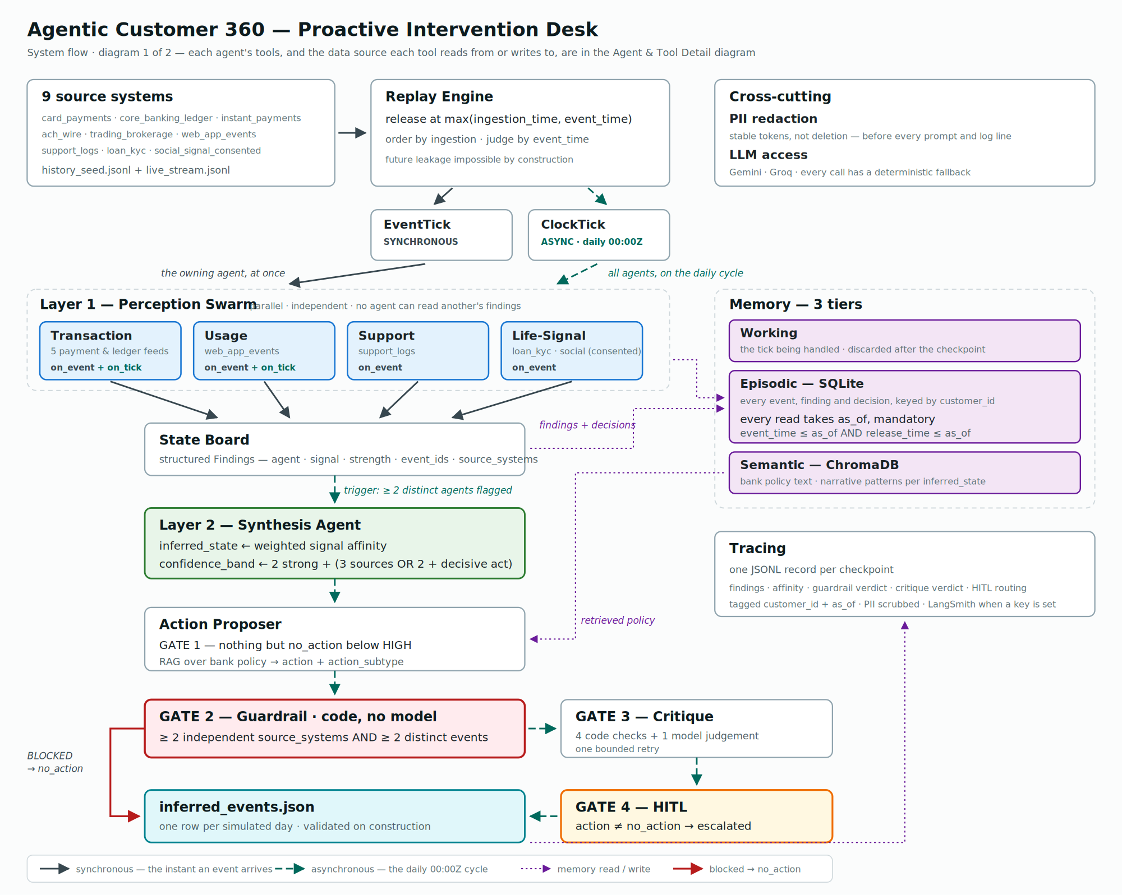
Appendix B — Agent & Tool Detail
Each agent's toolset, and the data source every tool reads from or writes to. Full resolution: docs/architecture_agents.svg
