Global Logistics Performance Analysis Report
Project #3 – International Supply Chain & LPI Score Assessment

Prepared by:
Lyle Cory Miller

Role Targeted:
Business Analyst | Operations Analyst | Systems Analyst

Tools Used:
Excel • SQL • Power BI

Date Completed:
November 2024

Portfolio Repository:
• GitHub – lylecorymiller
• LinkedIn – lylecorymiller

Project #3: Global Logistics Performance Analysis Report
Project Overview
This project evaluates international logistics performance using the Logistics Performance Index (LPI). The goal is to identify country-level strengths and weaknesses in supply chain efficiency, highlight infrastructure quality gaps, and provide strategic recommendations to improve global logistics operations.Objectives
- Identify top & bottom 3 countries by LPI Score (2023)
- Analyze global LPI score trends (2010–2023)
- Visualize LPI performance distribution across countries
- Compare global infrastructure quality by country
- Support policy and business decisions through data-driven logistics insights
Tools Used
- Excel - Data Cleaning & Preparation
- SQL (Microsoft SQL Server) - Data Extraction & Analysis
- Power BI – Data Visualization, Calculated Fields & Interactive dashboard
Dataset Source
This project uses the dataset “Logistics Performance Index (LPI)” from the World Bank’s Logistics Performance Index (LPI), which measures the logistics efficiency of 100+ countries based on factors like customs, infrastructure, international shipments, and delivery timelines.
Data Cleaning & Preparation
Performed in Excel and SQL, the dataset was cleaned and structured for analysis through:
- Removed grouped ranks, duplicate scores, and metadata columns from the raw LPI dataset
- Merged LPI data across years (2010–2023) into a standardized long-format structure
- Handled missing values and cleaned data inconsistencies
- Enforced consistent column names and ensured consistent data types
- Manually mapped regions to countries for global segmentation
- Created a Data Dictionary tab to document all fields and descriptions
- Exported cleaned dataset as .xlsx, .csv for use in SQL analysis and Power BI visualizations
Key Insights & Findings
- Top & Bottom 3 Countries by LPI Scores (2023)
- Top Performers: Singapore (4.30), Finland (4.20), Denmark, Germany, Netherlands, Switzerland (4.10).
- Lowest Countries: Libya & Afghanistan (1.90), Somalia (2.00).
Summary of Impact: Countries with conflict or underdeveloped infrastructure rank lowest, while Northern Europe and East Asia lead in global logistics.
- Global Average LPI Trend (2010–2023)
- Global average improved from 2.87 (2010) to 3.00 (2023).
- Sharp increase in 2023, showing renewed global investment.
Summary of Impact: Reflects steady supply chain progress and increasing investment in logistics modernization.
- Global LPI Score Distribution by Country (2023)
- Countries across Europe and East Asia dominate high LPI scores.
- Lower scores are concentrated in Sub-Saharan Africa and fragile economies.
Summary of Impact: Signals urgent need for logistics support and infrastructure funding in low-performing regions.
- Infrastructure Quality Leaders & Laggards (2023)
- Top Performers: Singapore (4.6), Switzerland (4.4), Canada (4.3), Germany (4.3).
- Lowest Performers: Libya (1.7), Afghanistan (1.7), Madagascar/Haiti (1.8).
Summary of Impact: Infrastructure quality strongly correlates with LPI success. Improving logistics infrastructure in low-performing regions is critical for economic development.
Power BI Dashboard Preview
The Power BI dashboard delivers interactive insights on:
- Global logistics performance by country
- Top and bottom LPI scores (2023)
- Infrastructure performance segmentation
- Global LPI score averages across time (2010–2023)
- Region-level comparisons and global heat map
- Dashboard Name: Global Logistics Performance Dashboard (Power BI Visualization).
- Upload Details: Published to Power BI and saved as .pbix file
- Dashboard Preview: See Figure 1 below
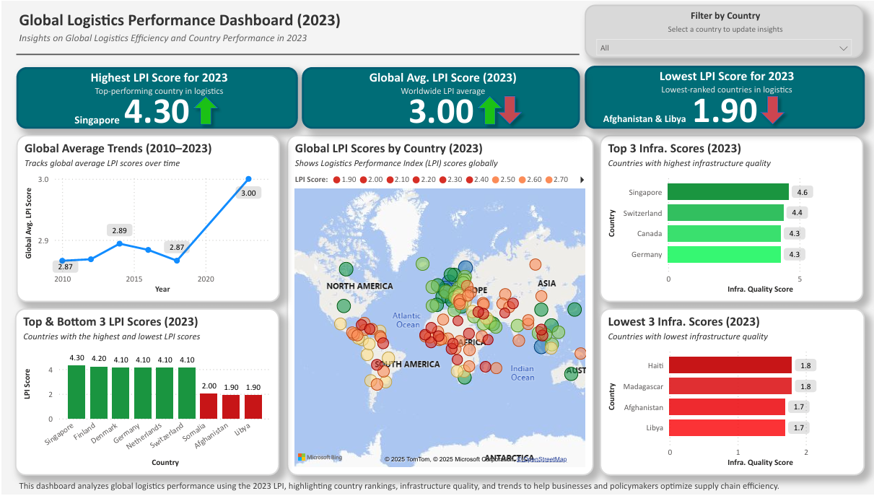
Figure 1: Global Logistics Performance Dashboard (2023) – Power BI Visualization.
Business Impact & Recommendations
This analysis helps policymakers and business leaders strengthen logistics systems by:
- Investing in Infrastructure
- Prioritize improvements in low-performing countries to support trade growth.
- Benchmarking High Performers
- Apply successful strategies from top countries like Singapore and Germany to improve logistics policy and technology.
- Tracking Progress Over Time
- Use LPI data as an ongoing benchmark to guide reforms and monitor logistics development

SQL Queries & Data Extraction
To analyze logistics performance trends, key insights were extracted using SQL in Microsoft SQL Server. Below are the primary queries:
- Retrieve Available Years in the Dataset
SELECT DISTINCT Current_Year
FROM LPI_International_Logistics_Analysis;
Purpose: Lists all unique years in the dataset to support trend analysis.
- Top 3 LPI Scores (2023)
SELECT TOP 3 Economy, LPI_Score
FROM LPI_International_Logistics_Analysis
WHERE Current_Year = 2023
ORDER BY LPI_Score DESC;
Purpose: Identifies the 3 countries with the highest LPI scores in 2023.
- Bottom 3 LPI Scores (2023)
SELECT TOP 3 Economy, LPI_Score
FROM LPI_International_Logistics_Analysis
WHERE Current_Year = 2023
ORDER BY LPI_Score ASC;
Purpose: Returns the 3 lowest-ranked countries by logistics performance in 2023.
- Global Average LPI Scores Over Time
SELECT Current_Year, AVG(LPI_Scores) AS Avg_LPI_Score
FROM LPI_International_Logistics_Analysis
GROUP BY Current_Year
ORDER BY Current_Year ASC;
Purpose: Calculates average LPI score per year to visualize global trends.
- Infrastructure Scores by Country (2023)
SELECT Economy, Infrastructure_Score
FROM LPI_International_Logistics_Analysis
WHERE Current_Year = 2023
ORDER BY Infrastructure_Score DESC;
Purpose: Ranks 2023 infrastructure scores to compare top and bottom countries.

SQL Summary
SQL was used to extract, filter, and analyze logistics performance data directly from the cleaned dataset. Key queries retrieved top and bottom LPI scores, tracked global trends from 2010 to 2023, and calculated global averages for deeper insight into performance changes over time. This structured querying approach ensured data accuracy, transparency, and reproducibility throughout the analysis process.
Key SQL Queries Used:
- Retrieve Unique Years for Time-Series Analysis
- Top 3 & Bottom 3 Countries by LPI Score (2023)
- Global Average LPI Score by Year (2010–2023)
- Global LPI Score Distribution by Country (2023)
- Top & Bottom Countries by Infrastructure Score (2023)
File Export & Submission
- Cleaned dataset exported as .xlsx and .csv for use in SQL and Power BI
- Power BI Dashboard .pbix saved for portfolio use
- SQL Query File .sql saved for portfolio use
- Dashboard image exported as .png and .pdf for professional sharing
- Finalized documentation (this report) saved as .docx and .pdf
- GitHub README included as both README.md and .pdf
- All project files are organized and stored in GitHub and LinkedIn portfolio for easy access
Final Thoughts
This project delivers a data-driven assessment of global logistics performance using Excel, SQL, and Power BI. It identifies performance gaps across countries, highlights infrastructure disparities, and provides actionable recommendations to support trade readiness and supply chain strategy—key focus areas for roles such as Business Analyst, Operations Analyst, and Systems Analyst.
The interactive dashboard and all supporting files are included in my professional portfolio on GitHub, including the Power BI file: Logistics_Performance_Dashboard.pbix and the SQL queries used in this analysis: logistics_analysis_queries.sql.

