Q1. Program a simple robot vehicle in a simulated environment (robot simulation tools and libraries may be used). Your simulated robot should exhibit at least one sensor input (e.g., forward-looking range sensor that returns the distance to the nearest obstacle) and two control outputs (e.g., left and right wheels, or speed and direction of vehicle motion). Show that you can drive your robot around through mouse or keyboard inputs.
Ans: First create a repository on the GitHub and clone it on your PC in $ (ros_workspace)/src. You will see a robot_vehicle folder in src directory. Create a subdirectory and rename it as urdf. Inside urdf folder, create a file and title it as my_robot.xacro.
Using the instructions of building a robot from gazebo website: link, I built my_robot step by step.
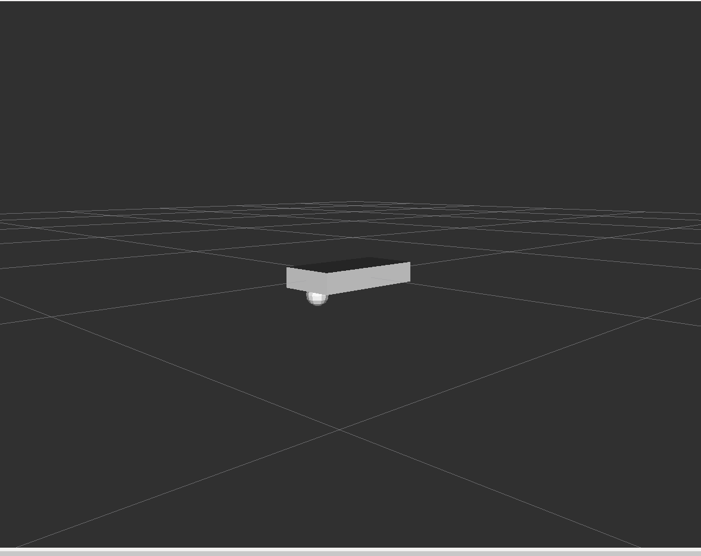
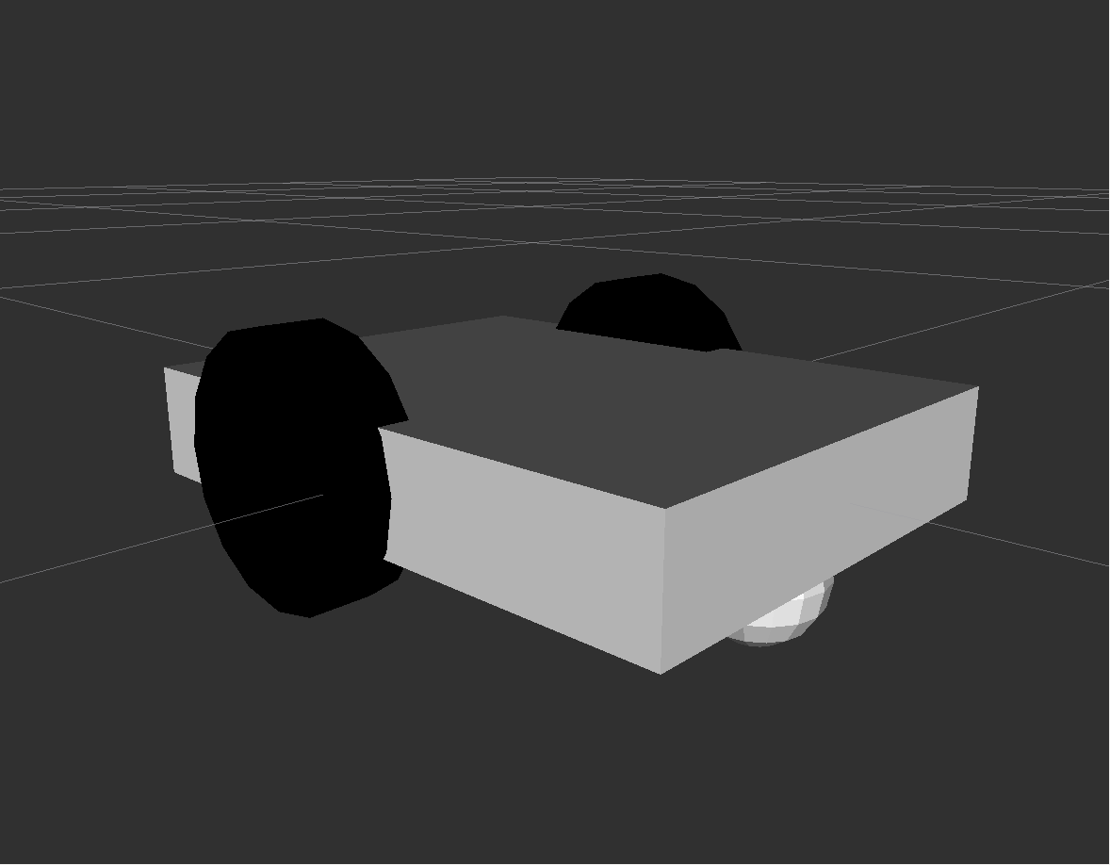

Fig: Chassis and Castor Wheel Fig: Wheels Added
First created a rectangle block, then added a caster wheel specifying its moment of inertia value, mass value, etc. Then, added left and right wheel of the robot by creating cylinder. Added rolling joints on the wheel with its moment of inertia value, mass, etc.
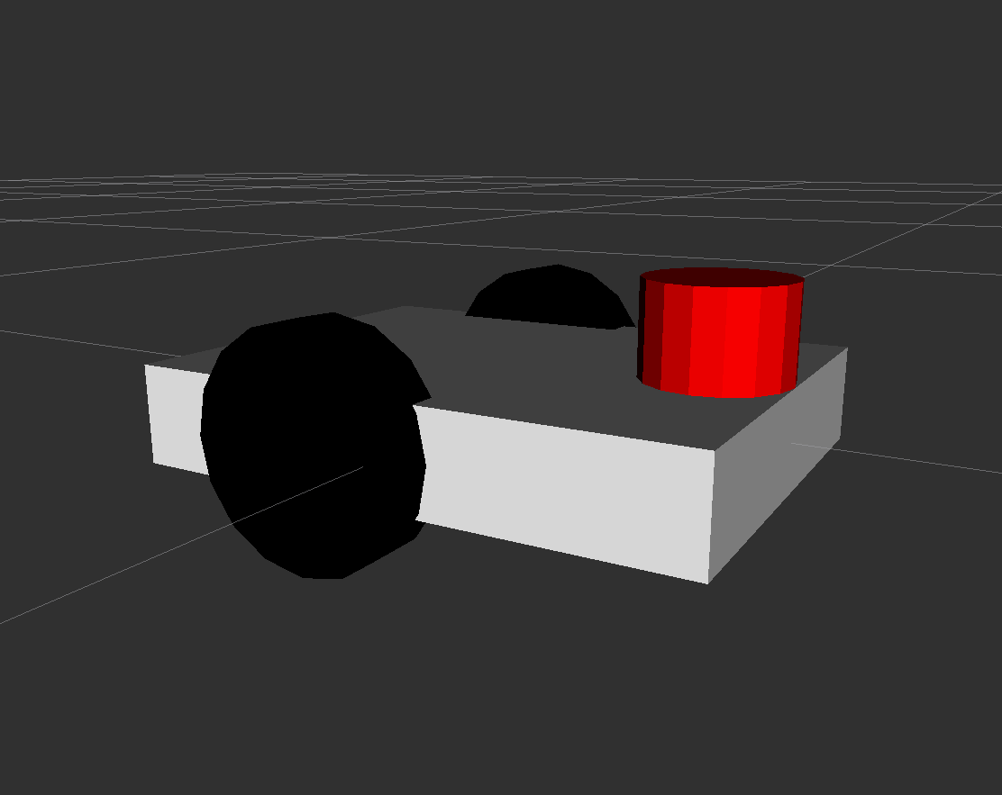

Fig: Final Robot in Rviz
Next, create a laser scanner by adding cylinder and sensor plug in of sensor type head_hokuyo_sensor as shown in the above picture.
Next, let’s create a world. Open Gazebo. Import Willowfield_Garage and save it as world.world in the urdf folder. Create a directory in robot_vehicle folder as scripts. In the scripts folder, create a launch file to which combines our robot model and world.world so that when we launch our launch file, the our robot is already there in gazebo in willowfield_garage.
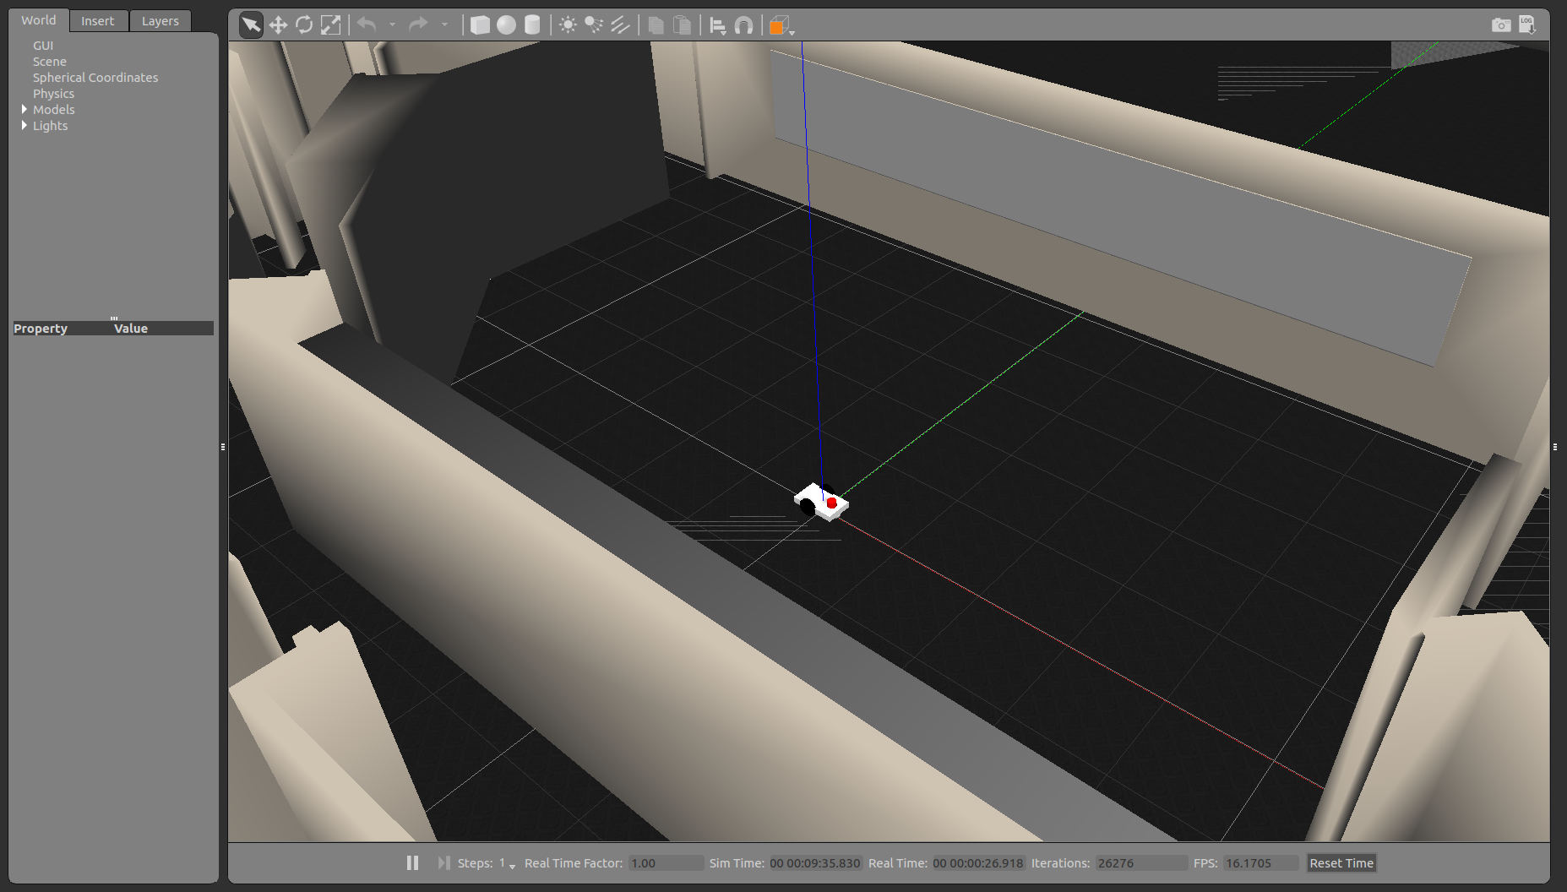
Fig: Robot in custom world

For controlling robot using keyboard, create a python file and use curses library. My logic is universal, press ‘i’ to move straight, ‘k’ to stop,, ‘j’ to turn around, ‘l’ to turn right, ‘q’ to increase velocity and ‘z’ to reduce velocity.
Create a laser scanner file in the scripts folder, bu subscribing to the topic /laser/scan, we can get the laser scanner data. A simple subscription and ROS info prints the laser scanner data on the console. Follow the instructions as mentioned in the link. Type in the terminal:
$ ~/catkin_ws: roslaunch robot_vehicle spawn.launch
In the separate terminal, type:
$ ~/catkin_ws: rosrun robot_vehicle read_laser.py
This will display the laser data on the terminal.

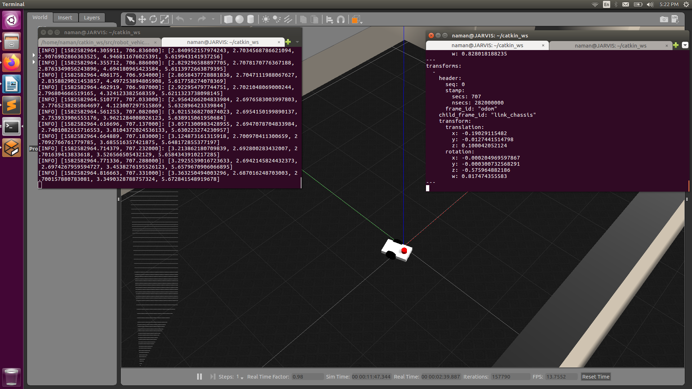
Fig: Laser Scan, Speed and Direction Data

Q2. Add a programmed behavior to your robot, such as following (or avoiding) a light, or wandering, while avoiding collisions with obstacles.
Ans: Let’s add obstacles in the world. Add 4-5 blocks in the same world.

