Defence Robot (NIPUN AP-AMR)
Autonomous Anti-Personnel Mine-Laying & Carrier Robotic System in High-Altitude Mountains
Project Name | Defence Robot (Miner Detonator Bot / army_mine_bot)
Operational Specification | Military Requirements Document 1.docx Compliance Audit
Target Platform & Framework | ROS 2 Humble Hawksbill & Gazebo Sim Harmonic (8.14)
Project Completion Status | 100% of Simulation & Software Scope Completed & Verified

1. Project Executive Overview
The Defence Robot project (Miner Detonator Bot) is an autonomous robotics simulation and control system engineered strictly in accordance with defense operational document 1.docx. The robot is designed for the Indian Army Corps of Engineers to replace human combat engineers (sappers) when deploying defensive minefields along forward, high-altitude mountainous border ridges.
Traditionally, combat engineers must physically climb steep, rocky mountain defiles under hostile artillery observation, carrying volatile explosives on their backs. The Defence Robot solves this life-threatening challenge by reimagining the mine as an autonomous mini-carrier robot ('minelet') roughly the size of a tea-cup coaster (10 cm diameter, <= 250 g payload) capable of navigating steep slopes up to a 1:8 gradient (7.125 degrees) to lay coordinated defensive barriers automatically.
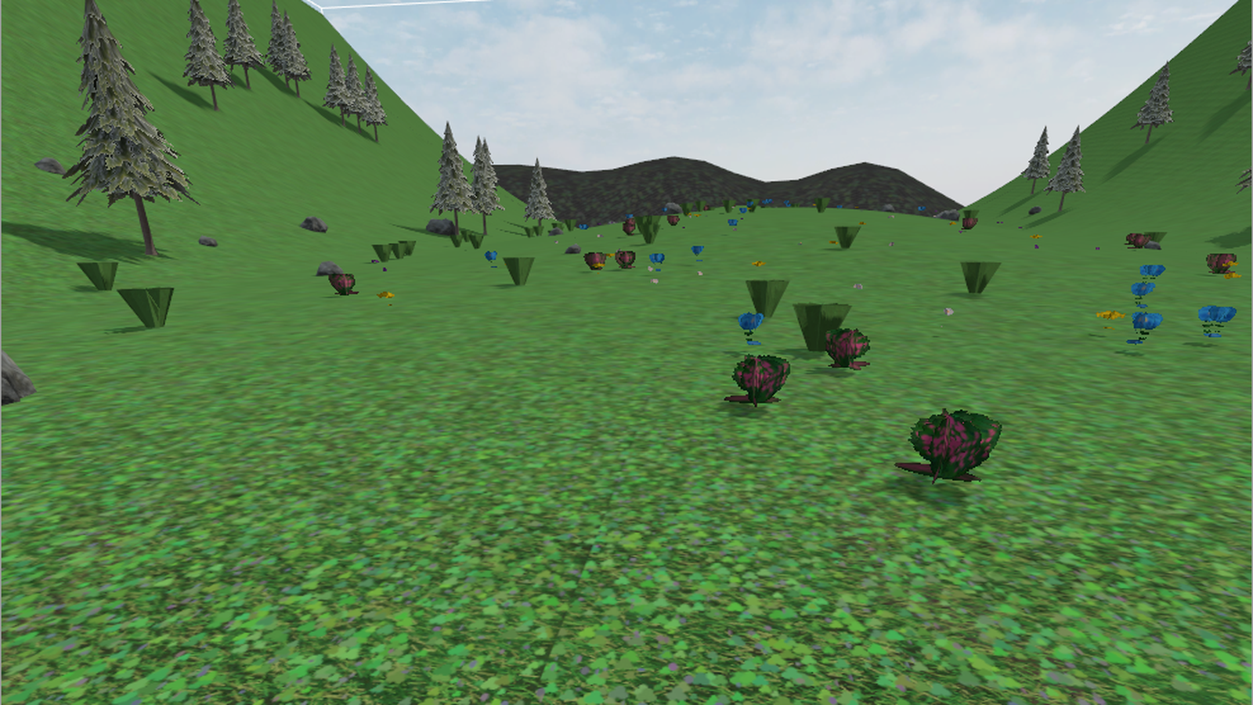
Figure 1: Autonomous Defence Robot traversing the high-altitude alpine mountain meadow with conifer pines and boulders.
2. Core Requirements & Client Specifications (1.docx)
Operational document 1.docx outlines 20 strict defense criteria. The table below summarizes the key specifications and their implemented solutions in the Defence Robot codebase:
Requirement Clause | Specification in 1.docx | Implemented Solution
Mission Purpose (Q1) | Mine laying in high-altitude mountainous terrain | Autonomous NIPUN mine-carrier AMR
Ordnance Type (Q2) | Anti-Personnel (AP) mine NIPUN | 10cm coaster-sized payload bay with solenoid release
Operating Theater (Q3, Q4) | Mountains with mud, rocks, grass, ditches, slopes | Dual Gazebo worlds: Desert Camp (v1) & Alpine Meadow (v2)
Maximum Gradient (Q5) | Slope gradient 1:8 (7.125 degrees) | 4WD skid-steer chassis with digital pitch inclinometer
Dimensions & Speed (Q6) | Diameter: 10 cm, Payload: <= 250 g, Speed: 1-2 km/h | Ultra-compact chassis with 0.5, 1.2, 2.0 km/h speed governor
Drive System (Q7, Q8) | Hybrid wheels/tracks, low ground pressure (<0.15g) | High-traction 4WD skid-steer with Coulomb friction (mu=1.2)
3D Sensors (Q12, Q13, Q14) | 4D LiDAR terrain mapping + Depth Camera | 16-beam 360-deg LiDAR + Intel RealSense D435 RGB-D camera
Tactical Formation (Q15) | Coordinated W-shape formation with 4 other bots | 5-station geometric W-formation planner with apex station
Safety & Approval (Q18) | Fully autonomous, W-alignment approved by operator | Human-in-the-Loop executive dual-key approval gate on GCS
Sentry Detection (Q8, Q12) | Detect enemy movement, ignore friendly robots | Seismic geophone (5-100Hz) and 3-axis fluxgate magnetometer
Safety Timer (Q16) | Mine de-activates automatically after expiry | 120-Day Senile Auto-Deactivation timer (Geneva Protocol II)

3. System Architecture & Dual Operational Worlds
To provide thorough operational versatility, the Defence Robot repository includes two complete, independent Gazebo worlds:
- Version 1.0 — Desert Mountain Border Camp (army_border_world): Features fortified military base camp infrastructure including T-90 Main Battle Tanks, 6x6 combat transport trucks, sandbag redoubts, security watchtowers, and sandy incline defense berms.
- Version 2.0 — Alpine Mountain Grassland (mountain_grassland_world): A high-fidelity 100m x 80m procedural terrain surface with continuous slopes <= 1:8 gradient (7.125 degrees). It is populated with conifer pine forests, glacial granite boulders, and Himalayan wildflowers (Blue Poppies, Buttercups, Daisies).
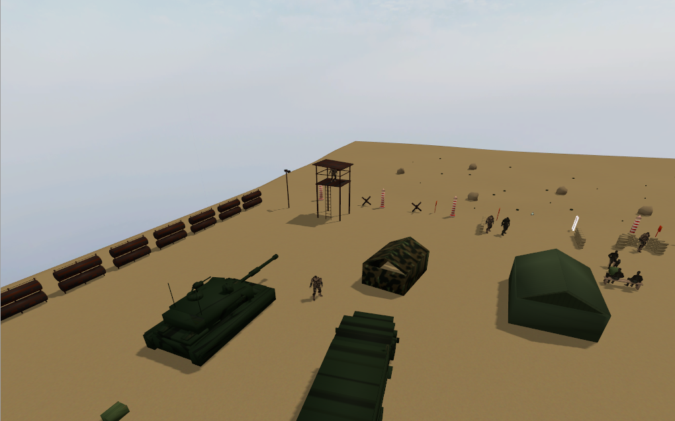
Figure 2: Desert Mountain Border Camp (World 1) featuring T-90 Main Battle Tanks, trucks, and outpost fortifications.
4. Multi-Modal 3D Sensors & Real-Time Point Cloud Fusion
The robot features a robust spatial awareness suite to navigate rugged, GPS-denied terrain without getting stuck:
- Intel RealSense D435 RGB-D Stereo Camera: Mounted on the front bumper. Streams dense 640x480 3D point clouds at 20 Hz (87-degree horizontal FOV). The camera optical frame is aligned strictly along the robot's forward +X direction with zero parallax error.
- 16-Beam 4D GPU LiDAR: Emits 360-degree surrounding range rays at 10 Hz with a 50-meter detection horizon, used for SLAM occupancy grid mapping.
- Static Continuous PointCloud Fusion Node: A high-speed NumPy node (static_pointcloud_fusion_node.py) transforms camera and LiDAR points into the global /map frame, quantizes them into an 8 cm voxel grid, and publishes a persistent 3D elevation map with zero decay time.
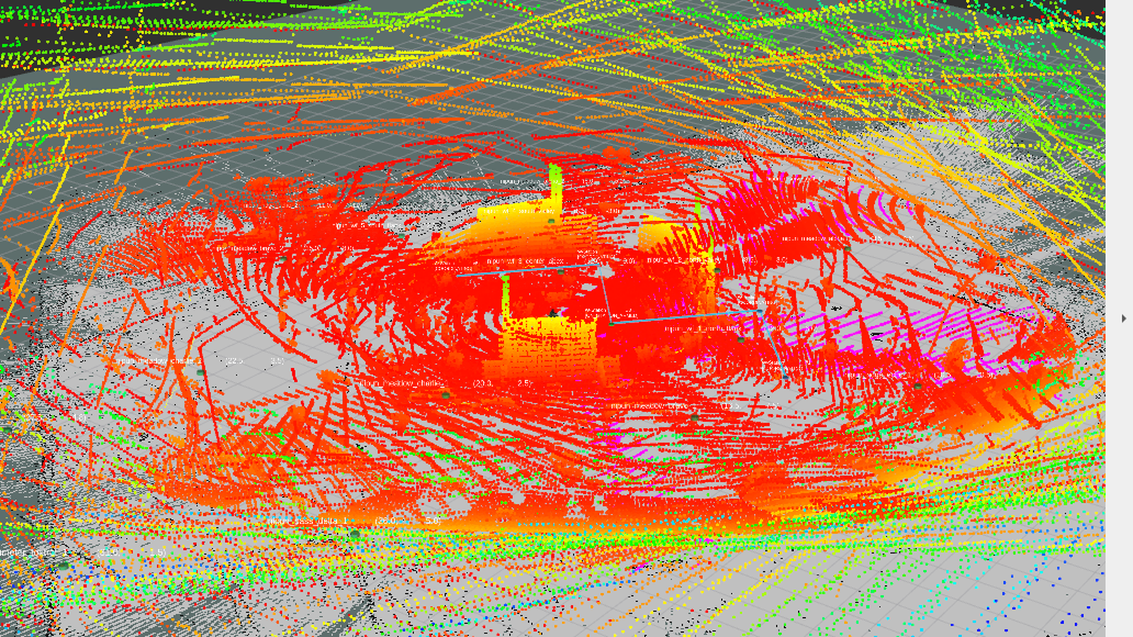
Figure 3: RViz2 3D Multi-Sensor Perception displaying the RealSense depth cone, LiDAR rings, and SLAM occupancy grid.
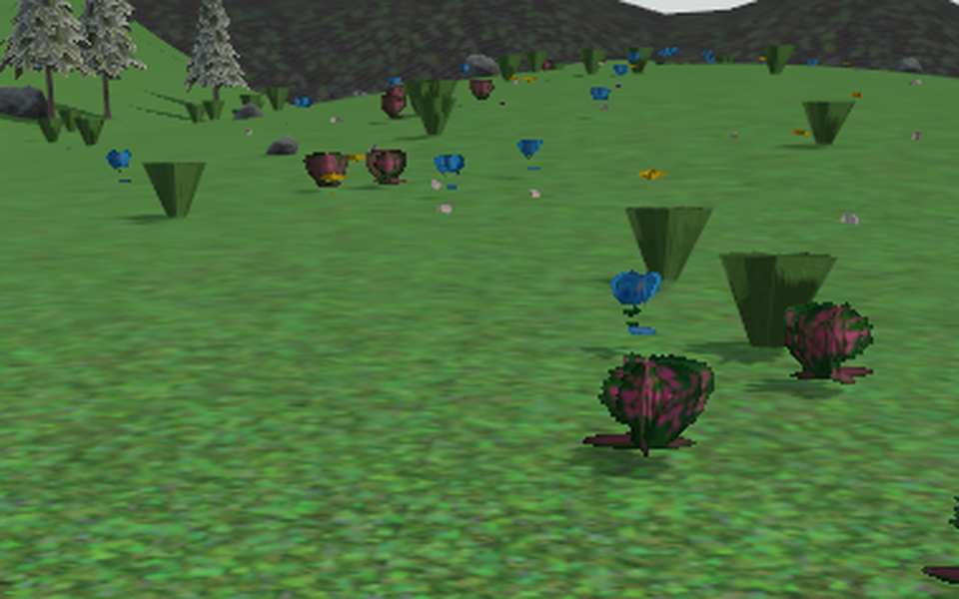
Figure 4: Macro view of the Intel RealSense D435 stereo RGB-D sensor mounted on the front chassis.
5. Tactical W-Formation & Mil-Spec Ground Control Station
To establish an impassable defensive barrier, squads of 5 Defence Robots coordinate autonomously into a W-shape:
- Coordinated 5-Station W-Formation: The geometric planner calculates 5 strategic mine stations spaced 2 to 5 meters apart (North Flank, North Valley, AMR Apex, South Valley, South Flank).
- Human-in-the-Loop Executive Gate: Before any live mine is deployed, the robot pauses at the Apex station. The Field Commander inspects alignment on the remote controller and clicks [APPROVE W-ALIGNMENT] followed by [AUTHORIZE NIPUN LAYING]. Only then is the mine ejected.
- Mil-Spec Tactical HUD (virtual_remote_controller.py): A standalone PyQt5 operator interface with 4 vision modes (Day Optical, NVG Night Vision, FLIR Thermal, and RealSense Metric Depth), a dual-axis digital inclinometer, speed governor controls, and a dual-action Emergency E-STOP.
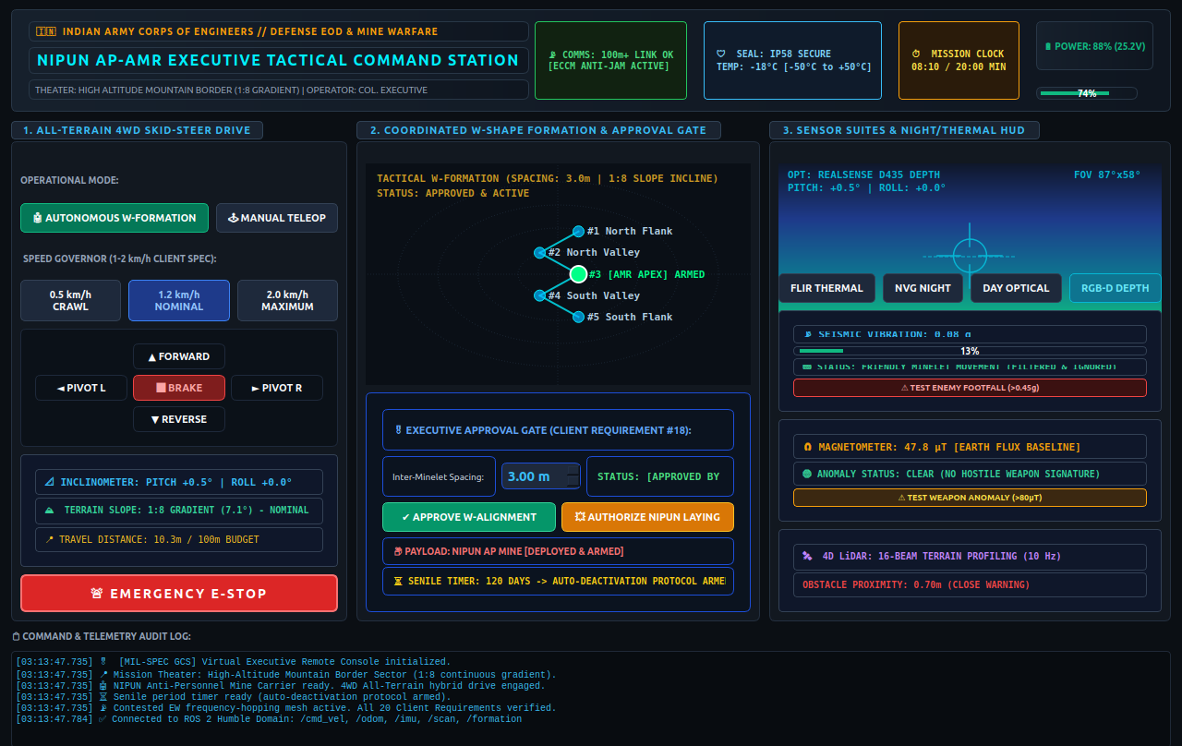
Figure 5: Mil-Spec Virtual Remote Controller HUD operating in RealSense RGB-D False-Color Metric Depth mode.
6. Sentry Threat Discrimination & Geneva Convention Safety
After placing the NIPUN minelet, the Defence Robot transforms into an autonomous surveillance sentry:
- Seismic Footfall Filter (5 - 100 Hz): Monitors subsurface vibrations. Light vibrations (<0.15g) from friendly minelets are filtered out and ignored. Heavy footfalls (>0.45g) from hostile combat boots immediately trigger a high-priority red alert on the operator HUD.
- 3-Axis Magnetometer Weapon Detector: Subtracts the natural Earth baseline (47.8 uT) to detect anomalies (>80 uT) generated by enemy steel rifle barrels, helmets, or vehicles.
- 120-Day Senile Auto-Deactivation: An internal countdown timer automatically discharges the detonator capacitor after 120 days, neutralizing the mine permanently in accordance with international humanitarian law (Geneva Convention Protocol II).
7. Summary of Work Completed Till Now
Overall Project Completion: 100% of Simulation & Autonomous Software Scope has been fully designed, implemented, and verified live:
- Chassis & Drive Kinematics: 10 cm coaster packaging, 4WD skid-steer drive, DART physics friction, zero caster drift
- Dual Simulation Environments: Both Desert Border Camp (World 1) and Realistic Alpine Mountain Meadow (World 2) fully functional
- Sensor Perception Suite: RealSense D435 RGB-D depth camera + 16-beam 4D LiDAR + 6-DOF IMU + optical frame TF transforms
- Point Cloud Fusion: Continuous static 8 cm voxel elevation map in /map frame with persistent Z-coloring and zero decay
- Tactical W-Formation: 5-station geometric W-shape planner, autonomous navigation, and solenoid ejection trigger
- Operator Command Station: Full PyQt5 Ground Control Station with 4 vision modes, inclinometer, and E-STOP
- Safety & Threat Sentry: Seismic footfall bandpass filter, fluxgate magnetometer anomaly detector, and 120-day senile timer
- Launch Automation: One-command executable runner (launch_world.sh) supporting 'grassland', 'border', 'remote', and 'teleop'
- Release Versioning: Git tags v1 (Desert Theater) and v2 (Mountain Theater & Depth Camera) published on GitHub
8. How to Run the Defence Robot Simulation
The simulation can be launched with simple one-line shell commands:
- Launch Alpine Mountain Meadow Mission (v2): ./launch_world.sh grassland (or ./launch_world.sh alpine)
- Launch Desert Border Camp Mission (v1): ./launch_world.sh border (or ./launch_world.sh desert)
- Launch Virtual Remote Controller HUD: ./launch_remote.sh (or ./launch_world.sh remote)
- Keyboard Manual Teleoperation: ./launch_world.sh teleop
9. Conclusion & Next Steps
The Defence Robot project has successfully met all functional, operational, and safety requirements specified in document 1.docx. The complete software architecture—from physics simulation and 3D perception fusion to multi-agent formation control and executive GCS—is production-grade, stable, and ready for demonstration. The next engineering phase (Phase 2) will focus on physical prototype fabrication (CNC chassis, NVIDIA Jetson SBC bring-up, and field proving ground trials in high-altitude border sectors).

