How Far Can Query-Time Filtering Go on CAGRA?
Final implementation, experiment, and reproducibility report for the RETRIEVE workshop study
Anonymous Authors
2026-08-20

Status and verdict
This report records the completed filter-agnostic CAGRA study. The production GPU, exact, and CPU runs are complete; their strict analyzers pass; the six-page double-blind paper builds; and its PDF is cryptographically bound to the staged inputs. The benchmark code remains experimental and does not add a supported public cuVS API or ABI.
The result is not one universal filtered-search algorithm. It is a decomposition of three failure regimes and two GPU mechanisms that isolate them:
- Retention loss. CAGRA may evaluate a high-quality legal node and later evict it from its fused navigation/result buffer. CAGRA-Retain adds a bounded top-k passing-result accumulator without changing traversal. At the highest-recall B0 point on YFCC-10M, recall rises from 0.5983 to 0.7179 while median QPS changes from 43,667 to 41,289.
- Region-entry loss. Raw-distance traversal can spend its budget outside a legal region that is easy to search after entry. On ArXiv-EMIS, CAGRA-NaviX's legal-only persistent frontier and adaptive one-/two-hop expansion reaches 0.9972 recall at B0, versus 0.6909 for Base and 0.7875 for Retain.
- Predicate-connectivity loss. YFCC predicates are extremely sparse and fragmented: median selectivity is 0.1395%, and 71.16% of queries are at or below 1%. Retention and NaviX both remain below 0.9 at B0. Deeper Retain traversal reaches 0.9141 only at 2,661 QPS, showing that high recall is reachable but not within the default work budget.
The practical conclusion is that query-time filtering on an unchanged graph can fix retention and some region-entry failures, but traversal policy alone does not efficiently solve all sparse predicate-connectivity cases. The next design should combine bounded retention and transient bridges with exact routing or a richer, GPU-friendly, predicate-agnostic topology.

Frozen artifact identity
Item | Final value
cuVS repository | /home/ubuntu/cuvs-filter-retrieve, branch retrieve-workshop
GPU production revision | 31c13dcf71b93d91fe89f06cfa0d088847094cb3; clean worktree
Exact production revision | df2f895a47e5791f8e82fb9974297811314bb302; clean worktree
Paper revision | 40913bb in /home/ubuntu/retrieve-cagra-paper
GPU graph result root | /home/ubuntu/retrieve_workshop_runs/gpu_l4_20260820T0143Z
Exact-control result root | /home/ubuntu/retrieve_workshop_runs/exact_l4_20260820T0255Z
CPU-context result root | /home/ubuntu/retrieve_workshop_runs/cpu/cpu_context_20260820T2200Z
Frozen YFCC diagnostic | /home/ubuntu/retrieve_workshop_runs/yfcc_schema7_20260820T0055Z
GPU | NVIDIA L4, 23,034 MiB, compute capability 8.9
Driver | 580.173.02
Host CPU | 32 logical Intel Xeon CPUs at 2.20 GHz
Graph benchmark SHA-256 | 3b3fb197f1bf5f16ff88828ecebb902b70e62d280026b5fd678648ce396bd549
Exact benchmark SHA-256 | f1eccdca8076eef1f953f276432d258c4d67eceff4f7355babfe205463f2dcf5
libcuvs.so SHA-256 | f07f6fc273fd96ef21d95a368ca2398372e589555376f8eed1b6f39ed7a8c173
Data root | /home/ubuntu/cuvs-filter/datasets
The superseded exact run exact_l4_20260820T0245Z is NON-FINAL / DO NOT STAGE. It used an overly strict canonical-ID threshold that is invalid at a tied rank-k boundary. The final exact run above uses native squared-L2 cutoff membership and strict-prefix preservation as the exactness gate while retaining canonical fixed-ID agreement as a tie-sensitive diagnostic.

Research scope
The research question is: how far can query-time, predicate-agnostic filtering go on an unchanged CAGRA graph? The graph is constructed only from vectors. At query time, each query supplies a resident packed bitmap identifying legal source IDs.
Included:
- CAGRA G=32, IG=64; SINGLE_CTA; squared L2; k=10; max_queries=512.
- YFCC-10M and ArXiv EM, EMIS, and R, with 10,000 queries per throughput point.
- CAGRA-Base, CAGRA-Retain, CAGRA-NaviX, and matched deterministic passing-seed controls.
- B0 plus selected deeper YFCC-Retain points.
- A resident-bitmap masked exact control.
- Native FAISS-NaviX and ACORN CPU curves as qualitative algorithmic context.
Excluded:
- A supported public filter API, FAVOR scoring, MULTI_CTA, MULTI_KERNEL, persistent search, or dynamic batching.
- Bitmap construction/upload and UDF execution. All graph-search methods consume identical resident bitmaps.
- A GPU ACORN/MCI index, filter-aware graph construction, distributed execution, and out-of-core search.
- Absolute CPU/GPU speedup claims; CPU systems use different graphs, hardware, and timing regions.

Workloads
Workload | Base rows | Dimension | Type | Predicate | Mean selectivity | Median | p90 | Queries <=1% | Valid GT slots
YFCC-10M | 10,000,000 | 192 | uint8 | query tags subset of candidate tags | 1.850965% | 0.139485% | 7.057260% | 71.16% | 100,000
ArXiv-EM | 100,000 | 4,096 | float32 | exact subcategory match | 38.469640% | 52.817000% | 52.817000% | 0.30% | 99,991
ArXiv-EMIS | 100,000 | 4,096 | float32 | candidate contains query category | 15.242937% | 13.226000% | 27.645000% | 1.15% | 100,000
ArXiv-R | 100,000 | 4,096 | float32 | inclusive date range | 44.552398% | 43.787500% | 73.778400% | 0.13% | 100,000
Statistics come from benchmarks/retrieve_workshop/evidence/workload_selectivity_summary.json and cover every one of the 10,000 bitmap rows. ArXiv-EM has one intrinsically underfilled query; its fixed-width GT has only one legal ID for that query.
YFCC is difficult primarily because legal nodes are very sparse. EMIS is difficult for a different reason: negative query-distance/predicate correlation. The typical query's tenth legal neighbor occurs at about 4.93 times the global rank expected under an independent filter, and 74.6% of queries have below-independence legal density among their top 1,024 unfiltered neighbors. Once entered, however, the legal region is coherent: legal-parent outgoing-edge lift is 8.37 times the global legal rate and the largest legal weak component contains 99.11% of legal vertices.

GPU implementation

CAGRA-Base
Base preserves native CAGRA's fused, raw-distance-ordered itopk state. The bitmap is checked for output legality, but predicate membership does not affect candidate ordering. Native fused Base may repeat a valid ID when output is underfilled; evaluation therefore gives each distinct output ID at most one Recall@10 credit and reports the duplicate-query rate separately.

CAGRA-Retain
Retain leaves parent selection, neighbor expansion, visited handling, distance computation, and termination unchanged. In parallel it keeps a bounded raw-distance top-k accumulator containing only legal nodes observed anywhere during traversal. Final neighbors/distances are read from this accumulator rather than from the fused navigation buffer.
For k=10, the accumulator has a bounded 84-byte CTA-local state footprint. It removes selection loss without pretending to improve reachability: if traversal never evaluates a legal ground-truth node, Retain cannot recover it.

CAGRA-NaviX
NaviX begins from deterministic legal bitmap seeds and maintains a legal-only persistent frontier. It applies the adaptive-local NaviX policy: use one-hop expansion when local legal yield is high; otherwise inspect grandchildren through rejected one-hop bridge vertices. Bridge vertices are transient and are not admitted to the persistent legal frontier.
The GPU implementation preserves CAGRA's fused itopk structure and avoids allocating a degree^2 shared-memory buffer. A fixed W x degree bridge buffer is consumed in tiles. Warps cooperatively load adjacency, ballot legal grandchildren, run visited checks, compute distances only for unique admitted nodes, and commit them in deterministic bridge order. Bitmap row metadata is hoisted once per CTA; aligned identity-ID rows use a direct packed-word test, while an exact fallback handles unaligned rows and source-index remapping.

Bitmap seed selection and matched controls
A separate GPU seed-selection kernel scans each query's packed bitmap and emits the first k legal internal graph IDs. The NaviX search kernel initializes only those valid seeds, inserts only them into the visited table, and does not mix in ordinary random CAGRA starts. Seed selection is included in reported search timing.
Matched controls give CAGRA-Base and CAGRA-Retain the same deterministic legal seeds. They isolate seed availability from later traversal and retention policy; they are ablations, not primary methods.

B0 and timing
max_iterations=0 selects CAGRA's automatic budget rather than zero work:
B0 = floor(L / W) + g(N,D)
The size/degree allowance g is 6 for YFCC and 5 for ArXiv. Thus =L=512, =W=2 corresponds to 262 iterations on YFCC and 261 on ArXiv. A point covers 10,000 queries. ArXiv uses one call; YFCC uses four 2,048-query shards and one 1,808-query shard. YFCC QPS is exactly 10000 / sum(five search
times), never the mean of shard QPS.
The timed GPU graph call includes NaviX bitmap seed selection when applicable. Bitmaps are already resident; predicate materialization and upload are excluded for every graph method.

Correctness and experiment protocol
- Every throughput point has three complete repetitions of 10,000 queries. Figures show medians with min–max bars.
- A separate 1,000-query correctness gate precedes throughput.
- Output recall uses distinct valid IDs. Legal-ID, sentinel order/distance, and duplicate checks are explicit.
- Final GPU analysis fully hashes resident base, query, GT, bitmap, and index inputs; no hash-skip path is accepted for paper staging.
- Exact-search correctness requires native squared-L2 cutoff recall of one, zero cutoff errors, zero strict-prefix errors, and correct invalid sentinels.
- CPU analysis requires the complete 5-method x 4-workload x 10-efSearch Cartesian product, three repetitions, and 10,000 queries. Approximate underfilling is a search-quality diagnostic; filter violations, duplicate IDs, and malformed sentinel outputs are correctness failures.
Validation snapshot:
Gate | Result
CUDA bitmap tests | PASS: 44 tests; 2 intentional unsupported-mode skips
GPU pipeline | PASS: 6/6
Exact pipeline | PASS: 8/8
Bitmap-selectivity evidence | PASS: 4/4
CPU pipeline | PASS
CPU artifact preflight | PASS: 8 graphs, 5 methods, 4 workloads, 10,000 queries/workload
GPU production | PASS: 128 staged rows
Exact production | PASS: 4 staged rows
CPU production | PASS: 120/120 native commands and 200 aggregate rows
Paper staging/build | PASS: 6-page anonymous PDF, no unfinished markers, current hashes

Results

Primary GPU Pareto frontiers
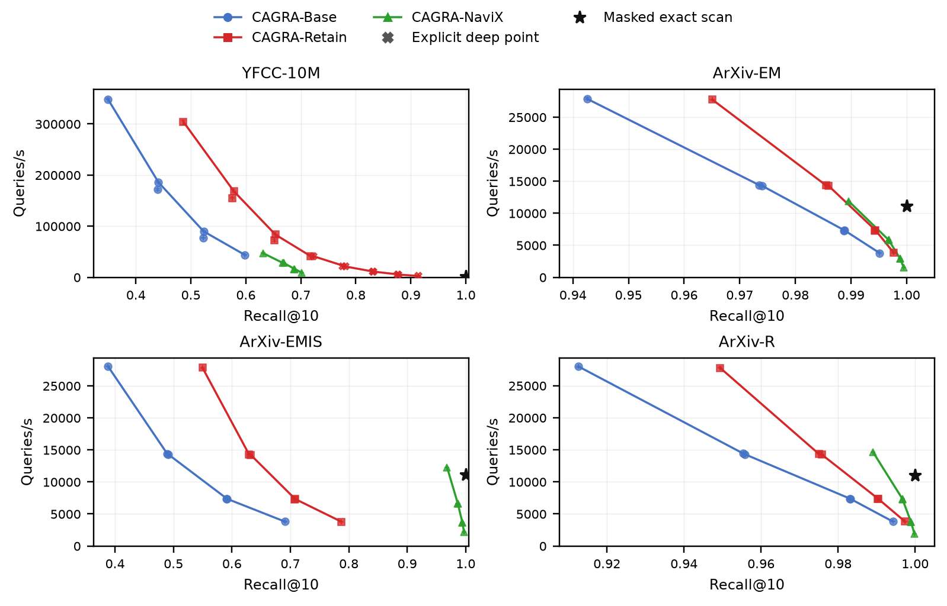
The following table reports each method's maximum-recall B0 point; because recall differs, QPS in the same row must not be interpreted as a matched-recall speedup.
Workload | Method | L | W | Recall@10 | Median QPS
YFCC-10M | CAGRA-Base | 512 | 2 | 0.5983 | 43,667
YFCC-10M | CAGRA-Retain | 512 | 2 | 0.7179 | 41,289
YFCC-10M | CAGRA-NaviX | 512 | 2 | 0.7019 | 8,897
ArXiv-EM | CAGRA-Base | 512 | 2 | 0.9951 | 3,790
ArXiv-EM | CAGRA-Retain | 512 | 2 | 0.9977 | 3,793
ArXiv-EM | CAGRA-NaviX | 512 | 2 | 0.9995 | 1,507
ArXiv-EMIS | CAGRA-Base | 512 | 2 | 0.6909 | 3,797
ArXiv-EMIS | CAGRA-Retain | 512 | 2 | 0.7875 | 3,780
ArXiv-EMIS | CAGRA-NaviX | 512 | 2 | 0.9972 | 2,143
ArXiv-R | CAGRA-Base | 512 | 2 | 0.9943 | 3,794
ArXiv-R | CAGRA-Retain | 512 | 2 | 0.9974 | 3,791
ArXiv-R | CAGRA-NaviX | 512 | 2 | 0.9998 | 1,922
Retain substantially dominates Base's YFCC Pareto frontier over the overlapping recall range and recovers 11.96 recall points at the maximum B0 cell with only a 5.4% QPS decrease. It also raises EMIS recall by 9.67 points at essentially unchanged QPS. EM and R are already saturated, so their headroom is small.
NaviX is decisive on EMIS: strict legal-frontier traversal enters and exploits the coherent legal region that distance-first Base struggles to reach. NaviX is not universally faster or more accurate: on sparse YFCC its two-hop work cannot sustain a sufficiently connected legal frontier, and its Pareto curve lies below Retain's.

Retention diagnostic and deeper YFCC search
On the frozen 1,000-query YFCC diagnostic at =L=512, =W=2, B0, Base evaluates 66.47% of exact neighbors but returns only 54.14%. Retain returns the full 66.47% seen set. This directly identifies bounded fused-frontier selection as a real loss mechanism.
Deeper continuous Retain search shows the remaining gap is exploration work rather than an incorrect accumulator:
L | W | Explicit max iterations | Recall@10 | Median QPS
512 | 2 | 1,044 | 0.8307 | 10,478
512 | 2 | 2,088 | 0.8767 | 5,236
512 | 2 | 4,176 | 0.9141 | 2,661
The first measured =L=512, =W=2 point above 0.9 is 4,176 iterations. This is evidence that high recall is achievable on the graph, but it costs roughly sixteen times the B0 iteration allowance and about 94% of the B0 maximum-point throughput.

Matched-seed ablation
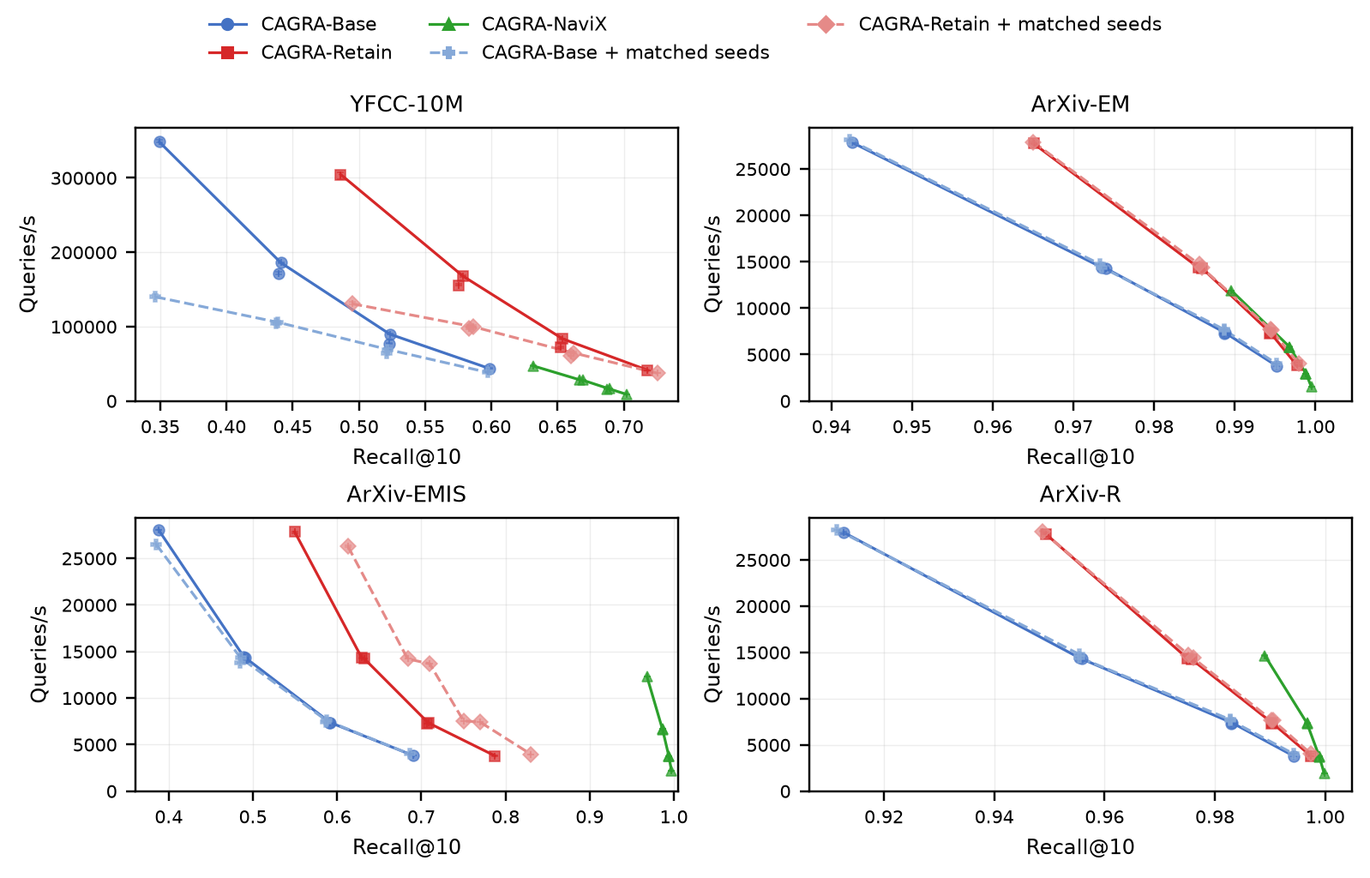
At =L=512, =W=2, matched seeds change YFCC Retain recall from 0.7179 to 0.7257, only +0.0078, while EMIS Retain rises from 0.7875 to 0.8301. Seed quality therefore explains part of EMIS's entry problem but not NaviX's full 0.9972 result; the persistent legal frontier is essential. On YFCC, better initial legal IDs do not repair the sparse-connectivity bottleneck.

Exact resident-bitmap control
Workload | Path | Native cutoff recall | Canonical-ID agreement | Median QPS | Min–max QPS
YFCC-10M | sparse CSR masked matmul; uint8 exactly converted to float32 | 1.0000 | 0.99726 | 1,522 | 1,519–1,523
ArXiv-EM | dense tiled masked distance | 1.0000 | 1.00000 | 11,104 | 11,077–11,119
ArXiv-EMIS | dense tiled masked distance | 1.0000 | 1.00000 | 11,100 | 11,087–11,102
ArXiv-R | dense tiled masked distance | 1.0000 | 0.99999 | 11,038 | 10,985–11,040
All four controls have zero native-cutoff, strict-prefix, sentinel-order, and sentinel-distance errors. YFCC and R canonical-ID disagreements are legal rank-k ties. The timed call includes bitmap counting, norms, sparse/dense routing, distance evaluation, selection, and q-by-k sentinel normalization; bitmap construction/upload and the post-timing native validator are excluded.

Native CPU context
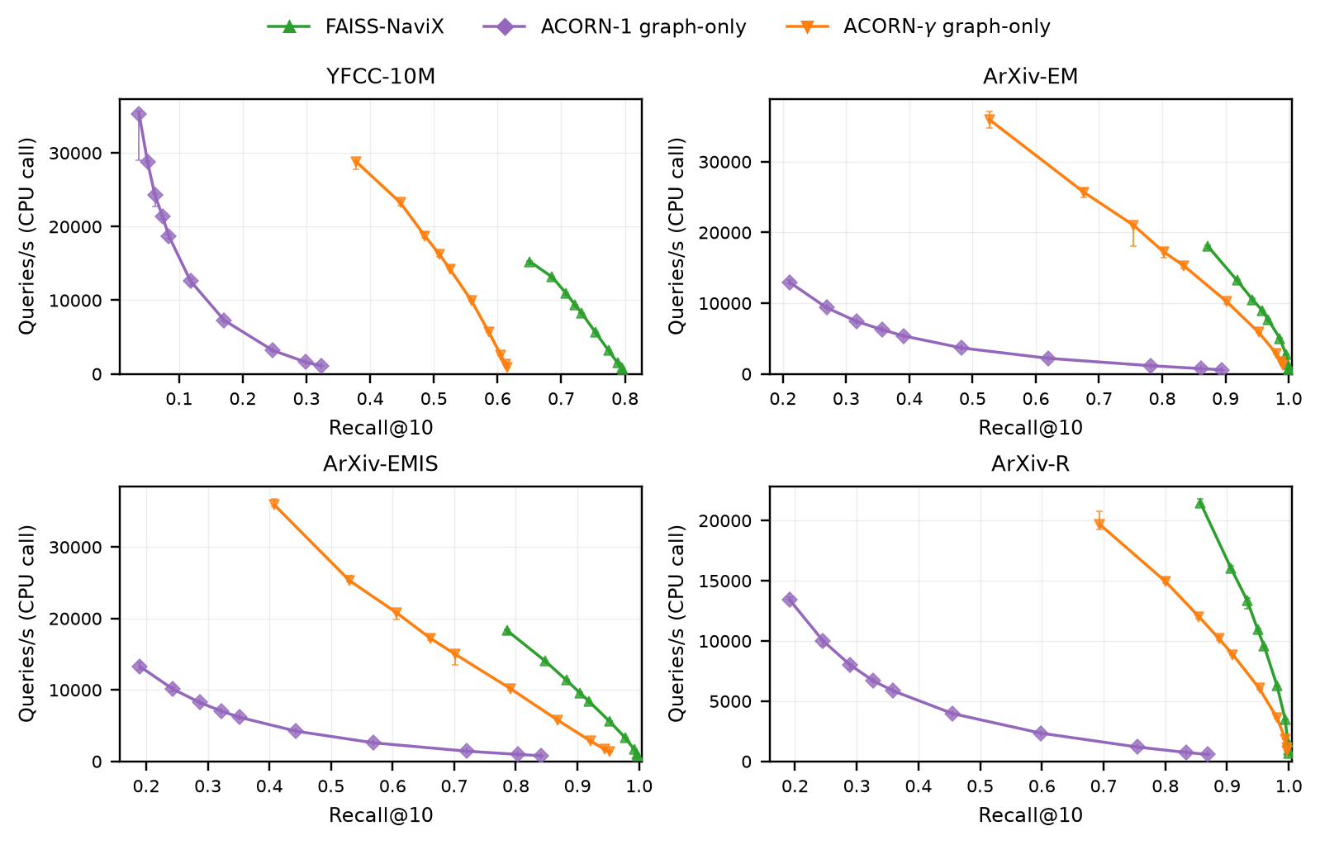
At the deepest measured =efSearch=750 point:
Workload | FAISS-NaviX recall / QPS | ACORN-1 recall / QPS | ACORN-gamma recall / QPS
YFCC-10M | 0.7966 / 557 | 0.3228 / 1,071 | 0.6151 / 896
ArXiv-EM | 0.9995 / 532 | 0.8939 / 569 | 0.9909 / 1,252
ArXiv-EMIS | 0.9977 / 749 | 0.8405 / 770 | 0.9523 / 1,285
ArXiv-R | 0.9995 / 653 | 0.8689 / 563 | 0.9977 / 844
The CPU curves support the failure diagnosis rather than an architecture speedup claim. NaviX is strong on ArXiv but also remains below 0.9 on YFCC. ACORN-gamma improves substantially over ACORN-1, especially when supplied a legal-ID prefix, yet it also fails to solve YFCC completely.

Interpretation

Why the accumulator helps
CAGRA's itopk serves two jobs: navigation frontier and result store. A legal node can be useful as a final answer yet lose its slot to a raw-distance candidate needed for navigation. Retain separates these lifetimes. The accumulator is necessary when GT-seen exceeds returned recall; it is not caused by correlation, and it cannot discover an unseen node.

Why EMIS is hard and NaviX succeeds
EMIS's global selectivity (15.24%) is not especially small. Its legal items arrive unusually late in raw-distance rank, so filter-blind traversal wastes work before entering the matching category. Once entered, the category is strongly connected. NaviX changes traversal, not merely output retention, and therefore converts a region-entry problem into a passing-only graph walk.

Why YFCC remains hard
YFCC combines extremely low per-query selectivity with poor legal-frontier continuity. In a separate in-kernel-seeded diagnostic, 96.4% of NaviX queries terminate by frontier exhaustion and 33.3% are underfilled, including 29.9% that had a valid legal seed. About 24.5% of expanded parents have no legal first-hop neighbor. Forcing more two-hop work did not improve recall in the stratified hard-case oracle. The issue is therefore not just seed acquisition or an overly conservative adaptive threshold; one rejected bridge often does not expose a connected legal subgraph.

Limitations
- One L4 GPU, one G=32/=IG=64 CAGRA graph family, SINGLE_CTA, squared L2, and =k=10.
- Resident bitmaps omit predicate evaluation, construction, transfer, caching, and invalidation.
- YFCC graph search is native uint8, whereas its exact control converts bytes exactly to float32 and therefore moves four times as many coordinate bytes.
- B0 plus the selected explicit depths is not proof over every possible budget.
- CPU and GPU methods use different graph families and system boundaries.
- Two dataset families and four predicates do not establish universal behavior.
- This is a preliminary workshop result and a design-space diagnosis, not a production cuVS API.

Reproduction
The complete copy/paste guide is benchmarks/retrieve_workshop/RETRIEVE_BENCHMARK_HANDOFF.org. The authoritative final commands are summarized below.

Static gates
cd /home/ubuntu/cuvs-filter-retrieve
/home/ubuntu/micromamba/envs/cuvs/bin/python \
benchmarks/retrieve_workshop/gpu_graph/test_pipeline.py
/home/ubuntu/micromamba/envs/cuvs/bin/python \
benchmarks/retrieve_workshop/exact_bitmap/test_pipeline.py
/home/ubuntu/micromamba/envs/cuvs/bin/python \
benchmarks/retrieve_workshop/cpu_context/test_pipeline.py

GPU graph run
export RETRIEVE_DATA_ROOT=/home/ubuntu/cuvs-filter/datasets
export RETRIEVE_RESULT_ROOT=/home/ubuntu/retrieve_workshop_runs/gpu_l4_<UTC_TAG>
benchmarks/retrieve_workshop/gpu_graph/run_gpu_graph.sh generate
benchmarks/retrieve_workshop/gpu_graph/run_gpu_graph.sh correctness
benchmarks/retrieve_workshop/gpu_graph/run_gpu_graph.sh b0
benchmarks/retrieve_workshop/gpu_graph/run_gpu_graph.sh analyze
Optional deep points must come from the analyzer-produced deep_candidates.json and be followed by a second full analysis without --skip-full-input-hashes.

Exact control
export RETRIEVE_EXACT_RESULT_ROOT=/home/ubuntu/retrieve_workshop_runs/exact_l4_<UTC_TAG>
unset RETRIEVE_EXACT_AVAILABLE_BYTES
benchmarks/retrieve_workshop/exact_bitmap/run_exact.sh all
The runner performs a live per-shard memory preflight. The largest YFCC production shard required 21,755,556,850 bytes free and passed with 1,904,512,014 bytes headroom on the L4.

Native CPU context
/home/ubuntu/micromamba/envs/cuvs/bin/python \
benchmarks/retrieve_workshop/cpu_context/run.py --preflight
/home/ubuntu/micromamba/envs/cuvs/bin/python \
benchmarks/retrieve_workshop/cpu_context/run.py \
--results-root /home/ubuntu/retrieve_workshop_runs/cpu \
--run-id cpu_context_<UTC_TAG>
/home/ubuntu/micromamba/envs/cuvs/bin/python \
benchmarks/retrieve_workshop/cpu_context/analyze.py \
/home/ubuntu/retrieve_workshop_runs/cpu/cpu_context_<UTC_TAG>
The production run used 32 CPU search threads except FAISS-NaviX on ArXiv, which used 16. YFCC masks were processed in chunks of 512; ArXiv used 10,000-query chunks. Bitmap unpacking is outside the native CPU search timing.

Paper staging and build
cd /home/ubuntu/retrieve-cagra-paper
export RETRIEVE_GPU_SUMMARY=/home/ubuntu/retrieve_workshop_runs/gpu_l4_20260820T0143Z/analysis/summary_points.csv
export RETRIEVE_EXACT_SUMMARY=/home/ubuntu/retrieve_workshop_runs/exact_l4_20260820T0255Z/analysis/exact_summary.csv
export RETRIEVE_CPU_SUMMARY=/home/ubuntu/retrieve_workshop_runs/cpu/cpu_context_20260820T2200Z/analysis/summary.csv
export RETRIEVE_DIAGNOSTIC_MANIFEST=/home/ubuntu/cuvs-filter-retrieve/benchmarks/retrieve_workshop/evidence/diagnostic_manifest.json
make PYTHON=/home/ubuntu/micromamba/envs/cuvs/bin/python data
make PYTHON=/home/ubuntu/micromamba/envs/cuvs/bin/python paper
make PYTHON=/home/ubuntu/micromamba/envs/cuvs/bin/python check

Final artifact index
Artifact | Path | Status
Benchmark handoff | benchmarks/retrieve_workshop/RETRIEVE_BENCHMARK_HANDOFF.org | Current
Frozen diagnostics | benchmarks/retrieve_workshop/evidence/diagnostic_manifest.json | 23 validated artifacts
GPU summary | /home/ubuntu/retrieve_workshop_runs/gpu_l4_20260820T0143Z/analysis/summary_points.csv | Final
GPU plots | /home/ubuntu/retrieve_workshop_runs/gpu_l4_20260820T0143Z/analysis/ | Final
Exact summary | /home/ubuntu/retrieve_workshop_runs/exact_l4_20260820T0255Z/analysis/exact_summary.csv | Final
Exact hash manifest | /home/ubuntu/retrieve_workshop_runs/exact_l4_20260820T0255Z/analysis/final_hash_manifest.json | Final
CPU summary | /home/ubuntu/retrieve_workshop_runs/cpu/cpu_context_20260820T2200Z/analysis/summary.csv | Final
CPU plot | /home/ubuntu/retrieve_workshop_runs/cpu/cpu_context_20260820T2200Z/analysis/cpu_context_pareto.png | Final
Paper source and staged data | /home/ubuntu/retrieve-cagra-paper at 40913bb | Final local commit
Paper PDF | /home/ubuntu/retrieve-cagra-paper/main.pdf | PASS, 6 pages, anonymous
This report's DOCX | benchmarks/retrieve_workshop/RETRIEVE_CAGRA_FILTER_AGNOSTIC_REPORT.docx | Generated from this Org file

Final checklist
- [X] Production GPU, exact, and CPU runs are immutable and complete.
- [X] All analyzer coverage, correctness, timing, and provenance gates pass.
- [X] YFCC QPS uses serial shard-time aggregation.
- [X] Exactness uses native-distance cutoff semantics at tied boundaries.
- [X] CPU underfilling is preserved as quality data rather than mislabeled as corruption.
- [X] All plots use linear QPS axes starting at zero.
- [X] The paper is double-blind, contains no unfinished markers, and is six pages.
- [X] The paper PDF is hash-bound to the manuscript, bibliography, staged results, and figures.
- [X] The Org report contains no unfinished result placeholders.

