SINGLE_{CTA} Passing-Accumulator Throughput Optimization

Verdict
The bounded passing-result accumulator can be made substantially cheaper without changing the public API or its search results. The retained kernel changes improve geometric-mean QPS over the previous implementation by:
Workload | Default + accumulator | FAVOR + accumulator
YFCC-10M | +19.20% | +31.68%
ArXiv EM | +0.89% | +1.81%
ArXiv EMIS | +0.43% | +0.73%
ArXiv R | +0.44% | +1.24%
YFCC is the clearest throughput win: every one of its 64 matched accumulator cells improved. The worst improvements were +11.18% for default + accumulator and +16.85% for FAVOR + accumulator. The ArXiv gains are smaller because each candidate requires a 4,096-dimensional float distance; distance work dominates the UDF and accumulator bookkeeping. ArXiv still confirms that the optimized path is correct across easy, range, and strongly negatively correlated predicates.
The optimization does not solve insufficient traversal at B0. It makes retaining passing results cheaper. In particular, YFCC still needs deeper exploration to reach 0.905 recall, and EMIS still needs a larger budget despite the accumulator's large retention benefit.

Scope and compatibility
- SINGLE_{CTA} only; MULTI_{CTA} behavior is unchanged.
- Generic UDF and FAVOR retention-safe accumulator paths are covered.
- No public fields, signatures, defaults, or serialized formats changed.
- Accumulator-disabled default CAGRA remains on its original hot path. Its YFCC geometric-mean QPS changed by -0.09%, and its ArXiv change is within -0.01% to +0.03%, which is benchmark noise.
- Both FAVOR throughput curves include per-query selectivity sampling end to end. Default CAGRA performs no selectivity estimation.

Accumulator invariant
For each query, the accumulator stores at most k candidates that pass the UDF, ordered by raw distance and graph-id tie-break. Its final entry is the current kth passing result. Once the accumulator is full, this raw-distance threshold can only decrease.
Therefore a new candidate whose raw distance is strictly worse than a full accumulator's current threshold cannot enter the final top-k. It is safe to discard that candidate before invoking the UDF. Equal-distance candidates are not discarded because the graph-id tie-break can still change the result.
The accumulator remains passive with respect to traversal: its contents do not seed, score, stop, or otherwise change the fused CAGRA frontier. It only changes which already-discovered passing candidates are retained for final output.

Retained optimizations

Threshold pruning before the UDF
favor_observe_passing_candidates snapshots the kth accumulator entry before evaluating a candidate's UDF. Strictly worse candidates are skipped. A concurrent insertion can only lower the kth threshold, so a stale snapshot can cause extra work but cannot incorrectly discard a candidate.

Reuse FAVOR's child predicate outcome
FAVOR scoring and the passing accumulator previously evaluated the same child predicate independently. The distance/scoring phase now writes one byte per child into temporary shared memory:
Value | Meaning
0 | invalid or unprocessed child
1 | UDF passed
2 | UDF rejected
3 | valid child whose predicate was unnecessary for scoring and accumulation
The accumulator consumes this byte instead of invoking the UDF again. The UDF is evaluated during child scoring only if the candidate can affect FAVOR scoring or can still enter the accumulator. The scratch space is allocated only for FAVOR + accumulator. Diagnostic kernels retain their independent hash-outcome byte and receive a separate predicate-outcome region.
This also removes pointless child UDF work from FAVOR legacy configurations when the effective child penalty is zero. On YFCC, FAVOR without the accumulator improves by +29.65% geometric-mean QPS with recall unchanged.

Skip discarded legacy postprocessing
When the accumulator supplies final neighbors and raw distances, the fused frontier's legacy UDF filtering, invalid compaction, and refill are discarded. Those stages are now skipped entirely for accumulator output. Accumulator-disabled searches still execute the original postprocessing.

Rejected experiments

Single-warp lock-free shared insertion
A specialized single-warp insertion path serialized winner selection without the shared lock. It was flat to slightly slower at B0 and about 0.8% slower in a representative deep traversal. After threshold pruning, relatively few candidates reach insertion, so lock contention is no longer the dominant cost. The experiment was fully reverted.

Fuse the default-path UDF into distance computation
Evaluating the default accumulator's UDF in the distance lead lane regressed B0 QPS by about 5.5% and deep-traversal QPS by about 19%. Random metadata reads moved onto the distance critical path and reduced latency hiding. The default distance path was restored unchanged.

Persistent register-owned accumulator
This was not implemented. The same JIT kernel binary serves accumulator-enabled and disabled modes, so persistent per-thread register ownership could reduce occupancy for every mode. The measured lock-free experiment also showed that insertion was no longer the limiting component.

YFCC-10M results
The throughput sweep contains 64 matched (L, W, max_iterations) cells for each of four methods, 10,000 queries per cell, one external repetition after warmup, and end-to-end FAVOR sampling. Recall changed by at most 0.00037 relative to the previous sweep.
Variant | Geometric-mean QPS change | Worst cell | Median cell
default CAGRA | -0.09% | -1.23% | -0.15%
default + accumulator | +19.20% | +11.18% | +18.36%
FAVOR | +29.65% | +5.04% | +32.17%
FAVOR + accumulator | +31.68% | +16.85% | +32.19%
Representative cells:
Variant | Parameters | Old QPS | New QPS | Recall
default + accumulator | B0, L=64, W=1 | 92.70k | 122.77k | 0.4862
FAVOR + accumulator | B0, L=64, W=1 | 54.57k | 72.65k | 0.4528
default + accumulator | L=64, W=4, max_{iter}=2088 | 2.27k | 2.57k | 0.9120
FAVOR + accumulator | L=64, W=4, max_{iter}=2088 | 1.79k | 2.15k | 0.9091

Full Pareto frontier
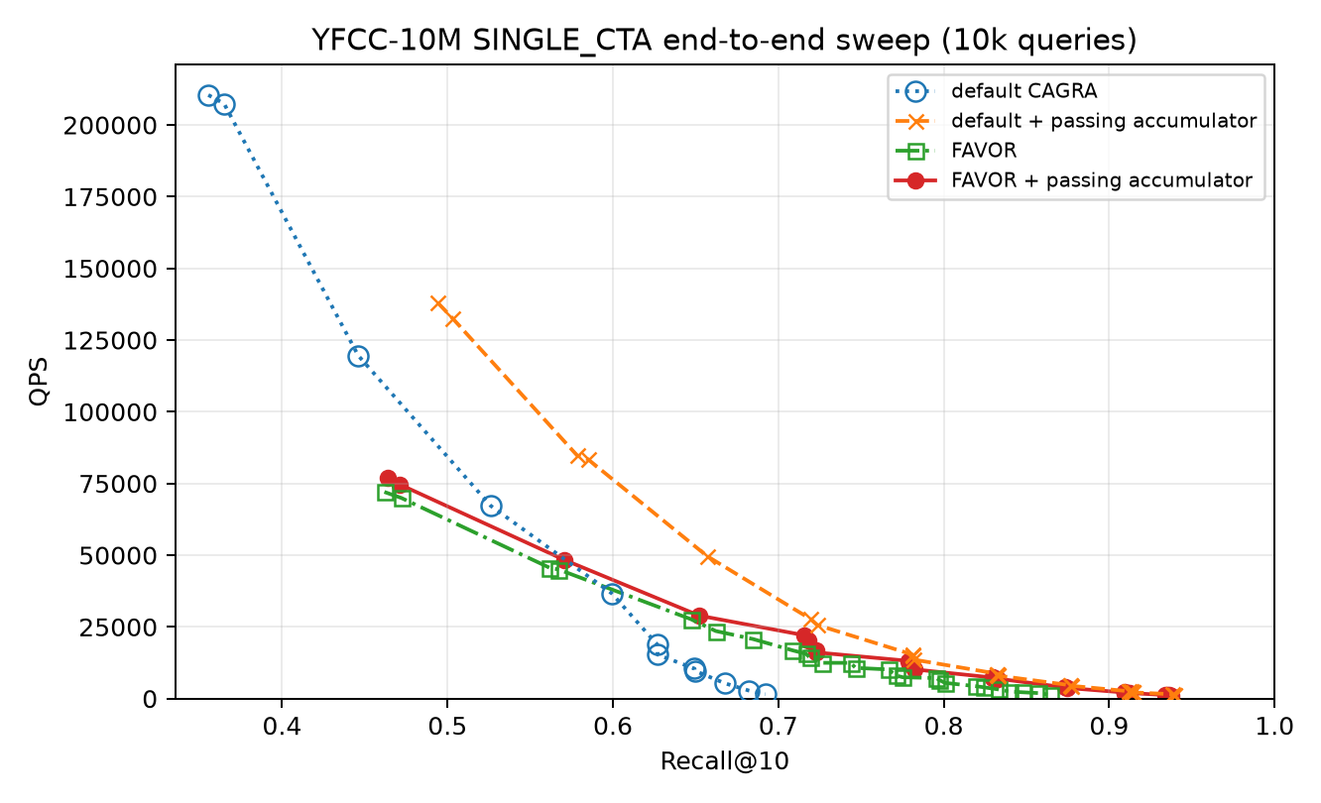
YFCC-10M end-to-end QPS versus Recall@10 for the four matched SINGLE_{CTA} methods.
Detailed measurement record: benchmarks/favor/YFCC_ACCUMULATOR_THROUGHPUT_OPTIMIZATION_REPORT.org

ArXiv results
The throughput sweep contains 256 rows for each of EM, EMIS, and R: the same 64 matched parameter cells for four methods. Every throughput row and every short correctness-gate row reports zero filter violations and zero invalid-sentinel errors. Recall is unchanged from the previous build apart from at most 0.00002 run noise in accumulator-disabled traversal.
Predicate | Default | Default + accumulator | FAVOR | FAVOR + accumulator
EM | +0.02% | +0.89% | +2.30% | +1.81%
EMIS | -0.00% | +0.43% | +1.20% | +0.73%
R | -0.01% | +0.44% | +1.63% | +1.24%
The small optimization percentages are consistent with Amdahl's law. ArXiv vectors contain 4,096 float32 coordinates (16 KiB per candidate), whereas YFCC contains 192 uint8 coordinates (192 B per candidate). The retained changes reduce UDF and accumulator work, not distance evaluations.
EMIS demonstrates why the accumulator itself is still valuable even when optimizing it barely changes total QPS:
Comparison over 64 matched EMIS cells | Geometric-mean QPS delta | Mean recall delta
default -> default + accumulator | -0.35% | +0.2100
FAVOR -> FAVOR + accumulator | -0.82% | +0.2167
At EMIS B0 (L=64, W=1, max_iterations=0), default recall rises from 0.38886 to 0.54956 for a QPS change from 28.63k to 28.34k. FAVOR recall rises from 0.38558 to 0.55716 while QPS changes from 27.90k to 27.56k. The accumulator fixes a major result-retention failure, but the remaining B0 gap is an exploration-depth problem.

Full Pareto frontiers
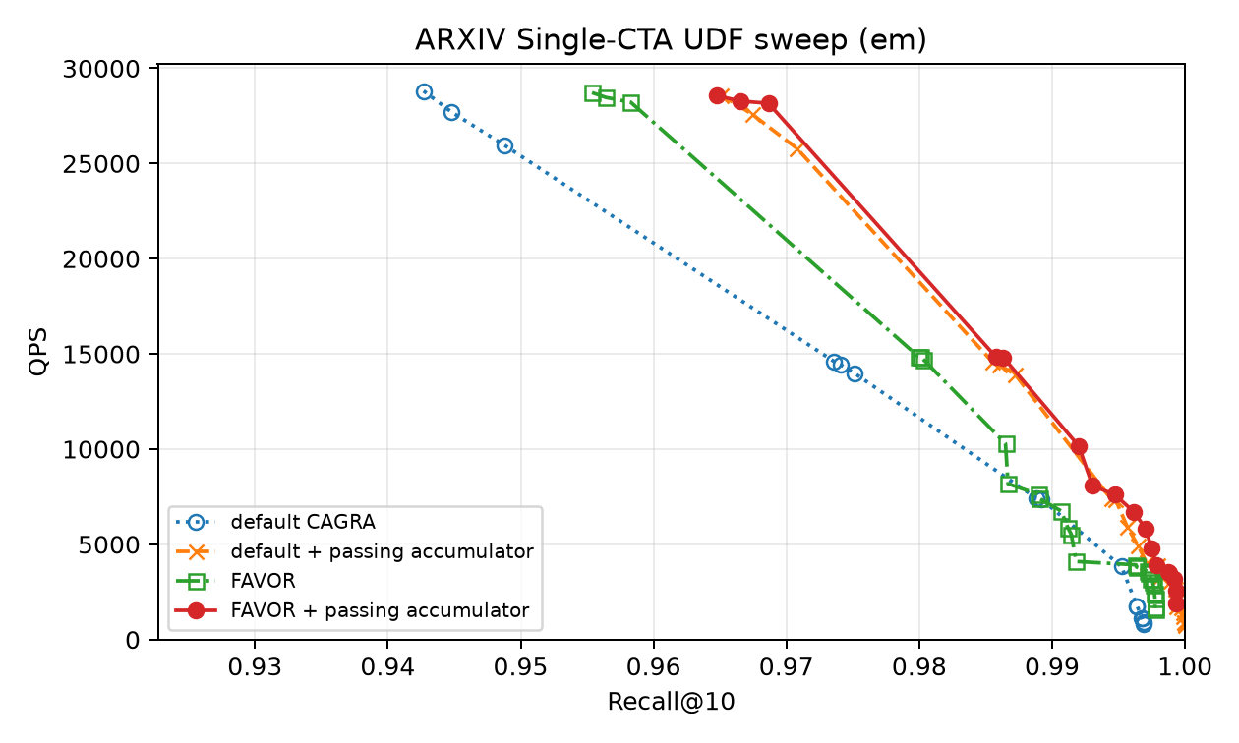
ArXiv EM end-to-end QPS versus Recall@10 over the full parameter sweep.
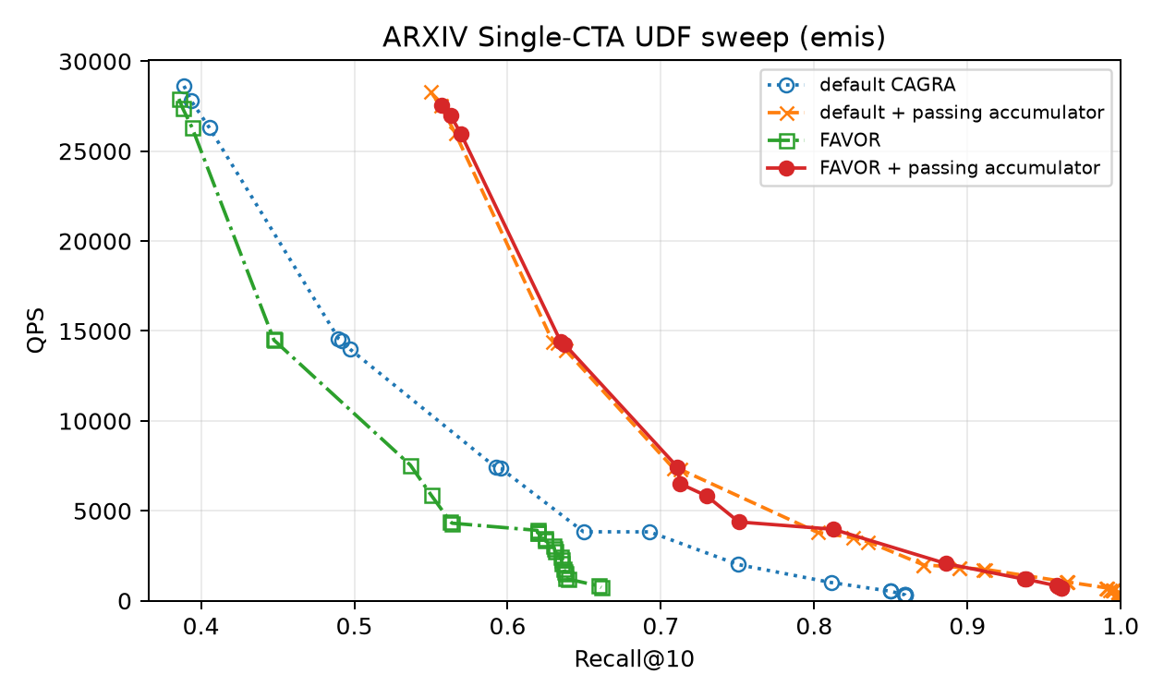
ArXiv EMIS end-to-end QPS versus Recall@10 over the full parameter sweep.
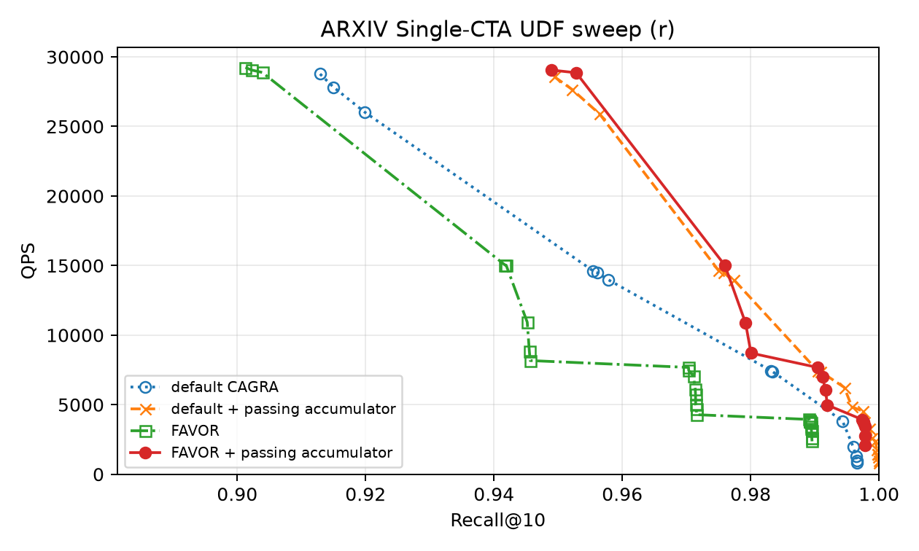
ArXiv R end-to-end QPS versus Recall@10 over the full parameter sweep.

B0 cross-sections
The B0 plots isolate max_iterations=0 while still sweeping L and W. They make the accumulator's immediate recall benefit visible without mixing it with explicit deep continuation.
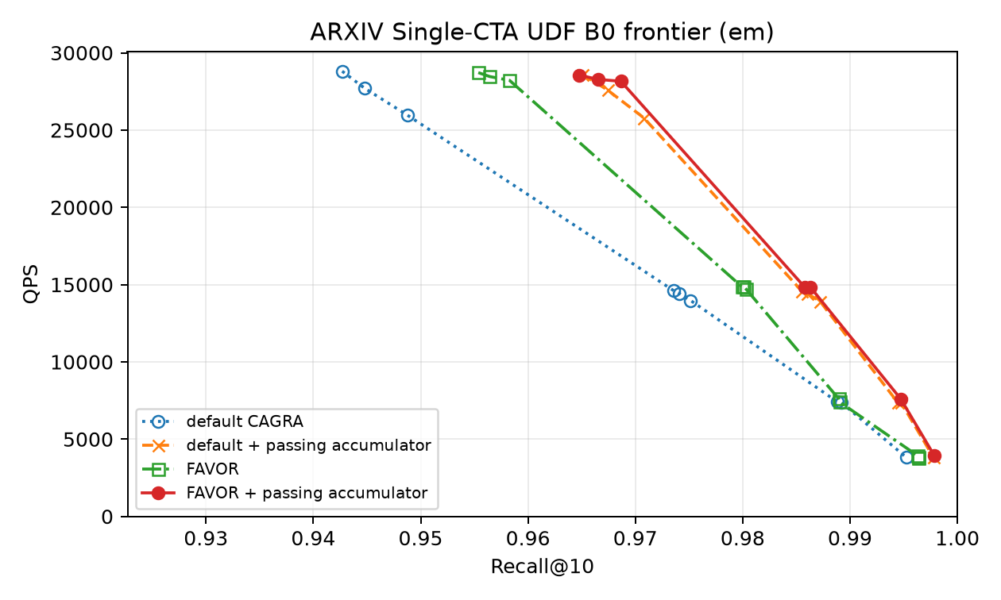
ArXiv EM B0 end-to-end QPS versus Recall@10.
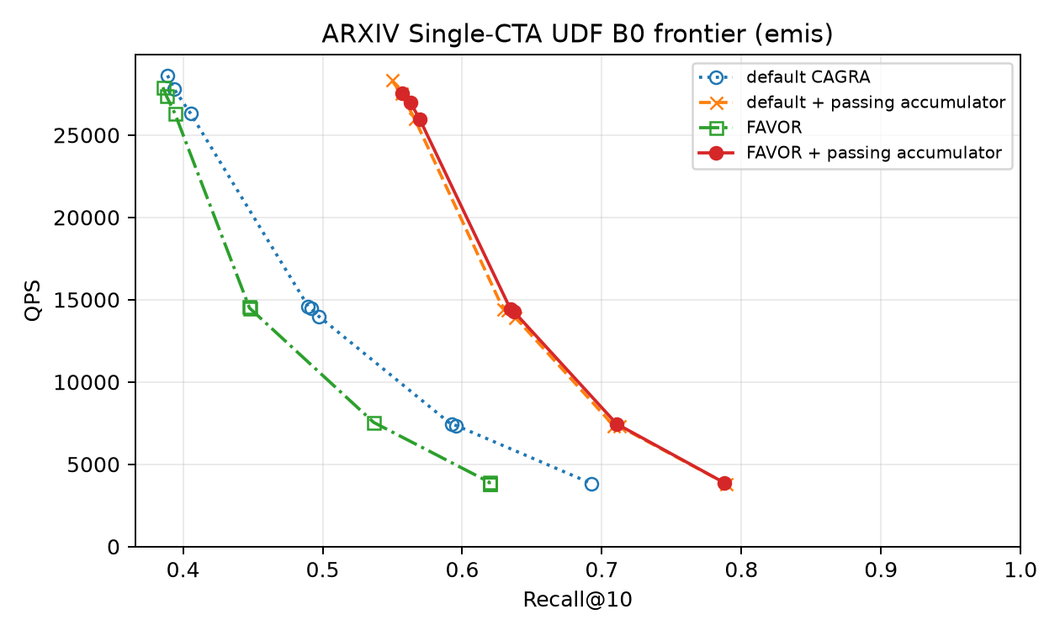
ArXiv EMIS B0 end-to-end QPS versus Recall@10.
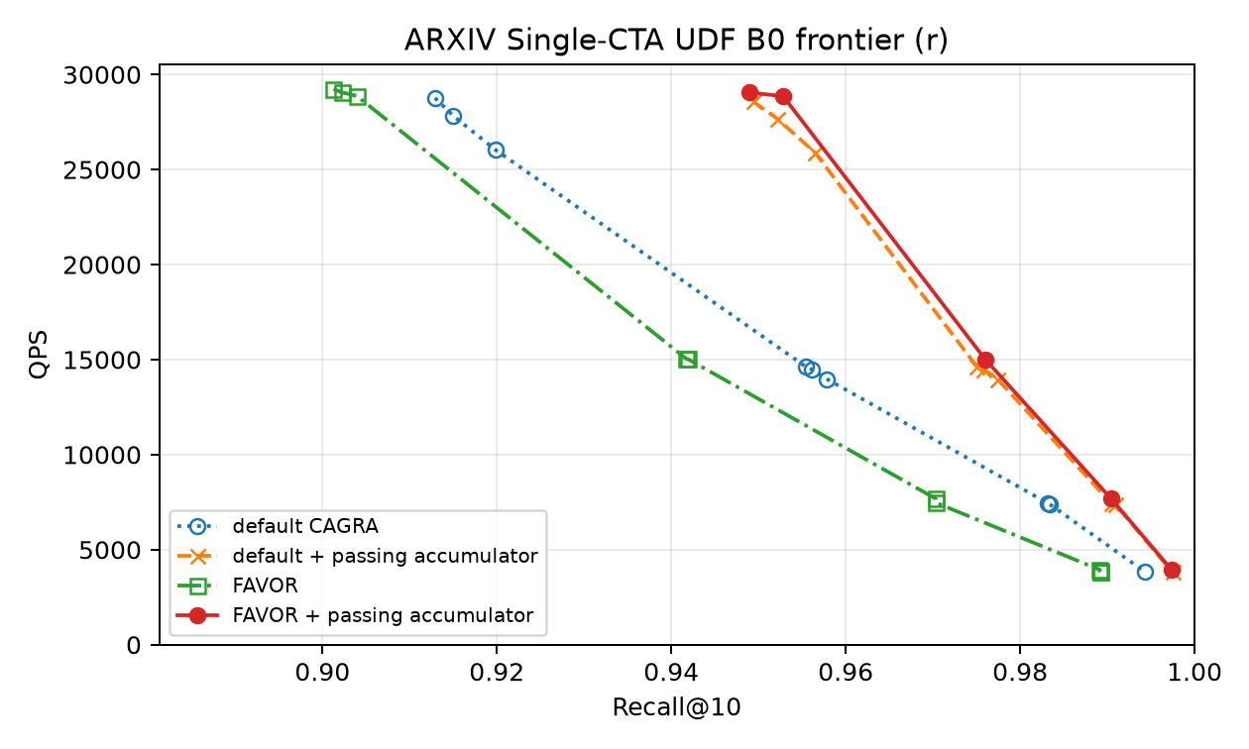
ArXiv R B0 end-to-end QPS versus Recall@10.
Detailed measurement record: benchmarks/favor/ARXIV_ACCUMULATOR_THROUGHPUT_OPTIMIZATION_REPORT.org

Verification
- Build targets: cuvs, NEIGHBORS_ANN_CAGRA_FILTER_UDF_TEST, and CUVS_CAGRA_ANN_BENCH.
- Full UDF test binary: 42 tests run, 30 passed, 12 intentionally skipped for non-SINGLE_{CTA} parameterizations, zero failures.
- New passivity test compares accumulator output with unfiltered CAGRA for k in {1,10,31,32,33,64}, covering both sides of the 32-lane boundary.
- YFCC throughput: 256/256 rows complete and correct.
- ArXiv throughput: 768/768 rows complete and correct.

Reproduction
cmake --build cpp/build -j 8 --target cuvs NEIGHBORS_ANN_CAGRA_FILTER_UDF_TEST CUVS_CAGRA_ANN_BENCH
LD_PRELOAD=$PWD/cpp/build/libcuvs.so cpp/build/gtests/NEIGHBORS_ANN_CAGRA_FILTER_UDF_TEST
YFCC_RESULT_ROOT=$PWD/benchmarks/favor/yfcc_udf/results_accumulator_optimized_20260809 \
benchmarks/favor/yfcc_udf/run_experiment.sh accumulator_comparison
python benchmarks/favor/yfcc_udf/analyze.py --sweep-only \
--result-root benchmarks/favor/yfcc_udf/results_accumulator_optimized_20260809 \
--data-root datasets \
--report benchmarks/favor/YFCC_ACCUMULATOR_THROUGHPUT_OPTIMIZATION_REPORT.org
ARXIV_RESULT_ROOT=$PWD/benchmarks/favor/arxiv_udf/results_accumulator_optimized_20260809 \
benchmarks/favor/arxiv_udf/run_experiment.sh all
python benchmarks/favor/arxiv_udf/analyze.py \
--result-root benchmarks/favor/arxiv_udf/results_accumulator_optimized_20260809 \
--report benchmarks/favor/ARXIV_ACCUMULATOR_THROUGHPUT_OPTIMIZATION_REPORT.org

