Automatic-Retention FAVOR for CAGRA
SINGLE_{CTA} Performance Evaluation
Nam Anh Dang
2026-07-31

Scope
This report compares three SINGLE_CTA bitset-filtered search methods: default CAGRA, fixed-retention FAVOR with lambda=1 and =rho=0.5, and automatic-retention FAVOR with lambda=1 and =rho=auto. It reports the complete measured QPS–recall and latency–recall curves for six dataset/scale combinations at 1%, 10%, 50%, and 90% passing selectivity. The document describes the methods and measurements only; it does not make a deployment recommendation.

Methods

Default filtered CAGRA
Default CAGRA tests the bitset during traversal and invalidates a node that does not pass. A rejected node therefore cannot remain in the candidate set as a route to other nodes.

Shared FAVOR penalty
Both FAVOR variants keep rejected nodes available for traversal and add a penalty to their raw distance. The batch-level reference penalty is
C(s,B) = (1 - s)(B - s) / (2sB)
D_reference = C(s,B) * delta_d
where s is the fraction of dataset rows that pass the bitset, B is CAGRA's internal top-k size (itopk), and delta_d is the graph-specific distance-spacing statistic loaded from the index sidecar.
The query-local penalty is
D_query = min(D_reference, lambda * g_q)
where lambda is a dimensionless multiplier (1 in this evaluation) and g_q is the average gap across the interquartile span of the query's sorted, finite initial candidate distances. For fewer than four finite candidates, g_q uses the average gap over the full finite span. A missing or degenerate span produces zero penalty.
For a rejected candidate with raw distance d, let tau be the worst finite distance currently retained in the CTA and let h=max(tau-d,0) be the candidate's retention headroom. Both variants use
D_effective = min(D_query, rho * h)
score = d + D_effective
while passing candidates retain score=d. Because rho<1, the penalty alone cannot move a rejected candidate beyond the current retention boundary.

Fixed retention
The previous retention method uses rho=0.5 for every query, selectivity, and traversal size. Thus a rejected candidate can consume at most half of its current retention headroom.

Automatic retention
The automatic method derives rho once on the host from expected passing capacity:
E = sB
x = E / k
P_short = clamp(2(1 - x), 0, 1)
S(P_short) = P_short^2 * (3 - 2P_short)
rho = 0.5 + 0.4 * S(P_short)
Here k is the requested result count (10), E is the expected number of passing entries in the internal top-k, x expresses that capacity relative to k, P_short is a bounded shortfall pressure, and S is a smoothstep function. The rule gives rho=0.5 when E>=k and increases it smoothly toward 0.9 when the expected passing capacity falls to k/2 or below. A larger rho preserves rejected bridge candidates more aggressively when the internal candidate set is expected to contain too few passing rows.

GPU path
The filter check and penalty are fused into neighbor-distance computation, so each candidate is written once. The automatic rule changes only the scalar rho passed to the existing retention-safe kernel. It adds no candidate buffer and no per-candidate calculation beyond the fixed-retention path. A zero retention fraction selects the automatic rule only for SINGLE_CTA FAVOR; default CAGRA behavior is unchanged.

Results
Throughput uses 10,000 queries per batch and latency uses 10 queries per batch. Recall is Recall@10. Target values at 0.90 recall use linear interpolation only when the measured Pareto frontier brackets 0.90. If the fastest measured point already exceeds 0.90, that measured feasible point is reported. N/A means the measured frontier did not reach the target; no extrapolation is used.

Maximum measured recall (throughput sweep)
Dataset | Selectivity | Default | Fixed rho=0.5 | Automatic rho
SIFT-1M | 1% | 0.784 | 0.938 | 0.948
SIFT-1M | 10% | 0.971 | 0.962 | 0.962
SIFT-1M | 50% | 0.923 | 0.914 | 0.914
SIFT-1M | 90% | 0.940 | 0.936 | 0.936
GIST-1M | 1% | 0.762 | 0.804 | 0.827
GIST-1M | 10% | 0.912 | 0.905 | 0.905
GIST-1M | 50% | 0.950 | 0.948 | 0.948
GIST-1M | 90% | 0.960 | 0.958 | 0.958
BIGANN-1M | 1% | 0.772 | 0.826 | 0.922
BIGANN-1M | 10% | 0.970 | 0.958 | 0.958
BIGANN-1M | 50% | 0.927 | 0.916 | 0.916
BIGANN-1M | 90% | 0.943 | 0.938 | 0.938
BIGANN-10M | 1% | 0.786 | 0.863 | 0.919
BIGANN-10M | 10% | 0.936 | 0.926 | 0.926
BIGANN-10M | 50% | 0.939 | 0.933 | 0.933
BIGANN-10M | 90% | 0.954 | 0.949 | 0.949
MSTuring-1M | 1% | 0.703 | 0.660 | 0.692
MSTuring-1M | 10% | 0.923 | 0.916 | 0.916
MSTuring-1M | 50% | 0.930 | 0.928 | 0.928
MSTuring-1M | 90% | 0.946 | 0.945 | 0.945
MSTuring-10M | 1% | 0.676 | 0.634 | 0.662
MSTuring-10M | 10% | 0.919 | 0.910 | 0.910
MSTuring-10M | 50% | 0.931 | 0.930 | 0.930
MSTuring-10M | 90% | 0.945 | 0.945 | 0.945

Throughput at Recall@10 = 0.90 (QPS)
Dataset | Selectivity | Default | Fixed rho=0.5 | Automatic rho
SIFT-1M | 1% | N/A | 112,883 | 116,245
SIFT-1M | 10% | 498,582 | 482,481 | 517,017
SIFT-1M | 50% | 1,107,547 | 1,077,846 | 1,077,707
SIFT-1M | 90% | 1,249,974 | 1,207,791 | 1,197,802
GIST-1M | 1% | N/A | N/A | N/A
GIST-1M | 10% | 32,132 | 31,529 | 31,451
GIST-1M | 50% | 49,053 | 49,907 | 49,798
GIST-1M | 90% | 57,100 | 58,151 | 57,935
BIGANN-1M | 1% | N/A | N/A | 117,083
BIGANN-1M | 10% | 816,962 | 790,456 | 790,646
BIGANN-1M | 50% | 1,524,968 | 1,458,952 | 1,459,509
BIGANN-1M | 90% | 1,736,913 | 1,635,115 | 1,635,682
BIGANN-10M | 1% | N/A | N/A | 118,462
BIGANN-10M | 10% | 551,683 | 546,505 | 546,414
BIGANN-10M | 50% | 1,020,813 | 993,484 | 993,830
BIGANN-10M | 90% | 1,159,382 | 1,102,104 | 1,102,516
MSTuring-1M | 1% | N/A | N/A | N/A
MSTuring-1M | 10% | 100,204 | 94,511 | 94,399
MSTuring-1M | 50% | 226,902 | 227,894 | 227,645
MSTuring-1M | 90% | 280,800 | 279,614 | 279,310
MSTuring-10M | 1% | N/A | N/A | N/A
MSTuring-10M | 10% | 101,224 | 91,609 | 91,428
MSTuring-10M | 50% | 240,175 | 238,233 | 237,810
MSTuring-10M | 90% | 291,110 | 289,106 | 288,511

Batch-10 latency at Recall@10 = 0.90 (ms)
Dataset | Selectivity | Default | Fixed rho=0.5 | Automatic rho
SIFT-1M | 1% | N/A | 1.313 | 1.308
SIFT-1M | 10% | 0.524 | 0.376 | 0.351
SIFT-1M | 50% | 0.263 | 0.192 | 0.193
SIFT-1M | 90% | 0.234 | 0.177 | 0.176
GIST-1M | 1% | N/A | N/A | N/A
GIST-1M | 10% | 1.858 | 1.807 | 1.806
GIST-1M | 50% | 1.198 | 1.197 | 1.197
GIST-1M | 90% | 1.006 | 0.975 | 0.977
BIGANN-1M | 1% | N/A | N/A | 1.742
BIGANN-1M | 10% | 0.519 | 0.389 | 0.365
BIGANN-1M | 50% | 0.239 | 0.191 | 0.193
BIGANN-1M | 90% | 0.227 | 0.169 | 0.170
BIGANN-10M | 1% | N/A | N/A | 1.760
BIGANN-10M | 10% | 0.659 | 0.443 | 0.438
BIGANN-10M | 50% | 0.398 | 0.265 | 0.265
BIGANN-10M | 90% | 0.330 | 0.241 | 0.240
MSTuring-1M | 1% | N/A | N/A | N/A
MSTuring-1M | 10% | 1.870 | 1.761 | 1.760
MSTuring-1M | 50% | 1.095 | 0.753 | 0.752
MSTuring-1M | 90% | 0.823 | 0.585 | 0.585
MSTuring-10M | 1% | N/A | N/A | N/A
MSTuring-10M | 10% | 1.919 | 1.740 | 1.741
MSTuring-10M | 50% | 0.902 | 0.720 | 0.720
MSTuring-10M | 90% | 0.667 | 0.534 | 0.536

Complete Pareto figures
Each figure contains a throughput panel (QPS versus recall) and a batch-10 latency panel (latency versus recall) for all three methods.

SIFT-1M
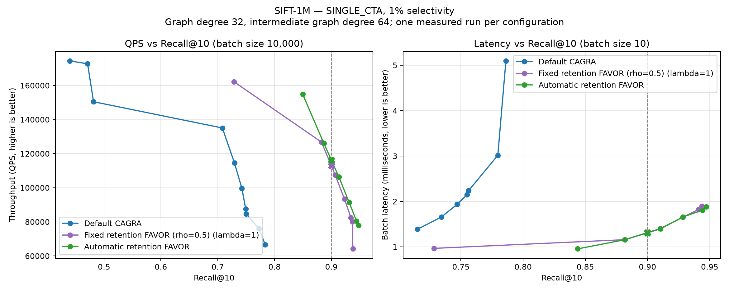
SINGLE_{CTA} on SIFT-1M at 1% passing selectivity.
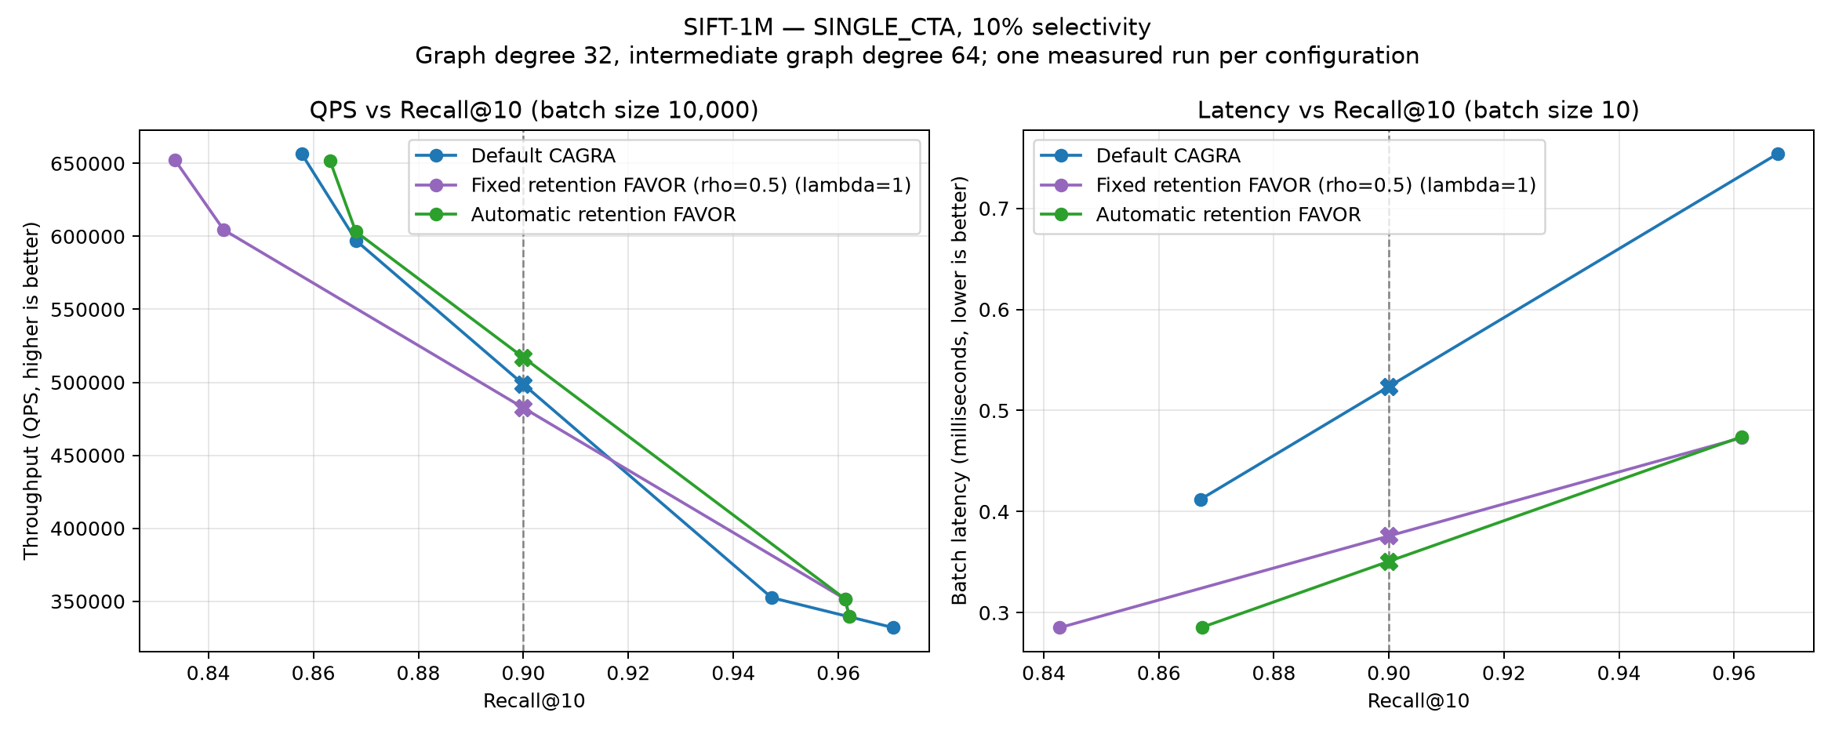
SINGLE_{CTA} on SIFT-1M at 10% passing selectivity.
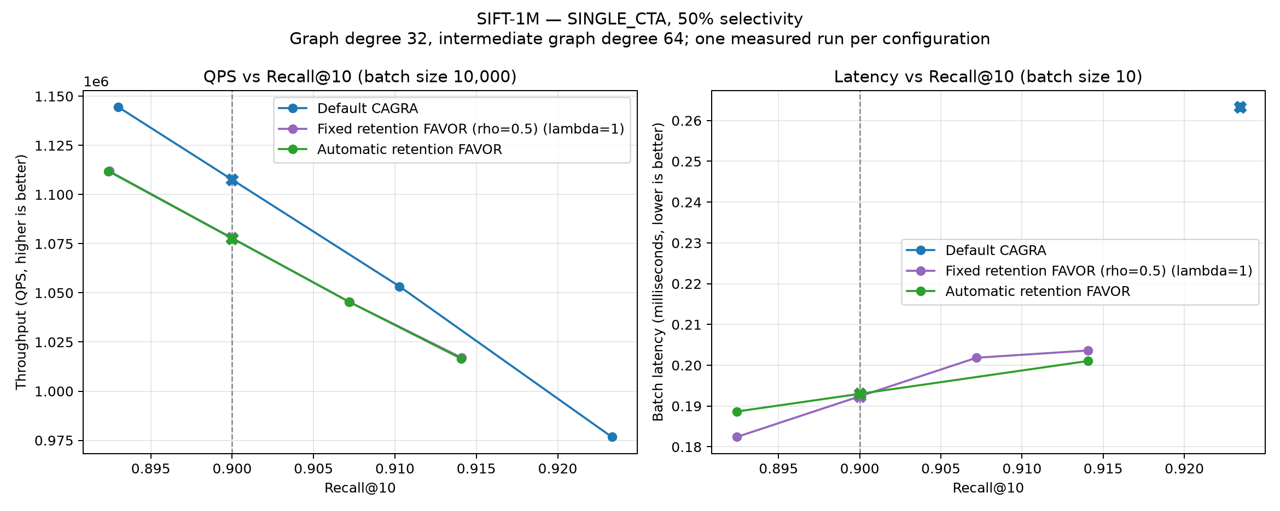
SINGLE_{CTA} on SIFT-1M at 50% passing selectivity.
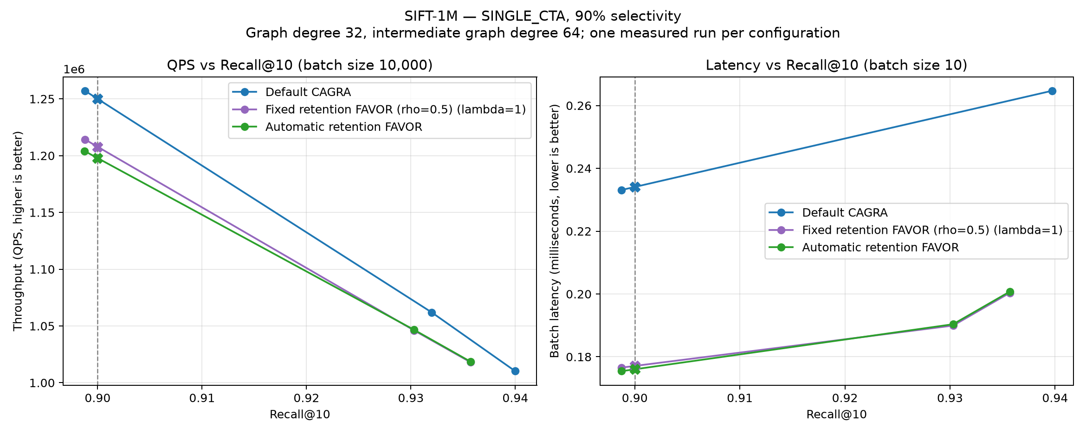
SINGLE_{CTA} on SIFT-1M at 90% passing selectivity.

GIST-1M
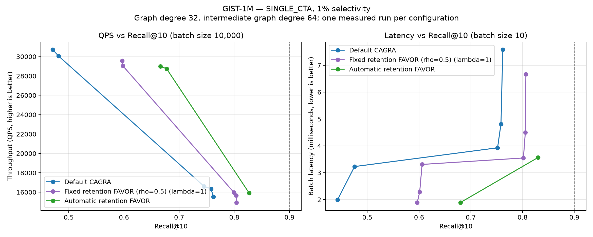
SINGLE_{CTA} on GIST-1M at 1% passing selectivity.
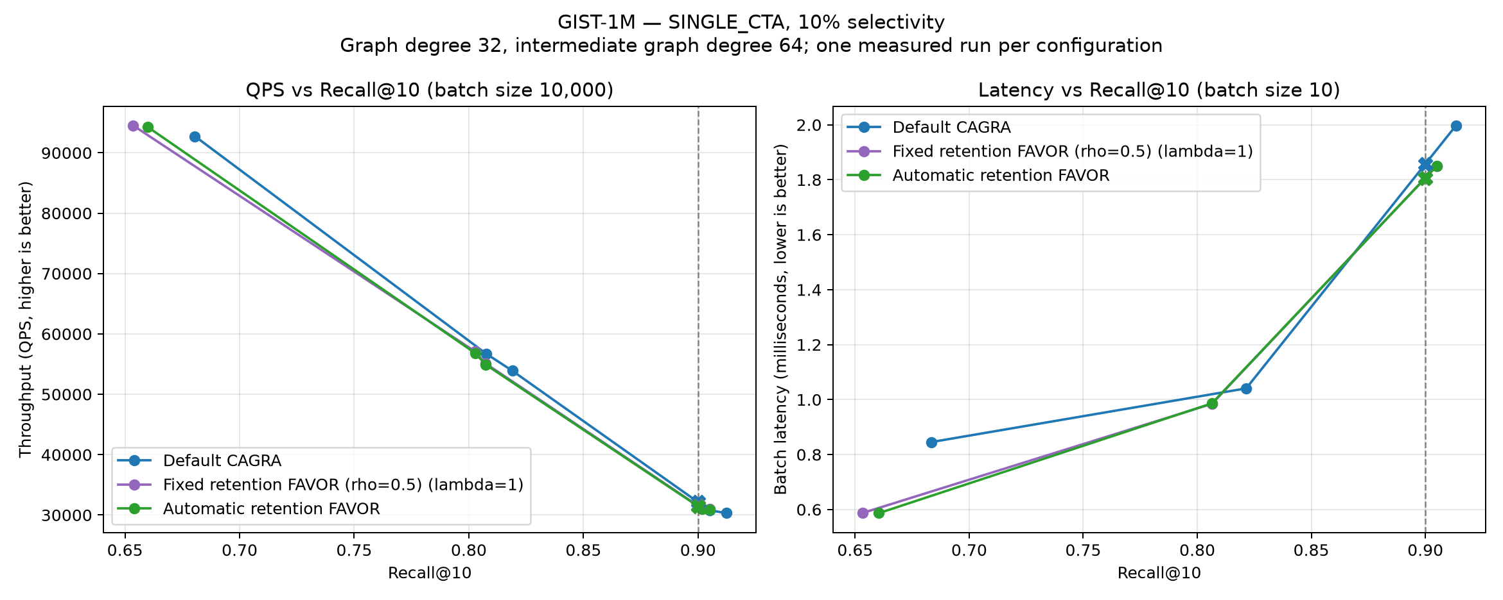
SINGLE_{CTA} on GIST-1M at 10% passing selectivity.
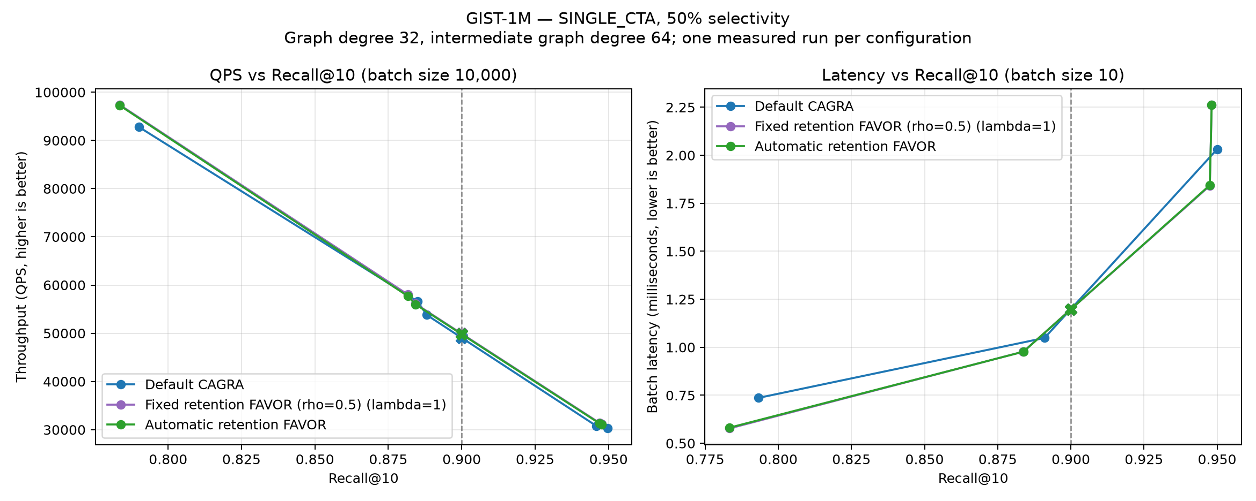
SINGLE_{CTA} on GIST-1M at 50% passing selectivity.
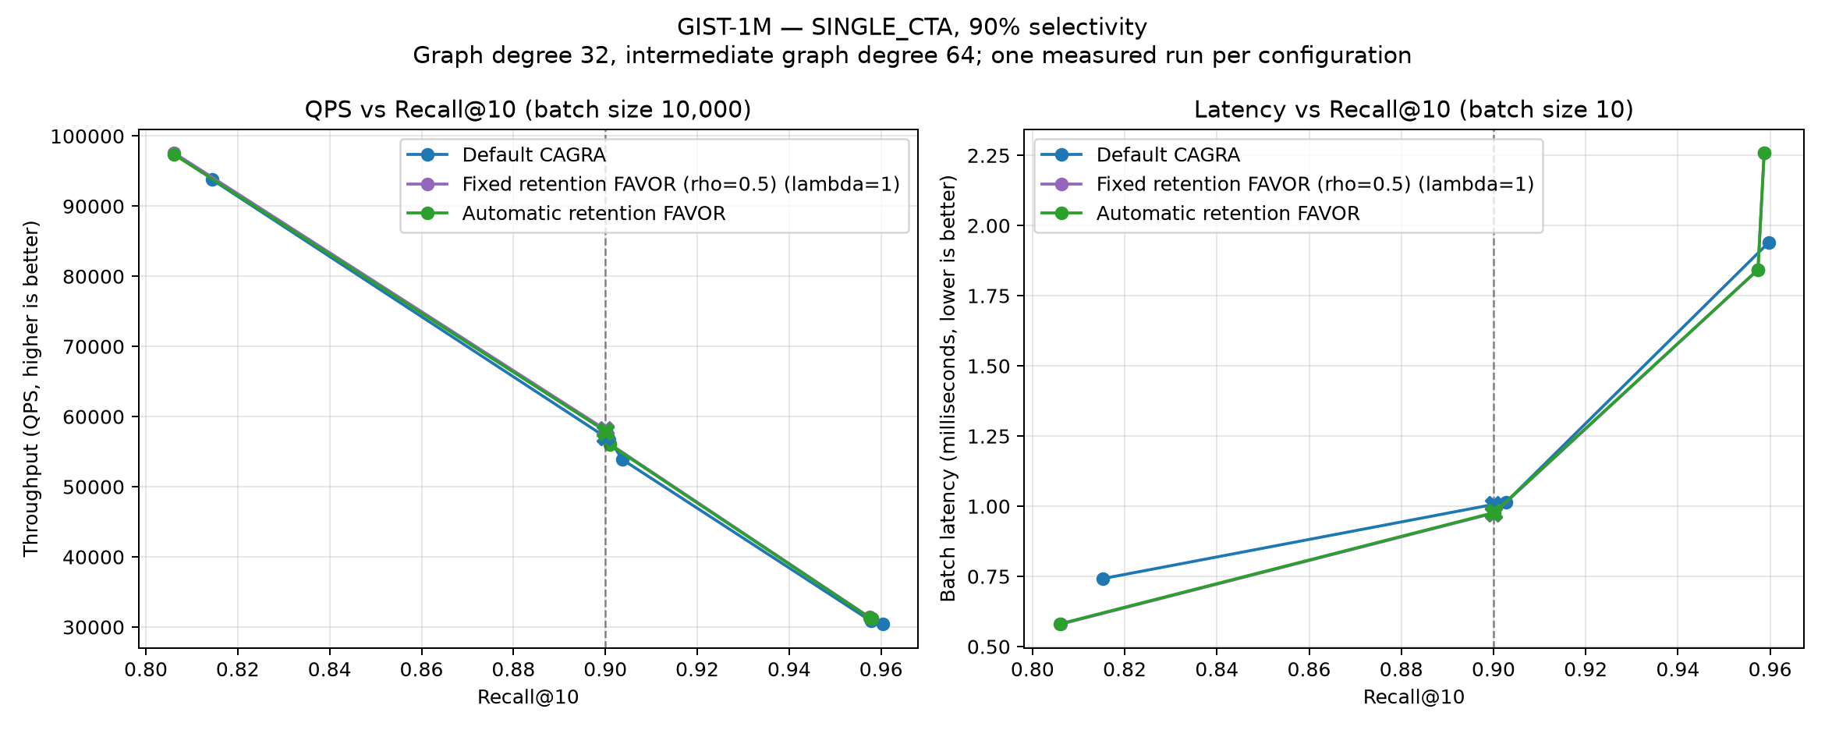
SINGLE_{CTA} on GIST-1M at 90% passing selectivity.

BIGANN-1M
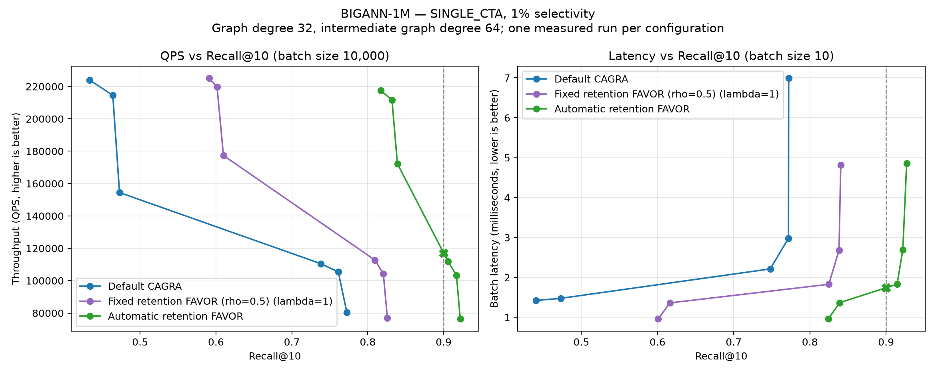
SINGLE_{CTA} on BIGANN-1M at 1% passing selectivity.
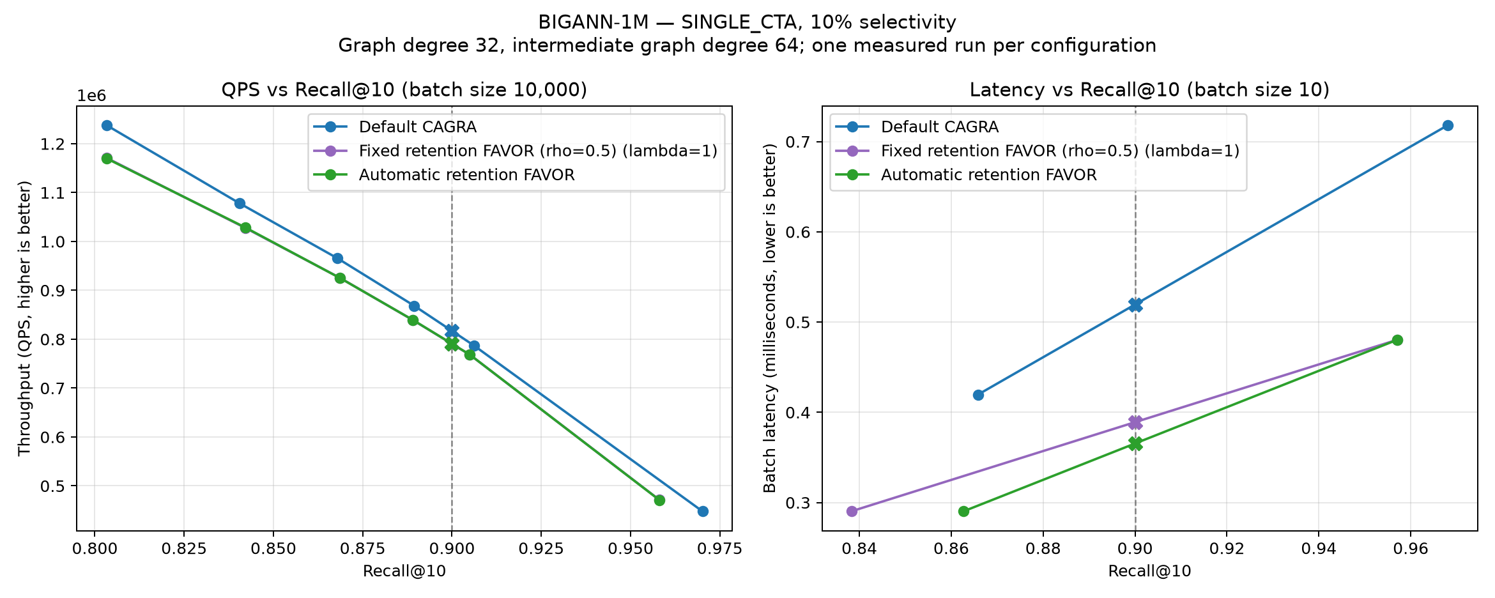
SINGLE_{CTA} on BIGANN-1M at 10% passing selectivity.
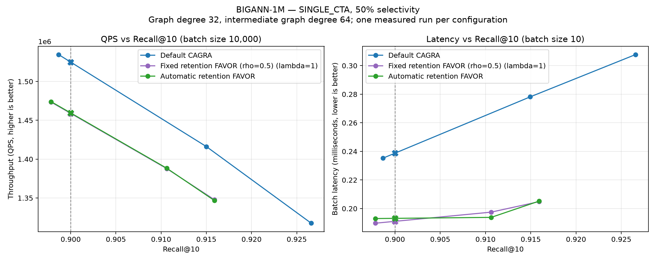
SINGLE_{CTA} on BIGANN-1M at 50% passing selectivity.
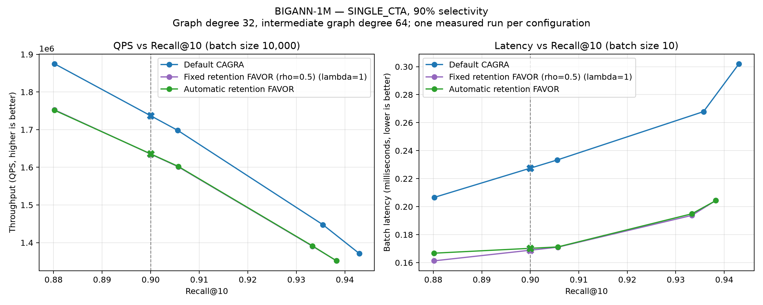
SINGLE_{CTA} on BIGANN-1M at 90% passing selectivity.

BIGANN-10M
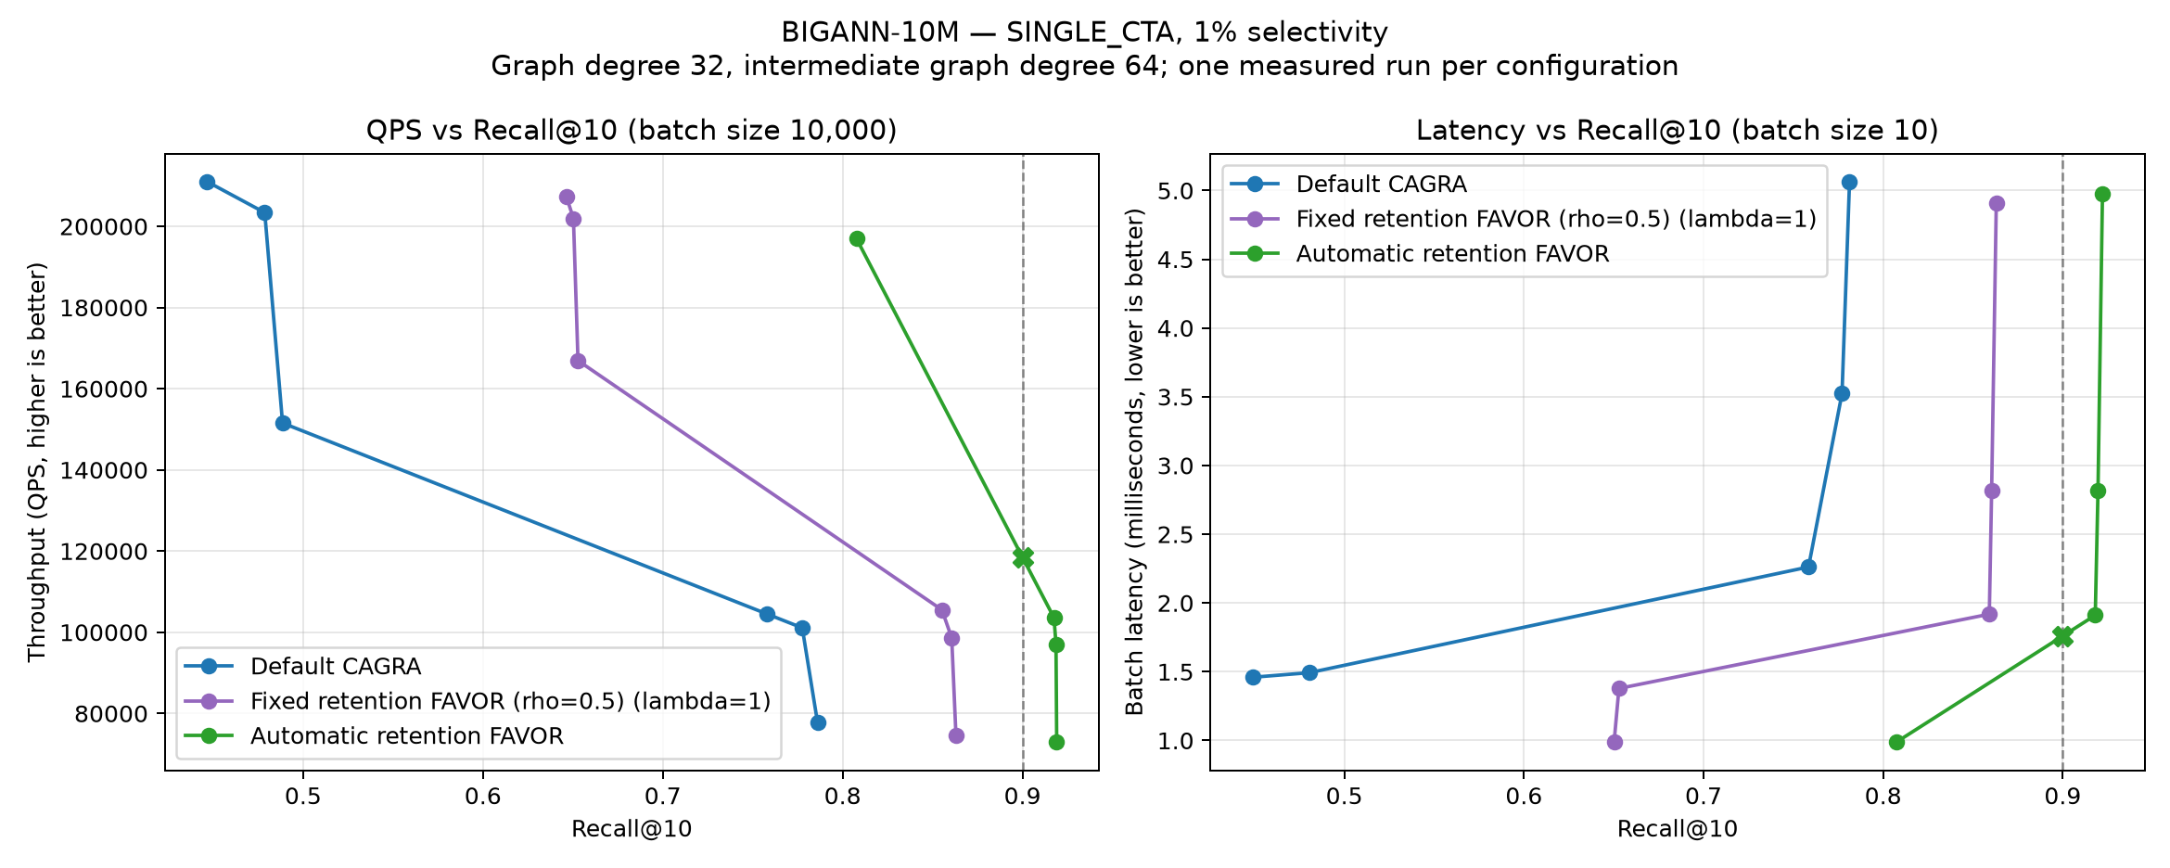
SINGLE_{CTA} on BIGANN-10M at 1% passing selectivity.
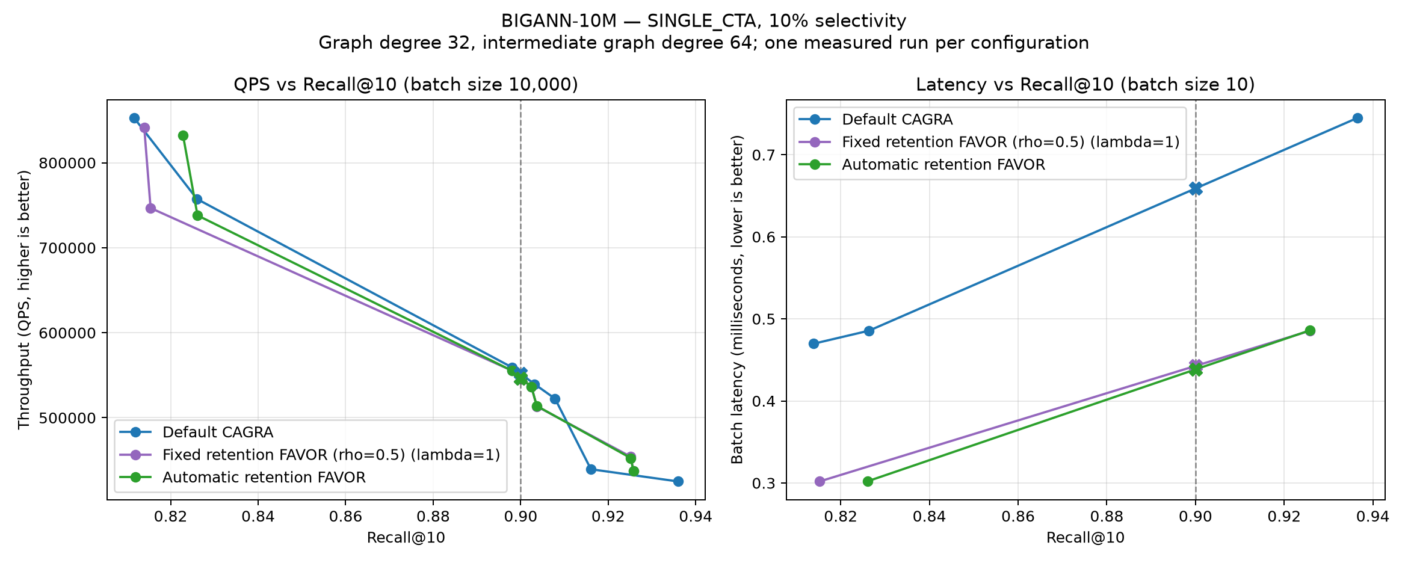
SINGLE_{CTA} on BIGANN-10M at 10% passing selectivity.
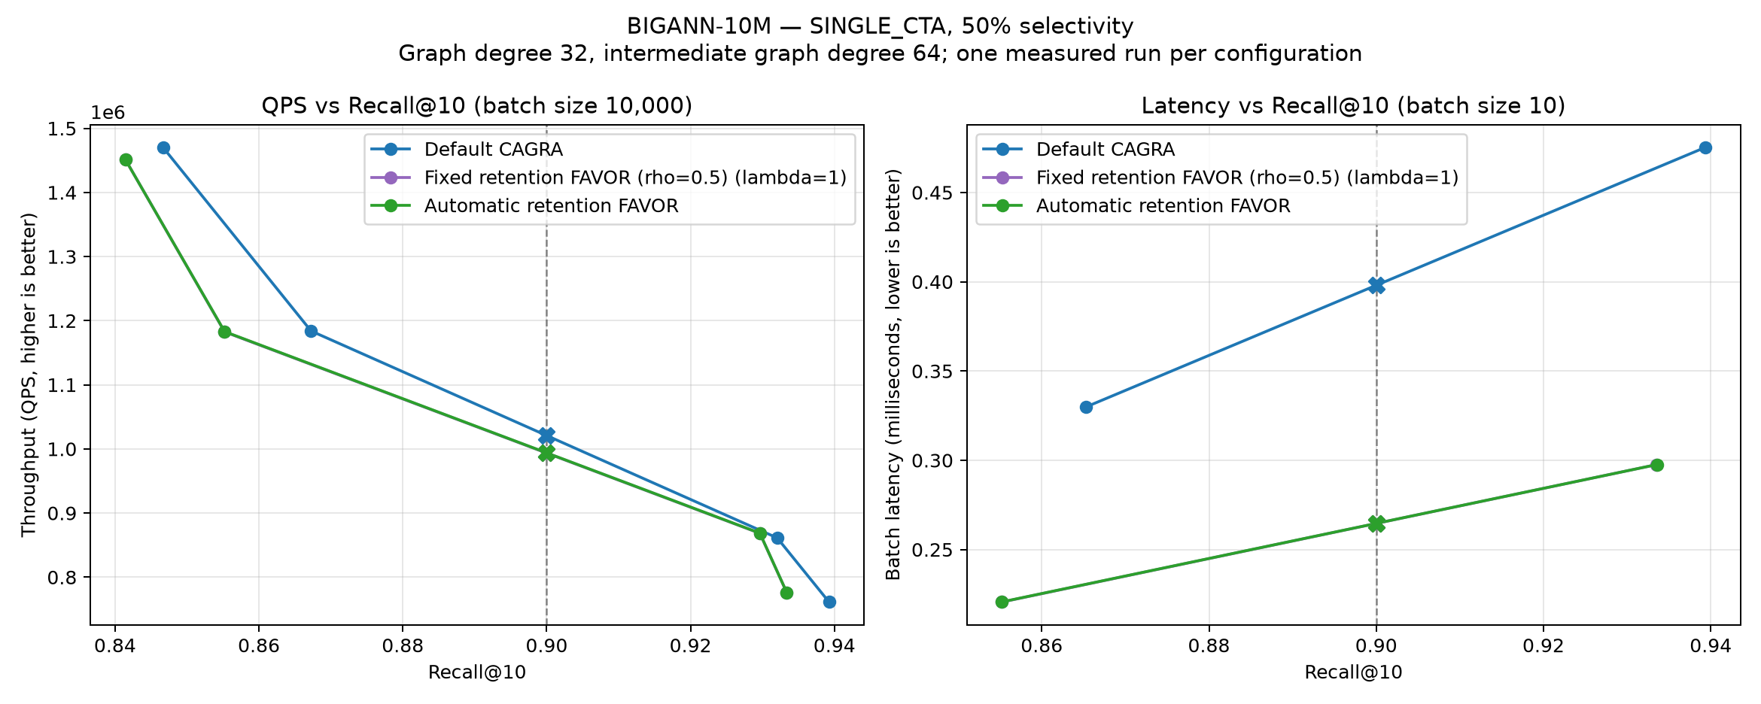
SINGLE_{CTA} on BIGANN-10M at 50% passing selectivity.
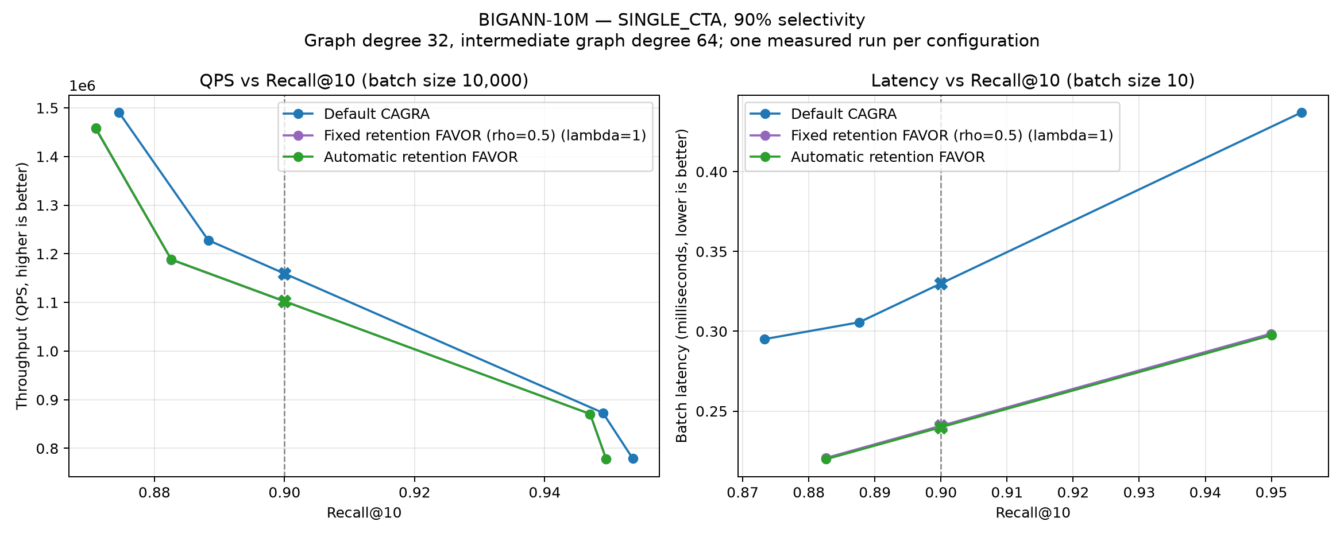
SINGLE_{CTA} on BIGANN-10M at 90% passing selectivity.

MSTuring-1M
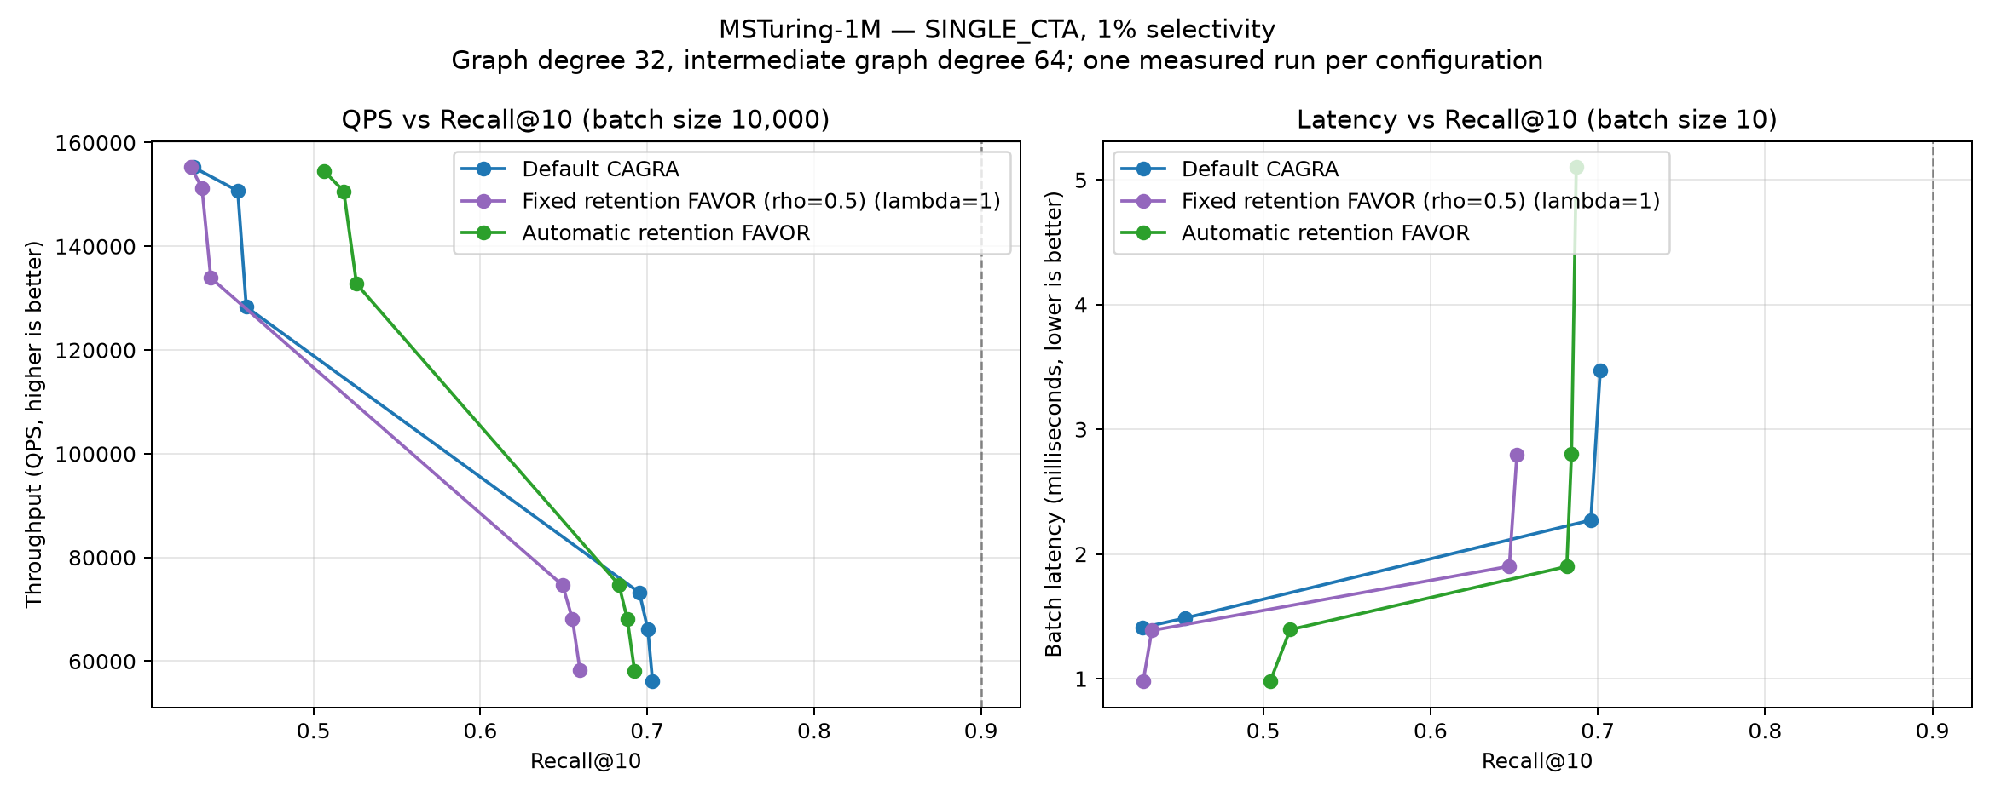
SINGLE_{CTA} on MSTuring-1M at 1% passing selectivity.
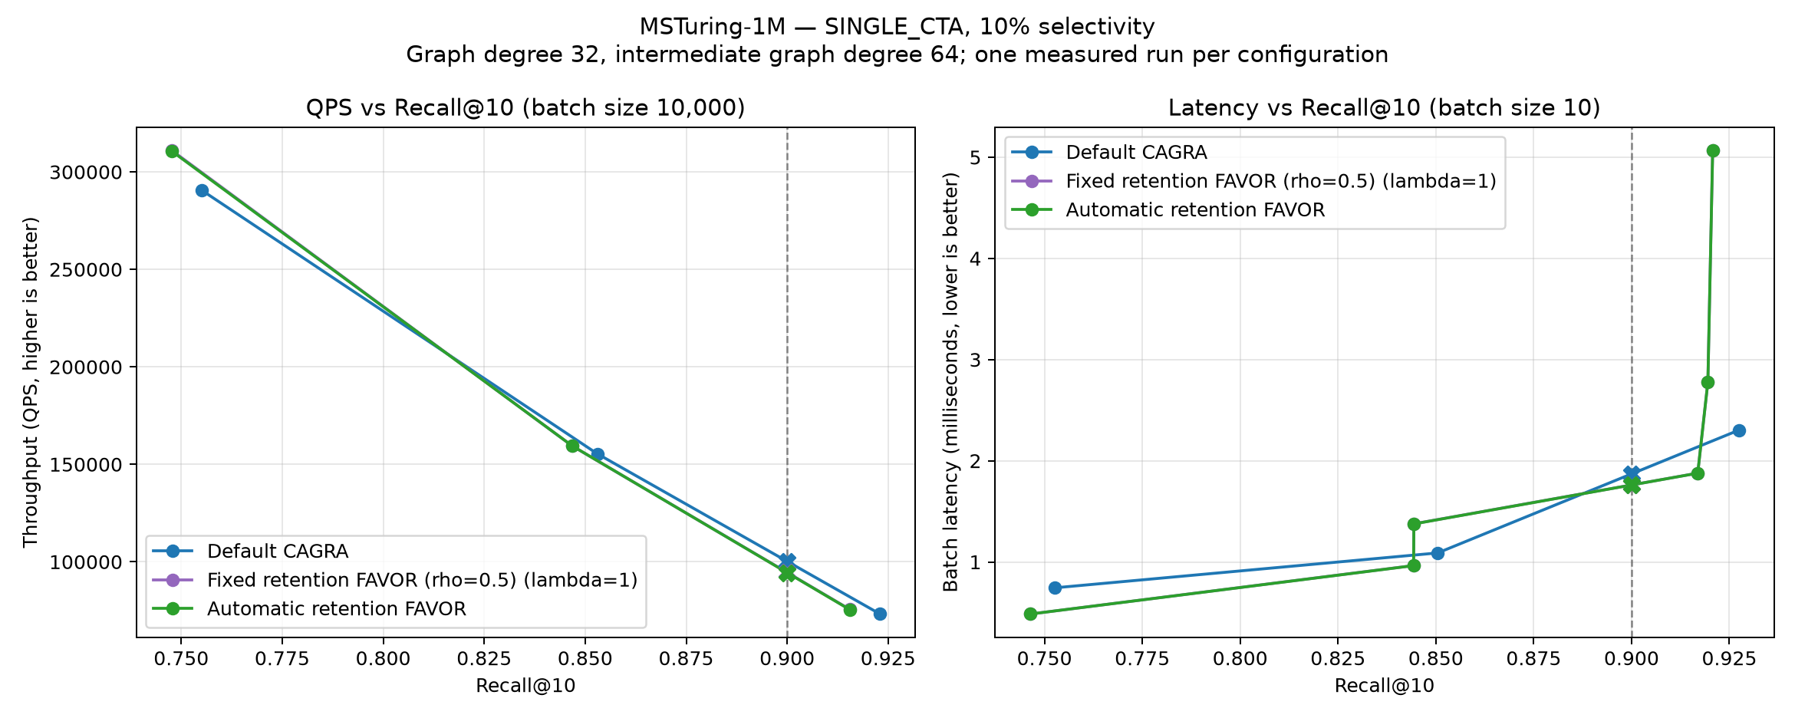
SINGLE_{CTA} on MSTuring-1M at 10% passing selectivity.
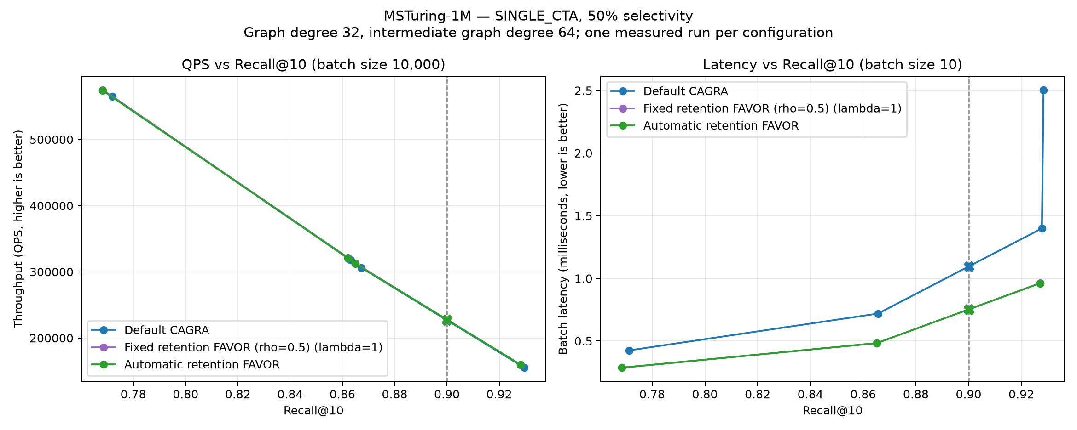
SINGLE_{CTA} on MSTuring-1M at 50% passing selectivity.
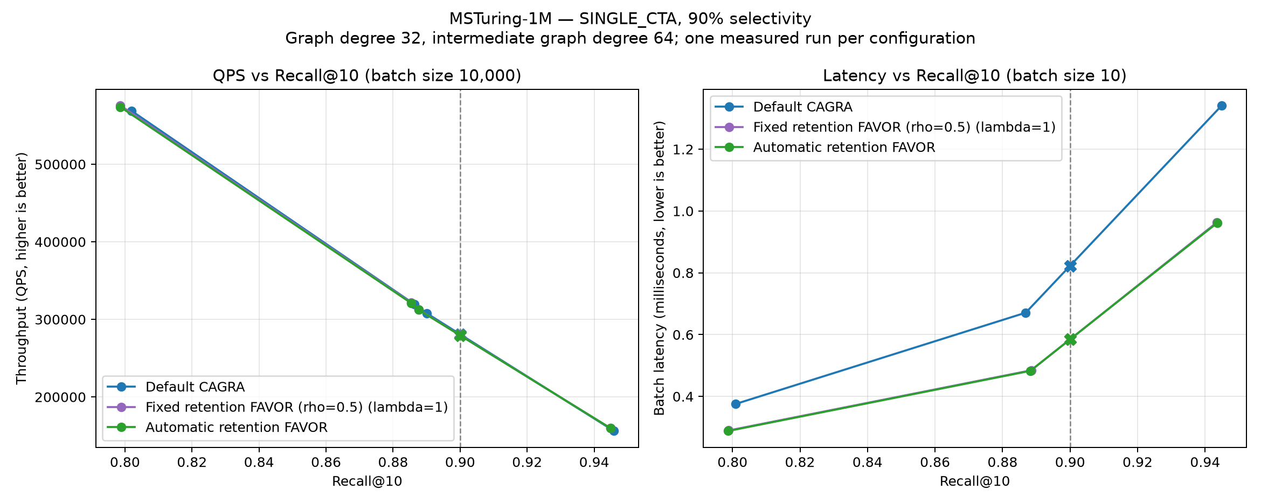
SINGLE_{CTA} on MSTuring-1M at 90% passing selectivity.

MSTuring-10M
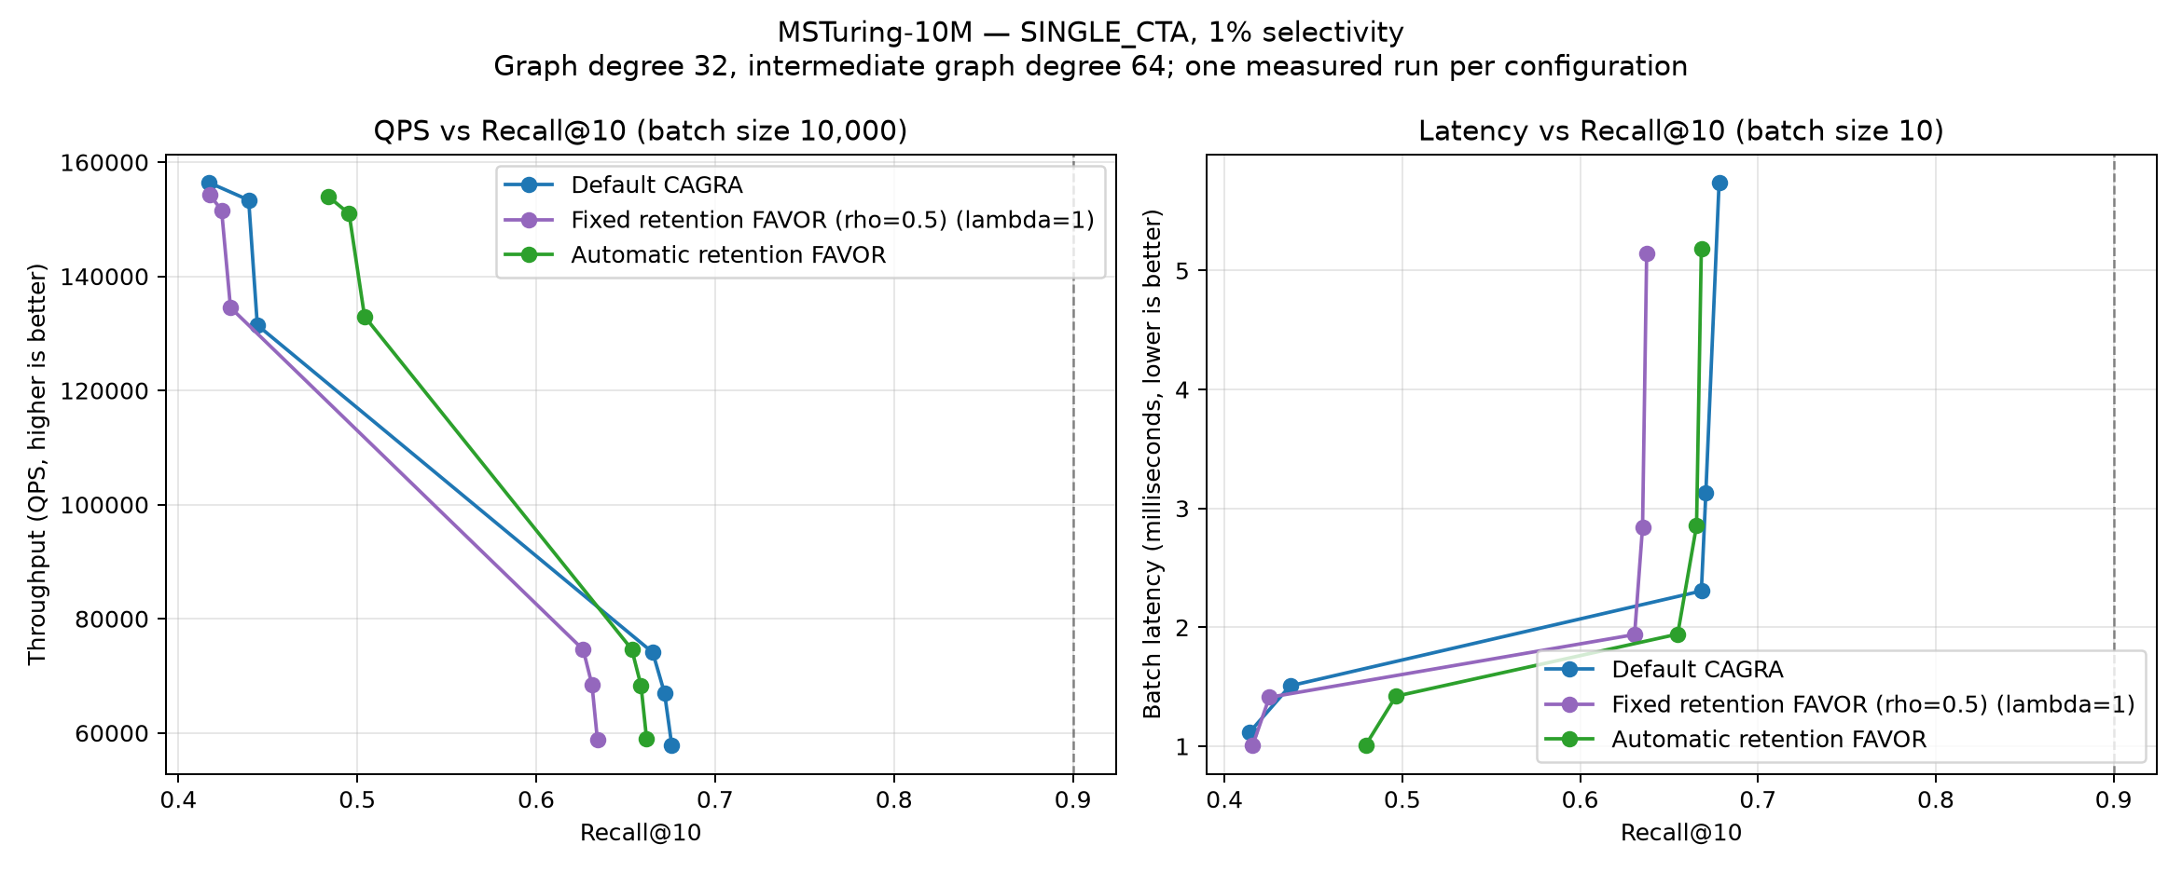
SINGLE_{CTA} on MSTuring-10M at 1% passing selectivity.
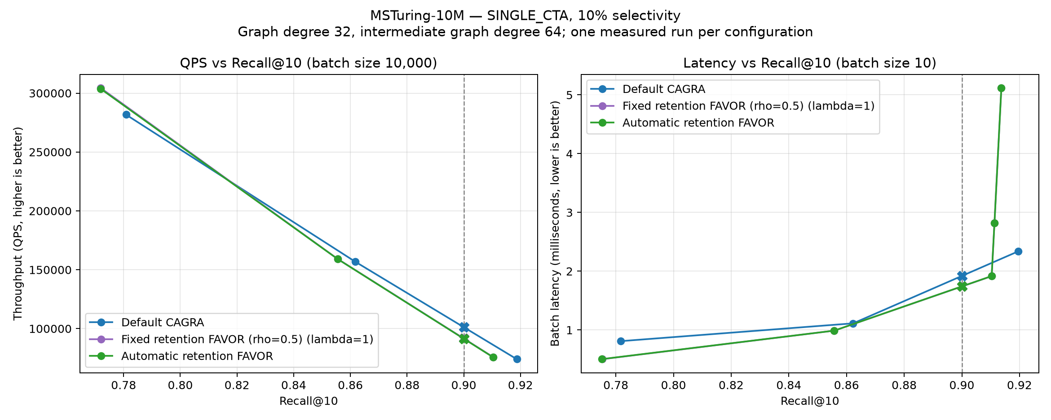
SINGLE_{CTA} on MSTuring-10M at 10% passing selectivity.
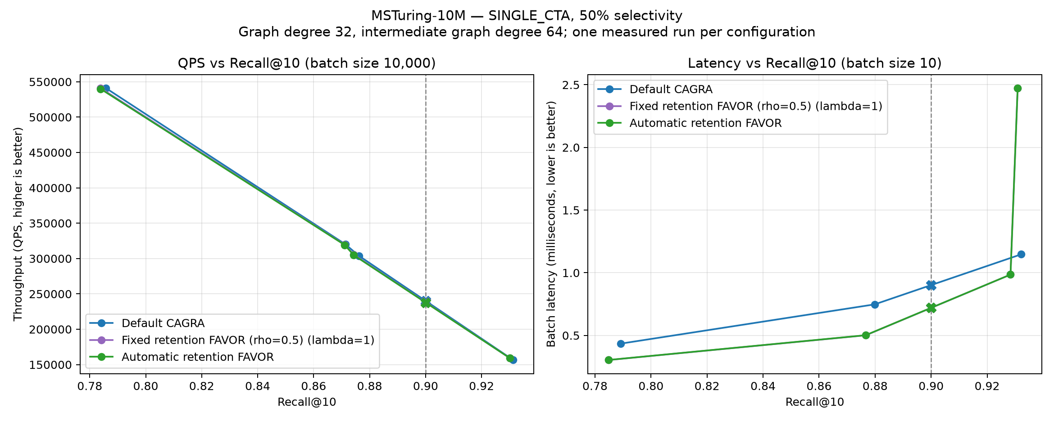
SINGLE_{CTA} on MSTuring-10M at 50% passing selectivity.
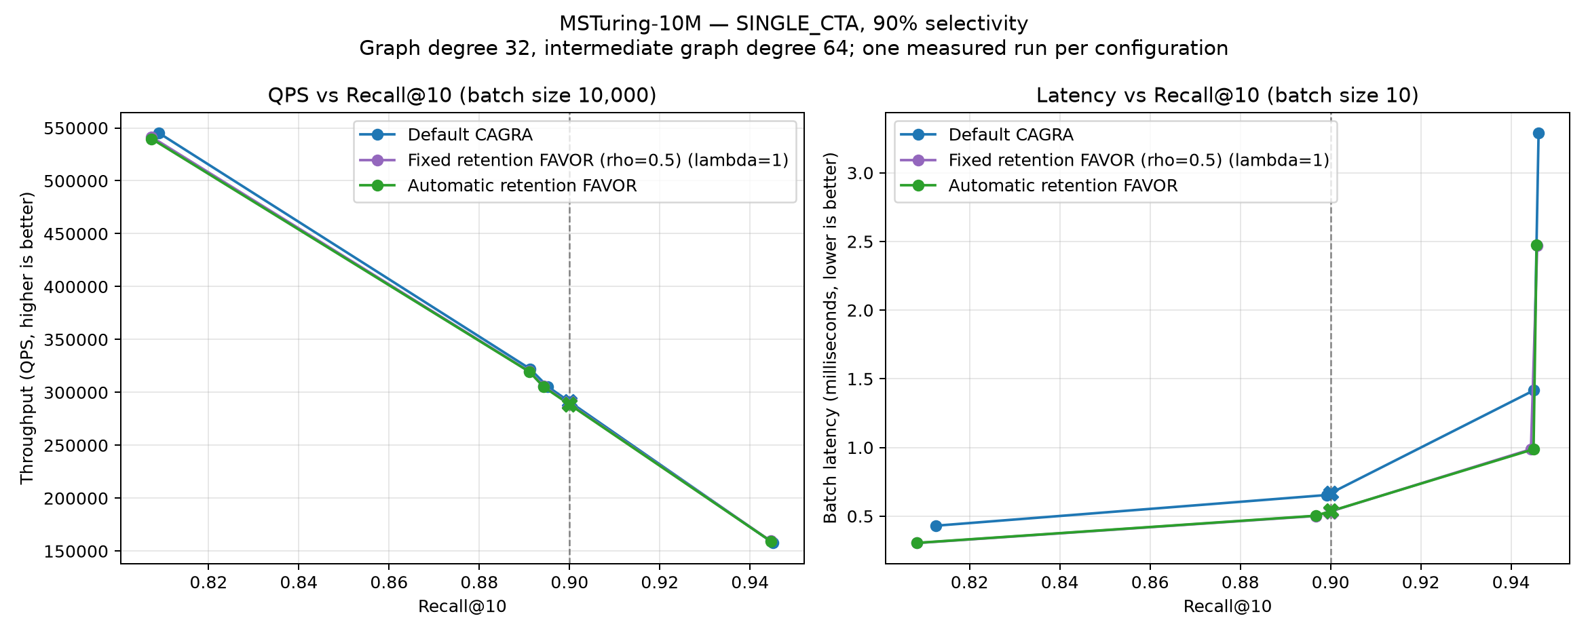
SINGLE_{CTA} on MSTuring-10M at 90% passing selectivity.

Appendix: benchmark parameters

Dataset and index inputs
Dataset | Rows | Dim | Type | Query file | Subset
SIFT-1M | 1,000,000 | 128 | float32 | query.fbin | none
GIST-1M | 1,000,000 | 960 | float32 | query₁₀₀₀₀.fbin | none
BIGANN-1M | 1,000,000 | 128 | uint8 | query.public.10K.u8bin | first 1M
BIGANN-10M | 10,000,000 | 128 | uint8 | query.public.10K.u8bin | none
MSTuring-1M | 1,000,000 | 100 | float32 | query.fbin | none
MSTuring-10M | 10,000,000 | 100 | float32 | query.fbin | none
Every dataset uses cagra_g32_ig64.index (maximum graph degree 32, intermediate graph degree 64) and its cagra_g32_ig64.index.delta_d sidecar. Exact bitsets and precomputed exact filtered ground truth are used at every selectivity.

Common search and measurement parameters
Parameter | Value
Search mode | SINGLE_{CTA}
Result count k | 10
Passing selectivity | 1%, 10%, 50%, 90%
Throughput batch | 10,000 queries
Latency batch | 10 queries
Benchmark repetitions | 1
Minimum measured time | 0.2 s
Warm-up time | 0.1 s
FAVOR penalty mode | cagra_{retentionsafe}
Penalty lambda | 1
Fixed retention fraction | 0.5
Automatic retention selector | favor_{retentionfraction} = 0
GPU | NVIDIA A30, 24 GB

Search cells
Each tuple is (itopk, search_width, max_iterations, thread_block_size). Zero for max_iterations or thread_block_size requests the existing planner/default behavior. The same cell set was used for batch 10 and batch 10,000 and for fixed and automatic retention.
Dataset | Selectivity | Cells
SIFT-1M | 1% | (256,1,0,0); (256,2,0,0); (256,4,0,0); (512,1,0,0); (512,2,0,0); (512,4,0,0); (512,4,80,0); (512,4,96,0); (512,4,112,0); (512,4,128,0)
SIFT-1M | 10% | (64,2,0,0); (64,4,0,0); (128,1,0,0); (128,2,0,0); (128,4,0,0)
SIFT-1M | 50% | (32,4,0,0); (32,4,11,0); (32,4,12,0)
SIFT-1M | 90% | (32,4,0,0); (32,4,10,0); (32,4,12,0)
GIST-1M | 1% | (256,1,0,0); (256,2,0,0); (256,4,0,0); (512,1,0,0); (512,2,0,0); (512,4,0,0)
GIST-1M | 10% | (64,4,0,0); (128,2,0,0); (128,4,0,0); (256,1,0,0); (256,2,0,0); (256,4,0,0)
GIST-1M | 50% | (64,4,0,0); (128,2,0,0); (128,4,0,0); (256,1,0,0); (256,2,0,0); (256,4,0,0)
GIST-1M | 90% | (64,4,0,0); (128,2,0,0); (128,4,0,0); (256,1,0,0); (256,2,0,0); (256,4,0,0)
BIGANN-1M | 1% | (256,1,0,0); (256,2,0,0); (256,4,0,0); (512,1,0,0); (512,2,0,0); (512,4,0,0)
BIGANN-1M | 10% | (64,4,0,0); (128,4,0,0); (128,4,12,64); (128,4,14,64); (128,4,16,64); (128,4,18,64); (128,4,20,64)
BIGANN-1M | 50% | (32,4,0,0); (32,4,11,0); (32,4,12,0)
BIGANN-1M | 90% | (32,4,0,0); (32,4,9,0); (32,4,10,0); (32,4,12,0)
BIGANN-10M | 1% | (256,1,0,0); (256,2,0,0); (256,4,0,0); (512,1,0,0); (512,2,0,0); (512,4,0,0)
BIGANN-10M | 10% | (64,2,0,0); (64,4,0,0); (128,1,0,0); (128,2,0,0); (128,2,54,64); (128,2,55,64); (128,2,56,64); (128,4,0,0); (128,4,28,64); (128,4,29,64); (128,4,30,64)
BIGANN-10M | 50% | (32,1,0,0); (32,2,0,0); (32,4,0,0); (64,1,0,0); (64,2,0,0); (64,4,0,0)
BIGANN-10M | 90% | (32,1,0,0); (32,2,0,0); (32,4,0,0); (64,1,0,0); (64,2,0,0); (64,4,0,0)
MSTuring-1M | 1% | (256,1,0,0); (256,2,0,0); (256,4,0,0); (512,1,0,0); (512,2,0,0); (512,4,0,0)
MSTuring-1M | 10% | (128,4,0,0); (256,2,0,0); (256,4,0,0); (512,1,0,0); (512,2,0,0); (512,4,0,0)
MSTuring-1M | 50% | (64,4,0,0); (128,2,0,0); (128,4,0,0); (256,1,0,0); (256,2,0,0); (256,4,0,0)
MSTuring-1M | 90% | (64,4,0,0); (128,2,0,0); (128,4,0,0); (256,1,0,0); (256,2,0,0); (256,4,0,0)
MSTuring-10M | 1% | (256,1,0,0); (256,2,0,0); (256,4,0,0); (512,1,0,0); (512,2,0,0); (512,4,0,0)
MSTuring-10M | 10% | (128,4,0,0); (256,2,0,0); (256,4,0,0); (512,1,0,0); (512,2,0,0); (512,4,0,0)
MSTuring-10M | 50% | (64,4,0,0); (128,2,0,0); (128,4,0,0); (256,1,0,0); (256,2,0,0); (256,4,0,0)
MSTuring-10M | 90% | (64,4,0,0); (128,2,0,0); (128,4,0,0); (256,1,0,0); (256,2,0,0); (256,4,0,0)

Artifact locations and reproduction
The prior default/fixed-retention measurements and configurations are in results_retention_safe_single_full. Automatic-retention raw JSON and generated configurations are in results_automatic_retention_single_full. Plot data, target summaries, the parameter-cell CSV, and figures are in results_automatic_retention_single_comparison.
benchmarks/favor/run_automatic_retention_single_full.sh
python benchmarks/favor/generate_automatic_retention_single_report.py
cd benchmarks/favor
pandoc -f org -t docx --standalone \
-o AUTOMATIC_RETENTION_FAVOR_SINGLE_CTA_REPORT.docx \
AUTOMATIC_RETENTION_FAVOR_SINGLE_CTA_REPORT.org

