Automatic-Retention FAVOR for CAGRA
SINGLE_{CTA} and MULTI_{CTA} Performance Evaluation
Nam Anh Dang
2026-08-02

Scope
This report compares default CAGRA, fixed-retention FAVOR with lambda=1 and
=rho=0.5, and automatic-retention FAVOR with lambda=1 and =rho=auto in both SINGLE_CTA and MULTI_CTA. It reports measured QPS–recall and latency–recall curves for six dataset/scale combinations at 1%, 10%, 50%, and 90% passing selectivity. The document describes the methods and measurements only; it does not make a deployment recommendation.

Methods

Default filtered CAGRA
Default CAGRA tests the bitset during traversal and invalidates a node that does not pass. A rejected node therefore cannot remain in the candidate set as a route to other nodes.

Shared FAVOR penalty
Both FAVOR variants keep rejected nodes available for traversal and add a penalty to their raw distance. The batch-level reference penalty is
C(s,B) = (1 - s)(B - s) / (2sB)
D_reference = C(s,B) * delta_d
where s is passing selectivity, B is CAGRA's configured internal top-k size, and delta_d is the graph-specific distance-spacing statistic loaded from the index sidecar. The query-local penalty is
D_query = min(D_reference, lambda * g_q)
where lambda is 1 in this evaluation and g_q is the average gap across the interquartile span of the CTA's sorted, finite initial candidate distances. For a rejected candidate with raw distance d, let tau be the worst finite distance currently retained and h=max(tau-d,0) be its retention headroom. Both variants use
D_effective = min(D_query, rho * h)
score = d + D_effective
while passing candidates retain score=d. Because rho<1, the penalty alone cannot move a rejected candidate beyond the current retention boundary.

Fixed retention
The fixed method uses rho=0.5 for every query, selectivity, and traversal size.

Automatic retention
The automatic method derives rho once on the host from expected passing capacity:
E = sB
x = E / k
P_short = clamp(2(1 - x), 0, 1)
S(P_short) = P_short^2 * (3 - 2P_short)
rho = 0.5 + 0.4 * S(P_short)
Here k is the requested result count (10). The rule gives rho=0.5 when E>=k and increases it smoothly toward 0.9 when expected passing capacity falls to k/2 or below. SINGLE_CTA uses its internal top-k for B. MULTI_CTA uses the user-configured global itopk, matching its reference-penalty convention; the selectivity-inflated number of physical CTA result slots does not redefine this policy.

Control-region interpretation
Whenever sB>=k, automatic retention resolves exactly to rho=0.5 and therefore passes the same kernel policy parameter as fixed retention. In the MULTI_CTA grid this control region includes itopk>=1024 at 1%, itopk>=128 at 10%, and every cell at 50% and 90%. The configuration and plot label remain rho=auto because zero is the host-side selector, even though the resolved kernel value is 0.5.
Batch-size-1 Google Benchmark rows may execute different iteration counts and query samples. Small fixed-versus-automatic differences in recall, QPS, latency, or apparent Pareto crossover within this control region are sampling noise, not an automatic-policy effect. Those cells are equivalence controls and must not be used to claim a win or loss.

GPU path
The filter check and penalty are fused into neighbor-distance computation, so each candidate is written once. The automatic rule changes only the scalar rho passed to the existing retention-safe kernel. It adds no candidate buffer and no per-candidate calculation beyond the fixed-retention path. A zero public retention fraction selects the automatic host rule in either CTA mode; default CAGRA remains unchanged.

SINGLE_{CTA} cutoff-indexing caveat
The archived SINGLE_CTA measurements preserve the implementation under test. Its query-gap and retention-cutoff helpers index the bitonic result buffer as though physical positions were logical sorted ranks, but CAGRA's bitonic layout is swizzled. In the hard SINGLE_CTA itopk=512 cells, physical tail slot 511 is logical rank 496 rather than rank 511; the sampled quartile positions likewise correspond to logical ranks 124 and 372 rather than 127 and 383. The resulting D_query and tau therefore differ from the intended logical-rank formula. Fixed and automatic curves remain a controlled comparison because both use the same helper, but this report does not present either curve as a corrected-cutoff result. MULTI_CTA uses a linear sorted CTA-local buffer and is not affected by this indexing caveat.

SINGLE_{CTA} results
Throughput uses 10,000 queries per batch and latency uses 10 queries per batch. Recall is Recall@10. Target values at 0.90 use interpolation only when the measured Pareto frontier brackets 0.90; otherwise the fastest measured feasible point is used. N/A means the measured frontier did not reach the target. No extrapolation is used.

Maximum measured recall (throughput sweep)
Dataset | Selectivity | Default | Fixed rho=0.5 | Automatic rho
SIFT-1M | 1% | 0.784 | 0.938 | 0.948
SIFT-1M | 10% | 0.971 | 0.962 | 0.962
SIFT-1M | 50% | 0.923 | 0.914 | 0.914
SIFT-1M | 90% | 0.940 | 0.936 | 0.936
GIST-1M | 1% | 0.762 | 0.804 | 0.827
GIST-1M | 10% | 0.912 | 0.905 | 0.905
GIST-1M | 50% | 0.950 | 0.948 | 0.948
GIST-1M | 90% | 0.960 | 0.958 | 0.958
BIGANN-1M | 1% | 0.772 | 0.826 | 0.922
BIGANN-1M | 10% | 0.970 | 0.958 | 0.958
BIGANN-1M | 50% | 0.927 | 0.916 | 0.916
BIGANN-1M | 90% | 0.943 | 0.938 | 0.938
BIGANN-10M | 1% | 0.786 | 0.863 | 0.919
BIGANN-10M | 10% | 0.936 | 0.926 | 0.926
BIGANN-10M | 50% | 0.939 | 0.933 | 0.933
BIGANN-10M | 90% | 0.954 | 0.949 | 0.949
MSTuring-1M | 1% | 0.703 | 0.660 | 0.692
MSTuring-1M | 10% | 0.923 | 0.916 | 0.916
MSTuring-1M | 50% | 0.930 | 0.928 | 0.928
MSTuring-1M | 90% | 0.946 | 0.945 | 0.945
MSTuring-10M | 1% | 0.676 | 0.634 | 0.662
MSTuring-10M | 10% | 0.919 | 0.910 | 0.910
MSTuring-10M | 50% | 0.931 | 0.930 | 0.930
MSTuring-10M | 90% | 0.945 | 0.945 | 0.945

Throughput at Recall@10 = 0.90 (QPS)
Dataset | Selectivity | Default | Fixed rho=0.5 | Automatic rho
SIFT-1M | 1% | N/A | 112,883 | 116,245
SIFT-1M | 10% | 498,582 | 482,481 | 517,017
SIFT-1M | 50% | 1,107,547 | 1,077,846 | 1,077,707
SIFT-1M | 90% | 1,249,974 | 1,207,791 | 1,197,802
GIST-1M | 1% | N/A | N/A | N/A
GIST-1M | 10% | 32,132 | 31,529 | 31,451
GIST-1M | 50% | 49,053 | 49,907 | 49,798
GIST-1M | 90% | 57,100 | 58,151 | 57,935
BIGANN-1M | 1% | N/A | N/A | 117,083
BIGANN-1M | 10% | 816,962 | 790,456 | 790,646
BIGANN-1M | 50% | 1,524,968 | 1,458,952 | 1,459,509
BIGANN-1M | 90% | 1,736,913 | 1,635,115 | 1,635,682
BIGANN-10M | 1% | N/A | N/A | 118,462
BIGANN-10M | 10% | 551,683 | 546,505 | 546,414
BIGANN-10M | 50% | 1,020,813 | 993,484 | 993,830
BIGANN-10M | 90% | 1,159,382 | 1,102,104 | 1,102,516
MSTuring-1M | 1% | N/A | N/A | N/A
MSTuring-1M | 10% | 100,204 | 94,511 | 94,399
MSTuring-1M | 50% | 226,902 | 227,894 | 227,645
MSTuring-1M | 90% | 280,800 | 279,614 | 279,310
MSTuring-10M | 1% | N/A | N/A | N/A
MSTuring-10M | 10% | 101,224 | 91,609 | 91,428
MSTuring-10M | 50% | 240,175 | 238,233 | 237,810
MSTuring-10M | 90% | 291,110 | 289,106 | 288,511

Batch-10 latency at Recall@10 = 0.90 (ms)
Dataset | Selectivity | Default | Fixed rho=0.5 | Automatic rho
SIFT-1M | 1% | N/A | 1.313 | 1.308
SIFT-1M | 10% | 0.524 | 0.376 | 0.351
SIFT-1M | 50% | 0.263 | 0.192 | 0.193
SIFT-1M | 90% | 0.234 | 0.177 | 0.176
GIST-1M | 1% | N/A | N/A | N/A
GIST-1M | 10% | 1.858 | 1.807 | 1.806
GIST-1M | 50% | 1.198 | 1.197 | 1.197
GIST-1M | 90% | 1.006 | 0.975 | 0.977
BIGANN-1M | 1% | N/A | N/A | 1.742
BIGANN-1M | 10% | 0.519 | 0.389 | 0.365
BIGANN-1M | 50% | 0.239 | 0.191 | 0.193
BIGANN-1M | 90% | 0.227 | 0.169 | 0.170
BIGANN-10M | 1% | N/A | N/A | 1.760
BIGANN-10M | 10% | 0.659 | 0.443 | 0.438
BIGANN-10M | 50% | 0.398 | 0.265 | 0.265
BIGANN-10M | 90% | 0.330 | 0.241 | 0.240
MSTuring-1M | 1% | N/A | N/A | N/A
MSTuring-1M | 10% | 1.870 | 1.761 | 1.760
MSTuring-1M | 50% | 1.095 | 0.753 | 0.752
MSTuring-1M | 90% | 0.823 | 0.585 | 0.585
MSTuring-10M | 1% | N/A | N/A | N/A
MSTuring-10M | 10% | 1.919 | 1.740 | 1.741
MSTuring-10M | 50% | 0.902 | 0.720 | 0.720
MSTuring-10M | 90% | 0.667 | 0.534 | 0.536

Complete Pareto figures
Each figure contains a batch-10,000 QPS panel and a batch-10 latency panel for all three methods. Both y-axes begin at zero.

SIFT-1M
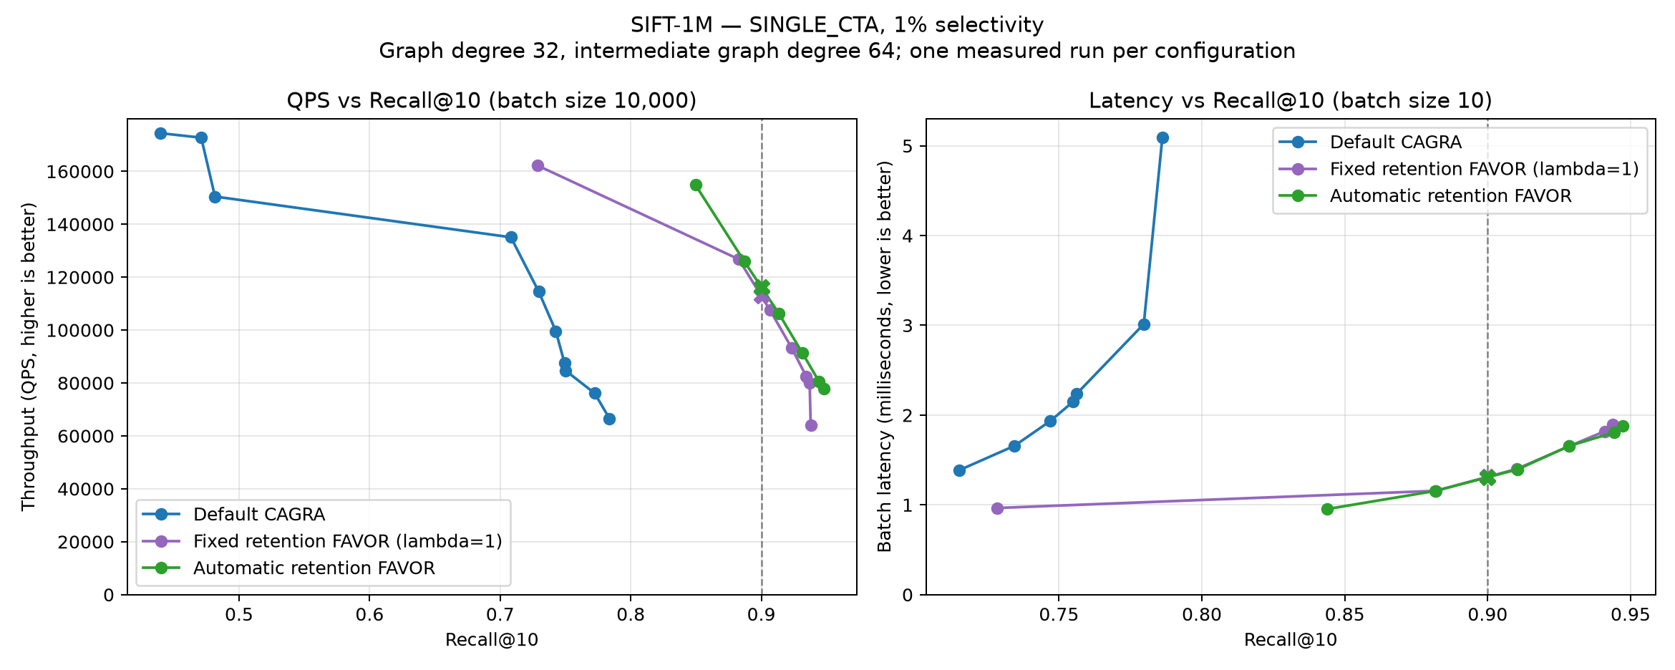
SINGLE_{CTA} on SIFT-1M at 1% passing selectivity.
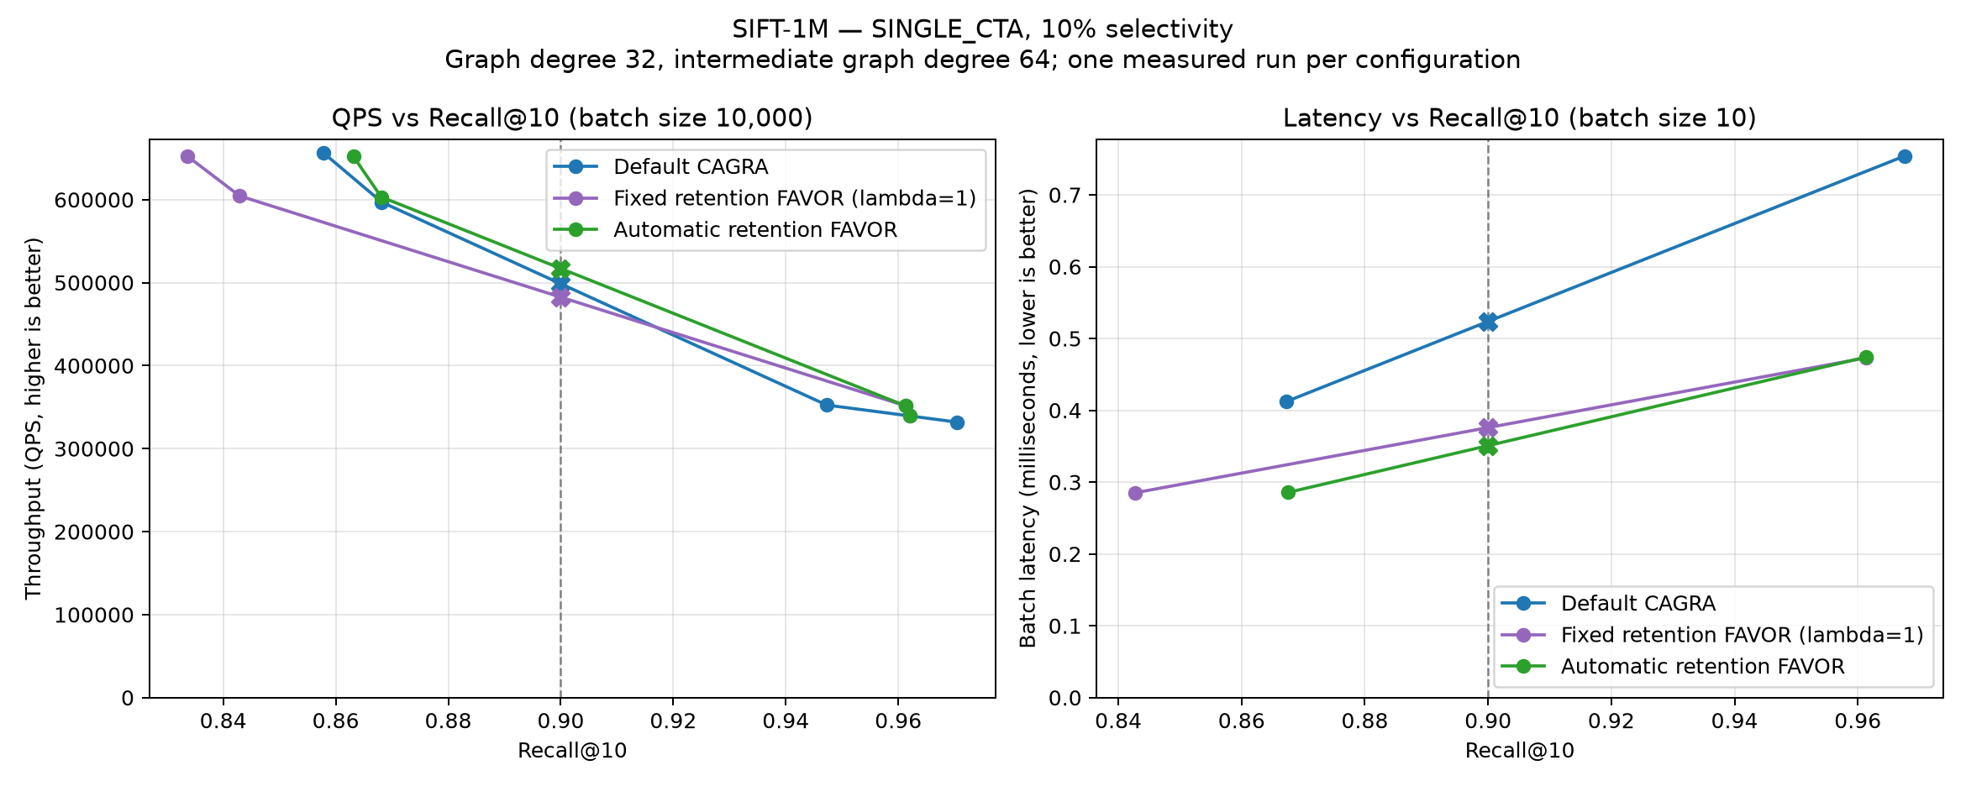
SINGLE_{CTA} on SIFT-1M at 10% passing selectivity.
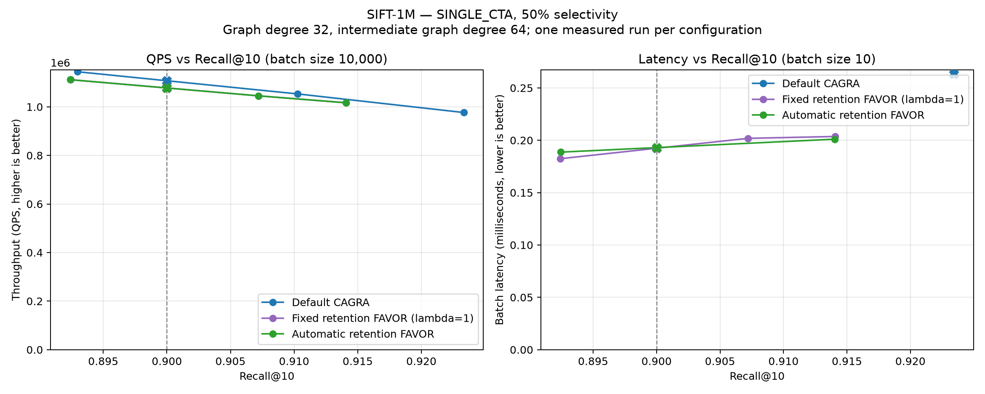
SINGLE_{CTA} on SIFT-1M at 50% passing selectivity.
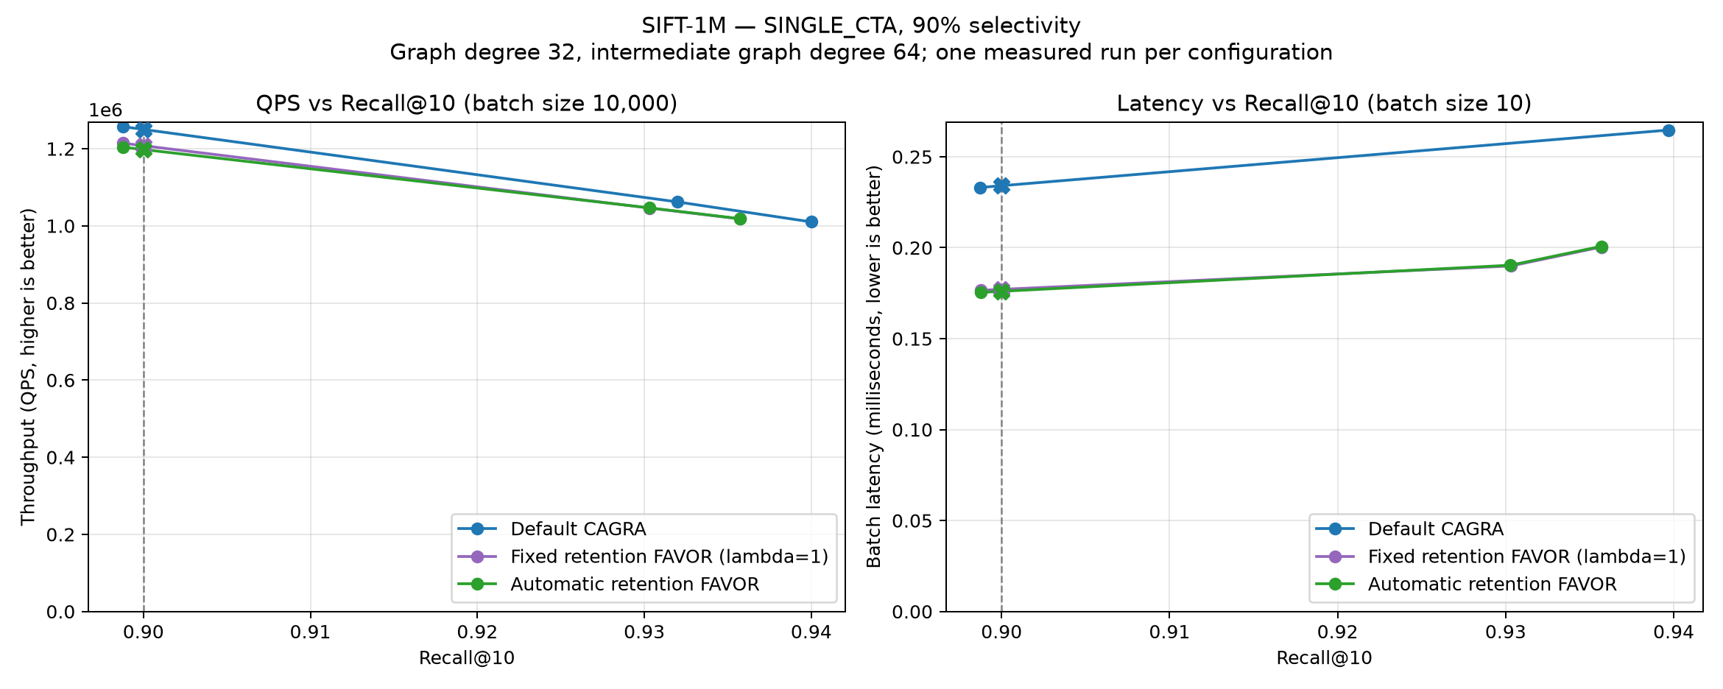
SINGLE_{CTA} on SIFT-1M at 90% passing selectivity.

GIST-1M
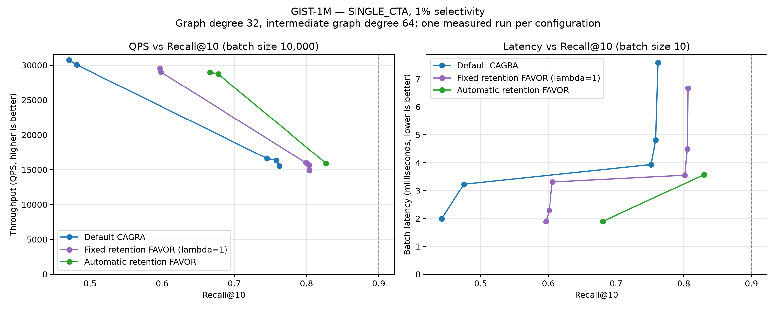
SINGLE_{CTA} on GIST-1M at 1% passing selectivity.
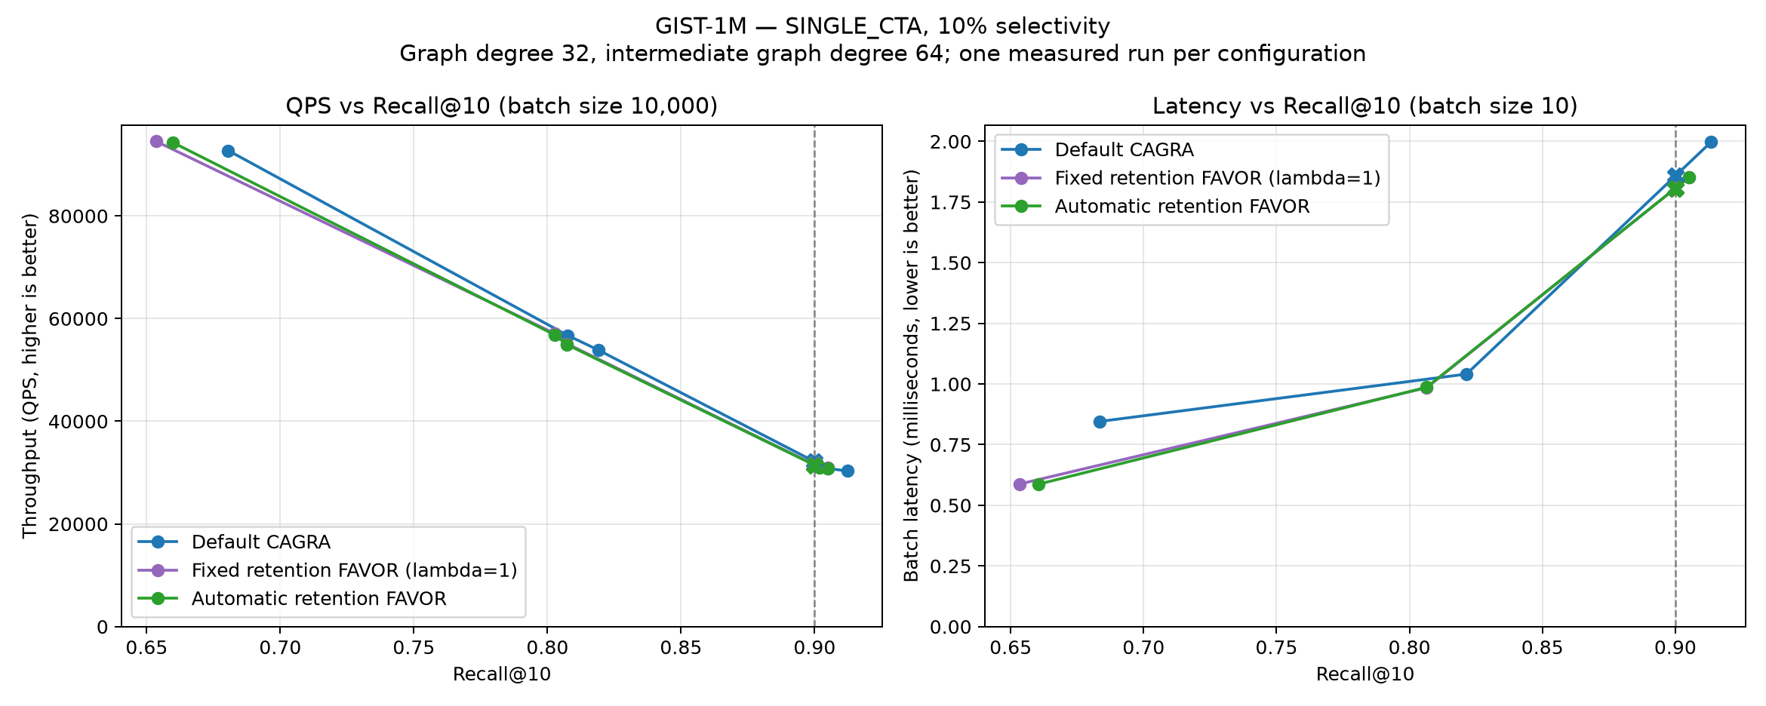
SINGLE_{CTA} on GIST-1M at 10% passing selectivity.
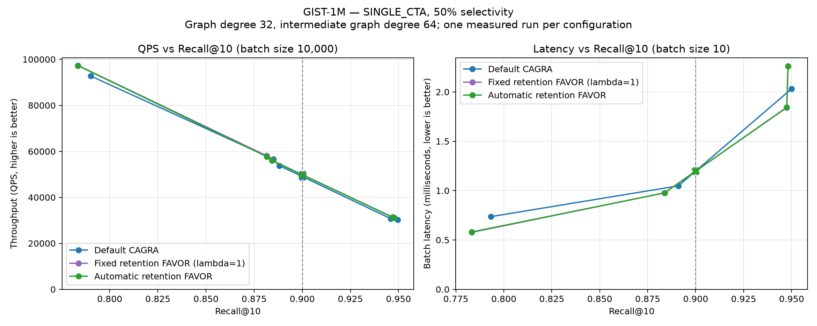
SINGLE_{CTA} on GIST-1M at 50% passing selectivity.
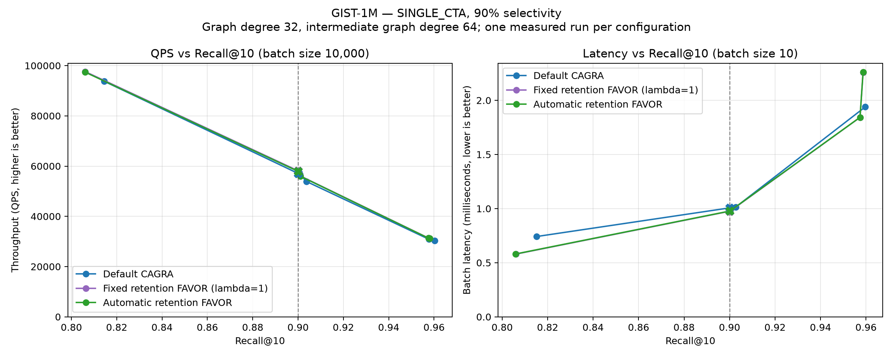
SINGLE_{CTA} on GIST-1M at 90% passing selectivity.

BIGANN-1M
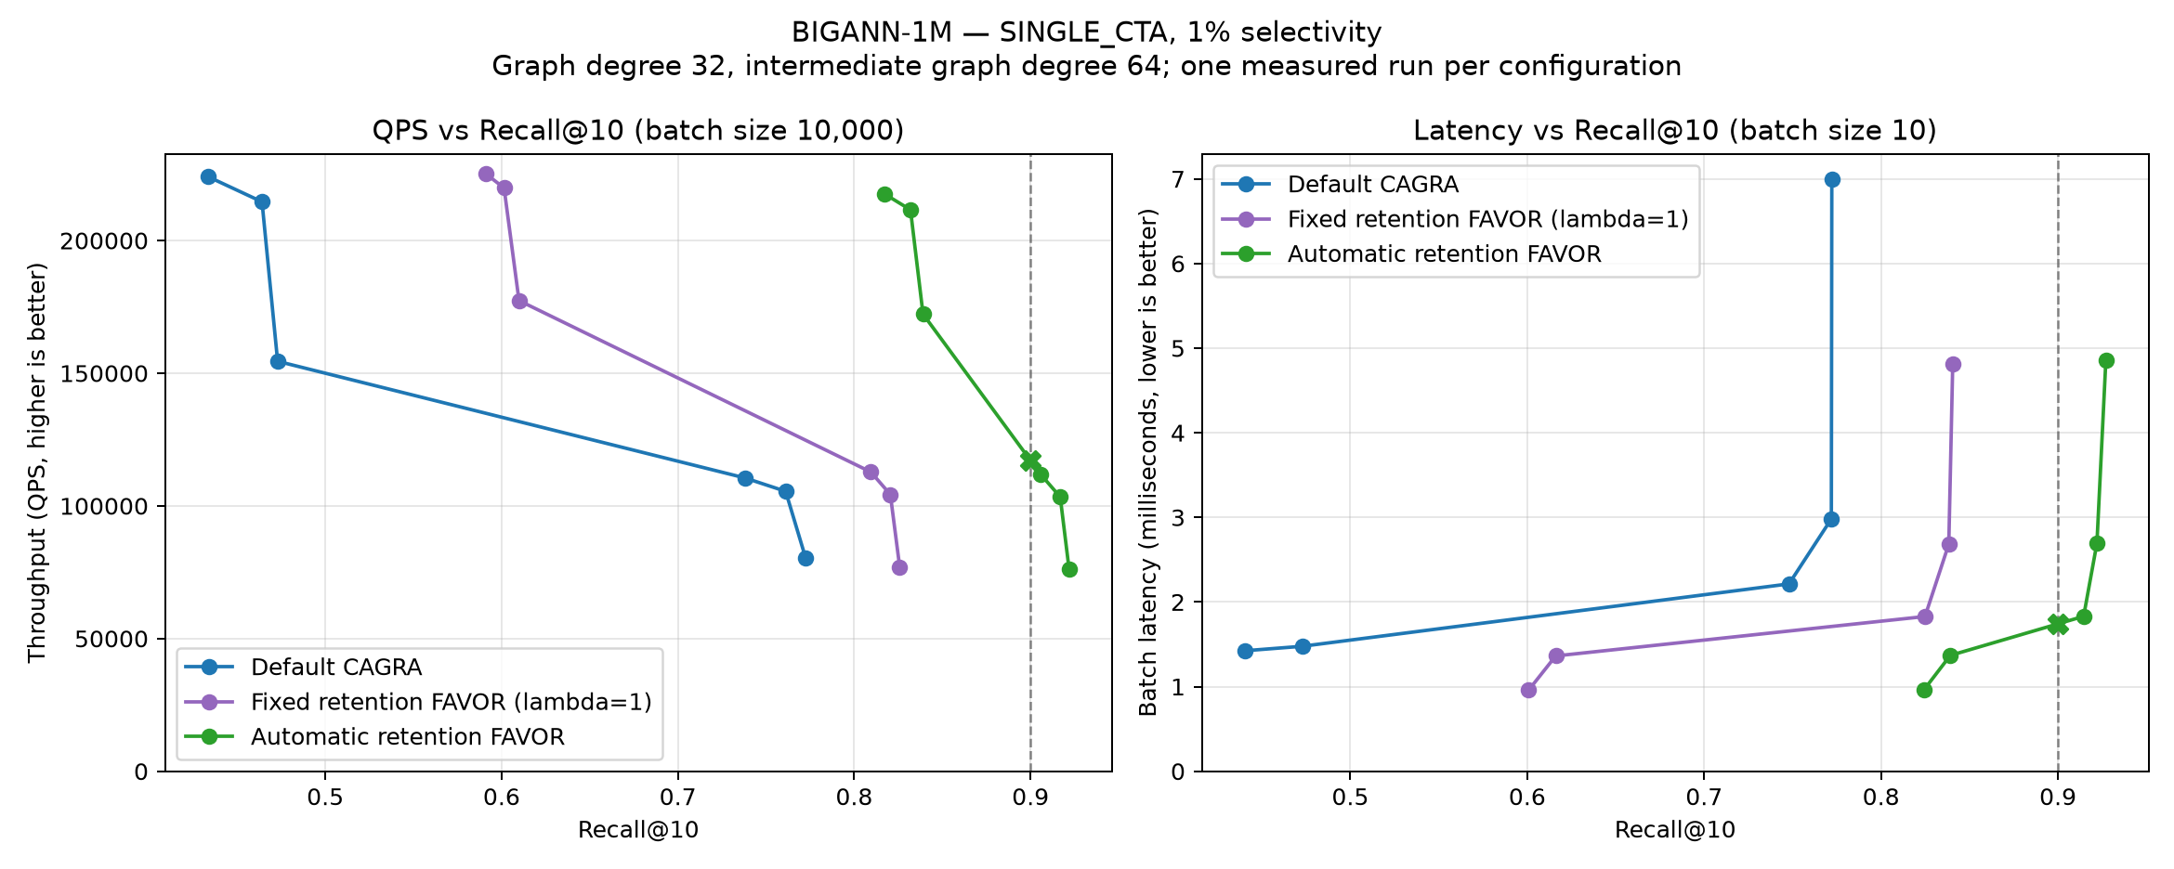
SINGLE_{CTA} on BIGANN-1M at 1% passing selectivity.
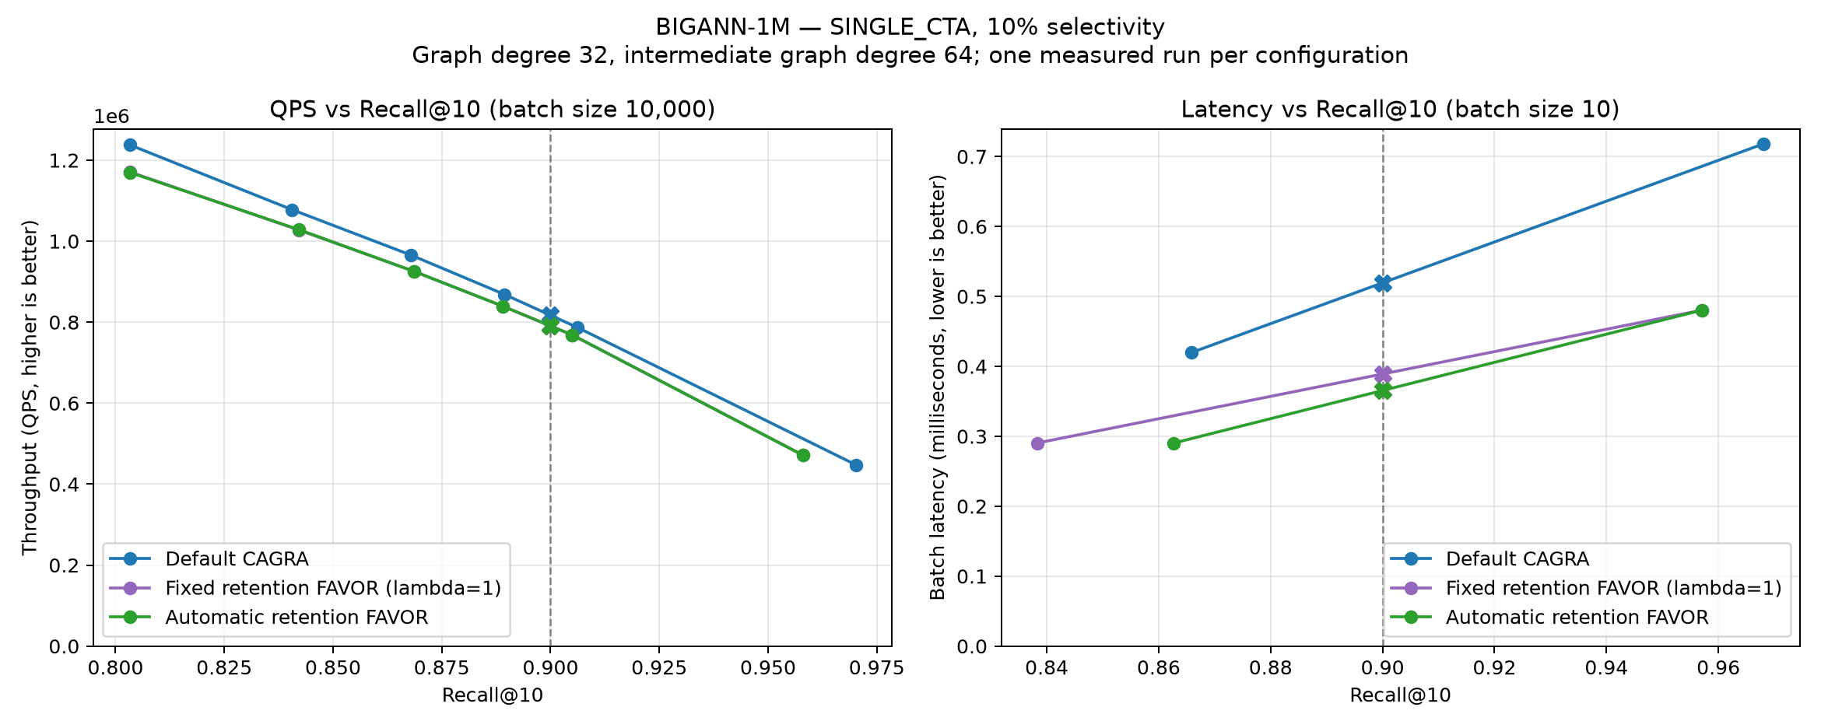
SINGLE_{CTA} on BIGANN-1M at 10% passing selectivity.
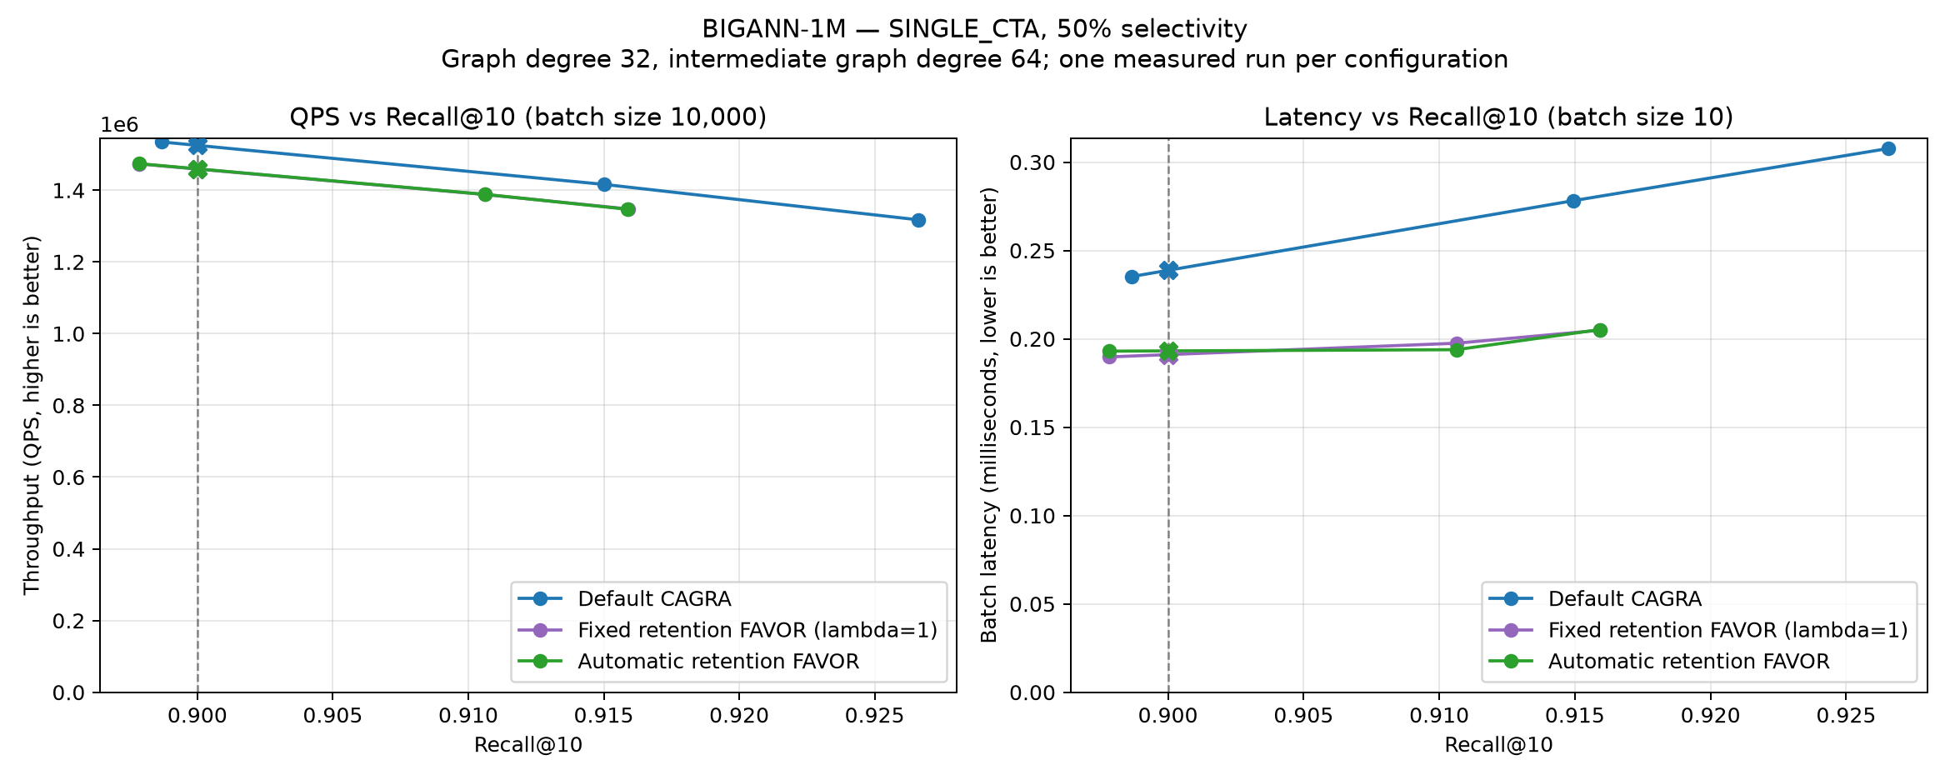
SINGLE_{CTA} on BIGANN-1M at 50% passing selectivity.
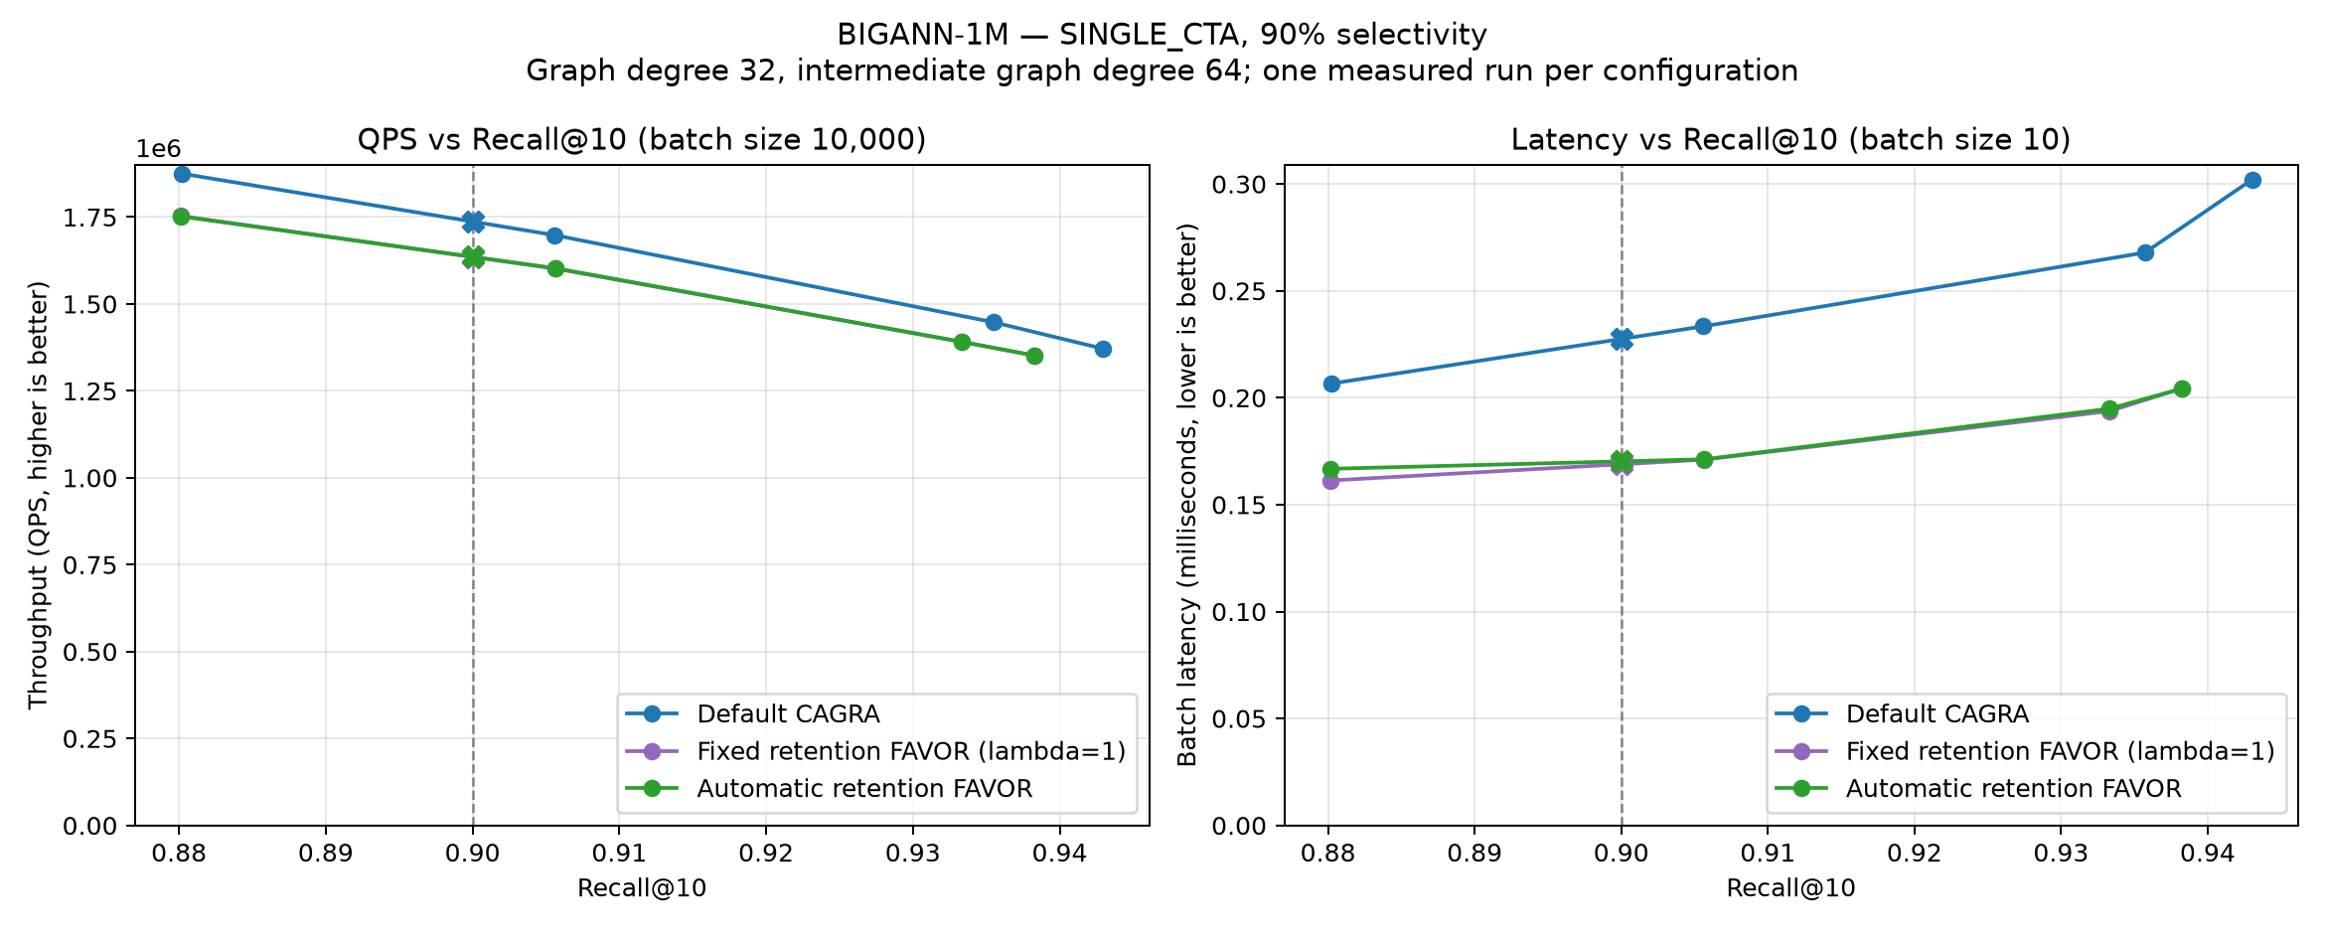
SINGLE_{CTA} on BIGANN-1M at 90% passing selectivity.

BIGANN-10M
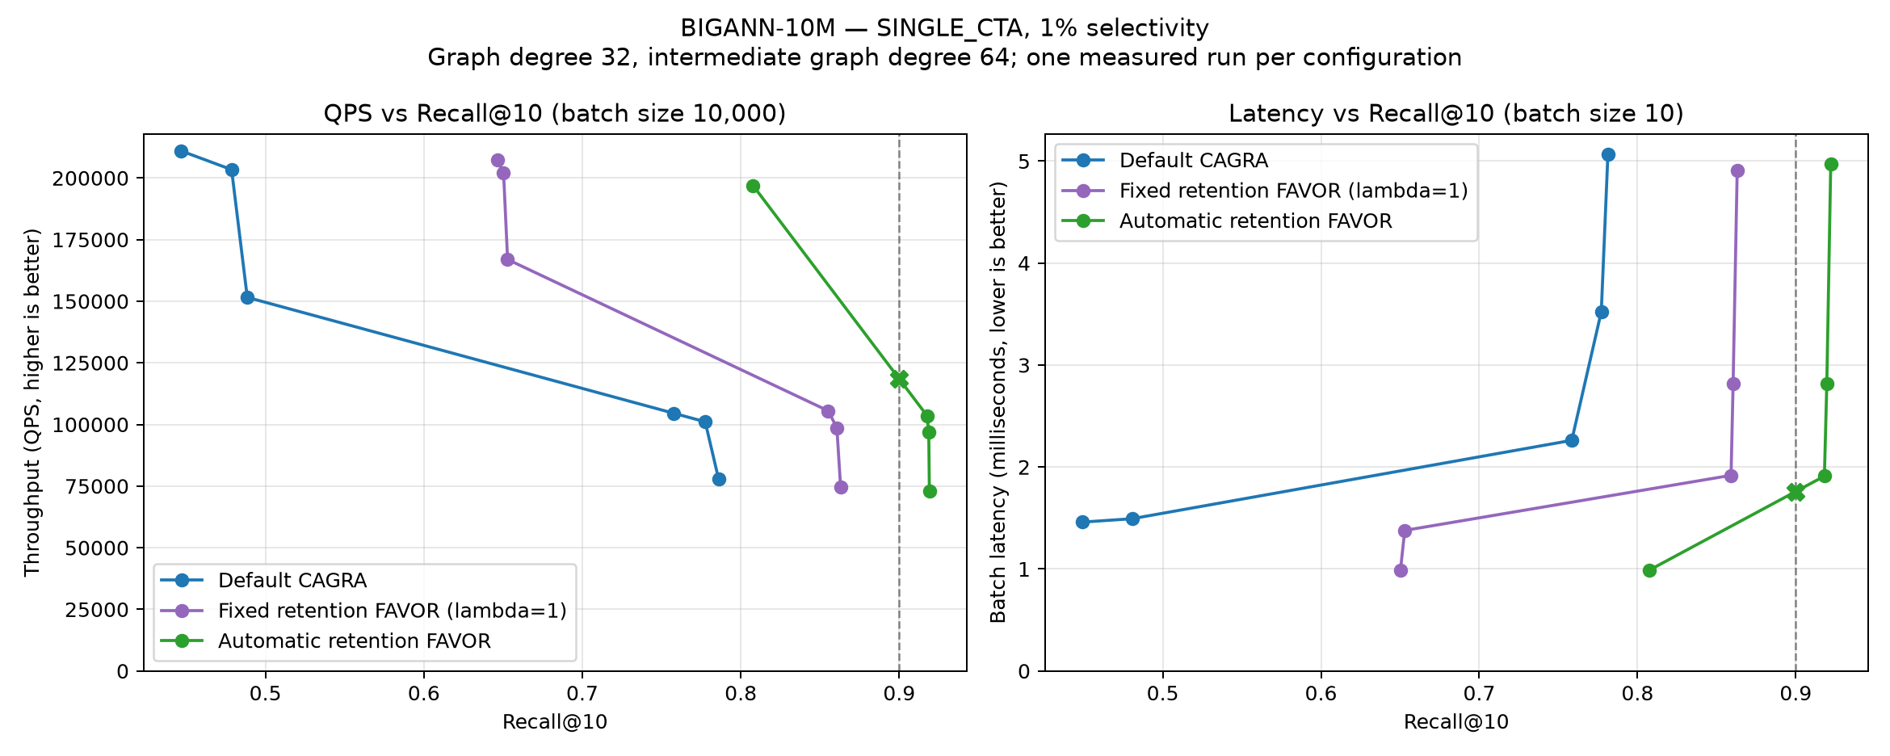
SINGLE_{CTA} on BIGANN-10M at 1% passing selectivity.
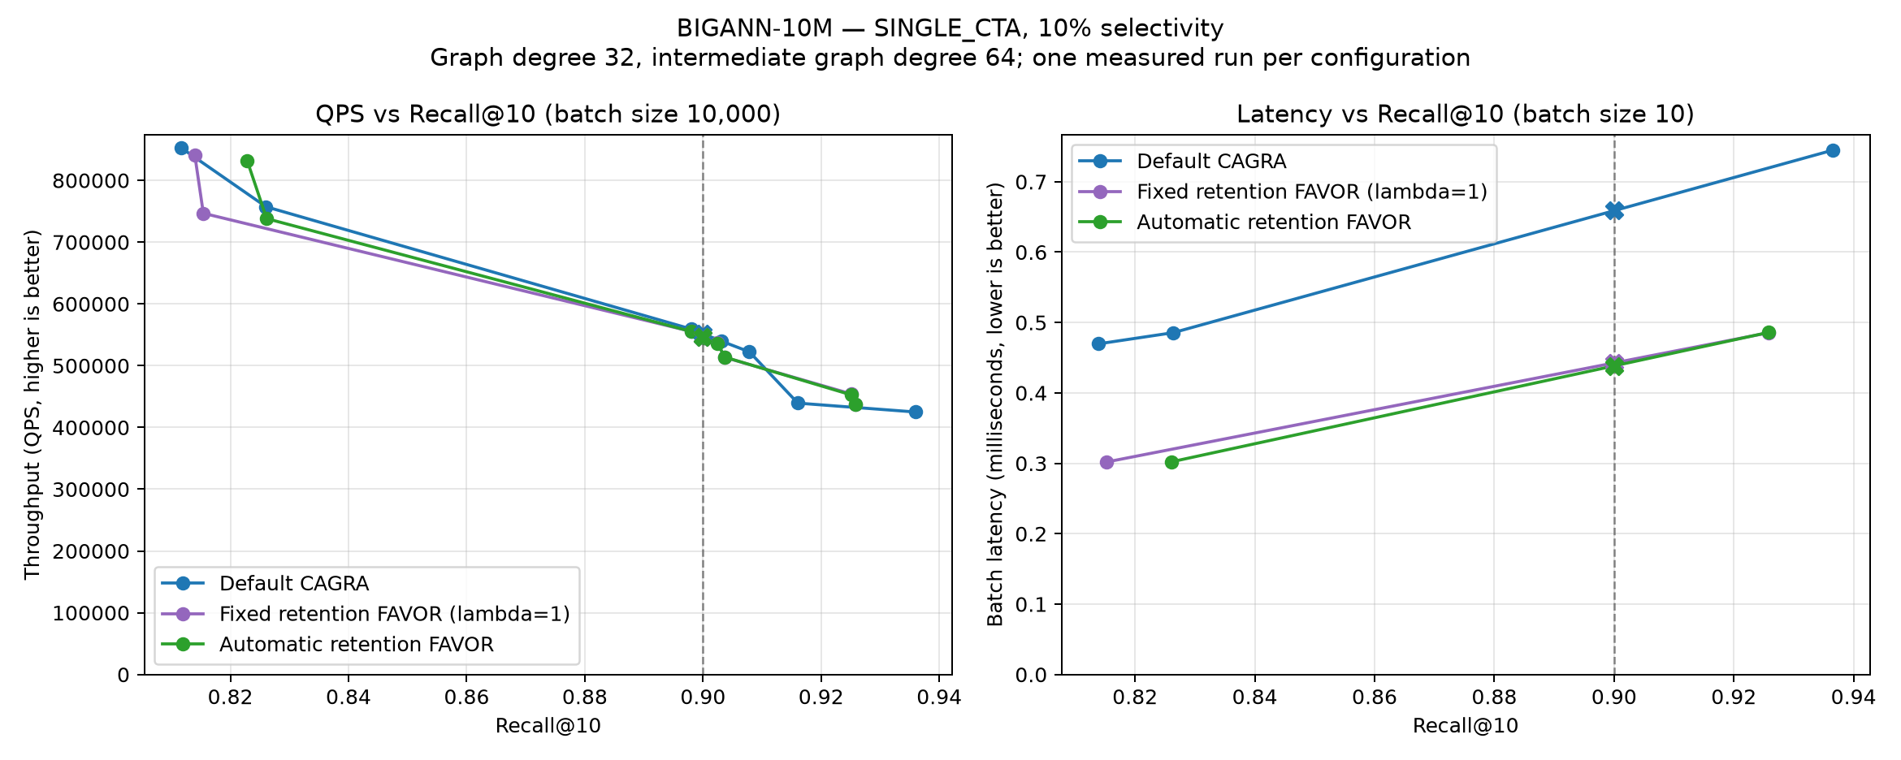
SINGLE_{CTA} on BIGANN-10M at 10% passing selectivity.
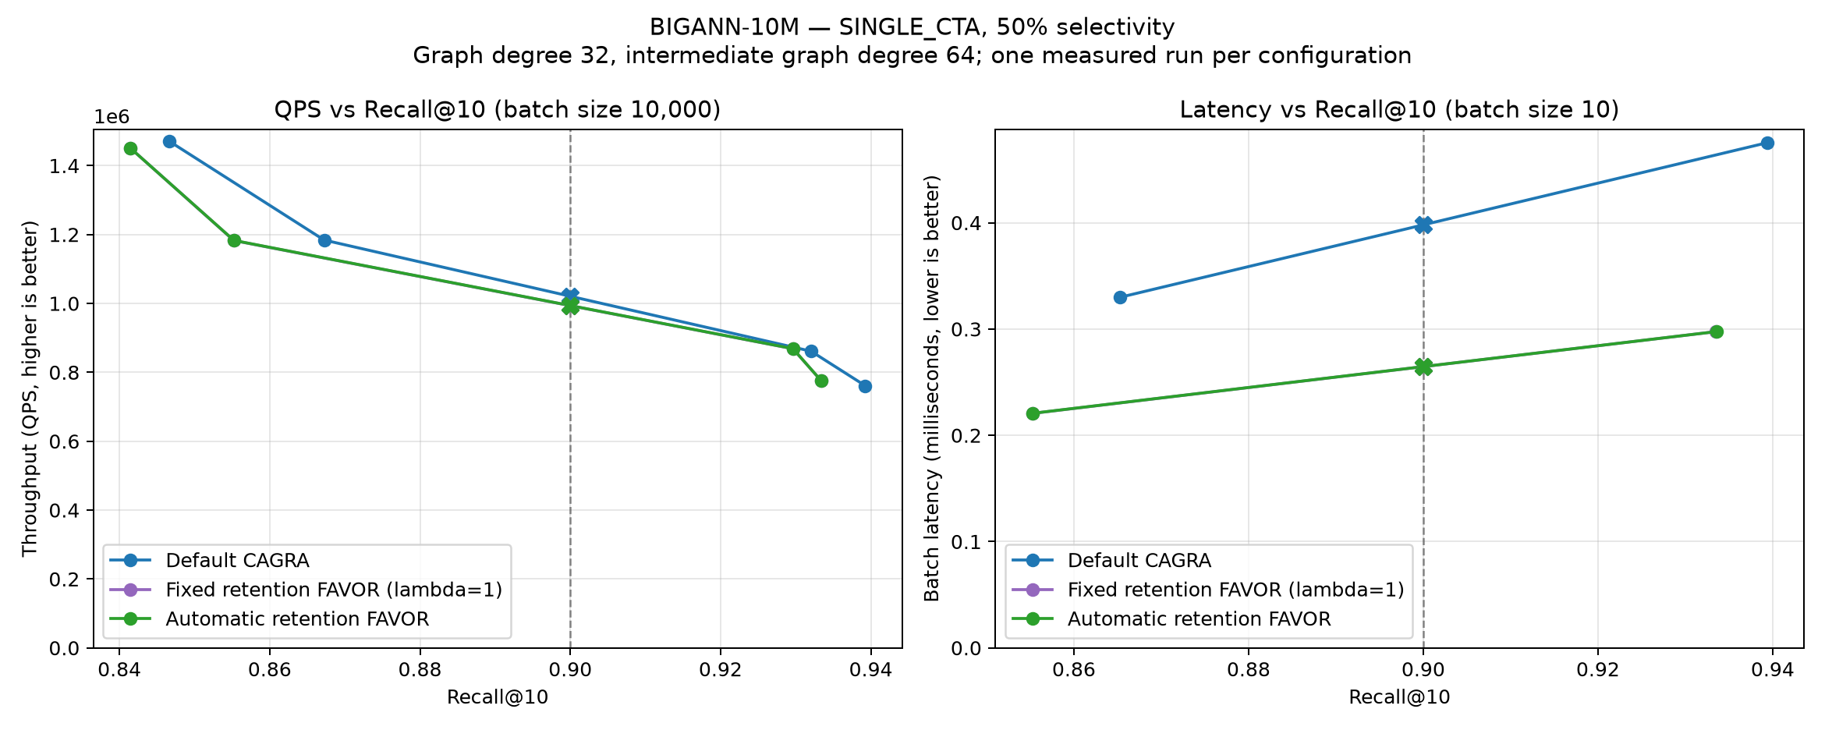
SINGLE_{CTA} on BIGANN-10M at 50% passing selectivity.
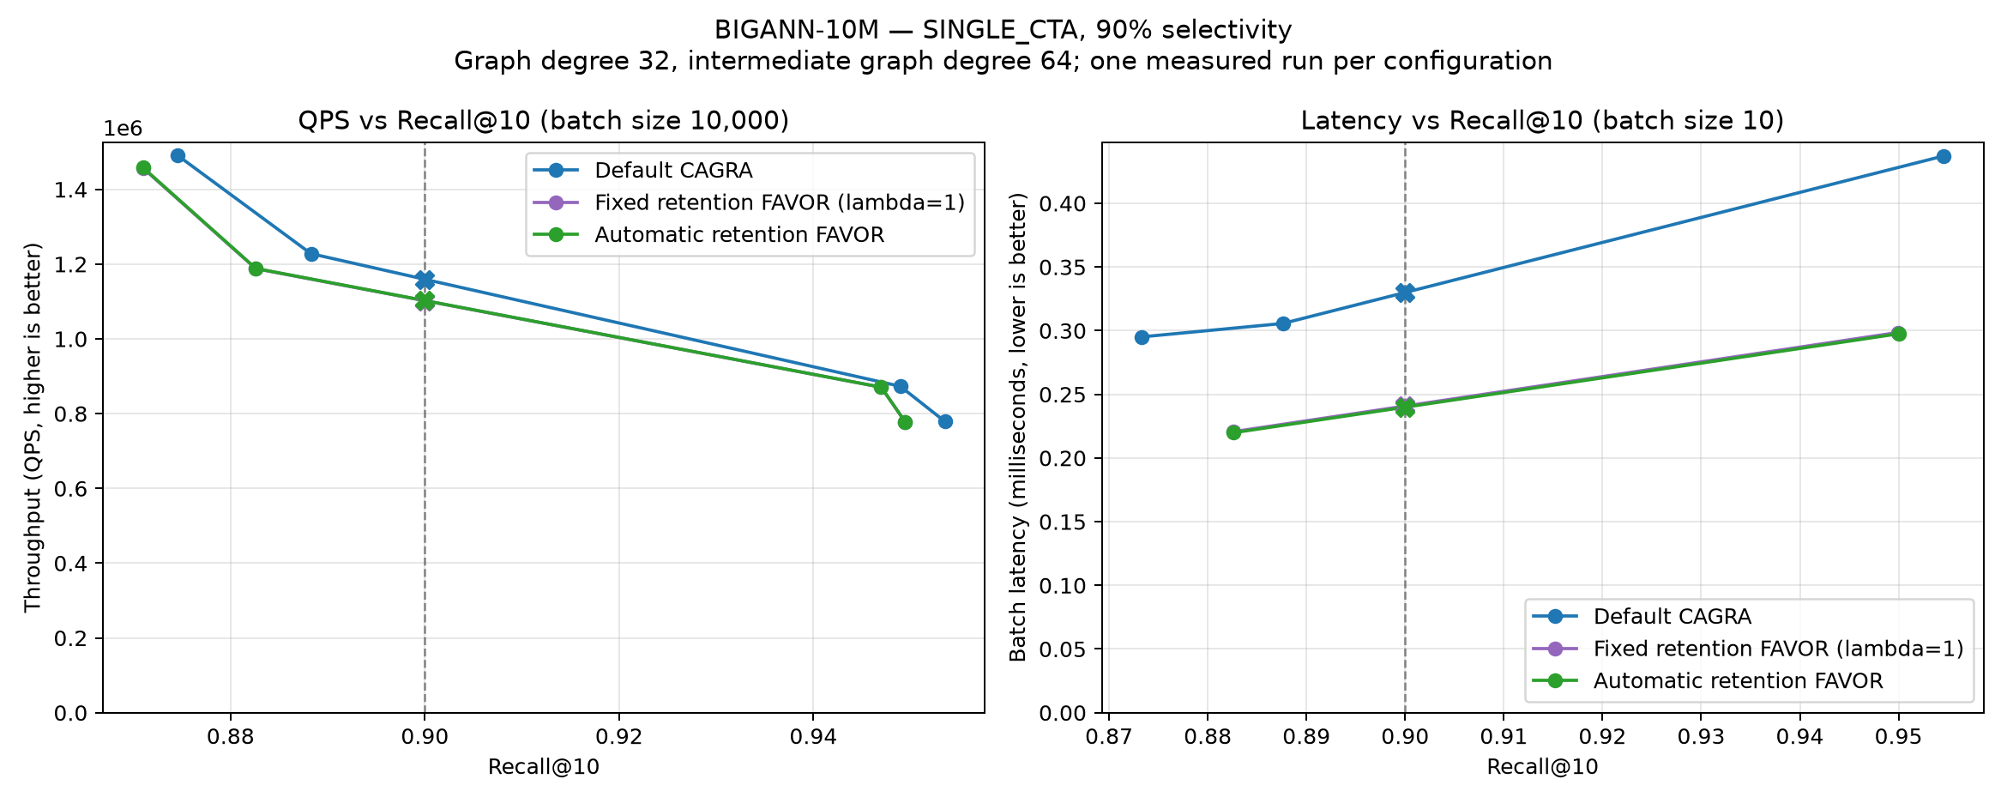
SINGLE_{CTA} on BIGANN-10M at 90% passing selectivity.

MSTuring-1M
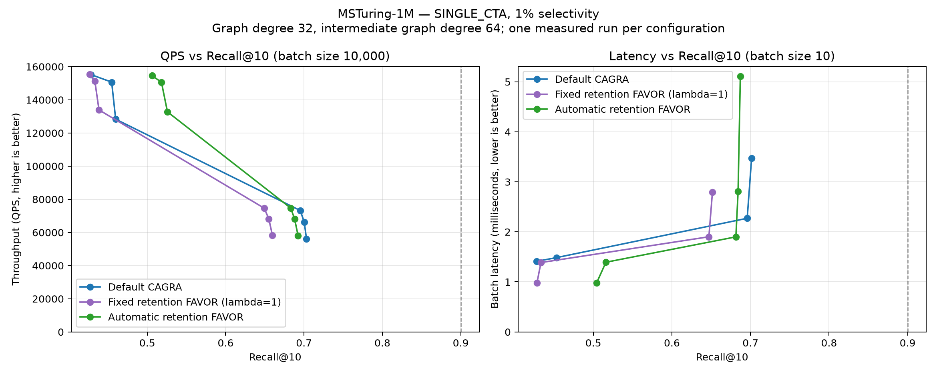
SINGLE_{CTA} on MSTuring-1M at 1% passing selectivity.
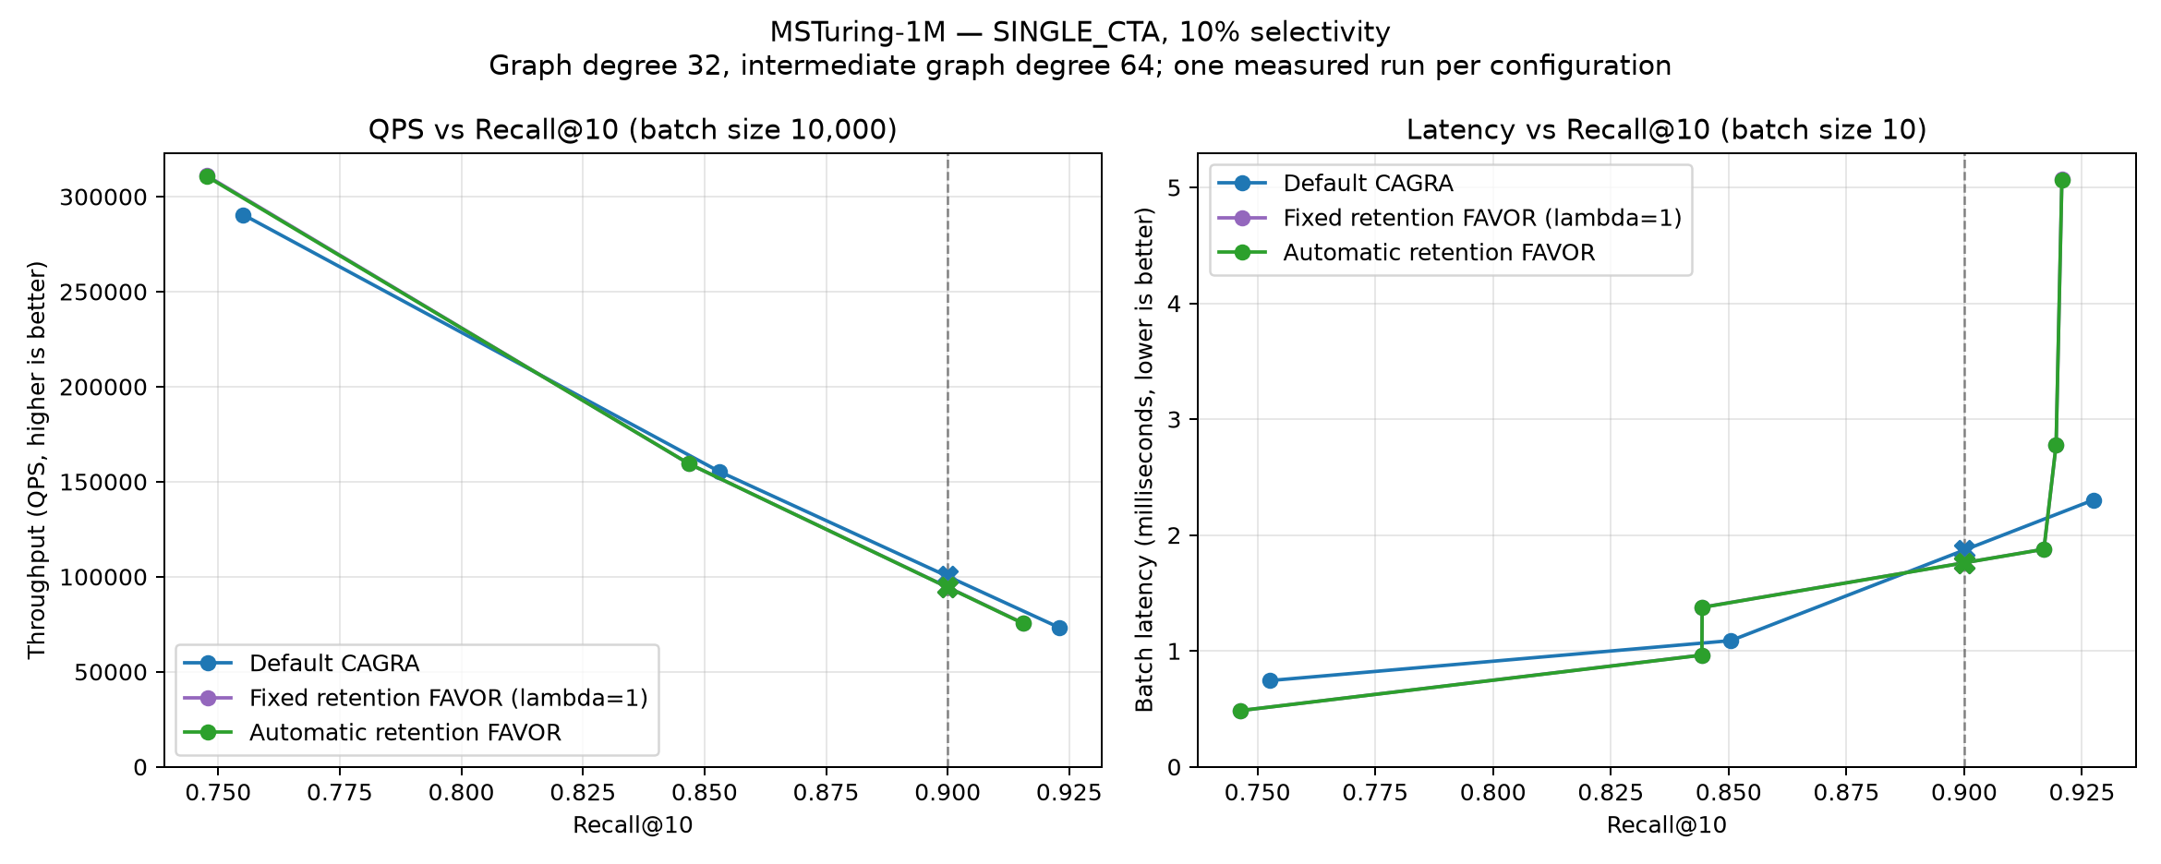
SINGLE_{CTA} on MSTuring-1M at 10% passing selectivity.
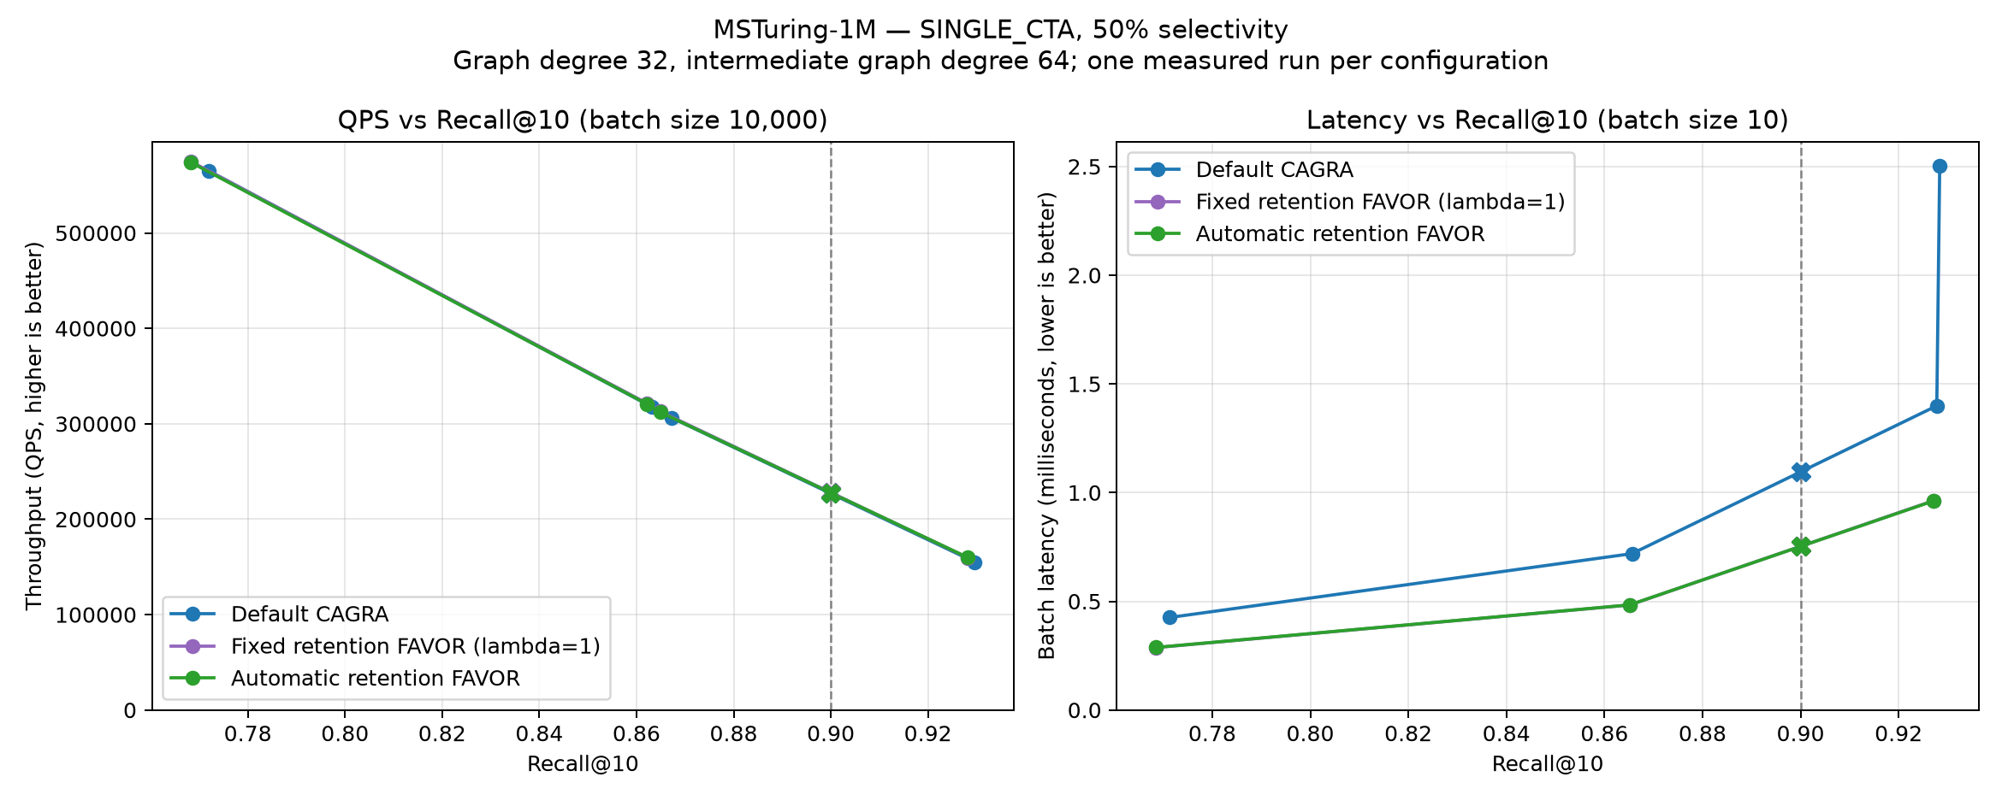
SINGLE_{CTA} on MSTuring-1M at 50% passing selectivity.
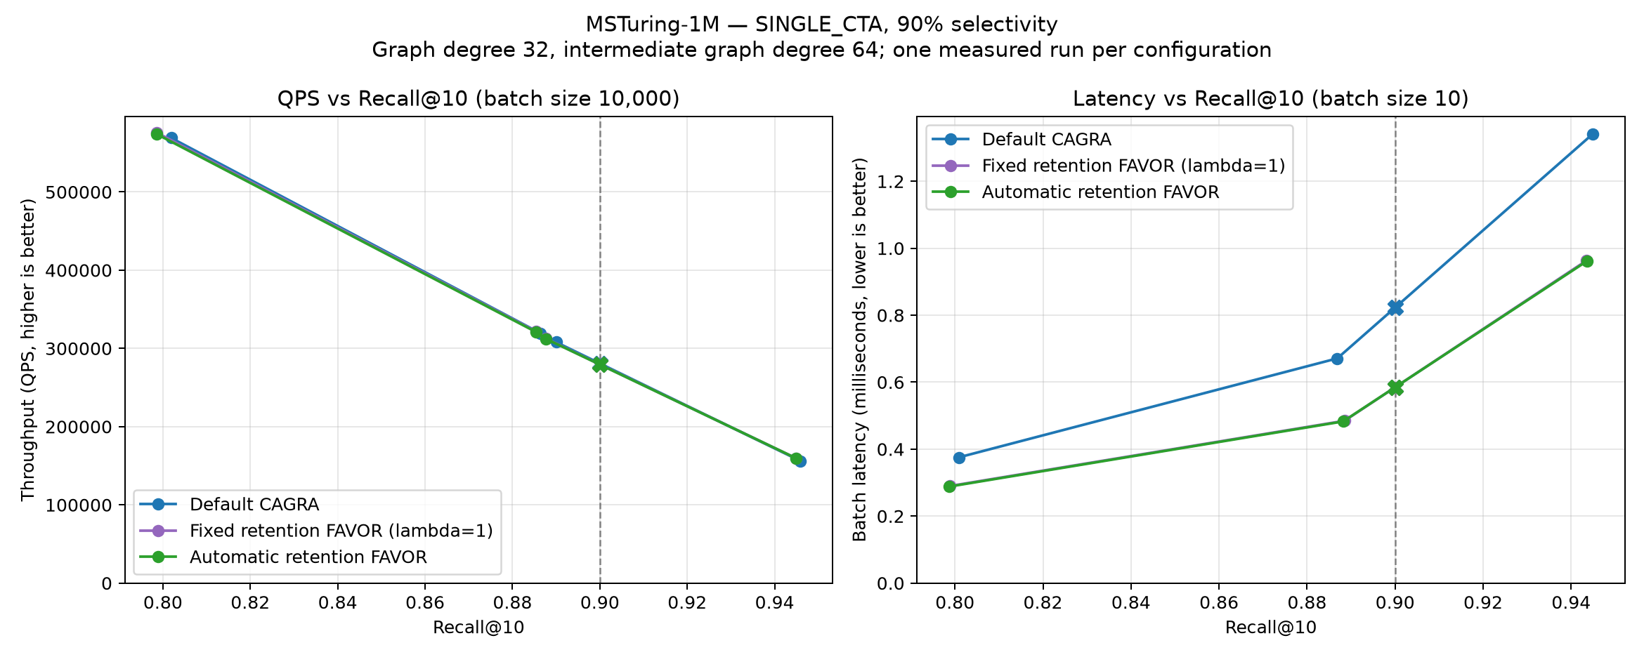
SINGLE_{CTA} on MSTuring-1M at 90% passing selectivity.

MSTuring-10M
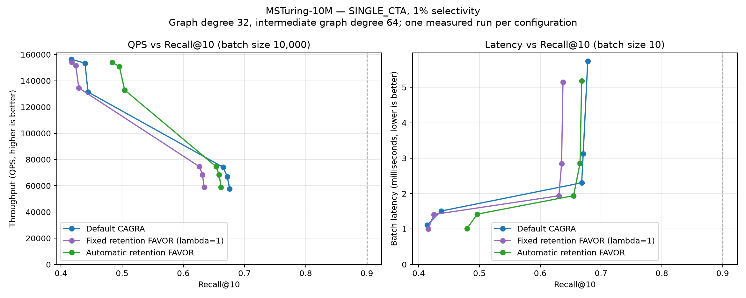
SINGLE_{CTA} on MSTuring-10M at 1% passing selectivity.
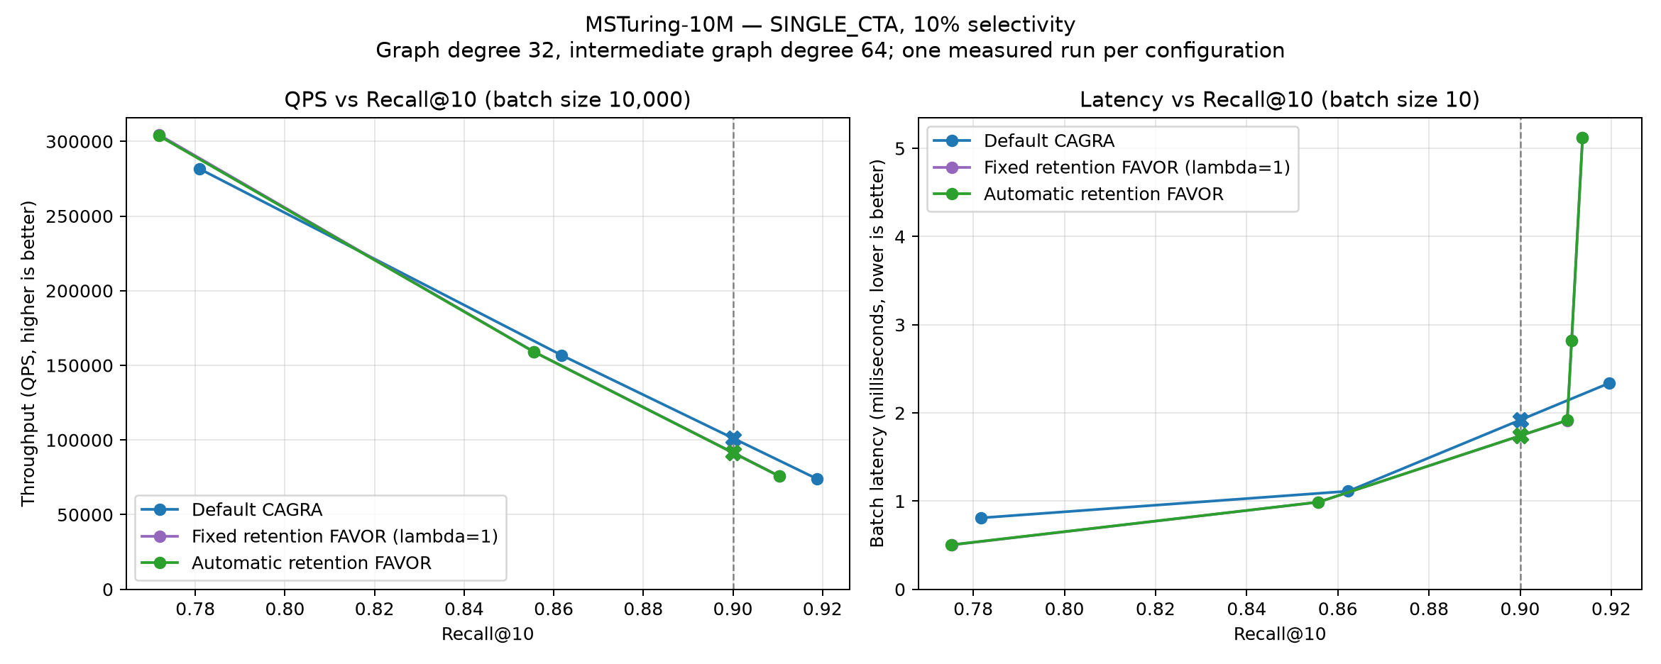
SINGLE_{CTA} on MSTuring-10M at 10% passing selectivity.
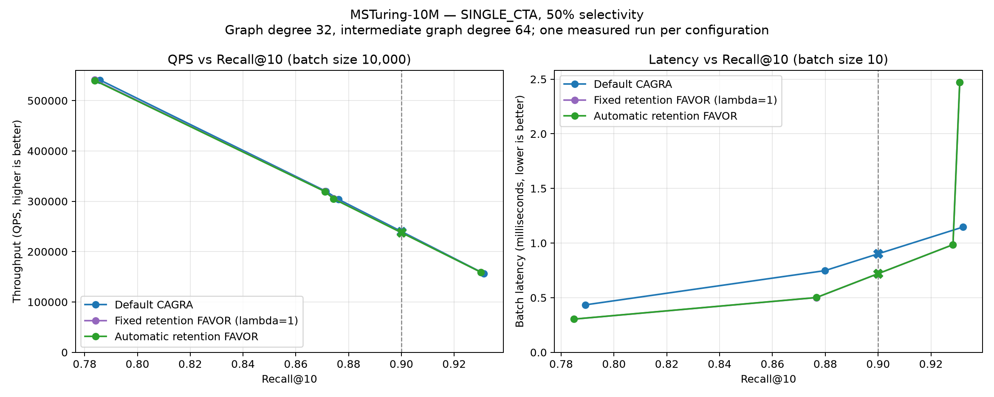
SINGLE_{CTA} on MSTuring-10M at 50% passing selectivity.
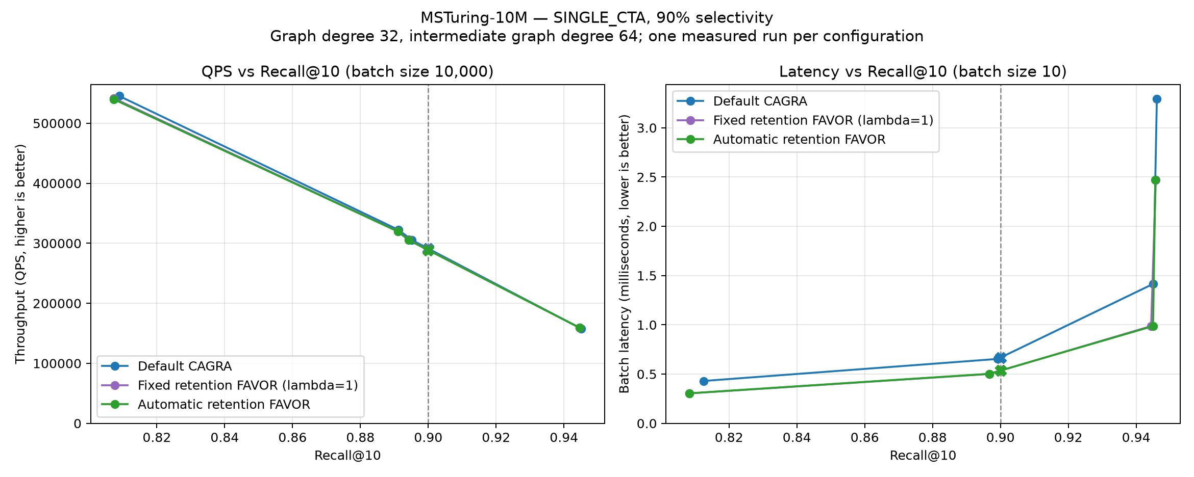
SINGLE_{CTA} on MSTuring-10M at 90% passing selectivity.

MULTI_{CTA} results
MULTI_CTA uses a one-query batch. Reported QPS is the reciprocal of single-query latency and is not saturated large-batch throughput. Target values at Recall@10 = 0.99 follow the same measured-feasible/bracketed-interpolation rule as SINGLE_CTA, with no extrapolation.

Maximum measured recall (batch-size-1 sweep)
Dataset | Selectivity | Default | Fixed rho=0.5 | Automatic rho
SIFT-1M | 1% | 1.000 | 1.000 | 1.000
SIFT-1M | 10% | 1.000 | 1.000 | 1.000
SIFT-1M | 50% | 1.000 | 1.000 | 1.000
SIFT-1M | 90% | 0.999 | 0.999 | 1.000
GIST-1M | 1% | 1.000 | 1.000 | 1.000
GIST-1M | 10% | 0.999 | 0.999 | 0.999
GIST-1M | 50% | 0.997 | 0.997 | 0.996
GIST-1M | 90% | 0.996 | 0.996 | 0.995
BIGANN-1M | 1% | 1.000 | 1.000 | 1.000
BIGANN-1M | 10% | 1.000 | 1.000 | 1.000
BIGANN-1M | 50% | 1.000 | 1.000 | 1.000
BIGANN-1M | 90% | 1.000 | 1.000 | 1.000
BIGANN-10M | 1% | 1.000 | 1.000 | 1.000
BIGANN-10M | 10% | 1.000 | 1.000 | 1.000
BIGANN-10M | 50% | 1.000 | 1.000 | 1.000
BIGANN-10M | 90% | 1.000 | 1.000 | 1.000
MSTuring-1M | 1% | 0.999 | 0.998 | 0.998
MSTuring-1M | 10% | 0.997 | 0.996 | 0.996
MSTuring-1M | 50% | 0.994 | 0.994 | 0.993
MSTuring-1M | 90% | 0.992 | 0.992 | 0.991
MSTuring-10M | 1% | 0.997 | 0.994 | 0.995
MSTuring-10M | 10% | 0.995 | 0.995 | 0.994
MSTuring-10M | 50% | 0.995 | 0.995 | 0.994
MSTuring-10M | 90% | 0.995 | 0.995 | 0.996

Batch-size-1 QPS at Recall@10 = 0.99
Dataset | Selectivity | Default | Fixed rho=0.5 | Automatic rho
SIFT-1M | 1% | 3,054 | 3,264 | 3,463
SIFT-1M | 10% | 3,538 | 3,640 | 3,652
SIFT-1M | 50% | 3,670 | 3,745 | 3,731
SIFT-1M | 90% | 3,770 | 3,806 | 3,805
GIST-1M | 1% | 893 | 735 | 399
GIST-1M | 10% | 1,840 | 1,854 | 1,870
GIST-1M | 50% | 2,246 | 2,304 | 2,274
GIST-1M | 90% | 2,376 | 2,323 | 2,296
BIGANN-1M | 1% | 2,978 | 3,194 | 3,310
BIGANN-1M | 10% | 3,566 | 3,668 | 3,666
BIGANN-1M | 50% | 3,721 | 3,746 | 3,746
BIGANN-1M | 90% | 3,831 | 3,815 | 3,837
BIGANN-10M | 1% | 3,034 | 3,276 | 3,082
BIGANN-10M | 10% | 3,344 | 3,502 | 3,502
BIGANN-10M | 50% | 3,572 | 3,619 | 3,629
BIGANN-10M | 90% | 3,641 | 3,647 | 3,622
MSTuring-1M | 1% | 2,634 | 2,629 | 2,316
MSTuring-1M | 10% | 3,181 | 3,315 | 3,315
MSTuring-1M | 50% | 3,243 | 3,331 | 3,319
MSTuring-1M | 90% | 3,301 | 3,283 | 3,280
MSTuring-10M | 1% | 1,651 | 1,341 | 1,383
MSTuring-10M | 10% | 2,720 | 2,826 | 2,806
MSTuring-10M | 50% | 3,009 | 3,140 | 3,137
MSTuring-10M | 90% | 3,149 | 3,157 | 3,148

Single-query latency at Recall@10 = 0.99 (microseconds)
Dataset | Selectivity | Default | Fixed rho=0.5 | Automatic rho
SIFT-1M | 1% | 327.449 | 306.434 | 288.859
SIFT-1M | 10% | 282.700 | 274.773 | 273.844
SIFT-1M | 50% | 272.689 | 267.159 | 268.226
SIFT-1M | 90% | 265.286 | 262.805 | 262.891
GIST-1M | 1% | 1158.312 | 1422.631 | 2521.289
GIST-1M | 10% | 567.982 | 565.357 | 559.986
GIST-1M | 50% | 445.405 | 434.356 | 440.200
GIST-1M | 90% | 421.520 | 430.560 | 436.275
BIGANN-1M | 1% | 335.801 | 313.206 | 302.148
BIGANN-1M | 10% | 280.470 | 272.638 | 272.783
BIGANN-1M | 50% | 268.941 | 267.142 | 267.147
BIGANN-1M | 90% | 261.005 | 262.167 | 260.654
BIGANN-10M | 1% | 329.614 | 305.302 | 324.614
BIGANN-10M | 10% | 299.397 | 285.542 | 285.532
BIGANN-10M | 50% | 280.075 | 276.472 | 275.674
BIGANN-10M | 90% | 274.807 | 274.337 | 276.169
MSTuring-1M | 1% | 380.090 | 380.485 | 432.205
MSTuring-1M | 10% | 314.549 | 301.687 | 301.656
MSTuring-1M | 50% | 308.393 | 300.259 | 301.273
MSTuring-1M | 90% | 302.969 | 304.616 | 304.877
MSTuring-10M | 1% | 606.634 | 765.647 | 743.711
MSTuring-10M | 10% | 367.696 | 354.021 | 356.603
MSTuring-10M | 50% | 332.709 | 318.504 | 318.837
MSTuring-10M | 90% | 317.627 | 316.883 | 317.771

Complete Pareto figures
Each figure contains batch-size-1 reciprocal QPS and latency panels for all three methods. Both y-axes begin at zero.

SIFT-1M
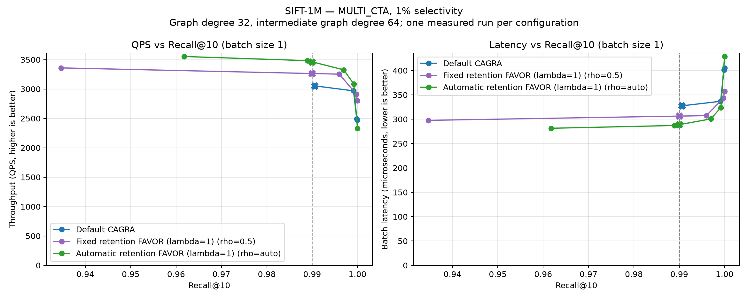
MULTI_{CTA} on SIFT-1M at 1% passing selectivity.
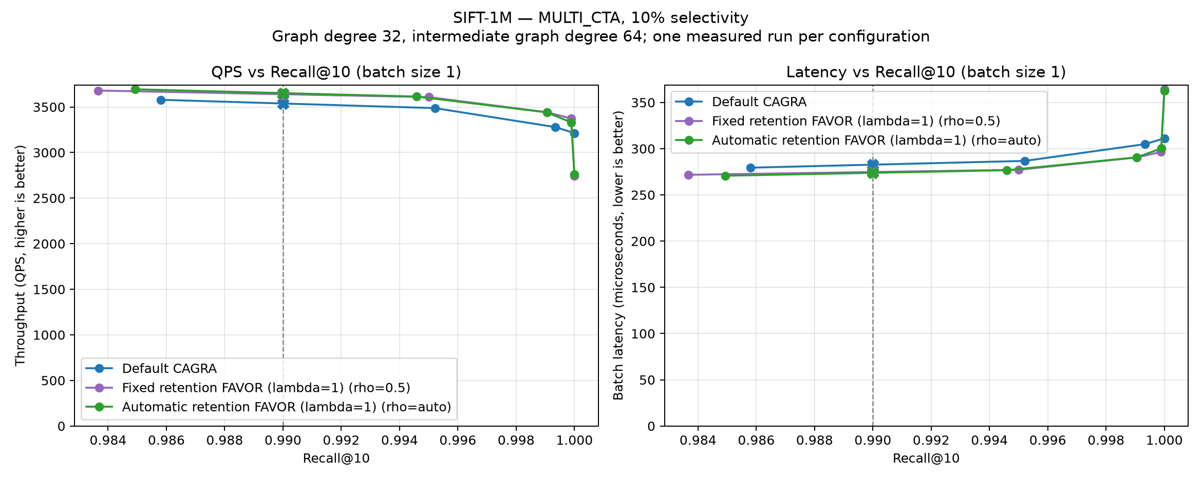
MULTI_{CTA} on SIFT-1M at 10% passing selectivity.
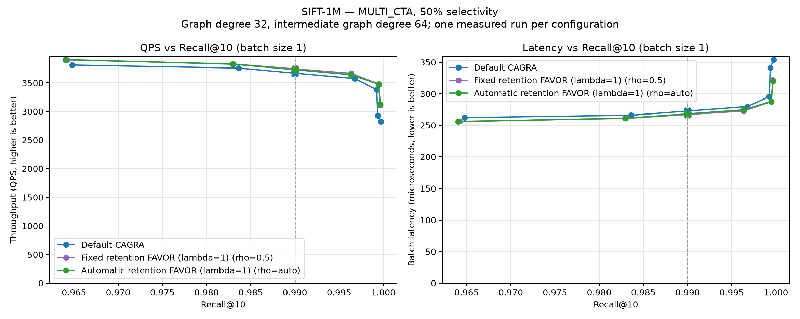
MULTI_{CTA} on SIFT-1M at 50% passing selectivity.
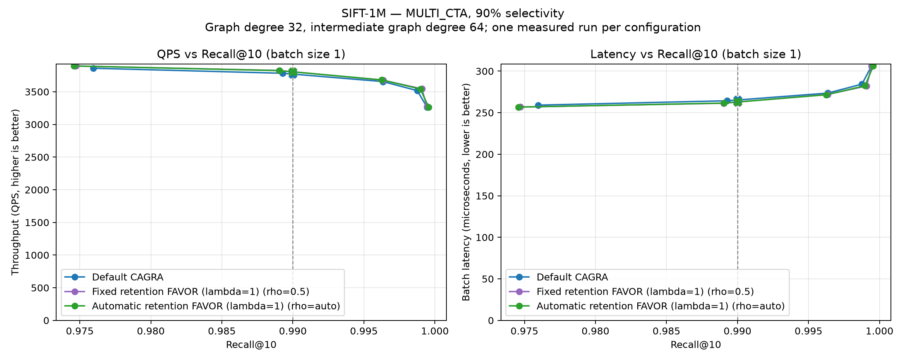
MULTI_{CTA} on SIFT-1M at 90% passing selectivity.

GIST-1M
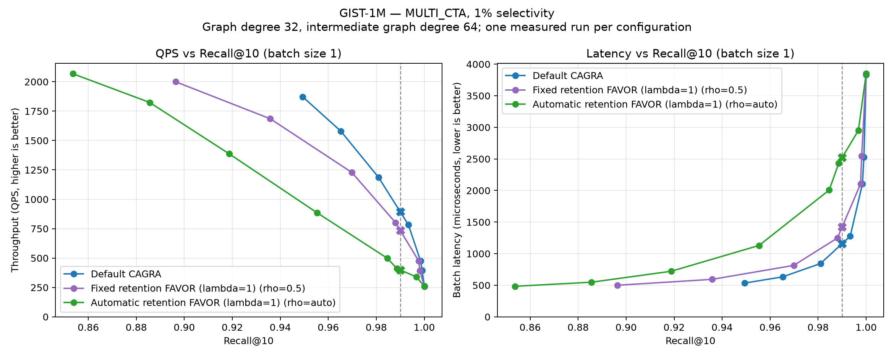
MULTI_{CTA} on GIST-1M at 1% passing selectivity.
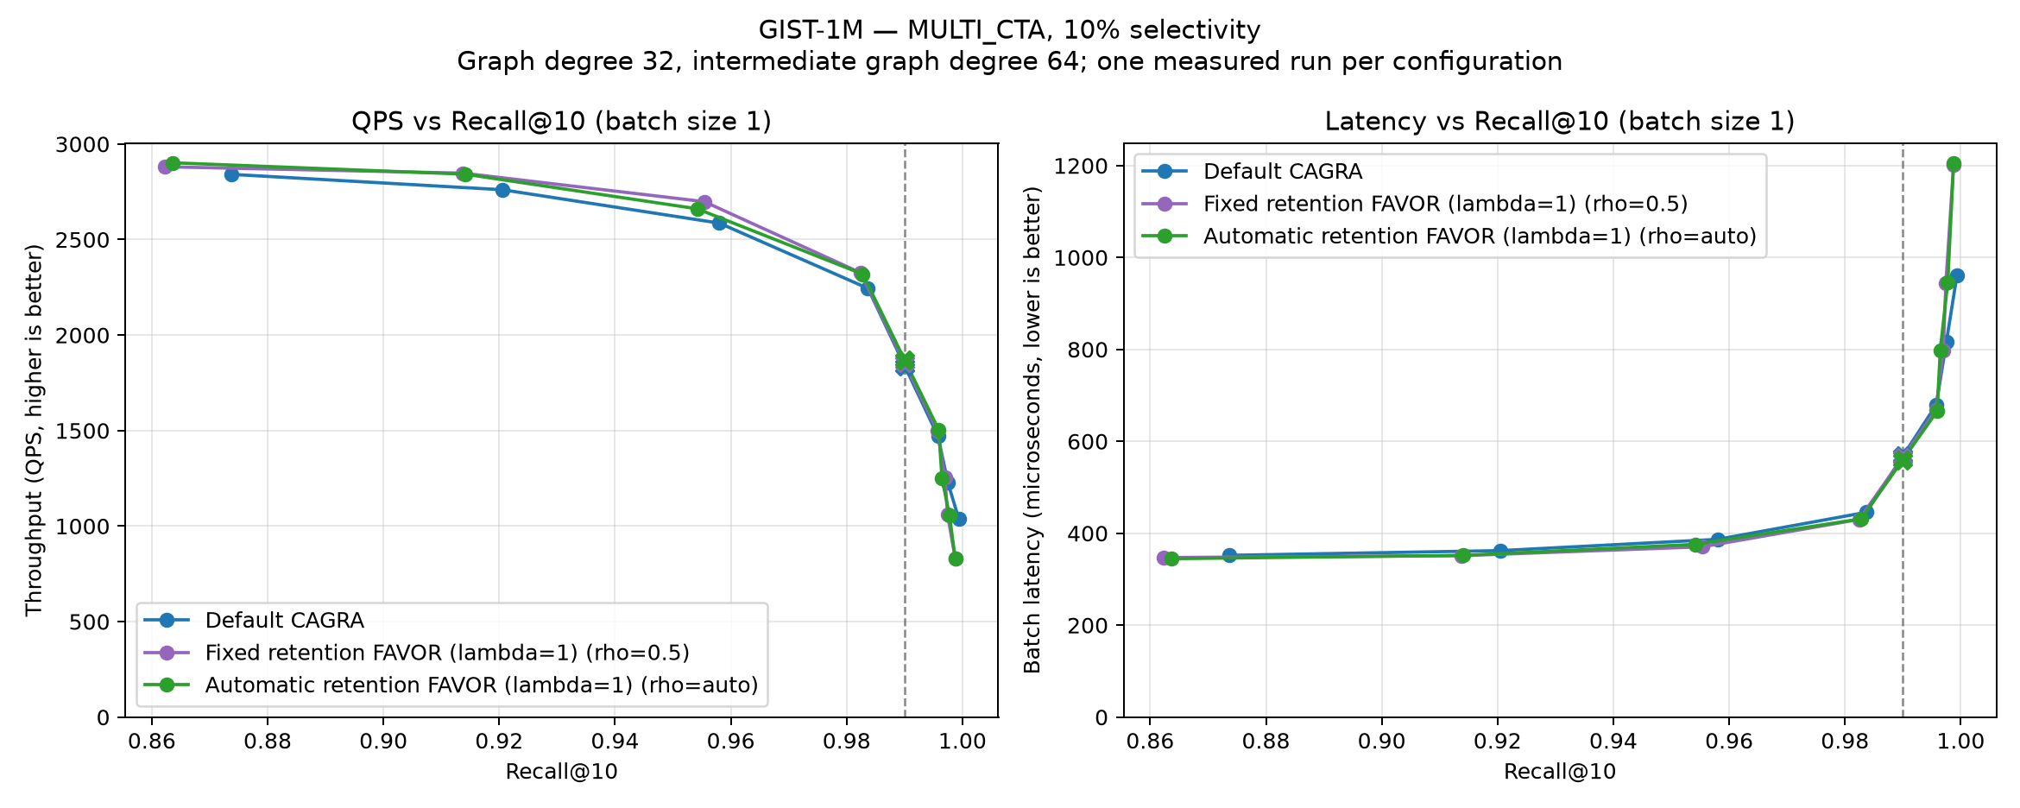
MULTI_{CTA} on GIST-1M at 10% passing selectivity.
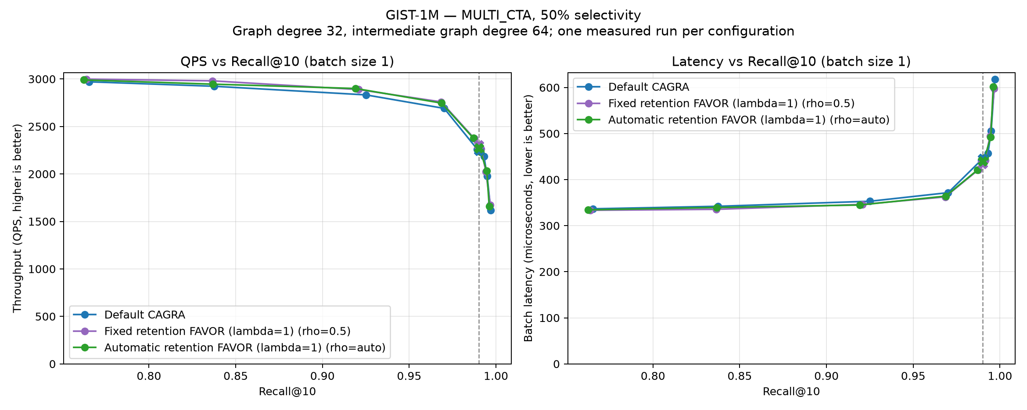
MULTI_{CTA} on GIST-1M at 50% passing selectivity.
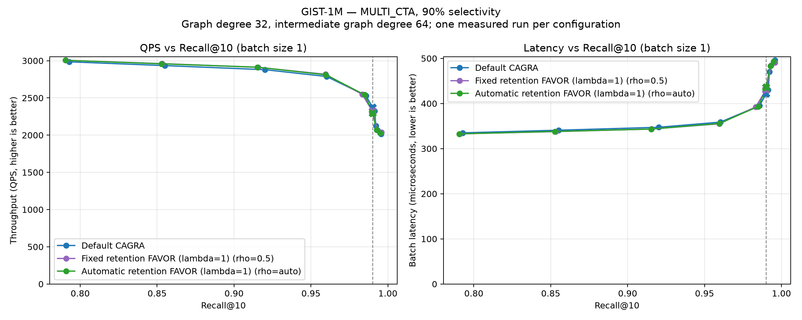
MULTI_{CTA} on GIST-1M at 90% passing selectivity.

BIGANN-1M
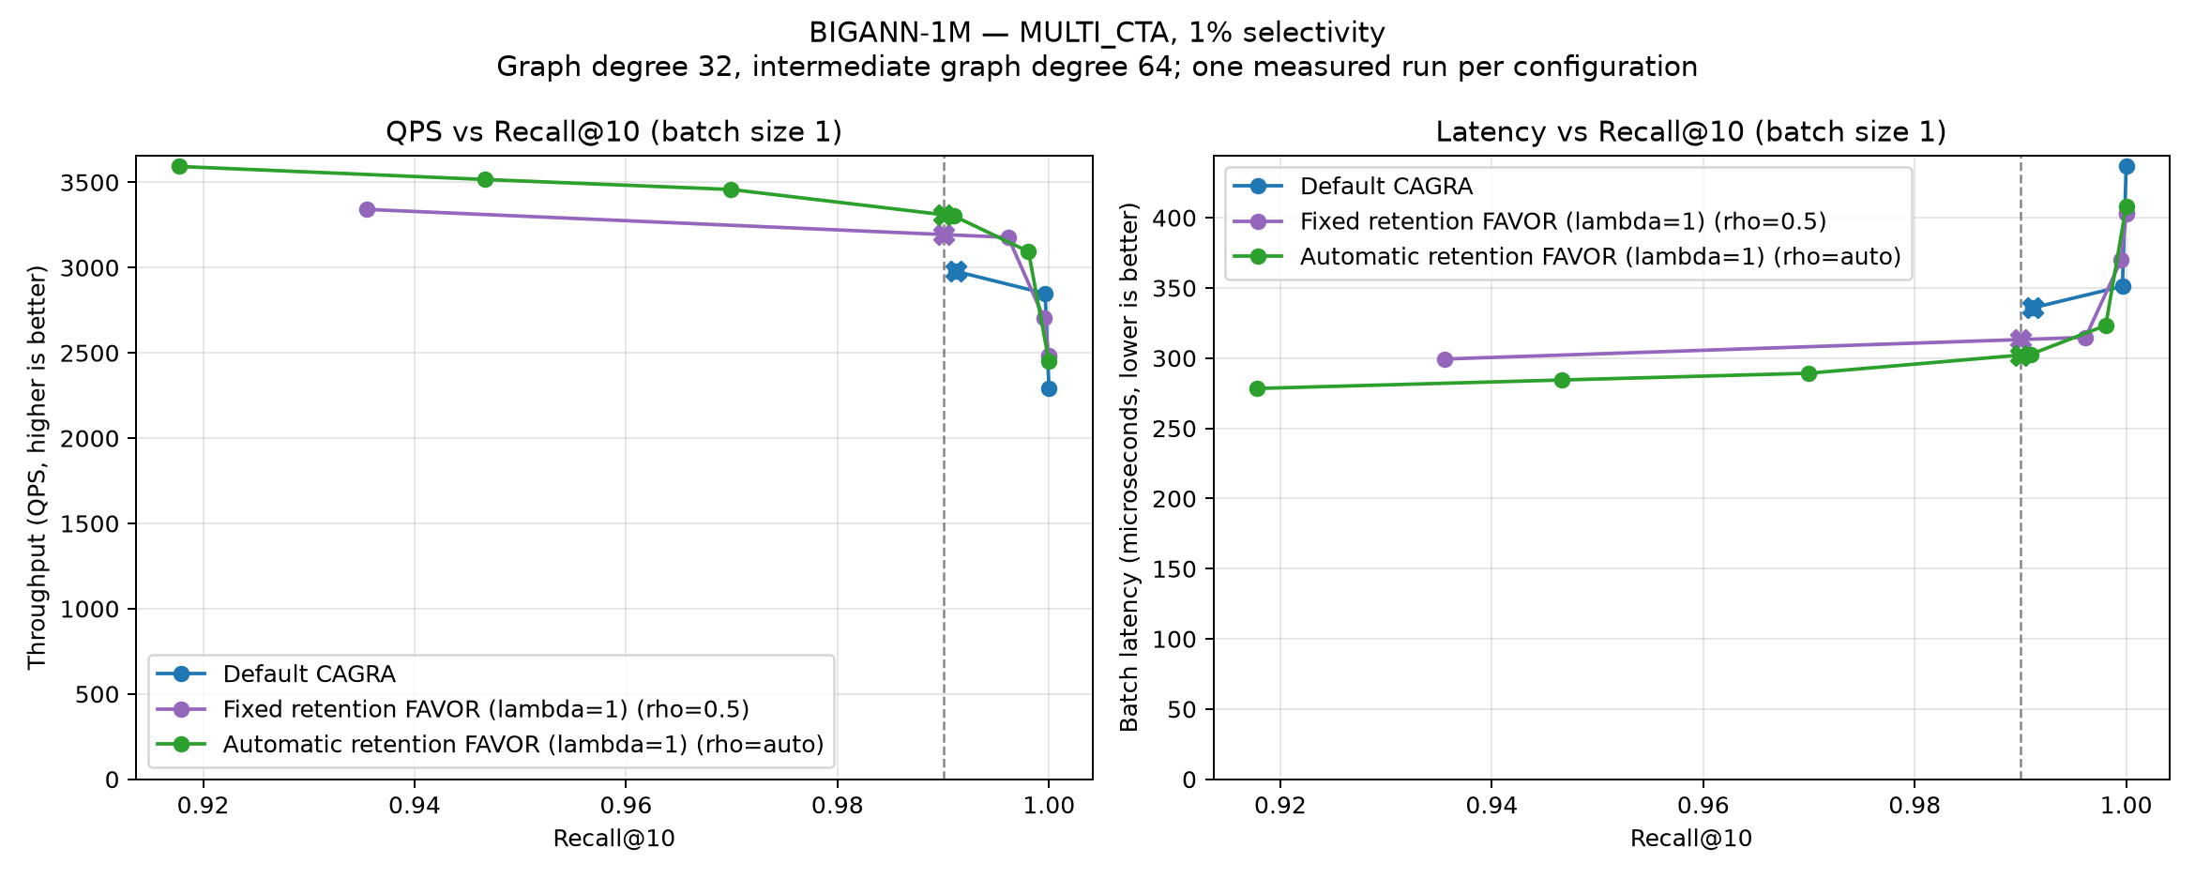
MULTI_{CTA} on BIGANN-1M at 1% passing selectivity.
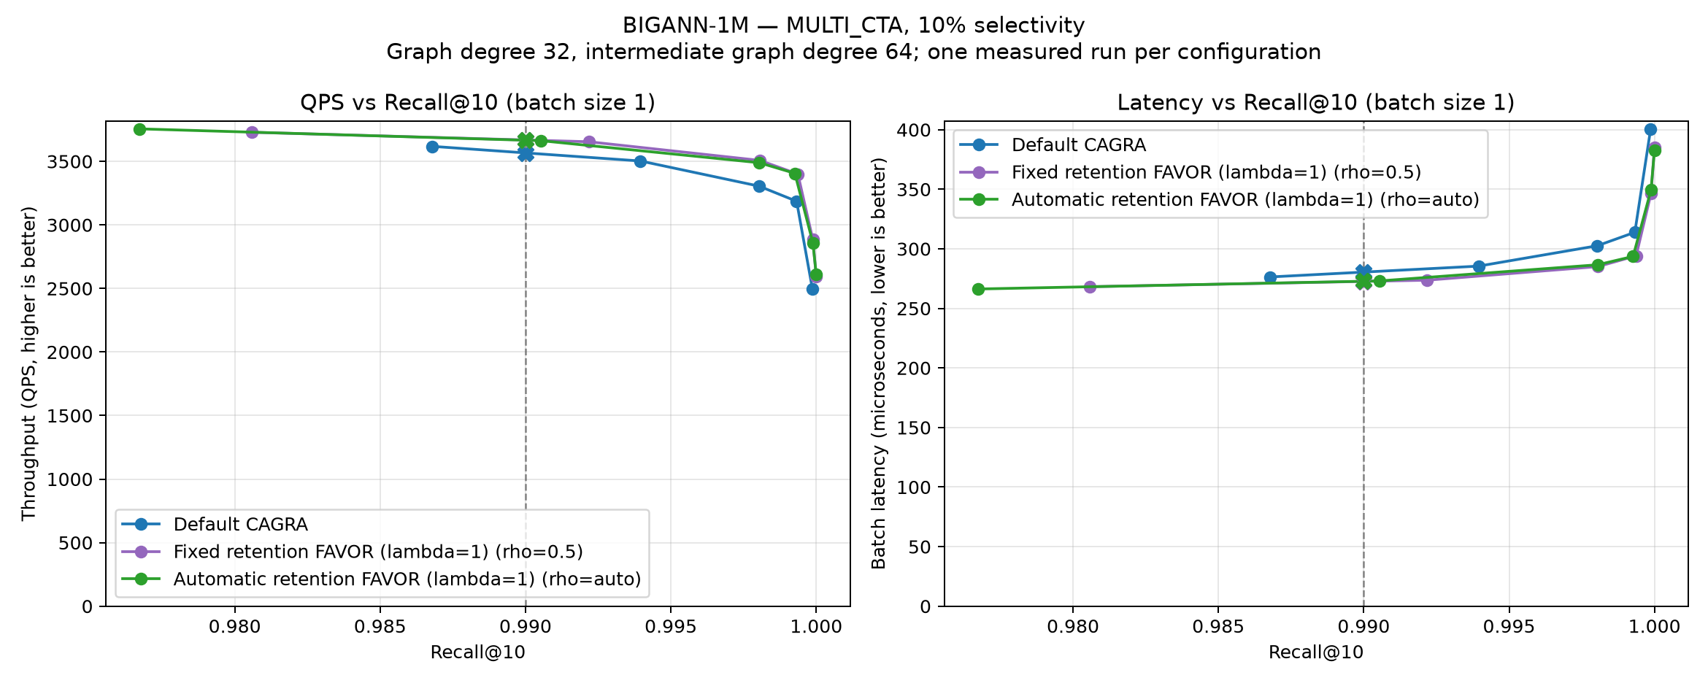
MULTI_{CTA} on BIGANN-1M at 10% passing selectivity.
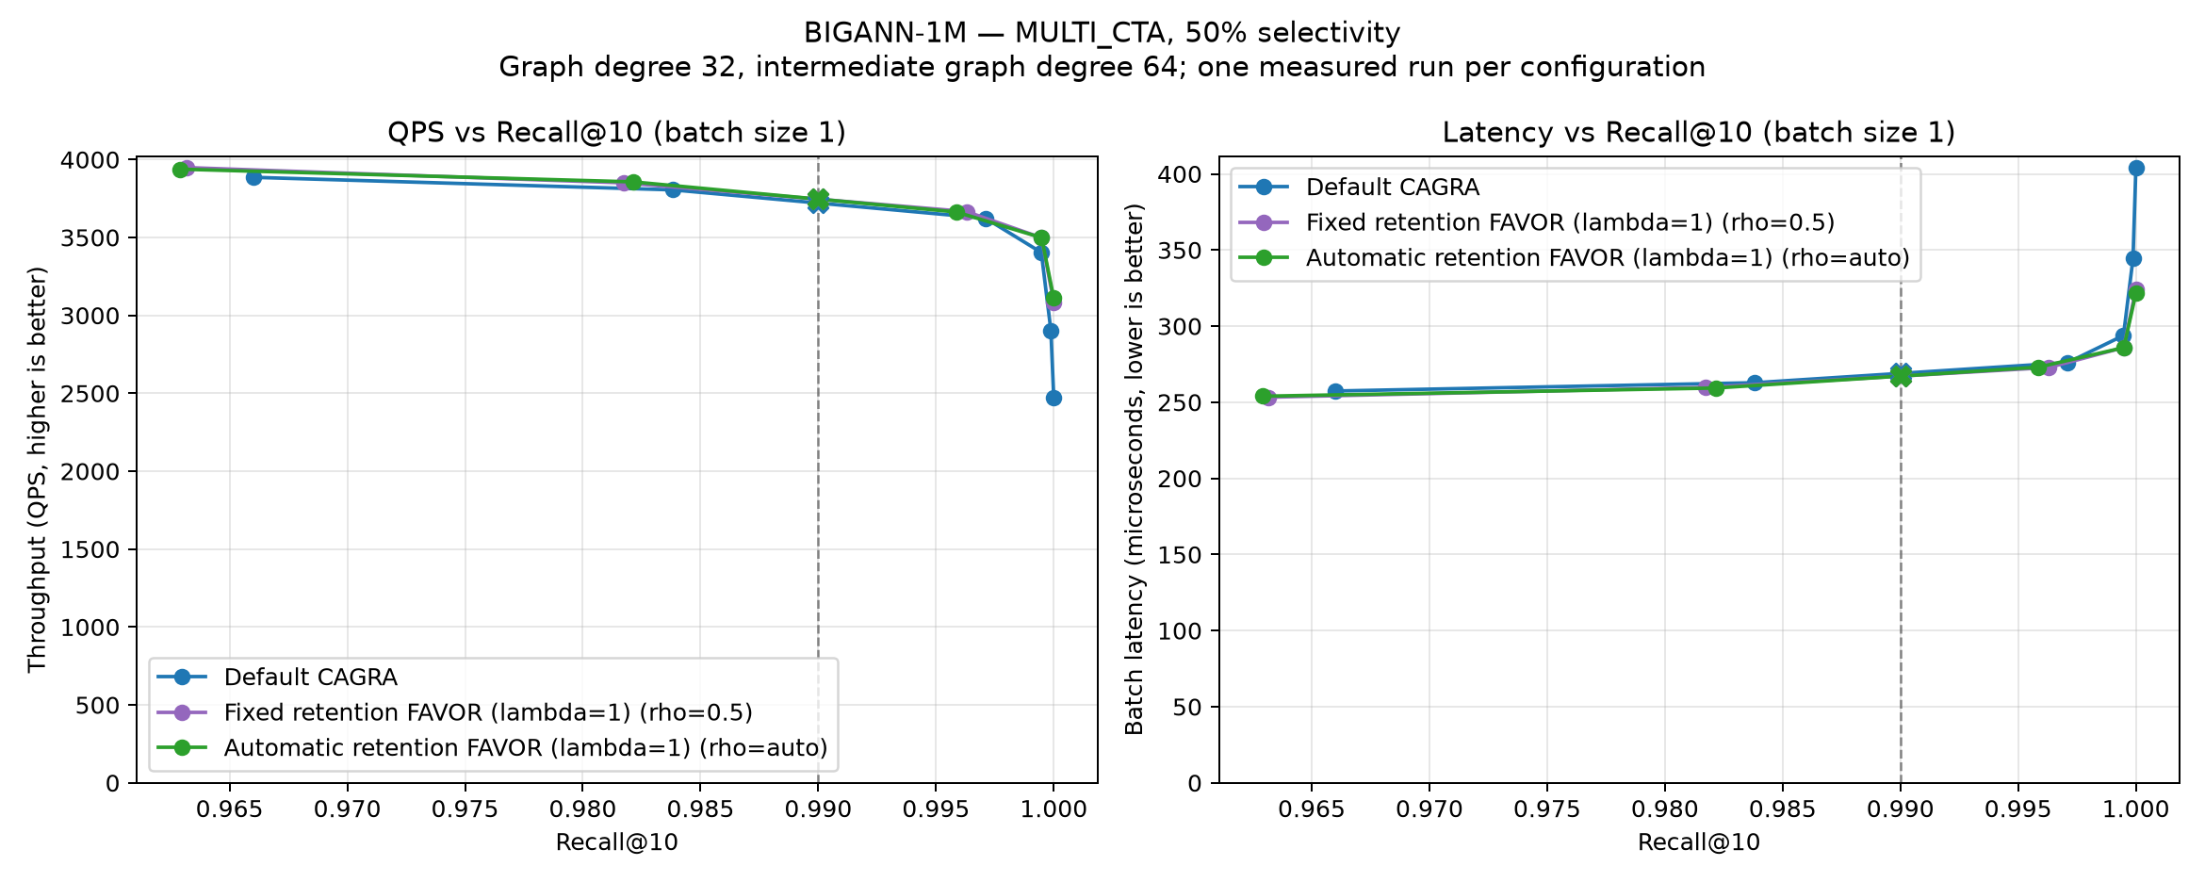
MULTI_{CTA} on BIGANN-1M at 50% passing selectivity.
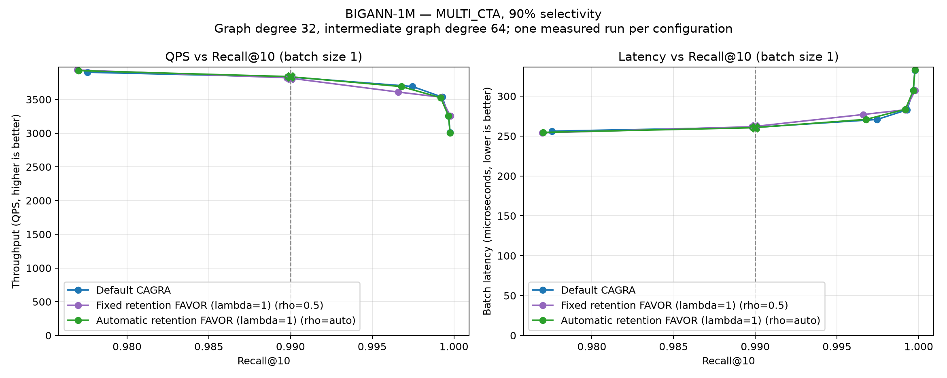
MULTI_{CTA} on BIGANN-1M at 90% passing selectivity.

BIGANN-10M
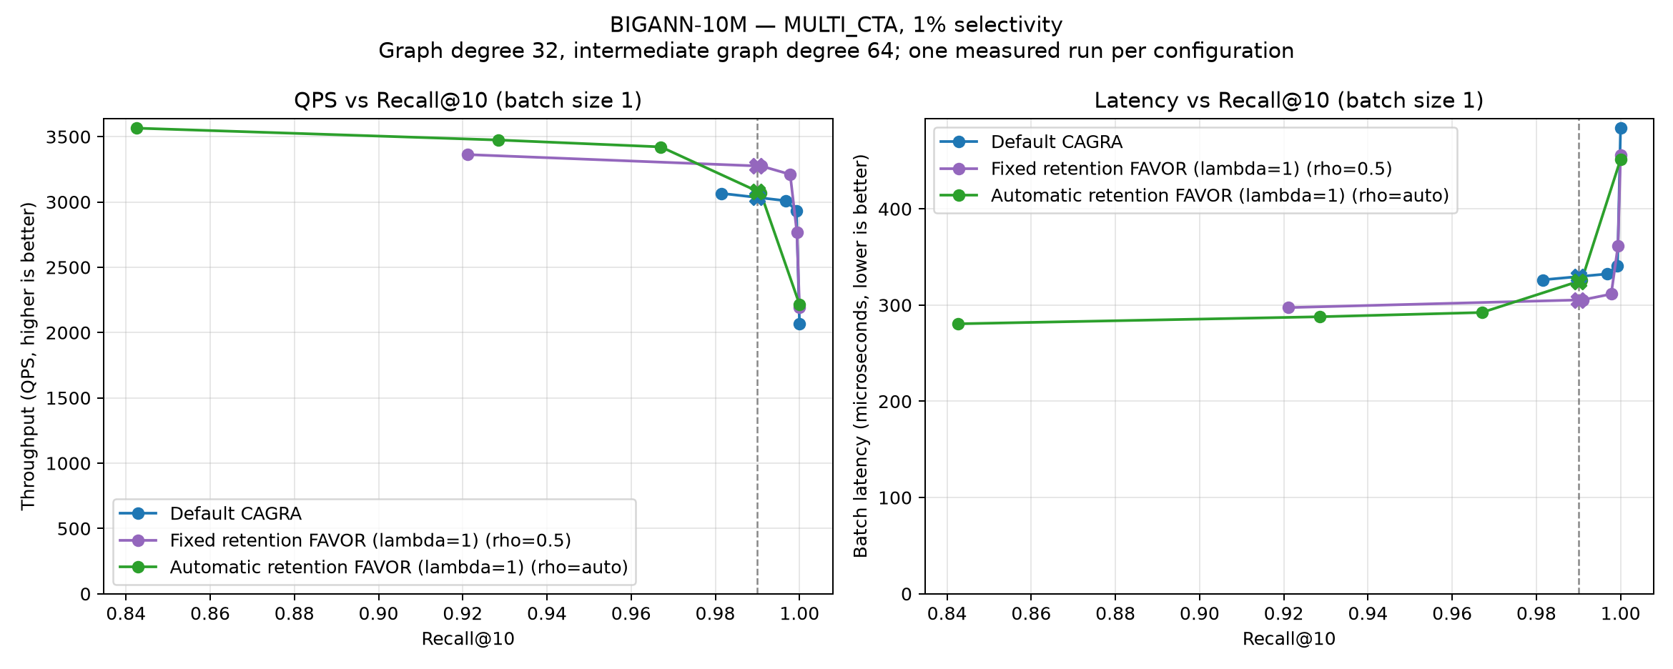
MULTI_{CTA} on BIGANN-10M at 1% passing selectivity.
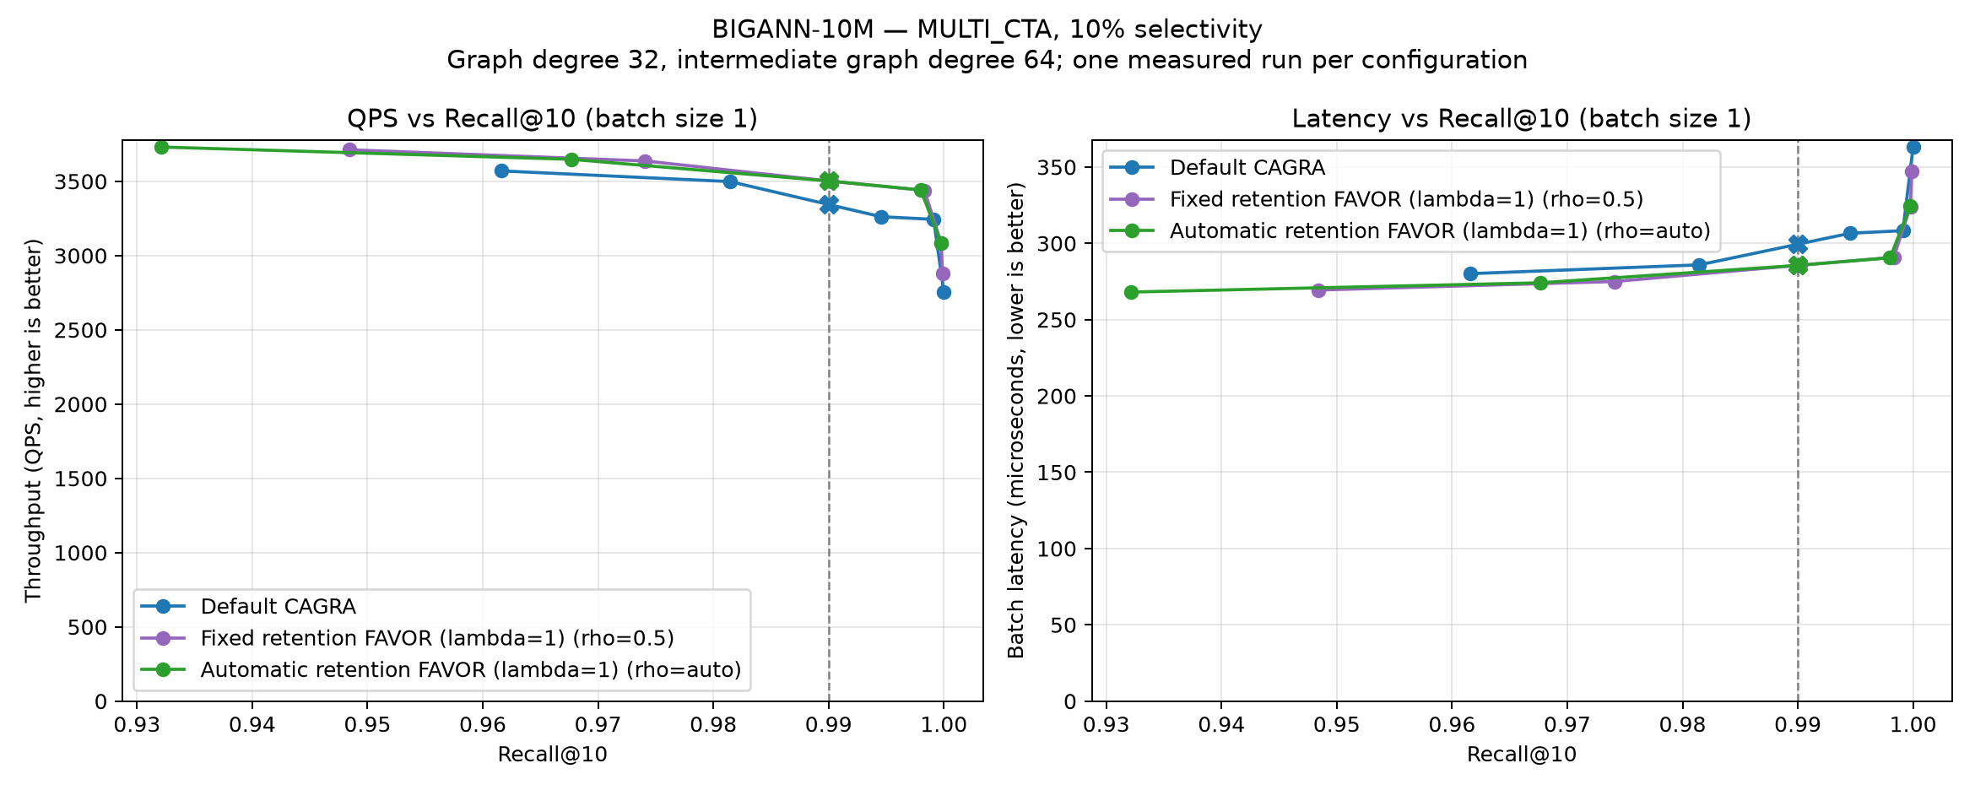
MULTI_{CTA} on BIGANN-10M at 10% passing selectivity.
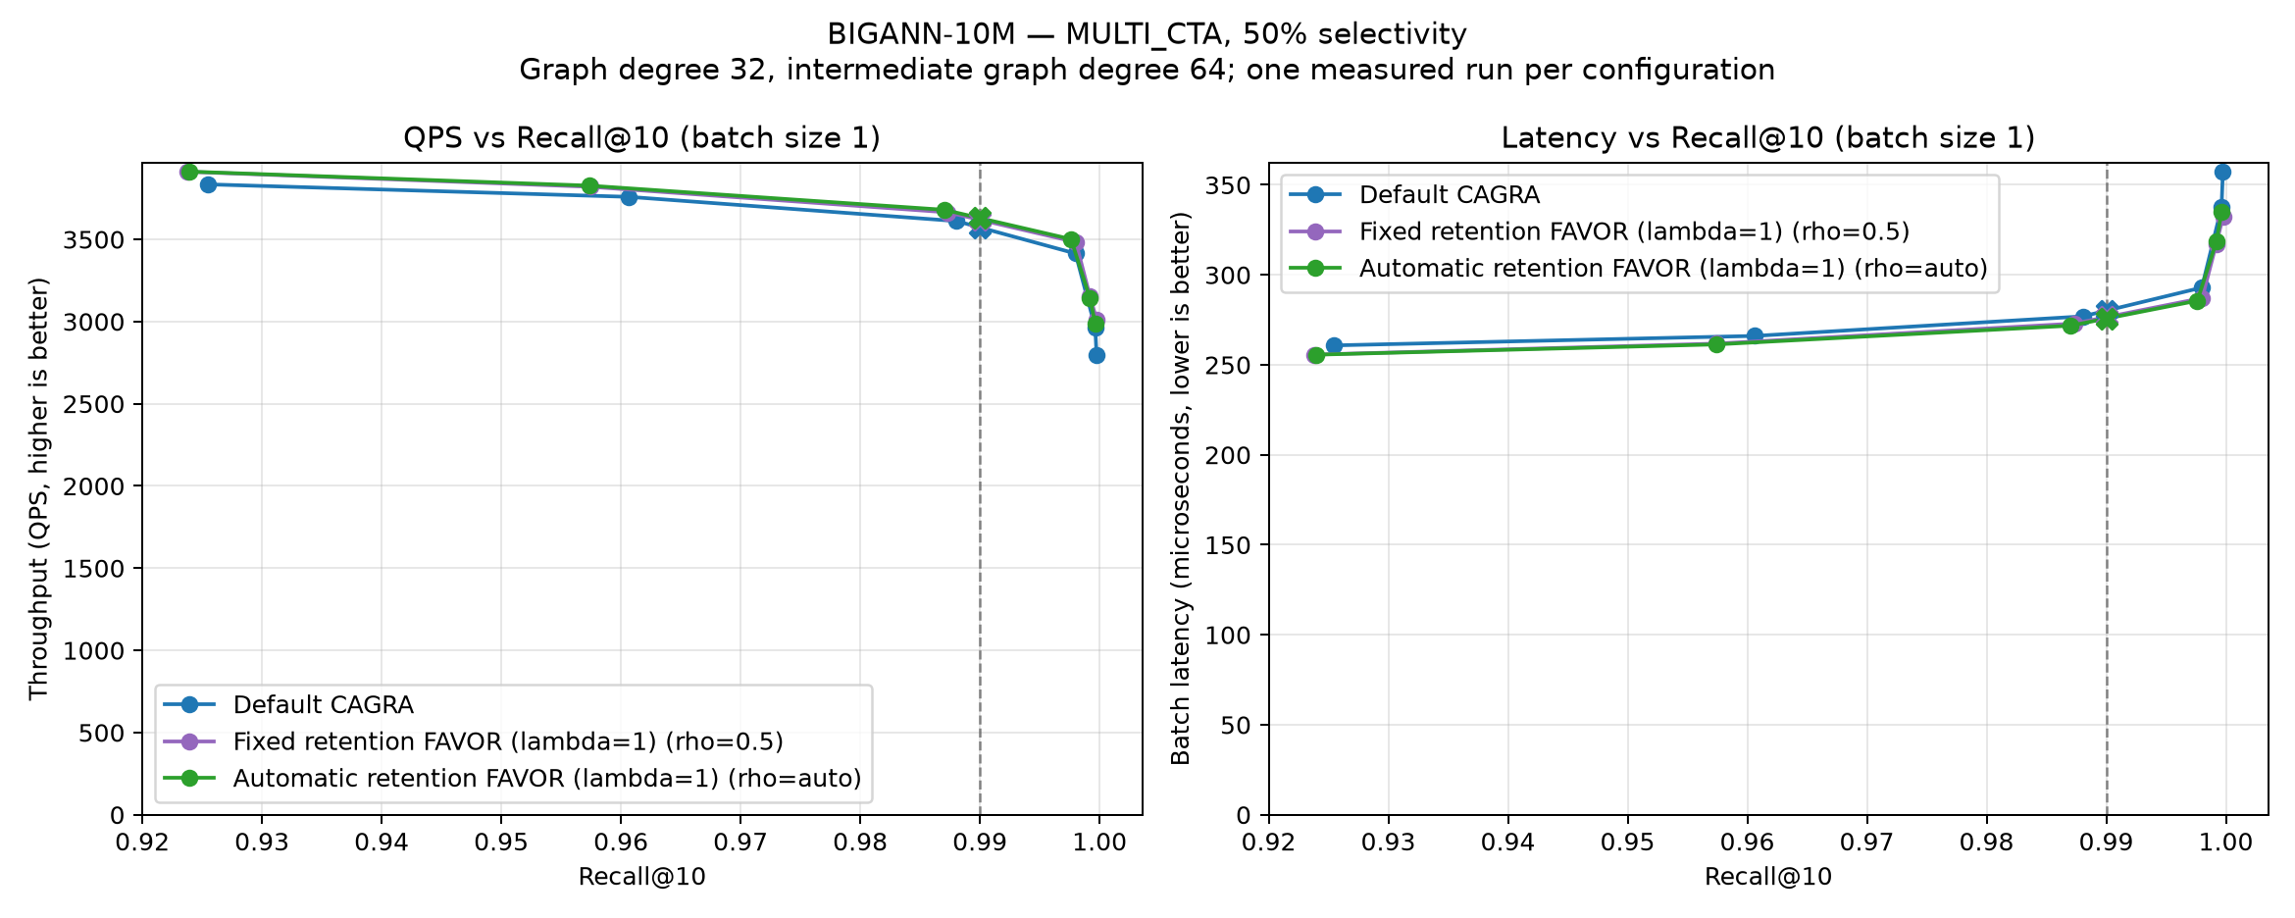
MULTI_{CTA} on BIGANN-10M at 50% passing selectivity.
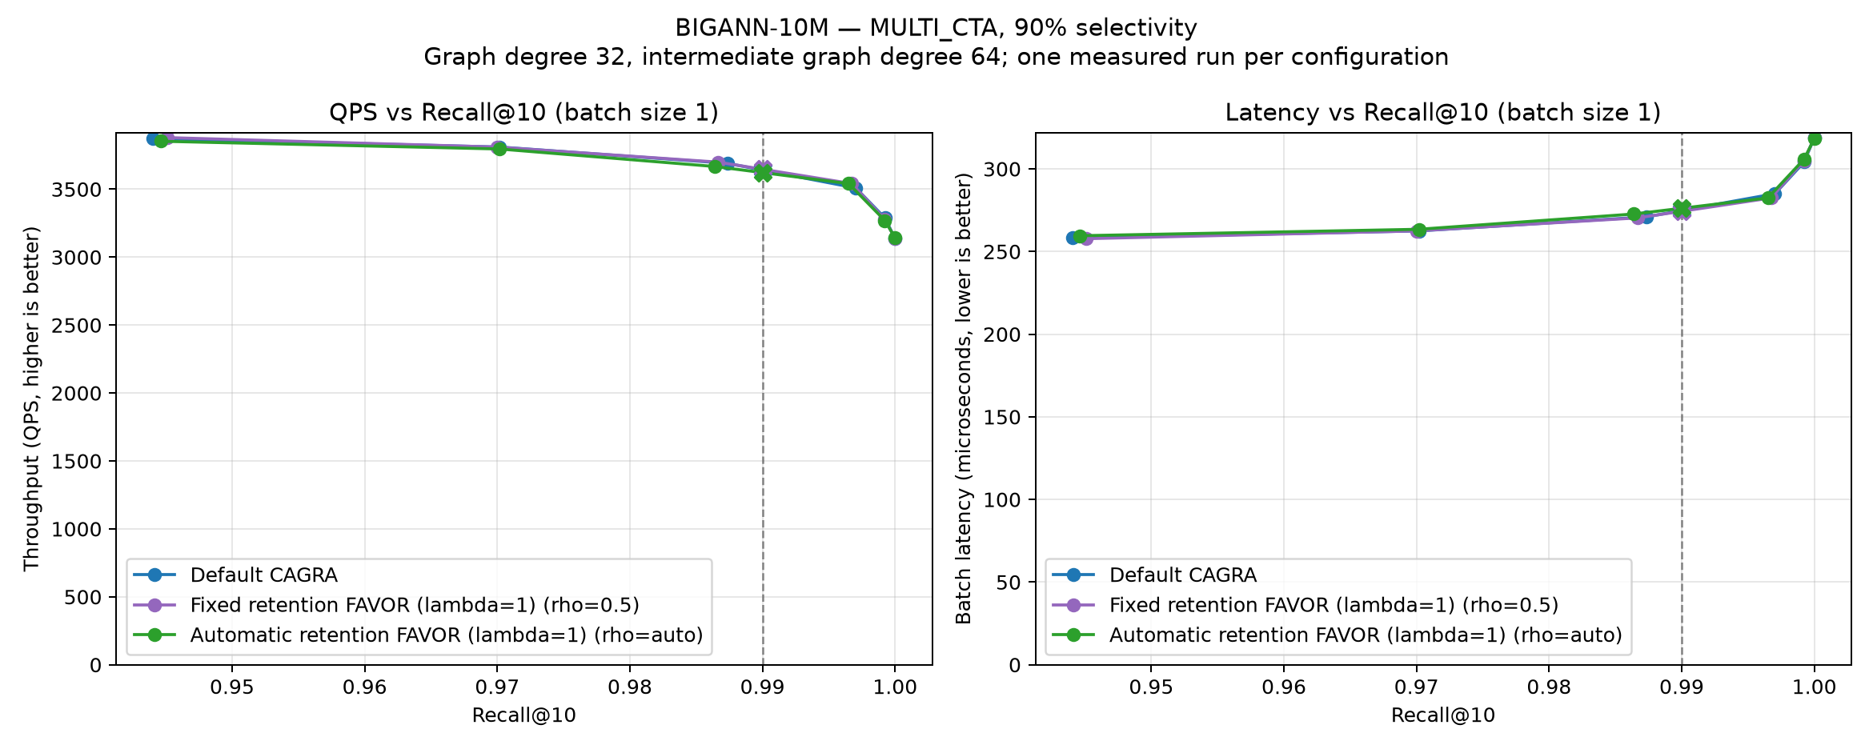
MULTI_{CTA} on BIGANN-10M at 90% passing selectivity.

MSTuring-1M
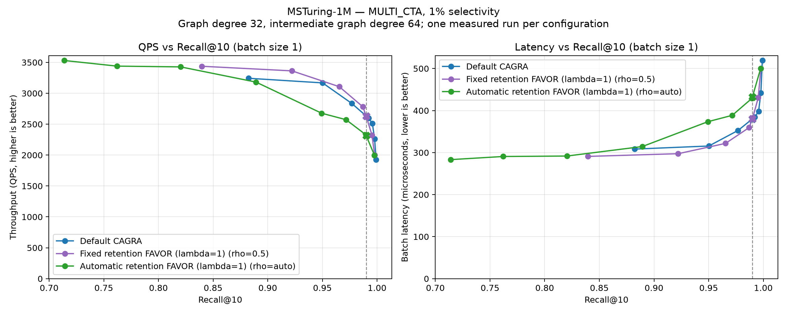
MULTI_{CTA} on MSTuring-1M at 1% passing selectivity.
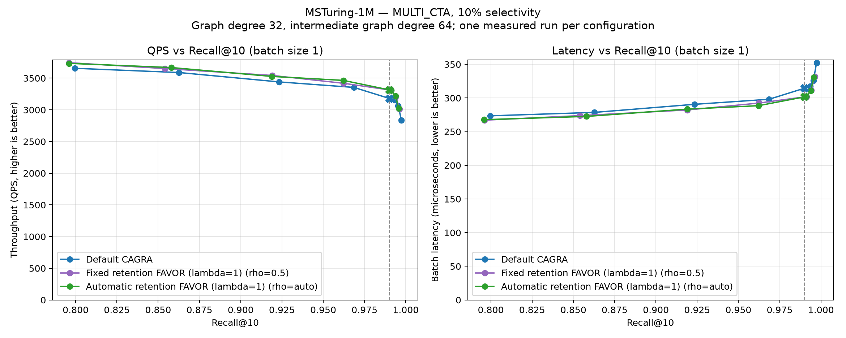
MULTI_{CTA} on MSTuring-1M at 10% passing selectivity.
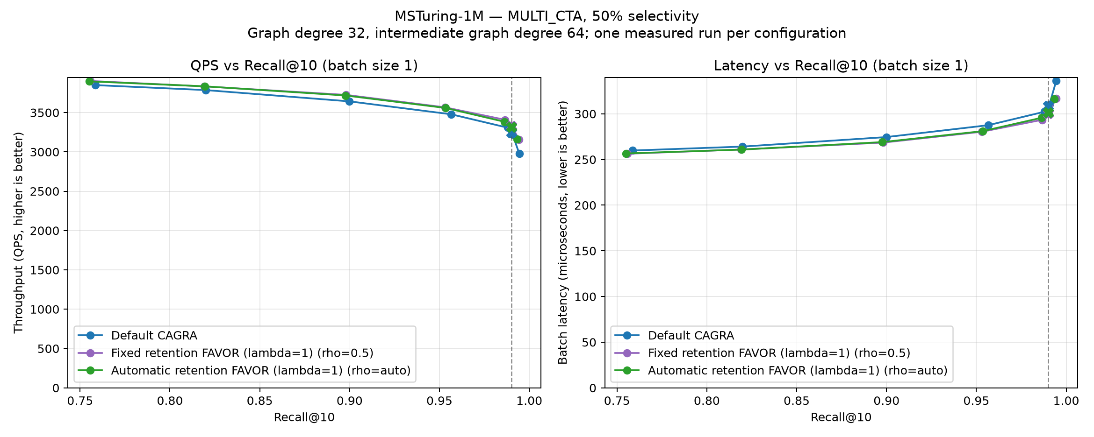
MULTI_{CTA} on MSTuring-1M at 50% passing selectivity.
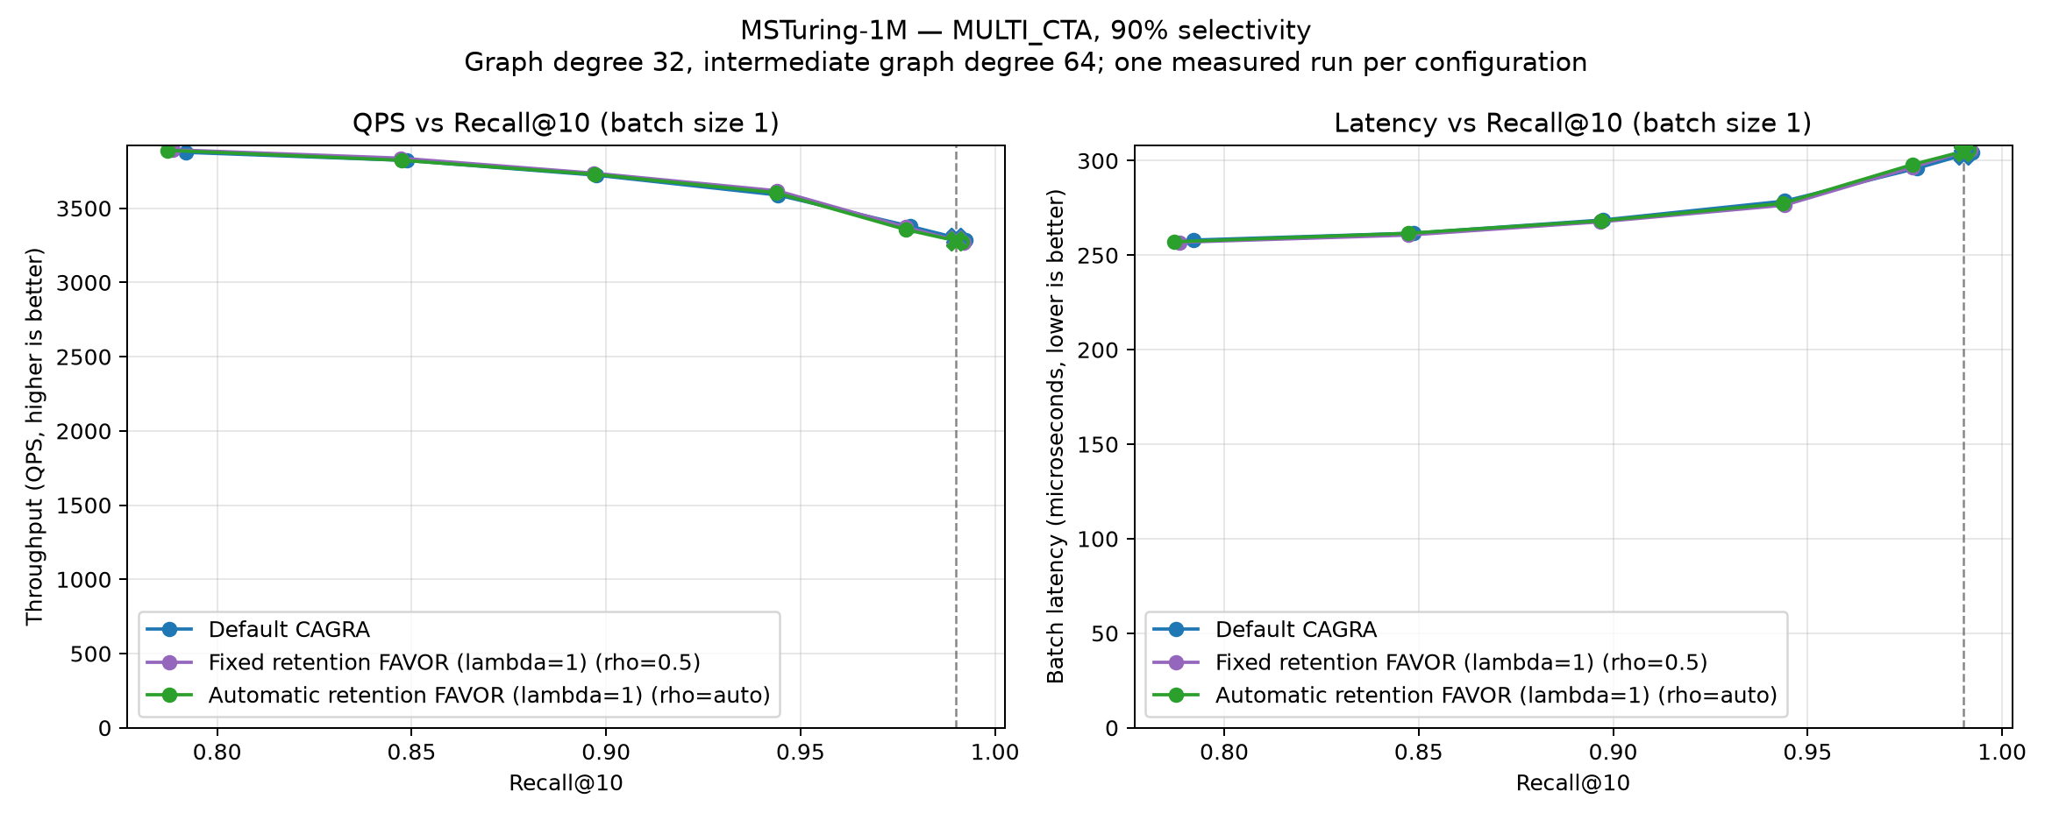
MULTI_{CTA} on MSTuring-1M at 90% passing selectivity.

MSTuring-10M
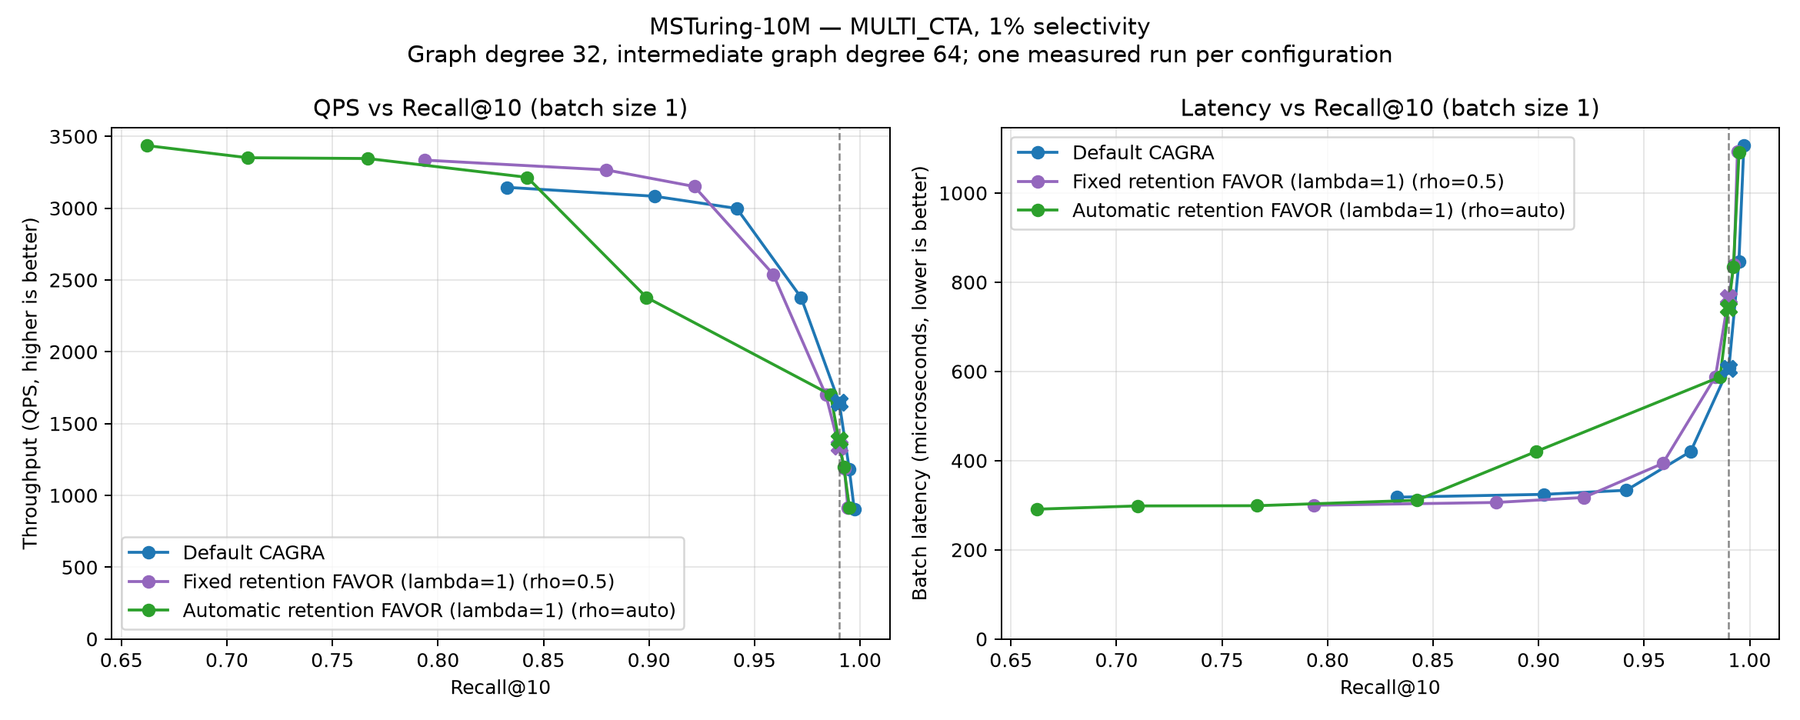
MULTI_{CTA} on MSTuring-10M at 1% passing selectivity.
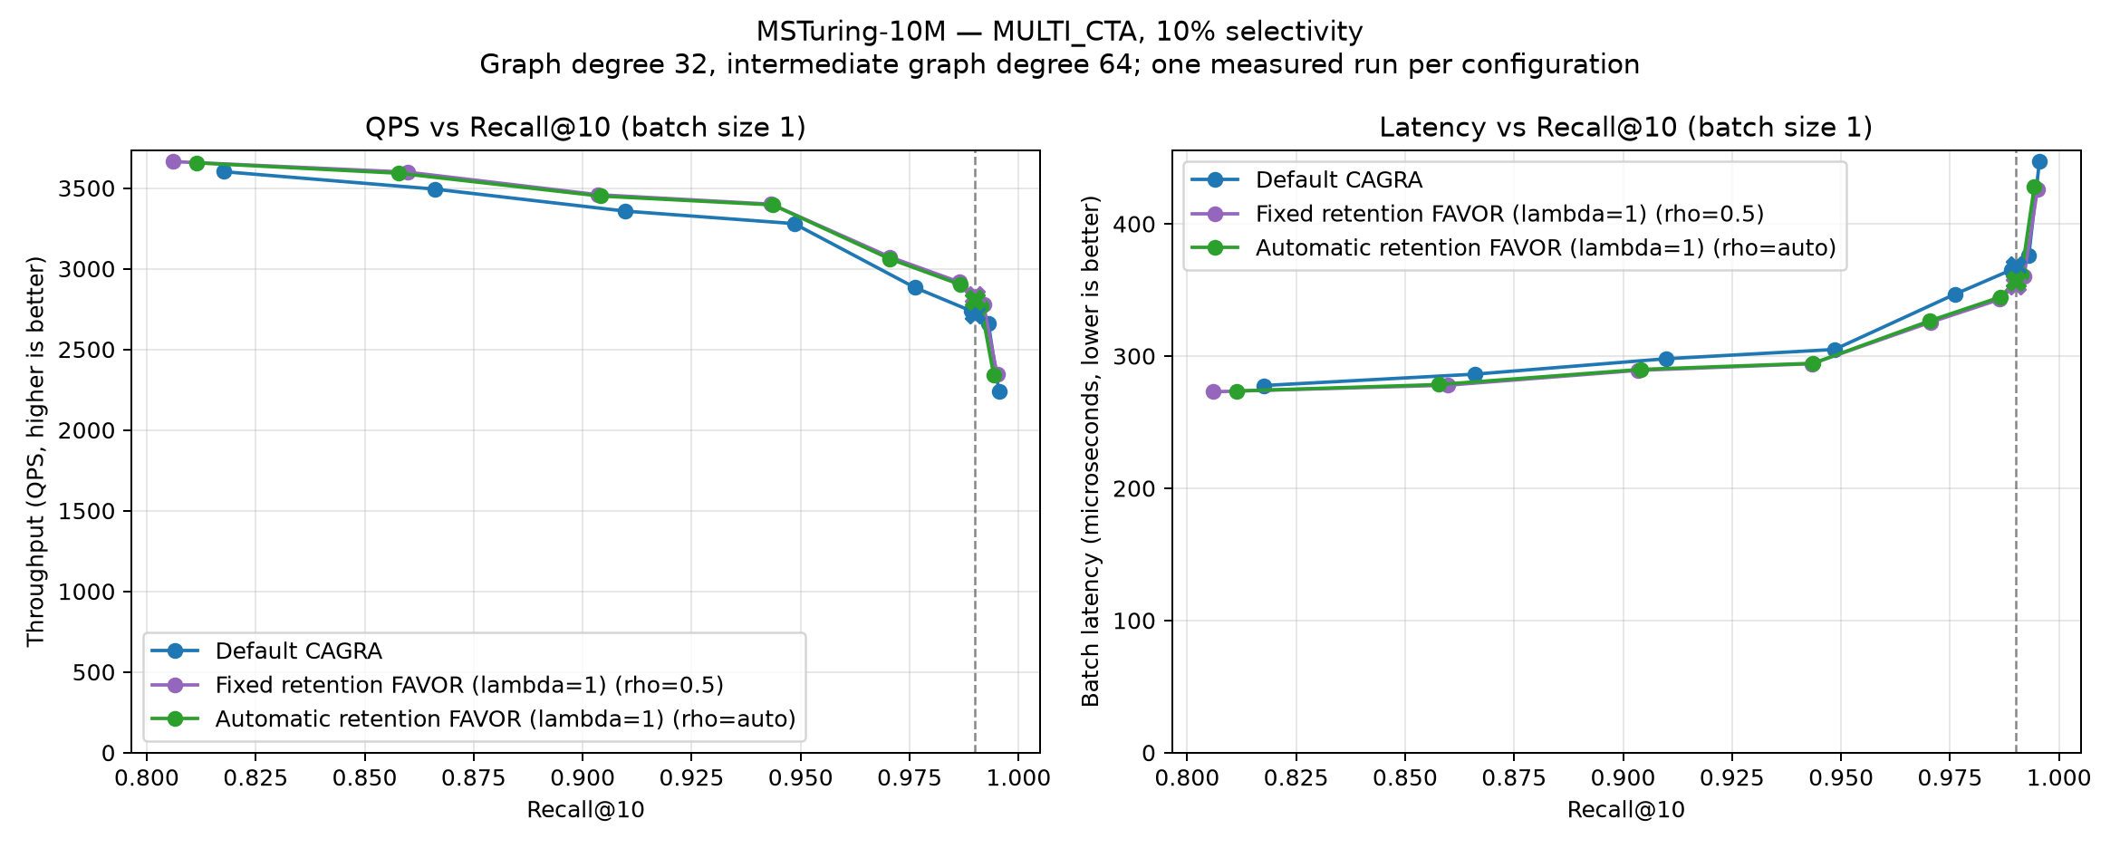
MULTI_{CTA} on MSTuring-10M at 10% passing selectivity.
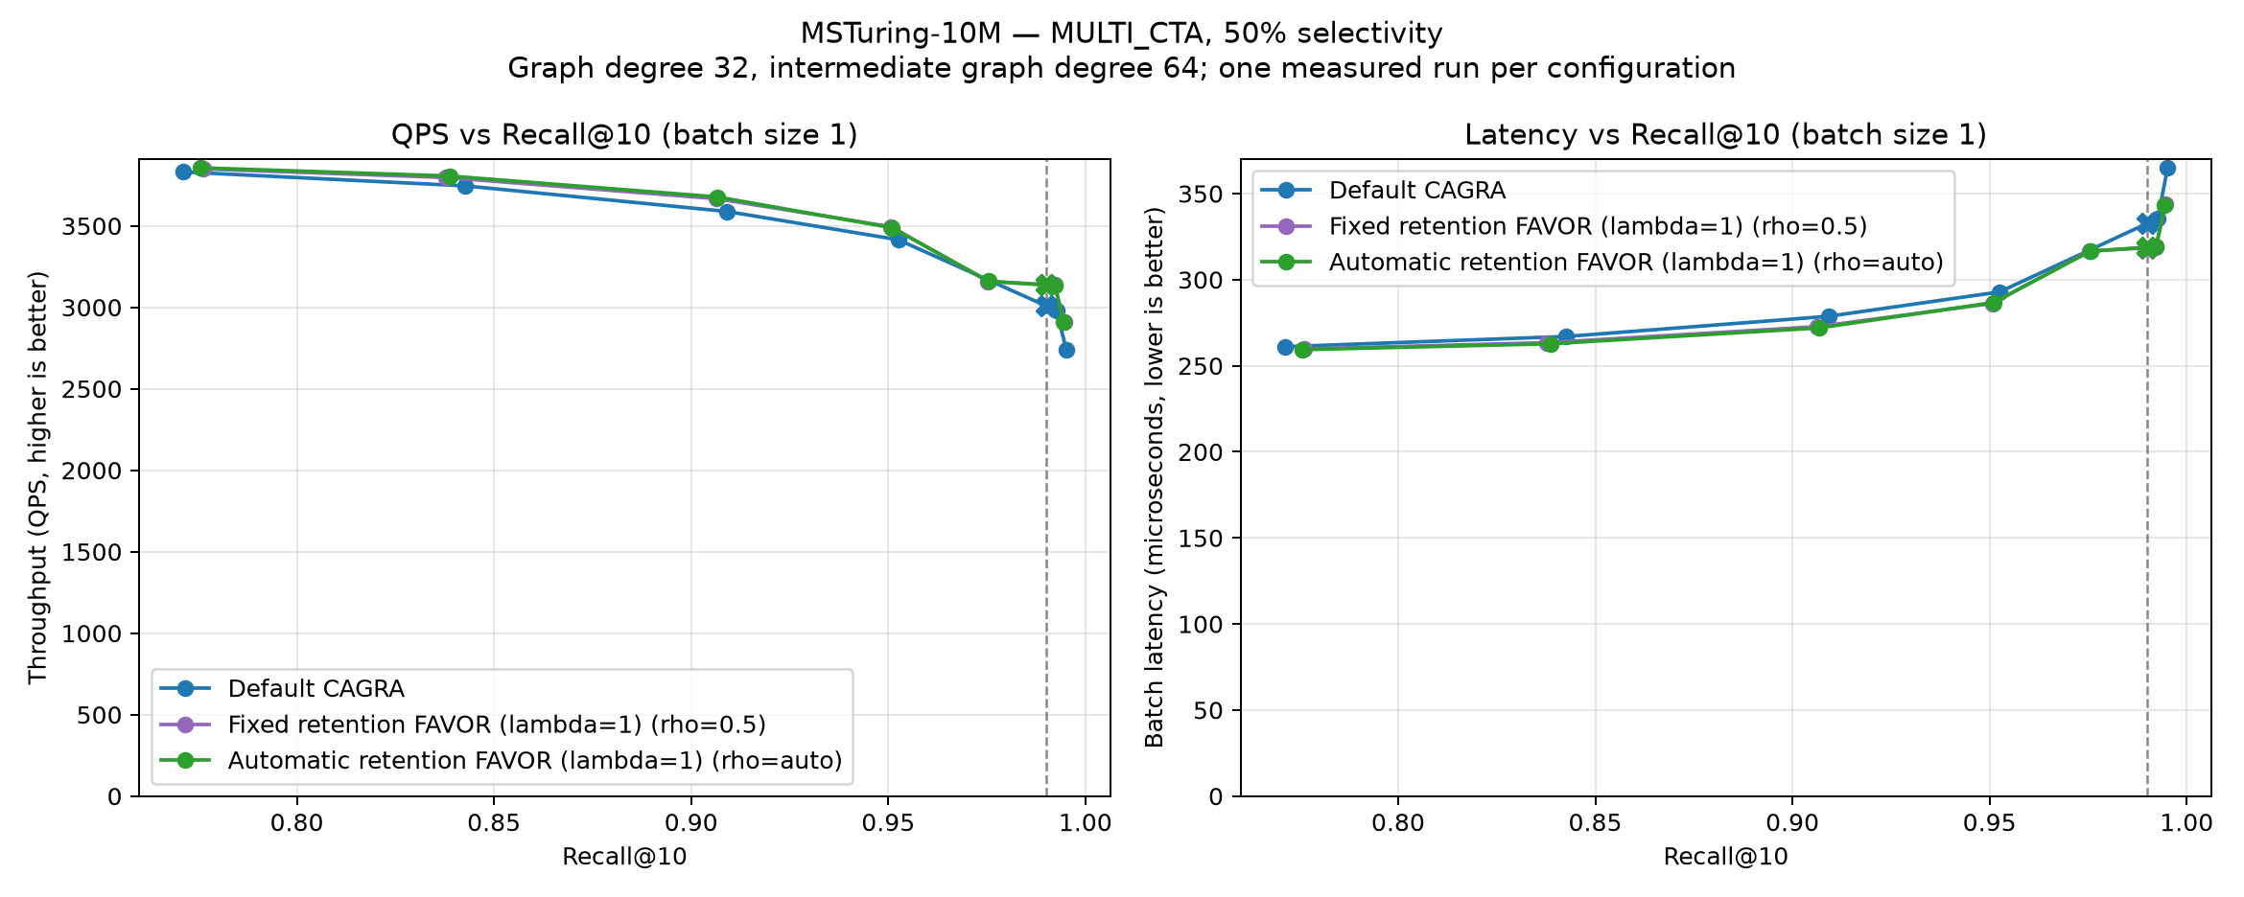
MULTI_{CTA} on MSTuring-10M at 50% passing selectivity.
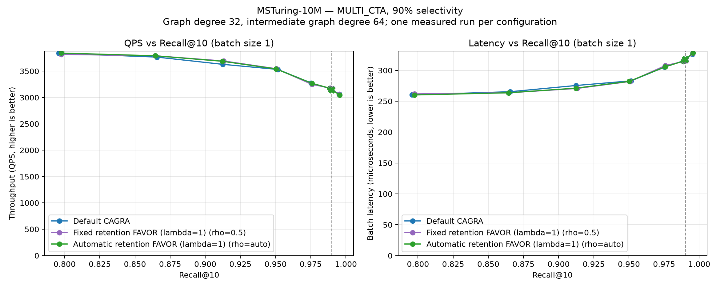
MULTI_{CTA} on MSTuring-10M at 90% passing selectivity.

Appendix: benchmark parameters

Dataset and index inputs
Dataset | Rows | Dim | Type | Query file | Subset
SIFT-1M | 1,000,000 | 128 | float32 | query.fbin | none
GIST-1M | 1,000,000 | 960 | float32 | query₁₀₀₀₀.fbin | none
BIGANN-1M | 1,000,000 | 128 | uint8 | query.public.10K.u8bin | first 1M
BIGANN-10M | 10,000,000 | 128 | uint8 | query.public.10K.u8bin | none
MSTuring-1M | 1,000,000 | 100 | float32 | query.fbin | none
MSTuring-10M | 10,000,000 | 100 | float32 | query.fbin | none
Every dataset uses cagra_g32_ig64.index and its matching .delta_d sidecar. Exact bitsets and precomputed exact filtered ground truth are used throughout. All experiments use k=10, one benchmark repetition, minimum measured time 0.2 s, and warm-up 0.1 s. FAVOR runs use cagra_retention_safe and lambda=1; default CAGRA has no FAVOR penalty. The archived SINGLE_CTA curves were measured on NVIDIA A30; the new MULTI_CTA default, fixed, and automatic curves were all measured on NVIDIA L4. Absolute timing is compared only within a CTA mode, never between these GPUs.

SINGLE_{CTA} search cells
Each tuple is (itopk, search_width, max_iterations, thread_block_size). Zero requests existing planner/default behavior. Default, fixed, and automatic retention use the same cells for batch 10 and batch 10,000.
Dataset | Selectivity | Cells
SIFT-1M | 1% | (256,1,0,0); (256,2,0,0); (256,4,0,0); (512,1,0,0); (512,2,0,0); (512,4,0,0); (512,4,80,0); (512,4,96,0); (512,4,112,0); (512,4,128,0)
SIFT-1M | 10% | (64,2,0,0); (64,4,0,0); (128,1,0,0); (128,2,0,0); (128,4,0,0)
SIFT-1M | 50% | (32,4,0,0); (32,4,11,0); (32,4,12,0)
SIFT-1M | 90% | (32,4,0,0); (32,4,10,0); (32,4,12,0)
GIST-1M | 1% | (256,1,0,0); (256,2,0,0); (256,4,0,0); (512,1,0,0); (512,2,0,0); (512,4,0,0)
GIST-1M | 10% | (64,4,0,0); (128,2,0,0); (128,4,0,0); (256,1,0,0); (256,2,0,0); (256,4,0,0)
GIST-1M | 50% | (64,4,0,0); (128,2,0,0); (128,4,0,0); (256,1,0,0); (256,2,0,0); (256,4,0,0)
GIST-1M | 90% | (64,4,0,0); (128,2,0,0); (128,4,0,0); (256,1,0,0); (256,2,0,0); (256,4,0,0)
BIGANN-1M | 1% | (256,1,0,0); (256,2,0,0); (256,4,0,0); (512,1,0,0); (512,2,0,0); (512,4,0,0)
BIGANN-1M | 10% | (64,4,0,0); (128,4,0,0); (128,4,12,64); (128,4,14,64); (128,4,16,64); (128,4,18,64); (128,4,20,64)
BIGANN-1M | 50% | (32,4,0,0); (32,4,11,0); (32,4,12,0)
BIGANN-1M | 90% | (32,4,0,0); (32,4,9,0); (32,4,10,0); (32,4,12,0)
BIGANN-10M | 1% | (256,1,0,0); (256,2,0,0); (256,4,0,0); (512,1,0,0); (512,2,0,0); (512,4,0,0)
BIGANN-10M | 10% | (64,2,0,0); (64,4,0,0); (128,1,0,0); (128,2,0,0); (128,2,54,64); (128,2,55,64); (128,2,56,64); (128,4,0,0); (128,4,28,64); (128,4,29,64); (128,4,30,64)
BIGANN-10M | 50% | (32,1,0,0); (32,2,0,0); (32,4,0,0); (64,1,0,0); (64,2,0,0); (64,4,0,0)
BIGANN-10M | 90% | (32,1,0,0); (32,2,0,0); (32,4,0,0); (64,1,0,0); (64,2,0,0); (64,4,0,0)
MSTuring-1M | 1% | (256,1,0,0); (256,2,0,0); (256,4,0,0); (512,1,0,0); (512,2,0,0); (512,4,0,0)
MSTuring-1M | 10% | (128,4,0,0); (256,2,0,0); (256,4,0,0); (512,1,0,0); (512,2,0,0); (512,4,0,0)
MSTuring-1M | 50% | (64,4,0,0); (128,2,0,0); (128,4,0,0); (256,1,0,0); (256,2,0,0); (256,4,0,0)
MSTuring-1M | 90% | (64,4,0,0); (128,2,0,0); (128,4,0,0); (256,1,0,0); (256,2,0,0); (256,4,0,0)
MSTuring-10M | 1% | (256,1,0,0); (256,2,0,0); (256,4,0,0); (512,1,0,0); (512,2,0,0); (512,4,0,0)
MSTuring-10M | 10% | (128,4,0,0); (256,2,0,0); (256,4,0,0); (512,1,0,0); (512,2,0,0); (512,4,0,0)
MSTuring-10M | 50% | (64,4,0,0); (128,2,0,0); (128,4,0,0); (256,1,0,0); (256,2,0,0); (256,4,0,0)
MSTuring-10M | 90% | (64,4,0,0); (128,2,0,0); (128,4,0,0); (256,1,0,0); (256,2,0,0); (256,4,0,0)

MULTI_{CTA} search cells
The tuple schema is identical. Default, fixed, and automatic retention use the same batch-size-1 cells, including MSTuring-10M values through itopk=2048.
Dataset | Selectivity | Cells
SIFT-1M | 1% | (32,1,0,0); (64,1,0,0); (128,1,0,0); (256,1,0,0); (512,1,0,0); (1024,1,0,0)
SIFT-1M | 10% | (32,1,0,0); (64,1,0,0); (128,1,0,0); (256,1,0,0); (512,1,0,0); (1024,1,0,0)
SIFT-1M | 50% | (32,1,0,0); (64,1,0,0); (128,1,0,0); (256,1,0,0); (512,1,0,0); (1024,1,0,0)
SIFT-1M | 90% | (32,1,0,0); (64,1,0,0); (128,1,0,0); (256,1,0,0); (512,1,0,0); (1024,1,0,0)
GIST-1M | 1% | (32,1,0,0); (64,1,0,0); (128,1,0,0); (256,1,0,0); (512,1,0,0); (640,1,0,0); (768,1,0,0); (1024,1,0,0)
GIST-1M | 10% | (32,1,0,0); (64,1,0,0); (128,1,0,0); (256,1,0,0); (512,1,0,0); (640,1,0,0); (768,1,0,0); (1024,1,0,0)
GIST-1M | 50% | (32,1,0,0); (64,1,0,0); (128,1,0,0); (256,1,0,0); (512,1,0,0); (640,1,0,0); (768,1,0,0); (1024,1,0,0)
GIST-1M | 90% | (32,1,0,0); (64,1,0,0); (128,1,0,0); (256,1,0,0); (512,1,0,0); (640,1,0,0); (768,1,0,0); (1024,1,0,0)
BIGANN-1M | 1% | (32,1,0,0); (64,1,0,0); (128,1,0,0); (256,1,0,0); (512,1,0,0); (1024,1,0,0)
BIGANN-1M | 10% | (32,1,0,0); (64,1,0,0); (128,1,0,0); (256,1,0,0); (512,1,0,0); (1024,1,0,0)
BIGANN-1M | 50% | (32,1,0,0); (64,1,0,0); (128,1,0,0); (256,1,0,0); (512,1,0,0); (1024,1,0,0)
BIGANN-1M | 90% | (32,1,0,0); (64,1,0,0); (128,1,0,0); (256,1,0,0); (512,1,0,0); (1024,1,0,0)
BIGANN-10M | 1% | (32,1,0,0); (64,1,0,0); (128,1,0,0); (256,1,0,0); (512,1,0,0); (1024,1,0,0)
BIGANN-10M | 10% | (32,1,0,0); (64,1,0,0); (128,1,0,0); (256,1,0,0); (512,1,0,0); (1024,1,0,0)
BIGANN-10M | 50% | (32,1,0,0); (64,1,0,0); (128,1,0,0); (256,1,0,0); (512,1,0,0); (1024,1,0,0)
BIGANN-10M | 90% | (32,1,0,0); (64,1,0,0); (128,1,0,0); (256,1,0,0); (512,1,0,0); (1024,1,0,0)
MSTuring-1M | 1% | (32,1,0,0); (64,1,0,0); (128,1,0,0); (256,1,0,0); (512,1,0,0); (640,1,0,0); (768,1,0,0); (1024,1,0,0)
MSTuring-1M | 10% | (32,1,0,0); (64,1,0,0); (128,1,0,0); (256,1,0,0); (512,1,0,0); (640,1,0,0); (768,1,0,0); (1024,1,0,0)
MSTuring-1M | 50% | (32,1,0,0); (64,1,0,0); (128,1,0,0); (256,1,0,0); (512,1,0,0); (640,1,0,0); (768,1,0,0); (1024,1,0,0)
MSTuring-1M | 90% | (32,1,0,0); (64,1,0,0); (128,1,0,0); (256,1,0,0); (512,1,0,0); (640,1,0,0); (768,1,0,0); (1024,1,0,0)
MSTuring-10M | 1% | (32,1,0,0); (64,1,0,0); (128,1,0,0); (256,1,0,0); (512,1,0,0); (1024,1,0,0); (1536,1,0,0); (2048,1,0,0)
MSTuring-10M | 10% | (32,1,0,0); (64,1,0,0); (128,1,0,0); (256,1,0,0); (512,1,0,0); (1024,1,0,0); (1536,1,0,0); (2048,1,0,0)
MSTuring-10M | 50% | (32,1,0,0); (64,1,0,0); (128,1,0,0); (256,1,0,0); (512,1,0,0); (1024,1,0,0); (1536,1,0,0); (2048,1,0,0)
MSTuring-10M | 90% | (32,1,0,0); (64,1,0,0); (128,1,0,0); (256,1,0,0); (512,1,0,0); (1024,1,0,0); (1536,1,0,0); (2048,1,0,0)

Artifact locations and reproduction
SINGLE_CTA fixed/default data is in results_retention_safe_single_full; its automatic data and combined outputs are in results_automatic_retention_single_full and results_automatic_retention_single_comparison. All three fresh MULTI_CTA series are in results_automatic_retention_multi_full; processed tables and plots are in results_automatic_retention_multi_comparison.
benchmarks/favor/run_automatic_retention_single_full.sh
benchmarks/favor/run_automatic_retention_multi_full.sh
python benchmarks/favor/generate_automatic_retention_report.py
cd benchmarks/favor
pandoc -f org -t docx --standalone \
-o AUTOMATIC_RETENTION_FAVOR_SINGLE_MULTI_CTA_REPORT.docx \
AUTOMATIC_RETENTION_FAVOR_SINGLE_MULTI_CTA_REPORT.org

