Sparse Adaptive Termination for SINGLE_{CTA} FAVOR
2026-08-01
Table of Contents

Executive result
This experiment tested whether sparse SINGLE_{CTA} FAVOR should continue beyond CAGRA's automatic iteration budget until a FAVOR-inspired, query-local convergence condition is satisfied. The condition recovered Recall@10 from 0.8300 to 0.9220 on GIST-1M and from 0.7216 to 0.9450 on MSTuring-1M at 1% selectivity. It reached only 0.8942 on MSTuring-10M and reduced the measured 10,000-query QPS substantially on all three focused workloads. It therefore fails the rollout gate and is retained only as an explicit internal experiment; normal CAGRA and FAVOR behavior is unchanged.
The planned all-dataset Pareto sweep was intentionally not run. The agreed focused gate required Recall@10 >= 0.90 on all three failures and higher QPS than default CAGRA near that recall. The MSTuring-10M recall miss and the fixed-cell throughput regressions make a larger sweep unjustified.

Method

Why a new termination condition was tested
At 1% selectivity, the existing automatic-retention kernel frequently reaches CAGRA's derived max_iterations while useful unexpanded entries remain in its fused candidate/result buffer. Larger fixed budgets recover recall, but make every query pay the worst-case cost. Reference FAVOR uses separate HNSW candidate and result queues; CAGRA has one fused buffer, so that condition cannot be copied literally.
The experiment treats a short sorted prefix of CAGRA's existing buffer as a virtual result set and keeps the remainder as frontier reserve. It adds neither a second queue nor a result accumulator.

Query-local condition
For query q:
m = 32 * ceil((2*k + 1) / 32)
converged(q) =
Vq == m
AND Pq >= ceil(m / 2)
AND frontier_best(q) > boundary(q)
Variables:
- k is the requested output count. These runs use k=10.
- m is the warp-aligned virtual-result prefix size. For k=10, m=32.
- Vq is the number of valid entries in the first m sorted buffer positions.
- Pq is the number of those entries that pass the query's bitset filter. For m=32, at least 16 must pass.
- boundary(q) is the penalized distance at rank m-1.
- frontier_best(q) is the penalized distance of the nearest unexpanded entry.
The strict distance comparison handles equal-distance candidates conservatively. The condition is checked only after the original automatic budget B0, so it cannot terminate earlier than the current automatic method.

Safety ceiling
Continuation is bounded as follows:
X = max(ceil(T / w), ceil(k / (s*w)))
Bhard = max(B0, L + 4*X)
- T is CAGRA's physical itopk size; these runs use T=512.
- w is search_width, the number of parents expanded per CAGRA iteration.
- s is selectivity, equal to 1 - filtering_rate.
- L is CAGRA's graph-depth allowance derived from dataset size and graph degree.
- B0 is CAGRA's existing automatically resolved iteration limit.
- Bhard is the experimental safety limit. The factor four is a runtime guard, not a convergence claim.
The extension is eligible only for bitset-filtered SINGLE_{CTA} automatic-retention FAVOR when the user left max_iterations at zero, s < 0.10, and s*T < k. An explicitly configured iteration limit remains strict.

GPU implementation
The FAVOR JIT kernel reuses its existing parent-pickup pass: the first selected parent is already the nearest unexpanded candidate. Warp 0 checks the 32-entry prefix with direct packed-bitset loads, warp ballots, and population counts. The implementation adds no candidate buffer, post-processing kernel, or new synchronization phase. New diagnostic stop codes distinguish query-local convergence from the safety cap.
No public API was modified. Because the performance gate failed, activation defaults off and is available only for reproduction through the internal CUVS_FAVOR_EXPERIMENTAL_ADAPTIVE_TERMINATION=1 environment switch.

Focused benchmark results
All measurements use one serial run on the same NVIDIA A30, k=10, itopk=512, 1% selectivity, degree-32 CAGRA graphs, a 10,000-query throughput workload, and a batch-10 latency workload. All three methods were rerun with identical 0.1-second warmup and 0.2-second minimum benchmark time. Latency cells report their own batch-10 recall because a ten-query sample is noisy.
Dataset | Method | Throughput recall | QPS | Batch-10 recall | Batch latency (ms)
GIST-1M | Default CAGRA | 0.7452 | 16,225 | 0.7514 | 4.037
GIST-1M | Automatic retention at B0 | 0.8300 | 15,635 | 0.8345 | 4.070
GIST-1M | Adaptive continuation | 0.9220 | 5,530 | 0.9330 | 22.384
MSTuring-1M | Default CAGRA | 0.7032 | 49,102 | 0.6966 | 5.228
MSTuring-1M | Automatic retention at B0 | 0.7216 | 49,102 | 0.7104 | 5.555
MSTuring-1M | Adaptive continuation | 0.9450 | 9,204 | 0.9457 | 41.010
MSTuring-10M | Default CAGRA | 0.6758 | 50,664 | 0.6815 | 5.295
MSTuring-10M | Automatic retention at B0 | 0.6966 | 49,148 | 0.6996 | 5.674
MSTuring-10M | Adaptive continuation | 0.8942 | 9,339 | 0.9225 | 37.584
The values are fixed-configuration observations, not claimed speedups at matched recall. Only the adaptive points approach the target in these cells, while their much larger traversal cost makes them unsuitable as the supported default.
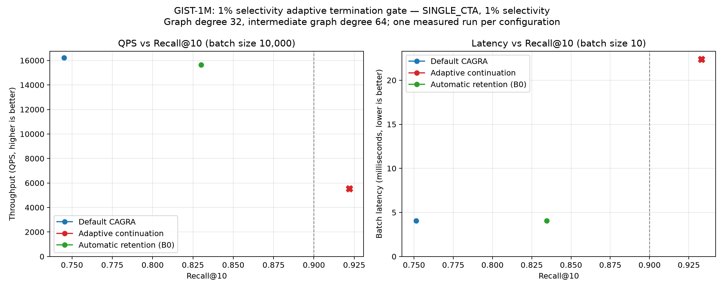
GIST-1M focused throughput and latency comparison; every y-axis starts at zero.
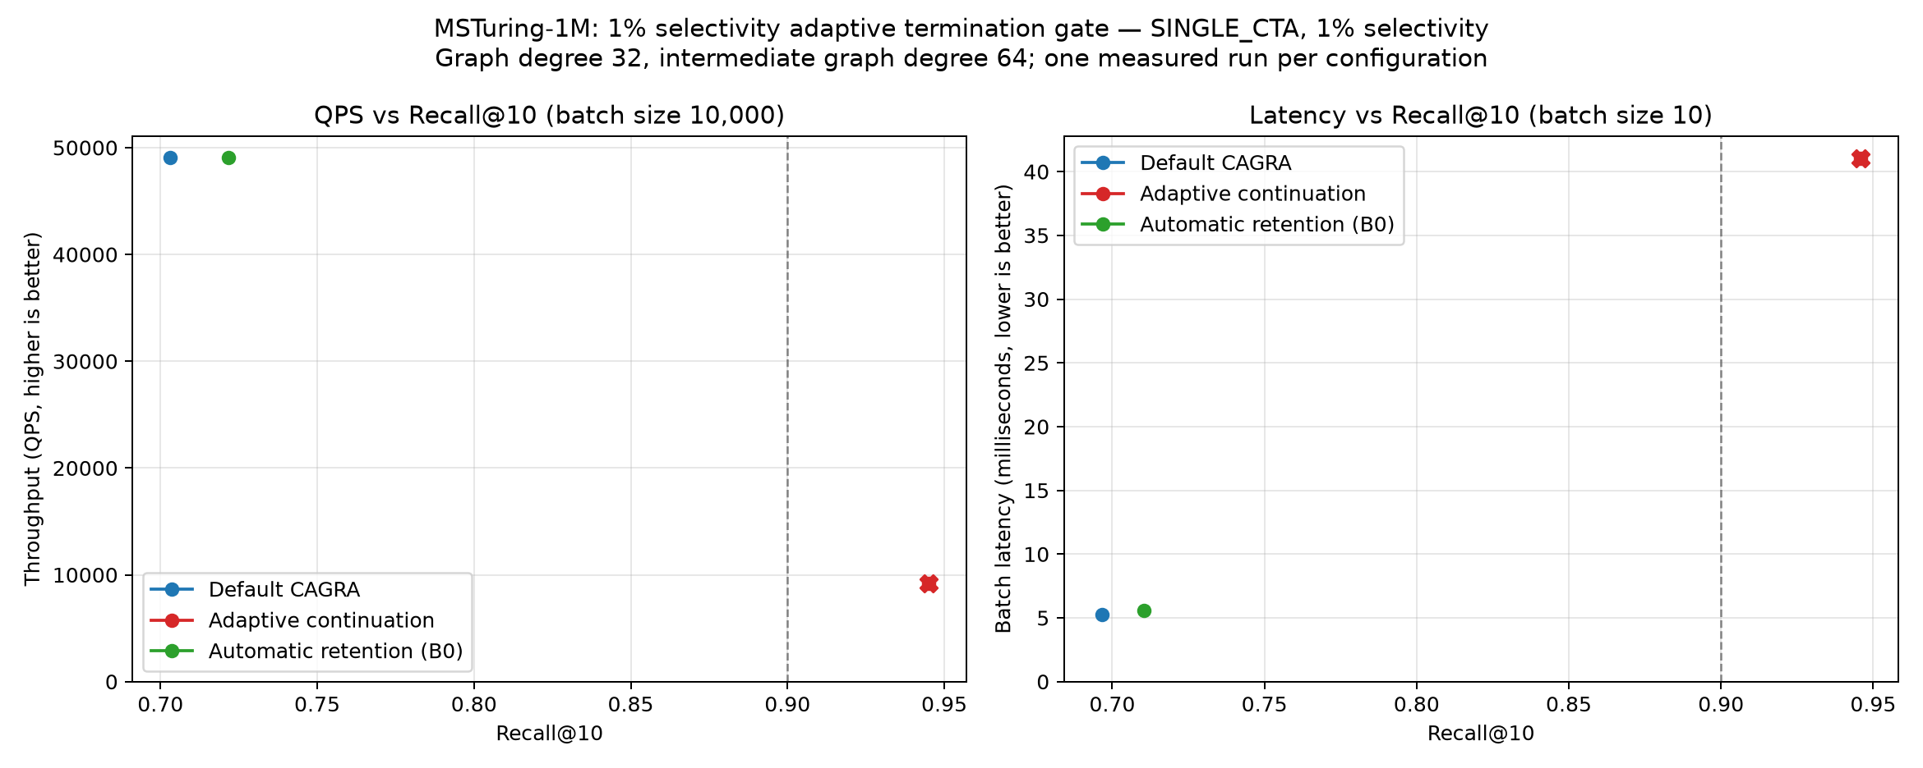
MSTuring-1M focused throughput and latency comparison; every y-axis starts at zero.
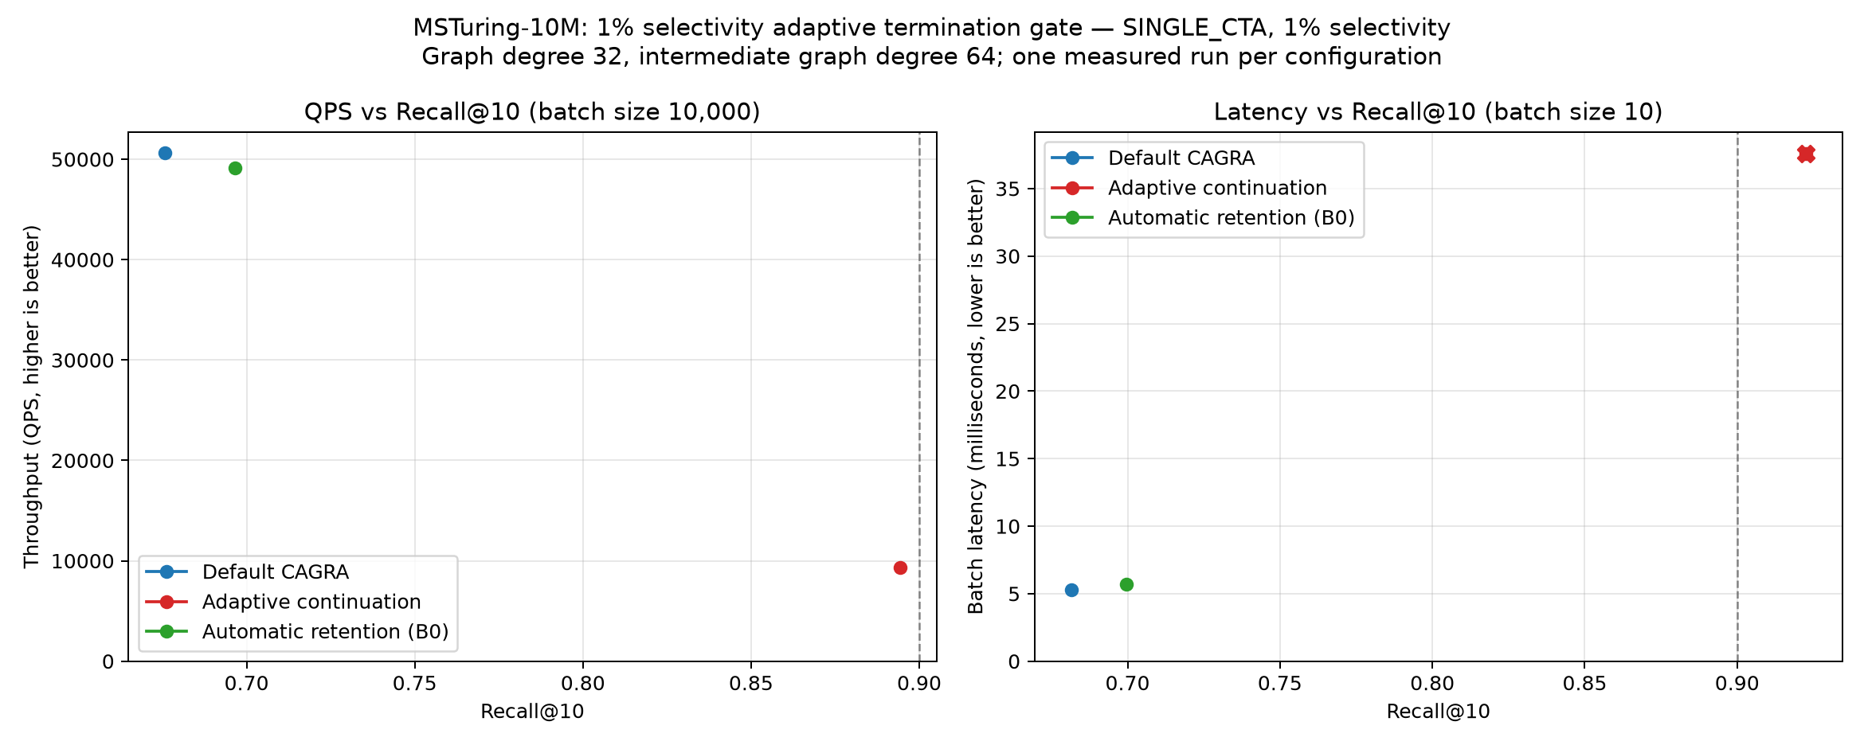
MSTuring-10M focused throughput and latency comparison; every y-axis starts at zero.

Diagnostic interpretation
Instrumented 10,000-query captures were run on all six available dataset/scale combinations. Diagnostic timings are invalid; the table is for traversal behavior only.
Dataset | Recall@10 | Mean iterations | p50 / p90 / p99 iterations | Converged | Hit Bhard | Mean terminal passes | Hash-full events
SIFT-1M | 0.9546 | 240.9 | 133 / 612 / 1,005 | 98.41% | 1.59% | 46.28 | 0
GIST-1M | 0.9220 | 398.2 | 360 / 727 / 1,005 | 98.20% | 1.80% | 39.65 | 0
BIGANN-1M | 0.9759 | 2,243.8 | 2,259 / 3,070 / 3,787 | 99.51% | 0.49% | 35.65 | 0
BIGANN-10M | 0.9776 | 1,729.1 | 1,749 / 2,700 / 3,483 | 99.79% | 0.21% | 36.38 | 0
MSTuring-1M | 0.9450 | 2,649.6 | 2,617 / 3,469 / 4,005 | 98.11% | 1.89% | 36.69 | 0
MSTuring-10M | 0.8942 | 2,488.8 | 2,469 / 3,320 / 4,006 | 98.62% | 1.38% | 36.87 | 0
The condition does not merely run every query to Bhard: 98.1–99.8% stop by the virtual-prefix condition. It nevertheless converges too late. The hard ceiling also sizes CAGRA's exact visited hash before launch, so even queries that stop earlier pay for a larger per-query table. The combination of deeper traversal and worst-case hash sizing explains the throughput loss.
The 32-entry virtual prefix requires 16 passing entries and finishes with roughly 36–46 passing entries in the full itopk buffer. In contrast, applying the paper's 50%-of-itopk requirement literally would require 256 passing entries for T=512 and would be unusable for these captures.

Reproduction
Build with all available CPU threads, then run the opt-in experiment:
PARALLEL_LEVEL=$(nproc) ./build.sh libcuvs bench-ann -n
FAVOR_ADAPTIVE_TERMINATION=1 \
FAVOR_SELECTIVITIES=1 \
FAVOR_ITOPK_VALUES=512 \
FAVOR_RETENTION_FRACTIONS=0 \
FAVOR_MAX_QUERIES=2048 \
FAVOR_BENCHMARK_REPETITIONS=1 \
./benchmarks/favor/run_benchmarks.sh DATA_DIR RESULT_DIR DATASET_NAME PREFIX TITLE QUERY BASE DTYPE
The diagnostic matrix is reproduced with:
./benchmarks/favor/run_favor_trace_diagnostics.py \
--output benchmarks/favor/results_adaptive_termination_diagnostics \
--phase summary --resume

Verdict
The experiment validates the original diagnosis: the fixed automatic budget is too short for several sparse workloads, and query-local continuation recovers many missing neighbors. This specific one-pass policy is not a performance solution. It should remain disabled; a future attempt should avoid sizing every query for Bhard, for example by compacting and continuing only the hard-query subset in a second pass.

