SEBI

BULLETIN

FEBRUARY 2021 VOL. 19 NUMBER 02

(LOGO)

SECURITIES AND EXCHANGE BOARD OF INDIA

EDITORIAL COMMITTEE

Shri Amarjeet Singh

Dr. Prabhakar R. Patil

Shri Prabhas Rath

Ms. Sangeeta Rathod

Ms. Deepthi L.S.

Dr. Deepali Dixit

Shri Jitendra Kumar

The Securities and Exchange Board of India Bulletin is issued by the Department of Economic and Policy Analysis, Securities and Exchange Board of India under the direction of an Editorial Committee. SEBI is not responsible for accuracy of data/information/interpretations and opinions expressed in the case of signed articles/speeches as authors are responsible for their personal views. SEBI has no objection to the material published herein being reproduced, provided an acknowledgement of the same is made. A readable version of SEBI Bulletin is available at http://www.sebi.gov.in. Further, soft copy of SEBI Bulletin is available free of cost to the subscribers/readers, who register at bulletin@sebi.gov.in along with their complete address. Any comments and suggestions on any of the features/sections may be sent to bulletin@sebi.gov.in

CONTENTS

CAPITAL MARKET REVIEW

REVIEW OF GLOBAL FINANCIAL MARKETS

HIGHLIGHTS OF DEVELOPMENTS IN INTERNATIONAL SECURITIES MARKET

POLICY DEVELOPMENTS AT SEBI

REGULATORY ACTIONS TAKEN BY SEBI

TABLES

PUBLICATIONS

CAPITAL MARKET REVIEW

- Trends in Resource Mobilisation by Corporates

Table 1: Fund Mobilisation by Corporates (₹ crore)
Particulars | Dec-20 | Jan-21
A. Funds Mobilisation through Public Issue (I+II) | 1,652 | 10,262
I. Equity Public Issue | 1,652 | 5,015
a. IPOs (i+ii) | 1,353 | 4,933
i. Main Board | 1,351 | 4,933
ii. SME Platform | 3 | 0
b. FPOs | 0 | 0
c. Equity Right Issue | 299 | 81
II. Debt Public Issue | 0 | 5,248
B. Funds Mobilisation through Private Placement | 97,335 | 62,127
1. QIP/IPP | 7,423 | 1,170
2. Preferential Allotment | 1,782 | 5,333
3. Private Placement of Debt | 88,130 | 55,624
Total Funds Mobilised (A+B) | 98,987 | 72,389
Source: SEBI, NSE, BSE and MSEI

- During January 2021, there were two Main Board IPO issues and one rights issue, mobilising ₹4,933 crore and ₹81crore, respectively.
- During January 2021, there were four public issues of corporate bonds, amounting to ₹5,248 crore compared to no public issue of corporate bond during December 2020.
- An amount of ₹ 6,503 crore was raised through private placement of equity (i.e., preferential allotment and QIP) during January 2021, against ₹ 9,205 crore during December 2020.
- Private placement of corporate debt reported on BSE and NSE stood at ₹55,624 crore during December 2020, compared to ₹88,130 crore during December 2020.

- Trends in the Secondary Market

- At the end of January 2021, Nifty 50 closed at 13,635 points registering a decrease of 2.5 per cent as compared to the 13,982 points level at the end of December 2020.
- S&P BSE Sensex closed at 46,286 at the end of January 2021, indicating a decrease of 3.1 per cent as compared to the 47,751 at the end of December 2020.
- Nifty 50 reached its intraday high for the month at 14,754, on January 21, 2021 and intraday low for the month at 13,597, on January 29, 2021. S&P BSE Sensex too reached its intraday high at 50,184 for the month, on January 21, 2021 and intraday low at 46,160 for the month, on January 29, 2021.
- The P/E ratios of S&P BSE Sensex and Nifty 50 were 31.8 and 36.6, respectively, at the end of January 2021 compared to 33.5 and 38.5, respectively, at the end of December 2020.
Table 2: Snapshot of Indian Capital Market
Description | Dec-20 | Jan-21 | Change over the Month
Index in Equity Market
Nifty 50 | 13,982 | 13,635 | -2.5
Sensex | 47,751 | 46,286 | -3.1
Nifty Midcap | 5,873 | 6,003 | 2.2
Nifty Smallcap | 7,088 | 7,177 | 1.3
BSE Midcap | 17,941 | 18,082 | 0.8
BSE Smallcap | 18,098 | 17,988 | -0.6
Market Capitalisation (₹ crore)
BSE | 1,88,03,519 | 1,86,12,644 | -1.0
NSE | 1,86,46,769 | 1,84,74,450 | -0.9
P/E Ratio
Sensex | 33.5 | 31.8 | -5.2
Nifty 50 | 38.5 | 36.6 | -4.9
No. of Listed Companies
BSE | 5,454 | 5,455 | 0.0
NSE | 1,962 | 1,965 | 0.2
Gross Turnover in Equity Segment (₹ crore)
BSE | 99,415 | 1,04,063 | 4.7
NSE | 13,74,552 | 14,49,445 | 5.4
Gross Notional Turnover in Equity Derivatives Segment (₹ crore)
BSE | 49,02,205 | 49,33,029 | 0.6
NSE | 6,72,62,248 | 7,19,13,140 | 6.9
Gross Notional Turnover in Currency Derivatives Segment (₹ crore)
BSE | 4,96,941 | 4,40,262 | -11.4
NSE | 11,60,619 | 10,01,206 | -13.7
MSEI | 14,310 | 13,562 | -5.2
Gross Notional Turnover in Interest Rate Derivatives Segment (₹ crore)
BSE | 1,087 | 1,101 | 1.2
NSE | 5,464 | 4,094 | -25.1
Source: BSE, NSE and MSEI
Figure 1: Movement of S&P BSE Sensex and Nifty 50 during January 2021

Note: The closing values of Nifty 50 and Sensex have been rebased with respective closing values of first day of the month.
Source: BSE and NSE

- At the end of January 2021, the market capitalisation of both the BSE and NSE decreased by one per cent and 0.9 per cent, respectively over the level as at the end of previous month.

Figure 2: Trends in Average Daily Values of Nifty 50 and NSE Equity Cash Segment Turnover

Note: ADV implies Average Daily Values and ATD implies Average Daily Turnover
Source: NSE
Figure 3: Trends in Average Daily Values of S&P BSE Sensex and BSE Equity Cash Segment Turnover

Note: ADV implies Average Daily Values and ATD implies Average Daily Turnover
Source: BSE

- During January 2021, the gross turnover in the equity cash segments, both at BSE and NSE, grew by 4.7 per cent and 5.4 per cent, respectively.

- During January 2021, the selected BSE sectoral indices, referred to in Figure 4, posted mixed returns. Amongst these, return by S&P BSE Auto increased by 6.3 per cent, followed by S&P BSE Capital Goods (3.9 per cent) and S&P BSE Teck (2.5 per cent), over the previous month. On the other hand, returns from S&P BSE Metal decreased by 4.9 per cent, followed by S&P BSE Bankex (3.4 per cent), S&P BSE Power (2.8 per cent) and S&P BSE Realty (2.4 per cent). The average daily volatility and monthly returns for these select BSE indices for January 2021 are illustrated in Figure 4.

Figure 4: Performance of BSE Sectoral Indices during January 2021 (per cent)

Source: BSE

- Similarly, the select sectoral indices of the NSE, referred to in Figure 5, posted mixed returns. Amongst these, returns by Nifty PSU Bank increased by 3.5 per cent, followed by Nifty IT (1.6 per cent) and Nifty Infrastructure (0.6 per cent), over the previous month. On the other hands, Nifty Pharma returns decreased by 5.8 per cent, followed by Nifty Energy (4.5 per cent), Nifty FMCG (3.1 per cent) and Nifty PSE (2.7 per cent). The average daily volatility and monthly returns of these select NSE indices for January 2021 are illustrated in Figure 5.

Figure 5: Performance of NSE Sectoral Indices during January 2021 (per cent)

Source: NSE

- Trends in Depository Accounts
- As at the end of January 2021, there were 211 lakh demat accounts at NSDL and 304 lakh demat accounts at CDSL. Further, till the end of January 2021, 5,654 listed companies were signed up with NSDL and 5,747 listed companies were signed up with CDSL to make their equity holdings available in dematerialised form.

- Trends in Derivatives Segment

- Equity Derivatives
Table 3: Trends in Equity Derivatives Market
Description | NSE |  |  | BSE
 | Dec-20 | Jan-21 | Percentage Change Over Month | Dec-20 | Jan-21 | Percentage Change Over Month
A. Turnover (` crore)
(i) Index Futures | 6,91,463 | 7,32,707 | 6.0 | 483.9 | 347.2 | -28.2
(ii) Options on Index
Put | 3,07,28,815 | 3,26,47,285 | 6.2 | 20,29,266 | 7,89,525 | -61.1
Call | 3,16,20,338 | 3,34,81,060 | 5.9 | 28,72,455 | 41,43,157 | 44.2
(iii) Stock Futures | 15,87,988 | 17,65,967 | 11.2 | 0.0 | 0.0 | NA
(iv) Options on Stock
Put | 7,62,420 | 9,28,070 | 21.7 | 0.0 | 0.0 | NA
Call | 18,71,224 | 23,58,051 | 26.0 | 0.0 | 0.0 | NA
Total | 6,72,62,248 | 7,19,13,140 | 6.9 | 49,02,205 | 49,33,029 | 0.6
B. No. of Contracts
(i) Index Futures | 79,89,064 | 80,16,190 | 0.3 | 4,575 | 3,087 | -32.5
(ii) Options on Index
Put | 36,49,50,536 | 37,06,62,774 | 1.6 | 2,24,46,596 | 76,24,305 | -66.0
Call | 36,63,57,313 | 36,79,28,467 | 0.4 | 2,54,77,518 | 3,48,84,632 | 36.9
(iii) Stock Futures | 1,98,41,495 | 2,07,69,652 | 4.7 | 0 | 0 | NA
(iv) Options on Stock
Put | 96,34,933 | 1,09,93,251 | 14.1 | 0 | 0 | NA
Call | 2,19,05,972 | 2,58,24,971 | 17.9 | 0 | 0 | NA
Total | 79,06,79,313 | 80,41,95,305 | 1.7 | 4,79,28,689 | 4,25,12,024 | -11.3
C. Open Interest in Terms of Value ( ` crore)
(i) Index Futures | 22,386 | 18,887 | -15.6 | 7 | 5 | -18.4
(ii) Options on Index
Put | 88,988 | 95,293 | 7.1 | 79 | 133 | 68.9
Call | 64,000 | 1,00,168 | 56.5 | 90 | 292 | 223.4
(iii) Stock Futures | 1,16,163 | 1,17,927 | 1.5 | 0.0 | 0.0 | NA
(iv) Options on Stock
Put | 12,930 | 16,517 | 27.7 | 0 | 0.0 | NA
Call | 21,843 | 29,689 | 35.9 | 0 | 0.0 | NA
Total | 3,26,309 | 3,78,480 | 16.0 | 175.6 | 430.0 | 144.9
D. Open Interest in Terms of No of Contracts
(i) Index Futures | 2,28,432 | 2,02,739 | -11.2 | 61 | 51 | -16.4
(ii) Options on Index
Put | 9,05,213 | 10,05,699 | 11.1 | 717 | 1,241 | 73.1
Call | 6,65,045 | 10,64,901 | 60.1 | 821 | 2,721 | 231.4
(iii) Stock Futures | 14,71,076 | 15,12,278 | 2.8 | 0 | 0 | NA
(iv) Options on Stock
Put | 1,69,475 | 2,17,285 | 28.2 | 0 | 0 | NA
Call | 2,88,536 | 3,98,082 | 38.0 | 0 | 0 | NA
Total | 37,27,777 | 44,00,984 | 18.1 | 1,599 | 4,013 | 151.0
Source: NSE and BSE

BSE
- During January 2021, the notional turnover of the equity derivatives segment at BSE increased marginally by 0.6 per cent to ₹ 49.3 lakh crore compared to ₹49 lakh crore in December 2020.
- As at the end of January 2021, the open interest in terms of value at BSE stood at ₹ 430 crore compared to ₹ 175.6 crore as at the end of December 2020, registering an increase of 144.9 per cent.

NSE
- The monthly notional turnover in the equity derivatives segment at NSE increased by 6.9 per cent to ₹ 719.1 lakh crore in January 2021 from ₹ 672.6 lakh crore in December 2020.
- During the above period,
(i) the notional turnover of index options increased by 6.1 per cent to ₹661.3 lakh crore from ₹623.5 lakh crore, and accounted for 92 per cent of the total equity derivatives turnover of NSE;
(ii) the notional turnover of stock options increased by 24.8 per cent to ₹32.9 lakh crore from ₹26.3 lakh crore;
(iii) the notional turnover of index futures increased by 6 per cent to ₹7.3 lakh crore from ₹6.9 lakh crore; and
(iv) the notional turnover of stock futures increased by 11.2 per cent to ₹17.7 lakh crore from ₹15.9 lakh crore.
- As at end of January 2021, the open interest in terms of value at NSE stood at ₹ 3,78,480 crore compared to ` 3,26,309 crore in December 2020, indicating an increase of 16 per cent.

Figure 6: Trends of Average Daily Notional Turnover at BSE and NSE (` crore)

Note: ADNV implies Average Daily Notional Turnover
Source: BSE and NSE

- During January 2021, the percentage share of weekly options (BSE and NSE together) to the total index options notional turnover (BSE and NSE Together) stood at 72.8 per cent compared to 79 per cent in December 2020. The percentage share of monthly options for both the exchanges to total index options notional turnover increased to 26.6 per cent in January 2021 from 20.5 per cent in December 2020.

Figure 7: Maturity-wise percentage Share of Total Index Options Turnover (per cent)

Source: BSE and NSE

- Currency Derivatives
- During January 2021, the monthly notional turnover of currency derivatives in India (NSE, BSE and MSEI together) stood at ₹14,55,030 crore as compared to ₹16,71,870 crore in December 2020, registering a decrease of 13 per cent during the period under consideration.

Figure 8: Trends of Currency Derivatives at NSE, MSEI and BSE (` crore)

Source: BSE, NSE and MSEI

- Interest Rate Derivatives
- During January 2021, the monthly notional turnover of interest rate derivatives at NSE decreased by 25.1 per cent to ₹4,094 crore from ₹ 5,464 crore during December 2020.
- The monthly notional turnover of interest rate futures at BSE increased by 1.2 per cent to ₹ 1,101 crore from ₹ 1,087 crore during the same period.

Figure 9: Trends of Interest Rate Futures at NSE and BSE

Source: BSE and NSE

- Trading in Corporate Debt Market
- During January 2021, BSE registered 5,537 trades of corporate debt with traded value of ₹ 48,385 crore, as compared to 6,496 trades of corporate debt with a traded value of ₹ 34,626 crore in the previous month.
- At NSE, 5,221 trades were recorded with a traded value of ₹83,618 crore in January 2021 as compared to 5,719 trades were recorded with a traded value of ₹76,874 crore in December 2020.

Figure 10: Trends in Reported Turnover of Corporate Bonds (` crore)

Source: BSE and NSE

- Trends in Institutional Investments

- Trends in Fund Mobilisation/Transactions by Mutual Funds
- As at end of January 2021, there were a total of 1,728 mutual fund schemes in the market, of which 999 were open-ended schemes, 706 were close-ended schemes and 23 were interval schemes.
- The mutual fund industry saw a net outflow of ₹ 35,587 crore during January 2021, against the net inflow of ₹ 2,968 crore during December 2020.
- The funds mobilised by open-ended schemes during January 2021 was ₹6,47,286 crore against redemption/repurchase of ₹ 6,79,836 crore, resulting in a net outflow of ₹32,550 crore from open-ended schemes. Of the total funds mobilised by the open-ended schemes during the month under consideration, ₹5,95,284 crore was mobilised through income/debt oriented schemes, ₹24,130 crore through growth/equity oriented schemes, ₹14,736 crore through hybrid schemes, ₹236 crore through solution oriented schemes and ₹12,899 crore through other schemes.
- During January 2021, close-ended schemes worth ₹ 3,035 crore were matured/ repurchased. Also, interval schemes worth ₹ 3 crore were matured/redeemed during the period.
- The net assets under management of mutual funds stood at ₹30.5 lakh crore as at the end of January 2021, down from ₹31 lakh crore as at the end of December 2020.

- In the secondary market transactions, during January 2021, mutual funds liquidated ₹ 13,032 crore from equity schemes and deployed ₹ 11,832 crore in debt schemes.

Figure 11: Trends in Mutual Funds Transactions in Secondary Market (` crore)

- Trends in Investments by the Foreign Portfolio Investors (FPIs)

- During January 2021, FPIs invested a total of ₹ 14,631 crore in the Indian securities market compared to an investment of ₹ 71,046 crore in December 2020. During January 2021, FPIs invested only in Equity of ₹ 19,473 crore, however, FPIs withdraw of ` 2,518 crore from Debt Securities, ` 2,306 crore from Debt-Voluntary Retention Route (VRR) and ` 17 crore from Hybrid securities. On the other hand, FPIs invested ` 62,016 crore in Equity, ` 4,079 crore in Debt, ` 2,463 crore in Debt-VRR and ` 2,489 crore in Hybrid securities during December 2020.

- The assets of FPIs in India, as reported by custodians, as at the end of January 2021 was ₹41,15,463 crore, out of which the notional value of offshore derivative instruments (ODIs) (including ODIs on derivatives) was ₹ 84,976 crore which is 2.1 per cent of total assets of FPIs.

Figure 12: Trends in FPIs’ Investments

Source: CDSL and NSDL

- Trends in Portfolio Management Services (PMS)
- As at end of October 2020, AUM of the portfolio management industry stood at ₹19.2 lakh crore. Of the total AUM, funds from EPFO/PFs account for ₹14.6 lakh crore.
- There were 1,55,796 total clients in PMS industry as at the end of October 2020, of which 1,45,404 clients belong to discretionary services category, 8,409 clients belong to non-discretionary services category and 1,983 clients belong to advisory services category of portfolio management services.

- Trends in Substantial Acquisition of Shares and Takeovers

During January 2021, three open offers with offer value of ₹141 crore were closed under SEBI (Substantial Acquisition of Shares and Takeover) Regulations, 2011 (SAST Regulations) as against four open offer with offer value of ₹ 48 crore were closed in December 2020. Of the three offers, one open offer was for change in control of management and two were made under Substantial Acquisition.

Figure 13: Details of Open Offers Closed under the SEBI (SAST) Regulations

IX. Commodity Derivatives Markets

- Market Trends

- During January 2021, MCX iCOMDEX composite index, witnessed an increase of 1.3 per cent (M-o-M) driven by increase in futures prices of energy, base metals (lead and nickel), bullion (silver) and cotton contracts of agri. segments. On Y-o-Y basis, MCX iCOMDEX composite index increased by 5.3 per cent.
- During the month, MCX iCOMDEX crude oil index increased by 8.0 per cent on account of increase in futures price of crude oil by 8.4 per cent. MCX iCOMDEX base metal index increased by 0.4 per cent as the futures prices of lead and nickel increased by 2.4 per cent and 3.5 per cent respectively during the month. However, futures prices of other base metals viz. aluminium, copper and zinc decreased in January 2021. MCX iCOMDEX bullion index decreased by 0.9 per cent due to decrease in futures prices of gold by 2.1 per cent. In the agri. segment, futures prices of all the traded commodities except cotton decreased during the month. Cardamom contracts was not traded during the month also.
- NKrishi index increased by 1.1 per cent (M-o-M) as futures prices of eight out of 10 constituent commodities of the index viz. guarseed, soybean, chana, turmeric, cottonseed oilcake, jeera, coriander and barley witnessed an upend. On Y-o-Y basis NKrishi index increased by 13.8 per cent. On account of rebalancing, refined soy oil has been replaced by soybean in NKrishi index for the period 1st Jan. 2021 to 31st March, 2021.
- Monthly trends in MCX iCOMDEX composite Index and NKrishi Index are provided in Table 64.
Figure 14: Movement of Commodity Derivatives Market Indices during Dec-2020

Source: MCX and NCDEX

Table 4: Snapshot of Indian Commodity Derivative Markets
Items | 2019-20 | Dec- 2020 | Jan -2021 | Percentage variation  M-o-M
- Indices
Nkrishi | 3,179.9 | 3,666.0 | 3,708.0 | 1.1
MCX iCOMDEX | 8,255.5 | 10,503.8 | 10,638.0 | 1.3
- Turnover (₹crore)
All-India | 92,24,839.9 | 7,79,471.3 | 7,67,726.7 | -1.5
MCX, of which | 86,89,517.6 | 6,75,292.2 | 6,69,693.7 | -0.8
Futures | 83,97,775.0 | 6,60,033.7 | 6,43,734.6 | -2.5
Options | 2,91,742..7 | 15,258.5 | 25,959.1 | 70.1
BSE, of which | 46,438.7 | 66,922.5 | 62,537.6 | -6.6
Futures | 46,438.7 | 121.4 | 96.7 | -20.4
Options | - | 66,801.0 | 62,440.9 | -6.5
NCDEX, of which | 4,42,009.1 | 34,267.0 | 32,731.4 | -4.5
Futures | 4,41,967.0 | 34,253.6 | 32,730.1 | -4.4
Options | 42.2 | 13.4 | 1.2 | -90.8
NSE, of which | 6,362.0 | 2,986.9 | 2,751.0 | -7.9
Futures | 6,362.0 | 1,449.1 | 837.2 | -42.2
Options | - | 1,537.8 | 1,913.8 | 24.4
ICEX (Futures) | 40,511.3 | 2.8 | 13.2 | 376.2
Source: MCX, BSE, NCDEX, NSE, ICEX.

B. Turnover

- During January 2021, pan- India turnover of the commodity derivatives decreased by 1.5 per cent to ₹7,67,726.7 crore driven by decrease in turnover at all exchanges except ICEX during the month. The agricultural segment contributed 6.0 per cent to the total turnover, while non-agricultural segment accounted for 94.0 per cent.
- The total turnover at MCX decreased by 0.8 per cent to ₹6,69,693.7 crore during January 2021 driven by decrease in traded value of bullion, metal and energy futures by 2.4 per cent, 5.5 per cent and 0.1 per cent respectively. However, turnover in agri. futures increased by 17.7 per cent. The turnover in iCOMDEX bullion and iCOMDEX metal index futures decreased by 17.9 per cent and 8.7 per cent to ₹ 5,679.3 crore and ₹ 1,181.5 crore respectively during the month.
- The notional turnover of options segment at MCX increased by 70.1 per cent during the month owing to increase in traded value in bullion and energy segments by 84.9 per cent and 1.8 per cent respectively. The options contracts contributed 3.9 per cent to the total turnover at MCX.
- The total turnover at BSE decreased by 6.6 per cent to ₹ 62,537.6 crore driven by decrease in turnover in bullion options by 6.5 per cent. Turnover in futures contracts of bullion and agri. also declined by 12.3 per cent and 21.2 per cent respectively.
- During the month, the total turnover at NCDEX decreased by 4.5 per cent to ₹32,731.4 crore, due to decrease in traded volume and value of eleven out of total 16 traded commodities. Turnover in Agridex futures indices increased to ₹12.7 crore, an increase of 50.0 per cent during January 2021.
- NCDEX relaunched futures trading in gur and steel long contracts (metal segment- non-agri.) on 15th December, 2020 and 18th January, 2021 respectively. While the gur contracts registered a total turnover of ₹10.6 crore and ₹6.6 crore in December 2020 and January 2021 respectively, steel long contracts recorded a total turnover of ₹24.2 crore in January 2021.
- The total turnover at NSE decreased by 7.9 per cent to ₹2,751.0 crore during the month on account of decline in turnover in bullion and agri. futures by 27.1 per cent and 42.4 per cent respectively in January 2021. Turnover in bullion options, however, increased by 24.4 per cent during the month.
- In January 2021, the total turnover at ICEX, increased to ₹13.2 crore from ₹2.8 crore recorded in December 2020.
- The turnover of agricultural and non-agricultural commodities at exchanges is shown in Figures 15, 16 and 17 and the details are given in Tables 65 to 69.

Figure 15: Trends in Turnover of Agricultural Commodity Derivatives

Source: MCX, NCDEX, BSE & ICEX

Figure 16: Trends in Turnover of Non-Agricultural Futures contracts

Source: MCX, ICEX, BSE & NSE.

Figure 17: Trends in Turnover of Non-Agricultural Options contracts

Source: MCX, BSE & NSE.

OVERVIEW OF THE GLOBAL FINANCIAL MARKETS

- The global economic expansion rate eased for the third month in a row during January 2021. The JPMorgan Global Composite Purchasing Managers’ Index (PMI), compiled by IHS Markit, decreased to 52.3 in January 2021 from 52.7 in December 2020. A reading of PMI above 50 means growth or expansion in economic activity.

- In its latest January 2021, Global Economic Prospects report, the World Bank informed that the global economy has contracted by 4.3 per cent in 2020, representing the fourth most severe global recession in the past 150 years. As per the report, although the global economy is expected to recover from the COVID-19 induced recession, progress will be slow and subdued. While global growth is projected at 4.0 per cent in 2021, but another spike in COVID-19 cases could reduce it to 1.6 per cent. The report flags that the expected slower pace of vaccinations in developing countries relative to advanced economies represents a substantial headwind to activity.

- In the January 2021 World Economic Outlook update, IMF estimated the world economy growth rates at -3.5, 5.5 per cent and 4.2 per cent for year 2020, 2021 and 2022 respectively. There was an upward revision for 2021 by 30 bps. Estimated growth rates for India are -8.0, 11.5 and 6.8 per cent for year 2020, 2021 and 2022 respectively. Growth rates for China was kept at 2.3, 8.1 and 5.6 respectively for the same years.
- The emerging equity markets outperformed advanced markets in January 2021. MSCI Emerging Market (EM) index increased by 3.0 per cent in January 2021 over the previous month, while MSCI World index decreased by -1.1 per cent during same period.

- The volatility in the equity markets remained moderate during January 2021. The CBOE VIX index rose to 33.1 as on 31 January, 2021 from 22.8 as on the end of last month.

- The bond markets remained mostly flat during December 2020. While the US 10-year government bond yield increased by 18 bps to 1.09 per cent during January 2020. The 10-year government bond yield of India declined by 8 bps to 5.95 per cent as on 31 January, 2021, compared to end of the previous month.

- The crude oil prices increased by USD 3.8 per barrel (or by 7.6 per cent) to USD 52.2 per barrel in January 2021. Gold prices, decreased by 2.7 per cent during January to USD 1,847.7 on 31 January, 2021 from USD 1,894.4 on 31 December, 2020.

- As per the latest estimate, the US economy expanded by 4.0 per cent Q-o-Q in annualised terms in the Q4 of 2020, compared to 33.4 per cent increase Q-o-Q in annualised terms during the previous quarter. The US unemployment rate remained unchanged at 6.3 per cent in January 2021 from 6.7 per cent in the previous month. The US PMI data also indicate rising economic activity. The IHS Market’s US Composite PMI rose to 58.0 in January 2021 from 55.3 in December 2020.

- The UK economy grew by 1.0 per cent Q-o-Q in Q4 of 2020, against 16.1 per cent expansion of the previous quarter. The economic activity recorded steepest fall since May 2020 as third national lockdown hit the UK economy. The IHS Markit UK composite PMI observed at 40.6 in January 2021 from 50.4 in previous month.

- According to the data published by Eurostat, the Eurozone economy shrank by 0.6 per cent Q-o-Q in Q4 of 2020, after growing by 12.4 per cent in Q3 of 2020. All major economies in the Eurozone posted decrease in GDP in Q4. Among the largest economies of Eurozone Decrease in France was -1.3 per cent), in Netherlands, it was -0.1 per cent and in Italy, it was-2.0 per cent as compared to the previous quarter. GDP growth in Germany and Spain reflected a positive growth of 0.1 and 0.4 respectively.

- GDP growth of China rebounded strongly by 2.6 per cent year-on-year in Q4 of 2020, compared to growth rate of 3.0 per cent in Q3 of 2020. According to IMF projections, the Chinese economy is expected to slow down to 2.3 per cent in 2020 before recovering to strong growth of 8.1 per cent in 2021.

- India’s GDP growth contracted by 7.5 per cent Y-o-Y during Q2 of 2020-21 compared to -23.9 per cent growth Y-o-Y in Q1 of 2020-21. The business activity in hotels and transportation declined by 15.6 per cent and manufacturing declined by 39.3 per cent. There was a decline in growth rates of public administration services (-12.2 per cent), mining and quarrying (-9.1 per cent) and construction (-8.6 per cent) sectors.

- According to the First Advance Estimate released by MOSPI, GDP of India is estimated to fall by 7.7 per cent during the full Financial Year 2020-21, compared to 4.2 per cent expansion in 2019-20. World Bank estimates India’s GDP to grow by -9.6 per cent in 2020. According to IMF projections, the Indian economy is expected to grow by 11.5 per cent in 2021. IMF also revised its India GDP growth estimate for 2020 to -8.0 per cent changing it by 2.7 per cent.

- Retail inflation (CPI Inflation) in India observed to be 5.1 per cent in January 2021, compared to 5.2 per cent in a month earlier. Index of Industrial Production (IIP) grew by 1.0 per cent in December 2020, compared to 1.9 per cent contraction in November 2020. The mining sector witnessed contraction of 4.8 per cent as compared to growth of 5.7 per cent a year ago, while the manufacturing sector grew by 1.6 per cent in December 2020 as against a contraction of 0.3 per cent in December 2019. India’s manufacturing PMI for January remained was observed to be 57.7 in January 2021 against 56.4 of the previous month. The services PMI was observed to be 52.8 in January 2021 against 52.3 of the previous month.

Market Trends –

Equity Markets (Figures 1-2, Table A1)-
- In the month of January 2021, highest annualized monthly volatility amongst the BRICS countries was observed in Russian Traded (75.5 per cent) followed by Brazil IBOVESPA (56.3 per cent) and India (Sensex and Nifty 50 both 41.2 per cent). The lowest annualized volatility among BRICS was observed in Shanghai Composite (22.2 per cent) and South Africa FTSE (34.8 per cent). Among the developed markets, highest annualized volatility was observed in France CAC 40 (59.9 per cent) and the lowest was observed at Hong Kong HANG SENG (29.0 per cent)).

- In most of the analyzed markets, an increase was observed in most of the indices during January 2021 over the previous month. Amongst BRICS nations, an increase was observed in South Africa FTSE (5.2 per cent) followed by Shanghai SE Composite (0.3 per cent). However, a decrease was observed for Brazil’s IBOVESPA (3.3 per cent), followed by India (India (S&P BSE SENSEX: 3.1 per cent and Nifty 50: 2.5 per cent), followed by Russia Traded (1.4 per cent). Among the developed economies, in the month of January 2021, highest indices growth was observed for Hong Kong HANG SENG (3.9 per cent) followed by South Korea KOSPI (3.6 per cent). A negative monthly growth was observed in France CAC 40 (2.7 per cent) followed by German DAX (-2.1 per cent) and Dow Jones Indus. Avg (-2.0 per cent). Growth for Nasdaq COMPOSITE, UK FTSE 100, Singapore STI and Japan Nikkei were 1.4, -0.8, 2.1 and 0.8 per cent respectively.

Figure 1: Stock Market Trends in Selected Developed Markets

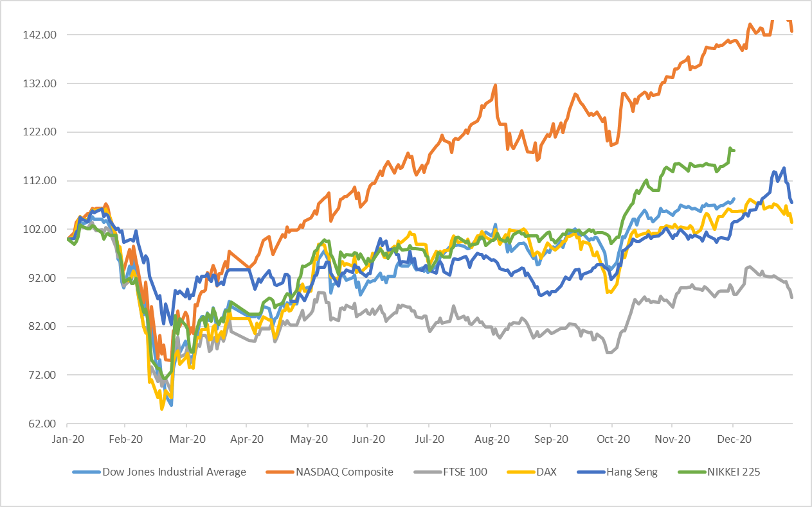

Note: All indices have been normalised to 100 on 31 January 2020.

Source: Refinitiv

Figure 2: Stock Market Trends in Selected Emerging Markets
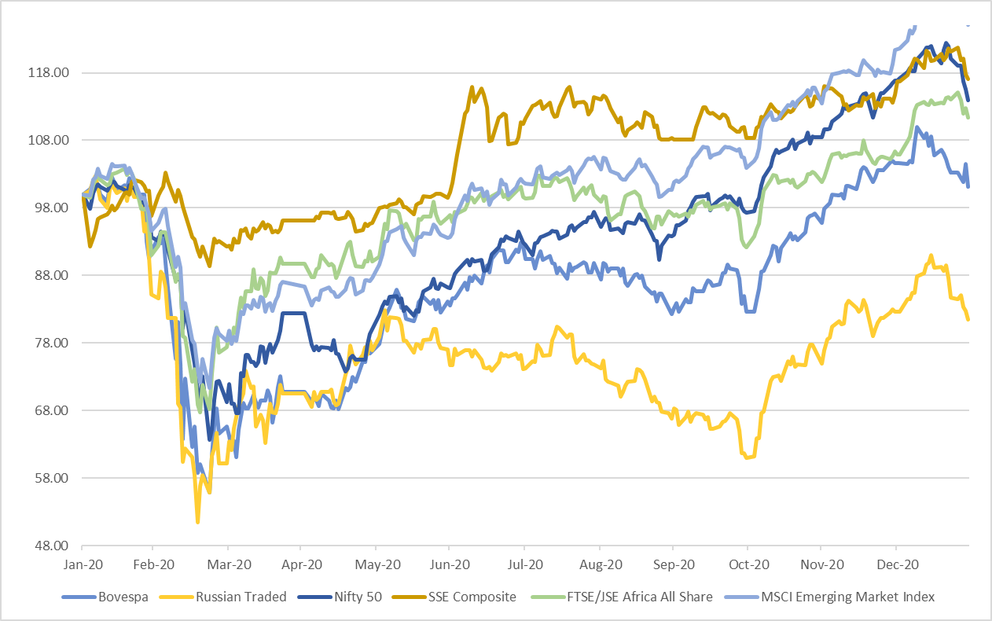

Note: All indices have been normalised to 100 on 31 January 2020.

Source: Refinitiv

BOND Market (Figures 3-4)
- Among the countries analysed, for bond yield, 10-year bond yield showed a positive change for most developed and developing economies (Chart 3 & 4) except for Germany in January 2021, where it was negative.

Figure 3: Movement of 10-year Government Bond Yields in Developed Nations

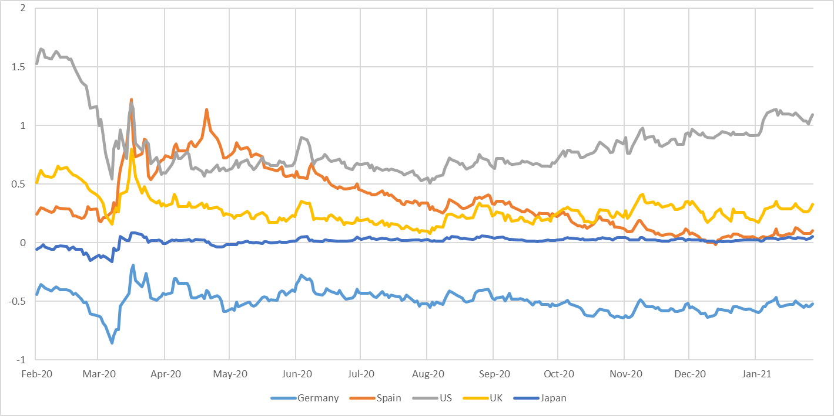

Source: Refinitiv

Figure 4: Movement of 10-year Government Bond Yields in BRIC Nations
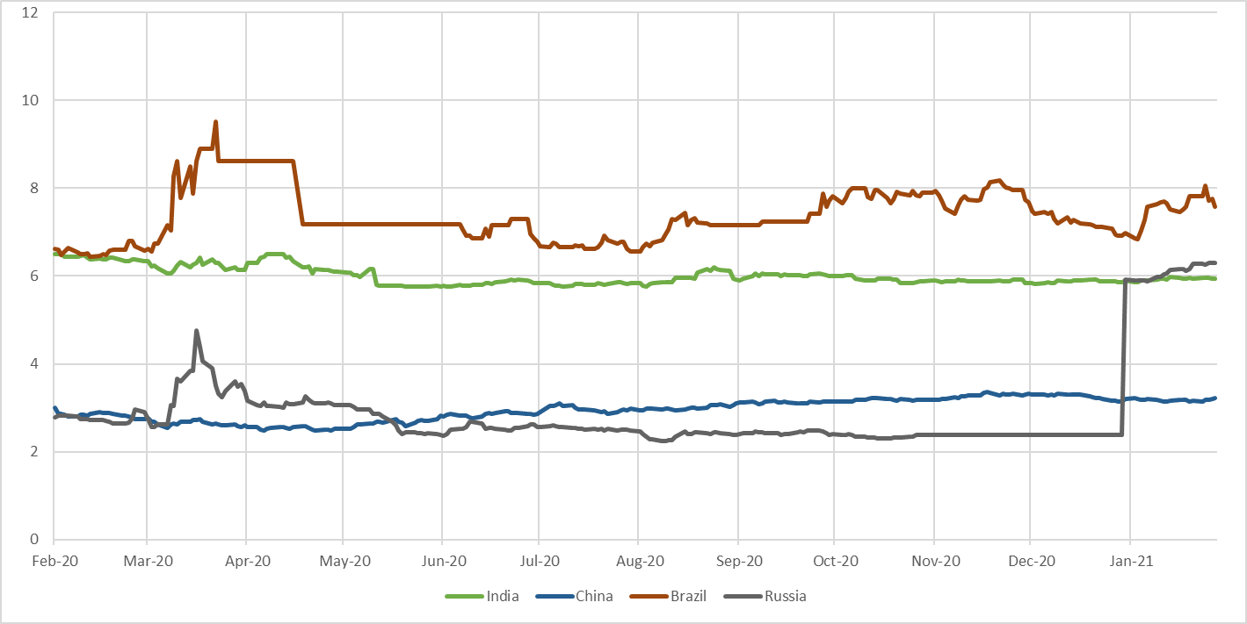

Source: Refinitiv

Fund Mobilisation by Issuance of Equity and Bonds (Table A2) –
- There was a 3.8 per cent increase in the fund mobilization at the selected analyzed exchanges world-wide during December 2020 (at 352,659 million USD) against previous month (at 339,667 million USD). Only 24.7 per cent of the total fund mobilization in November 2020 was in equity and remaining was in debt.
- As per the data available on World Federation of Exchanges (WFE), highest amount mobilized through equities and bonds in December 2020 was at National Stock Exchange of India (52,018 million USD) followed by LSE Group (50,522 million USD) and Korea Exchange (38,489 million USD).
- In December 2020, fund mobilization at LSE Group in equity was, 3,535 million USD and the remaining amount was raised through bonds whereas at Korea Exchange entire amount was raised through bonds only. At National Stock Exchange of India, 1,472 million USD were raised through equity and the remaining amount was raised through bonds.
- Maximum fund mobilization through equities in December 2020 was at Hong Kong Exchanges and Clearing (17,920 million USD) followed by Shanghai Stock Exchange (13,513 million USD).

Market Capitalisation of Major Exchanges (Table A3) –

- Most of the analysed exchanges of selected markets, reflected an increase in market capitalization in the month of December 2020 as compared to previous month.
- Among the exchanges which registered highest increase in market capitalization were B3 - Brasil Bolsa Balcão, Korea Exchange, and National Stock Exchange of India (14.8, 13.5 and 9.4 per cent respectively).
- Among the exchanges which showed least growth of the market capitalization among the analysed ones were Japan Exchange Group (1.9 per cent), Singapore Exchange (2.4 per cent) and BME Spanish Exchanges (2.7 per cent).

Derivatives (Figures 5-6, Table A4–A8) –

- During December 2020, the highest number of single stock futures contracts traded was at Borsa Istanbul (179,887,591) followed by Korea Exchange (113,477,821). The highest number of single stock options were traded at Nasdaq - US (206,395,272) followed by B3 - Brasil Bolsa Balcão (148,607,456).
- In the same period, highest number of contracts of index futures were traded at B3 - Brasil Bolsa Balcão (272,635,237) followed by CME Group (92,124,131). Among the stock index options, the highest number of contacts were traded at NSE (731,307,849) followed by Korea Exchange (74,689,131).
- Highest number of currency futures contracts were traded at Moscow Exchange (89,221,113) followed by NSE India (72,299,426). The highest number of currency options were traded at NSE (79,833,474) followed by Moscow Exchange (2,252,169).
- In December 2020, the highest number of interest rate futures and interest rate options contracts were traded at CME Group (90,905,523 and 20,083,814 respectively) followed by B3 - Brasil Bolsa Balcão (46,508,053 and 21,274,153 respectively).
- The highest number of commodity futures contracts were traded at Shanghai Futures Exchange (261,195,933) followed by Dalian Commodity Exchange (245,991,015) in December 2020. Among the commodity options the highest number of contracts were traded at CME Group (11,496,254) followed by Zhengzhou Commodity Exchange (6,433,716) during the same period.
- In January 2020, most of the analysed currencies appreciated against dollar. Real and Rand were most appreciating currencies against dollar among the analysed currencies.

US Treasury Securities (Table A9)

- At the end of December 2020, Japan was the biggest foreign holder of US Treasury Securities with 17.9 per cent followed by China with 15.1 per cent. The total foreign holding of US Treasury Securities at the end of December 2020 was USD 7,036 billion. The holdings of US Treasury Securities by India reduced to 3.0 from 3.1 per cent at the end of December 2020 against a month earlier.

Figure 5: Movement of the Major Currencies against USD
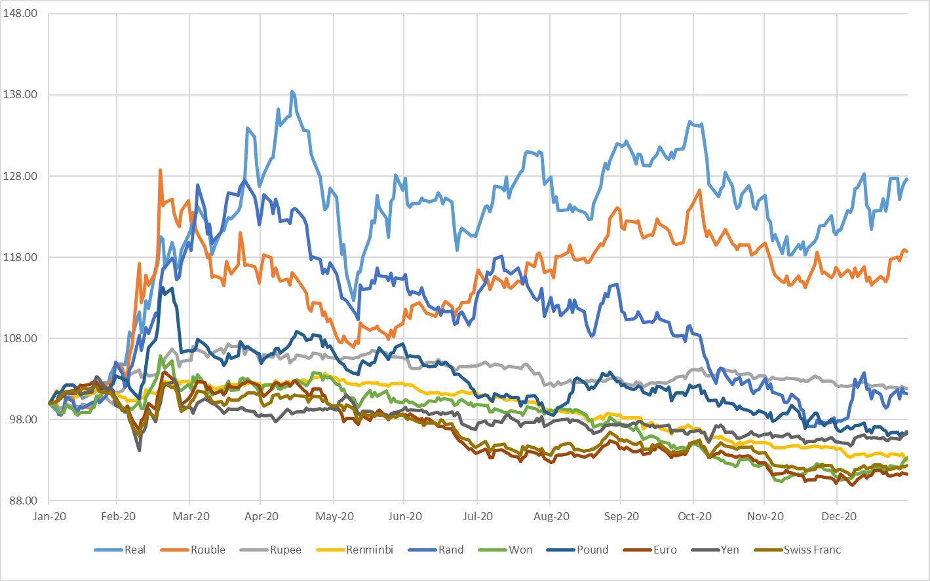
Note: All indices have been normalised to 100 on 31 January 2020.

Source: Refinitiv

Figure 6: Movement of the US Dollar Index and MSCI EM Currency Index

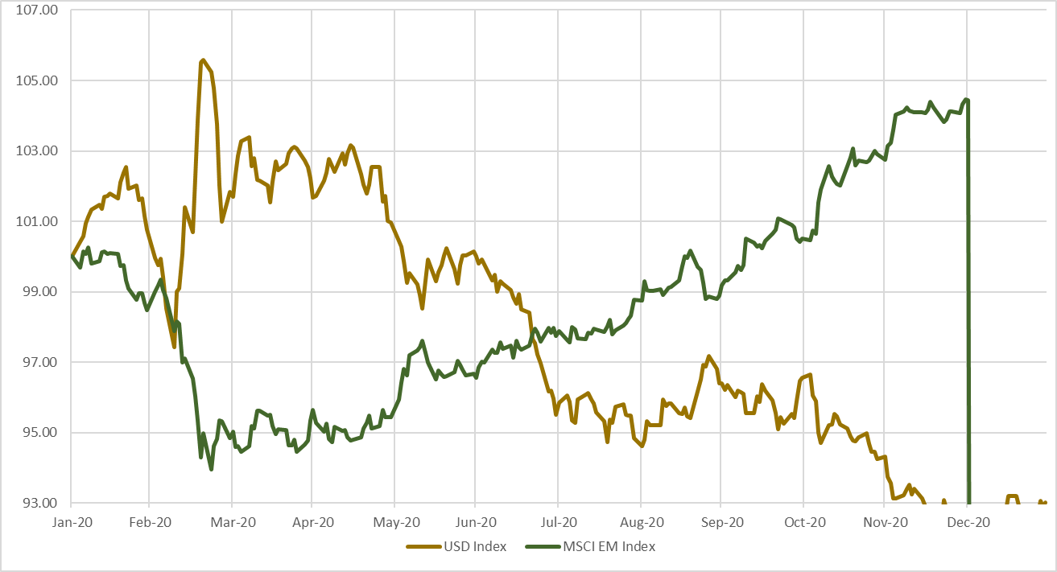
Note:
- All indices have been normalised to 100 on 31 January 2020.
- The U.S. Dollar Index is an index of the value of the United States dollar relative to a basket of foreign currencies. The Index goes up when the U.S. dollar gains value compared to other currencies. The index is maintained and published by Intercontinental Exchange. It is a weighted geometric mean of the dollar's value relative to following select currencies: Euro, Japanese yen, Pound sterling, Canadian dollar, Swedish krona, Swiss franc.
- The MSCI Emerging Markets (EM) Currency Index tracks the performance of twenty-five emerging-market currencies relative to the US Dollar.

Source: Refinitiv

Table A1: Performance of Stock Indices
Country | Name of the Index | Closing Value as on | Closing Value before |  |  |  | Monthly Volatility (Annualised) | P/E Ratio
 |  | 31-Jan-2021 | 1-Month | 3-Month | 6-Month | 1-Year
BRICS Nations
Brazil | BRAZIL IBOVESPA | 115067.6 | 119017.2 | 93952.4 | 102912.2 | 113760.6 | 115067.6 | 119017.2
Russia | RUSSIAN TRADED | 1776.2 | 1802.3 | 1329.5 | 1618.1 | 2179.9 | 1776.2 | 1802.3
India | Nifty 50 | 13634.6 | 13981.8 | 11642.4 | 11073.5 | 11962.1 | 13634.6 | 13981.8
India | S&P BSE SENSEX | 46285.8 | 47751.3 | 39614.1 | 37606.9 | 40723.5 | 46285.8 | 47751.3
China | SHANGHAI SE COMPOSITE | 3483.1 | 3473.1 | 3224.5 | 3310.0 | 2976.5 | 3483.1 | 3473.1
South Africa | FTSE/JSE AFRICA ALL SHR | 62472.1 | 59408.7 | 51684.7 | 55721.8 | 56079.5 | 62472.1 | 59408.7
Developed Markets
USA | NASDAQ COMPOSITE | 13070.7 | 12888.3 | 10911.6 | 10745.3 | 9150.9 | 39.9 | NA
USA | DOW JONES INDUS. AVG | 29982.6 | 30606.5 | 26501.6 | 26428.3 | 28256.0 | NA | 22.6
France | CAC 40 | 5399.2 | 5551.4 | 4594.2 | 4783.7 | 5806.3 | 59.9 | 22.3
Germany | DAX | 13432.9 | 13718.8 | 11556.5 | 12313.4 | 12982.0 | 43.5 | 23.9
UK | FTSE 100 | 6407.5 | 6460.5 | 5577.3 | 5897.8 | 7286.0 | 43.9 | 16.9
Hong Kong | HANG SENG | 28283.7 | 27231.1 | 24107.4 | 24595.4 | 26312.6 | 29.0 | 15.5
South Korea | KOSPI | 2976.2 | 2873.5 | 2267.2 | 2249.4 | 2119.0 | 49.7 | NA
Japan | NIKKEI 225 | 27663.4 | 27444.2 | 22977.1 | 21710.0 | 23205.2 | NA | 27.8
Singapore | STRAITS TIMES STI | 2902.5 | 2843.8 | 2423.8 | 2529.8 | 3153.7 | 42.2 | 12.0
Taiwan | TAIWAN TAIEX | 15138.3 | 14732.5 | 12546.3 | 12664.8 | 11495.1 | 34.0 | 20.5
Note: P/E Ratios as on the last trading day of month. Trailing PE ratio has been used from Refinitiv for all Indices apart from Sensex, Nifty 50, Kospi, Nikkei and Taiwan Taiex. Forward PE from Refinitiv was used for Kospi, Nikkei and Taiwan Taiex. Data for Sensex and Nifty was taken from respective exchange website. Data is as on 14 January 2021
Source: Refinitiv, BSE and National Stock Exchange

Table A2: Fund Mobilisation by Issuance of Equity and Bond in Major Exchanges (USD million)
Month | Nov-20 |  |  | Dec-20
Exchange Name | Bond | Equity | Total | Bond | Equity | Total
B3 - Brasil Bolsa Balcão | NA | 0 | 0 | NA | 0 | 0
Nasdaq - US | NA | 0 | 0 | NA | 0 | 0
NYSE | NA | 12,067 | 12,067 | NA | 7,196 | 7,196
ASX Australian Securities Exchange | NA | 3,264 | 3,264 | NA | 10,820 | 10,820
Hong Kong Exchanges and Clearing | 24,907 | 7,451 | 32,358 | 8,620 | 17,920 | 26,539
Japan Exchange Group | 4,251 | 2,668 | 6,919 | 16,969 | 7,412 | 24,381
Korea Exchange | 49,520 | 0 | 49,520 | 38,489 | 0 | 38,489
National Stock Exchange of India | 35,042 | 1,916 | 36,958 | 50,546 | 1,472 | 52,018
Shanghai Stock Exchange | NA | 8,136 | 8,136 | NA | 13,513 | 13,513
Shenzhen Stock Exchange | 13,622 | 7,676 | 21,299 | 15,272 | 9,588 | 24,861
Singapore Exchange | 10,138 | 107 | 10,246 | 19,035 | 498 | 19,532
BME Spanish Exchanges | 15,897 | 81 | 15,979 | 32,278 | 3,001 | 35,279
Deutsche Boerse AG | 29,881 | 0 | 29,881 | 10,796 | 0 | 10,796
Euronext | NA | 4,215 | 4,215 | NA | 11,801 | 11,801
Johannesburg Stock Exchange | 4,313 | 90 | 4,403 | 3,796 | 117 | 3,913
LSE Group | 67,467 | 7,380 | 74,848 | 46,987 | 3,535 | 50,522
Moscow Exchange | 29,576 | 0 | 29,576 | 22,616 | 383 | 22,999
Grand Total | 284,615 | 55,053 | 339,667 | 265,405 | 87,254 | 352,659
Note: For Funds mobilised through issuance of bonds, data may differ due to different reporting rules & calculation methods. Fund mobilisation data for equities are (i) excluding investment funds and (ii) including Alternative and SME Markets except the following exceptions:
- Australian Securities Exchange: including investment funds
- BME: Including investment companies listed (open-end investment companies).
- Euronext: includes Belgium, England, France, Netherlands and Portugal
- Korea Exchange: including Kosdaq market data
- LSE Group: includes London Stock Exchange and BorsaItaliana
- Nasdaq Nordic Exchanges include Copenhagen, Helsinki, Iceland, Stockholm, Tallinn, Riga and Vilnius Stock Exchanges
- NSE India: including “Emerge” market data

NA = Not Available
Source: World Federation of Exchanges

Table A3: Domestic Market Capitalisation of Major Exchanges (USD billion)

Exchange | Nov-20 | Dec-20 | % Change MoM
Nasdaq - US | 18,007 | 19,060 | 5.8%
NYSE | 25,300 | 26,233 | 3.7%
LSE Group | 3,721 | 4,046 | 8.7%
Deutsche Boerse AG | 2,147 | 2,284 | 6.4%
BME Spanish Exchanges | 739 | 759 | 2.7%
Japan Exchange Group | 6,595 | 6,718 | 1.9%
Singapore Exchange | 638 | 653 | 2.4%
Hong Kong Exchanges and Clearing | NA | 6,130 | NA
Korea Exchange | 1,917 | 2,176 | 13.5%
ASX Australian Securities Exchange | 1,603 | 1,721 | 7.3%
B3 - Brasil Bolsa Balcão | 861 | 988 | 14.8%
Moscow Exchange | 639 | 695 | 8.8%
National Stock Exchange of India | 2,334 | 2,552 | 9.4%
Shanghai Stock Exchange | 6,716 | 6,976 | 3.9%
Shenzhen Stock Exchange | 4,980 | 5,238 | 5.2%
Johannesburg Stock Exchange | 971 | 1,052 | 8.3%

NA: Not Available

Source: World Federation of Exchanges

Note:
- The figures provided in some versions of SEBI Bulletin are sourced from Refinitiv which provides country wise market capitalization data (estimated internally by Refinitiv).
- The figures provided World Federation of Exchanges are more detailed and are provided by respective member exchanges.
- As per the data available as on 14 January 2021.

Table A4: Stock Futures and Stock Options Traded in Major Exchanges

Notional Turnover in (USD million)
Exchange | Dec-20
 | Single Stock Futures |  |  | Single Stock Options
 | Number of | Notional | Open | Number of | Notional | Open
 | Contracts Traded | Turnover | Interest | Contracts Traded | Turnover | Interest
B3 - Brasil Bolsa Balcão | 66,177,500 | 400 | 22,146,700 | 148,607,456 | 52,160 | 46,530,971
Bolsa de Valores de Colombia | NA | NA | NA | NA | NA | NA
Bolsa Mexicana de Valores | 3,814 | 1 | 2,064 | 2,000 | 1 | 2,420
Cboe Global Markets | NA | NA | NA | 140,098,531 | NA | 265,226,043
Nasdaq - US | NA | NA | NA | 206,395,272 | NA | NA
MIAX Exchange Group | NA | NA | NA | 59,881,839 | 1,082,617 | NA
ASX Australian Securities Exchange | 614,351 | 914 | 354,922 | 4,076,643 | 9,105 | 5,507,751
Hong Kong Exchanges and Clearing | 106,283 | 623 | 22,564 | 12,305,422 | 60,005 | 8,860,221
Japan Exchange Group | NA | NA | NA | 829 | NA | 15,244
Korea Exchange | 113,477,821 | 86,628 | 6,859,116 | 74,786 | NA | 21,504
National Stock Exchange of India | 19,841,495 | 217,372 | 1,568,297 | 31,540,905 | 360,506 | 914,728
Singapore Exchange | 289,978 | NA | 46,208 | NA | NA | NA
Taiwan Futures Exchange | 3,892,004 | 28,187 | 373,047 | 10,223 | 84 | 4,337
Thailand Futures Exchange | 7,557,080 | NA | 1,783,284 | NA | NA | NA
Athens Stock Exchange | 1,460,725 | 328 | 352,787 | 1,547 | 1 | 606
BME Spanish Exchanges | 2,763,009 | 983 | 1,329,543 | 3,219,304 | 3,222 | 6,257,121
Borsa Istanbul | 179,887,591 | 18,547 | 8,211,995 | 490,525 | 68 | 639,613
Budapest Stock Exchange | 8,825 | 64 | 4,356 | 0 | 0 | 0
Deutsche Boerse AG | 8,635,484 | 38,642 | 5,217,610 | 15,076,019 | 72,506 | 49,863,712
Euronext | 997,665 | 6,173 | 646,826 | 5,995,276 | 24,350 | 12,519,273
Moscow Exchange | 20,376,092 | 6,304 | 1,160,880 | 179,225 | 53 | 200,350
Nasdaq Nordic and Baltics | 161,955 | 516 | NA | 1,551,554 | 2,986 | NA
Tehran Stock Exchange | 0 | 0 | NA | 3,830,226 | 50 | NA
Tel-Aviv Stock Exchange | NA | NA | NA | 51,535 | 0 | 58,221
Warsaw Stock Exchange | 246,231 | 754 | 32,558 | NA | NA | NA
Dubai Gold and Commodities Exchange | 2,290 | 6 | 180 | NA | NA | NA
Grand Total | 426,500,193 | 406,442 | 50,112,937 | 633,389,117 | 1,667,716 | 396,622,115
NA: Not Available
Source: World Federation of Exchanges

Table A5: Index Futures and Index Options Traded in Major Exchanges
Notional Turnover in (USD million)
Exchange | Dec-20
 | Stock Index Futures |  |  | Stock Index Options
 | Number of  Contracts Traded | Notional  Turnover | Open  Interest | Number of  Contracts Traded | Notional  Turnover | Open  Interest
B3 - Brasil Bolsa Balcão | 272,635,237 | 1,272,120 | 919,804 | 5,448,821 | 46,008 | 499,493
Bolsa de Valores de Colombia | NA | NA | NA | NA | NA | NA
Bolsa Mexicana de Valores | 61,062 | 1,342 | 12,059 | 370 | 8 | 168
Cboe Global Markets | NA | NA | NA | 33,652,807 | NA | 19,753,530
Nasdaq - US | NA | NA | NA | 261,536 | NA | NA
MIAX Exchange Group | NA | NA | NA | 256 | 1 | NA
Matba Rofex | 70,951 | 61 | 1,588 | 390 | 0 | 0
CME Group | 92,124,131 | 10,946,225 | 4,194,048 | 11,035,412 | 2,244,208 | 2,422,117
Cboe Futures Exchange | 3,365,457 | NA | 299,570 | NA | NA | NA
ASX Australian Securities Exchange | 1,746,299 | 212,159 | 277,267 | 381,330 | 19,879 | 381,541
Hong Kong Exchanges and Clearing | 6,959,448 | 679,603 | 566,431 | 2,235,046 | 150,308 | 1,697,059
Japan Exchange Group | 22,553,759 | 1,507,604 | 1,452,884 | 1,854,524 | NA | 1,332,791
Korea Exchange | 14,637,796 | 774,369 | 658,409 | 74,689,131 | 6,306,821 | 2,222,084
National Stock Exchange of India | 7,989,064 | 94,651 | 298,620 | 731,307,849 | 8,534,667 | 3,835,527
Singapore Exchange | 13,201,294 | NA | 1,378,504 | 415,111 | NA | 1,375,430
Taiwan Futures Exchange | 8,652,082 | 490,400 | 177,537 | 19,003,166 | 482,359 | 408,338
Thailand Futures Exchange | 5,762,706 | NA | 306,796 | 191,573 | NA | 26,380
Bursa Malaysia Derivatives | 251,229 | 5,135 | 26,493 | 747 | 0 | 212
China Financial Futures Exchange | 6,109,028 | 1,234,838 | 510,065 | 2,164,729 | 2,449 | 143,125
Athens Stock Exchange | 43,533 | 199 | 5,648 | 3,164 | 14 | 1,542
BME Spanish Exchanges | 477,065 | 39,043 | 103,542 | 312,785 | 3,101 | 378,385
Borsa Istanbul | 7,734,253 | 16,068 | 498,868 | 22,987 | 47 | 27,202
Budapest Stock Exchange | 48,372 | 67 | 5,137 | 0 | 0 | 0
Deutsche Boerse AG | 47,206,287 | 2,160,318 | 9,574,450 | 29,650,488 | 1,162,281 | 44,363,459
Euronext | 2,683,981 | 214,651 | 585,114 | 1,387,339 | 99,839 | 509,702
Moscow Exchange | 14,052,453 | 37,515 | 464,474 | 1,520,839 | 4,081 | 238,142
Nasdaq Nordic and Baltics | 2,398,409 | 54,436 | NA | 379,012 | 8,665 | NA
Tel-Aviv Stock Exchange | NA | NA | NA | 2,310,641 | 105,403 | 198,880
Warsaw Stock Exchange | 543,686 | 5,767 | 38,399 | 29,470 | 157 | 18,977
Grand Total | 531,307,582 | 19,746,571 | 22,355,707 | 918,259,523 | 19,170,294 | 79,834,084

NA: Not Available.

Source: World Federation of Exchanges

Table A6: Currency Futures and Options Traded in Major Exchanges
Notional Turnover in (USD million)
Exchange | Dec-20
 | Currency Futures |  |  | Currency Options
 | Number of  Contracts Traded | Notional  Turnover | Open  Interest | Number of  Contracts Traded | Notional  Turnover | Open  Interest
B3 - Brasil Bolsa Balcão | 72,050,191 | 957,294 | 6,775,520 | 719,981 | 741 | 980,527
Bolsa de Valores de Colombia | NA | NA | NA | NA | NA | NA
Bolsa Mexicana de Valores | 1,191,349 | 11,976 | 473,752 | 5,200 | 55 | 80
Matba Rofex | 11,194,718 | 11,889 | 3,901,535 | 1,250 | 0 | 177
CME Group | 21,003,473 | 2,078,674 | 1,735,102 | 710,654 | 83,701 | 538,509
Hong Kong Exchanges and Clearing | 170,325 | 16,519 | 28,612 | 513 | 52 | 2,483
Korea Exchange | 8,174,366 | 82,500 | 899,781 | NA | NA | NA
National Stock Exchange of India | 72,299,426 | 77,992 | 104,826,173 | 79,833,474 | 80,879 | 88,430,005
Singapore Exchange | 2,078,646 | NA | 132,670 | 1,102 | NA | 1,185
Taiwan Futures Exchange | 25,691 | 784 | 2,291 | 4 | 0 | 662
Thailand Futures Exchange | 270,498 | NA | 44,059 | NA | NA | NA
Borsa Istanbul | 6,659,834 | 7,093 | 3,006,045 | 62,097 | 66 | 52,875
Budapest Stock Exchange | 568,640 | 654 | 513,976 | 200 | 0 | 200
Moscow Exchange | 89,221,113 | 91,608 | 3,096,726 | 2,252,169 | 2,282 | 985,758
Tel-Aviv Stock Exchange | NA | NA | NA | 1,182,622 | 12,116 | 482,903
Dubai Gold and Commodities Exchange | 734,328 | 5,231 | 33,957 | NA | NA | NA
Grand Total | 285,642,598 | 3,342,215 | 125,470,199 | 84,769,266 | 179,893 | 91,475,364

NA: Not Available

Source: World Federation of Exchanges

Table A7: Interest Rate Futures and Options Traded in Major Exchanges
Notional Turnover in (USD million)
Exchange | Dec-20
 | Interest Rate Futures |  |  | Interest Rate Options
 | Number of  Contracts Traded | Notional  Turnover | Open  Interest | Number of  Contracts Traded | Notional  Turnover | Open  Interest
B3 - Brasil Bolsa Balcão | 46,508,053 | 1,205,274 | 32,075,503 | 21,274,153 | 401 | 55,270,756
Bolsa de Valores de Colombia | NA | NA | NA | NA | NA | NA
Bolsa Mexicana de Valores | 9,000 | 54 | 4,000 | NA | NA | NA
CME Group | 90,905,523 | 48,320,577 | 22,965,618 | 20,083,814 | 9,770,906 | 26,456,435
ASX Australian Securities Exchange | 12,871,991 | 1,582,890 | 3,291,510 | 1,400 | 108 | 0
Japan Exchange Group | 790,707 | NA | 68,798 | 18,344 | NA | 3,710
Korea Exchange | 3,969,166 | 434,393 | 448,127 | NA | NA | NA
National Stock Exchange of India | 276,020 | 748 | 1,470,411 | 0 | 0 | 0
Singapore Exchange | 51,818 | NA | 13,786 | NA | NA | NA
China Financial Futures Exchange | 1,858,061 | 301,765 | 201,548 | NA | NA | NA
Deutsche Boerse AG | 42,643,096 | 7,896,175 | 4,656,740 | 3,933,307 | 746,613 | 1,879,253
Moscow Exchange | 16,167 | 11 | 22,304 | NA | NA | NA
Nasdaq Nordic and Baltics | 281,259 | 34,176 | 13,000 | 459,464 | 55,830 | 0
Grand Total | 200,180,861 | 59,776,063 | 65,231,345 | 45,770,482 | 10,573,856 | 83,610,154

NA: Not Available

Source: World Federation of Exchanges

Table A8: Commodity Futures and Options Traded in Major Exchanges
Notional Turnover in (USD million)
Exchange | Dec-20
 | Commodities Futures |  |  | Commodities Options
 | Number of  Contracts Traded | Notional  Turnover | Open  Interest | Number of  Contracts Traded | Notional  Turnover | Open  Interest
B3 - Brasil Bolsa Balcão | 239,768 | 2,171 | 77,643 | 36,572 | 14 | 63,632
Matba Rofex | 83,603 | 980 | 53,898 | 9,695 | 10 | 22,314
CME Group | 66,009,713 | 3,448,050 | 13,814,153 | 11,496,254 | 542,420 | 9,748,660
ASX Australian Securities Exchange | 71,906 | 1,893 | 168,925 | 6,235 | 1,382 | 47,582
Hong Kong Exchanges and Clearing | 17,107 | 482 | 1,374 | NA | NA | NA
National Stock Exchange of India | 13,768 | 198 | 43 | 30,536 | 211 | 2,169
NZX Limited | 13,443 | 61 | 42,837 | 6,870 | 23 | 15,450
Singapore Exchange | 2,173,974 | NA | 930,703 | 190,286 | NA | 449,297
Taiwan Futures Exchange | 15,947 | 320 | 1,479 | 3,486 | 39 | 246
Thailand Futures Exchange | 602,391 | NA | 34,475 | NA | NA | NA
Bursa Malaysia Derivatives | 1,110,497 | 22,414 | 165,594 | 3,803 | 0 | 14,503
Zhengzhou Commodity Exchange | 240,572,104 | 1,366,313 | 7,682,150 | 6,433,716 | 767 | 804,432
Dalian Commodity Exchange | 245,991,015 | 2,383,251 | 7,939,716 | 6,379,873 | 1,255 | 929,181
Multi Commodity Exchange of India | 16,832,018 | 90,349 | 185,115 | 113,230 | 2,089 | 9,255
Shanghai Futures Exchange | 261,195,933 | 3,146,049 | 6,536,608 | NA | NA | NA
Borsa Istanbul | 14,235,299 | 3,890 | 1,843,362 | NA | NA | NA
Deutsche Boerse AG | 442,036 | 24,974 | 2,745,363 | 102,152 | 455 | 258,387
Euronext | 1,080,141 | 15,304 | 651,780 | 77,878 | 1,081 | 244,407
LSE Group | 20 | 1 | 160 | NA | NA | NA
Moscow Exchange | 45,026,436 | 24,558 | 1,676,170 | 516,543 | 267 | 52,500
Dubai Gold and Commodities Exchange | 12,527 | 189 | 4,146 | NA | NA | NA
London Metal Exchange | 10,781,225 | 1,351,576 | 2,043,809 | 392,422 | 47,052 | 317,255
The Saint-Petersburg International Mercantile Exchange | 2,715 | 25 | 1,715 | NA | NA | NA
Grand Total | 906,523,586 | 11,883,049 | 46,601,218 | 25,799,551 | 597,064 | 12,979,270
NA: Not Available

Source: World Federation of Exchanges

Table A9: Major Foreign Holders of US Treasury Securities (USD billion)
Country/ Month |  |  |  |  |  | 2020
 | Jan | Feb | Mar | Apr | May | Jun | Jul | Aug | Sep | Oct | Nov | Dec
Japan | 1211.8 | 1268.6 | 1272.6 | 1266.5 | 1260.4 | 1261.5 | 1293 | 1278.4 | 1276.2 | 1269.5 | 1260.8 | 1256.8
China, Mainland | 1078.6 | 1092.3 | 1081.6 | 1072.8 | 1083.7 | 1074.4 | 1073.4 | 1068 | 1061.7 | 1054 | 1063 | 1061.5
United Kingdom | 450.3 | 477.1 | 469.7 | 429.2 | 445.8 | 445.2 | 424.6 | 419.4 | 428.5 | 442.8 | 420.5 | 446.6
Ireland | 271.7 | 282.8 | 271.6 | 301.3 | 324.2 | 330.4 | 330.9 | 335.3 | 315.8 | 316.4 | 314.3 | 315.4
Luxembourg | 255.2 | 260.8 | 246.1 | 265.5 | 262.7 | 267.6 | 264.7 | 268.8 | 262.5 | 266.2 | 267.8 | 275.1
Brazil | 283.3 | 285.9 | 264.4 | 259.5 | 264.4 | 264.1 | 265.7 | 265 | 265.1 | 262.9 | 262.2 | 259
Switzerland | 238.1 | 243.7 | 244.6 | 241.3 | 243.1 | 247.8 | 250.8 | 253.8 | 255.8 | 255.9 | 253.6 | 254.8
Belgium | 206.5 | 218 | 206.1 | 210.2 | 212.1 | 218.7 | 211.9 | 215 | 218.1 | 239.6 | 240.5 | 246.7
Hong Kong | 253 | 268.4 | 256 | 259.4 | 269 | 266.4 | 267.1 | 250.9 | 245.5 | 229.2 | 226.5 | 230.5
Taiwan | 199.2 | 201.9 | 205 | 201.7 | 199.2 | 204.6 | 209.7 | 212 | 213.5 | 218.2 | 222.3 | 228.7
India | 164.3 | 177.5 | 156.5 | 157.4 | 169.9 | 182.7 | 194.6 | 196.5 | 213.5 | 222.4 | 220.2 | 210.1
Cayman Islands | 225.1 | 228.2 | 209.4 | 213.1 | 216.7 | 224 | 222.3 | 229 | 231.6 | 221.5 | 222.9 | 200.2
Singapore | 160.7 | 165.4 | 151.5 | 146.1 | 142.1 | 150.5 | 158.6 | 160.3 | 159 | 162 | 163.8 | 169
Saudi Arabia | 182.9 | 184.4 | 159.1 | 125.3 | 123.5 | 124.9 | 124.6 | 130 | 131.2 | 134.2 | 137.6 | 134.4
Korea | 121.1 | 116.1 | 110.8 | 120 | 117.3 | 122.7 | 123.1 | 122.7 | 123.2 | 119.1 | 122.8 | 129.1
Canada | 157.9 | 148.3 | 131.5 | 136.3 | 129.9 | 127.6 | 133.9 | 131.1 | 128 | 131.3 | 127.4 | 126.7
France | 134 | 147.6 | 156 | 137.7 | 130.5 | 144.3 | 130.3 | 133.6 | 135.4 | 137.2 | 132.7 | 103.2
Norway | 97.7 | 103.3 | 98 | 93.2 | 87.6 | 89.5 | 90.6 | 91.4 | 91.3 | 83.6 | 89.8 | 92.8
Thailand | 96 | 91.3 | 81.8 | 80.5 | 85.8 | 85.5 | 87.9 | 85.7 | 83.2 | 82 | 82 | 80.5
Germany | 83.7 | 86 | 77.3 | 77.7 | 80.6 | 79.5 | 78.4 | 78.9 | 74.8 | 74.3 | 73.1 | 78.3
Bermuda | 64.8 | 65.9 | 64.2 | 65.5 | 63.9 | 66.9 | 66.6 | 70.9 | 73.6 | 71.5 | 72.5 | 71.7
Netherlands | 67.7 | 70.9 | 69.1 | 66.2 | 67.9 | 69.4 | 71.2 | 68.5 | 69.2 | 69.7 | 71.7 | 71.2
Israel | 45.6 | 45.1 | 41.1 | 43.2 | 46.8 | 47.6 | 48.4 | 47.7 | 51.5 | 53.3 | 57 | 54.9
Mexico | 45.8 | 47.5 | 40.9 | 45.4 | 47.4 | 47 | 47.6 | 49.5 | 49.2 | 48.8 | 52.7 | 50.5
Poland | 37.7 | 38.8 | 35.6 | 34.4 | 38 | 39.7 | 42.5 | 43.8 | 44.1 | 46.1 | 47.5 | 49.9
Kuwait | 41.9 | 43.6 | 40.1 | 44.5 | 43.6 | 44.9 | 47.9 | 46.4 | 46.6 | 47.1 | 46.1 | 46.1
Philippines | 40.4 | 41.8 | 43.1 | 42.7 | 42.7 | 44.2 | 43.8 | 47.6 | 46.7 | 47.3 | 48.6 | 43.1
Italy | 44.6 | 46.8 | 44.8 | 41.5 | 41.4 | 42.4 | 42.6 | 43.5 | 44 | 44.2 | 41.3 | 40.4
Australia | 45.1 | 43.7 | 46.3 | 44.8 | 43.5 | 41.9 | 42.8 | 41.6 | 38.3 | 39.1 | 40.1 | 38.2
Sweden | 45 | 45.4 | 39.5 | 36.5 | 37.1 | 39.1 | 40 | 38.3 | 38.2 | 37.7 | 37.7 | 38
United Arab Emirates | 39.8 | 37.3 | 28 | 26.3 | 27.9 | 26.1 | 29.5 | 36.6 | 33.1 | 29.1 | 36.8 | 36.3
Spain | 43.9 | 46.2 | 43.8 | 44 | 47.3 | 44 | 41.9 | 41.3 | 41.3 | 35.2 | 33.7 | 33.7
Vietnam | 30.3 | 31 | 30.7 | 29.6 | 30.3 | 30.3 | 29.9 | 30.1 | 30.4 | 32.6 | 31.9 | 31.8
Colombia | 29.7 | 30.8 | 29.3 | 26.5 | 28.2 | 29.4 | 29.8 | 30.6 | 29.8 | 31.9 | 30.8 | 31.4
All Other | 533.8 | 543.9 | 503.1 | 517.6 | 523.5 | 522.2 | 536.5 | 521.4 | 521.5 | 512.4 | 501.2 | 499.4
Grand Total | 7027.3 | 7226.2 | 6949.5 | 6903.4 | 6978 | 7047 | 7097.2 | 7083.5 | 7071.3 | 7068.4 | 7053.6 | 7036.1
Of which:
For. Official | 4169.9 | 4264.9 | 4117.9 | 4047.4 | 4105.9 | 4148 | 4192 | 4200.1 | 4199.6 | 4167.5 | 4177 | 4187.3
Treasury Bills | 294.8 | 306.1 | 283.2 | 331 | 355.7 | 382.5 | 393.6 | 385 | 371.5 | 375.4 | 370.8 | 361
T-Bonds & Notes | 3875.1 | 3958.8 | 3834.6 | 3716.4 | 3750.2 | 3765.5 | 3798.4 | 3815.1 | 3828.1 | 3792 | 3806.1 | 3826.3
Note:
- Data available as on 20 January 2021
- The data in this table are collected primarily from U.S.-based custodians and broker-dealers. Since U.S. securities held in overseas custody accounts may not be attributed to the actual owners, the data may not provide a precise accounting of individual country ownership of Treasury securities (see TIC FAQ #7 at: http://www.treasury.gov/resource-center/data-chart-center/tic/Pages/ticfaq1.aspx)
- Estimated foreign holdings of U.S. Treasury marketable and non-marketable bills, bonds, and notes reported under the Treasury International Capital (TIC) reporting system are based on monthly data on holdings of Treasury bonds and notes as reported on TIC Form SLT, Aggregate Holdings of Long-Term Securities by U.S. and Foreign Residents and on TIC Form BL2, Report of Customers' U.S. Dollar Liabilities to Foreign Residents.
Source: Department of the Treasury/Federal Reserve Board

HIGHLIGHTS OF DEVELOPMENTS IN
INTERNATIONAL SECURITIES MARKET

1) IOSCO Issues Sound Practices to Assist Members in Enhancing Complaint Handling and Protect Retail Investors

The Board of the International Organization of Securities Commissions (IOSCO) published a report that sets forth nine sound practices aimed at assisting its members in developing and improving their complaint handling procedures and mechanisms for retail investors.

Source: https://www.iosco.org/news/pdf/IOSCONEWS590.pdf

2) Fee Rate Advisory #2 for Fiscal Year 2021

The Securities and Exchange Commission has announced that starting on February 25, 2021, the fee rates applicable to most securities transactions will be set at $5.10 per million dollars.

Consequently, each self-regulatory organization will continue to pay the Commission a rate of $22.10 per million for covered sales occurring on charge dates through February 24, 2021, and a rate of $5.10 per million for covered sales occurring on charge dates on or after February 25, 2021.

The reduction in the fee rate for fiscal year 2021 is due primarily to the substantially higher dollar amount of covered sales in recent months, a trend that began in March of 2020 due to record market volume during the COVID-19 pandemic, which has resulted in the Commission already assessing a substantial proportion of its target collection amount for fiscal year 2021.

Source: https://www.sec.gov/news/press-release/2021-8

POLICY DEVELOPMENTS AT SEBI

1. Refund of Security Deposit

Letter dated June 10, 2019 was issued to NSE regarding refund of security deposit and arbitration mechanism after the surrender of membership of trading members. In this regard, all exchanges were advised about the steps needs to be followed regarding refund of security deposit on surrender of membership by trading members.

Source: SEBI/HO/MIRSD/FCR/CIR/P/2021/01 dated January 06, 2021

2. Transfer of Excess Contribution made by Stock Exchanges from Core SGF of one Clearing Corporation to the Core SGF of another Clearing Corporation

It has been decided to allow transfer of excess contribution made by stock exchanges from core SGF of one clearing corporation to the core SGF of another clearing corporation, in inter-operable scenario subject to certain compliances by stock exchanges and clearing corporations.

Source: SEBI/HO/MRD2/DCAP/CIR/P/2021/03 dated January 08, 2021

3. Monthly Reporting of Portfolio Managers

Vide circular dated February 13, 2020, portfolio managers were required to submit a monthly report regarding their portfolio management activity, on SEBI Intermediaries Portal within seven working days of the end of each month, as per a prescribed format.

In order to broaden the information obtained under monthly reports, certain modifications are indicated in the specified format.

Source: SEBI/HO/IMD/DF1/CIR/P/2021/02 dated January 08, 2021

4. Amendment to Regulation 20(6) of SEBI (Alternative Investment Funds) Regulations, 2012

In terms of the amendment to SEBI (Alternative Investment Funds) Regulations, 2012 (“AIF Regulations”), notified on January 08, 2021, exemption is granted from applicability of clause (i) and (ii) of the first proviso to Regulation 20(6), subject to certain conditions including each investor furnishing a waiver to the AIF in respect of compliance with these clauses, in the manner specified by SEBI.

A format was issued for waiver to be furnished by the investors in this regard.

Source: SEBI/HO/IMD/DF6/CIR/P/2021/004 dated January 08, 2021

5. Review of Volatility Scan Range for Options Contracts in Commodity Derivatives Segment

In consultation with the clearing corporations (CCs), the minimum Volatility Scan Range (VSR) values for underlying commodities were prescribed based on their volatility viz, high, medium and low as categorised in SEBI circular No. SEBI/HO/CDMRD/ DRMP/CIR/P/2020/15 dated January 27, 2020.

The VSR in respect of various categories of commodities shall be subject to the prescribed minimum values. CCs (providing clearing and settlement for options) were advised to review the value of VSR by back testing on a monthly basis using last 3 years’ data by 15th of every month and any change in VSR is required to be implemented from 1st trading day of the following month.

The circular shall be effective from the first trading day of the month of April 01, 2021.

Source: SEBI/HO/ CDMRD/DRMP/CIR/P/2021/08 dated January 11, 2021.

6. Revision in Daily Price Limits for Commodity Futures Contracts

Norms for Daily Prince Limits (DPL) for commodity futures contracts (excluding Index Futures and options) were revised. Accordingly, the base price for fixing the DPL slabs shall be the previous day’s closing price of the underlying contract on the respective stock exchange. A breach of the slab shall be considered when trading in a contract is executed at the upper or lower band of the prescribed slab.

Source: SEBI/HO/ CDMRD/DRMP/CIR/P/2021/09 dated January 11, 2021.

7. Norms for Investment and Disclosure by Mutual Funds in Exchange Traded Commodity Derivatives

It was clarified that mutual funds shall not write options, or purchase instruments with embedded written options in goods or on commodity futures.

Source: SEBI/HO/IMD/DF2/CIR/P/2021/10 dated January 15, 2021.

8. Relaxation from Compliance with certain Provisions of the SEBI (Listing Obligations and Disclosure Requirements) Regulations, 2015 due to the COVID -19 Pandemic

SEBI vide circular no. SEBI/HO/CFD/CMD1/CIR/P/2020/79 dated May 12, 2020 had inter-alia relaxed certain provisions of the SEBI (Listing Obligations and Disclosure Requirements) Regulations, 2015 related to general meetings, pursuant to relaxations by the Ministry of Corporate Affairs (MCA).
In view of further relaxations by MCA, the relaxations in Paras 3 to 6 of the aforementioned SEBI circular dated May 12, 2020 in respect of sending physical copies of annual report to shareholders and requirement of proxy for general meetings held through electronic mode, are extended for listed entities, till December 31, 2021.

Source: SEBI/HO/CFD/CMD2/CIR/P/2021/11 dated January 15, 2021.

9. Relaxations relating to Procedural Matters –Issues and Listing.

Vide circular dated May 06, 2020 one-time relaxation from strict enforcement of certain ICDR Regulations, 2018 relating to right issues opening up to July 31, 2020 were granted. Thereafter, based on the representation from market participants, these relaxations were extended up to December 31, 2020. The relaxation mentioned at point (iv) of circular dated May 06, 2020 were further extended up to March 31, 2021, provided the lead manager(s) shall continue to comply with provisions of the said circular.

Source: SEBI/HO/CFD/DIL1/CIR/P/2021/13 dated January 19, 2021

10. Revision of Monthly Cumulative Report

Format for reporting the Monthly Cumulative Report (MCR) was prescribed vide circular dated January 22, 2019. Pursuant to introduction of a new scheme category and to bring transparency in reporting of segregated portfolios, MCR format is revised to be applicable from January 2021 onwards.
Source: SEBI/HO/IMD/DF3/CIR/P/2021/014 dated January 29, 2021

Disclaimer: The summary has been prepared for the convenience of readers. In case of any ambiguity, please refer to the original circular.

REGULATORY ACTIONS TAKEN BY SEBI

Orders passed by Whole Time Members / Adjudication Officers:

Date | Case Name | Action | Entity | Violation | PENALTY (`)
01/01/2021 | Reliance Petroleum Limited (now known as Reliance  Industries Limited) | Adjudication | Reliance Industries Ltd.;  Mukesh D. Ambani;  Mumbai SEZ Ltd.;  Navi Mumbai SEZ Pvt. Ltd. | Section 12A(a), (b), (c) of SEBI Act and regulations 3 and 4 of PFUTP Regulations, 2003, Regulations 3(a), (b), (c), (d) and Regulations 4(1), 4(2) & (e) of SEBI (Prohibition of Fraudulent and Unfair Trade Practices Relating to Securities Market) Regulations, 2003 and SEBI Circular no. SMDRP/DC/CIR-10/01 dated November 02, 2001 | 70,00,00,000
04/01/2021 | GJ Advisory Services and Profit Ideas Advisory Services | 11B | GJ Advisory Services and its Proprietor Gourav Jain, Profit Ideas Advisory Services and its Proprietor Poonam Jain | SEBI (Investment Advisers) Regulations, 2013 | -
05/01/2021 | EDynamics Solutions Limited | Adjudication | Edynamics Solutions Limited, Bharat Gupta, Anita Guota, Vinod Kumar, Vikas Saini | Regulation 6(2)(a), (b) and (c) of SEBI (Listing Obligations and Disclosure Requirements) Regulations, 2015 -Others, Accounting Fraud  Listing Agreement –Others;  SEBI (Prohibition of Fraudulent and Unfair Trade Practices relating to Securities Market) Regulations, 2003 -Shell companies; SEBI Act, 1992-  Securities Contracts (Regulation) Act, 1956- | 80,00,000
06/01/2021 | Alliance  Research | 11B | Mudassir  Hasan, Proprietor  of Alliance  Research | SEBI (Investment Advisers) Regulations, 2013 and SEBI (Prohibition of Fraudulent and Unfair Trade Practices relating to Securities Market) Regulations, 2003 (PFUTP Regulations) | -
07/01/2021 | HPC Bioscience LTD | Adjudication | Mayur Development And Leasing Ltd | Section 11(3) and 11C (3) of SEBI Act, 1992 | 10,00,000
07/01/2021 | LN Industries India Ltd | Adjudication | China Jogiraju Patsamatla, Padma Mundunuri | Regulations 3 (a), (b), (c), (d), 4 (1), 4 (2) (a), and 4 (2) (e) of SEBI (PFUTP) Regulations, 2003 | 10,00,000
07/01/2021 | Thirani Projects Ltd | Adjudication | Mobonair Wireless Pvt Ltd | 11 C (3) r/w 11C(2) of the SEBI Act, 1992 | 5,00,000
08/01/2021 | Anukaran Commercial Enterprises Limited | 11B | Mountain View Developers Private Limited, Rajesh Chetanji Tawri, Aanand Balavantrai Boghani, Kaushik Bipinchandra Dhanki | Regulation 3(a),(b),(c),(d) and Regulation 4(1), (2) (a),(e) of PFUTP 2003 | -
08/01/2021 | Maharashtra Polybutenes Ltd | Other | Vishal Vijay Shah | SEBI Circular No. SEBI/MRD/SE/Cir33/2003/27 dated August 27, 2003 and Clauses A (1), (2), and (5) of the Code of Conduct of Stock Brokers as specified in Schedule II of Regulation 7 of the SEBI (Stock Brokers) Regulations, 1992 | -
08/01/2021 | Bengal & Assam Company Limited | Exemp-tion to proposed acquirer | Proposed Acquirer Bharat Hari Singhania Family Trust,  Raghupati Singhania Family Trust,  Vinita Singhania Family Trust | Exemption from complying with the requirements of Regulation 3 and 4 of the Takeover Regulations 2011 | -
08/01/2021 | IL&FS Securities  Services Limited | 11B | IL&FS Securities  Services Limited | SEBI (Stock Brokers) Regulations, 1992, and SEBI PFUTP Regulations, 2003
08/01/2021 | Kanchan International Limited | Adjudication | Satish Vasant Ghone | Section 11(3) and 11C (3) of SEBI Act, 1992 | 10,00,000
08/01/2021 | Global Securities Ltd. | Adjudication | Yogesh Shah, Smita D Gandhi, Yogesh Bhai Shah Huf | Regulation 13(4A) read with 13(5) r/w Regulation 12 of the SEBI (Prohibition of Insider Trading) Regulations, 2015-Regulation 13(4A) read with 13(5) r/w Regulation 12 of the SEBI (PIT) Regulations, 2015 | 6,00,000
11/01/2021 | Orient Resorts India Pvt Limited | Adjudication | Orient Resorts India Pvt Ltd;  Darshanbhai Arvindbhai Shah;  Dilpesh Vasantlal Shah | Section 12(1B) of the SEBI Act and Regulation 3, 5, 73 and 74 of the SEBI (Collective Investment Schemes) Regulations, 1999 | 8500000
11/01/2021 | Fortis Healthcare Limited | Adjudication | Fortis Healthcare Holdings Private Limited | Regulations 29(2) read  with 29(3) of  SEBI (Substantial Acquisition of Shares and Takeovers) Regulations, 2011 | 1,00,000
12/01/2021 | Alora Trading Company Ltd | Adjudication | Thakkar Jagdishchandra Dahyalal HUF;  Jagdishbhai Dahyalal Thakkar;  Bhavnaben Jagdishkumar Thakkar;  Dhaval Jagdishkumar Thakkar | Regulations 29(1) r/w 29(3) of SEBI (Substantial Acquisition of Shares and Takeovers) Regulations, 2011 | 4,00,000
13/01/2021 | CNBC Awaaz “Stock 20-20” Show | 11B | Hemant Ghai;  Shyam Mohini Ghai;  Jaya Hemant Ghai. | Section 12A€ of the SEBI Act and Regulation 4(1) of the SEBI (Prohibition of Fraudulent and Unfair Trade Practices relating to Securities Market) Regulations, 2003 | -
13/01/2021 | Moral Group of Companies | 11B | Moral Devcon Limited and six Others. | SEBI (Issue  and Listing of Debt Securities) Regulations, 2008 (ILDS Regulations) | -
13/01/2021 | Investigation in the matter of disclosures by Bhoruka Aluminium Ltd In respect of its GDR issue | Adjudication | Ajay Kumar Dalmia | Section 12A(a), (b), (c) of SEBI Act, 1992 r/w Regulations 3(a), (b), (c), (d) and 4(1) of the SEBI (Prohibition of Fraudulent and Unfair Trade Practices relating to Securities Market) Regulations, 2003 | 2000000
15/01/2021 | GDR Issue of Farmax India Ltd. | Adjudication | Sanjay Aggarwal | Section 12A9a), (b), (c) of SEBI Act, 1992 r/w Regulations 3(a), (b), (c), (d) and 4(1) of SEBI (Prohibition of Fraudulent and Unfair Trade Practices relating to Securities Market) Regulations, 2003 | 10,00,000
15/01/2021 | Pankaj Piyush Trade and Investments Limited | 11B | Pankaj Piyush Trade and Investments Limited and 14 others | Sec 12A (b) and (c) of SEBI Act 1992 read with Regulation 3 (c) and 4 (1 of SEBI (PFUTP) Regulations 2003 and 4(1) of the SEBI (Prohibition of Fraudulent and Unfair Trade Practices relating to Securities Market) Regulations, 2003
15/01/2021 | Garware Polyster Ltd. | Adjudication | Garware Polyester Ltd;  Sonia Garware;  Sheela S Garware;  Sarita Garware;  Shashikant B Garware  Monika Rajiv Garware Modi | Regulation 13(6) of the SEBI (Prohibition of Insider Trading) Regulations, 1992  Regulation 13(4) r/w 13(5) of the SEBI (Prohibition of Insider Trading) Regulations, 1992 | 38,00,000  11,00,000  7,00,000  9,00,000  1,00,000  10,00,000
18/01/2021 | Fairwealth Securities Limited | Adjudi-cation | Fairwealth Securities Limited | Provisions of SEBI circular MIRSD/SE/Cir19/2009 dated December 03, 2009;  Clauses 8, 2.4.2, 2.5.5  and 2.6 of SEBI circular  SEBI/HO/MIRSD/MIRSD/CIR/P/2016/95 dated September 26, 2016;  SEBI circular SEBI/HO/MIRSD/MIRSD2/CIR/P/2016/95 dated September 26, 2016;  Clause A(2) and A(5) of Code of Conduct for Stock Brokers specified in Regulation 9 of SEBI (Stock Brokers) Regulations,  1992; and  provisions of SEBI  circular no. SMD/SED/CIR/93/23321 dated November 18, 1993  . | 30,00,000
18/01/2021 | Nicer Green Housing and Infrastructure Developers Limited | Adjudi-cation | Nicer Green Housing And Infrastructure Developers Limited,  Surinder Kaur,  Pipal Singh Sidhu,  Ranjit Singh,  Karanjit Singh | Regulation 3 of SEBI (Collective Investment Schemes) Regulations, 1999 r/w section 12(B) of the SEBI Act 1992. | 70,00,000
19/01/2021 | Pankaj Piyush Tradeand Investments Limited | 11B | Vinod Kumar Bansal | Sec 12A (a),(b),(c) of SEBI Act 1992 read with Reg. 3 (b), (c), (d) and Reg. 4 (1), (2)(a) of SEBI (PFUTP) Regulations 2003 | 0
19/01/2021 | Schneider Electric President Systems |  | Schneider Electric President Systems | Circular SEBI/HO/MRD/DSA/CIR/P/2016/110 o dated October 10, 2016 | 0
19/01/2021 | Asit C. Mehta Investment Intermediates Ltd. | Adjudi-cation | Asit C. Mehta Investment Intermediates Ltd. | Provisions of section 23D of SCRA r/w Clause 1 of Annexure of SEBI Circular dated November 18, 1993;  Clause 3 of Annexure of SEBI Circular dated September 26, 2016,  Clause 3.2 of Annexure of SEBI Circular dated September 26, 2016;  Clause 2 of Annexure of SEBI Circular dated September 26, 2016;  SEBI Circular dated December 3, 2009 and Clause 8.1 of Annexure of SEBI Circular dated September 26, 2016;  Clause A(5) of Schedule II r/w Regulation 9(f) of Stock Brokers Regulations r/w NSE Circular dated August 29, 2002, NSE Circular dated September 25, 2002 and NSE Circular dated February 13, 2013;  Clause 2.4.2 of Annexure of SEBI Circular dated September 26, 2016 and Clause 12(e) of Annexure A of SEBI Circular dated December 3, 2009. | 27,00,000
20/01/2021 | Non-compliance with the order of disgorgement passed by SEBIs | Adjudi-cation | Firoz Rafiq Khanda, Mansoor Rafiq Khanda | Non-Compliance with the directions issued vide SEBI Order dated June 20, 2018. | 25,00,000
20/01/2021 | Trading activities of certain entities in Illiquid Stock Options at BSE | Adjudi-cation | Rohan Finance & Securities Limited | Regulations 3(a), (b), (c), (d), 4(1) and 4(2)(a) of SEBI (PFUTP) Regulations,2003 | 5,00,000
21/01/2021 | Trading activities of certain entities in Illiquid Stock Options at BSE | Adjudi-cation | Sanjivani Multivit Herbal Products Limited | Regulations 3(a), (b), (c), (d), 4(1) and 4(2)(a) of SEBI (PFUTP) Regulations,2003 | 21,80,000
22/01/2021 | Winsome Yarns Limited | Adjudi-cation | Shell Business Pvt. Ltd. | Regulations 77(1) and 77(3) of SEBI (Issue of Capital and Disclosure Requirements) Regulations, 2009 | 5,00,000
22/01/2021 | Non-compliance with summons in the matter of Dwitiya Trading Limited | Adjudi-cation | Jahman Dealers Pvt. Ltd | Sections 11C(2) & 11C(3) of the SEBI Act, 1992 | 5,00,000
21/01/2021 | BRH Wealth Kreators Limited | 11B | HDFC Bank Limited | 15 HB of SEBI Act, 1992, Non–compliance with the Interim Order | Penalty- 1 crore  Disgorgement – 158.68 crore
25/01/2021 | K Sera Sera Limited, now known as KSS Limited | Adjudication | KSS Limited, Rajesh Pavithram, Hussain Sattaf | Section 11C(3) of SEBI Act, 1992;  Section 12A(a), (b), (c) of SEBI Act read with Regulations 3(b), (c), (d) and Regulations 4(2)(c), (f), (k) and (r) of SEBI (Prohibition of Fraudulent and Unfair Trade Practices relating to Securities Market) Regulations, 2003 | 14,10,00,000
25/01/2021 | Genie Commercial Ventures Private Limited | Adjudication | Genie Commercial Ventures Private Limited | Non-submission of financial results for financial year ended March 31, 2019; SEBI (Listing Obligations and Disclosure Requirements) Regulations, 2015 | 3,00,000
25/01/2021 | Bull  Research  Investment  Advisors  Private  Limited | 11B | Bull Research  Investment Advisors  Private Limited, Ashif  Shaik, Vinit  Satpute, Sandeep  Kushwaha | 16(a), 16(b)(ii)  and 17(a)  of SEBI (Investment Advisors) Regulations, 2013  and Section 12A(a), (b), (c) of the SEBI Act, 1992 and Regulations 3(a), (b) (c) and (d) of SEBI (Prohibition of Fraudulent and Unfair Trade Practices relating to Securities Market) Regulations, 2003 | -
25/01/2021 | Simply  Earn  Research | 11B | Simply  Earn  Research, Animesh  Parida, Parth  R Trivedi | Section 12(1) of SEBI Act r/w regulation 3(1) of the SEBI (Investment Advisors) Regulations, 2013; | -
25/01/2021 | Vishwas Stocks Research Private Limited , Dalal Stocks Advisory Private Limited , Devki Stocks Private Limited and their Directors | 11B | Vishwas Stocks Research Private Limited , Dalal Stocks Advisory Private Limited , Devki Stocks Private Limited and their Directors | Section 12(1) of SEBI Act r/w regulation 3(1) of the SEBI (Investment Advisors) Regulations, 2013  Sections 12A(a), (b), (c) of the SEBI Act, Regulations 3(a), (b), (c), (d) and Regulations 4(1) and 4(2)(k) of SEBI (Prohibition of Fraudulent and Unfair Trade Practices relating to Securities Market) Regulations, 2003 | -
27/01/2021 | MPS Infotecnics Ltd. (formerly Visesh Infotecnics Ltd.) | Adjudication | Peeyush Agarwal, Mr. Karun Jain, Mr. Sanjiv Bhavnani, Mr. Rajinder Singh | SEBI (Prohibition of Fraudulent and Unfair Trade Practices relating to Securities Market) Regulations, 2003 | 50,00,000
27/01/2021 | Trading activities of certain entities in Illiquid Stock Options on BSE | Adjudication | Deejay Stocks Private Limited | Provisions 3(a), (b), (c), (d) and 4(1), 4(2)(a) of SEBI (PFUTP) Regulations,2003 | 5,00,000
27/01/2021 | Surabhi Chemicals and Investments Ltd | 11B | Akriti Advisory Services Pvt. Ltd. (Now Known As Jagruti Infra Developers Pvt. Ltd.), Sarvottam Advisory Pvt. Ltd., Saroj Devi Lakhani, Gita Devi Bhutra, Kailash Kumar Lakhani, Abhisek Bhutra, Heena Kaushik Mehta, Rajnikant Maganlal Mehta, Pravin Mahendra Pagare | Regulations 3(a), (b), (c), (d) and Regulations 4(1), 4(2) (a), € of SEBI (Prohibition of Fraudulent and Unfair Trade Practices relating to Securities Market) Regulations, 2003 | -
27/01/2021 | Kemrock Industries and Exports Ltd | 11B | Kemrock Industries And Exports Limited, Kaushik Bhatt, Mukund Bakshi, Kalpesh Mahendrabhai Patel, Dinesh Patel | Sections 12A(a) to (c) of the SEBI Act, 1992 r/w Regulations 3(a) to (d) and 4(1) of the SEBI (Prohibition of Fraudulent and Unfair Trade Practices relating to Securities Market) Regulations, 2003 | -
27/01/2021 | Tradebizz Research | 11B | Tradebizz Research Prop. Santosh Singh Parihar | SEBI (Investment Advisers) Regulations 2013 -Unauthorized Investment Advisory;  SEBI (Prohibition of Fraudulent and Unfair Trade Practices relating to Securities Market) Regulations, 2003 -Others | -
28/01/2021 | Unishire Urbanscape Pvt Ltd | Adjudication | Unishire Urbanscape Pvt Ltd, | Provisions 52(1), 52(4) and 52(5) of SEBI (Listing Obligations and Disclosure Requirements) Regulations, 2015 | 1,00,000
28/01/2021 | Rajesh Housing Private Limited | Adjudication | Rajesh Housing Private Limited | Provisions 52(1), 52(4) and 52(5) of SEBI (Listing Obligations and Disclosure Requirements) Regulations, 2015 | 1,00,000
29/01/2021 | KGN Enterprises Ltd., Gemstone Investment Ltd & Polytex India Ltd. | Adjudication | Dilip Jain, Jatin Shah, Janak Chimanlal Dave, Kiran Madhusudan Sheth, Kiran Bhiku Bhanaes, Jigar Praful Ghoghari, Jinal Apurva Rawal, Kishan Balaram Shigvan, Bhupesh Rathod | Section 11C(5) r/w 11C(6)(c) of SEBI Act | 16,00,000
29/01/2021 | Trading activities of certain entities in Illiquid Stock Options at BSE | Adjudication | Synergy Dealcom Private Limited ,Suyash Malu | Regulations 3(a), (b), (c), (d), 4(1) and 4(2) of SEBI (Prohibition of Fraudulent and Unfair Trade Practices relating to Securities Market) Regulations, 2003 | 13,60,000
29/01/2021 | Pincon Lifestyle Limited | Adjudication | Ashok Sharma, Sailesh Jha, Ecospace Infotech Private Limited, Pincers Commodities Private Limited, Cheroot Vanijya Pvt.Ltd., Darswana Vinimay Pvt. Ltd., Goldensight Commotrade Pvt. Ltd., | 12A(b) of SEBI Act r/w Regulations 3(a) and (c), 4(1), 4(2)(a), (e) of SEBI (Prohibition of Fraudulent and Unfair Trade Practices relating to Securities Market) Regulations, 2003 | 35,00,000
29/01/2021 | Master Capital Services Limited | Adjudication | Master Capital Services Limited | SEBI circular No. MIRSD/DR-1/Cir-16/09 dated November 06, 2009 | 2,00,000
29/01/2021 | Steel Exchange India Limited | Adjudication | Acuity Merchants Pvt Ltd and 22 Others. | Regulations 3(a), (b), (c), (d), 4(1), 4(2)(a) and (g) and of SEBI (Prohibition of Fraudulent and Unfair Trade Practices relating to Securities Market) Regulations, 2003 r/w Section 12A(a), (b) and (c) of the SEBI Act, 1992 | 2,08,00,000
29/01/2021 | Manpasand Beverages Limited | Adjudication | Mamta Agarwal | Provisions of  SEBI circular MIRSD/ DR-1/ Cir-16 /09 dated November 06, 2009 | 2,00,000
29/01/2021 | Rajasthan State Road Transport Corporation | Adjudication | Rajasthan State Road Transport Corporation | Provisions 52(1), 52(4) and 52(5) of SEBI (Listing Obligations and Disclosure Requirements) Regulations, 2015- | 2,00,000
29/01/2021 | Maharashtra Patbandhare Vittiya Company Limited (Erstwhile Sicom Limited) | Adjudication | Maharashtra Patbandhare Vittiya Company Limited (Erstwhile Sicom Limited) | Provisions 52(1), 52(4) and 52(5) of SEBI (Listing Obligations and Disclosure Requirements) Regulations, 2015 | 4,00,000
29/01/2021 | Delayed/non-submission of financial results | Adjudication | Bright Buildtech Pvt. Ltd. | Provisions 52(1), 52(4) and 52(5) of SEBI (Listing Obligations and Disclosure Requirements) Regulations, 2015
29/01/2021 | Kassa Finvest  Private Ltd | 11B | Kassa Finvest  Private Ltd | Clause 12 of SEBI circular no. MIRSD/SE/Cir - 19/2009 dated December 03, 2009 and Clause 33 of Rights and Obligations document for Stock Brok ers, Sub - Brokers and Clients as prescribed by SEBI vide its circular dated August 22, 2011 ;  Regulations 12 A (a) (b) and (c) of the SEBI Act and regulations 3(b), (c) and (d) and regulations 4(1) and 4(2) (k) of the SEBI (Prohibition of Fraudulent and Unfair Trade Practices Relating to Securities Market) Regulations, 2003.  SEBI/MRD/SE/Cir- 33/2003/27/08 dated August 27, 2003 and SEBI Master Circular on AML/ CFT CIR/ISD/AML/3/2010 dated December 31, 2010.  no. CIR/MRD/ICC/30/2013 dated September 26, 2013 and the Conditions of registration as specified under regulation 9(e) of the SEBI (Stock Brokers and Sub Brokers) Regulations, 1992. | Cancellation of Certificates of Registration
29/01/2021 | Vertex Spinning Limited | 11B | Vertex Spinning Limited and 17 Others | Section 12A(a) of SEBI Act, 1992;  Regulations 3(d ), 4(1), 4(2)(f), 4(2)(k) and 4(2)(r) of SEBI (Prohibition of Fraudulent and Unfair Trading Practices) Regulations, 2003 | -
29/01/2021 | Castor Seed Contracts at NCDEX | 11B | Investmart Comodities Ltd., Neer Ocean Multitrade  Pvt. Ltd.  and Mid-India Comodities Pvt. Ltd. | Clause A (2) of the Code of Conduct as contained in Schedule II read  with Regulation 9 of the SEBI (Stock Broker) Regulations, 1992 | 1,00,000
29/01/2021 | Amit Saraogi (Proprietor of Amit Saraogi and  Company) | Final Order Section r 12(3) of SEBI Act, 1992 | Amit Saraogi (Proprietor of Amit Saraogi and  Company) | Regulations 21(1), 21(2) and 21(4) of the Stock Brokers Regulations | -
29/01/2021 | Castor Seed Contracts at NCDEX |  | Investmart Comodities Ltd., Neer Ocean Multitrade  Pvt. Ltd.  and Mid-India Comodities Pvt. Ltd. | violating Clause  A (2) of the Code of Conduct as contained in Schedule II read  with Regulation 9 of the SEBI (Stock Broker) Regulations, 1992 | 1,00,000

Disclaimer: Regulatory actions consist of orders passed by Whole Time Member/Adjudication Officer. Please refer SEBI website for exhaustive list. The summary has been prepared for the convenience of readers. In case of any ambiguity, please refer to the original order.

In case of close ended schemes, at the time of maturity, AMC repurchases it units.
Based on data available on World Federation of Exchanges as on 15 January, 2020. BSE data from WFE has not been included as BSE is no longer providing data to WFE since June 2019.
Brazil, Russia, India, India, China, South Africa, USA, USA, France, Germany, UK, Hong Kong, South Korea, Japan, Singapore and Taiwan
Germany, Spain, USA, UK, Japan, India, China, Brazil and Russia.
Data available on as on 15th Feb 2020 on WFE as submitted by exchanges which are members of WFE,
USA, UK, Germany, France, Japan, Singapore, Hong Kong, China, Russia, India, S. Korea and Australia.
Real, Rouble, Rupee, Renminbi, Rand, Won, Pound, Euro, Yen, Franc

