SEBI

BULLETIN

JUNE 2021 VOL. 19 NUMBER 06

(LOGO)

SECURITIES AND EXCHANGE BOARD OF INDIA

EDITORIAL COMMITTEE

Shri Amarjeet Singh

Dr. Prabhakar R. Patil

Shri Prabhas Rath

Ms. Sangeeta Rathod

Ms. Deepthi L.S.

Dr. Deepali Dixit

Shri Jitendra Kumar

The Securities and Exchange Board of India Bulletin is issued by the Department of Economic and Policy Analysis, Securities and Exchange Board of India under the direction of an Editorial Committee. SEBI is not responsible for accuracy of data/information/interpretations and opinions expressed in the case of signed articles/speeches as authors are responsible for their personal views. SEBI has no objection to the material published herein being reproduced, provided an acknowledgement of the same is made. A readable version of SEBI Bulletin is available at http://www.sebi.gov.in. Further, soft copy of SEBI Bulletin is available free of cost to the subscribers/readers, who register at bulletin@sebi.gov.in along with their complete address. Any comments and suggestions on any of the features/sections may be sent to bulletin@sebi.gov.in

CONTENTS

CAPITAL MARKET REVIEW

REVIEW OF GLOBAL FINANCIAL MARKETS

HIGHLIGHTS OF DEVELOPMENTS IN INTERNATIONAL SECURITIES MARKET

POLICY DEVELOPMENTS AT SEBI

REGULATORY ACTIONS TAKEN BY SEBI

TABLES

PUBLICATIONS

CAPITAL MARKET REVIEW

- Trends in Resource Mobilisation by Corporates

Table 1: Fund Mobilisation by Corporates (₹ crore)

Particulars | Apr-21 | May-21
I. Equity Issue | 16,408 | 9,470
a. IPOs (i+ii) | 3,009 | 1
i. Main Board | 2,953 | 0
ii. SME Platform | 56 | 1
b. FPOs | 0 | 0
c. Equity Rights Issue | 280 | 25
d. QIP/IPP | 4,010 | 3,847
e. Preferential Allotment | 9,110 | 5,596
II. Debt Issue | 34,326 | 22,887
a. Debt Public Issue | 2,316 | 1,265
b. Private Placement of Debt | 32,010 | 21,622
Total Funds Mobilised (I+II) | 50,734 | 32,357
Source: SEBI, NSE, BSE and MSEI

- During May 2021, there was no main board IPO issue and one SME IPO issue mobilising ₹1 crore, compared to two main board IPO issues and five SME IPO issues mobilising ₹2,953 crore and ₹56 crore respectively in April 2021.
- During May 2021, there were one rights issue mobilizing ₹25 crore compared to three rights issues mobilizing ₹280 crore in April 2021.
- During May 2021, there were two public issues of corporate bonds compared to four public issues of corporate bonds in April 2021, amounting to ₹1,265 crore in the previous month.
- An amount of ₹9,444 crore were raised through private placement of equity (i.e., preferential allotment and QIPs) during May 2021, against ₹13,120 crore raised during April 2021.
- Private placement of corporate debt reported on exchanges stood at ₹21,622 crore during May 2021, compared to ₹32,010 crore during April 2021, a decrease of 32.5 per cent over previous month.

- Trends in the Secondary Market

- At the end of May 2021, both Sensex and Nifty 50 registered an increase of 6.5 per cent and closed at 51,937 and 15,583 respectively as compared to the closing value of 48,782 and 14,631 at the end of April 2021.
- Nifty 50 and S&P BSE Sensex reached their intraday high for the month at 15,606 and 52,013 respectively, on May 31, 2021 and their intraday low for the month at 14,416 and 48,028 respectively, on May 03, 2021.
- The P/E ratios of S&P BSE Sensex and Nifty 50 were 31.3 and 29.2, respectively, at the end of May 2021 compared to 32.1 and 32.2, respectively, at the end of April 2021.

Table 2: Snapshot of Indian Capital Market
Description | Apr-21 | May-21 | Change during the Month
Index in Equity Market
Nifty 50 | 14,631 | 15,583 | 6.5
Sensex | 48,782 | 51,937 | 6.5
Nifty Midcap 50 | 6,725 | 7,206 | 7.1
Nifty Smallcap 100 | 8,565 | 9,267 | 8.2
BSE Midcap | 20,312 | 21,758 | 7.1
BSE Smallcap | 21,670 | 23,596 | 8.9
Market Capitalisation (₹ crore)
BSE | 2,07,02,706 | 2,22,99,810 | 7.7
NSE | 2,05,56,971 | 2,21,51,945 | 7.8
P/E Ratio
Sensex | 32.1 | 31.3 | -2.4
Nifty 50 | 32.2 | 29.2 | -9.3
No. of Listed Companies
BSE | 5,485 | 5,489 | 0.1
NSE | 1,968 | 1,973 | 0.3
Gross Turnover in Equity Segment (₹ crore)
BSE | 82,879 | 1,12,501 | 35.7
NSE | 13,30,687 | 15,67,915 | 17.8
Gross Turnover in Equity Derivatives Segment (₹ crore)
BSE | 60,38,012 | 64,79,644 | 7.3
NSE | 8,86,35,463 | 8,66,52,832 | -2.2
Gross Turnover in Currency Derivatives Segment (₹ crore)
BSE | 4,48,636 | 4,17,946 | -6.8
NSE | 14,90,638 | 11,05,378 | -25.8
MSEI | 9,626 | 12,608 | 31.0
Gross Turnover in Interest Rate Derivatives Segment (₹ crore)
BSE | 155 | 2,276 | 1,364.1
NSE | 2,365 | 2,811 | 18.9
Note: #NSE changed the PE methodology by taking into account consolidated earnings w.e.f. March 31, 2021
Source: BSE, NSE and MSEI
Figure 1: Movement of S&P BSE Sensex and Nifty 50 during May 2021

Note: The closing values of Nifty 50 and Sensex have been rebased with respective closing values of last day of the previous month.
Source: BSE and NSE

- At the end of May 2021, the market capitalisation of both the BSE and NSE increased by 7.7 per cent and 7.8 per cent respectively per cent each over the level as at the end of previous month.

Figure 2: Trends in Average Daily Values of Nifty 50 and Average Daily Turnover of NSE Equity Cash Segment

Note: ADV implies Average Daily Values and ADT implies Average Daily Turnover
Source: NSE
Figure 3: Trends in Average Daily Values of Sensex and Average Daily Turnover of BSE Equity Cash Segment

Note: ADV implies Average Daily Values and ADT implies Average Daily Turnover
Source: BSE

- During May 2021, the gross turnover in the equity cash segments, both at BSE and NSE, increased by 35.7 per cent and 17.8 per cent, respectively over previous month.

- During May 2021, the selected BSE sectoral indices, referred to in Figure 4, witnessed mixed trends. Amongst these, S&P Power increased by 13.5 per cent, followed by S&P BSE PSU (13.0 per cent), S&P BSE Consumer Goods (11.1 per cent), S&P BSE Oil (9.8 per cent), S&P BSE Auto (8.6 per cent) and S&P BSE Realty (8.6 per cent), BSE Bank (8.1 per cent), S&P BSE Metal (5.9 per cent), S&P BSE Teck (3.9 per cent), and S&P BSE Consumer Durables (3.3 per cent) over the previous month. The average daily volatility and monthly returns for these select BSE indices for May 2021 are illustrated in Figure 4.

Figure 4: Trends of BSE Sectoral Indices during May 2021 (per cent)

Source: BSE

- Similarly, during May 2021, the select sectoral indices of the NSE, Nifty PSU increased by 18.1 per cent, followed by Nifty PSE (10.7 per cent), Nifty Energy (10.4 per cent), Nifty Realty (8.6 per cent), Nifty Bank (8.4 per cent), Nifty Infrastructure (6.8 per cent), Nifty Services (6.0 per cent), Nifty IT (5.7 per cent), Nifty FMCG (4.8 per cent) and Nifty Pharma (4.3 per cent). The average daily volatility and monthly returns of these select NSE indices for May 2021 are illustrated in Figure 5.

Figure 5: Trends of NSE Sectoral Indices during May 2021 (per cent)

Source: NSE

- Trends in Depository Accounts
- As at the end of May 2021, there were 222 lakh demat accounts at NSDL and 375 lakh demat accounts at CDSL. Further, till the end of May 2021, 5,697 listed companies were signed up with NSDL and 5,771 listed companies were signed up with CDSL to make their equity holdings available in dematerialised form.

- Trends in Derivatives Segment

- Equity Derivatives
Table 3: Trends in Equity Derivatives Market
Description | NSE |  |  | BSE
 | Apr-21 | May-21 | Percentage Change Over Month | Apr-21 | May-21 | Percentage Change Over Month
A. Turnover (` crore)
(i) Index Futures | 7,24,984 | 6,12,520 | -15.5 | 170.1 | 193.4 | 13.7
(ii) Options on Index
Put | 3,97,16,033 | 3,78,00,824 | -4.8 | 2,69,159 | 19,59,640 | 628.1
Call | 4,33,18,977 | 4,28,58,735 | -1.1 | 57,68,683 | 45,19,811 | -21.6
(iii) Stock Futures | 15,79,923 | 17,33,905 | 9.7 | 0.0 | 0.0 | NA
(iv) Options on Stock
Put | 9,82,108 | 9,91,741 | 1.0 | 0.0 | 0.0 | NA
Call | 23,13,439 | 26,55,105 | 14.8 | 0.0 | 0.0 | NA
Total | 8,86,35,463 | 8,66,52,832 | -2.2 | 60,38,012 | 64,79,644 | 7.3
B. No. of Contracts
(i) Index Futures | 77,56,774 | 63,87,640 | -17.7 | 1,480 | 1,646 | 11.2
(ii) Options on Index
Put | 43,97,22,484 | 40,78,08,269 | -7.3 | 24,87,683 | 1,84,68,965 | 642.4
Call | 46,25,41,633 | 44,84,47,280 | -3.0 | 4,67,88,322 | 3,65,40,390 | -21.9
(iii) Stock Futures | 1,69,38,642 | 2,23,45,925 | 31.9 | 0 | 0 | NA
(iv) Options on Stock
Put | 1,07,20,638 | 1,32,41,206 | 23.5 | 0 | 0 | NA
Call | 2,30,44,011 | 3,27,64,110 | 42.2 | 0 | 0 | NA
Total | 96,07,24,182 | 93,09,94,430 | -3.1 | 4,92,77,485 | 5,50,11,001 | 11.6
C. Open Interest in Terms of Value ( ` crore)
(i) Index Futures | 20,363 | 24,130 | 18.5 | 4 | 11 | 161.8
(ii) Options on Index
Put | 1,19,376 | 1,95,046 | 63.4 | 120 | 31 | -74.1
Call | 1,19,199 | 1,51,066 | 26.7 | 171 | 24 | -86.2
(iii) Stock Futures | 1,38,011 | 1,58,885 | 15.1 | 0.0 | 0.0 | NA
(iv) Options on Stock
Put | 21,496 | 28,554 | 32.8 | 0 | 0.0 | NA
Call | 34,044 | 52,552 | 54.4 | 0 | 0.0 | NA
Total | 4,52,490 | 6,10,233 | 34.9 | 294.6 | 65.2 | -77.9
D. Open Interest in Terms of No of Contracts
(i) Index Futures | 1,99,637 | 2,29,373 | 14.9 | 35 | 86 | 145.7
(ii) Options on Index
Put | 11,69,590 | 18,37,320 | 57.1 | 1,044 | 254 | -75.7
Call | 11,84,833 | 14,65,196 | 23.7 | 1,485 | 193 | -87.0
(iii) Stock Futures | 18,82,835 | 20,16,498 | 7.1 | 0 | 0 | NA
(iv) Options on Stock
Put | 2,97,070 | 3,72,028 | 25.2 | 0 | 0 | NA
Call | 4,73,326 | 6,92,186 | 46.2 | 0 | 0 | NA
Total | 52,07,291 | 66,12,601 | 27.0 | 2,564 | 533 | -79.2
Source: NSE and BSE

BSE
- During May 2021, the notional turnover of the equity derivatives segment at BSE increased by 7.3 per cent to ₹64.8 lakh crore compared from ₹60.4 lakh crore in April 2021.
- As at the end of May 2021, the open interest in terms of value at BSE stood at ₹65.2 crore compared to ₹294.6 crore as at the end of April 2021.

NSE
- The monthly notional turnover in the equity derivatives segment at NSE decreased by 2.2 per cent to ₹866.5 lakh crore in May 2021 from ₹886.4 lakh crore in April 2021.
- During the above period,
(i) the notional turnover of index options decreased by 2.9 per cent to ₹806.6 lakh crore, and accounted for 93.1 per cent of the total equity derivatives turnover of NSE;
(ii) the notional turnover of stock options increased by 10.7 per cent to ₹36 lakh crore;
(iii) the notional turnover of index futures decreased by 15.5 per cent to ₹6.1 lakh crore; and
(iv) the notional turnover of stock futures increased by 9.7 per cent to ₹17.3 lakh crore
- As at end of May 2021, the open interest in terms of value at NSE stood at ₹6,10,233 crore compared to ₹4,52,490 crore in April 2021.

Figure 6: Trends of Average Daily Notional Turnover at BSE and NSE (₹ crore)
m
Note: ADNT implies Average Daily Notional Turnover
Source: BSE and NSE

- During May 2021, the percentage share of weekly options (BSE and NSE together) to the total index options notional turnover (BSE and NSE together) stood at 73.6 per cent compared to 75.3 per cent in April 2021. The percentage share of monthly options for both the exchanges to total index options notional turnover increased to 25.9 per cent in May 2021 from 24.3 per cent in April 2021.

Figure 7: Maturity-wise percentage Share of Total Index Options Turnover (per cent)

Source: BSE and NSE

- Currency Derivatives
- During May 2021, the monthly notional turnover of currency derivatives in India (NSE, BSE and MSEI together) stood at ₹15,35,931 crore as compared to ₹19,48,899 crore in April 2021, registering a decrease of 21.2 per cent.

Figure 8: Trends of Currency Derivatives at NSE, MSEI and BSE (₹ crore)

Source: BSE, NSE and MSEI

- Interest Rate Derivatives
- During May 2021, the monthly notional turnover of interest rate derivatives at NSE increased by 18.9 per cent to ₹2,811 crore from ₹2,365 crore during April 2021.
- The monthly notional turnover of interest rate futures at BSE increased manifold to ₹2,276 crore from ₹155 crore during the same period.

Figure 9: Trends of Interest Rate Futures at NSE and BSE

Source: BSE and NSE

- Trading in Corporate Debt Market
- During May 2021, BSE registered 6,259 trades of corporate debt with traded value of ₹54,136 crore, as compared to 7,236 trades with traded value of ₹60,889 crore in the previous month.
- At NSE, 4,925 trades were recorded with a traded value of ₹79,924 crore in May 2021 as compared to 4,940 trades recorded with a traded value of ₹90,993 crore in April 2021.

Figure 10: Trends in Reported Turnover of Corporate Bonds (₹ crore)

Source: BSE and NSE

- Trends in Institutional Investments

- Trends in Fund Mobilisation/Transactions by Mutual Funds
- As at end of May 2021, there were a total of 1,597 mutual fund schemes in the market, of which 1027 were open-ended schemes, 549 were close-ended schemes and 21 were interval schemes.
- The mutual fund industry saw a net outflow of ₹38,602 crore during May 2021, against a net inflow of ₹92,906 crore during April 2021.
- The funds mobilised by open-ended schemes during May 2021 was ₹5,92,378 crore against redemption/repurchase of ₹6,11,190 crore, resulting in a net outflow of ₹18,812 crore from open-ended schemes. Of the total funds mobilised by the open-ended schemes during the month under consideration, ₹5,37,145 crore was mobilised through income/debt oriented schemes, ₹25,634 crore through growth/equity oriented schemes, ₹15,177 crore through hybrid schemes, ₹204 crore through solution oriented schemes and ₹14,219 crore through other schemes.
- During May 2021, ₹17,381 crore were matured/ repurchased by close-ended schemes. Interval schemes worth ₹1.17 crore were matured/redeemed during the period.
- The net assets under management of mutual funds stood at ₹33.05 lakh crore as at the end of May 2021, an increase of 2.1 per cent from ₹32.4 lakh crore as at the end of April 2021.
- In the secondary market transactions, during May 2021, mutual funds deployed ₹476 crore in equity schemes and ₹4,238 crore in debt schemes.

Figure 11: Trends in Mutual Funds Transactions in Secondary Market (₹ crore)

- Trends in Investments by the Foreign Portfolio Investors (FPIs)

- During May 2021, FPIs withdrew a total of ₹1,958 crore from the Indian securities market compared to a withdrawal of ₹8,836 crore in April 2021. During May 2021, FPIs liquidated ₹2,954 crore from equity and ₹1706 crore from debt securities. However, FPIs invested ₹709 crore in hybrid securities and ₹1,994 crore in debt-voluntary retention route during May 2021.

- The assets of FPIs in India, as reported by custodians, as at the end of May 2021 was ₹47,25,719 crore, out of which the notional value of offshore derivative instruments (ODIs) (including ODIs on derivatives) was ₹89,743 crore which is 1.9 per cent of total assets of FPIs.
Figure 12: Trends in FPIs’ Investments
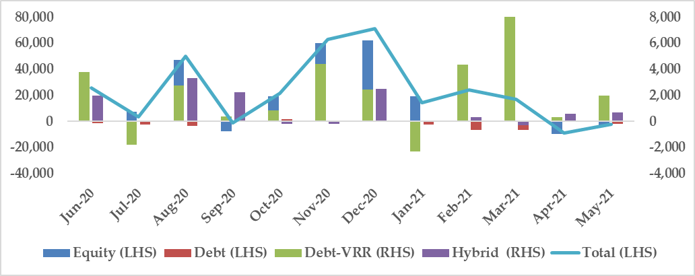
Source: CDSL and NSDL

- Trends in Portfolio Management Services
- As at end of May 2021, AUM of the portfolio management industry stood at ₹21.3 lakh crore compared to ₹20.7 lakh crore at the end of April 2021.
- There were 1,28,994 total clients in portfolio management industry as at the end of May 2021, of which 1,19,211 clients belong to discretionary services category, 8,073 clients belong to non-discretionary services category and 1,710 clients belong to advisory services category of portfolio management services.

- Trends in Substantial Acquisition of Shares and Takeovers

During May 2021, three open offers with offer value of ₹1,400 crore were closed under SEBI (Substantial Acquisition of Shares and Takeover) Regulations, 2011 (SAST Regulations) as against six open offers with offer value of ₹5,975 crore in April 2021. All three open offers were for change in control of management.

Figure 13: Details of Open Offers Closed under the SEBI (SAST) Regulations

IX. Commodity Derivatives Markets

- Market Trends

- During May 2021, MCX iCOMDEX composite index witnessed an increase of 3 per cent (M-o-M). This increase was driven by futures prices of energy, bullion, base metals (copper and zinc) and agri. (cotton and rubber) segments. On Y-o-Y basis, MCX iCOMDEX composite index increased by 31.6 per cent.
- During the month, MCX iCOMDEX crude oil index increased by 2.6 per cent on account of increase in futures price of crude oil by 3.1 per cent. MCX iCOMDEX bullion index increased by 4.7 per cent due to increase in futures prices of both gold and silver by 5.6 per cent and 6.5 per cent, respectively. MCX iCOMDEX base metal index also increased marginally by 0.7 per cent as the futures prices of copper and zinc increased by 0.1 per cent and 0.5 per cent respectively.
- NKrishi index increased marginally by 0.6 per cent (M-o-M) as mixed trend recorded in futures prices among its constituent commodities. Futures prices of five out of 10 constituent commodities of the index viz. guarseed, RM seed, cottonseed oilcake, coriander and gur witnessed an upend. On Y-o-Y basis, NKrishi index increased by 48.7 per cent.
- Movement in MCX iCOMDEX composite Index and NKrishi Index during May 2021 is given in Figure 14 and the monthly data of these indices is provided in Table 64.

Figure 14: Movement of Commodity Derivatives Market Indices during May 2021

Source: MCX and NCDEX

Table 4: Snapshot of Indian Commodity Derivatives Markets

Items | 2020-21 | Apr - 2021 | May -2021 | Percentage variation  M-o-M
- Indices
Nkrishi | 4,223.5 | 4,711.3 | 4,741.0 | 0.6
MCX iCOMDEX | 10,415.1 | 11,126.9 | 11,456.9 | 3.0
- Turnover (₹crore)
All-India | 92,22,927.2 | 6,91,010.9 | 8,22,175.8 | 19.0
MCX, of which | 82,64,585.1 | 5,67,936.1 | 7,09,903.4 | 25.0
Futures | 80,25,006.1 | 5,38,189.8 | 6,68,165.6 | 24.2
Options | 2,39,579.0 | 29,746.3 | 41,737.8 | 40.3
BSE, of which | 6,10,023.0 | 66,274.8 | 68,167.0 | 2.9
Futures | 4,958.8 | 185.4 | 195.3 | 5.4
Options | 6,05,064.2 | 66,089.4 | 67,971.7 | 2.8
NCDEX, of which | 3,18,813.8 | 55,231.4 | 42,923.0 | -22.3
Futures | 3,18,780.6 | 55,196.6 | 42,920.5 | -22.2
Options | 33.2 | 34.8 | 2.5 | -92.8
NSE, of which | 27,839.0 | 1,549.6 | 1,159.9 | -25.2
Futures | 5,483.7 | 599.0 | 313.7 | -47.6
Options | 22,355.3 | 950.7 | 846.2 | -11.0
ICEX (Futures) | 1,666.2 | 19.0 | 22.5 | 18.9
Source: MCX, BSE, NCDEX, NSE, ICEX.

B. Turnover

- During May 2021, pan- India turnover of the commodity derivatives increased by 19.0 per cent to ₹8,22,175.8 crore. This increase was driven by 23.0 per cent more turnover of non-agri. segment, which accounted for 93.4 per cent of the total turnover. However, the turnover of agri. segment decreased by 21 per cent. The agri. segment contributed 6.6 per cent to the total turnover. In terms of product wise segments, futures and options contracts contributed 86.6 per cent and 13.4 per cent to the total turnover.
- Among the exchanges, the turnover increased at MCX, BSE and ICEX while, it decreased at NCDEX and NSE .
- The turnover at MCX increased by 25 per cent to ₹7,09,903.4 crore during May 2021, driven bullion and metal futures which increased by 27.8 per cent and 62.7 per cent respectively. However, turnover in futures contracts of agri. and energy segments declined by 14.4 per cent and 2.2 per cent, respectively. The turnover in iCOMDEX bullion and iCOMDEX metal index futures increased by 26.8 per cent and 102.5 per cent to ₹ 4,668.3 crore and ₹ 3,594.1 crore respectively.
- The notional turnover of options contracts at MCX increased by 40.3 per cent to ₹41,738 crore during the month. The options turnover of all the three segments namely, bullion, metals and energy traded at MCX recorded an increase of 86.4 per cent, 121.4 per cent and 18.3 per cent, respectively. The turnover in options contracts contributed 5.9 per cent to the total turnover at MCX.
- During May 2021, the total turnover at BSE increased by 2.9 per cent to ₹68,167.0 crore. Options on gold accounted more than 99.7 per cent of the turnover of commodity derivatives contracts at BSE. The turnover in futures contracts of agri. segment increased by 5.4 per to ₹184.7 crore.
- During the month, the total turnover at NCDEX decreased by 22.3 per cent to ₹ 42,923.0 crore. This is on account of decrease in traded volume of 13 out of total 15 traded commodities. Turnover in Agridex futures Index also decreased to ₹ 5.1 crore from ₹ 9.4 crore recorded during last month. On the other hand, steel long contracts of non-agri. segment registered a total turnover of ₹15.9 crore during the month, an increase of 37.1 per cent over the last month.
- The total turnover at NSE decreased by 25.2 per cent to ₹1,159.9 crore in May 2021 on account of decrease in turnover in agri. futures and bullion options contracts by 47.6 per cent and 11 per cent respectively. The gold mini options and crude degummed soybean oil futures contract contributed 73 per cent and 26.5 per cent to the total turnover at NSE.
- In May 2021, the total turnover at ICEX, increased by 18.9 per cent to ₹22.5 crore due to decrease in turnover of agri. and steel long contracts by 25.6 per cent and 17.6 per cent respectively.
- The trends in turnover of agricultural and non-agricultural commodities at exchanges is shown in Figures 15, 16 and 17 and the details are given in Tables 65 to 69.

Figure 15: Trends in Turnover of Agricultural Commodity Derivatives

Source: MCX, NCDEX, NSE, BSE & ICEX

Figure 16: Trends in Turnover of Non-Agricultural Futures contracts

Source: MCX, NCDEX, NSE, BSE & ICEX.

Figure 17: Trends in Turnover of Non-Agricultural Options contracts

Source: MCX, BSE & NSE.

OVERVIEW OF THE GLOBAL FINANCIAL MARKETS

- The JPMorgan Global Composite Purchasing Managers’ Index (PMI), compiled by IHS Markit, decreased to 56.6 points in June 2021, up from 58.5 in May 2021. A reading of PMI above 50 means growth or expansion in economic activity.

- In its latest release of World Economic Outlook, International Monetary Fund (IMF) estimated that during 2020, the world output shrank by 3.2 per cent. The world economy is projected to grow at 6.0 per cent in 2021. The advanced economies are expected to grow at 5.6 per cent whereas emerging market growth rate is estimated as 6.3 per cent during 2021.

- The emerging markets outperformed developed equity markets in May 2021. MSCI Emerging Market (EM) index increased by 2.1 per cent in May 2021 over the previous month, while MSCI Developed Market Index increased by 1.3 per cent during same period.

- The volatility in the equity markets decreased during May 2021. The CBOE VIX index decreased to 16.8 at the end of May 2021 from 18.6 as at the end of last month.

- The US 10-year government bond yield decreased by 5 bps to 1.6 per cent during May 2021. The 10-year government bond yield of India decreased by 1 bps to 6.0 per cent at the end of May 2021, compared to end of the previous month.

- The WTI crude oil prices increased by USD 3.3 per barrel (or by 5.2 per cent) to USD 66.9 per barrel in May 2021. Gold prices increased by 7.8 per cent to USD 1,906.4 at the end of May 2021 from USD 1,768.6 at the end of April 2021.

- As per the latest estimate, the US economy expanded by 6.3 per cent Q-o-Q in annualised terms in the Q1 of 2021, compared to 4.5 per cent increase during the previous quarter. The US unemployment rate decreased to 5.8 per cent in May 2021 from 6.1 per cent in the previous month.

- The UK economy shrank by 1.6 per cent Q-o-Q in Q1 of 2021 against 1.3 per cent expansion in the previous quarter. The UK unemployment rate was observed to be 4.8 for May 2021.

- The Eurozone economy shrank by 0.3 per cent Q-o-Q in Q1 of 2021, after shrinking by 0.6 per cent in previous quarter. Amongst the largest economies of Eurozone a contraction was observed in Germany (-1.8 per cent), France (-0.1 per cent), Netherlands (-0.5 per cent) and Spain (-0.5 per cent).

- GDP growth of China was 0.4 per cent in Q1 of 2021, however, it was less than the growth in the previous quarter. Growth rate in GDP was of 3.2 per cent in Q4 of 2020 in China. According to IMF projections, the Chinese economy is expected to grow at the rate of 8.1 per cent in 2021 and at 6.4 per cent in 2022.

- As per MOSPI, India’s GDP grew by 1.6 per cent Y-o-Y during Q4 of 2020-21 compared to a Y-o-Y growth rate of 1.6 per cent in Q3 of 2020-21. In Q4 of 2020-21, the business activity in mining and quarrying declined by 5.7 per cent and hotels, transport, communication service declined by -2.3 per cent. Increase in growth rates was observed in public administration services, manufacturing and construction which grew by 2.3, 6.9 per cent and 14.5 per cent respectively in Q4 of 2020-21.

- According to the second advance estimates of GDP released by MOSPI on 31 May 2021, GDP of India is estimated to fall by 7.3 per cent during the 2020-21 as compared to 4.0 per cent expansion in 2019-20. World Bank estimated India’s GDP to contract by -7.3 per cent in 2020. According to IMF projections, the Indian economy is expected to contract by -7.3 per cent in 2020 and 9.5 per cent in 2021.

- Retail inflation (CPI Inflation) in India observed to be 6.3 per cent in May 2021 compared to 6.5 per cent in a month earlier. General IIP was observed to be 116.6, for mining it was observed at 161.9, for manufacturing 113.5 and for electricity 108.0.

Market Trends –

Equity Markets (Figures 1-2, Table A1)-
- In the month of May 2021, highest annualized monthly volatility amongst the BRICS countries was observed in Brazil IBOVESPA (18.7 per cent) followed by India (Sensex; 16.1 per cent and Nifty; 14.0 per cent) and South Africa FTSE (16.1 per cent). The lowest annualized volatility among BRICS was observed for Shanghai Composite (12.1 per cent) followed by Russian Traded (14.3 per cent). Among the developed markets, highest annualized volatility was observed in Japan Nikkei (23.2 per cent) and the lowest was observed at South Korea KOSPI (13.6 per cent).

- In most of the analyzed markets, an increase was observed in the indices during May 2021 over the previous month. Amongst BRICS nations, an increase was observed in Russian Traded (7.9 per cent), followed by India’s Nifty 50 & S&P BSE SENSEX (6.5 per cent each) and Brazil IBOVESPA grew by 6.2 per cent. Shanghai Composite grew by 4.9 per cent whereas South Africa FTSE grew by 1.5.

- Among the developed economies, in the month of May 2021, highest indices growth was observed for France CAC 40 (2.8 per cent) followed by USA Dow Jones (1.9 per cent). A decrease in monthly growth was observed in Nasdaq COMPOSITE (-1.5 per cent) and Singapore STI (1.7 per cent). Growth in UK FTSE 100, Japan Nikkei and German DAX were 0.8, 0.2 and 1.9 per cent respectively over the previous month.

Figure 1: Stock Market Trends in Selected Developed Markets

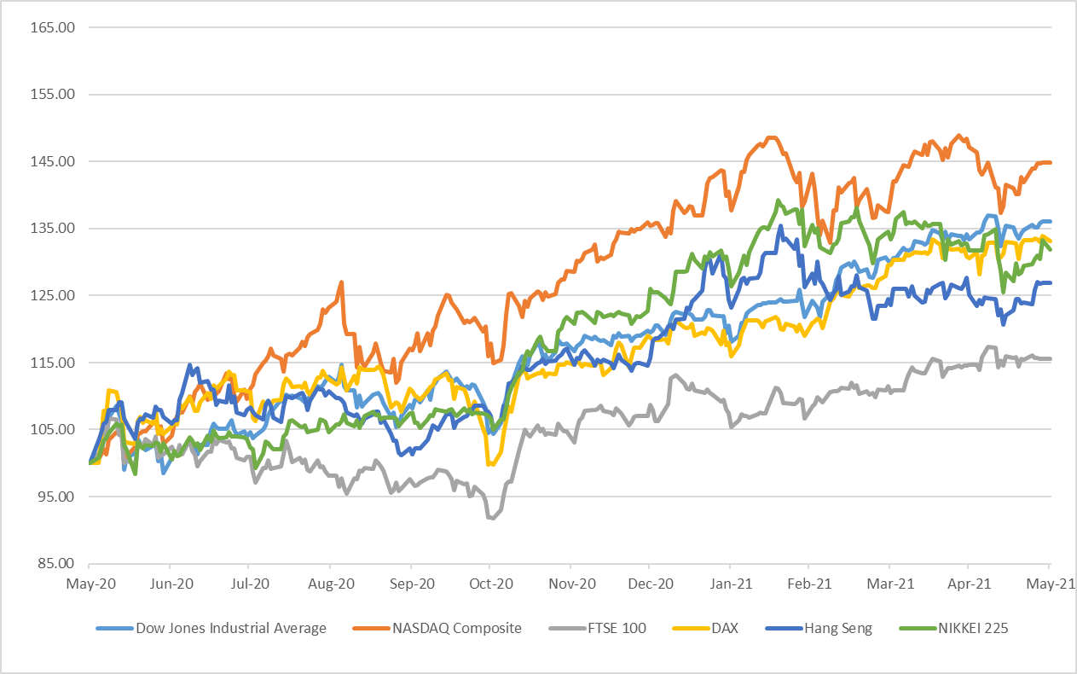

Note: All indices have been normalised to 100 on 31 May 2020.

Source: Refinitiv

Figure 2: Stock Market Trends in Selected Emerging Markets
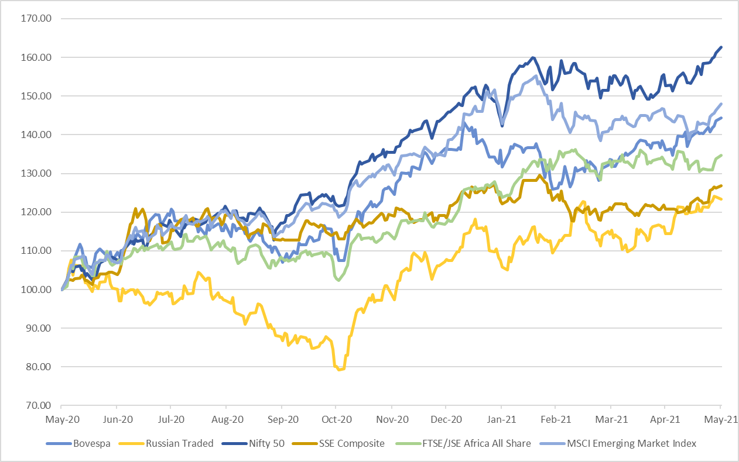

Note: All indices have been normalised to 100 on 31 May 2020.

Source: Refinitiv

Bond Market (Figures 3-4)
- Among the countries analysed, for bond yield, 10-year bond yield in May 2021, a negative change was observed for most developed and developing economies (Chart 3 & 4).

Figure 3: Movement of 10-year Government Bond Yields in Developed Nations

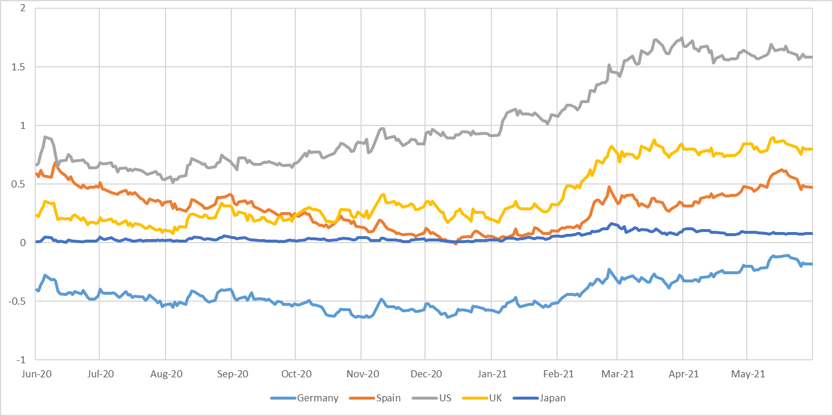

Source: Refinitiv

Figure 4: Movement of 10-year Government Bond Yields in BRIC Nations

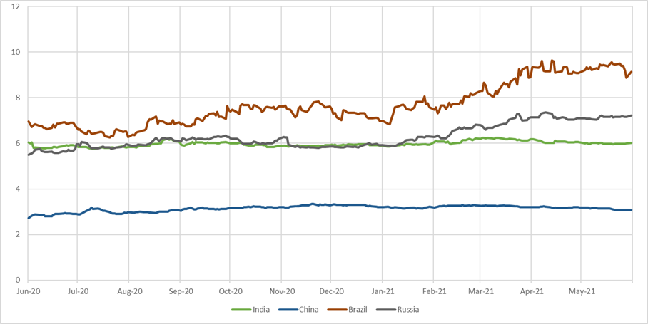

Source: Refinitiv

Fund Mobilisation by Issuance of Equity and Bonds (Table A2) –
- There was 6.1 per cent decrease in the fund mobilization at the selected analyzed exchanges world-wide during April 2021 (at 468,934 million USD) against previous month (at 499,345 million USD). Only 14.5 per cent of the total fund mobilization in April 2021 was in equity and remaining was in debt.
- As per the data available on World Federation of Exchanges (WFE), highest amount mobilized through equities and bonds in April 2021 was at Shanghai Stock Exchange (75,124 million USD) followed by Korea Exchange (69,026 million USD) and LSE Group London Stock Exchange (62,394 million USD).
- In April 2021, at Shanghai Stock Exchange, only 7,217 million USD were raised through equity and the remaining amount was raised through bonds whereas fund mobilization through equity was 113 million USD and 4,179 million USD respectively at Korea Exchange and LSE Group London Stock Exchange.
- Maximum fund mobilization through equities in April 2021 was at Hong Kong Exchanges and Clearing (12,614 million USD) followed by BME Spanish Exchanges (10,870 million USD).

Market Capitalisation of Major Exchanges (Table A3) –

- Most of the analysed exchanges of selected markets, reflected a rise in market capitalization in the month of April 2021 as compared to previous month.
- Among the exchanges which registered highest increase in market capitalization were B3 - Brasil Bolsa Balcão, Nasdaq - US, and Shenzhen Stock Exchange (6.8, 6.1 and 5.9 per cent respectively). Among the analysed exchanges, a decline in market capitalization was observed for Singapore Exchange (-2.4 per cent) and Japan Exchange Group (-1.4 per cent).

Derivatives (Figures 5-6, Table A4–A8) –

- During April 2021, the highest number of single stock futures contracts traded was at Borsa Istanbul (103,821,886) followed by Korea Exchange (100,740,437). Notional turnover of single stock futures was highest for NSE in April 2021. The highest number of single stock options were traded at Nasdaq - US (183,872,517) followed by Cboe Global Markets (120,857,606).
- During April 2021, the highest number of stock index futures contracts traded was at B3 - Brasil Bolsa Balcão (325,963,003) followed by CME Group (86,824,274). The highest number of stock index options were traded at NSE (902,264,117) which also recorded the highest notional turnover in this segment. Second highest number of stock index options were traded at Korea Exchange (50,444,695).
- Highest number of currency futures contracts were traded at Moscow Exchange (86,921,808) followed by NSE (77,097,710). The highest number of currency options were traded at NSE (119,090,619) which also recorded the highest notional turnover in this segment. NSE was followed by Moscow Exchange (2,434,798) in the currency options segment.
- In April 2021, the highest number of interest rate futures were traded at CME Group (111,693,023) followed by B3 - Brasil Bolsa Balcão (43,578,141). Highest number of interest rate options were traded at CME Group (36,577,125) followed by B3 - Brasil Bolsa Balcão (11,231,853).
- The highest number of commodity futures contracts were traded at Zhengzhou Commodity Exchange (220,290,729) followed by Shanghai Futures Exchange (217,593,015) in April 2021. Among the commodity options the highest number of contracts were traded at CME Group (11,983,674) followed by Zhengzhou Commodity Exchange (5,366,060) during the same period.
- In May 2021, most of the analysed currencies appreciated against dollar. Yen was the only currency to depreciate among the analysed currencies.

US Treasury Securities (Table A9)

- At the end of May 2021, Japan was the biggest foreign holder of US Treasury Securities holding 17.7 per cent of the total US treasury Securities followed by China with 15.1 per cent. The total foreign holding of US Treasury Securities at the end of May 2021 was USD 7,135 billion. The holdings of US Treasury Securities by India remained at 3.0 per cent at the end of May 2021.

Figure 5: Movement of the Major Currencies against USD
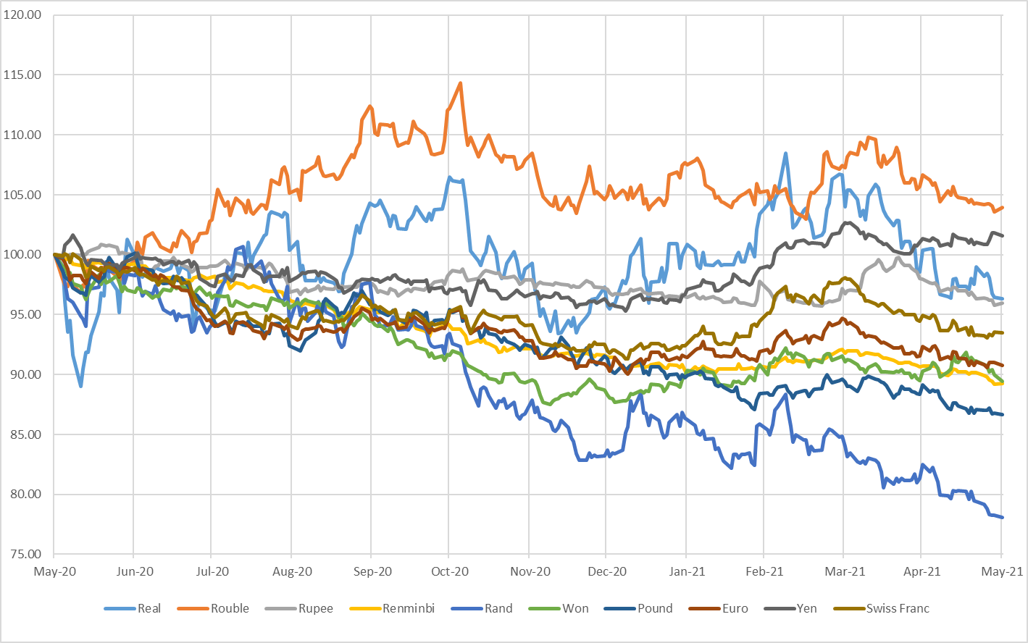
Note: All indices have been normalised to 100 on 31 May 2020.

Source: Refinitiv

Figure 6: Movement of the US Dollar Index and MSCI EM Currency Index

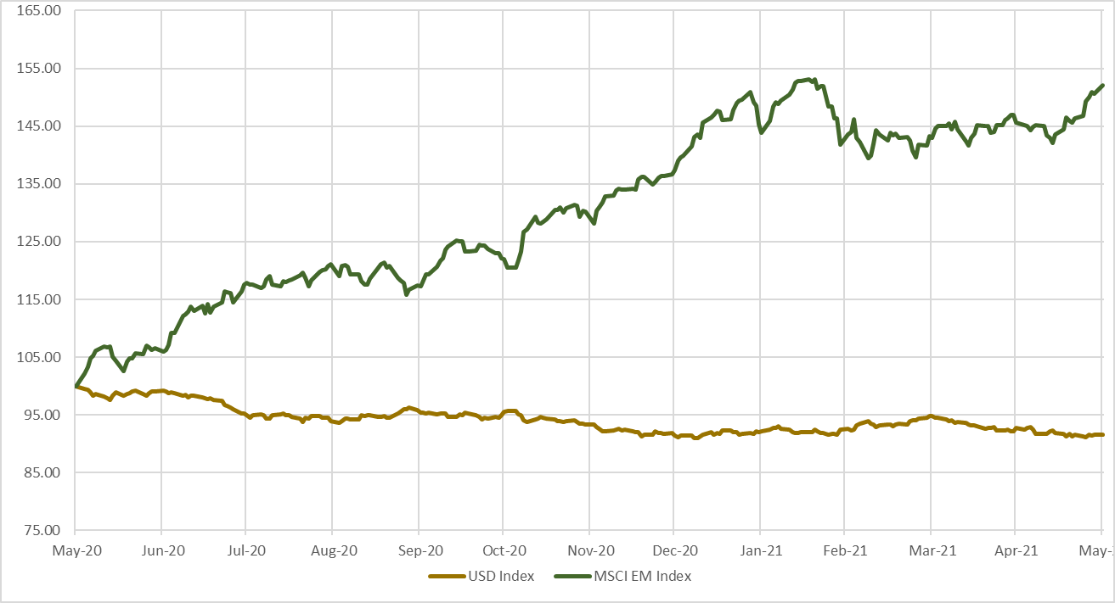
Note:
- All indices have been normalised to 100 on 31 May 2020.
- The U.S. Dollar Index is an index of the value of the United States dollar relative to a basket of foreign currencies. The Index goes up when the U.S. dollar gains value compared to other currencies. The index is maintained and published by Intercontinental Exchange. It is a weighted geometric mean of the dollar's value relative to following select currencies: Euro, Japanese yen, Pound sterling, Canadian dollar, Swedish krona, Swiss franc.
- The MSCI Emerging Markets (EM) Currency Index tracks the performance of twenty-five emerging-market currencies relative to the US Dollar.

Source: Refinitiv

Table A1: Performance of Stock Indices
Country | Name of the Index | Closing Value as on | Closing Value before |  |  |  | Monthly Volatility (Annualised) | P/E Ratio
 |  | 31-May-21 | 1-Month | 3-Month | 6-Month | 1-Year
BRICS Nations
Brazil | BRAZIL IBOVESPA | 126215.7 | 118893.8 | 110035.2 | 108893.3 | 87402.6 | 18.7 | 13.6
Russia | RUSSIAN TRADED | 2070.5 | 1919.7 | 1837.2 | 1632.6 | 1678.0 | 14.3 | 12.0
India | Nifty 50 | 15582.8 | 14631.1 | 14529.2 | 12969.0 | 9580.3 | 14.0 | 29.2
India | S&P BSE SENSEX | 51937.4 | 48782.4 | 49100.0 | 44149.7 | 32424.1 | 16.1 | 31.3
China | SHANGHAI SE COMPOSITE | 3615.5 | 3446.9 | 3509.1 | 3391.8 | 2852.4 | 12.1 | 13.1
South Africa | FTSE/JSE AFRICA ALL SHR | 67964.0 | 66937.0 | 66138.1 | 57091.9 | 50483.0 | 16.1 | 16.8
Developed Markets
USA | NASDAQ COMPOSITE | 13748.7 | 13962.7 | 13192.3 | 12198.7 | 9489.9 | 21.8 | NA
USA | DOW JONES INDUS. AVG | 34529.5 | 33874.9 | 30932.4 | 29638.6 | 25383.1 | 15.2 | 22.7
France | CAC 40 | 6447.2 | 6269.5 | 5703.2 | 5518.6 | 4695.4 | 17.1 | 27.2
Germany | DAX | 15421.1 | 15135.9 | 13786.3 | 13291.2 | 11586.9 | 17.6 | 18.8
UK | FTSE 100 | 7022.6 | 6969.8 | 6483.4 | 6266.2 | 6076.6 | 17.7 | 17.6
Hong Kong | HANG SENG | 29151.8 | 28724.9 | 28980.2 | 26341.5 | 22961.5 | 16.0 | 14.4
South Korea | KOSPI | 3203.9 | 3147.9 | 3013.0 | 2591.3 | 2029.6 | 13.6 | NA
Japan | NIKKEI 225 | 28860.1 | 28812.6 | 28966.0 | 26433.6 | 21877.9 | 23.2 | 17.1
Singapore | STRAITS TIMES STI | 3164.3 | 3218.3 | 2949.0 | 2806.0 | 2510.8 | 14.1 | 13.8
Taiwan | TAIWAN TAIEX | 17068.4 | 17566.7 | 15953.8 | 13722.9 | 10942.2 | 34.8 | 17.3

Note: * P/E Ratios as on the last trading day of month. Trailing PE ratio has been used from Refinitiv for all Indices apart from Sensex, Nifty 50, Kospi, Nikkei and Taiwan Taiex. Data for Sensex and Nifty was taken from respective exchange website. Refinitiv data is as on 05 July 2021.
Source: Refinitiv, BSE and National Stock Exchange

Table A2: Fund Mobilisation by Issuance of Equity and Bond in Major Exchanges (USD million)
Month | Mar-21 |  |  | Apr-21
Exchange Name | Bond | Equity | Total | Bond | Equity | Total
NYSE | NA | 13,117 | 13,117 | NA | 3,840 | 3,840
ASX Australian Securities Exchange | NA | 4,903 | 4,903 | NA | 4,681 | 4,681
Hong Kong Exchanges and Clearing | 11,639 | 12,186 | 23,825 | 24,892 | 12,614 | 37,506
Japan Exchange Group | 8,047 | 4,104 | 12,151 | 8,428 | 1,303 | 9,731
Korea Exchange | 60,339 | 1,148 | 61,488 | 68,913 | 113 | 69,026
National Stock Exchange of India | 54,302 | 0 | 54,302 | 35,374 | 1,472 | 36,846
Shanghai Stock Exchange | 67,765 | 12,441 | 80,206 | 67,908 | 7,217 | 75,124
Shenzhen Stock Exchange | 14,747 | 6,039 | 20,786 | 45,123 | 8,516 | 53,639
Singapore Exchange | 37,198 | 20 | 37,218 | 28,165 | 913 | 29,078
BME Spanish Exchanges | 47,336 | 6,527 | 53,863 | 41,974 | 10,870 | 52,843
Deutsche Boerse AG | 44,503 | 106 | 44,608 | 0 | 1,907 | 1,907
Euronext | NA | 6,696 | 6,696 | 0 | 10,120 | 10,120
Johannesburg Stock Exchange | 4,427 | 227 | 4,654 | 4,363 | 44 | 4,407
LSE Group London Stock Exchange | 62,530 | 3,847 | 66,376 | 58,216 | 4,179 | 62,394
Moscow Exchange | 15,150 | 0 | 15,150 | 17,791 | 0 | 17,791
Grand Total | 427,983 | 71,361 | 499,345 | 401,146 | 67,788 | 468,934
Note: For Funds mobilised through issuance of bonds, data may differ due to different reporting rules & calculation methods. Fund mobilisation data for equities are (i) excluding investment funds and (ii) including Alternative and SME Markets except the following exceptions:
- Australian Securities Exchange: including investment funds
- BME: Including investment companies listed (open-end investment companies).
- Euronext: includes Belgium, England, France, Netherlands and Portugal
- Korea Exchange: including Kosdaq market data
- LSE Group: includes London Stock Exchange and BorsaItaliana
- Nasdaq Nordic Exchanges include Copenhagen, Helsinki, Iceland, Stockholm, Tallinn, Riga and Vilnius Stock Exchanges
- NSE India: including “Emerge” market data

NA = Not Available
Source: World Federation of Exchanges

Table A3: Domestic Market Capitalisation of Major Exchanges (USD billion)
Exchnage | Mar-21 | Apr-21 | % Change MoM
Nasdaq - US | 19,790 | 20,991 | 6.1%
NYSE | 23,559 | 24,676 | 4.7%
LSE Group | 4,315 | NA | NA
Deutsche Boerse AG | 2,447 | 2,540 | 3.8%
BME Spanish Exchanges | 774 | 819 | 5.9%
Japan Exchange Group | 6,760 | 6,665 | -1.4%
Singapore Exchange | 702 | 685 | -2.4%
Hong Kong Exchanges and Clearing | 6,697 | 6,869 | 2.6%
Korea Exchange | 2,231 | 2,324 | 4.2%
ASX Australian Securities Exchange | 1,754 | 1,855 | 5.8%
B3 - Brasil Bolsa Balcão | 913 | 975 | 6.8%
Moscow Exchange | 746 | 752 | 0.8%
National Stock Exchange of India | 2,775 | 2,776 | 0.0%
Shanghai Stock Exchange | 6,920 | 7,069 | 2.2%
Shenzhen Stock Exchange | 5,040 | 5,339 | 5.9%
Johannesburg Stock Exchange | 1,131 | 1,155 | 2.2%

NA: Not Available

Source: World Federation of Exchanges

Note:
- The figures provided in some versions of SEBI Bulletin are sourced from Refinitiv which provides country wise market capitalization data (estimated internally by Refinitiv).
- The figures provided World Federation of Exchanges are more detailed and are provided by respective member exchanges.
- As per the data available as on 02 August 2021.

Table A4: Stock Futures and Stock Options Traded in Major Exchanges

Notional Turnover in (USD million)
Exchange | Apr-21
 | Single Stock Futures |  |  | Single Stock Options
 | Number of | Notional | Open | Number of | Notional | Open
 | Contracts Traded | Turnover | Interest | Contracts Traded | Turnover | Interest
B3 - Brasil Bolsa Balcão | 65,136,300 | 340 | 33,624,200 | 120,407,640 | 41,278 | 48,046,403
Bolsa de Valores de Colombia | 2,578 | 4 | 9,306 | 0 | 0 | 0
Bolsa Mexicana de Valores | 10 | 0 | 3,750 | 3,500 | 1 | 14,000
Cboe Global Markets | NA | NA | NA | 120,857,606 | NA | 276,857,503
Nasdaq - US | NA | NA | NA | 183,872,517 | NA | NA
MIAX Exchange Group | NA | NA | NA | 68,198,432 | 1,496,189 | NA
ASX Australian Securities Exchange | 35,711 | 65 | 305,121 | 3,677,111 | 9,019 | 5,832,252
Hong Kong Exchanges and Clearing | 166,796 | 1,003 | 38,615 | 10,693,466 | 59,610 | 10,877,333
Japan Exchange Group | NA | NA | NA | 20,055 | NA | 34,225
Korea Exchange | 100,740,437 | 82,619 | 7,510,854 | 147,171 | NA | 43,341
National Stock Exchange of India | 16,938,642 | 213,344 | 3979,705,975 | 33,764,649 | 445,013 | 1596,782,036
Singapore Exchange | 283,069 | NA | 48,625 | NA | NA | NA
Taiwan Futures Exchange | 7,245,298 | 46,545 | 593,294 | 11,588 | 150 | 5,276
Thailand Futures Exchange | 4,489,735 | NA | 2,568,948 | NA | NA | NA
Athens Stock Exchange | 1,017,829 | 185 | 599,659 | 674 | 1 | 436
BME Spanish Exchanges | 21,306 | 18 | 1,509,860 | 807,404 | 668 | 7,091,177
Borsa Istanbul | 103,821,886 | 10,711 | 8,573,685 | 590,492 | 63 | 959,306
Budapest Stock Exchange | 7,356 | 49 | 7,279 | 0 | 0 | 0
Deutsche Boerse AG | 9,216,411 | 46,976 | 8,913,640 | 17,656,805 | 77,870 | 66,504,378
Euronext | 2,402,741 | 11,826 | 2,846,732 | 5,905,293 | 26,126 | 16,411,642
Moscow Exchange | 17,418,370 | 4,904 | 1,911,506 | 227,430 | 69 | 506,740
Nasdaq Nordic and Baltics | 147,515 | 434 | 140,542 | 1,285,285 | 3,196 | 3,685,232
Tehran Stock Exchange | NA | NA | NA | 4,087,771 | 47 | NA
Tel-Aviv Stock Exchange | NA | NA | NA | 85,780 | 0 | 96,426
Warsaw Stock Exchange | 147,542 | 313 | 45,249 | NA | NA | NA
Dubai Gold and Commodities Exchange | 1,776 | 5 | 184 | NA | NA | NA
Grand Total | 329,241,308 | 419,343 | 4048,957,024 | 572,300,669 | 2,159,301 | 2033,747,706
NA: Not Available
Source: World Federation of Exchanges

Table A5: Index Futures and Index Options Traded in Major Exchanges
Notional Turnover in (USD million)
Exchange | Apr-21
 | Stock Index Futures |  |  | Stock Index Options
 | Number of  Contracts Traded | Notional  Turnover | Open  Interest | Number of  Contracts Traded | Notional  Turnover | Open  Interest
B3 - Brasil Bolsa Balcão | 325,963,003 | 1,491,559 | 582,747 | 4,295,617 | 4,981 | 572,512
Bolsa de Valores de Colombia | 2,976 | 3 | 5,783 | NA | NA | NA
Bolsa Mexicana de Valores | 16,473 | 386 | 17,101 | 302 | 7 | 199
Cboe Global Markets | NA | NA | NA | 36,703,334 | NA | 23,260,143
Nasdaq - US | NA | NA | NA | 472,441 | NA | NA
MIAX Exchange Group | 1,561 | NA | 8 | 5,535 | 15 | NA
Matba Rofex | 68,240 | 48 | 1,840 | 616 | 0 | 0
CME Group | 86,824,274 | 10,975,695 | 4,749,446 | 11,363,174 | 2,550,966 | 2,803,273
Cboe Futures Exchange | 4,177,642 | NA | 368,297 | NA | NA | NA
ASX Australian Securities Exchange | 683,215 | 91,127 | 252,919 | 379,117 | 19,963 | 420,912
Hong Kong Exchanges and Clearing | 7,023,311 | 697,220 | 522,639 | 1,531,430 | 163,869 | 1,611,144
Japan Exchange Group | 18,859,056 | 944,726 | 1,567,392 | 1,937,537 | NA | 1,551,456
Korea Exchange | 7,569,384 | 481,300 | 569,964 | 50,444,695 | 4,562,548 | 2,651,902
National Stock Exchange of India | 7,756,774 | 97,898 | 12,233,610 | 902,264,117 | 11,212,614 | 141,148,190
Singapore Exchange | 12,287,913 | NA | 1,341,329 | 516,560 | NA | 1,645,301
Taiwan Futures Exchange | 8,097,593 | 540,217 | 166,564 | 16,002,711 | 491,284 | 442,171
Thailand Futures Exchange | 2,838,359 | NA | 335,041 | 96,893 | NA | 47,020
Bursa Malaysia Derivatives | 214,089 | 3,900 | 33,557 | 544 | 0 | 127
China Financial Futures Exchange | 5,608,164 | 1,160,216 | 545,398 | 2,227,880 | 2,873 | 168,868
Athens Stock Exchange | 27,812 | 145 | 7,926 | 3,968 | 21 | 2,005
BME Spanish Exchanges | 492,796 | 43,706 | 111,109 | 66,263 | 684 | 600,624
Borsa Istanbul | 7,495,193 | 13,112 | 539,881 | 19,974 | 36 | 20,809
Budapest Stock Exchange | 30,923 | 44 | 12,270 | 0 | 0 | 0
Deutsche Boerse AG | 23,701,689 | 1,375,849 | 10,192,127 | 26,502,004 | 1,129,725 | 52,224,813
Euronext | 2,469,836 | 219,190 | 656,333 | 1,185,175 | 91,964 | 628,116
Moscow Exchange | 14,462,864 | 41,124 | 503,640 | 1,505,592 | 4,383 | 441,482
Nasdaq Nordic and Baltics | 2,432,966 | 63,597 | 433,086 | 483,610 | 12,692 | 395,106
Tel-Aviv Stock Exchange | NA | NA | NA | 1,577,624 | 79,352 | 124,796
Warsaw Stock Exchange | 357,070 | 3,765 | 34,456 | 19,211 | 102 | 18,652
Grand Total | 539,463,176 | 18,244,826 | 35,784,463 | 1059,605,924 | 20,328,079 | 230,779,621

NA: Not Available.

Source: World Federation of Exchanges

Table A6: Currency Futures and Options Traded in Major Exchanges
Notional Turnover in (USD million)
Exchange | Apr-21
 | Currency Futures |  |  | Currency Options
 | Number of  Contracts Traded | Notional  Turnover | Open  Interest | Number of  Contracts Traded | Notional  Turnover | Open  Interest
B3 - Brasil Bolsa Balcão | 72,590,890 | 975,846 | 2,432,625 | 403,437 | 335 | 838,597
Bolsa de Valores de Colombia | 22,770 | 950 | 12,511 | 4 | 0 | 8
Bolsa Mexicana de Valores | 132,322 | 1,326 | 616,986 | 1,620 | 16 | 4,105
Matba Rofex | 7,912,956 | 8,405 | 2,488,679 | 1,294 | 0 | 1,397
CME Group | 13,369,358 | 1,297,992 | 1,773,477 | 647,571 | 76,431 | 524,371
Hong Kong Exchanges and Clearing | 155,460 | 10,625 | 27,276 | 705 | 71 | 2,502
Korea Exchange | 8,070,210 | 80,853 | 933,020 | NA | NA | NA
National Stock Exchange of India | 77,097,710 | 80,998 | 4,430,297 | 119,090,619 | 120,290 | 3,471,214
Singapore Exchange | 2,236,144 | NA | 136,586 | 306 | NA | 331
Taiwan Futures Exchange | 20,441 | 613 | 2,584 | 0 | 0 | 385
Thailand Futures Exchange | 332,875 | NA | 41,781 | NA | NA | NA
Borsa Istanbul | 6,294,151 | 6,423 | 1,916,062 | 31,439 | 31 | 31,827
Budapest Stock Exchange | 617,774 | 734 | 519,897 | 0 | 0 | 0
Moscow Exchange | 86,921,808 | 90,342 | 3,793,294 | 2,434,798 | 2,583 | 2,008,934
Tel-Aviv Stock Exchange | NA | NA | NA | 1,176,775 | 11,852 | 622,304
Dubai Gold and Commodities Exchange | 650,475 | 3,575 | 177,020 | 0 | 0 | 0
Grand Total | 276,425,344 | 2,558,683 | 19,302,095 | 123,788,568 | 211,610 | 7,505,975

NA: Not Available

Source: World Federation of Exchanges

Table A7: Interest Rate Futures and Options Traded in Major Exchanges
Notional Turnover in (USD million)
Exchange | Apr-21
 | Interest Rate Futures |  |  | Interest Rate Options
 | Number of  Contracts Traded | Notional  Turnover | Open  Interest | Number of  Contracts Traded | Notional  Turnover | Open  Interest
B3 - Brasil Bolsa Balcão | 43,578,141 | 989,845 | 30,772,200 | 11,231,853 | 77 | 30,899,731
Bolsa de Valores de Colombia | 9,770 | 672 | 13,393 | NA | NA | NA
Bolsa Mexicana de Valores | 0 | 0 | 4,000 | NA | NA | NA
CME Group | 111,693,023 | 59,184,865 | 28,002,403 | 36,577,125 | 20,406,520 | 41,935,885
ASX Australian Securities Exchange | 7,463,603 | 1,175,868 | 3,401,766 | 700 | 54 | 0
Japan Exchange Group | 495,842 | NA | 81,222 | 22,087 | NA | 2,405
Korea Exchange | 4,290,273 | 446,720 | 503,518 | NA | NA | NA
National Stock Exchange of India | 120,931 | 319 | 27,378 | 0 | 0 | 0
Singapore Exchange | 13,294 | NA | 12,651 | NA | NA | NA
China Financial Futures Exchange | 1,810,049 | 305,490 | 244,160 | NA | NA | NA
Deutsche Boerse AG | 36,252,791 | 6,634,472 | 5,544,042 | 4,412,062 | 847,481 | 2,032,363
Moscow Exchange | 13,299 | 8 | 41,254 | NA | NA | NA
Nasdaq Nordic and Baltics | 194,033 | 22,911 | 1,566,878 | 457,249 | 53,991 | 0
Grand Total | 205,935,049 | 68,761,172 | 70,214,865 | 52,701,076 | 21,308,124 | 74,870,384

NA: Not Available

Source: World Federation of Exchanges

Table A8: Commodity Futures and Options Traded in Major Exchanges
Notional Turnover in (USD million)
Exchange | Apr-21
 | Commodities Futures |  |  | Commodities Options
 | Number of  Contracts Traded | Notional  Turnover | Open  Interest | Number of  Contracts Traded | Notional  Turnover | Open  Interest
B3 - Brasil Bolsa Balcão | 316,787 | 3,106 | 119,373 | 78,414 | 35 | 110,080
Matba Rofex | 85,991 | 1,586 | 60,511 | 16,550 | 13 | 24,696
CME Group | 73,677,402 | 4,367,532 | 13,863,773 | 11,983,674 | 614,529 | 10,958,538
ASX Australian Securities Exchange | 100,055 | 2,725 | 171,605 | 5,671 | 913 | 45,574
Hong Kong Exchanges and Clearing | 23,805 | 593 | 884 | NA | NA | NA
National Stock Exchange of India | 4,743 | 81 | 141 | 20,390 | 128 | 3,948
NZX Limited | 18,739 | 138 | 48,167 | 320 | 2 | 8,648
Singapore Exchange | 1,819,838 | NA | 1,134,626 | 343,206 | NA | 686,985
Taiwan Futures Exchange | 11,279 | 213 | 1,188 | 2,672 | 29 | 243
Thailand Futures Exchange | 768,297 | NA | 47,546 | NA | NA | NA
Bursa Malaysia Derivatives | 1,198,576 | 25,681 | 209,793 | 7,500 | 0 | 23,600
Zhengzhou Commodity Exchange | 220,290,729 | 1,448,242 | 8,804,384 | 5,366,060 | 632 | 756,351
Dalian Commodity Exchange | 179,228,157 | 1,651,722 | 7,963,762 | 5,242,329 | 867 | 887,966
Multi Commodity Exchange of India | 13,878,859 | 72,674 | 242,808 | 457,989 | 4,017 | 11,777
Shanghai Futures Exchange | 217,593,015 | 2,870,191 | 6,555,378 | 2,501,429 | 928 | 193,834
Borsa Istanbul | 9,895,655 | 3,023 | 1,428,456 | NA | NA | NA
Deutsche Boerse AG | 505,281 | 25,534 | 2,231,075 | 30,435 | 1,013 | 275,964
Euronext | 1,621,770 | 24,454 | 592,311 | 170,155 | 2,448 | 214,675
Moscow Exchange | 57,273,047 | 39,549 | 2,300,024 | 510,872 | 335 | 72,252
Dubai Gold and Commodities Exchange | 4,475 | 64 | 1,026 | NA | NA | NA
London Metal Exchange | 10,079,000 | 1,540,592 | 1,892,049 | 537,247 | 92,149 | 511,409
The Saint-Petersburg International Mercantile Exchange | 10,729 | 51 | 2,853 | NA | NA | NA
Grand Total | 788,406,229 | 12,077,752 | 47,671,733 | 27,274,913 | 718,040 | 14,786,540
NA: Not Available

Source: World Federation of Exchanges

Table A9: Major Foreign Holders of US Treasury Securities (USD billion)
Country/ Month |  |  |  |  | 2020 |  |  |  |  |  | 2021
 | May | Jun | Jul | Aug | Sep | Oct | Nov | Dec | Jan | Feb | Mar | Apr
Japan | 1261.6 | 1293 | 1278.4 | 1276.2 | 1273.1 | 1260.8 | 1251.3 | 1276.7 | 1258 | 1240.3 | 1276.8 | 1266.2
China, Mainland | 1074.4 | 1073.4 | 1068 | 1061.7 | 1054 | 1063 | 1072.3 | 1095.2 | 1104.2 | 1100.4 | 1096.1 | 1078.4
United Kingdom | 445.7 | 424.6 | 419.4 | 428.5 | 442.8 | 420.5 | 440.6 | 438.7 | 459.5 | 443.2 | 431.8 | 467.7
Ireland | 330.2 | 330.7 | 335.2 | 315.7 | 316.3 | 314.2 | 318.1 | 313.6 | 316 | 309.8 | 307 | 304.9
Luxembourg | 267.3 | 264.7 | 268.8 | 262.5 | 266.2 | 267.8 | 287.7 | 281.4 | 282.1 | 282.8 | 291 | 287.6
Switzerland | 247.3 | 250.4 | 253.4 | 255.4 | 255.5 | 253.3 | 255.5 | 254 | 257.8 | 254.8 | 261 | 264.9
Brazil | 264.1 | 265.7 | 265 | 265.1 | 262.9 | 262.2 | 258.3 | 260.4 | 259 | 255.5 | 255.3 | 251.8
Belgium | 218.8 | 211.8 | 214.9 | 218.1 | 239.5 | 240.5 | 253.5 | 248.2 | 236.7 | 235.8 | 234.8 | 236.4
Taiwan | 204.6 | 209.7 | 212 | 213.5 | 218.2 | 222.3 | 235.4 | 239.6 | 234.5 | 231.5 | 234 | 236.3
Cayman Islands | 229.6 | 222.3 | 229 | 231.6 | 221.5 | 222.9 | 222.9 | 217.6 | 216 | 215.2 | 226 | 228.7
Hong Kong | 262.2 | 262.7 | 246.7 | 241.7 | 226.6 | 223.8 | 224.1 | 223.9 | 225 | 227 | 215.9 | 224.1
India | 182.7 | 194.6 | 196.5 | 213.5 | 222.4 | 220.2 | 216.2 | 211.6 | 204.4 | 200 | 208.7 | 215.8
Singapore | 150.5 | 158.6 | 160.3 | 159 | 162 | 163.8 | 168.1 | 164.3 | 161.4 | 170.2 | 171.1 | 176.3
Saudi Arabia | 124.9 | 124.6 | 130 | 131.2 | 134.2 | 137.6 | 136.4 | 135.1 | 132.9 | 130.8 | 130.3 | 127.3
Korea | 122.7 | 123.1 | 122.7 | 123.2 | 119.1 | 122.8 | 130.9 | 125.2 | 125.7 | 122.9 | 120.3 | 123.2
Canada | 127.6 | 133.9 | 131.1 | 128 | 131.3 | 127.4 | 119.9 | 126.7 | 112.7 | 106 | 116.1 | 121.1
Norway | 88.7 | 89.9 | 90.6 | 90.5 | 82.9 | 89 | 87.5 | 91.5 | 97.6 | 94.4 | 109.3 | 113.6
France | 144.1 | 130 | 133.3 | 135.1 | 136.9 | 132.4 | 111.3 | 122 | 108.7 | 114.9 | 107.8 | 109.5
Germany | 79.4 | 78.2 | 78.7 | 74.7 | 74.2 | 73 | 75.4 | 74.8 | 73.5 | 77.6 | 77.8 | 77.1
Bermuda | 70.9 | 71.1 | 74.2 | 76.1 | 73.9 | 74 | 72.6 | 68.2 | 67.1 | 66.3 | 67.1 | 66.3
Netherlands | 69.4 | 71.2 | 68.5 | 69.2 | 69.7 | 71.7 | 69.7 | 69.8 | 66.1 | 65.8 | 65 | 63.7
Israel | 47.6 | 48.4 | 47.7 | 51.5 | 53.3 | 57 | 48.7 | 53.7 | 58.2 | 61 | 61.4 | 58.3
United Arab Emirates | 26.1 | 29.5 | 36.6 | 33.1 | 29.1 | 36.8 | 32.2 | 33.8 | 50.6 | 45.6 | 43.7 | 57.3
Thailand | 85.5 | 87.9 | 85.7 | 83.2 | 82 | 82 | 80 | 82.2 | 80.6 | 66.9 | 59.8 | 57
Poland | 39.7 | 42.5 | 43.8 | 44.1 | 46.1 | 47.5 | 50.5 | 53.3 | 53.2 | 52.6 | 52.5 | 54
Philippines | 44.2 | 43.8 | 47.6 | 46.7 | 47.3 | 48.6 | 43.3 | 48 | 50.8 | 50.9 | 50.7 | 50.2
Mexico | 47 | 47.6 | 49.5 | 49.2 | 48.8 | 52.7 | 49.4 | 49.8 | 49.4 | 48 | 48.4 | 49.1
Kuwait | 44.7 | 47.9 | 46.4 | 46.6 | 47.1 | 46.1 | 46.6 | 45.3 | 44.8 | 45.7 | 45.8 | 45.9
Australia | 43 | 43.8 | 42.9 | 39.3 | 39.5 | 40.6 | 39.8 | 41 | 40.5 | 41.3 | 42.9 | 45.4
Sweden | 39.1 | 40 | 38.3 | 38.2 | 37.7 | 37.7 | 40.3 | 42.2 | 40.8 | 40 | 41.3 | 43
Chile | 29.8 | 30.1 | 29.4 | 29.4 | 29.1 | 27.7 | 27.3 | 30.1 | 38.2 | 38.3 | 38 | 39.4
Vietnam | 30.3 | 29.9 | 30.1 | 30.4 | 32.6 | 31.9 | 33.2 | 37.4 | 37.3 | 37.8 | 37.3 | 38.9
Italy | 42.4 | 42.6 | 43.5 | 44 | 44.2 | 41.3 | 39.1 | 38.3 | 36.8 | 36.5 | 37.7 | 38.2
Colombia | 29.4 | 29.8 | 30.6 | 29.8 | 31.9 | 30.8 | 31 | 32.4 | 30.6 | 35.2 | 35.1 | 35.8
All Other | 536.6 | 548.3 | 533.3 | 533.4 | 518.5 | 507.2 | 501.8 | 493.4 | 487.9 | 483.6 | 472.7 | 481.7
Grand Total | 7052.1 | 7096.2 | 7082 | 7069.2 | 7070.4 | 7051.2 | 7070.8 | 7119.6 | 7098.7 | 7028.4 | 7070.3 | 7135
Of which:
For. Official | 4147.1 | 4191.2 | 4199.3 | 4198.9 | 4166.8 | 4176.2 | 4186.5 | 4224.6 | 4235.4 | 4202.2 | 4201.6 | 4226.1
Treasury Bills | 382.3 | 393.6 | 385 | 371.5 | 375.4 | 370.8 | 361 | 378.1 | 406.2 | 360.6 | 320.2 | 296.1
T-Bonds & Notes | 3764.8 | 3797.6 | 3814.3 | 3827.4 | 3791.3 | 3805.4 | 3825.6 | 3846.6 | 3829.2 | 3841.6 | 3881.4 | 3930
Note:
- Data available as on 16 July 2021
- The data in this table are collected primarily from U.S.-based custodians and broker-dealers. Since U.S. securities held in overseas custody accounts may not be attributed to the actual owners, the data may not provide a precise accounting of individual country ownership of Treasury securities (see TIC FAQ #7 at: http://www.treasury.gov/resource-center/data-chart-center/tic/Pages/ticfaq1.aspx)
- Estimated foreign holdings of U.S. Treasury marketable and non-marketable bills, bonds, and notes reported under the Treasury International Capital (TIC) reporting system are based on monthly data on holdings of Treasury bonds and notes as reported on TIC Form SLT, Aggregate Holdings of Long-Term Securities by U.S. and Foreign Residents and on TIC Form BL2, Report of Customers' U.S. Dollar Liabilities to Foreign Residents.
Source: Department of the Treasury/Federal Reserve Board
HIGHLIGHTS OF DEVELOPMENTS IN
INTERNATIONAL SECURITIES MARKET

1) IOSCO sees strong support for its vision for an International Sustainability Standards Board under the IFRS Foundation
To support its work on securities issuers’ sustainability-related disclosures, the SustainableFinance Taskforce (STF) of the International Organization of Securities Commissions (IOSCO) held two roundtables on April 26 and May 07, 2021-- the latter jointly organized with the World Economic Forum (WEF). The objective of the roundtables was to engage in a constructive dialogue with global stakeholders on IOSCO’s priorities to enhance the reliability, comparability and consistency of sustainability-related disclosures and collect views on the
practical implementation of a global system architecture for these disclosures.

The roundtables were attended by senior representatives from a wide range of stakeholder
groups, spanning IOSCO STF member jurisdictions, including international and multilateral
organizations, sustainability reporting organizations; global asset managers and other capital
markets participants; corporate issuers; accounting firms and the accountancy profession; the
IFRS Foundation; and IOSCO member authorities.

Source: https://www.iosco.org/news/pdf/IOSCONEWS603.pdf

2) IOSCO to launch 2021 World Investor Week to promote investor education

IOSCO is preparing to launch
its fifth annual World Investor Week (WIW) from 04 to 10 October 2021. Jurisdictions can choose any other week of October or November to promote financial and
investor education, considering the conditions resulting from the COVID-19 pandemic.

IOSCO organizes the WIW, a week-long global campaign, to raise awareness of the importance of investor education and protection and to highlight the various initiatives of
securities regulators in these two critical areas.

Source: https://www.iosco.org/news/pdf/IOSCONEWS605.pdf

3) FCA proposes stronger protection for consumers in financial markets

as a part of its ongoing work to monitor and address behaviour that could lead to poor outcomes for consumers, Financial Conduct Authority (FCA) has set out plans for a new Consumer Duty, which will set a higher level of consumer protection in retail financial markets for firms to adhere to.

The Consumer Duty, which firms will have to follow or face regulatory action, including enforcement investigations if they fail to do so, will have 3 key elements viz. the Consumer Principle, cross-cutting rules and a suite of rules and guidance that set more detailed expectations for firm conduct in relation to 4 specific outcomes – communications, products and services, customer service and price and value. As part of the FCA's ongoing work to monitor and address behaviour that could lead to poor outcomes for consumers, the FCA is proposing to expand its existing rules and principles to ensure firms provide a higher level of consumer protection consistently which will enable consumers to get good outcomes.

Source: https://www.fca.org.uk/news/press-releases/fca-proposes-stronger-protection-consumers-financial-markets

POLICY DEVELOPMENTS AT SEBI

1. Relaxation in Timelines for Compliance with Regulatory Requirements by Debenture Trustees

Timelines were extended for Debenture Trustees for regulatory requirements prescribed in SEBI circular dated November 12,2020 for the quarter/half year/ year ending March 31, 2021 due to the COVID-19 pandemic.

Source: SEBI/HO/MIRSD/CRADT/CIR/P/2021/56 Dated May 03, 2021

2. Business Responsibility and Sustainability Reporting by Listed Entities

In terms of amendment to regulation 34 (2) (f) of LODR Regulations vide Gazette notification no. SEBI/LAD-NRO/GN/2021/22 dated May 05, 2021, new reporting requirements were introduced on ESG parameters called the Business Responsibility and Sustainability Report (BRSR).

The BRSR is accompanied with a guidance note to enable the companies to interpret the scope of disclosures. The BRSR seeks disclosures from listed entities on their performance against the nine principles of the ‘National Guidelines on Responsible Business Conduct and reporting under each principle is divided into essential and leadership indicators. It is intended towards having quantitative and standardized disclosures on ESG parameters to enable comparability across companies, sectors and time.

With effect from the financial year 2022-2023, filing of BRSR shall be mandatory for the top 1000 listed companies (by market capitalization) and shall replace the existing BRR. Filing of BRSR is voluntary for the financial year 2021-22.

Source: SEBI/HO/CFD/CMD-2/P/CIR/2021/562 Dated May 10, 2021

3. Procedure for Seeking Prior Approval for Change in Control of SEBI Registered Portfolio Managers

Procedure for seeking SEBI’s prior approval in case of change in control of portfolio managers is prescribed. Under this procedure, online application needs to be made to SEBI for prior approval through the SEBI’s Intermediary Portal.

The prior approval will be valid for a period of six months from the date of such go ahead.

Source: SEBI/HO/IMD/IMD-I/DOF1/P/CIR/2021/564 Dated May 12, 2021

4. Relaxation from Compliance to REITs and InvITs

Timelines were extended for regulatory filings and compliances for InvITs and REITs for the period ending March 31, 2021 by one month due to COVID-19 pandemic.

Source: SEBI/HO/DDHS/DDHS_Div3/P/CIR/2021/563 Dated May 14, 2021

5. Enhancement of Overall Limit for Overseas Investment by Alternative Investment Funds/Venture Capital Funds

In consultation with Reserve Bank of India, overseas investment limit was raised for alternative investment funds and venture capital funds from USD 750 million to USD 1,500 million.

Source: SEBI/HO/IMD/DF6/CIR/P/2021/565 dated May 21, 2021

6. Format of Compliance Report on Corporate Governance by Listed Entities

In order to bring about transparency and to strengthen the disclosures around loans/ guarantees/comfort letters/ security provided by the listed entity, directly or indirectly to promoter/ promoter group entities or any other entity controlled by them, disclosures mandated vide SEBI circular CIR/CFD/CMD/5/2015 dated September 24, 2015 and modified vide circular SEBI/HO/CFD/CMD1/CIR/P/2019/78 dated July 16, 2019, were mandated in the prescribed format on a half yearly basis, in the Compliance Report on Corporate Governance. The same shall be effective from financial year 2021-22.

Source: SEBI/HO/CFD/CMD-2/P/CIR/2021/567 Dated May 31, 2021

7. Disclosure pertaining Risk-O-Meter of the Scheme and the Benchmark and Details of the Portfolio

SEBI, vide circular no. SEBI/HO/IMD/IMD-II DOF3/P/CIR/2021/555 dated April 29, 2021, specified disclosures with regard to disclosure of (a) risk-o-meter of the scheme and the benchmark along with the performance disclosure of the scheme vis-à-vis benchmark and (b) details of portfolio, which were applicable from June 01, 2021. Based on the representation received from AMFI, timelines extended for implementation of disclosure of risk-o-metre of the scheme along with the performance of the scheme and benchmark and details of portfolio to September 01, 2021.

Source: SEBI/HO/IMD/IMD-II DOF3/P/CIR/2021/566 Dated May 31, 2021

8. Circular on Relaxation in Compliance with Requirements pertaining to Alternative Investment Funds/Venture Capital Funds

Timelines extended for regulatory filings by Alternative Investment Funds (AIFs) and Venture Capital Funds (VCFs) during the period ending March 2021 to July 2021 as prescribed under SEBI (AIF) Regulations, 2012 and circulars issued there under. AIFs and VCFs may submit regulatory filings for the aforesaid periods, as applicable, on or before September 30, 2021.

Source: SEBI/HO/IMD/IMD-I/DOF6/CIR/2021/568 Dated May 31, 2021
Disclaimer: The summary has been prepared for the convenience of readers. In case of any ambiguity, please refer to the original circular.
REGULATORY ACTIONS TAKEN BY SEBI

Orders passed by Whole Time Members / Adjudication Officers:

Sl.  No. | Date | Case Name | Action | Entity | Violation | PENALTY (`)
1 | 03/05/2021 | Aakruti Nirmiti Limited | 11B | Aakruti Nirmiti Limited and 19 Others. | Sections 56(1), 56(3), 60, 73 read with Section 67 of the Companies Act, 1956 and Clauses 2.1.1, 2.1.4, 2.2, 4.11, 4.14, 5.3.1, 5.4.1, 5.6.2, 8.8.1, 5.6A and 6.0 to 6.15 of SEBI ((Disclosure and Investor Protection) Guidelines, 2000 | -
2 | 05/05/2021 | Biocon Limited | 11B | Gangwal Sunil Kumar, Vihit Investment, Mohd. Faisal, AKG Securities and Consultancy Ltd, Paramount Incorporation, Minesh Jormalbhai Mehta. | Section 12A (a)of SEBI Act 1992, Regulation 3 (b), 4(1), 4(2)(a), (e) &(g) of PFUTP Regulations, 2003. | 60,00,000
3 | 11/05/2021 | Max Capital Proprietor – Mahesh Tillore | 11B | Max Capital Proprietor – Mahesh Tillore | Section 12(1) of SEBI Act, 1992 read with Regulation 3(1) of the SEBI (Investment Advisers) Regulations, 2013  Section 12A (c) of SEBI Act, 1992 and Regulations 3(d), 4(1) and 4(2)(k) of PFUTP Regulations, 2003 | -
4 | 11/05/2021 | PC Jeweller Ltd | 11B | Shivani Gupta, QDPL | Regulation 3(1) and 4(1) of SEBI (Prohibition of Insider Trading) Regulations, 2015. Section 12A (d),(e) of SEBI Act, 1992 | Penalty – Rs 1 Crore  Disgorgement –Rs. 8,30,83,345.77
5 | 19/05/2021 | ALGO Solution (Proprietor: Shri Piyush Porwal) | 11B | ALGO Solution (Proprietor: Shri Piyush Porwal) | Section 12A (c) of SEBI Act, 1992, Regulations 3(d), 4(1) and 4(2)(k) of PFUTP Regulations, 2003 | -
6 | 19/05/2021 | Investmart (Proprietor: Mr. Anshuman Bhise) | 11B | Investmart (Proprietor: Mr. Anshuman Bhise) | Section 12A (c) of SEBI Act, 1992 and Regulation 2(1)(c) 3(d), 4(1) and 4(2)(k) of PFUTP Regulations, 2003 | -
7 | 20/05/2021 | Crayon Capital Limited | 11B | Crayon Capital Limited | Regulation 2(1)(cc) of CIS Regulations and Section 2(h) of SCRA 1956. | -
8 | 21/05/2021 | Tata Finance Limited | 11B | MSS Securities Private Limited (Formerly known as “Malini Sanghvi Securities Pvt. Ltd”) | SEBI dated October 29, 1993,read with Regulation 17(1)(j) of Broker Regulations and Regulation 27(5)read with Regulation 38 of SEBI (Intermediaries) Regulations, 2008 | -
9 | 24/05/2021 | Anita Shyam Mhatre | 11B | Anita Shyam Mhatre, Sanjay Parekh, Rakesh Shah | Section 12A (a), (b), (c) of SEBI Act, 1992 and Regulation 3 (a), (b), (c) and (d) and 4 (1) of PFUTP Regulations. | 14,00,000
10 | 24/05/2021 | Le Waterina Resorts and Hotels Limited | 11B | Sanjay Jalan, Anila Jalan, Rinku Jalan | Section 12A (a), (b) and (c) of the SEBI Act, 1992 read withregulation 3(a), (b), (c), (d) and regulation 4 (1), 4 (2) (a), (d) (g) of the PFUTP Regulations, 2003. | 1,00,000
11 | 24/05/2021 | Tree House Education and Accessories Ltd | 11B | Rajesh Bhatia, Geeta Bhatia, | Regulations 3(1) and 4(1) of SEBI (PIT) Regulations, 2015 and Section 12A (d) & (e) of the SEBI Act, 1992. Clause 6 of the Minimum Standards for Code of Conduct to Regulate, Monitor and Report Trading by Insiders specified in Schedule B read with regulation 9(1) of SEBI (PIT) Regulations, 2015 | 1,00,000
12 | 24/05/2021 | Tara Jewels Limited | 11B | Rajeev Vasant Sheth, Aarti Sheth, Divya Sheth. | Regulation 3(1) and 4(1) of PIT Regulations and Section 12A(d) & (e) of the SEBI Act. Clause 6 of the Minimum Standards for Code of Conduct to Regulate, Monitor and Report Trading by Insiders specified in Schedule B read with regulation 9(1) of PIT Regulations | 1,00,000
13 | 28/05/2021 | BRD Securities Limited | 11B | BRD Securities Limited and 9 others | Regulations 4(2)(d), 4(2)(e), 5 (1), (2), (5), & (7), 6 (1), 7, 26 (1), (2) & (6), 32 (1), 36, 37,46 (1), 47 (1), 49 (1), 57 (1), 58 (1) & (2)and 63of of the SEBI (Issue of Capital and Disclosure Requirements) Regulations 2009, read with ICDR Regulations, 2018, | 50,00,000
14 | 28/05/2021 | Trading in the scrip of ECE Industries Limited | 11B | Bhiragacha Finance Company Pvt. Ltd and 9 others | sections 12A (a), (b) and (c) of the SEBI Act, 1992 read with regulations 3 (b),(c),(d), 4(1) & 4(2)(d) of the PFUTP Regulations, 2003 and regulations 4(5) (a), (b), (c) of the SEBI (Delisting of Equity Shares) Regulations, 2009 | 75,00,000
15 | 28/05/2021 | Tatia Global Vennture Limited | 11B | Tatia Global Vennture Limited and 7 others | Section 12A(a), (b) & (c) of SEBI Act, 1992  Section 23E of SCRA, 1956.  Sections 11(2)(i), 11(2)(ia) of SEBI Act, 1992,  Regulations 4(1) (a), (b), (c), (e) & (g), 23(2), 24(3), 33, Clause B(2) of Schedule III read with Regulations 30 and 48, of LODR Regulations and Section 21 of SCRA,1956. | 50,00,000
16 | 28/05/2021 | Osian’s-Connoisseurs of Art Private Limited | 11B | Osian’s-Connoisseurs of Art Private Limited |  | 2,00,000
17 | 31/05/2021 | Samco Securities Limited | 11B | Samco Securities Limited | SEBI Circular No. SEBI/HO/MIRSD/MIRSD2/CIR/P/2016/95datedSeptember26,2016 | 2,00,000
18 | 31/05/2021 | Infosys Limited | 11B | Pranshu Bhutra and 7 others | Regulation 9A(2)(a) and Regulation 9(4) of PIT Regulations. | -
19 | 17/05/2021 | Gromo Trade & Consultancy Limited | Adjudication | Gromo Trade & Consultancy Ltd. and 11 others | Regulations 3(a), (b), (c) & (d), 4(1) and 4(2) (a) & (e) of SEBI (Prohibition of Fraudulent and Unfair Trade Practices Relating to Securities Market) Regulations, 2003 (PFUTP Regulations), Section 21 of Securities Contracts (Regulation) Act, 1956 read with Clause 43 of Listing Agreement. | 67,00,000
20 | 19/05/2021 | Alps Motor Finance Limited | Adjudication | Vishnudham Marketing Private Limited and 13 others | Regulation 3 (a) (b) (c) (d) and 4 (1), 4(2)(a)and(e) of the SEBI PFUTP Regulations, 2003 | 1,05,00,000
21 | 19/05/2021 | Wisdom Agro Tech India Ltd | Adjudication | Govinda Pilai Reghukumara, Gilbert James Dhason, Kumaresan Vasantha kumari, Jeyashoba Thankappan Rajam. | Directions issued under Section 11B of SEBI Act, Section 12(1B) of SEBI Act read with Regulation 3 of Collective Investment Scheme Regulations | 5,00,000
22 | 19/05/2021 | Grovalue Commodity Private Limited | Adjudication | Grovalue Commodity Private Limited | Regulation 17 (1) (g) of Brokers Regulation, Section 23D of SCRA, 1956 | 7,00,000
23 | 19/05/2021 | Balance Equity Broking (I) Pvt. Ltd. | Adjudication | Balance Equity Broking (I) Pvt. Ltd. | Circular no. SMD/SED/CIR/93/23321 dated 18 Nov, 1993 | 17,00,000
24 | 19/05/2021 | B. R. Jalan Securities Private Limited | Adjudication | B. R. Jalan Securities Private Limited | Clause 1(D) of SEBI Circular No. SMD/SED/CIR/93/23321 dated November 18, 1993 | 5,00,000
25 | 19/05/2021 | Pankaj Piyush Trade and Investments Ltd | Adjudication | Pankaj Piyush Trade and Investments Ltd, Vinod Kumar Bansal, Renu Bansal, Seema Mangal, Ankit Agarwal, Radha Agarwal. | Section 12A(a), (b), (c) of the SEBI Act, 1992 r/w regulations 3(a), 3(b), 3(c), 3(d), 4(2)(a), 4(2)(f) and 4(2)(r) of PFUTP Regulations, 2003 | 55,00,000
26 | 19/05/2021 | Biocon Ltd | Adjudication | Narendra Chirmule, Biocon Ltd. | Clause 13 of model of code of conduct prescribed under Schedule B of Regulation 9(1) and 9(2) of SEBI (Prohibition of Insider Trading) Regulations, 2015 | 14,00,000
27 | 19/05/2021 | Non filing/ delayed filing of financial results. | Adjudication | Karnataka State Financial Corporation Limited | Regulation 52(1) of SEBI (Listing Obligations and Disclosure Requirements) Regulations, 2015 | 1,00,000
28 | 19/05/2021 | Non filing/ delayed filing of financial results. | Adjudication | Delhi Transco Limited | Regulation 52(1) of SEBI (Listing Obligations and Disclosure Requirements) Regulations, 2015 | 1,00,000
29 | 19/05/2021 | Cairn India Ltd | Adjudication | Cairn India Ltd, P Elango, Aman Mehta, Neerja Sharma. | Regulation 3 (a) (b) (c) (d), 4 (1), 4 (2) (k) and (r) of SEBI (PFUTP) Regulations, 2003, Section 19(1) (a) of SEBI (Buyback) Regulations. | 5,70,00,000
30 | 19/05/2021 | Non filing/ delayed filing of financial results | Adjudication | Berar Finance Ltd. | Regulation 52(1) of SEBI (Listing Obligations and Disclosure Requirements) Regulations, 2015 | 1,00,000
31 | 20/05/2021 | Dealing in illiquid stock options at BSE | Adjudication | 4A Financials Securities Limited | Regulation 3(a), 4(1) and 4(2)(a) of the PFUTP Regulations | 6,00,000
32 |  | GDR Issue of Morepen Laboratories Ltd. |  | Manoj Joshi
33 | 21/05/2021 | Dealing in illiquid stock options at BSE | Adjudication | Cliff Trexim Private Limited | Regulations 3 (a), (b), (c), (d) and 4 (1), 4 (2) (a) of PFUTP Regulations | 5,00,000
34 | 21/05/2021 | Dealing in illiquid stock options at BSE | Adjudication | Binani Metals Ltd | Regulations 3 (a), (b), (c), (d) and 4 (1), 4 (2) (a) of PFUTP Regulations | 6,30,000
35 | 21/05/2021 | Marg Limited | Adjudication | G R K Reddy and 21 others. | SEBI order dated November 15, 2019 and communication-order dated July 02, 2020 r/w rule 4(1) of the SEBI (Procedure for Holding Inquiry and Imposing Penalties) Rules, 1995 regulations 11(1) read with regulation 14(2) of SEBI (Substantial Acquisition of Shares and Takeovers) Regulations, 1997 | 1,00,00,000
36 | 25/05/2021 | Silicon Valley Infotech Limited | Adjudication | Ojas Suppliers Pvt. Ltd. | Regulation 4 (a), (b), (c) and (d) read with Regulation 13 of SEBI (Prohibition of Fraudulent and Unfair Trade Practices relating to Securities Market) Regulations, 2003 (PFUTP Regulations) | 5,00,000
37 | 25/05/2021 | Silicon Valley Infotech Limited | Adjudication | Amluckie Investment Company Ltd | Regulation 4(a), (b), (c) and (d) of PFUTP Regulations, 1995 read with Regulation 13 of PFUTP Regulations, 2003. Regulation 7(1A) of SEBI (Substantial Acquisition of Shares and Takeovers) Regulations, 1997 and Regulation 13(3) of the SEBI (Prohibition of Insider Trading) Regulations, 1992 | 6,00,000
38 | 25/05/2021 | Trading activities of Sunil Kumar Kayan & Co. | Adjudication | Sunil Kumar Kayan & Co. | Section 23D of the Securities Contracts (Regulation) Act, 1956 (SCRA) | 1,50,000
39 | 27/05/2021 | Amrapali Capital & Finance Services Ltd | Adjudication | Amrapali Capital & Finance Services Ltd | Section 23D of SCRA, SEBI Circular SMD/SED/CIR/93/23321 dated November 18, 1993, SEBI circular SEBI/HO/MIRSD/MIRSD2/CIR/P/2016/95 dated September 26, 2016, SEBI Circular CIR/HO/MIRSD/MIRSD/CIR/P/2017/64 dated June 22, 2017, SEBI Circular ref no. CIR/MIRSD/16/2011 dated August 22, 2011, SEBI Circular No. CIR/MIRSD/15/2011 dated August 02, 2011and SEBI Circular no. MIRSD/SE/Cir-19/2009 dated December 3, 2009. | 4,00,000
40 | 28/05/2021 | GDR issue of K Sera Sera Limited (now known as KSS Limited) | Adjudication | Dinesh Bhanusali | Section 12A(a), (b), (c) of SEBI Act read with Regulations 3(b), (c), (d) and 4(2)(c), (f), (k), (r) of PFUTP Regulations | 1,00,00,000
41 | 28/05/2021 | Mahadushi International Trade Limited (currently known as Negotium International Trade Limited) | Adjudication | Gajgamini Merchandise Private Limited, Sidhiman Vyapaar Private Limited, Vishnudham Marketing Private Limited, Muchmore Vincom Private Limited, Gajendra Kumar Tyagi, Diwakar Bhagwati | Regulation 13(3) read with 13(5) of the PIT Regulations and Regulation 29(2) read with regulation 29(3)of SEBI (Substantial Acquisition of Shares and Takeovers) Regulations (SAST Regulations) | 25,00,000
42 | 28/05/2021 | Valuemart Retail Solutions Limited | Adjudication | Manish Uppal | Regulation 29, 10 (1) (g) of the SAST Regulations, | 1,00,000
43 | 28/05/2021 | Illiquid stock options at BSE limited | Adjudication | Capony Consulting | Regulations 3 (a), (b), (c), (d) and 4 (1), 4 (2) (a) of PFUTP Regulations | 5,00,000
44 | 28/05/2021 | Todi Securities Pvt. Ltd. | Adjudication | Todi Securities Pvt. Ltd. | Regulations 3, 4 (1) & 4 (2) (a) of the PFUTP Regulations and clause A(2), (3) & (4) of the Code of Conduct under Schedule II of Stock Brokers Regulation. | 12,00,000
45 | 28/05/2021 | Comfort Securities Private Limited | Adjudication | Comfort Securities Private Limited | Section 23D of the SCRA, 1956 and Section 19G of the Depositories Act, 1996 | 7,00,000
46 | 28/05/2021 | Illiquid Stock Options on BSE | Adjudication | Sanjay Gupta | Regulations 3(a), (b), (c), (d), 4(1) and 4(2)(a) of PFUTP Regulations | 5,00,000
47 | 28/05/2021 | Illiquid Stock Options on BSE | Adjudication | Radhe Krishna Fiscal Private Limited | Regulations 3(a), (b), (c), (d), 4(1) and 4(2)(a) of PFUTP Regulations | 5,00,000
48 | 28/05/2021 | Illiquid Stock Options on BSE | Adjudication | Prakash Estates Private Limited | Regulations 3(a), (b), (c), (d), 4(1) and 4(2)(a) of PFUTP Regulations | 5,00,000
49 | 28/05/2021 | GDR issue of Winsome Yarns Ltd | Adjudication | Winsome Yarns Ltd, Manish Bagrodia | Section 12A(a), (b), (c) of SEBI Act read with Regulations 3(a), (b), (c), (d) and 4(1), 4(2)(f), (k), (r) of PFUTP Regulations and Section 21 of SCRA read with Clauses 32, 36(7) and 50 of Listing Agreement | 12,00,00,000
50 | 31/05/2021 | PMC Fincorp Limited | Adjudication | PMC Fincorp Limited, Raj Kumar Modi, Prabhat Management Services Pvt Ltd, R R P Management Services Pvt Ltd. | Section 12A (a), (b), (c) of SEBI Act read with Regulation 3 (a), (b), (c), (d) and4(1) of SEBI(Prohibition of Fraudulent and Unfair Trade Practices Relating to Securities Market) Regulations, 2003 (PFUTP Regulations) | 40,00,000
51 | 31/05/2021 | Capstocks & Securities (India) Pvt. Ltd. | Adjudication | Capstocks & Securities (India) Pvt. Ltd. | SEBI Circular SMD/SED/CIR/93/23321 dated November 18, 1993;  Circular SEBI/HO/MIRSD/MIRSD2/CIR/P/2016/95 dated September 26, 2016.  Circular SEBI/MIRSD/SE/Cir-19/2009 dated December 03, 2009  Circular CIR/HO/MIRSD/MIRSD2/CIR/P/2017/108 dated September 26, 2017 | 7,00,000
52 | 31/05/2021 | Trading in Illiquid Stock Options on BSE | Adjudication | Shiva Commodities Private Ltd. | Regulations 3(a), (b), (c), (d), 4(1) and 4(2)(a) of PFUTP Regulations, 2003 | 10,40,000
53 | 31/05/2021 | SDC Techmedia Limited (Formerly known as One Source Techmedia Limited) | Adjudication | Mr. Jose Charles Martin | Regulation 29(1) read with Regulation 29(3) of the SEBI (Substantial Acquisition of Shares and Takeovers) Regulations, 2011 (SAST Regulations) | 2,00,000
54 | 31/05/2021 | Himachal Fibres Limited | Adjudication | Rajesh Gupta | Regulation 7(1A) read with 7(2) and 8(2) of SAST Regulations, 1997. | 1,00,000
55 | 31/05/2021 | Himachal Fibres Limited | Adjudication | Harish Gupta | Regulation 8(2) of SAST Regulations, 1997. | 1,00,000
56 | 31/05/2021 | Himachal Fibres Limited | Adjudication | Chandra Devi Jatan Raj Kathari | Regulation 8(2) of SAST Regulations, 1997 | 1,00,000
57 | 31/05/2021 | Himachal Fibres Limited | Adjudication | Dyal Sarup | Regulation 8(2) for F.Y. 2007 and 2010 of SAST Regulations. | 1,00,000
58 | 31/05/2021 | Illiquid Stock Options on BSE | Adjudication | Swaran Financial Pvt Ltd | Regulations 3(a), (b), (c), (d), 4(1) and 4(2)(a) of PFUTP Regulations | 12,00,000
59 | 31/05/2021 | Illiquid Stock Options on BSE | Adjudication | Laxmi Iron & Steel Works Pvt. Ltd | Regulations 3(a), (b), (c), (d), 4(1) and 4(2)(a) of PFUTP Regulations | 5,00,000
60 | 31/05/2021 | Illiquid Stock Options on BSE | Adjudication | Sarswati Sales Private Limited | Regulations 3(a), (b), (c), (d), 4(1) and 4(2)(a) of PFUTP Regulations | 14,50,000
61 | 31/05/2021 | Pyramid Saimira Theatre Limited | Adjudication | Yatin B Shah | Section 12A of SEBI Act and Regulations3(a), 3(b), 3(c), 3(d), 4(1), 4(2)(a)and 4(2)(e) of PFUTP Regulations, 2003 | 2,00,000
62 | 31/05/2021 | Pyramid Saimira Theatre Limited | Adjudication | Rakesh Sharma, Rajesh Unnikrishnan, Dharmesh Shah | Section 12A of SEBI Act and Regulations3(a), 3(b), 3(c), 3(d), 4(1), 4(2)(e) and 4(2)(r) of PFUTP Regulations, 2003 | 6,00,000
63 | 31/05/2021 | Pyramid Saimira Theatre Limited | Adjudication | Maheshbhai Himatlal Sheth, Deepak Thakkar, Raju G. Shah, Sharda Pujara, Meet Shares and Stocks Services Ltd, Mukesh Jain, Sanjay Gupta | Section 12A of SEBI Act and Regulations3(a), 3(b), 3(c), 3(d), 4(1), 4(2)(a), 4(2)(b)and 4(2)(e) of PFUTP Regulations, 2003. | 13,00,000
64 | 31/05/2021 | Pyramid Saimira Theatre Limited | Adjudication | Amol Kokane, Falguni Jayesh Shah, Hardik Mithani, Priyanka Darshan Desai, Inventure Growth & Securities Ltd, SPJ Stock Broker Pvt Ltd, DKG Securities Pvt Ltd, APL Infrastructure Ltd, Milanbhai Mithani | Section 12A(a), 12A(b) and 12A(c) of SEBI Act and Regulation 3(a), 3(b), 3(c), 3(d), 4(1), 4(2)(a), 4(2)(b)and 4(2)(e) of PFUTP Regulations, 2003 | 21,00,000

Disclaimer: Regulatory actions consist of orders passed by Whole Time Member/Adjudication Officer. Please refer SEBI website for exhaustive list. The summary has been prepared for the convenience of readers. In case of any ambiguity, please refer to the original order.

In case of close ended schemes, at the time of maturity, AMC repurchases it units.
The growth rates over corresponding period of previous year are to be interpreted considering the unusual circumstances on account of COVID 19 pandemic since March 2020.
Based on data available on World Federation of Exchanges as on 02 August 2021. BSE data from WFE has not been included as BSE is no longer providing data to WFE since June 2019.
Brazil, Russia, India, India, China, South Africa, USA, USA, France, Germany, UK, Hong Kong, South Korea, Japan, Singapore and Taiwan
Germany, Spain, USA, UK, Japan, India, China, Brazil and Russia.
Data available on as on 02 August 2021 on WFE as submitted by exchanges which are members of WFE,
USA, UK, Germany, France, Japan, Singapore, Hong Kong, China, Russia, India, S. Korea and Australia.
Real, Rouble, Rupee, Renminbi, Rand, Won, Pound, Euro, Yen, Franc

