

**Tribhuvan University**

**Faculty of Humanities and Social Science**

**ANIME STORE**

**A PROJECT REPORT**

**Submitted to**

**Department of Computer Application**

**Everest College**

**In partial fulfillment of the requirements for the Bachelors in Computer Application**

Submitted by

Ayush Pakhrin – 35502023

Robina Shahi - 35502014

December- 2023

Under the Supervision of

**Mr. Santu Deula**



**Tribhuvan University**

**Faculty of Humanities and Social Sciences**

**Everest College**

**Supervisor’s Recommendation**

I hereby recommend that this project prepared under my supervision by “**Ayush Pakhrin** and **Robina Shahi**” entitled “**Anime Store**” in partial fulfillment of the requirements for the degree of Bachelor of Computer Application is recommended for the final evaluation.

………………….

SIGNATURE

Name: Mr. Santu Deula

…………………..

SUPERVISOR

Lecturer

Faculty of Humanities and Social Sciences

Everest College



**Tribhuvan University**

**Faculty of Humanities and Social Sciences**

**Everest College**

**LETTER OF APPROVAL**

This is to certify that this project is prepared by "**Ayush Pakhrin and Robina Shahi"** entitled “**AR Store**” in partial fulfillment of the requirements for the degree of Bachelor in Computer Application has been evaluated. In our opinion it is satisfactory in the scope and quality as a project for the required degree.

|  |  |
| --- | --- |
| **……………………………….**  **Mr. Santu Deula**  **Supervisor**  **Kathmandu 44600** | **……………………………….**  **Mr. Kamal Pathak**  **Coordinator**  **Kathmandu 44600** |
| **……………………………….**  **Internal Examiner** | **……………………………….**  **External Examiner** |

# ABSTRACT

This report is submitted in the partial fulfillment of the requirement for a Bachelor in Computer Application (BCA), Everest College. The project entitled as ’AR Store’ is a e-commerce website which allows the purchase of anime-related merchandise, manga, stationaries and other collectibles. The system aims to provide an efficient platform for purchasing goods, processing orders, and enhancing the overall shopping experience for customers. It offers them a platform where they can find and purchase their favorite anime merchandise and collectibles. The system aspires to create a thriving online space that not only meets the merchandise needs of anime enthusiasts but also contributes to community-building and engagement within the global anime fandom.

**Keywords:** DFD, SQL, HTML, PHP

# ACKNOWLEDGEMENT

We sincerely acknowledge and thank those who have contributed their valuable time in helping us to achieve success in our project work. We would like to express our gratitude to all those who gave us the possibility to complete this project. We want to thank Everest College for allowing us to do this project. We are indebted and thankful to our Project Guide. Mr. Santu Deula to whom we owe their piece of knowledge for his valuable and timely guidance, cooperation, encouragement & time spent doing this project work.

We are immensely obliged to our friends for their elevating inspiration, encouraging guidance, and kind supervision in the completion of our project. We sincerely thank the IT staff for providing us with sufficient information which helped us to complete our project successfully.

**With respect,**

Ayush Pakhrin

Robina Shahi

Table of Content

ABSTRACT 4

ACKNOWLEDGEMENT 5

CHAPTER 1: INTRODUCTION 8

1.1 Background 8

1.2 Problem Statement 8

1.3 Objective 9

1.4 Scope and Limitations 10

CHAPTER 2: BACKGROUND REVIEW AND LITERATURE REVIEW 11

2.1 Background Review 11

2.2 Literature Review 11

CHAPTER 3: SYSTEM ANALYSIS AND DESIGN 12

3.1 System Analysis 12

3.1.1 Requirement Analysis 14

3.1.2 Feasibility Analysis 15

3.1.3 Data Modeling (ER-Diagram) 18

3.1.4 Process Modeling (DFD) 18

3.2 System Design 19

3.2.1 Architectural Design 19

3.2.2 Database Schema Design 19

3.2.3 Interface Design 20

CHAPTER 4: IMPLEMENTATION AND TESTING 21

4.1 Implementation 21

4.1.1 Tools Used 21

4.1.2 Implementation Details of Modules 22

4.2 Testing 23

4.2.1 Test Cases for Unit Testing 23

4.2.2 Test Cases for System Testing 23

CHAPTER 5: CONCLUSION AND FUTURE RECOMMENDATION 24

5.1 Conclusion 24

5.2 Future Recommendations 24

CHAPTER 5: BIBLIOGRAPHY 25

REFERENCES 28

List of Figure

1. Fig 3.1 Waterfall Model
2. Fig 3.2 Use-Case Diagram
3. Fig 3.3 Gantt-Chart of AR store
4. Fig 3.4 Database Schema
5. Fig 3.5 Context-Diagram of AR Store
6. Fig 3.6 E-R Diagram
7. Fig 3.7 System Architecture
8. Fig 4.1 Incremental Development Methodology

List of Table

1. Table 3.1 Project Schedule
2. Table 4.1 Test Cases for Unit Testing

# CHAPTER 1: INTRODUCTION

## **1.1 Background**

The fast development of technology in recent years has drastically changed how we do business and engage with the outside world. The development of e-commerce websites is a crucial result of this digital revolution. These online stores have completely changed how people shop by giving them a simple and easy way to look through, buy, and sell a variety of goods and services. E-commerce, short for electronic commerce, refers to the buying and selling of goods and services over the internet. It has reshaped the retail landscape, providing both businesses and consumers with unprecedented opportunities and advantages. From small startups to multinational corporations, countless enterprises have embraced e-commerce as a crucial aspect of their operations, recognizing its potential to reach a global customer base and increase profitability. It is impossible to emphasize how handy e-commerce websites are. Long lines at checkout counters and shortened store hours are things of the past. Consumers may research a wide range of goods and services, and make purchases either at home or on the move with just a few clicks.

Due to the e-commerce platforms' global accessibility and 24-hour availability, users may now access goods from all over the world, facilitating trade on a scale never before possible. In conclusion, Ecommerce websites have also given many small firms and entrepreneurs the ability to reach a global customer base without having to make substantial upfront investments in physical infrastructure.

## **1.2 Problem Statement**

Limited Product Availability and Variety:

The limited selection and availability of products on e-commerce platforms is one of the main problems experienced by anime fans. These sites frequently fall short of offering a wide variety of stuff, disappointing fans looking for certain things. The options available to collectors and ardent fans may also be limited by the difficulty of locating specific niche goods or unique limited-edition items.

Limited Community Interaction and Engagement:

Strong senses of community and participatory engagement are characteristics of the anime fandom. However, the majority of online shops selling anime-related goods don't have any tools to encourage fan engagement and interaction. Users are unable to connect with like-minded people, share their passion, or get recommendations or insights about recent releases or upcoming events due to the lack of forums, discussion boards, or social sharing functionality.

There is an urgent need for an optimized anime e-commerce website to meet the growing demand and changing expectations of anime fans. Such a platform can offer a truly immersive and exceptional shopping experience for anime fans all over the world by addressing the issues of limited product selection and availability, inadequate product information and authenticity, limited community engagement and personalization, and complex user interfaces. The anime e-commerce sector can realize its potential as a thriving and welcoming marketplace for all enthusiasts.

## **1.3 Objective**

i. To increase Sales and Revenue.

ii. To develop an intuitive and user-friendly website design.

iii. To drive innovation and stay up-to-date.

iv. To promote e-commerce in Nepal.

## **1.4 Scope and Limitations**

The Anime Store automates the typical procedures of e-commerce websites and enhance the direction connection between sellers and consumers. It maintains the consistency and user-friendly environment. It will offer limited and unique range of merchandise, stationary, etc. Users can directly buy from the website using multiple payment options. Users can search for wide variety of goods and products.

The Anime Store can have limited digital contents and physical products to ship. International shipping could be a challenge. Most follow the community trends so active monitoring is required.

Admin must preserve the data of users. There will be unavailability of popular items and products.

# CHAPTER 2: BACKGROUND REVIEW AND LITERATURE REVIEW

## **2.1 Background Review**

Websites that sell anime usually provide a wide selection of goods, such as figurines, apparel, accessories, Blu-rays, DVDs, manga, and rare collectibles. The anime fan base's wide range of interests is catered to by this diversity. Manga, clothes, accessories, figurines, and rare collectibles are just a few of the products available on anime websites. This diversity offers something for the wide spectrum of interests of the anime fan base. Community involvement features like forums, comments, and social media interaction are integrated into certain popular anime-commerce websites. This creates a forum for debates and criticism while also strengthening the sense of community among anime fans.

## **2.2 Literature Review**

Study up on business concepts, technology developments, and e-commerce trends in academic literature. An analysis of the particular environment of anime e-commerce websites is based on an understanding of the larger landscape. Review research about social media integration with e-commerce sites. Look at research on how consumers behave when they shop online, including what influences their decisions to buy, how to establish trust, and how the user experience affects their level of pleasure.

# CHAPTER 3: SYSTEM ANALYSIS AND DESIGN

## **3.1 System Analysis**

In this chapter, we will discuss and analyze the development process of the Library Management System including software requirement specification (SRS) and a comparison between existing and proposed systems. The functional and non-functional requirements are included in the SRS part to provide a complete description and overview of system requirements before the developing process is carried out.

Software Development Life Cycle

Waterfall Methodology

A traditional project management method known as the "waterfall methodology" is characterized by sequential and linear phases, where each phase is finished before moving on to the next. It is suitable for projects with clearly defined requirements and little scope for change because it places an emphasis on careful planning, documentation, and a structured progression of tasks.

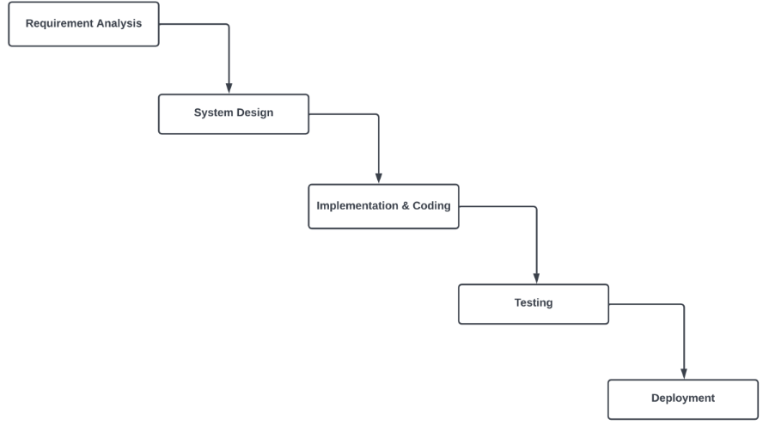

**Figure 3.1: Waterfall Model of AR Store**

**Requirement Analysis**: During this phase, various functional and non-functional requirements were collected by doing research of the domain as well as by studying previously existing systems. The requirements were filtered by analyzing the requirements and those requirements that we felt would not suit in this system were discarded.

**System Design**: The requirement documentation was studied and the system architecture was designed with the help of those requirement documentation. Activities like Database Schema Design, UI Design, DFD, ERD and many more were performed.

**Implementation & Coding**: In this phase, the requirements as well as the system design were studied thoroughly and implemented into a working system. Small units were prepared at first and those small units were integrated into bigger modules. Unit testing was also performed during this phase in order to test out the smaller modules that were prepared in the meantime.

**Testing**: After a long time of requirement gathering, system designing and implementing the designs in the system, all the modules were finally integrated into a fully working system and the system was tested as a whole. The errors as well as minor bugs were checked and fixed.

**Deployment**: Once the functional and non-functional testing was done, the product was deployed in the real environment away from the testing environment.

## **3.1.1 Requirement Analysis**

* **Functional Requirements**
  + **Customers**
    1. **Allow customers to purchase.**
    2. **Allow customers to change their account details.**
    3. **Allow customers to register and login.**
    4. **Allow customers to view products details.**
    5. **Allow customers to perform transaction via different payment method.**
  + **Admin**
    1. **Allow admin to insert products and categories.**
    2. **Allow admin to modify the products details.**
    3. **Allow admin to manage the order and view payment.**
    4. **Allow admin to view all the users.**

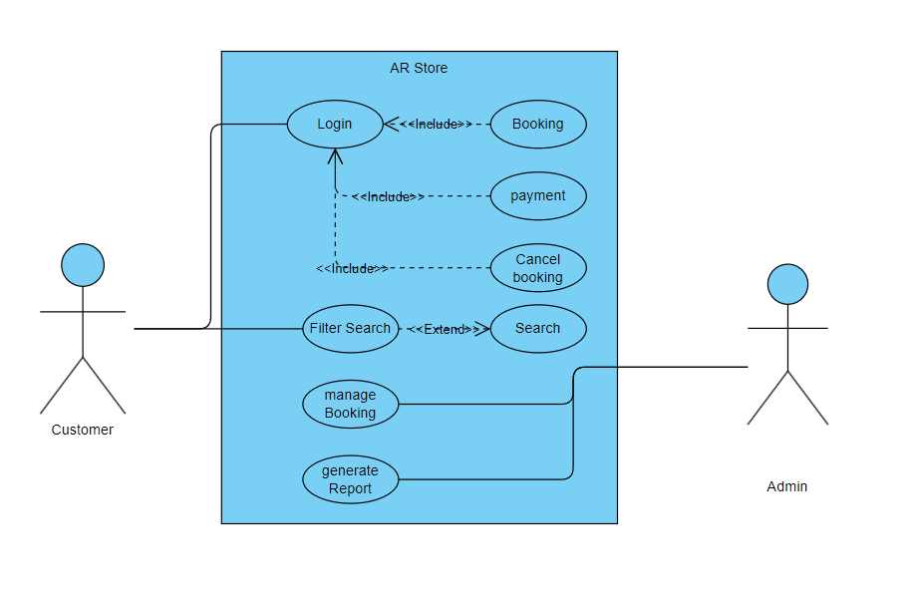

**Fig:3.2 Use-case Diagram**

* **Non-Functional Requirements**
* Reliability

The Server performs desired tasks as expected. The system does its work with more accuracy like user registration to the system, user validation and authorization, and issue operation, return status, and updating the database.

* Scalability

The proposed system would be scalable to support an extended number of users.

* Security

The system provides access to only legitimate users. It will be secure on a network and only authorized persons can access it.

* Maintainability

The proposed system would be easy to maintain and extend. Minor modifications to the system would not cause harm to the running application.

## **3.1.2 Feasibility Analysis**

It is wise to think about the feasibility of any problem we undertake. Feasibility is the system of impact, which happens in the organization by the development of the system. The impact can be either positive or negative. When the positive nominates the negatives, then the system is considered feasible.

1. Technical Feasibility

We can strongly say that is technically feasible since there will not be more difficulty in getting the required resources for the development and maintenance of the system. All the resources needed for the development of the software as well as the maintenance of the same are available in the organization. We are utilizing the resources that are already available.

1. Operational Feasibility

Operation feasibility is a measure of how well a proposed system solves problems and takes advantage of the opportunities identified during scope definition and how it satisfies the requirements identified in the requirements analysis phase of system development.

1. Economic Feasibility

The development of this application is highly economically feasible. We did not spend much money on the development of the system. The only thing to be done is to make an environment for development with effective supervision. If we are doing so, we can attain the maximum usability of the corresponding resources. Therefore, the system is economically feasible.

1. Schedule Feasibility

The schedule feasibility shows the estimated time to complete the project. This includes the schedules of each process in a project and the total project time. This can change if an unexpected challenge occurs.

**Gantt Chart**

This allows us to see at a glance:

* What the various activities are
* When each activity begins and ends
* How long each activity is scheduled to last

The Various Phases of the Project:

|  |  |  |
| --- | --- | --- |
| **S.No.** | **Phase** | **Task Duration** |
| 1. | Requirement Analysis | 5 Days |
| 2. | System Design | 15 Days |
| 3. | Implementation | 18 Days |
| 4. | Testing | 8 Days |
| 5. | Deployment | 2 Days |

**Table 3.1: Project Schedule for AR Store**

The Gantt Chart of Library Management System has a start date and end date for each phase. It has weeks moving from left to right and phases of the Waterfall Methodology moving across the vertical axis.

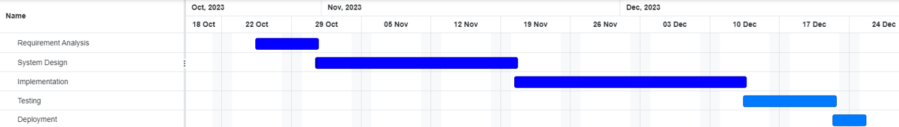

**Figure 3.3: Gantt-Chart of AR Store**

During the research for this system, various requirements were collected for this system and the requirements were analyzed for 5 days. For the next 15 days, various activities related to system design such as database design, data modeling, process modeling and many more were performed. The designs were implemented into a working system in another 2.5 weeks. The system was then tested for any bugs and errors for another week.

## **3.1.3 Data Modeling (ER-Diagram)**

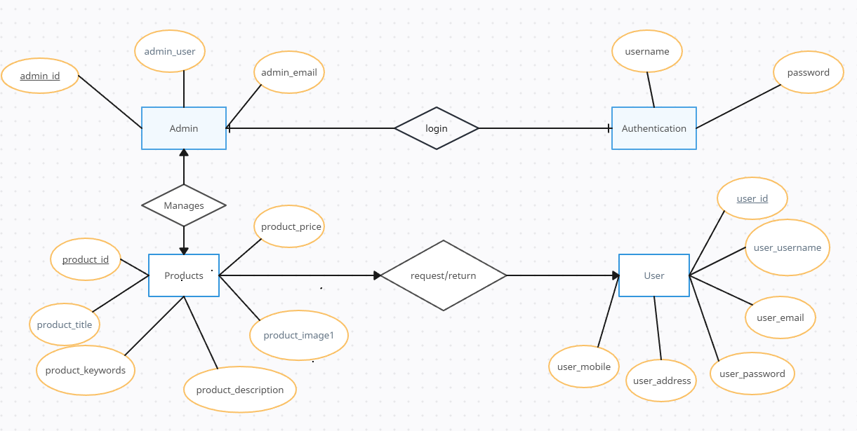

**Fig 3.6 ER Diagram**

## **3.1.4 Process Modeling (DFD)**

For Process Modeling of the Library Management System, a context diagram (Level-0 DFD) and Level-1 DFD of the system was designed. The figures below shows the context diagram and level-1 DFD for Doctor Appointment Booking System are shown:

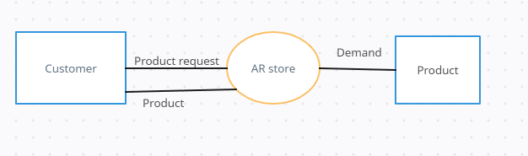

**Figure 3.5: Context – Diagram of AR Store**

## **3.2 System Design**

The system is collectively developed with HTML, CSS, JavaScript as front end and PHP, MySQL as back end.

## **3.2.1 Architectural Design**

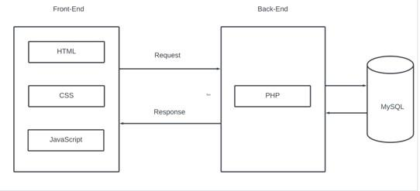

**Fig 3.7 System Architecture**

## **3.2.2 Database Schema Design**

Following database tables are included in the database schema of the AR Store. User, admin, products, categories, and cart.

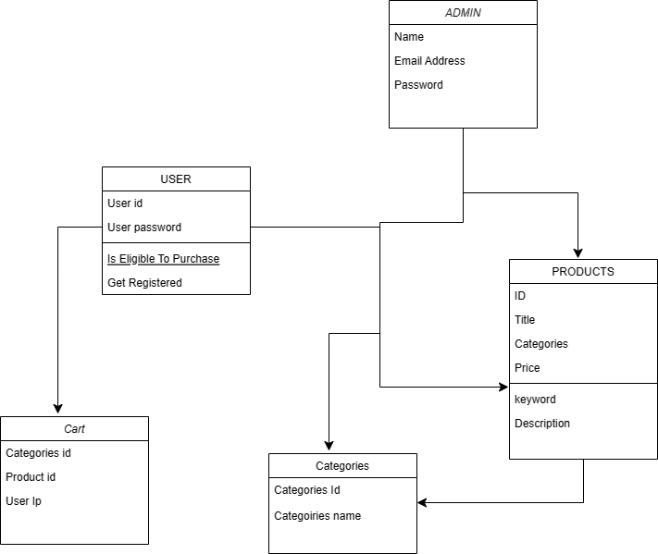

**Fig 3.4 Database Schema Design**

## **3.2.3 Interface Design**

It is very important for the interface to be accessible for all the modules without any extra hard work or efforts. Each interface needs to be the best and easy for the one using it.

**Admin Interface:**

1. **Login Page**: The owner needs to have a proper login ID in order to get access to the program.
2. **Admin Page**: Admin can perform various activities from here.
3. **Category List**: The owner needs to know which category to add, edit and remove.
4. **Product List**: Admin need to know which product to add, edit and remove.
5. **User List**: Admin can view all the users.
6. **Payment List**: Admin can view all the payments.

**User Interface**

The students also have a separately themed user interface which has less complexity. It includes the following pages:

1. **Login Page**: User has to enter its particular username and a keyword as a password.
2. **Product List**: It includes all the products and categories.
3. **Account Modification:** User can modify the account details.
4. **Payment:** User can have different Payment Methods.

# **CHAPTER 4: IMPLEMENTATION AND TESTING**

## **4.1 Implementation**

## **4.1.1 Tools Used**

* **HTML:** Hypertext Markup Language, commonly abbreviated as HTML, is the standard markup language used to create web pages. Along with CSS, and JavaScript, HTML is a cornerstone technology used to create web pages, as well as to create user interfaces for mobile and web applications. Web browsers can read HTML files and render them into visible or audible web pages. HTML describes the structure of a website semantically and, before the advent of Cascading Style Sheets (CSS), included cues for the presentation or appearance of the document (web page), making it a markup language, rather than a programming language.
* **CSS:** Cascading Style Sheets is a style sheet language used for describing the look and formatting of a document written in a markup language
* **JavaScript:** JavaScript is a high-level, dynamic, untyped and interpreted programming language. It is the programming language of HTML and the web.
* **PHP:**  PHP is a server-side scripting language designed for web development but also used as a general-purpose programming language. Originally created by Rasmus Lerdorf in 1994, the PHP reference implementation is now produced by The PHP Group. PHP originally stood for Personal Home Page, but it now stands for the recursive backronym PHP: Hypertext Preprocessor. PHP code may be embedded into HTML code, or it can be used in combination with various web template systems, web content management systems and web frameworks.
* **MySQL:** MySQL is a popular choice of database for use in web applications, and is a central component of the widely used LAMP open-source web application software. LAMP is an acronym for "Linux, Apache, MySQL, Perl/PHP/Python".
* **Apache Server:** The Apache HTTP Server is the world’s most widely used web server software. Apache is developed and maintained by an open community of developers under the auspices of the Apache Software Foundation.

## **4.1.2 Implementation Details of Modules**

The spiral model is a risk-driven method where the process is represented as spiral rather than a sequence of activities and it includes best features from the waterfall and prototyping models. In addition, it introduces a new component called: risk-assessment. Each loop in the spiral represents a phase, thus the first loop might be concerned with system feasibility. The next loop might be concerned with the requirements definition and the next with system design, and the like.

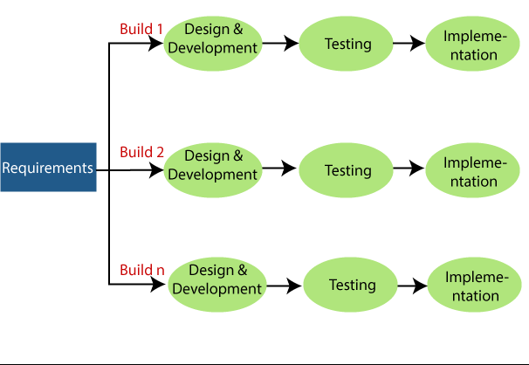

**Fig 4.1 Incremental Development Methodology**

## **4.2 Testing**

The main objective of overall testing processes is to check whether developed website platforms according to the requirement. Software testing is a process that should be done during the development process.

## **4.2.1 Test Cases for Unit Testing**

|  |  |  |
| --- | --- | --- |
| Test unit | Test Case | Result |
| Login | No user name and password provided | Error message pop up  “Invalid Username and password”. |
| Login | Wrong username and password provided | Error message pop up “Invalid username and password”. |
| Login | Correct user name and password provided | The system will give access to the Main page. |
| Add Product | Giving Product Name, Price, Description, Category, Image | The system will successfully add Product to the database. |

**Table 4.1 Test Cases for Unit Testing**

## **4.2.2 Test Cases for System Testing**

The whole system was tested by running a website on a localhost. We checked if the entered data were saved on the database or not, deleted data were removed from database or not, edited data has been edited on database or not and so on.

# **CHAPTER 5: CONCLUSION AND FUTURE RECOMMENDATION**

## **5.1 Conclusion**

During the development of this website, different tasks and implementation of different frameworks were done. In conclusion, the development and maintenance of an anime e-commerce website present an exciting opportunity to engage and connect with a vibrant and passionate community of anime enthusiasts. The project creates a website offering them not only a place to shop but also a community to connect with and celebrate their shared love for anime.

## **5.2 Future Recommendations**

In the future the system may have the following additional feature:

* Better user interface & admin interface
* Live chat between Admin and customer.
* Better Stock management

# **CHAPTER 5: BIBLIOGRAPHY**

**Home Page:**

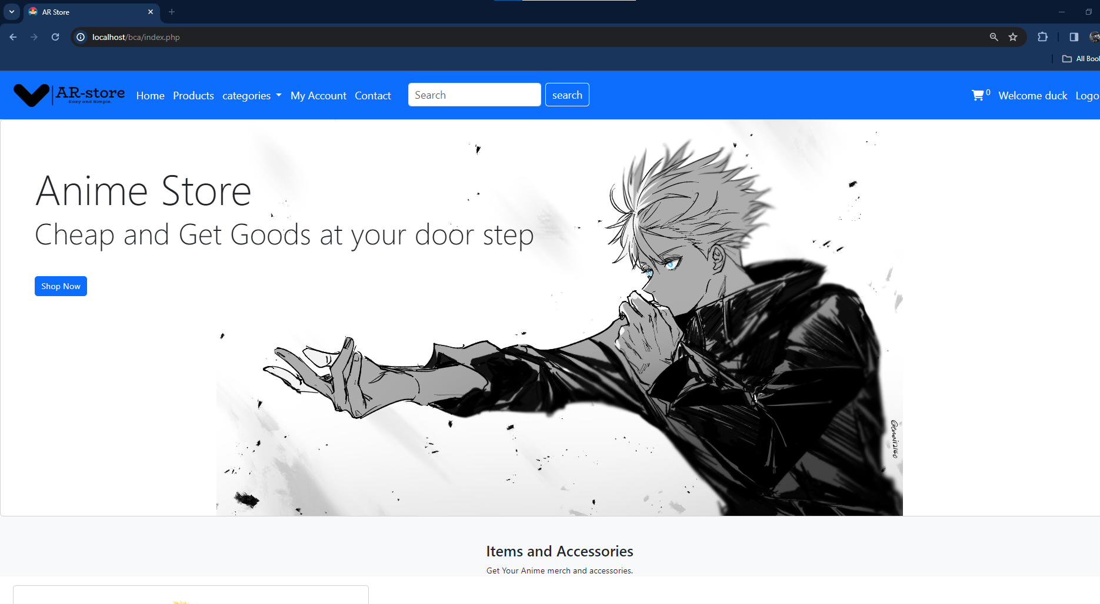

**Admin Page:**

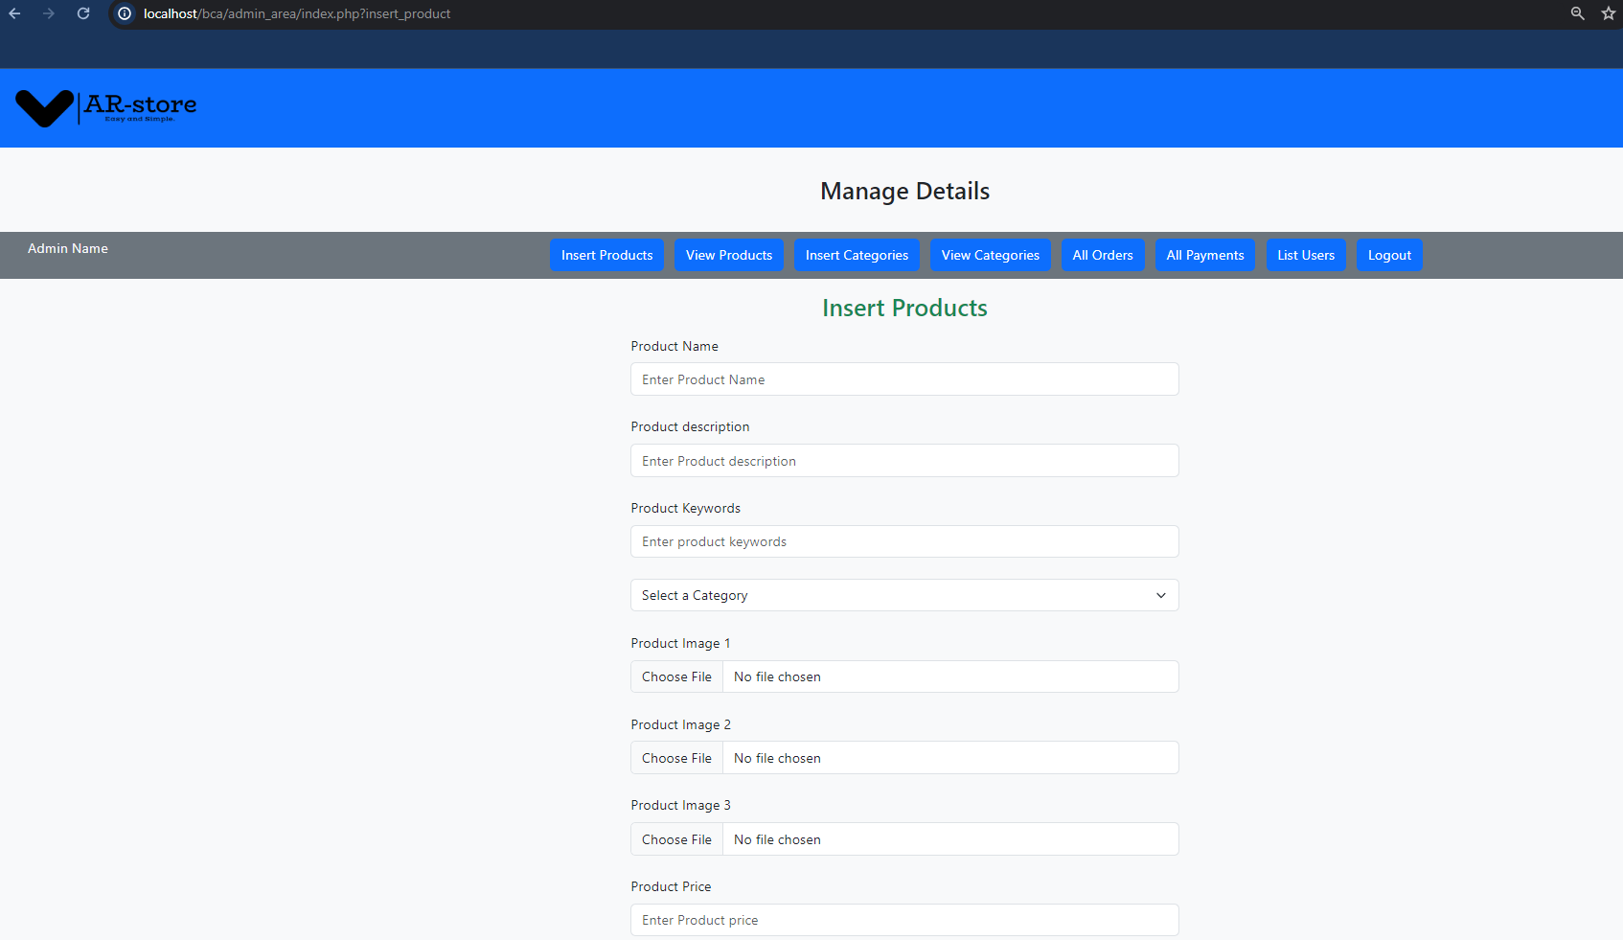

**Admin Registration:**

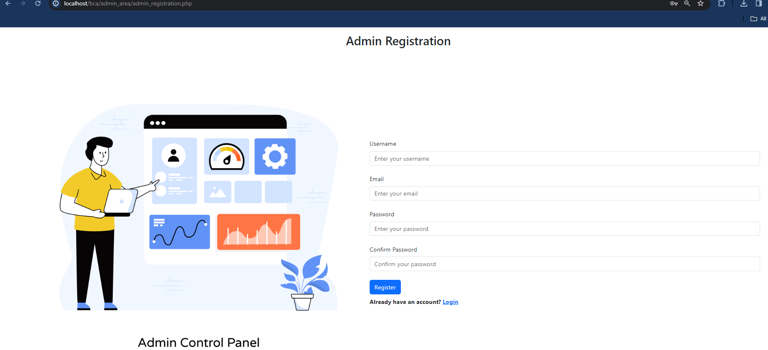

**Admin Login:**

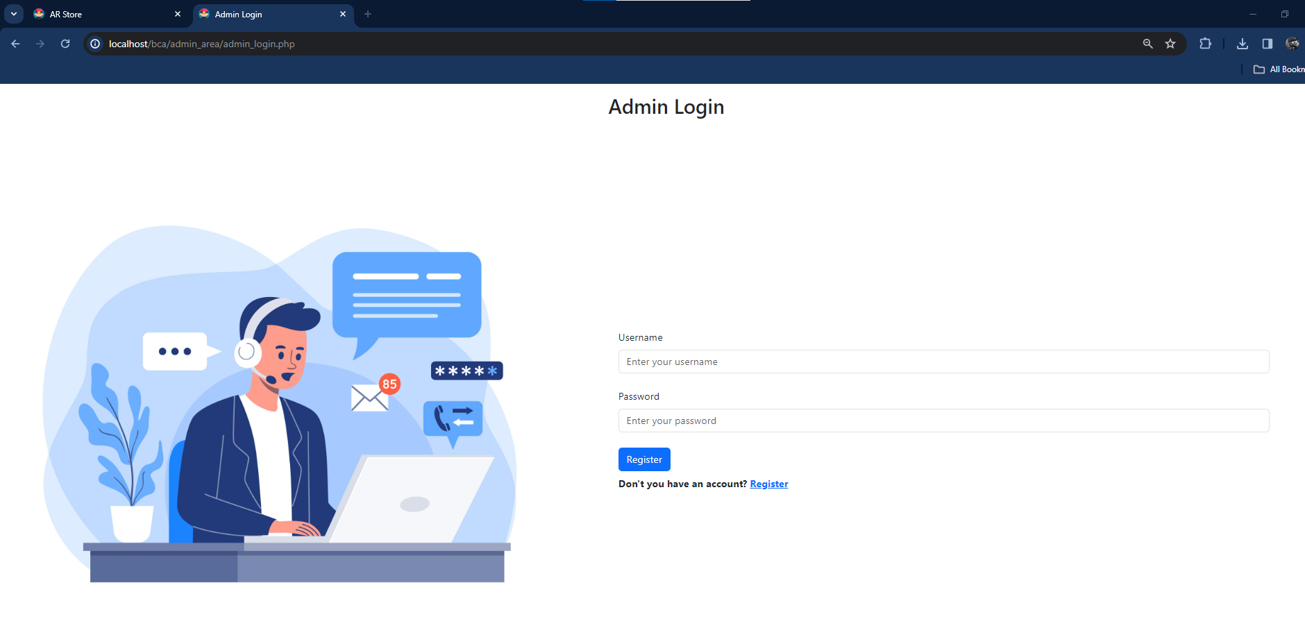

**User Registration:**

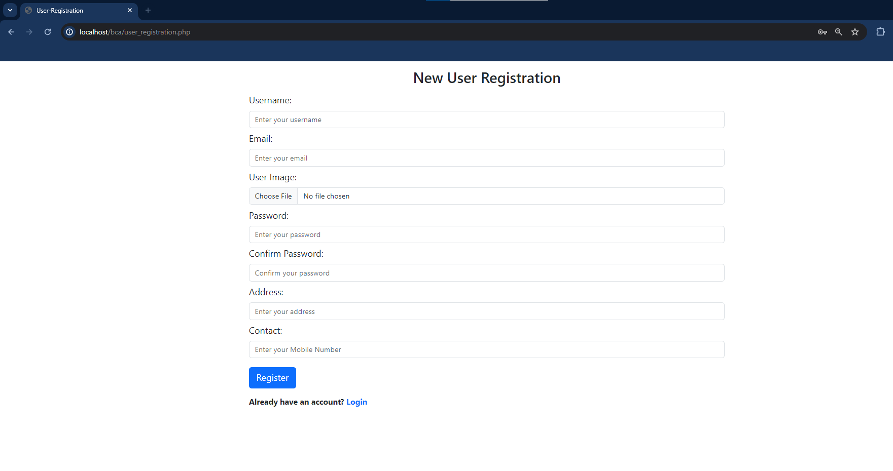

**User Login:**

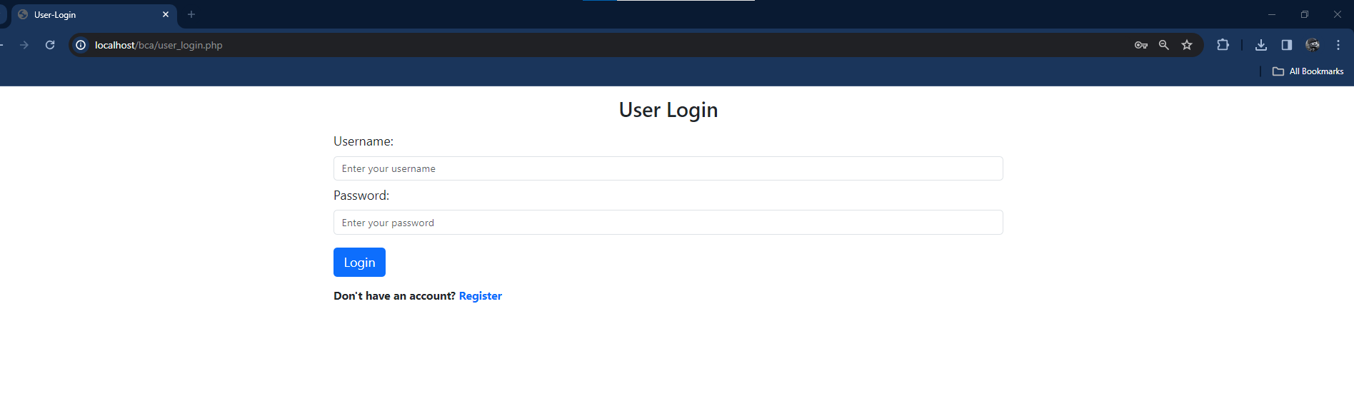

# **REFERENCES**

**Websites:**

1. Supreme Nepal, “Supreme Anime Website”,2019 [online]. Available: https://www.supremenepal.com/
2. Anime Forum, , “For community guidelines ”,2018 [online]. Available: https://www.animeforum.com/forum.php
3. Stack overflow, ”For web development resources and Communities.” <https://stackoverflow.com/>
4. Step by Step, “ For Web Development resource” https://www.youtube.com/watch?v=kIOTtRf9Drk&list=PL-h5aNeRKouEaGrQj6EXaqZsagEphQboI