# 1) Write a program to check whether given string is valid comment or not.

#include <stdio.h>

#include <stdbool.h>

void removeComments(const char *code, char *result) {

bool inSingleLineComment = false;

bool inMultiLineComment = false;

int j = 0;

for (int i = 0; code[i] != '\0'; ++i) {

if (inSingleLineComment) {

if (code[i] == '\n') {

inSingleLineComment = false;

result[j++] = code[i];

}

} else if (inMultiLineComment) {

if (code[i] == '*' && code[i + 1] == '/') {

inMultiLineComment = false;

i++; // Skip '/'

}

} else {

if (code[i] == '/' && code[i + 1] == '/') {

inSingleLineComment = true;

i++; // Skip '/'

} else if (code[i] == '/' && code[i + 1] == '*') {

inMultiLineComment = true;

i++; // Skip '*'

} else {

result[j++] = code[i];

}

}

}

result[j] = '\0';

}

int main() {

const char *code = "#include <stdio.h>\n"

"int main() {\n"

" // This is a single-line comment\n"

" printf(\"Hello, World!\\n\"); /* This is a multi-line comment */\n"

" /* This is another\n"

" multi-line comment */\n"

" return 0; // End of program\n"

"}\n";

char cleanedCode[1024];

removeComments(code, cleanedCode);

printf("Original code:\n%s\n", code);

printf("Cleaned code:\n%s\n", cleanedCode);

return 0;

}

Output:

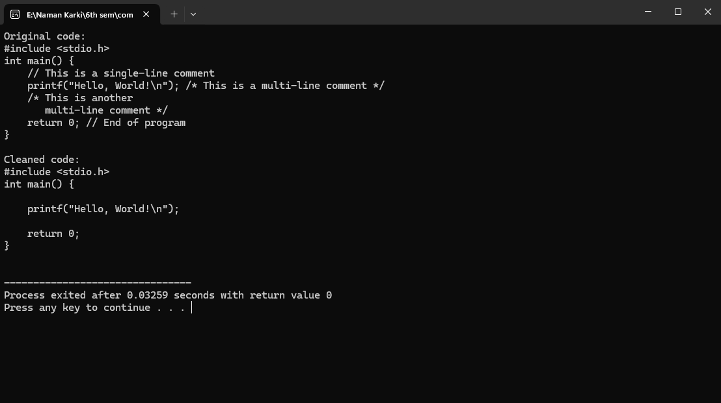

# 2)Write a program to recognize strings under a*, a*b+, abb.

#include <conio.h>

#include <stdio.h>

#include <stdlib.h>

#include <string.h>

int main() {

char s[20], c;

int state = 0, i = 0;

// clrscr();

printf("\n Enter a string:");

gets(s);

while (s[i] != '\0') {

switch (state) {

case 0:

c = s[i++];

if (c == 'a')

state = 1;

else if (c == 'b')

state = 2;

else

state = 6;

break;

case 1:

c = s[i++];

if (c == 'a')

state = 3;

else if (c == 'b')

state = 4;

else

state = 6;

break;

case 2:

c = s[i++];

if (c == 'a')

state = 6;

else if (c == 'b')

state = 2;

else

state = 6;

break;

case 3:

c = s[i++];

if (c == 'a')

state = 3;

else if (c == 'b')

state = 2;

else

state = 6;

break;

case 4:

c = s[i++];

if (c == 'a')

state = 6;

else if (c == 'b')

state = 5;

else

state = 6;

break;

case 5:

c = s[i++];

if (c == 'a')

state = 6;

else if (c == 'b')

state = 2;

else

state = 6;

break;

case 6:

printf("\n %s is not recognised.", s);

exit(0);

}

}

if (state == 1)

printf("\n %s is accepted under rule 'a'", s);

else if ((state == 2) || (state == 4))

printf("\n %s is accepted under rule 'a*b+'", s);

else if (state == 5)

printf("\n %s is accepted under rule 'abb'", s);

getch();

}

Output:

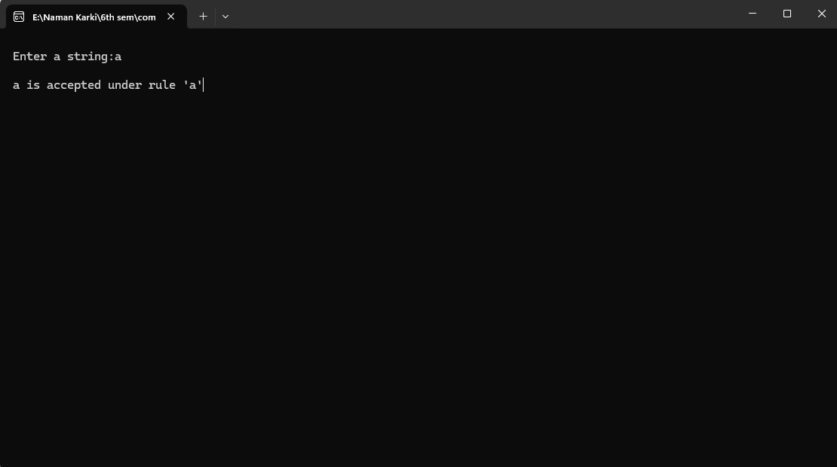

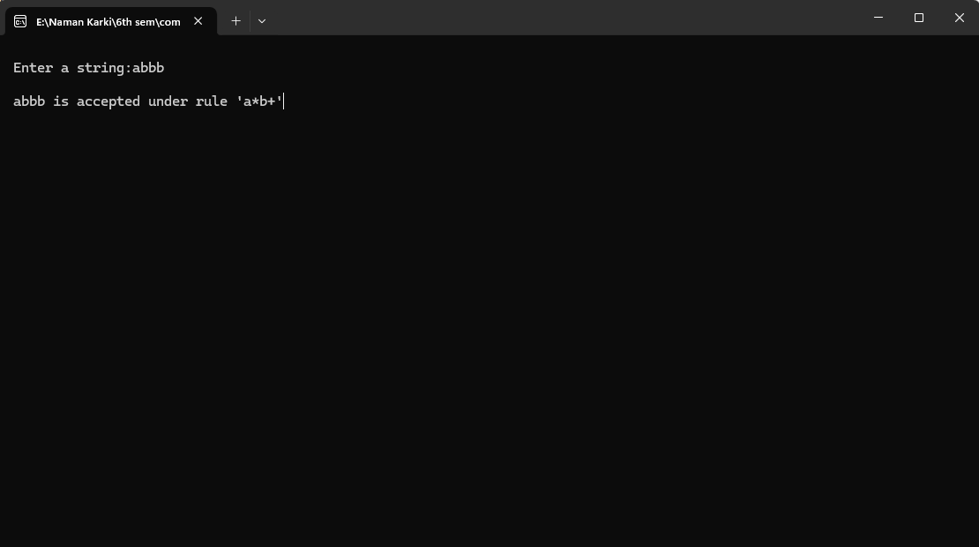

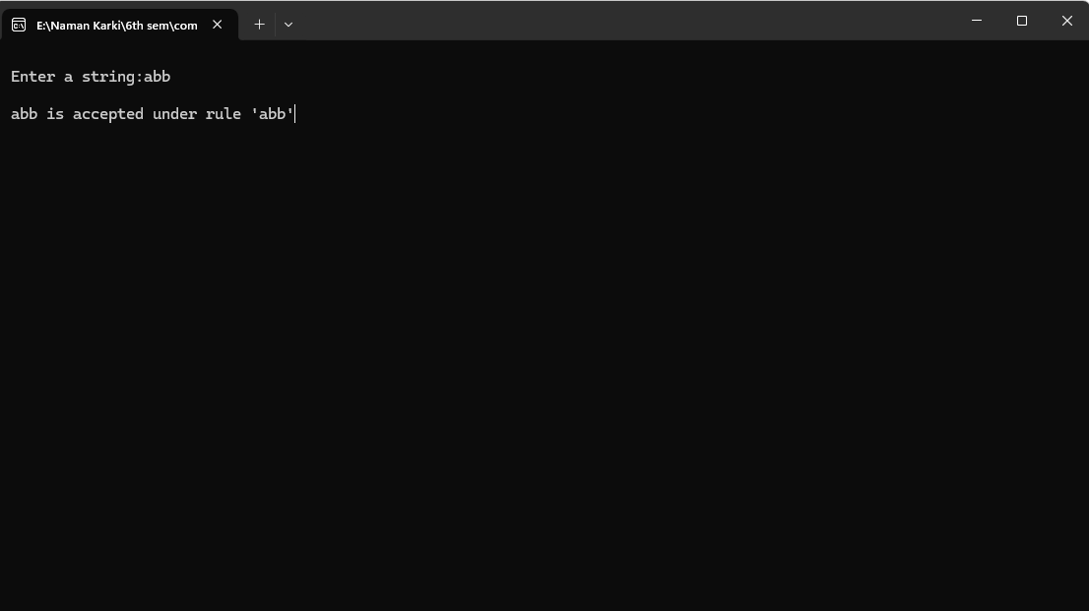

# 13) Write a program to implement symbol table.

## #include <stdio.h>

## #include <stdlib.h>

## #include <string.h>

## #define MAX_SYMBOLS 100

## // Define a structure for each entry in the symbol table

## typedef struct {

## char name[50];

## int address;

## } SymbolEntry;

## // Define the symbol table structure

## typedef struct {

## SymbolEntry entries[MAX_SYMBOLS];

## int count;

## } SymbolTable;

## // Function to initialize the symbol table

## void initializeSymbolTable(SymbolTable *table) {

## table->count = 0;

## }

## // Function to insert a symbol into the symbol table

## void insertSymbol(SymbolTable *table, char *name, int address) {

## if (table->count < MAX_SYMBOLS) {

## SymbolEntry *entry = &table->entries[table->count++];

## strncpy(entry->name, name, sizeof(entry->name));

## entry->address = address;

## printf("Inserted symbol: %s at address: %d\n", name, address);

## } else {

## printf("Symbol table full. Cannot insert symbol: %s\n", name);

## }

## }

## // Function to search for a symbol in the symbol table

## int searchSymbol(SymbolTable *table, char *name) {

## int i; // Declare 'i' outside the loop to conform with C89 standard

## for (i = 0; i < table->count; i++) {

## if (strcmp(table->entries[i].name, name) == 0) {

## return table->entries[i].address;

## }

## }

## return -1; // Symbol not found

## }

## int main() {

## SymbolTable symbolTable;

## initializeSymbolTable(&symbolTable);

## // Insert some symbols into the table

## insertSymbol(&symbolTable, "var1", 100);

## insertSymbol(&symbolTable, "var2", 200);

## insertSymbol(&symbolTable, "var3", 300);

## // Search for a symbol

## int address = searchSymbol(&symbolTable, "var2");

## if (address != -1) {

## printf("Address of var2: %d\n", address);

## } else {

## printf("Symbol not found\n");

## }

## return 0;

## }

Outout:

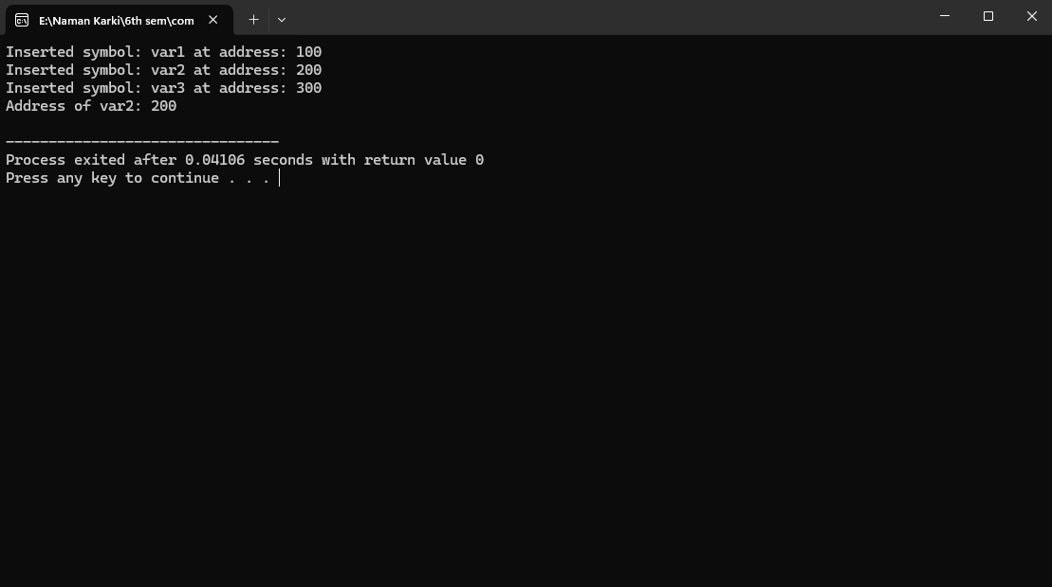.

# 3) WAP to check the pattern (a+b)*

#include <stdio.h>

#include <string.h>

// Function to check if a string matches the pattern (a+b)*

int matches_pattern(const char *string) {

int i;

for (i = 0; i < strlen(string); i++) {

if (string[i] != 'a' && string[i] != 'b') {

return 0; // If any character is not 'a' or 'b', the string does not match

}

}

return 1; // The string matches if all characters are 'a' or 'b'

}

int main() {

const char *language[] = {"", "a", "b", "ab", "ba", "aaa", "bbb", "abab", "baba", "aabbaabb"};

int num_strings = sizeof(language) / sizeof(language[0]);

int i;

printf("Strings matching pattern (a+b)*:\n");

for (i = 0; i < num_strings; i++) {

if (matches_pattern(language[i])) {

printf("%s matches the pattern (a+b)*\n", language[i]);

} else {

printf("%s does not match the pattern (a+b)*\n", language[i]);

}

}

return 0;

}

Output:

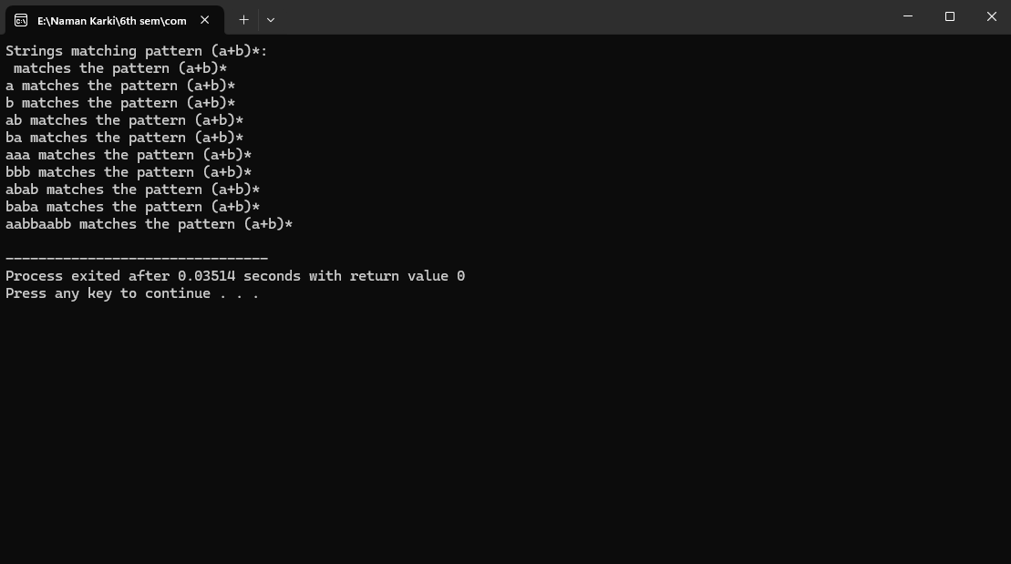

# 4) WAP for DFA function to simulate the automaton

#include <stdio.h>

// DFA function to simulate the automaton

int dfa(int state, int input) {

// Transition table

int transition[8][2] = {

{1, 2}, {3, 4}, {5, 6}, {7, 0}, {1, 2}, {3, 4}, {5, 6}, {7, 0}

};

return transition[state][input];

}

int main() {

int roll_number;

printf("Enter your class roll number: ");

scanf("%d", &roll_number);

// Convert roll number to binary and display it

int binary[8];

int i, state = 0;

printf("Binary representation: ");

for (i = 7; i >= 0; i--) {

binary[i] = roll_number % 2;

printf("%d", binary[i]);

roll_number /= 2;

}

printf("\n");

// Implement DFA

for (i = 0; i < 8; i++) {

state = dfa(state, binary[i]);

printf("%d",state);

}

// Check if the final state is accepting (even)

if (state == 0 || state == 4 || state == 6) {

printf("The roll number is odd .\n");

} else {

printf("The roll number is even.\n");

}

return 0;

}

Output:

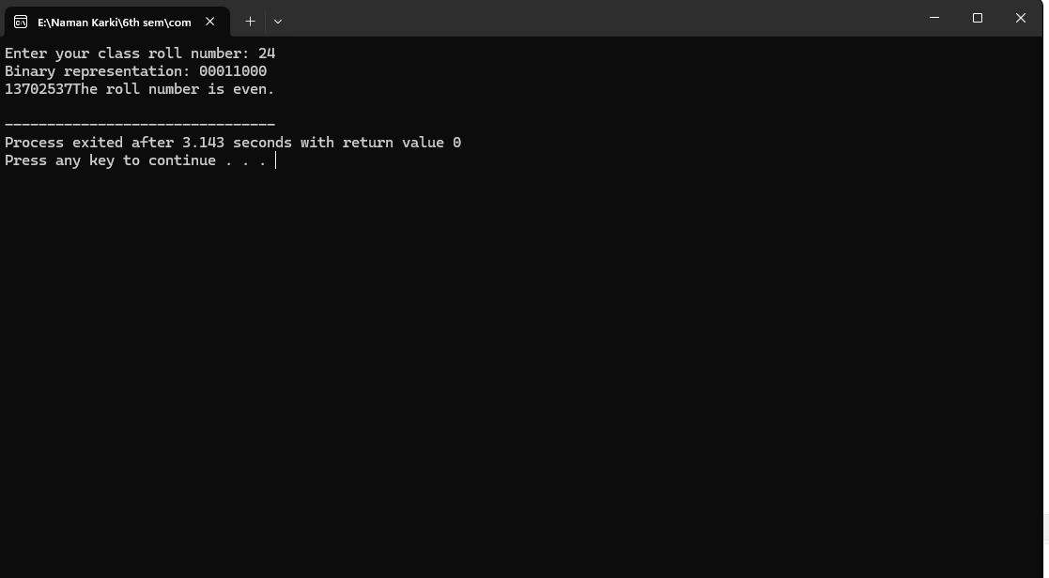

# 12) Write a program to implement final code (Assembly code) of given intermediate code

#include <stdio.h>

#include <stdlib.h>

#include <string.h>

#define MAX_CODE_SIZE 100

// Define the structure for intermediate code instructions

struct Instruction {

char opcode[10];

char operand1[10];

char operand2[10];

char result[10];

};

void generateAssemblyCode(struct Instruction* code, int codeSize) {

printf("Assembly Code:\n");

int i;

for (i = 0; i < codeSize; i++) {

if (strcmp(code[i].opcode, "LOAD") == 0) {

printf("MOV %s, %s\n", code[i].operand1, code[i].result);

} else if (strcmp(code[i].opcode, "ADD") == 0) {

printf("ADD %s, %s\n", code[i].operand1, code[i].operand2);

printf("MOV %s, %s\n", code[i].result, code[i].operand1);

}

}

}

int main() {

struct Instruction code[MAX_CODE_SIZE];

int codeSize = 0;

strcpy(code[codeSize].opcode, "LOAD");

strcpy(code[codeSize].operand1, "8");

strcpy(code[codeSize].operand2, "-");

strcpy(code[codeSize].result, "T1");

codeSize++;

strcpy(code[codeSize].opcode, "ADD");

strcpy(code[codeSize].operand1, "T1");

strcpy(code[codeSize].operand2, "4");

strcpy(code[codeSize].result, "T2");

codeSize++;

strcpy(code[codeSize].opcode, "LOAD");

strcpy(code[codeSize].operand1, "5");

strcpy(code[codeSize].operand2, "-");

strcpy(code[codeSize].result, "T3");

codeSize++;

strcpy(code[codeSize].opcode, "ADD");

strcpy(code[codeSize].operand1, "T2");

strcpy(code[codeSize].operand2, "T3");

strcpy(code[codeSize].result, "T4");

codeSize++;

// Generate assembly code

generateAssemblyCode(code, codeSize);

return 0;

}

Output:

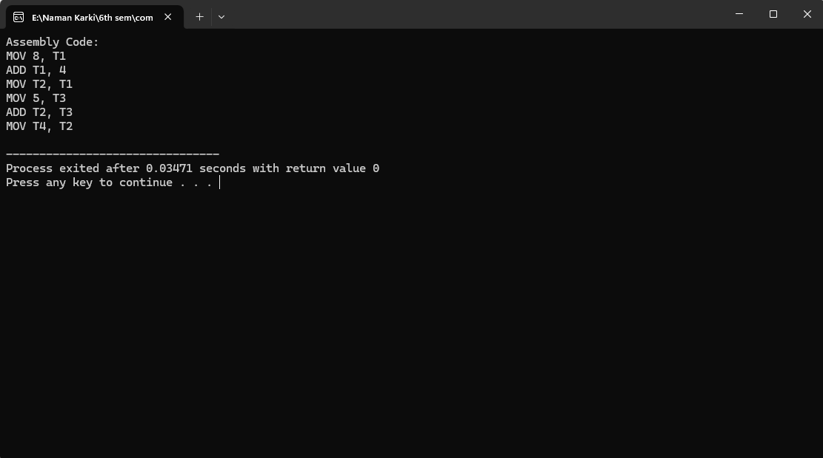

# 5) Write a programto test the given identidfier is valid or not?

#include <stdio.h>

#include <string.h>

#include <ctype.h>

int isValidIdentifier(const char *identifier) {

// Check if the identifier is empty

if (strlen(identifier) == 0) {

return 0; // Invalid if empty

}

// Check the first character

if (!(isalpha(identifier[0]) || identifier[0] == '_')) {

return 0; // Invalid if not a letter or underscore

}

// Check subsequent characters

int length = strlen(identifier);

int i;

for (i = 1; i < length; i++) {

if (!(isalpha(identifier[i]) || isdigit(identifier[i]) || identifier[i] == '_')) {

return 0; // Invalid if not a letter, digit, or underscore

}

}

// If all checks pass, the identifier is valid

return 1;

}

int main() {

char identifier[100];

int i;

printf("Enter an identifier: ");

scanf("%s", identifier);

if (isValidIdentifier(identifier)) {

printf("The identifier '%s' is valid.\n", identifier);

} else {

printf("The identifier '%s' is invalid.\n", identifier);

} return 0;

}

Output:

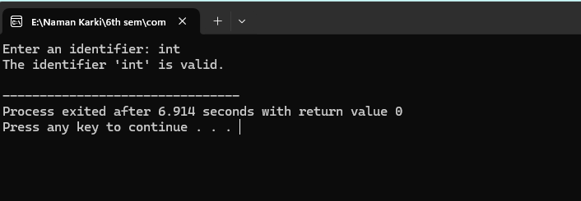

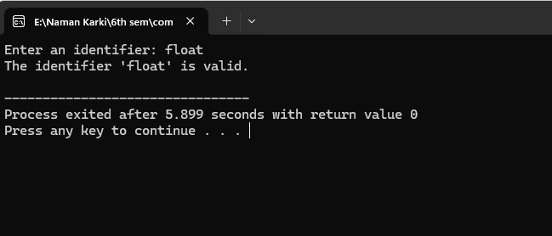

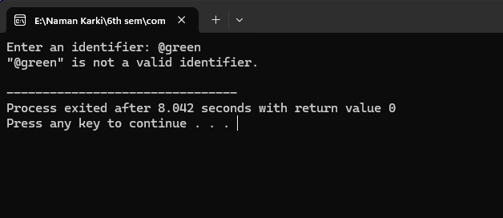

# 6)Write a program for lexical analyzer

#include <stdio.h>

#include <ctype.h>

#include <string.h>

// Token types

enum TokenType {

KEYWORD,

IDENTIFIER,

NUMBER,

OPERATOR,

SEPARATOR,

INVALID

};

// Function to check if a string is a keyword

int isKeyword(char* word) {

char keywords[6][10] = {"int", "float", "if", "else", "while", "for"};

int i;

for (i = 0; i < 6; i++) {

if (strcmp(keywords[i], word) == 0) {

return 1;

}

}

return 0;

}

// Function to check if a character is an operator

int isOperator(char c) {

char operators[] = "+-*/=!<>";

int i;

for (i = 0; operators[i]; i++) {

if (operators[i] == c) {

return 1;

}

}

return 0;

}

// Function to check if a character is a separator

int isSeparator(char c) {

char separators[] = ";,(){}";

int i;

for (i = 0; separators[i]; i++) {

if (separators[i] == c) {

return 1;

}

}

return 0;

}

// Function to tokenize the input string

void tokenize(char* input) {

char buffer[50];

int bufferIndex = 0;

int i;

for (i = 0; input[i]; i++) {

if (isalpha(input[i])) { // Identifier or keyword

buffer[bufferIndex++] = input[i];

while (isalnum(input[i + 1])) {

buffer[bufferIndex++] = input[++i];

}

buffer[bufferIndex] = '\0';

if (isKeyword(buffer)) {

printf("(%d, %s)\n", KEYWORD, buffer);

} else {

printf("(%d, %s)\n", IDENTIFIER, buffer);

}

bufferIndex = 0;

} else if (isdigit(input[i])) { // Number

buffer[bufferIndex++] = input[i];

while (isdigit(input[i + 1]) || input[i + 1] == '.') {

buffer[bufferIndex++] = input[++i];

}

buffer[bufferIndex] = '\0';

printf("(%d, %s)\n", NUMBER, buffer);

bufferIndex = 0;

} else if (isOperator(input[i])) { // Operator

buffer[bufferIndex++] = input[i];

printf("(%d, %s)\n", OPERATOR, buffer);

bufferIndex = 0;

} else if (isSeparator(input[i])) { // Separator

buffer[bufferIndex++] = input[i];

printf("(%d, %s)\n", SEPARATOR, buffer);

bufferIndex = 0;

} else if (!isspace(input[i])) { // Invalid character

printf("(%d, %c)\n", INVALID, input[i]);

}

}

}

// Main function

int main() {

char input[100];

printf("Enter some code: ");

fgets(input, sizeof(input), stdin);

tokenize(input);

return 0;

}

Output:

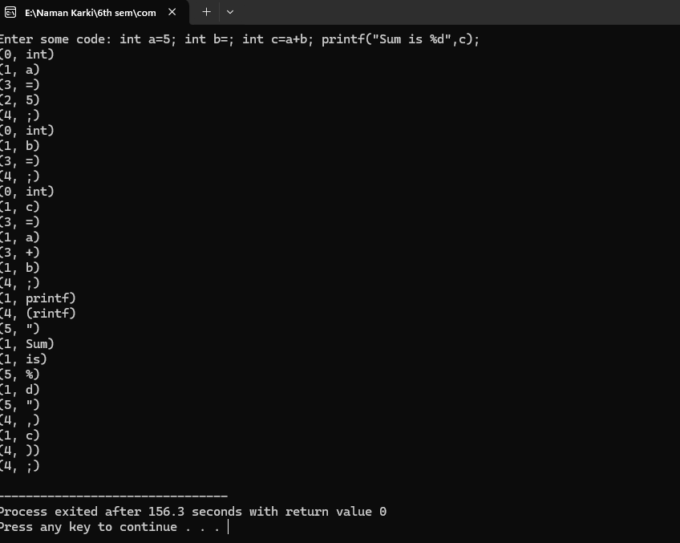

# 11) Write a program to implement immediate code generator.

#include <stdio.h>

#include <stdlib.h>

#include <string.h>

#define MAX_CODE_SIZE 100

// Define the structure for intermediate code instructions

struct Instruction {

char opcode[10];

char operand1[10];

char operand2[10];

char result[10];

};

// Function to generate intermediate code for arithmetic expressions

void generateIntermediateCode(char* expression, struct Instruction* code, int* codeSize) {

char* token = strtok(expression, "+-*/");

while (token != NULL) {

strcpy(code[*codeSize].opcode, "LOAD");

strcpy(code[*codeSize].operand1, token);

strcpy(code[*codeSize].operand2, "-");

sprintf(code[*codeSize].result, "T%d", *codeSize + 1);

(*codeSize)++;

token = strtok(NULL, "+-*/");

if (token != NULL) {

strcpy(code[*codeSize].opcode, "ADD");

strcpy(code[*codeSize].operand1, code[*codeSize - 1].result);

strcpy(code[*codeSize].operand2, token);

sprintf(code[*codeSize].result, "T%d", *codeSize + 1);

(*codeSize)++;

}

}

}

// Function to print intermediate code

void printIntermediateCode(struct Instruction* code, int codeSize) {

printf("Intermediate Code:\n");

int i; // Variable 'i' declaration moved inside the function

for (i = 0; i < codeSize; i++) { // Adjusted loop structure

printf("%s %s %s %s\n", code[i].opcode, code[i].operand1, code[i].operand2, code[i].result);

}

}

int main() {

char expression[100];

struct Instruction code[MAX_CODE_SIZE];

int codeSize = 0;

printf("Enter arithmetic expression: ");

scanf("%s", expression);

generateIntermediateCode(expression, code, &codeSize);

printIntermediateCode(code, codeSize);

return 0;

}

Output:

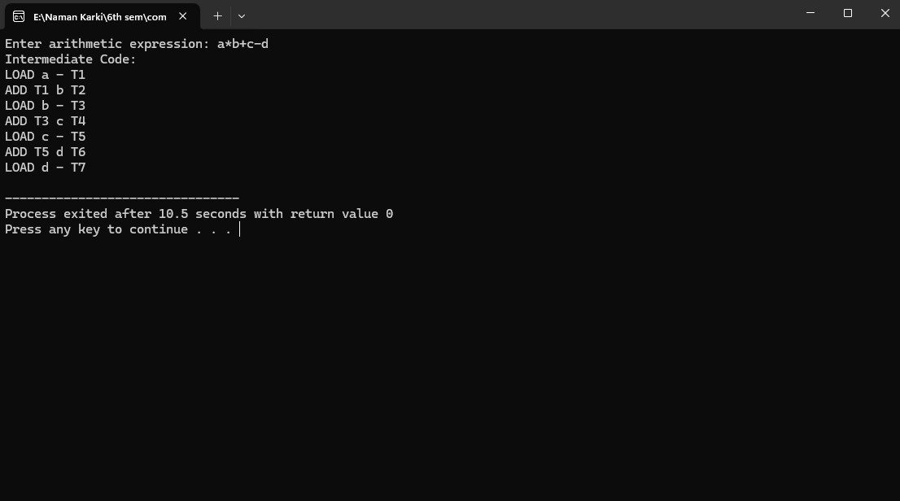

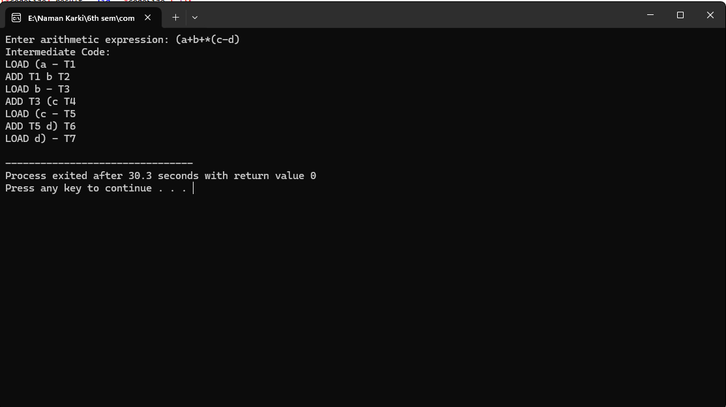

# 7) Write a program to find first of given grammar.

#include <stdio.h>

#include <stdlib.h>

#include <string.h>

#include <ctype.h>

#define MAX_RULES 10

#define MAX_LENGTH 10

// Structure to represent a production rule

struct Rule {

char nonTerminal;

char production[MAX_LENGTH];

};

// Function to check if a symbol is terminal

int isTerminal(char symbol) {

return islower(symbol) || symbol == '$';

}

// Function to check if a symbol is non-terminal

int isNonTerminal(char symbol) {

return isupper(symbol);

}

// Function to add a symbol to a set

void addToSet(char set[], char symbol) {

if (!strchr(set, symbol)) {

strncat(set, &symbol, 1);

}

}

// Function to find the first set for a given grammar

void findFirstSet(struct Rule rules[], int ruleCount, char nonTerminal, char firstSet[]) {

int i;

for (i = 0; i < ruleCount; i++) {

if (rules[i].nonTerminal == nonTerminal) {

char symbol = rules[i].production[0];

if (isTerminal(symbol) && symbol != '$') {

addToSet(firstSet, symbol);

} else if (isNonTerminal(symbol)) {

findFirstSet(rules, ruleCount, symbol, firstSet);

} else if (symbol == '$' && strlen(rules[i].production) == 1) {

addToSet(firstSet, '$');

} else {

int j = 0;

while (symbol != '\0') {

findFirstSet(rules, ruleCount, symbol, firstSet);

if (strchr(firstSet, '$')) {

j++;

symbol = rules[i].production[j];

} else {

break;

}

}

}

}

}

}

int main() {

struct Rule rules[MAX_RULES];

int ruleCount;

char nonTerminal;

char firstSet[MAX_LENGTH] = "";

printf("Enter the number of production rules: ");

scanf("%d", &ruleCount);

getchar(); // Clear newline character from buffer

printf("Enter the production rules in the format 'NonTerminal -> Production'\n");

int i;

for (i = 0; i < ruleCount; i++) {

scanf("%c -> %[^\n]s", &rules[i].nonTerminal, rules[i].production);

getchar(); // Clear newline character from buffer

}

printf("Enter the non-terminal whose first set you want to find: ");

scanf("%c", &nonTerminal);

findFirstSet(rules, ruleCount, nonTerminal, firstSet);

printf("First set of %c : {%s}\n", nonTerminal, firstSet);

return 0;

}

Output:

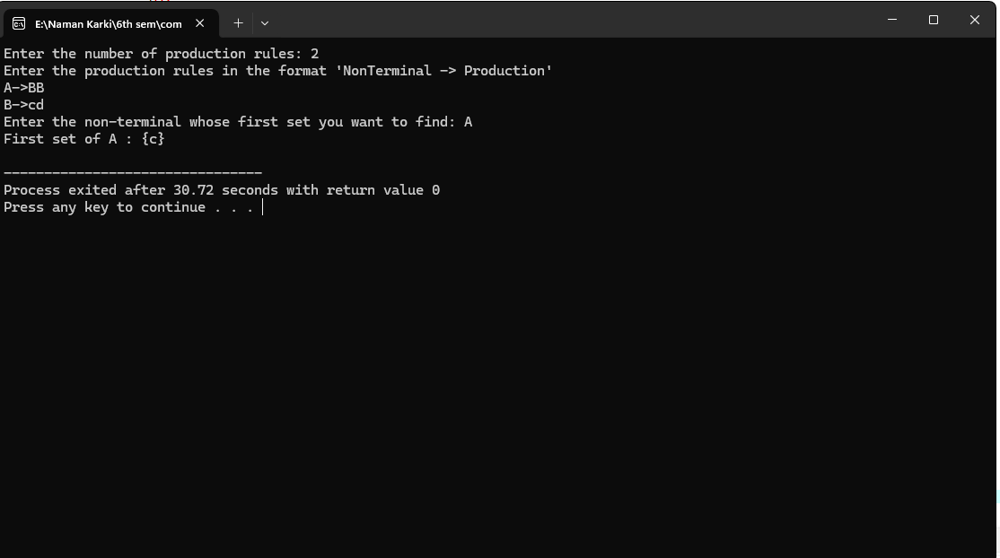

# 8) Write a program to find follow of given grammar.

#include <stdio.h>

#include <stdlib.h>

#include <string.h>

#include <ctype.h>

#define MAX_RULES 10

#define MAX_LENGTH 10

// Structure to represent a production rule

struct Rule {

char nonTerminal;

char production[MAX_LENGTH];

};

// Structure to represent a follow set

struct FollowSet {

char nonTerminal;

char follow[MAX_LENGTH];

};

// Function to check if a symbol is terminal

int isTerminal(char symbol) {

return islower(symbol) || symbol == '$';

}

// Function to check if a symbol is non-terminal

int isNonTerminal(char symbol) {

return isupper(symbol);

}

// Function to add a symbol to a set

void addToSet(char set[], char symbol) {

if (!strchr(set, symbol)) {

strncat(set, &symbol, 1);

}

}

// Function to find the follow set for a given grammar

void findFollowSet(struct Rule rules[], int ruleCount, struct FollowSet followSets[], int followSetCount, char nonTerminal) {

int i, j;

for (i = 0; i < ruleCount; i++) {

char* ptr = strchr(rules[i].production, nonTerminal);

if (ptr) {

while (*(ptr + 1)) {

char symbol = *(ptr + 1);

if (isTerminal(symbol)) {

addToSet(followSets[followSetCount].follow, symbol);

break;

} else if (isNonTerminal(symbol)) {

char firstSet[MAX_LENGTH] = "";

int foundEpsilon = 0;

for (j = 0; j < ruleCount; j++) {

if (rules[j].nonTerminal == symbol) {

if (rules[j].production[0] == '$' || isTerminal(rules[j].production[0])) {

addToSet(firstSet, rules[j].production[0]);

} else {

findFollowSet(rules, ruleCount, followSets, followSetCount, rules[j].production[0]);

strcat(firstSet, followSets[followSetCount].follow);

}

if (strchr(rules[j].production, '$')) {

foundEpsilon = 1;

} else {

foundEpsilon = 0;

break;

}

}

}

if (foundEpsilon) {

ptr++;

}

strcat(followSets[followSetCount].follow, firstSet);

} else {

break;

}

}

if (!*(ptr + 1)) {

for (j = 0; j < followSetCount; j++) {

if (followSets[j].nonTerminal == rules[i].nonTerminal) {

strcat(followSets[j].follow, followSets[followSetCount].follow);

break;

}

}

}

}

}

}

int main() {

struct Rule rules[MAX_RULES];

struct FollowSet followSets[MAX_RULES];

int ruleCount, followSetCount;

char nonTerminal;

printf("Enter the number of production rules: ");

scanf("%d", &ruleCount);

getchar(); // Clear newline character from buffer

printf("Enter the production rules in the format 'NonTerminal -> Production'\n");

int i;

for (i = 0; i < ruleCount; i++) {

scanf("%c -> %[^\n]s", &rules[i].nonTerminal, rules[i].production);

getchar(); // Clear newline character from buffer

}

printf("Enter the non-terminal whose follow set you want to find: ");

scanf("%c", &nonTerminal);

followSetCount = 0;

for (i = 0; i < ruleCount; i++) {

if (rules[i].nonTerminal == nonTerminal) {

strcpy(followSets[followSetCount].follow, "$");

followSets[followSetCount].nonTerminal = nonTerminal;

followSetCount++;

break;

}

}

findFollowSet(rules, ruleCount, followSets, followSetCount, nonTerminal);

printf("Follow set of %c : {%s}\n", nonTerminal, followSets[0].follow);

return 0;

}

Output:

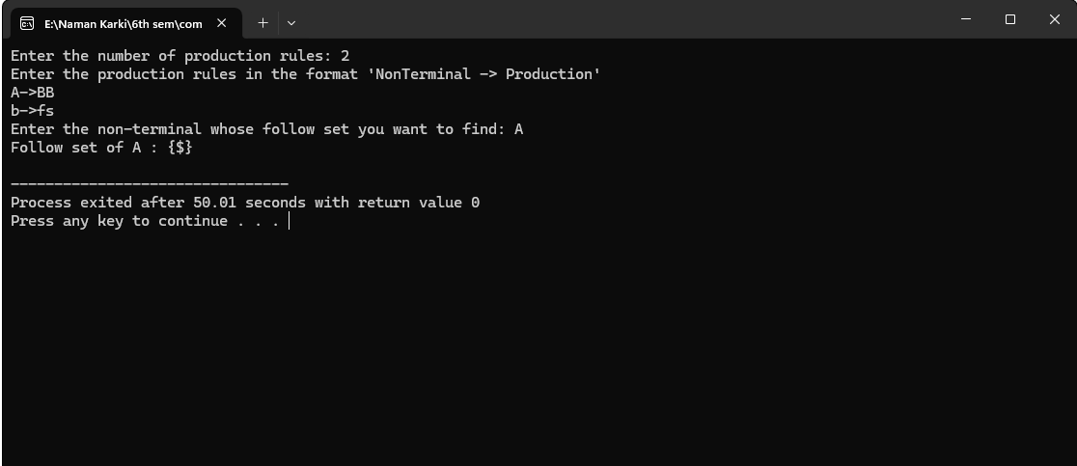

# 9) WAP to construct LL(1) table of given grammer.

#include<stdio.h>

#include<ctype.h>

#include<string.h>

#include<stdlib.h>

void followfirst(char , int , int);

void findfirst(char , int , int);

void follow(char c);

int count,n=0;

char calc_first[10][100];

char calc_follow[10][100];

int m=0;

char production[10][10], first[10];

char f[10];

int k;

char ck;

int e;

int main(int argc,char **argv)

{

int jm=0;

int km=0;

int i,choice;

char c,ch;

printf("How many productions ? :");

scanf("%d",&count);

printf("\nEnter %d productions in form A=B where A and B are grammar symbols :\n\n",count);

for(i=0;i<count;i++)

{

scanf("%s%c",production[i],&ch);

}

int kay;

char done[count];

int ptr = -1;

for(k=0;k<count;k++){

for(kay=0;kay<100;kay++){

calc_first[k][kay] = '!';

}

}

int point1 = 0,point2,xxx;

for(k=0;k<count;k++)

{

c=production[k][0];

point2 = 0;

xxx = 0;

for(kay = 0; kay <= ptr; kay++)

if(c == done[kay])

xxx = 1;

if (xxx == 1)

continue;

findfirst(c,0,0);

ptr+=1;

done[ptr] = c;

printf("\n First(%c)= { ",c);

calc_first[point1][point2++] = c;

for(i=0+jm;i<n;i++){

int lark = 0,chk = 0;

for(lark=0;lark<point2;lark++){

if (first[i] == calc_first[point1][lark]){

chk = 1;

break;

}

}

if(chk == 0){

printf("%c, ",first[i]);

calc_first[point1][point2++] = first[i];

}

}

printf("}\n");

jm=n;

point1++;

}

printf("\n");

printf("-----------------------------------------------\n\n");

char donee[count];

ptr = -1;

for(k=0;k<count;k++){

for(kay=0;kay<100;kay++){

calc_follow[k][kay] = '!';

}

}

point1 = 0;

int land = 0;

for(e=0;e<count;e++)

{

ck=production[e][0];

point2 = 0;

xxx = 0;

for(kay = 0; kay <= ptr; kay++)

if(ck == donee[kay])

xxx = 1;

if (xxx == 1)

continue;

land += 1;

follow(ck);

ptr+=1;

donee[ptr] = ck;

printf(" Follow(%c) = { ",ck);

calc_follow[point1][point2++] = ck;

for(i=0+km;i<m;i++){

int lark = 0,chk = 0;

for(lark=0;lark<point2;lark++){

if (f[i] == calc_follow[point1][lark]){

chk = 1;

break;

}

}

if(chk == 0){

printf("%c, ",f[i]);

calc_follow[point1][point2++] = f[i];

}

}

printf(" }\n\n");

km=m;

point1++;

}

char ter[10];

for(k=0;k<10;k++){

ter[k] = '!';

}

int ap,vp,sid = 0;

for(k=0;k<count;k++){

for(kay=0;kay<count;kay++){

if(!isupper(production[k][kay]) && production[k][kay]!= '#' && production[k][kay] != '=' && production[k][kay] != '\0'){

vp = 0;

for(ap = 0;ap < sid; ap++){

if(production[k][kay] == ter[ap]){

vp = 1;

break;

}

}

if(vp == 0){

ter[sid] = production[k][kay];

sid ++;

}

}

}

}

ter[sid] = '$';

sid++;

printf("\n\t\t\t\t\t\t\t The LL(1) Parsing Table for the above grammer :-");

printf("\n\t\t\t\t\t\t\t^^^^^^^^^^^^^^^^^^^^^^^^^^^^^^^^^^^^^^^^^^^^^^^^^^\n");

printf("\n\t\t\t=====================================================================================================================\n");

printf("\t\t\t\t|\t");

for(ap = 0;ap < sid; ap++){

printf("%c\t\t",ter[ap]);

}

printf("\n\t\t\t=====================================================================================================================\n");

char first_prod[count][sid];

for(ap=0;ap<count;ap++){

int destiny = 0;

k = 2;

int ct = 0;

char tem[100];

while(production[ap][k] != '\0'){

if(!isupper(production[ap][k])){

tem[ct++] = production[ap][k];

tem[ct++] = '_';

tem[ct++] = '\0';

k++;

break;

}

else{

int zap=0;

int tuna = 0;

for(zap=0;zap<count;zap++){

if(calc_first[zap][0] == production[ap][k]){

for(tuna=1;tuna<100;tuna++){

if(calc_first[zap][tuna] != '!'){

tem[ct++] = calc_first[zap][tuna];

}

else

break;

}

break;

}

}

tem[ct++] = '_';

}

k++;

}

int zap = 0,tuna;

for(tuna = 0;tuna<ct;tuna++){

if(tem[tuna] == '#'){

zap = 1;

}

else if(tem[tuna] == '_'){

if(zap == 1){

zap = 0;

}

else

break;

}

else{

first_prod[ap][destiny++] = tem[tuna];

}

}

}

char table[land][sid+1];

ptr = -1;

for(ap = 0; ap < land ; ap++){

for(kay = 0; kay < (sid + 1) ; kay++){

table[ap][kay] = '!';

}

}

for(ap = 0; ap < count ; ap++){

ck = production[ap][0];

xxx = 0;

for(kay = 0; kay <= ptr; kay++)

if(ck == table[kay][0])

xxx = 1;

if (xxx == 1)

continue;

else{

ptr = ptr + 1;

table[ptr][0] = ck;

}

}

for(ap = 0; ap < count ; ap++){

int tuna = 0;

while(first_prod[ap][tuna] != '\0'){

int to,ni=0;

for(to=0;to<sid;to++){

if(first_prod[ap][tuna] == ter[to]){

ni = 1;

}

}

if(ni == 1){

char xz = production[ap][0];

int cz=0;

while(table[cz][0] != xz){

cz = cz + 1;

}

int vz=0;

while(ter[vz] != first_prod[ap][tuna]){

vz = vz + 1;

}

table[cz][vz+1] = (char)(ap + 65);

}

tuna++;

}

}

for(k=0;k<sid;k++){

for(kay=0;kay<100;kay++){

if(calc_first[k][kay] == '!'){

break;

}

else if(calc_first[k][kay] == '#'){

int fz = 1;

while(calc_follow[k][fz] != '!'){

char xz = production[k][0];

int cz=0;

while(table[cz][0] != xz){

cz = cz + 1;

}

int vz=0;

while(ter[vz] != calc_follow[k][fz]){

vz = vz + 1;

}

table[k][vz+1] = '#';

fz++;

}

break;

}

}

}

for(ap = 0; ap < land ; ap++){

printf("\t\t\t %c\t|\t",table[ap][0]);

for(kay = 1; kay < (sid + 1) ; kay++){

if(table[ap][kay] == '!')

printf("\t\t");

else if(table[ap][kay] == '#')

printf("%c=#\t\t",table[ap][0]);

else{

int mum = (int)(table[ap][kay]);

mum -= 65;

printf("%s\t\t",production[mum]);

}

}

printf("\n");

printf("\t\t\t---------------------------------------------------------------------------------------------------------------------");

printf("\n");

}

int j;

printf("\n\nPlease enter the desired INPUT STRING = ");

char input[100];

scanf("%s%c",input,&ch);

printf("\n\t\t\t\t\t===========================================================================\n");

printf("\t\t\t\t\t\tStack\t\t\tInput\t\t\tAction");

printf("\n\t\t\t\t\t===========================================================================\n");

int i_ptr = 0,s_ptr = 1;

char stack[100];

stack[0] = '$';

stack[1] = table[0][0];

while(s_ptr != -1){

printf("\t\t\t\t\t\t");

int vamp = 0;

for(vamp=0;vamp<=s_ptr;vamp++){

printf("%c",stack[vamp]);

}

printf("\t\t\t");

vamp = i_ptr;

while(input[vamp] != '\0'){

printf("%c",input[vamp]);

vamp++;

}

printf("\t\t\t");

char her = input[i_ptr];

char him = stack[s_ptr];

s_ptr--;

if(!isupper(him)){

if(her == him){

i_ptr++;

printf("POP ACTION\n");

}

else{

printf("\nString Not Accepted by LL(1) Parser !!\n");

exit(0);

}

}

else{

for(i=0;i<sid;i++){

if(ter[i] == her)

break;

}

char produ[100];

for(j=0;j<land;j++){

if(him == table[j][0]){

if (table[j][i+1] == '#'){

printf("%c=#\n",table[j][0]);

produ[0] = '#';

produ[1] = '\0';

}

else if(table[j][i+1] != '!'){

int mum = (int)(table[j][i+1]);

mum -= 65;

strcpy(produ,production[mum]);

printf("%s\n",produ);

}

else{

printf("\nString Not Accepted by LL(1) Parser !!\n");

exit(0);

}

}

}

int le = strlen(produ);

le = le - 1;

if(le == 0){

continue;

}

for(j=le;j>=2;j--){

s_ptr++;

stack[s_ptr] = produ[j];

}

}

}

printf("\n\t\t\t=======================================================================================================================\n");

if (input[i_ptr] == '\0'){

printf("\t\t\t\t\t\t\t\tYOUR STRING HAS BEEN ACCEPTED !!\n");

}

else

printf("\n\t\t\t\t\t\t\t\tYOUR STRING HAS BEEN REJECTED !!\n");

printf("\t\t\t=======================================================================================================================\n");

}

void follow(char c)

{

int i ,j;

if(production[0][0]==c){

f[m++]='$';

}

for(i=0;i<10;i++)

{

for(j=2;j<10;j++)

{

if(production[i][j]==c)

{

if(production[i][j+1]!='\0'){

followfirst(production[i][j+1],i,(j+2));

}

if(production[i][j+1]=='\0'&&c!=production[i][0]){

follow(production[i][0]);

}

}

}

}

}

void findfirst(char c ,int q1 , int q2)

{

int j;

if(!(isupper(c))){

first[n++]=c;

}

for(j=0;j<count;j++)

{

if(production[j][0]==c)

{

if(production[j][2]=='#'){

if(production[q1][q2] == '\0')

first[n++]='#';

else if(production[q1][q2] != '\0' && (q1 != 0 || q2 != 0))

{

findfirst(production[q1][q2], q1, (q2+1));

}

else

first[n++]='#';

}

else if(!isupper(production[j][2])){

first[n++]=production[j][2];

}

else {

findfirst(production[j][2], j, 3);

}

}

}

}

void followfirst(char c, int c1 , int c2)

{

int k;

if(!(isupper(c)))

f[m++]=c;

else{

int i=0,j=1;

for(i=0;i<count;i++)

{

if(calc_first[i][0] == c)

break;

}

while(calc_first[i][j] != '!')

{

if(calc_first[i][j] != '#'){

f[m++] = calc_first[i][j];

}

else{

if(production[c1][c2] == '\0'){

follow(production[c1][0]);

}

else{

followfirst(production[c1][c2],c1,c2+1);

}

}

j++;

}

}

}

Output:

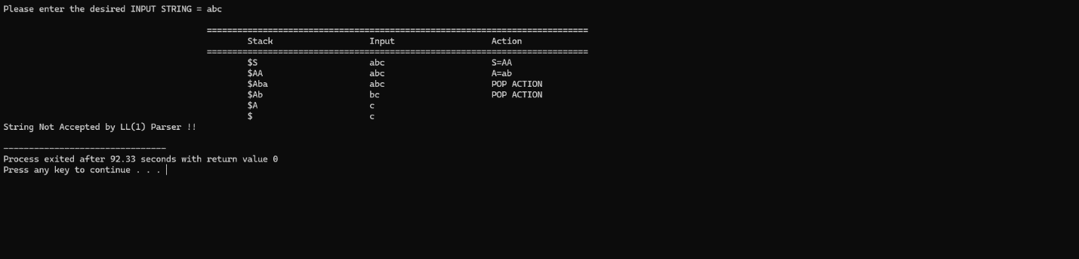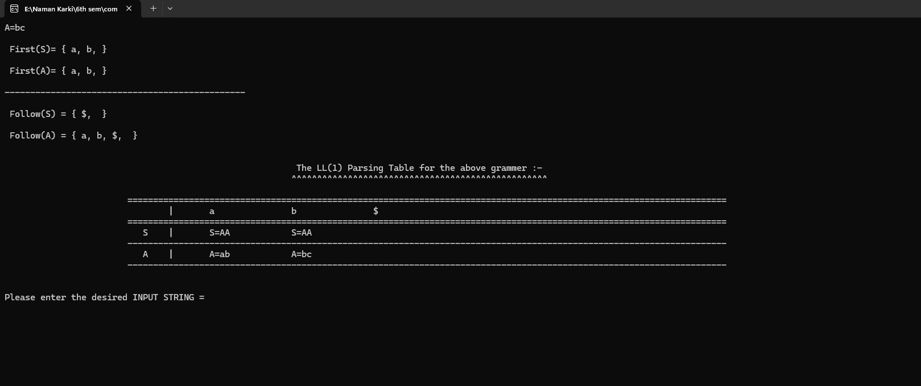

# 10) WAP to implement shift/reduce parsing.

#include<stdio.h>

#include<conio.h>

#include<string.h>

#include<stdlib.h>

int k=0,z=0,i=0,j=0,c=0;

char a[16],ac[20],stk[15],act[10];

void check();

void main()

{

puts("GRAMMAR is\n E->E+E \n E->E*E \n E->(E) \n E->id");

puts("enter input string ");

gets(a);

c=strlen(a);

strcpy(act,"SHIFT->");

puts("stack \t input \t action");

for(k=0,i=0; j<c; k++,i++,j++)

{

if(a[j]=='i' && a[j+1]=='d')

{

stk[i]=a[j];

stk[i+1]=a[j+1];

stk[i+2]='\0';

a[j]=' ';

a[j+1]=' ';

printf("\n$%s\t%s$\t%sid",stk,a,act);

check();

}

else

{

stk[i]=a[j];

stk[i+1]='\0';

a[j]=' ';

printf("\n$%s\t%s$\t%ssymbols",stk,a,act);

check();

}

}

getch();

}

void check()

{

strcpy(ac,"REDUCE TO E");

for(z=0; z<c; z++)

if(stk[z]=='i' && stk[z+1]=='d')

{

stk[z]='E';

stk[z+1]='\0';

printf("\n$%s\t%s$\t%s",stk,a,ac);

j++;

}

for(z=0; z<c; z++)

if(stk[z]=='E' && stk[z+1]=='+' && stk[z+2]=='E')

{

stk[z]='E';

stk[z+1]='\0';

stk[z+2]='\0';

printf("\n$%s\t%s$\t%s",stk,a,ac);

i=i-2;

}

for(z=0; z<c; z++)

if(stk[z]=='E' && stk[z+1]=='*' && stk[z+2]=='E')

{

stk[z]='E';

stk[z+1]='\0';

stk[z+1]='\0';

printf("\n$%s\t%s$\t%s",stk,a,ac);

i=i-2;

}

for(z=0; z<c; z++)

if(stk[z]=='(' && stk[z+1]=='E' && stk[z+2]==')')

{

stk[z]='E';

stk[z+1]='\0';

stk[z+1]='\0';

printf("\n$%s\t%s$\t%s",stk,a,ac);

i=i-2;

}

}

Output:

