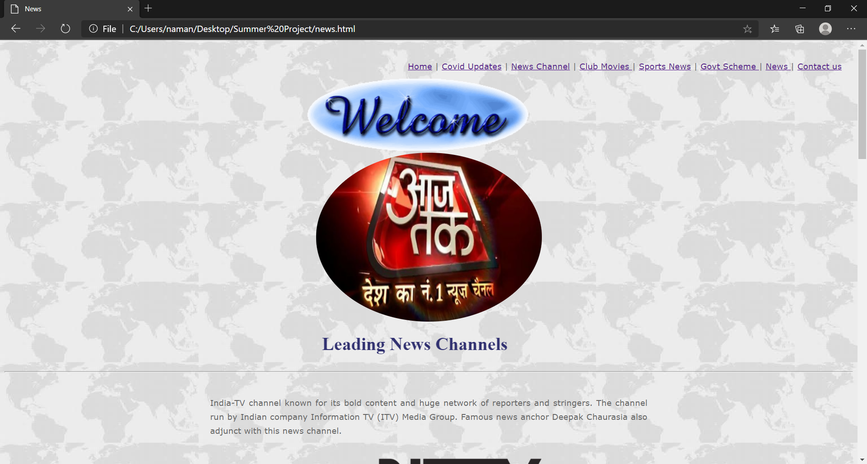
File : Index.html v
<html>
<head>
<title>Home</title>
<link rel="stylesheet" type="text/css"href="style.css">

</head>
<body>

<p class="pmenu" ><a href="home.html">Home</a> | <a href="covid.html"> Covid Updates</a> | <a href="news.html"> News Channel</a> | <a href="movies.html">Club Movies </a> | <a href="sports.html"> Sports News</a> | <a href="scheme.html"> Govt Scheme </a> | <a href="cnews.html"> News </a> | <a href="cnews.html"> Sports </a> | <a href="contact.html"> Contact us</a></p>
<center><marquee width="40%" behavior="alternate" scrollamount="3"><img src="images/welcome.gif" width="400" ></marquee></center>

<center>
<table width="800px" cellpadding="10" cellspacing="10">

<tr>
<td><a href="news.html"><img class="cimg" src="images/anchor.png" width="400" ></a></td>
<td><a href="movies.html"><img class="cimg" src="images/bajrangi.jpg" width="420" ></a></td>
</tr>
<tr>
<td align="center"><a href="news.html"><b>Leading News Channel</b></a></td>
<td align="center"><a href="movies.html"><b>100 Crores Club Movies</b></a></td>
</tr>
<tr>
<td><a href="scheme.html"><img class="cimg" src="images/beti.jpg" width="420" ></a></td>
<td><a href="cnews.html"><img class="cimg" src="images/modi.webp" width="400" ></a></td>
</tr>

<tr>
<td align="center"><a href="scheme.html"><b>Government Schemes</b></a></td>
<td align="center"><a href="cnews.html"><b>Trending News</b></a></td>
</tr>

<tr>
<td><a href="sports.html"><img class="cimg" src="images/cricket.png" width="420" ></a></td>
<td><a href="covid.html"><img class="cimg" src="images/corona.jpg" width="400" ></a></td>
</tr>

<tr>
<td align="center"><a href="sports.html"><b>Sports News</b></a></td>
<td align="center"><a href="covid.html"><b>Covid Latest Update</b></a></td>
</tr>

</tr>
<tr>
</table>
</center>

<center>
<font color="#6C6C6C">Copyright &copy; 2020, designed by Naman Kudesia </font><br>
<font color="#6C6C6C">Illegal copy of this site will be offensive crime</font></center>

</body>
</html>

