SmartBridge

Modern Application Development (Java Spring Boot)

**Week-2 Assignment**

**Student Name:** Naman

**Registration Number:** 20BCT0202

**Campus:** VIT Vellore

**MySQL Commands**

-- Creating tables in MySQL

CREATE TABLE customers (

id INT AUTO_INCREMENT PRIMARY KEY,

cname VARCHAR(50),

email VARCHAR(50),

phno NUMERIC(10)

);

CREATE TABLE orders (

id INT AUTO_INCREMENT PRIMARY KEY,

customer_id INT,

product_id INT,

quantity INT,

FOREIGN KEY (customer_id) REFERENCES customers(id)

);

-- Create Row commands in MySQL

INSERT INTO customers (cname, email, phno)

VALUES ('John Doe', 'johndoe@example.com', 9898098980),

('Jane Smith', 'janesmith@example.com', 9112091120),

('Bob Johnson', 'bobjohnson@example.com', 9001001009),

('Sam Smith', 'samsmith@example.com', 9002090020);

INSERT INTO orders (customer_id, product_id, quantity)

VALUES (1, 14627, 5),

(3, 13020, 10),

(3, 10023, 2),

(4, 10551, 20),

(1, 14002, 3),

(2, 10420, 11);

SELECT * FROM customers;

SELECT * FROM orders;

-- Update, Delete Row commands in MySQL

UPDATE customers

SET email = 'newemail@example.com', phno = 9010090100

WHERE id = 1;

UPDATE orders

SET quantity = 4

WHERE id = 1;

DELETE FROM orders

WHERE customer_id = 3;

SELECT * FROM customers;

SELECT * FROM orders;

-- Joins in MySQL

SELECT orders.id AS order_id, customer_id, customers.cname, orders.product_id, orders.quantity

FROM customers INNER JOIN orders ON customers.id = orders.customer_id;

SELECT orders.id AS order_id, customer_id, customers.cname, orders.product_id, orders.quantity

FROM customers LEFT JOIN orders ON customers.id = orders.customer_id;

SELECT orders.id AS order_id, customer_id, customers.cname, orders.product_id, orders.quantity

FROM customers RIGHT JOIN orders ON customers.id = orders.customer_id;

SELECT * FROM customers FULL JOIN orders;

-- Modifying tables in MySQL

ALTER TABLE customers

ADD address VARCHAR(80),

MODIFY cname VARCHAR(40),

DROP COLUMN phno;

-- Dropping tables in MySQL

DROP TABLE orders;

**Output:**

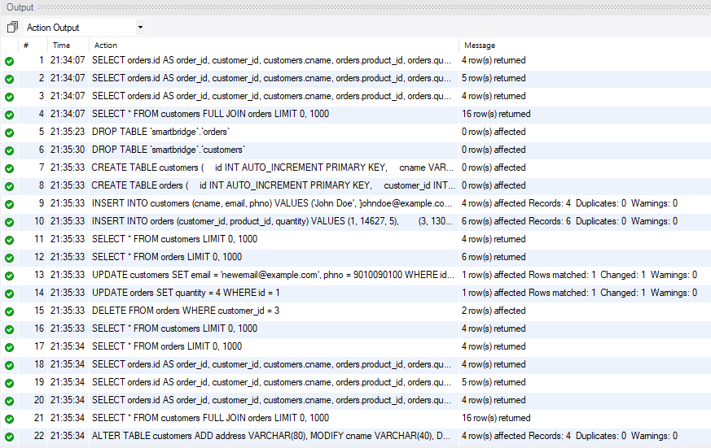

**Customers Table**

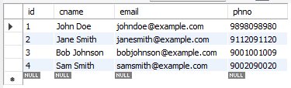

**Orders Table**

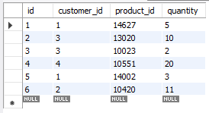

**Customers Table After Update, Delete Row Command**

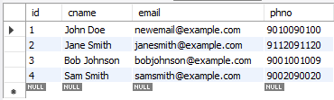

**Orders Table After Update, Delete Row Command**

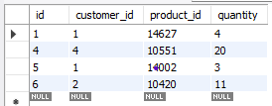

**Inner Join**

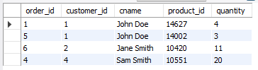

**Left Join**

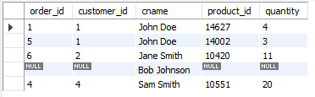

**Right Join**

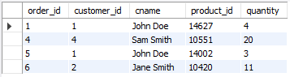

**Full Join**

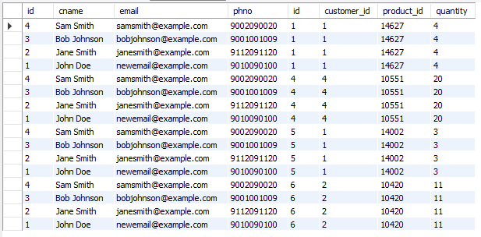

**MongoDB Commands**

**Creating a Database, Collections and Documents in MongoDB**

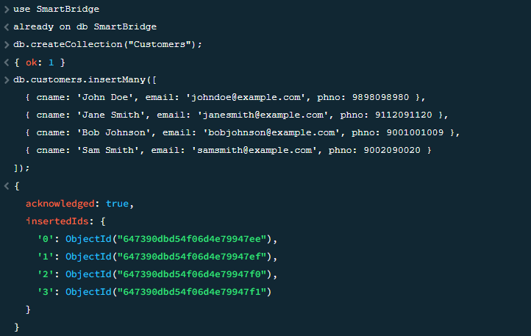

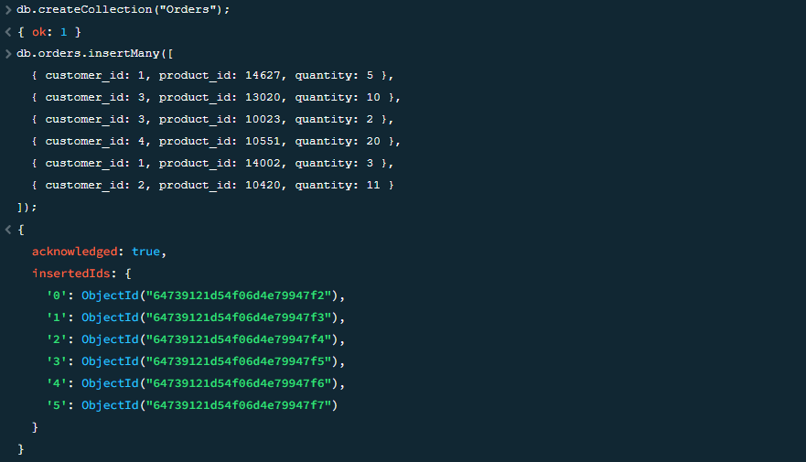

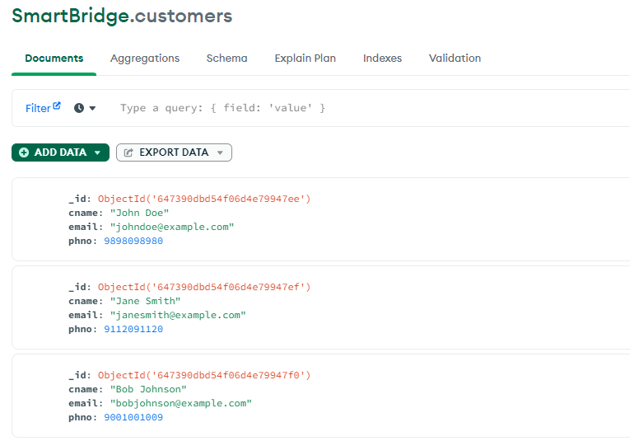

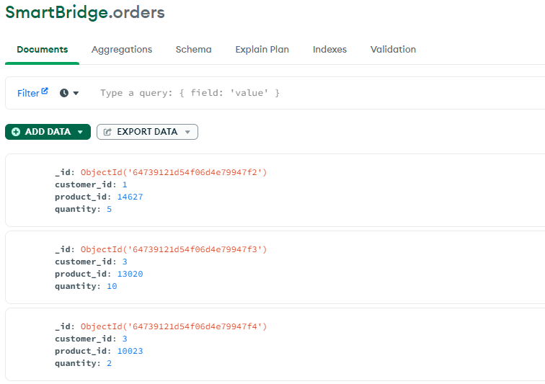

**Updating a Document in MongoDB**

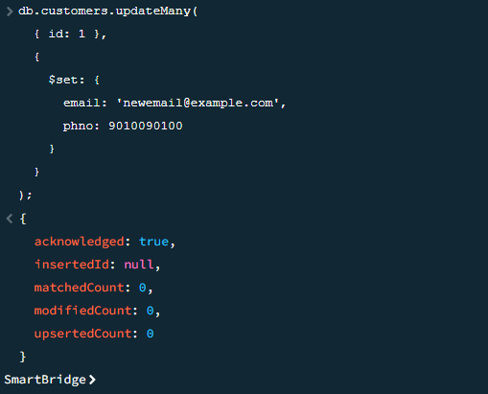

**Deleting Documents in MongoDB**

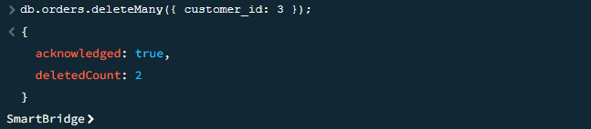

**Dropping a Collection in MongoDB**

