**PHASE 2: DESIGN**

**TEAM: BUG OFF**

**FULL WIREFRAME**

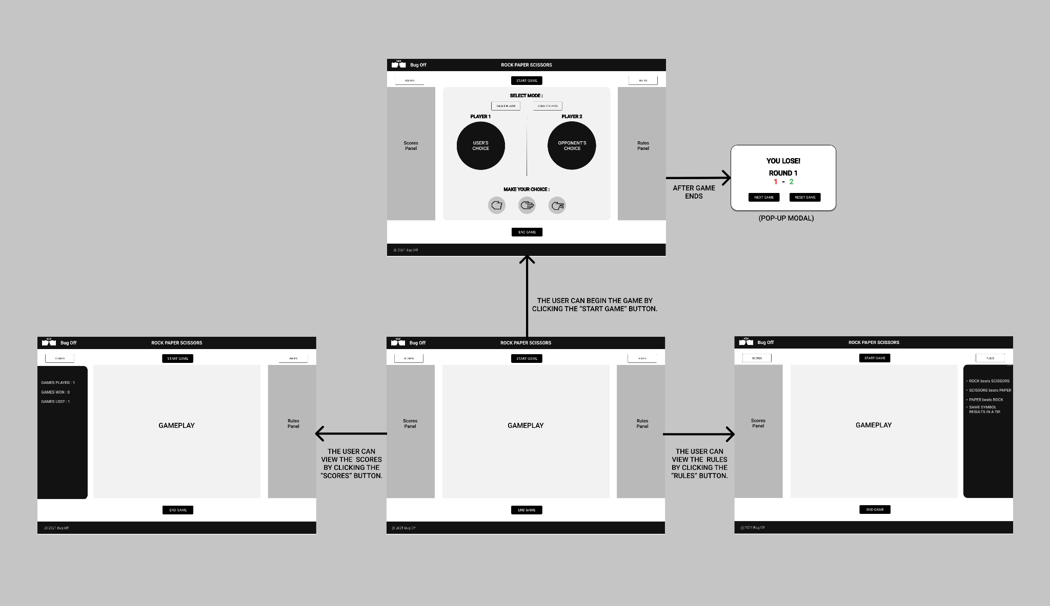

**LANDING PAGE**

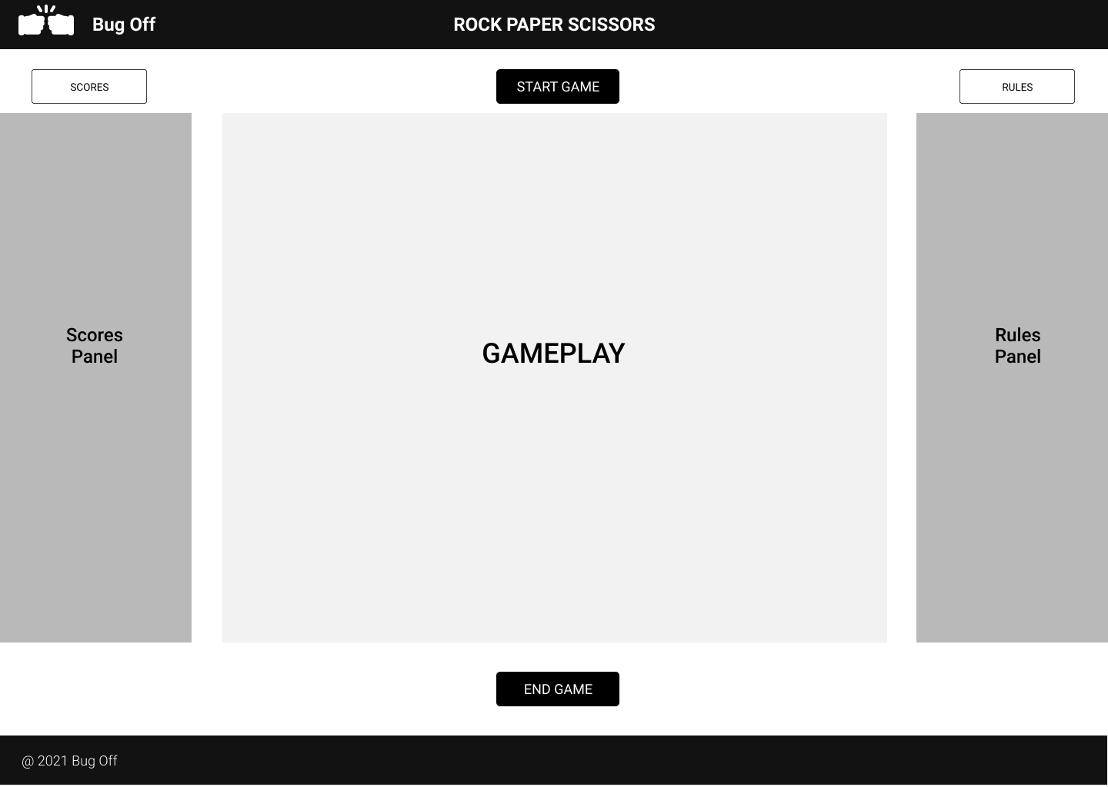

**GAMEPLAY PAGE**

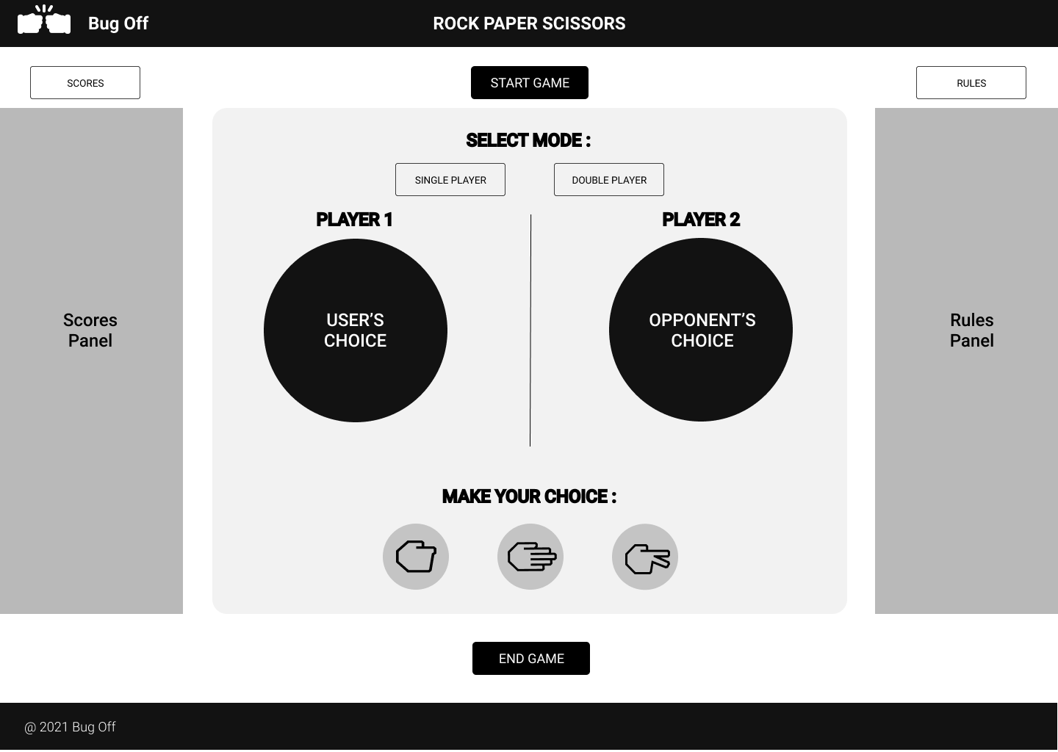

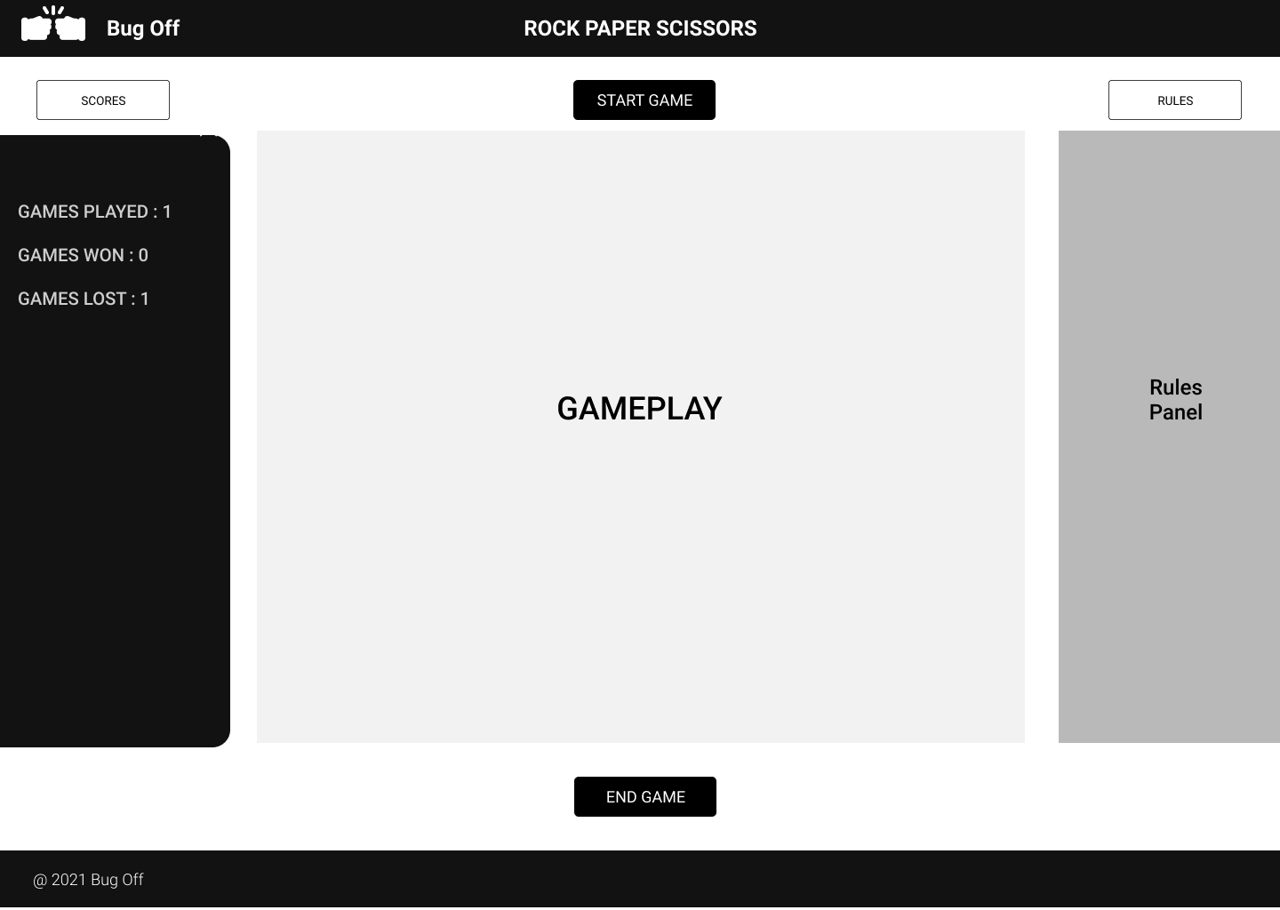

**SCORES PANEL**

**RULES PANEL**

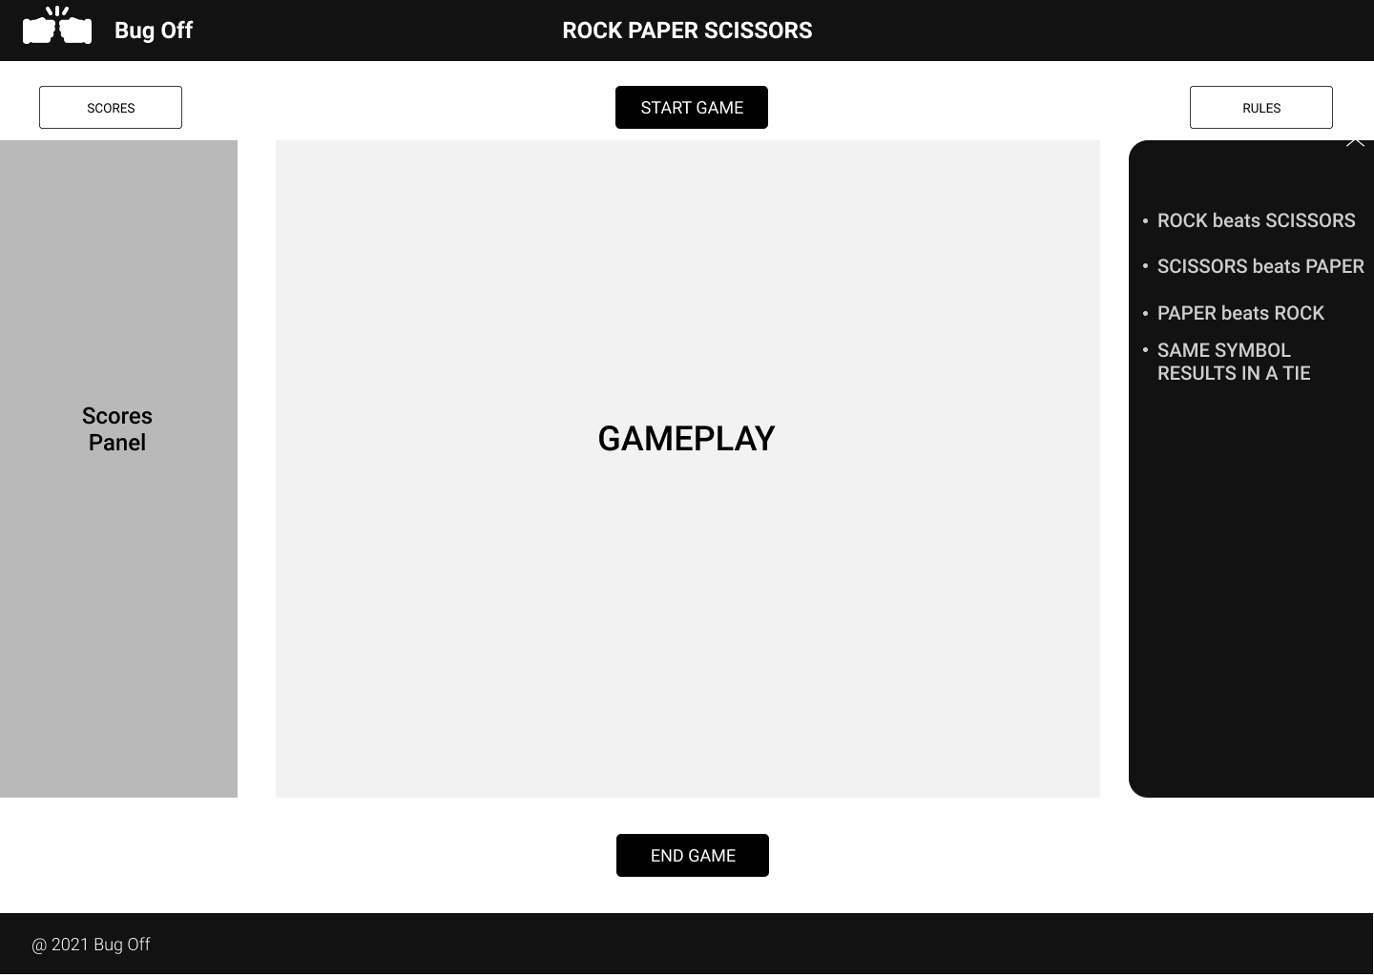

**AFTER GAME POP-UP MODAL**

