Report

on

A SMART QUIZ APPLICATION IN CLOUD ENVIRONMENT USING AWS

TABLES OF CONTENTS
CHAPTER No. | TITLE | PAGE NO.
 | ABSTRACT |  | i
 | LIST OF TABLES |  | ii
 | LIST OF FIGURES |  | iii
CHAPTER 1. INTRODUCTION
1.1 Purpose |  |  | 1
1.2 Scope |  |  | 1
1.3 Problem Definition |  |  | 2
1.4 Proposed solution |  |  | 3
CHAPTER 2. SYSTEM REQUIREMENT ANALYSIS
2.1 Overall Description |  |  | 4
2.1.1 | Product Perspective |  | 4
2.1.2 | Product Function |  | 4
2.1.3 | User Classes And Characteristics |  | 5
2.1.4 | Operating Environment |  | 5
2.1.5 | Design And Implementation Constraints |  | 5
2.1.6 | Assumptions And Dependencies |  | 5
2.2 External Interface Requirement |  |  | 6
2.2.1 User Required |  |  | 6
2.2.2 Hardware Required |  |  | 7
2.2.3 Software Required |  |  | 8
2.2.4 Communications Required |  |  | 8
2.3 Functional Requirement |  |  | 8
2.3.1 System Feature |  |  | 8
2.4 Non Functional Requirement |  |  | 9
2.4.1 Performance Requirement |  |  | 9
2.4.2 Safety Requirement |  |  | 9
2.4.3 Security Requirement |  |  | 9

2.5 Project Plan | 10
2.5.1 Team Members | 10
2.5.2 Division Of Work | 10
2.5.3 Time Schedule | 10

CHAPTER 3. ANALYSIS

3.1 | Methodology Used | 11
3.2 Use Case Diagram |  | 13
3.3 | Sequence Diagram | 17
3.4 | Activity Diagram | 21
3.5 | Class Diagram | 24
3.6 | Data Flow diagram | 25

CHAPTER 4. DESIGN

4.1 Architectural Design |  |  | 26
 | 4.1.1 | System Architectural Design | 26
 | 4.1.2 | Description Of Architectural Design | 26
4.2 | Database Design |  | 28
 | 4.2.1 | Normalization | 28
4.3 Component Design |  |  | 29
 | 4.3.1 | Flow Chart | 29
4.4 | Interface Design |  | 30
 | 4.4.1 | Screenshots | 30

CHAPTER 5. IMPLEMENTATION

5.1 Language And Database System Used |  | 36
5.2 | Features Of Language And Database Used | 36
5.3 | Description Of Third party tools Used | 36

CHAPTER 6. TESTING

6.1 | White Box Testing | 37
6.2 | Black Box Testing | 38

CHAPTER 7. | FUTURE SCOPE AND LIMITATION | 39
CHAPTER 8. | CONCLUSION | 40
CHAPTER 9. | REFERENCE | 41

ABSTRACT

The concept of questions is now very popular among educated circles and in entertainment shows. Although questions can be done in person and require detailed preparation, the questions contribute to the growth of individual knowledge and are a popular source of entertainment. This program in Java focuses on creating interactive queries with a very large quiz site. The program uses a lot of important concepts in the design of Java and the applet to get the final result is a view from the knowledge and get entertainment that includes value. The system reduces paperwork and all information will be stored securely on the Application. This app stores questions in a database where a set of six questions will appear. Designed to replace existing paper and manual adjustments. This program uses java as the front end and MySQL as the back end of the Application. The implementation of the program in the organization will significantly reduce time and provide easily calculated marks.

Project: "Question System" is a collection of a number of different types of questions such as technology, games, sports, etc. User can access / play all queries and try any of them. There will be a limited number of questions and each user of the correct answer will receive credit points. The user can see the answers and can ask a related question. There are many queries available right now online. But there are a few Providers of better understanding between users and the app such as providing appropriate answers, solving user queries, uploading user queries and answers to it, etc. Developing a friendly quiz app that will contain: Answers to all questions, resolving queries about any question, User query uploads and feedback, and improving the level of user knowledge. Creating an application that will contain a solution to the above problems. With this app the user will know about his level and can learn more information. And with this app the user can increase his knowledge in the middle of the world.

 | LIST OF TABLES
Table no. | Title | Page no.
2.1.4.1 | Operating Environment | 5
2.2.2.1 | Hardware Required | 7
2.2.3.1 | Software Required | 8
3.2.1 | Use case specification for Registration | 14
3.2.2 | Use case specification for Log-In | 14
3.2.3 | Use case specification for Home Page | 15
3.2.4 | Use case specification for Admin Home Page | 15
3.2.5 | Use case specification for Result | 16
3.2.6 | Use case specification for Log-Out | 16
4.2.1.1 | Standardization table | 27

1
1. INTRODUCTION

1.1. Purpose

This application provides a place to show puzzle, exercise Grammar, Skill, etc. It provides a good platform, where the student not only judges knowledge / skills but also is able to develop knowledge / skills at the same time.
1.2 Scope

The Scope of this project is very broad in terms of gaining knowledge and sharing knowledge among world.

Few points are:-

Can be used anywhere any time as it is a web based application.

This application will be used in educational institutions as well as in corporate world.

1.3 Problem Definition

“Our goal is to develop an app for users where the user can try any number of queries related to his or her preferences.”

First, we need to create links to the Home page, Registration, Login Page, Quiz Forum, Result Page, and User Profile. These are all pages that link to the server and the site. So, that can work well. Currently, there are Applications that only offer a limited number of queries related to a different domain. Many Applications do not have a single forum for technology-related questions, G.K, Fitness, Games, etc. And there is no Application where users can upload their questions and answers to others. We need to build an app that can solve all of the above problems. With this user he can get information, can solve his question, and spread his knowledge in the world.
1.4 Proposed Solution

The main requirement of the application is to find questions and answers. In this application for the first time the user needs to register or login using the user id and password. The user can then select any questions of their choice. Before starting the quiz there is a guide window where there are instructions related to quiz quiz. After that the user can start getting questions. Here the user can see if their answers are right or wrong and they can also see their individual answers. If there is any related question the user can ask it. Upon completion of the question the user will receive credit points for each of their correct answers. Initially the questions are given to the administrator but after some time the user himself can post the questions and their answers. After confirmation by the administrator the questions are displayed in the window. Question-related query that we can resolve by the administrator and users of this application. This app contains preliminary acknowledgment and a specific user who can post questions and answers. User profile will contain its name, age, qualifications, gender, mobile number, credit score, etc. This application will provide a link to an additional useful Application for the purpose of learning.
2. SYSTEM REQUIREMENT ANALYSIS

2.1 Overall Description-

2.1.2 Product Perspective

Quiz app based on web application. It usually communicates with the user and readers. Especially a quiz application where there are 4 categories. Each section will hold 10 questions, and each question has 1 mark. No negative tagging. If we do not try any questions it will show a “not tried” mark.

On the result screen, we will display the full marks found in the question, the wrong answer will also be displayed with the correct answer.

The main purpose of this app is to develop knowledge and skills for students and the user.
2.1.2 Product Function

Account login: Student/user can login using login id and password.

Account logout: Student/user can logout the account whenever required.

Result: Student/user attempted the quiz and gets a result.

Feedback: Student/user can give a feedback.

Play quiz: Student/user can play the quiz according to his/her choice.

Add Questions: Admin can add the question by selecting the topic.
2.1.3 User Classes And Characteristics
 | Users of the product must possess a minimal |  |  |  | level. Users must
 | know how to access the functionality of this system and get
 | benefited.
2.1.4 Operating Environment
 | S.NO. |  | NAME |  |  | HARDWARE
 | 1. |  | Processor |  |  | Intel dual core(32 bit)
 | 2. |  | RAM |  |  | 2 GB
 | 3. |  | Processor Speed |  |  | 2GHz

2.1.5 Design And Implementation Constraints

Programming Language used: JAVA.

Platform used: NETBEANS.

Database/Backend: MySQL.

Cloud Environment: AWS(Amazon Web Services)

2.1.6 Assumptions And Dependencies

We think users of our Application should have a little computer system knowledge and should have internet access. We rely on sources where we collect data and data is verified.
2.2 Enternal interface Requirements

2.2.1 User Required
The Admin has the access to overall control the functionalities of the system. The platform users i.e., admin student/user will be protected by login and password since; the platform allows the users to make some changes that can have propagating effects in the system. They can upload their updates and details in the system.

Home Page:
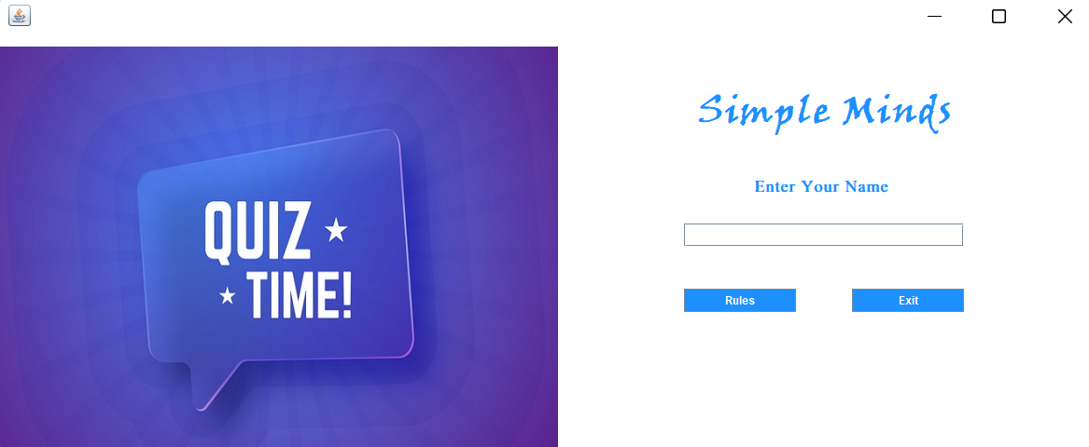

Rules page:
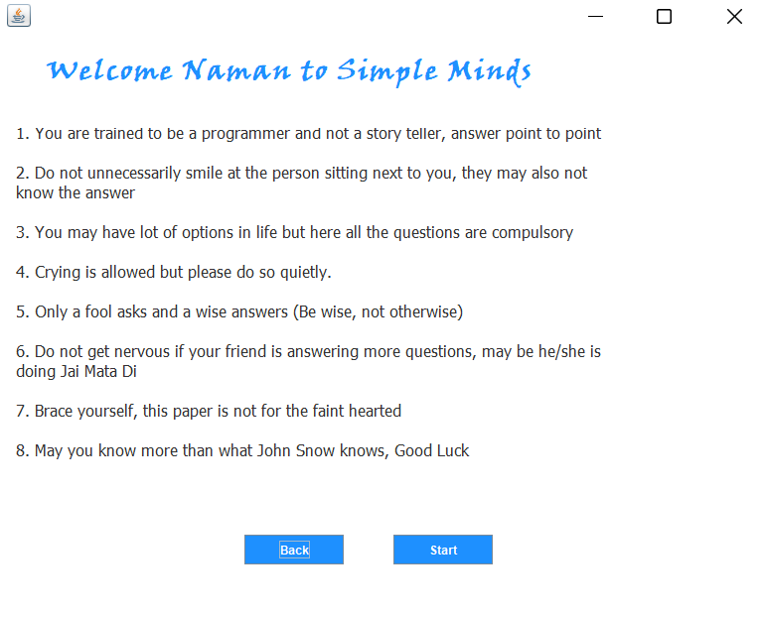g : 2.2.1.2 Registration page
2.2.2 Hardware Required
 |  | S.NO. |  | NAME | HARDWARE
1. |  |  |  | Processor | Intel dual core(32bit)
2. |  |  |  | RAM | 2 GB
3. |  |  |  | Processor Speed | 2 GHz

Table 2.2.2.1 Hardware Required

2.2.3 Software Required
 | S. No |  | NAME |  |  | SOFTWARE
 | 1 |  | Platform |  |  | Windows 7
 | 2 |  | Database tool |  |  | MySql
 |  |  | Table 2.2.3.1 Software Required

2.2.4 Communications Required

Windows

2.3 Functional Requirement

2.3.1 System Feature

This section provides the operating requirements applicable to the online quizing system.
There are three modules in this category:

1. Student or user module.

2. Administrative module.

The functionality each module is:
Student or user module:

The student/user have to login in application. They can choose any of the given quiz. Then the student/user will get result immediately after the completion of test.

Administrative module:

The manager can see all the tables in the Database and can add a question by selecting a specific topic.

2.4 Inaccurate Requirement

2.4.1 Operating Requirements

1. Response time-

The system will provide responses within 2 seconds after user login.

2. Capacity-

The system can support multiple computer but it need to be install on every computer separately.

2.4.2 Safety Requirements

All logged information, updates, user activities are securely stored.

2.4.3 Security Requirement

Any amendment for the Database shall be corresponding and done by system supervision.
2.5 Project Plot

2.5.1 Members

Name: Naman Raj Sharma

Email: namanrajsharma2611@gmail.com

2.5.3 Time Schedule

1. Requirement Analysis: Approximately 15 days

2. Design : Approximately 25 days

3. Coding : Approximately 30 days

4. Testing : Approximately 10 days
3 ANALYSIS

3.1 Methodology Used

The programming language used for the development of the project is JAVA and the software model used is the classic lifecycle model.

Waterfall Process model

The Classical Life Cycle or Waterfall Process Model was the first process model to introduce a sequential framework, outlining the basic basic components of an effective software development model. It lays the foundation for many levels of software development and consists of the following phases: needs analysis, design, coding, testing, and maintenance.
Advantages of the waterfall model:

o A simple goal.

o Easy to understand and apply.

o Categories clearly defined.

o It is easy to organize activities.

o The process and outcome are well documented.

o Customers / end users already know about it.

o Easy to handle.

Waterfall model disadvantages:

• Strong design and consistent process.

• The waterfall model is subject to a “fixed point solution” which means that even the smallest amendments in construction were difficult to integrate with the latest design phase.

• As the requirement was determined before moving on to the design phase, using an incomplete set of requirements, a complete design amendment was implemented.

- Once the phase is done, it is not repeated i.e. the movement from the waterfall to another and vice versa is not supported, the last days it is difficult to meet the case of large projects
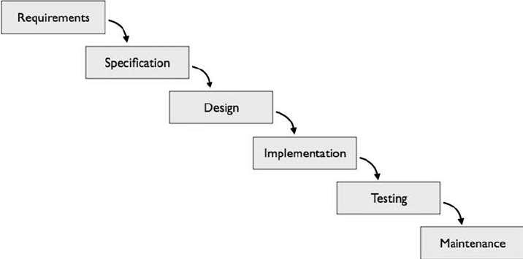
.

3.2 USECASE DIAGRAM

- USECASE DIAGRAM

A simple user interface diagram represents user interaction with a system that shows the relationship between the user and the unique user environment in which users are involved. The application case diagram can identify different types of system users and different operating conditions.
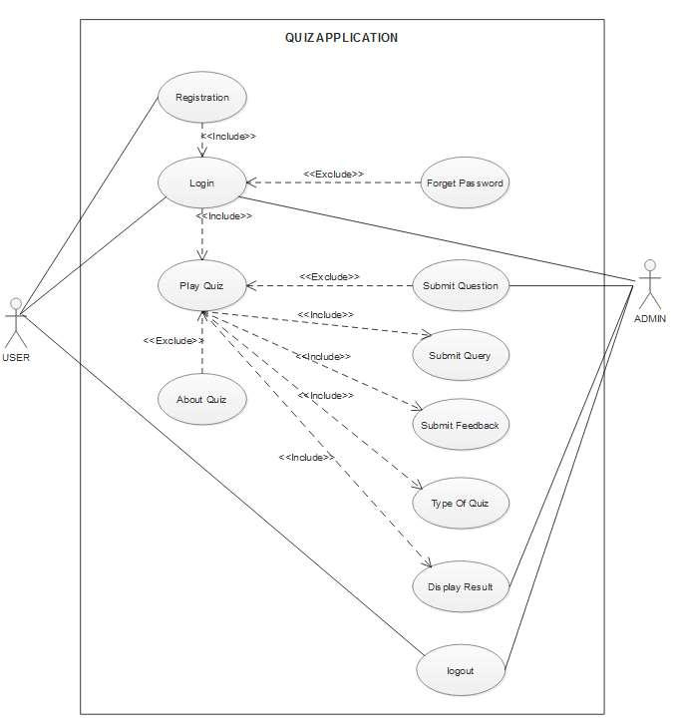

- USE CASE SPECIFICATION

Name of the use case | Registration
Actor | User/student
Precondition | None
Primary flow of events | Email id, password, dob, mobile
 | no., Security code.
Alternate flow of events | If email, password, dob, mobile
 | no. is wrong shows message
 | “incorrect the some details”.
Post condition | If successful register and come to
 | log in page.
Use case termination | Cancel
Table 3.2.1
Name of the use case | Log-In
Actor | User/student
Precondition | None
Primary flow of events | Email id , password
Alternate flow of events | If username or password is wrong
 | shows message “incorrect email id
 | and password”.
Post condition | If successful log and come to
 | home page.
Use case termination | Cancel
Table 3.2.2
Name of the use case | Home page
Actor | User/student
Precondition | Login Successfully
Primary flow of events | Can Access any of the given
 | quizzes.
Alternate flow of events | None.
Post condition | Will Attempt Quiz.
Use case termination | Cancel

Table 3.2.3

Name of the use case | Home page
Actor | Admin
Precondition | Login Successfully.
Primary flow of events | Can Submit question and can see
 | any of the Database.
Alternate flow of events | None.
Post condition | None.
Use case termination | Cancel

Table 3.2.4
Name of the use case | Result page
Actor | User/student
Precondition | Submit quiz.
Primary flow of events | Can see result.
Alternate flow of events | None.
Post condition | Can give feedback and go back to
 | Home Page.
Use case termination | Cancel

Table 3.2.5

Name of the use case | Logout
Actor | User/student
Precondition | Successful log in to the account
Primary flow of events | No primary flow.
Alternate flow of events | Session expired.
Post condition | User will be redirected to
 | application home page.
Use case termination | Cancel

Table 3.2.6
3.3 SEQUENCE DIAGRAM
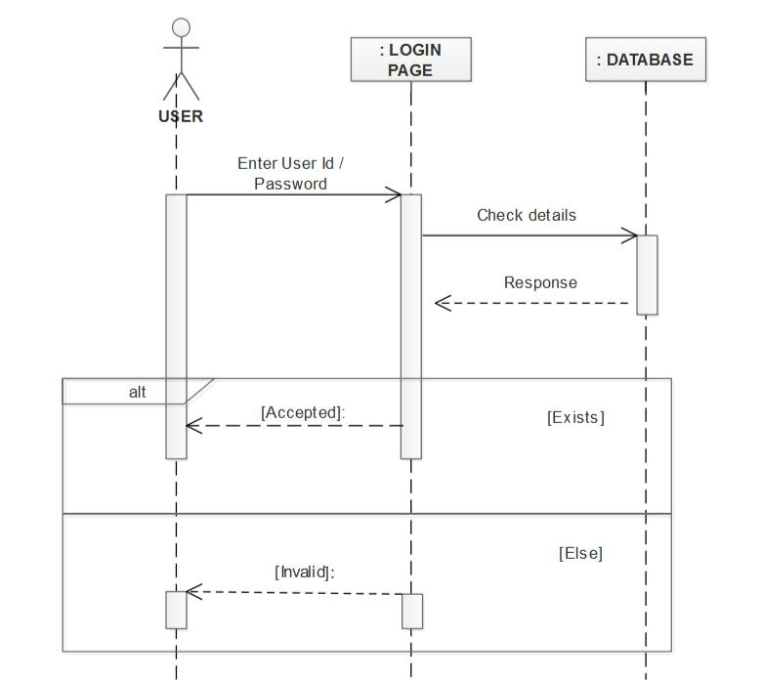

Fig: 3.3.1
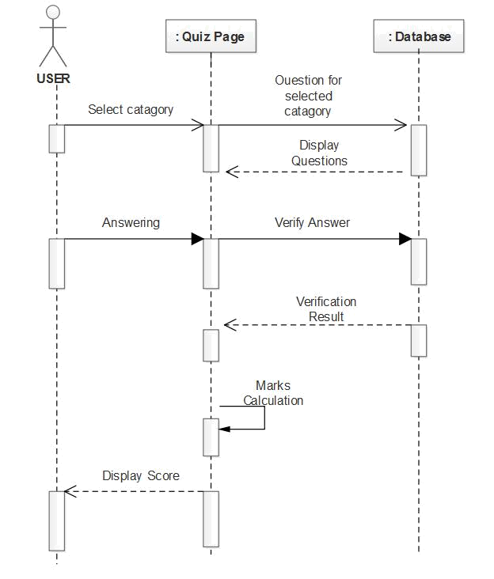

Fig : 3.3.2
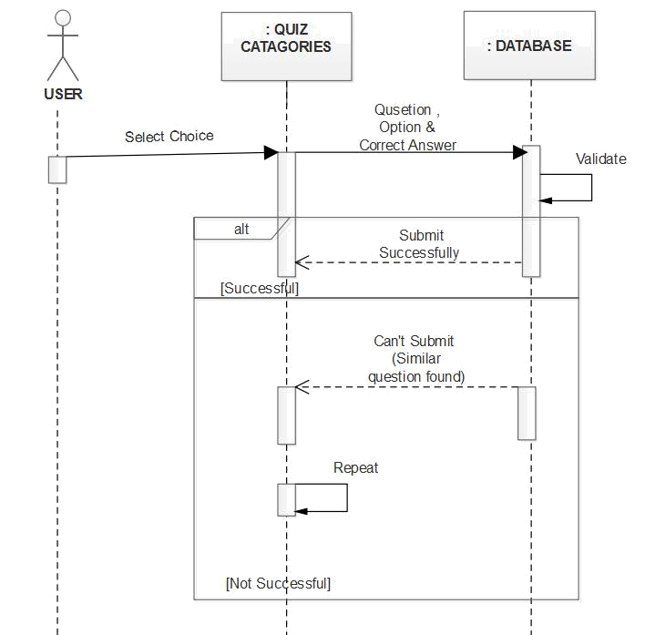

Fig : 3.3.3
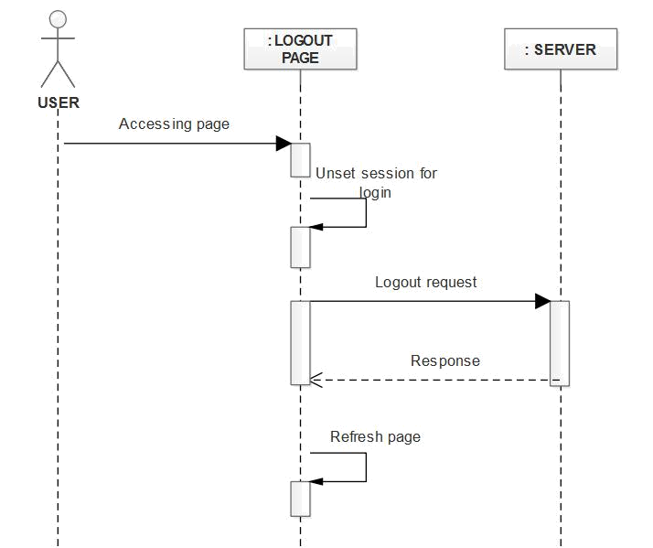

Fig : 3.3.4
3.4 ACTIVITY DIAGRAM
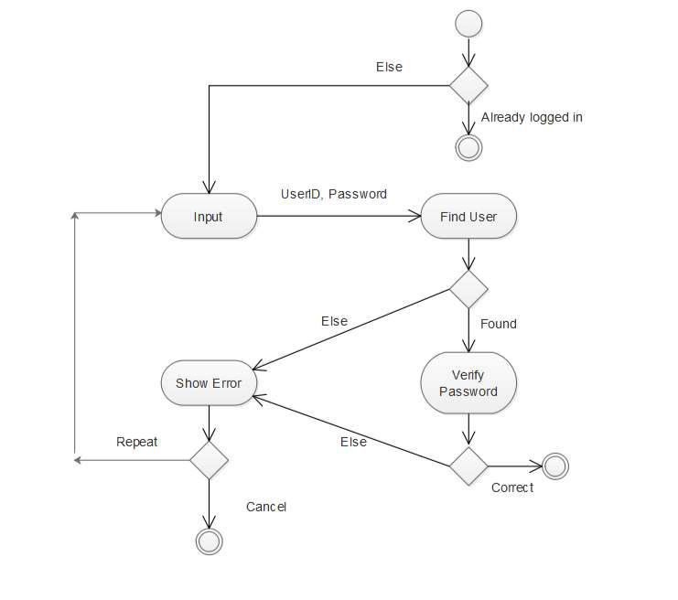

Fig : 3.4.1
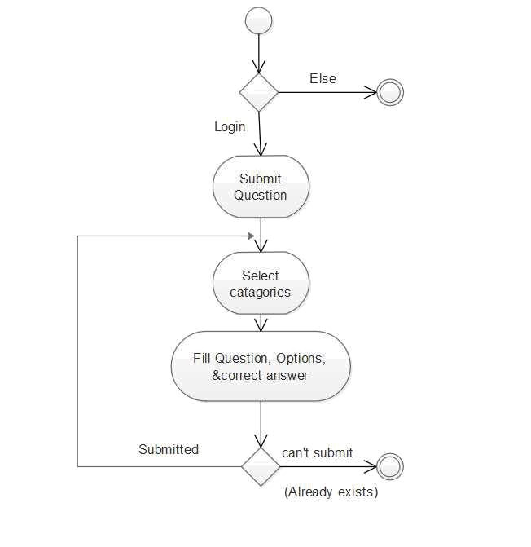

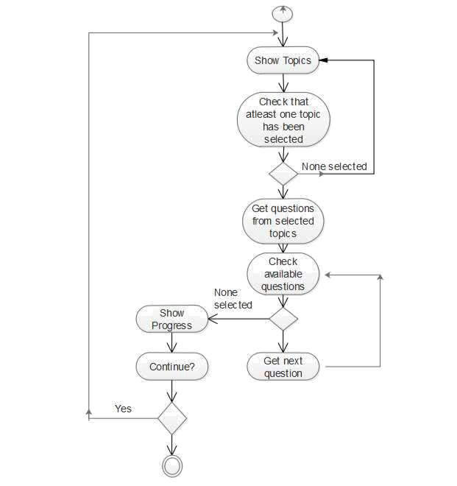

3.5 CLASS FIGURE
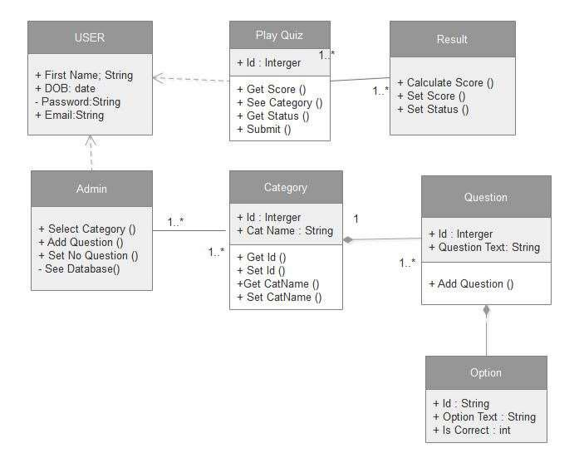

Fig: 3.5.1
3.6 Data flow diagram
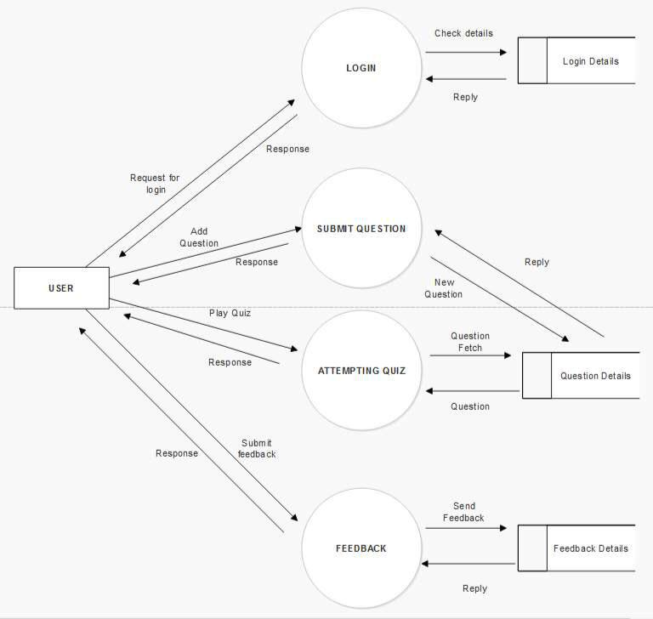

Fig: 3.6.1
4. DESIGN

4.1 Architectural Plan

4.1.1 System - Architectural Design

A three-phase architecture is a client software software architecture in which the visual interface of the application (presentation), working system intellect (“occupational rules”), data storage & access are industrialized and preserved as separate components, usually on separate stages. .

In addition to the common advantages of modular software with a well-defined interface, the three-phase Architecture is intended to allow any of these three categories to be developed or replaced independently due to required changes or technologies. For example, the change of the operating system in the launch stage will only affect the use of the line.

Typically, the visual application works on a desktop computer or workstations and uses a standard user interface operating system that may include one or more different modules running on operating system servers, as well as RDBMS on a stored server or a large frame containing a computer. data storage logic. The middle class may have many sections of its own (where the whole architecture is called “n-tier architecture”).
4.1.2 Description of Architectural Diagram
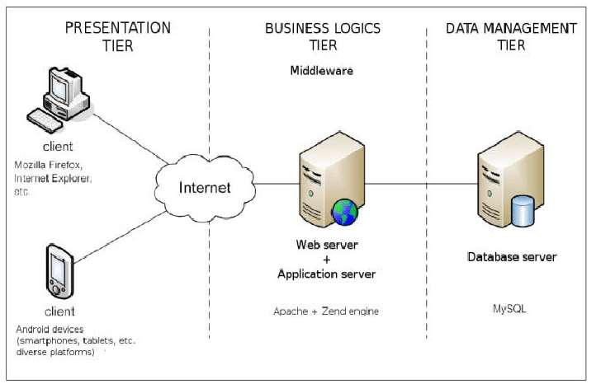

Fig: 4.1.2.1 A 3-Tier Architecture
Cloud Computing

Cloud computing is a framework by means of which virtualized infrastructure resources are delivered as a service to customers by using a public network which is the Internet.

Cloud infrastructure refers to the hardware and software components, such as servers, storage, networking, virtualization software, services and management tools, that support the computing requirements of a cloud computing model.

Cloud infrastructure underpins cloud computing by disaggregating the functions and features of those hardware and software components. Then, a cloud service provider -- or information technology (IT) department in the case of private cloud -- hosts those virtualized resources and delivers them to users over the internet or a network. These resources include virtual machines (VMs) and components, such as servers, memory, network switches, firewalls, load balancers and storage. These resources often support extensive and task-specific services, such as artificial intelligence (AI) and machine learning.

In a cloud computing architecture, cloud infrastructure refers to the back-end technology elements found within most enterprise data centers -- servers, persistent storage and networking equipment -- but on a much greater scale. Some large cloud providers, including hyperscale cloud companies, such as Facebook and LinkedIn, form partnerships with vendors to design custom infrastructure components that are optimized for specific needs, such as power efficiency or workloads that include big data and AI

Public vs. private vs. hybrid cloud architectures
Cloud infrastructure is present in each of the three main cloud computing deployment models: private cloud, public cloud and hybrid cloud.

Private cloud
In a private cloud, an organization typically builds and owns the cloud infrastructure components and houses them within its own data center. This setup is a single-tenant environment, meaning the organization is the only one using the dedicated infrastructure and services. This architecture seeks the best of both worlds: versatility and convenience of cloud-delivered services, with the tighter control, management and security that come with data center ownership.

Organizations may choose a private cloud infrastructure because their computing needs are irregular and would be too costly to run in a public cloud model. They may require greater control or security over infrastructure assets, critical applications or sensitive data or must meet specific regulatory and governance requirements.

Public cloud
In a public cloud model, the cloud infrastructure components are owned by a third-party public cloud provider, and these resources are shared among customers in multi-tenant environments. Customers pay for services and capabilities based on core infrastructure resources -- central processing unit (CPU) cycles, storage, bandwidth, etc., as well as higher-level services -- but do not own or manage those underlying resources themselves. Cloud providers sell these services on demand, typically per minute or hour, often through long-term commitments.

Hybrid cloud
A hybrid cloud consists of a mix of both models to form a single logical cloud for the user. A business can rely on a private cloud to run certain workloads or sensitive applications or host private sensitive data, while it runs other apps and data in a public cloud. Public cloud resources also can be tapped to handle bursts or spikes in demand to provide flexibility for private cloud use.

A related model is a multi-cloud model, in which an enterprise uses multiple cloud providers. This may be to run services concurrently for resiliency or migrate apps between providers.

What are the different types of cloud computing delivery models?
Cloud computing services are delivered in three models that reflect the levels of resources accessed and provided.

Infrastructure as a service
In an infrastructure as a service (IaaS) model, organizations consume cloud infrastructure components as resources and services over a dedicated internet connection. This typically carries recurring periodic costs to the user and enables providers to generate revenue through rental or other pay-as-you-go models.

On top of those basic cloud infrastructure services, providers offer an array of more granular, specialized services. Examples include container infrastructure, service fabrics, serverless functions and managed network services -- virtual private clouds, load balancers, domain name services, application delivery controllers, firewalls, etc.

Cloud providers typically price IaaS on a metered basis, with rates corresponding to usage at a given level of performance. Examples include the following:

increments of a standard virtual CPU size and corresponding memory;
storage service type (object or block), performance level (SSD or HDD) and availability; and capacity measured by usage per unit time, typically per month.
IaaS vendors also provide discounts for sustained usage or the use of a consistent level of compute capacity for a specified amount of time. Customers also can achieve savings through reserved capacity, where they prepay for a guaranteed level of capacity for a month, year or multiple years.

Platform as a service
In recent years, the lines have blurred between IaaS and platform as a service (PaaS), which builds additional capabilities on top of those infrastructure resources. These include functions such as load balancing, autoscaling, application development frameworks and automated deployment mechanisms. Customers' overall IT and business requirements should determine how far up and down the stack they rely upon a cloud provider's services.

Software as a service
A third type of cloud delivery model, software as a service (SaaS), does not directly involve customers using cloud infrastructure-based resources as they do with IaaS and PaaS models. With SaaS, a provider hosts and manages an application, typically set up as a multi-tenant architecture. Customers log in to use the service, typically through a browser. The customer's data used with the application can be stored locally, in the cloud or both.

Cloud infrastructure vs. cloud architecture
Cloud architecture refers to the blueprint for a cloud environment of components and services at massive scale, from which a provider offers a vast array of cloud services. These are delivered through isolated locations -- availability zones -- each with multiple connected physical data centers.

Cloud infrastructure is the physical representation of those plans: hardware, operating systems and virtual resources that deliver services for compute, storage, networking and middleware, all integrated together. Public clouds provide the abstracted capabilities of these physical resources to provide them as services that can easily scale to match individual customers' workloads. This includes separating control and management of those physical resources, such as using locally attached storage rather than shared disk arrays.

Public cloud services are designed to support multiple thousands of unique customers through multi-tenancy, and their architecture and infrastructure must ensure sufficient performance, reliability and security of that infrastructure.

What are the requirements for building a cloud infrastructure?
Most organizations seeking a cloud computing model rely on a public cloud provider, which has vastly more resources and expertise to design, build and manage a cloud infrastructure. These providers acquire infrastructure components -- sometimes with design input -- and customers select levels of abstracted resources, such as compute, sized virtualized instances and storage. They also provide higher-level services for self-service, orchestration, integration, security, reporting and billing, to name a few.

However, some organizations may require their own private cloud and choose to be responsible for the full stack, from the hardware to management and the applications and workloads that run on it. For them, building a private cloud infrastructure on premises requires the following:

a standardized architecture designed to share IT resources, provide scalability and elasticity for workloads, and ensure policy-based configurations and governance;
on-premises hardware and software from which to abstract resource capabilities, such as compute, virtualization and containers, storage and networking; and
additional management functions, such as integrations, orchestration, security, reporting and chargeback.
The specific tech stack for a private cloud depends upon the chosen provider. A business can build a private cloud using its preexisting hardware and vendor-provided software or choose a vendor to provide both the software and hardware components.

Alternatively, an enterprise can create a private cloud off premises using cloud providers' resources:

In a hosted private cloud, a service provider hosts and manages cloud services for a single customer on dedicated infrastructure -- hardware, networking and software.
A managed private cloud extends the hosted option, where the provider additionally manages other services, such as identity management.

A virtual private cloud is a walled-off environment in a public cloud where workloads are isolated from other customers but still run on multi-tenant servers. An extension of this concept involves on-premises infrastructure that is controlled by the cloud provider; examples include AWS Outposts, Azure Stack and Google Anthos.

Advantages of using cloud infrastructure
Using a cloud infrastructure presents several benefits for customers compared with procuring and managing in-house infrastructure. Of these benefits, cost and security are particular advantages for using a public cloud provider.

Flexibility. Customers can procure resources that are rapidly accessible and self-manage the resources to better align to business needs. This is particularly valuable to burst on-premises workloads into the cloud to utilize extra resources.
Reliability. Cloud providers' expansive infrastructure and redundancy options through availability zones deliver reliability at a scale beyond any single customer's in-house resources. Outages are rare but do occur, so customers should plan cloud usage based on their workloads' reliability and uptime requirements.
Cost. Using cloud infrastructure eliminates upfront capital costs associated with on-premises infrastructure and instead follows a consumption-based model. This pay-per-usage model charges users only for the infrastructure services they consume, generally on an hourly, weekly or monthly basis. Additionally, the large capital expenditures for on-premises infrastructure investments is converted to a smaller, recurring and predictable operational expense.
Security. Initial concerns about the security of public cloud resources have diminished. Cloud providers constantly invest in and improve their abilities to protect their infrastructure from security threats. Most cloud security issues can be traced to user misconfigurations of individual services, rather than external bad actors.

Disadvantages of cloud infrastructure
At the same time, there are several challenges to consider when using a cloud infrastructure.

Shared security. Although cloud providers are vigilant to secure their cloud infrastructure, it's exceedingly complex to oversee that scale of infrastructure and services. Moreover, the shared responsibility model means providers only secure their infrastructure -- customers are responsible for protecting their workloads and data through proper configuration, access controls and monitoring.
Visibility and management. The virtualization layer of a cloud infrastructure generally means customers do not have visibility into the actual physical hardware upon which their workloads run. Public cloud providers do offer dedicated hardware and bare-metal servers, which provide control over the entire server stack and also typically higher performance but at higher costs.
Out-of-control costs. A pay-as-you-go model works for cloud customers as long as they closely allocate and monitor the services they use. Overprovisioning, inactive resources and failure to understand service dependencies all can quickly add up to unexpected cloud costs. Customers must diligently monitor and manage cloud use as they consume increasingly granular, complex and integrated cloud services.

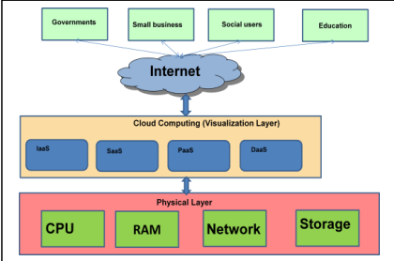
Cloud Computing Architecture

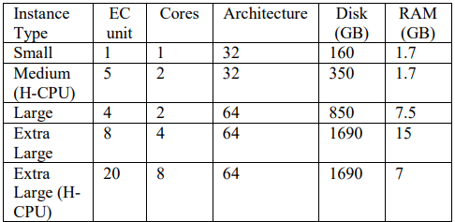
Features of Amazon EC2

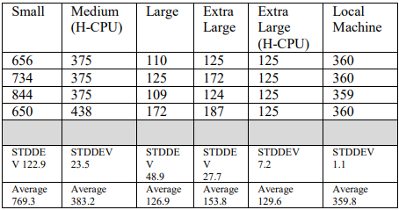
Response time of EC2 Instance (in milliseconds)

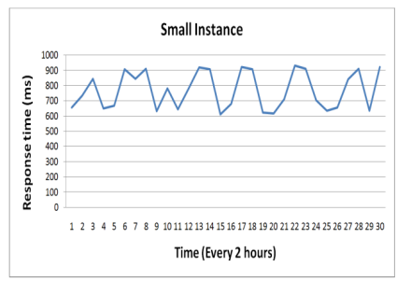
Response Time of Small instances

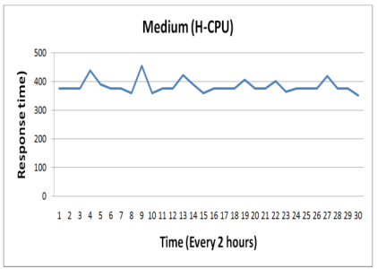
Response time of medium instances

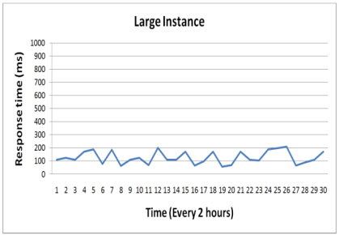
Response Time of Large instances

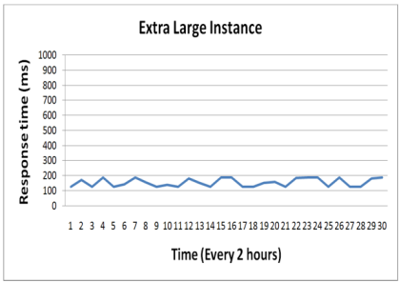
Response Time of Extra Large instance

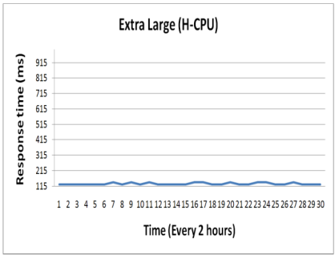
Response Time of Extra Large(H-CPU) instance

Presentation category

This is the highest level of programming .The presentation layer provides user experience for the applications .Usually, this involves the use of a GUI for intelligent clients, as well as web-based technologies.

with browser-based interaction. The presentation section displays information related to services such as browsing, sales, purchases, and cart content.

Logical category (also called enterprise logic, data access category, or intermediate category)

The logic tier is released in the re-launch phase, as it is in its own environment that controls the performance of the application by performing detailed processing.
.The purpose of the logical phase - critical business problems are solved. The component that creates this layer can be located on the server server, to assist with app sharing. These components can be used to enforce business rules, such as business algorithms and legal or government regulations, as well as data laws designed to keep data structures unchanged between certain or more information.

Data category

This section contains a database of data, a real DBMS access layer .It can be accessed through a business services layer and sometimes a user services layer. Here information is stored and retrieved. This section keeps the data natural and independent of the application server or business concept. Providing data is quality and improves metrics and performance

4.2 Database Design

4.2.1 Normalization

It is a process of forming data on a site. Normal performance is a systematic way of decomposing a table in order to eliminate the reuse of data with undesirable features such as adding, updating and deleting Confusion. This is a multi-case process that puts data in a table form by extracting duplicate data into related tables.

Normalization is mainly used for two purposes:
Eliminate unwanted data.

Ensuring data dependence makes sense i.e. data is stored reasonably.

Our table on the Application is in 1 NF form.
It states that table attributes cannot hold multiple values. Must hold a single value attribute. 1 NF does not allow quantity attribute, composite attribute, and your combinations.

Name

Password
Email id

Mobile no.

Address

DOB

Fig:4.2.1.1 Database Table
4.3 Component Diagram

4.1 Flow diagram

It is a type of illustration which symbolizes an process, a roadmap or process, showing steps such as boxes of many types, and connecting them with arrows. This diagram shows a model of a solution to a particular problem. Flow charts are used in examining, scheming, writing or working a process in a variety of fields.
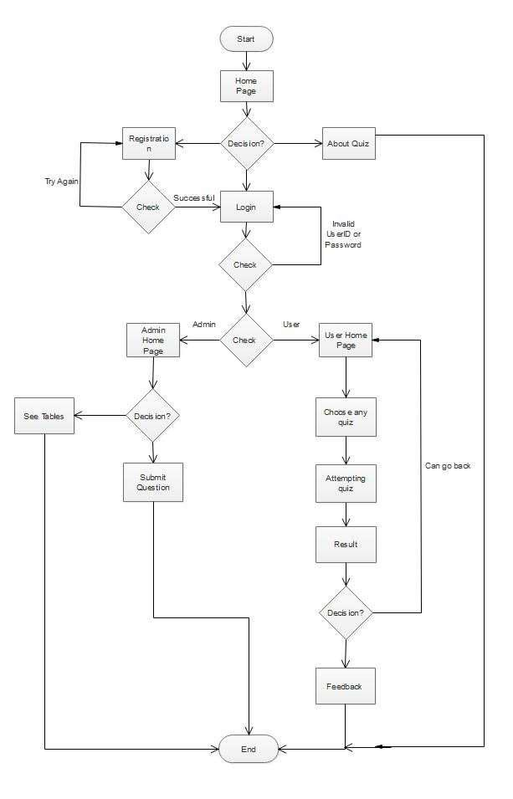

Flowchart

4.4 Interface Design

The user interface is a view of the end-to-end application where the user interacts with the software. The user can trick and control the software and hardware using the user interface.

The UI can be image-based, text-based, video-based, depending on the combination of fake computer software and software. The UI can be hardware or software or a combination of both.

4.4.1 Screen Shots

Home Page

Rules Page

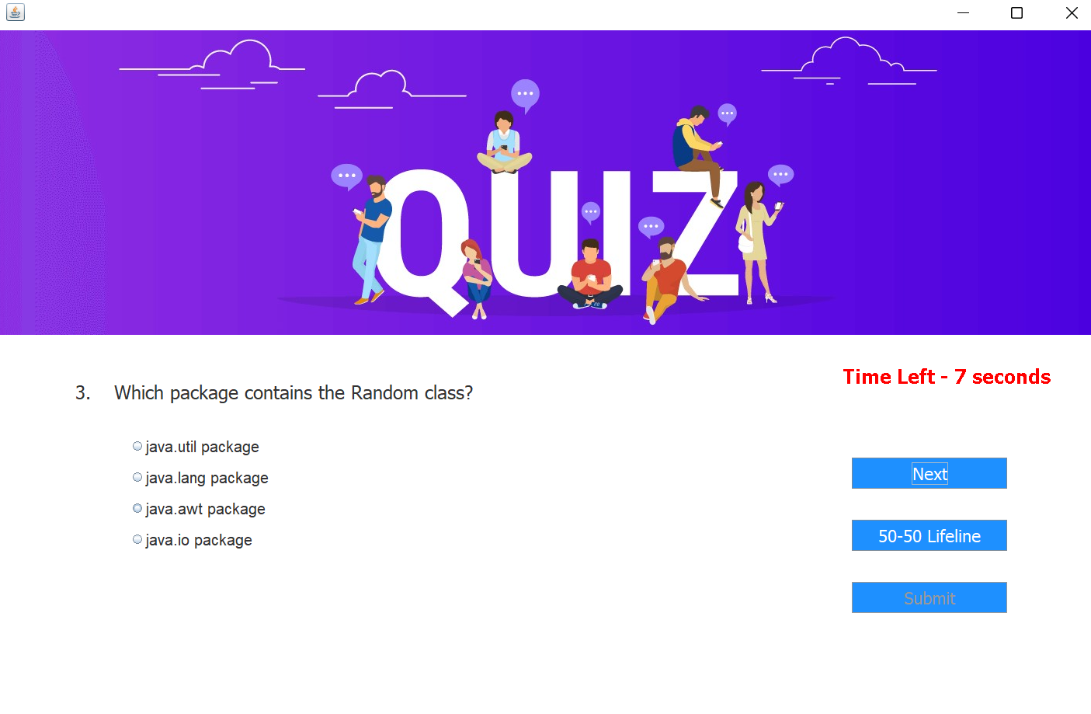
Quiz Page

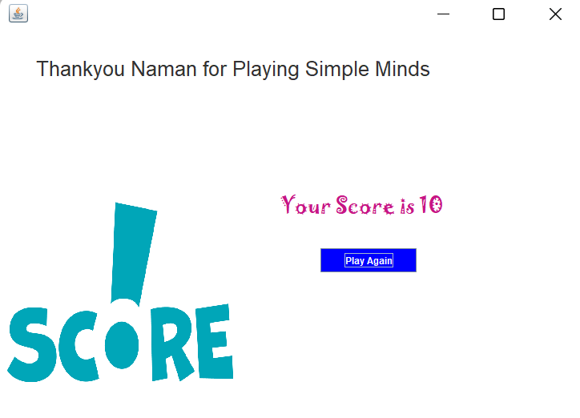

Score Page

5. Implementation

5.1 Language And Database For Implementation

For the frontend development:

Java AWT, Swing

For the backend development:
Java Applets

For the Database Management:
MySQL

5.2 Feature Of language & database used for the project

Java Applets: Applet is a special type of program embedded in a web page to produce dynamic content. It works within the browser and works on the client side.

MySQL: Single & Integrated Location, Analysis Services, Reporting Services, Management Services.

5.3 Third Party tools used

IDE: Netbeans (Glass fish server).

Designing phase: UML Diagram (Draw.io).
6 TESTING

6.1 White Box Testing

The white box test is defined as an internal design solution for software solution, design, and coding. In this type of test, the code appears in the tester. It emphases primarily on certifying the flow of inputs and outputs through the app, refining design and usability, enhancing safety. The white box check is also called Clear Test, Open Box Check, Structural Check, Open Test, Code-Based Testing and Glass Box Check.

White Box Test Cases
Name of Test Case: Registration

Input: Enter name, dob mail-id, mobile number.,

Results: Successful registration.

Expected Outcomes: Successful registration.

Result: Pass.

Test Case Name: Login.

Input: Enter the username is correct, the password is correct.

Results: Login successful.

Expected Results: successful entry

Result: Pass.

Test Case Name: Login.

Input: Enter the username is correct, the password is incorrect.

Results: login failed.

Expected results: login failed.

Result: Failed.

6.2 Black box Testing

A black box check is also known as Behavior Check, it is a software test method where the internal structure / design / use of the test item is unknown to the tester. These tests may or may not work, usually they work.

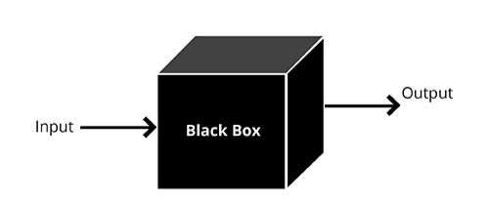
.

Fig: 6.2.1 Black Box Testing

Test cases Black Box Testing
Name of Test Case: Registration.

Input: Enter the required registration details.

Results: Successfully registered.

Expected Results: Successfully registered.

Result: Pass.
Name of Test Case: Registration.

Input: Enter the required registration details.

Results: Verification incorrect.

Expected Results: Not successfully registered.

Result: Failed.
7 FUTURE SCOPE & LIMITATIONS

SCOPE:-

The scope of this work is very broad in terms of information acquisition and information sharing in the world.

A few points are: -

It can be used anywhere at any time as it is a cloud application.

This application will also be used in educational institutions as in the corporate world.

LIMITATION(S):-
We want to apply the concept when the user himself adds a question
to others.

We want to use the concept where the user can solve any
a question related to each question at that time only.

We also want to apply the concept where every user can see another user's profile.
8 CONCLUSION

This online quiz app gives you the opportunity to play queries anywhere and anytime. Save time as user needs to wait for the result. Therefore the reader / user cannot wait for the result. All students / user gain additional knowledge and skills. The administrator reserves the right to ask multiple questions at any given stage of the application. The user can register, log in, and provide testing with his or her unique id, and can see results.

REFERENCE

https://www.W3schools.com/
https://stackoverflow.com/
https://www.quora.com/
https://www.draw.io/



