Git & GitHub Assignment Submission
Name: Naman Sharma
GitHub Repository: https://github.com/namansharma-eng/Assignment4-Git

Step 1: Initial SSH Authentication
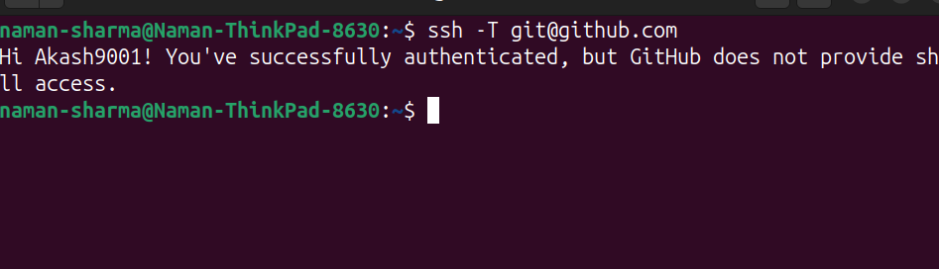

Step 2: Check Existing SSH Key
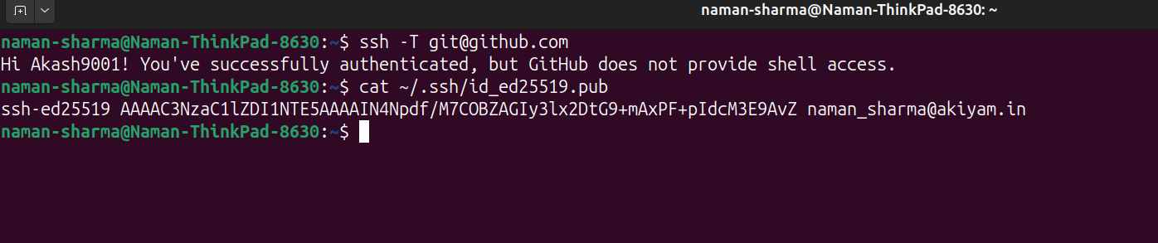

Step 3: Generate New SSH Key & Verify
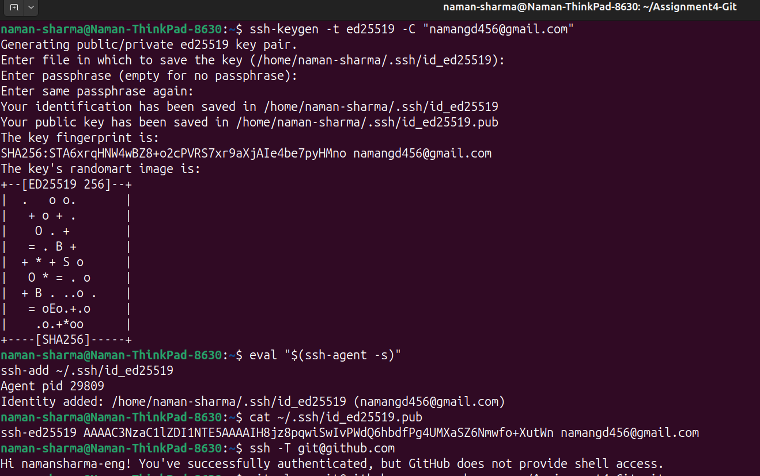

Step 4: Clone GitHub Repository

Step 5: Create Branch

Step 6: Copy Project Files

Step 7: Create .gitignore
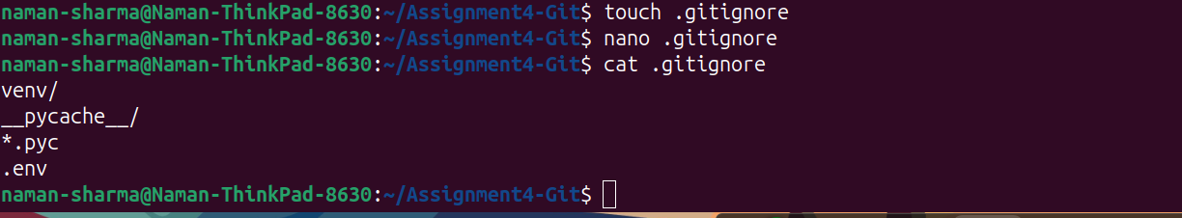

Step 8: Check Git Status
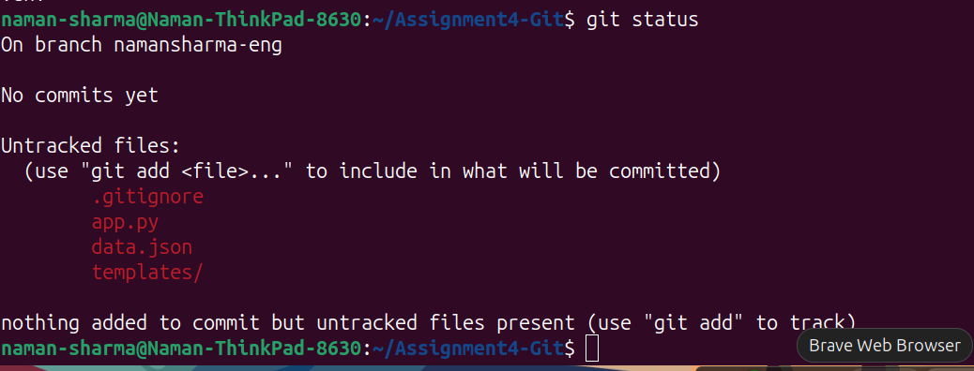

Step 9: Stage Files
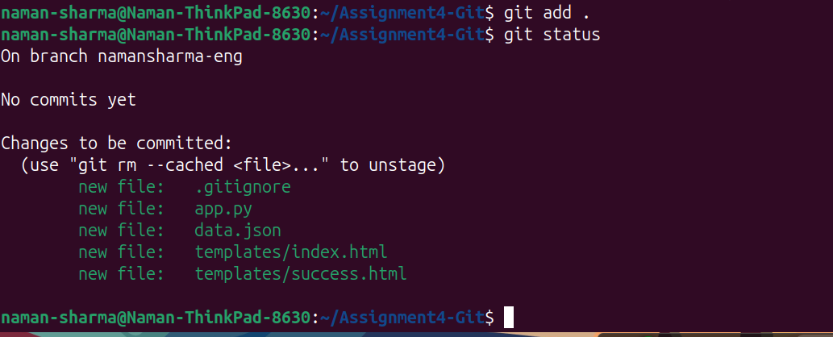

Step 10: Commit Changes
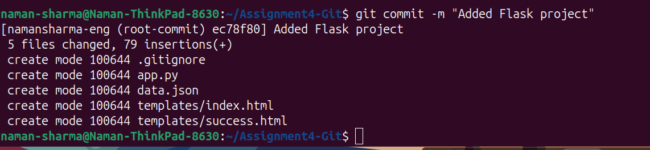

Step 11: Verify Remote
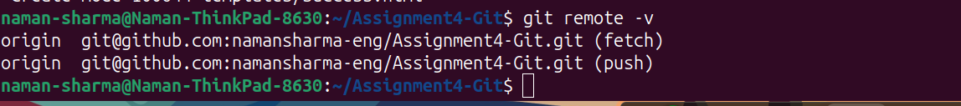

Step 12: Push Feature Branch
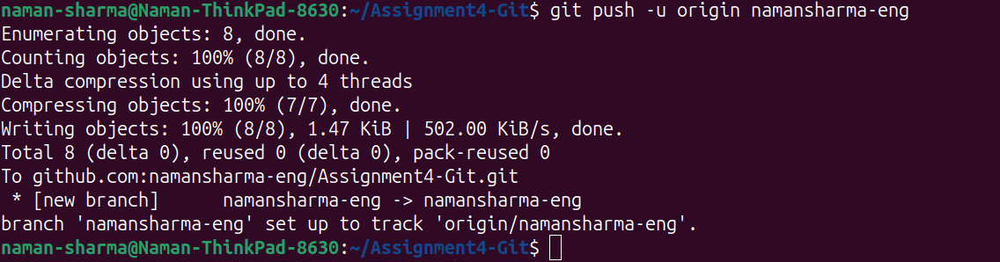

Step 13: Verify GitHub Repository
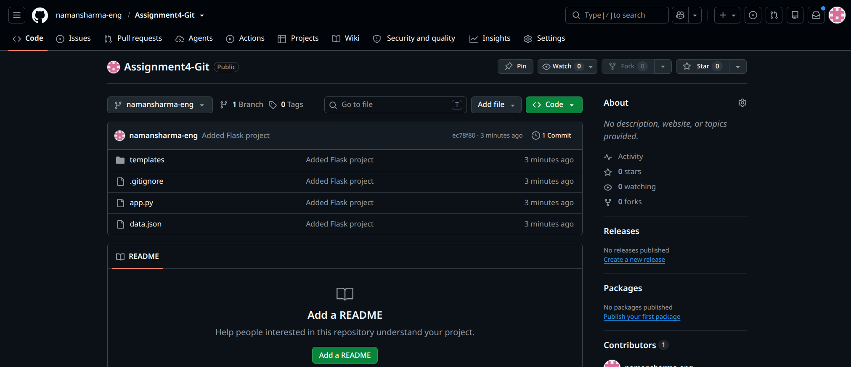

Step 14: Create Main Branch

Step 15: Merge into Main
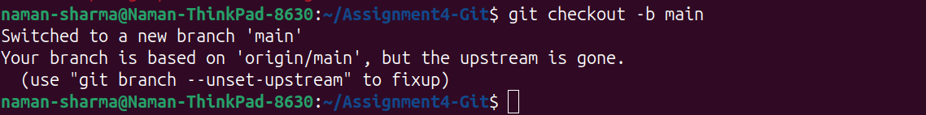

Step 16: Push Main Branch
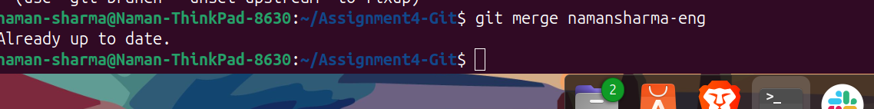

Step 17: Create namansharma-eng_new Branch
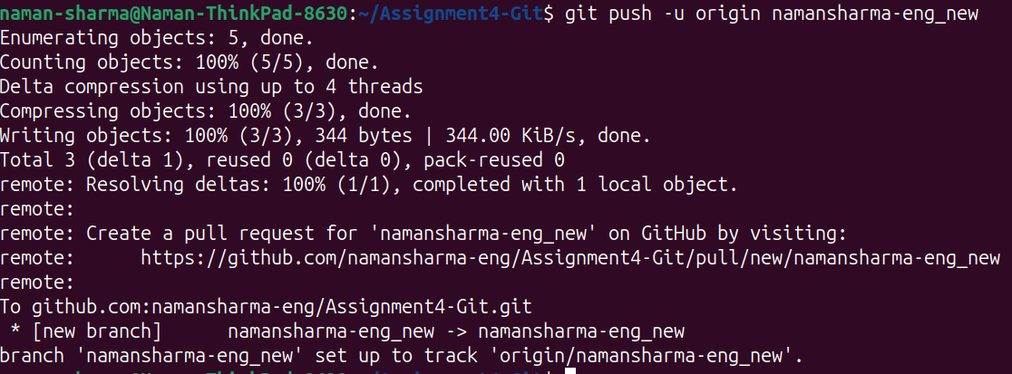

Step 18: Open data.json

Step 19: Update JSON File
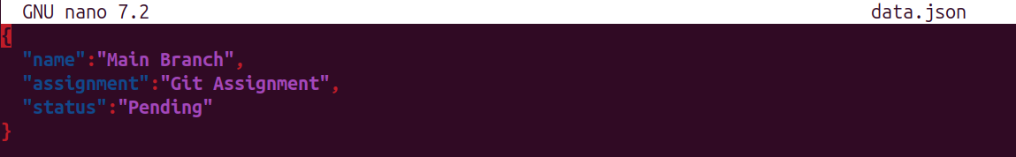

Step 20: Commit JSON Changes

Step 21: Push Updated Main

Step 22: Checkout Main
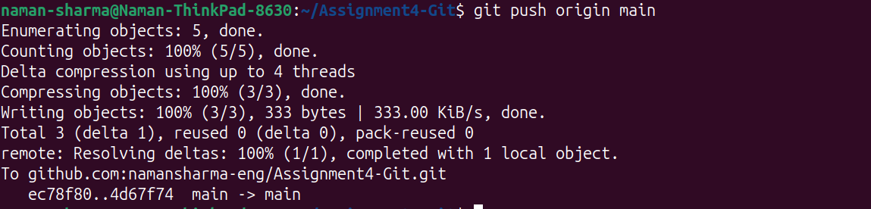

Step 23: Merge Branch (Conflict)


Step 24: Resolve Conflict
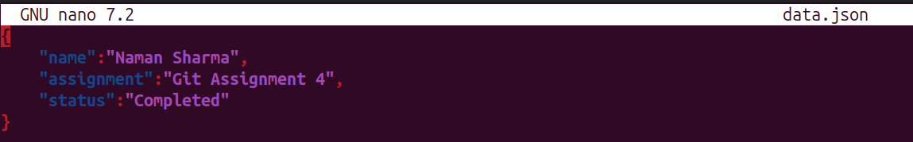

Step 25: Commit Conflict Resolution
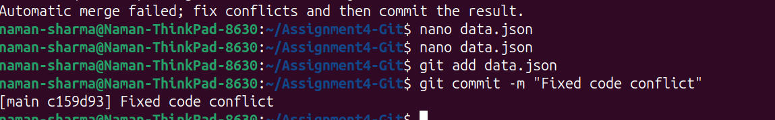

Step 26: Push Final Changes
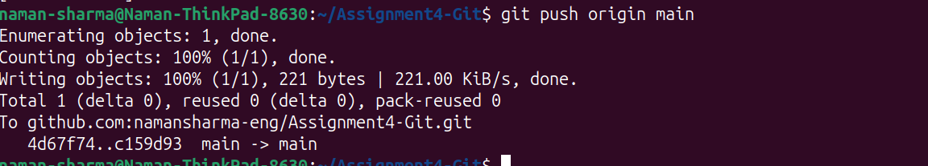

Part 5 – Git Reset, Rebase and Final Merge
This section demonstrates resetting the main branch to the Item ID commit, preserving staged changes using git reset --soft, rebasing master_1 while resolving conflicts, merging the rebased branch into main, and verifying the final commit history. Only the essential screenshots are included.

1. Reset main branch and recommit Item ID state
1. Reset main branch and recommit Item ID state
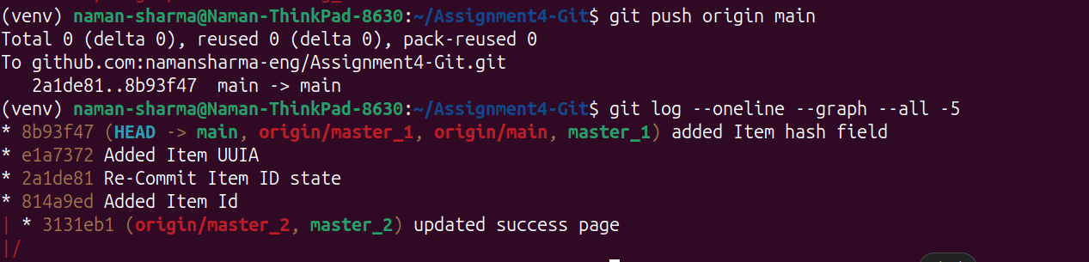

2. Resolve rebase conflict (UIIA and Item Hash)
2. Resolve rebase conflict (UIIA and Item Hash)
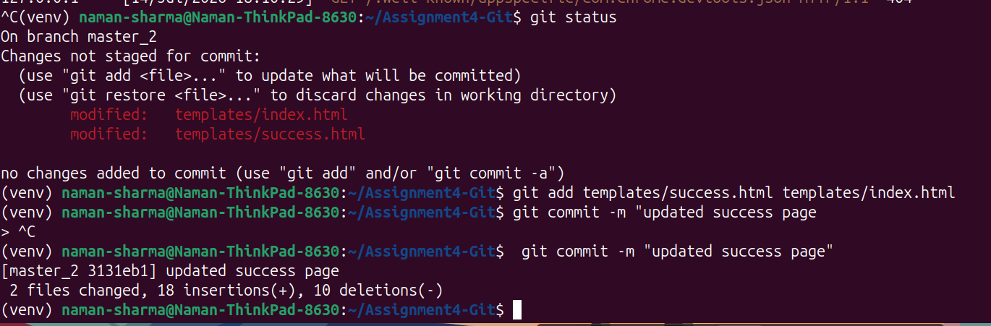

3. Rebase completed successfully
3. Rebase completed successfully
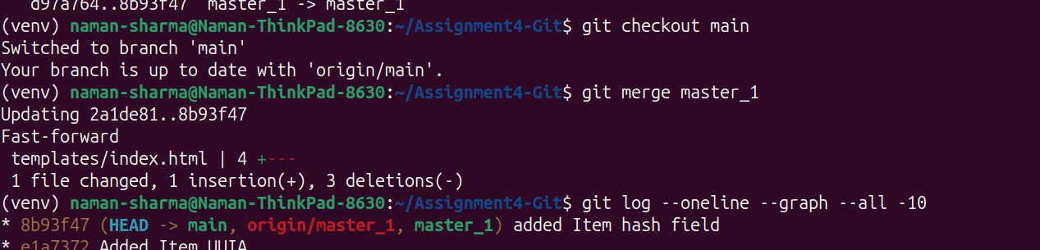

4. Merge rebased master_1 into main
4. Merge rebased master_1 into main
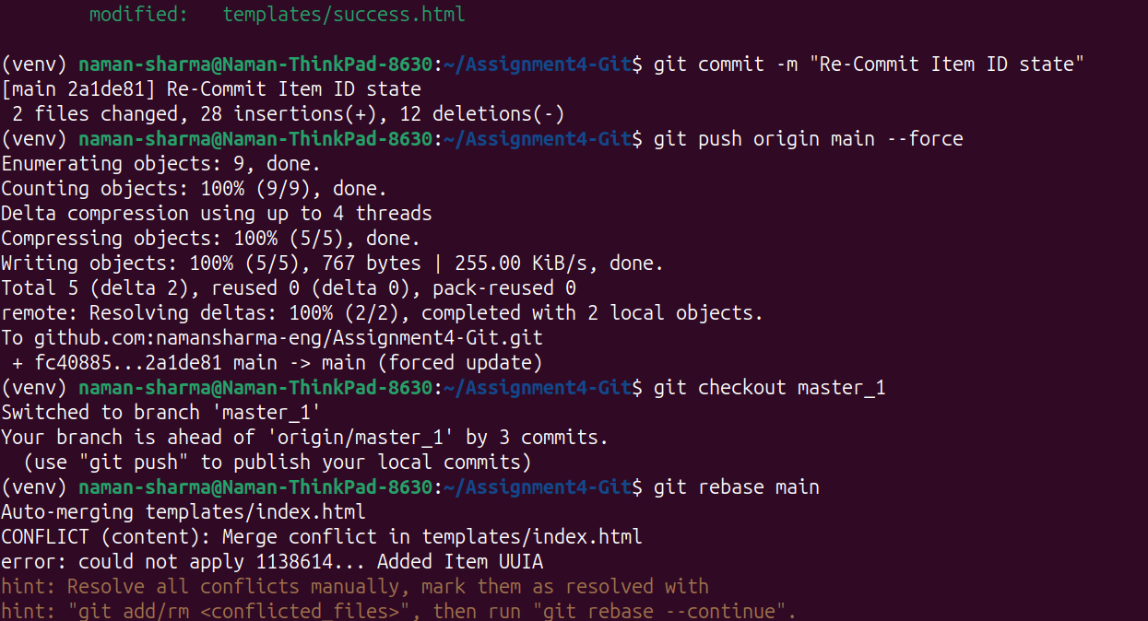

5. Verify final commit graph and push to GitHub
5. Verify final commit graph and push to GitHub
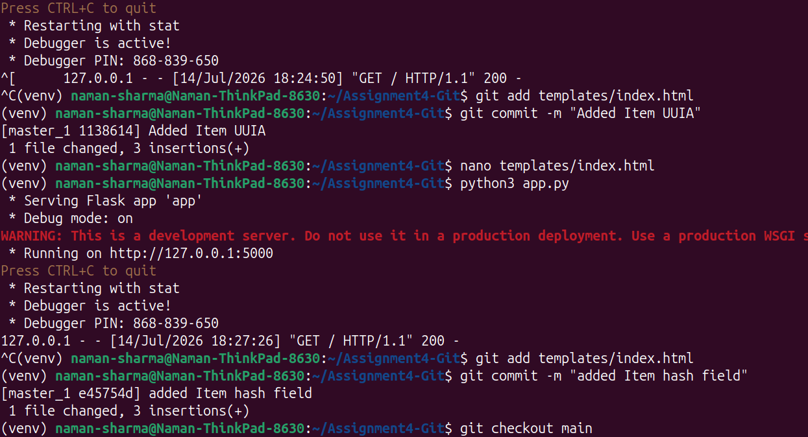

GitHub Repository

https://github.com/namansharma-eng/Assignment4-Git

