

GL BAJAJ INSTITUTE OF TECHNOLOGY AND MANAGEMENT, GREATER NOIDA

“PRACTICAL FILE”
ON
“IT SKILLS-2”
TOWARDS THE PARTIAL FULLFILLMENT FOR THE AWARD OF DEGREE OF
MASTER OF BUSINESS ADMINISTRATION (BA)
(Dr. A.P.J. Abdul Kalam Technical University, Lucknow, Uttar Pradesh)


By

NAMAN SINGH CHAUHAN
SEC-J
Roll No.-2501921570082

Session 2025-26

Under the Supervision of

Mr. Vijay Kumar Singh

INDEX
Sr.No. | TABLE OF CONTENT | Page NO.
 | INDEX | 2-3
1 | Create a pivot table in MS Excel from the given table. | 4
2 | To perform a goal seeking data analysis for the given table in MS Excel. | 5
3 | To perform the solver data analysis for the given table in EXCEL. | 6
4 | To perform the Scenario manager data analysis for low, high, average cost. | 7
5 | To perform the data validation criteria by whole number range in between 18-25 in MS Excel. | 8
6 | To perform the data validation criteria by Decimal number range in between 50.5 – 100.2 in MS Excel. | 9
7 | To perform the data validation criteria by List in MS Excel. | 10
8 | To perform the data validation criteria by Date in MS Excel. | 11
9 | To perform the data validation criteria by Text Length in MS Excel. | 12
10 | To perform the data validation criteria by Time in MS Excel. | 13
11 | To perform the data validation criteria by custom in MS Excel. | 14
12 | To calculate the Mean of the following table in MS Excel. | 15
13 | To calculate the Median of the following table in MS Excel. | 16
14 | To calculate the Mode of the following table in MS Excel. | 17
15 | To perform the data Analysis criteria by Anova Single Factor in MS Excel. | 18
16 | To perform the Data Analysis criteria by Anova: Two-Factor With replication in MS Excel. | 19
17 | To perform the Data Analysis criteria by Anova: Two-Factor Without replication in MS Excel. | 20
18 | To perform the Data Analysis criteria by correlation in MS Excel. | 21
19 | To perform the Data Analysis criteria by covariance in MS Excel. | 22
20 | To perform the Data Analysis criteria by Descriptive Statistics in MS Excel. | 23
21 | To perform the Data Analysis criteria by Exponential Smoothing in MS Excel. | 24
22 | To perform the Data Analysis criteria by F-test two sample for variance in MS Excel. | 25
23 | To perform the Data Analysis criteria by Fourier Analysis in MS Excel. | 26
24 | To perform the Data Analysis criteria by Histogram in MS Excel. | 27
25 | To perform the Data Analysis criteria by Moving Average in MS Excel. | 28
26 | To perform the Data Analysis criteria by Random Number Generation in MS Excel. | 29
27 | To perform the Data Analysis criteria by Rank and Percentile in MS Excel. | 30
28 | To perform the Data Analysis criteria by Regression in MS Excel. | 31
29 | To perform the Data Analysis criteria by Sampling in MS Excel. | 32
30 | To perform the Data Analysis criteria by t-Test: Paired two sample for means in MS Excel. | 33
31 | To perform the Data Analysis criteria by t-Test: two sample assuming equal variance in MS Excel. | 34
32 | To perform the Data Analysis criteria by t-Test: two sample assuming unequal variance in MS Excel. | 35
33 | To perform the Data Analysis criteria by z-test two sample for means in MS Excel. | 36
34 | To perform the trace precedent cell for the given table in MS Excel. | 37
35 | To perform the trace dependent cell for the given table in MS Excel. | 38
36 | For the given table perform the macros function in MS Excel. | 39
37 | To demonstrate the given table in line chart by using MS Excel. | 40
38 | To demonstrate the given table in area chart by using MS Excel. | 41
39 | To demonstrate the given table in bar chart by using MS Excel. | 42
40 | To demonstrate the given table in column chart by using MS Excel. | 43
41 | To demonstrate the given table in tree map chart by using MS Excel. | 44
42 | To demonstrate the given table in sunburst chart by using MS Excel. | 45
43 | To demonstrate the given table in pie chart by using MS Excel. | 46
44 | To demonstrate the given table in doughnut chart by using MS Excel. | 47
45 | To demonstrate the given table in histogram chart by using MS Excel. | 48
46 | To demonstrate the given table in box and whisker chart by using MS Excel. | 49
47 | To demonstrate the given table in scatter chart by using MS Excel. | 50
48 | To demonstrate the given table in bubble chart by using MS Excel. | 51
49 | To demonstrate the given table in waterfall chart by using MS Excel. | 52
50 | To demonstrate the given table in funnel chart by using MS Excel. | 53
51 | To demonstrate the given table in stock chart by using MS Excel. | 54
52 | To demonstrate the given table in surface chart by using MS Excel. | 55
53 | To demonstrate the given table in radar chart by using MS Excel. | 56
54 | To demonstrate the given table in combo chart by using MS Excel. | 57
55 | To demonstrate the given table in filled map chart by using MS Excel. | 58

PRACTICLE:1
Create a pivot table in MS Excel from the given table.
Sample Data:
Product | Region | Salesperson | Sales Amount | Quarter
Laptop | North | Amit | 45000 | Q1
Mobile | South | Priya | 32000 | Q1
Tablet | East | Ravi | 28000 | Q2
Laptop | West | Neha | 51000 | Q2
Mobile | North | Amit | 38000 | Q3
Tablet | South | Priya | 24000 | Q3
Steps to Perform:
Step 1: Open MS Excel and enter the above data starting from cell A1.
Step 2: Select any cell within the data range (e.g., A1).
Step 3: Go to Insert tab → Click on PivotTable.
Step 4: In the dialog box, select 'New Worksheet' and click OK.
Step 5: In the PivotTable Fields pane on the right, drag 'Product' to Rows, 'Region' to Columns, and 'Sales Amount' to Values.
Step 6: The pivot table will automatically calculate totals for each Product across each Region.
Step 7: You can also drag 'Quarter' to Filters to filter the table by quarter.
Step 8: Take a screenshot of the resulting pivot table.
Output / Screenshot:
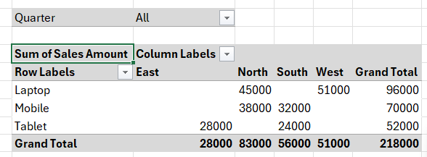

Result: | The Pivot Table was successfully created. It displays the total sales amount grouped by Product (rows) and Region (columns), providing a summarized view of the data.

PRACTICLE:2

To perform a goal seeking data analysis for the given table in MS Excel.
Sample Data:
Item | Units Sold | Price Per Unit | Revenue
Product A | 100 | 500 | 50000
Product B | 200 | 300 | 60000
Product C | 150 | 400 | 60000
Steps to Perform:
Step 1: Open MS Excel and enter the data above.
Step 2: In cell D2, enter the formula: =B2*C2 (Revenue = Units Sold × Price Per Unit).
Step 3: Suppose you want Revenue in D2 to be 75,000. Click on cell D2.
Step 4: Go to Data tab → What-If Analysis → Goal Seek.
Step 5: Set Cell: D2, to value: 75000, By changing cell: B2 (Units Sold).
Step 6: Click OK. Excel will calculate the required Units Sold to achieve Revenue of 75,000.
Step 7: Note the result (Units = 150 for Price 500).
Step 8: Take a screenshot of the Goal Seek dialog and result.
Output / Screenshot:
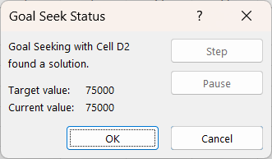
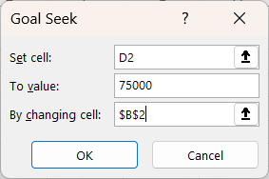

Result: | Goal Seek successfully found the input value (Units Sold) required to achieve the target Revenue of Rs. 75,000. The analysis confirms the use of backward calculation in Excel.

PRACTICLE - 3
Objective: To perform the solver data analysis for the given table in EXCEL.
Sample Data:
Variable | Value | Description
Units of Product A | 50 | Decision variable
Units of Product B | 30 | Decision variable
Profit per A | 200 | Fixed
Profit per B | 150 | Fixed
Total Profit |  | =C2*A2+C3*A3
tips to Perform:
Step 1: Go to File → Options → Add-ins → Manage Excel Add-ins → Check 'Solver Add-in' → OK.
Step 2: Enter the data: Units of A in B2, Units of B in B3, Profit per A = 200 in C2, Profit per B = 150 in C3.
Step 3: In cell B5, enter the formula: =B2*C2 + B3*C3 (Total Profit).
Step 4: Go to Data tab → Solver.
Step 5: Set Objective: B5 (Total Profit), To: Max.
Step 6: By Changing Variable Cells: B2:B3.
Step 7: Add Constraint: B2 <= 100, B3 <= 80, B2+B3 <= 150.
Step 8: Click Solve. Excel will find the optimal number of units to maximize profit.
Step 9: Accept the solution and take a screenshot.
Output / Screenshot:
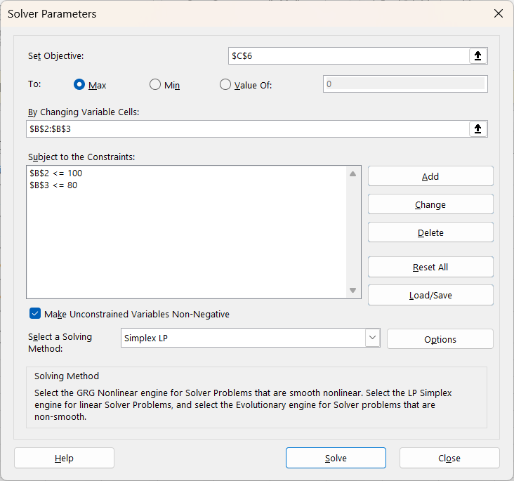

Result: | Solver successfully optimized the production mix. It determined the optimal number of units for Product A and Product B to maximize total profit within the given constraints.

PRACTICAL- 4
OBJECTIVE- To perform the scenario manager data analysis for low, high, and average costs for the given table in MS Excel
Sample Data:
Item | Units | Cost Per Unit | Total Cost
Raw Material | 500 | 50 | 25000
Labor | 200 | 80 | 16000
Overhead | 100 | 30 | 3000
Steps to Perform:
Step 1: Enter the above data in Excel. In D2:D4 enter formulas for Total Cost.
Step 2: In D6, enter Total = SUM (D2:D4).
Step 3: Go to Data tab → What-If Analysis → Scenario Manager.
Step 4: Click 'Add' to create first scenario named 'Low Cost'. Set C2=40, C3=60, C4=20. Click OK.
Step 5: Add second scenario 'High Cost': C2=70, C3=100, C4=50. Click OK.
Step 6: Add third scenario 'Average Cost': C2=55, C3=80, C4=35. Click OK.
Step 7: Click 'Summary' to generate a scenario summary report in a new sheet.
Step 8: Take screenshots of the Scenario Manager dialog and the summary sheet.
Output / Screenshot:
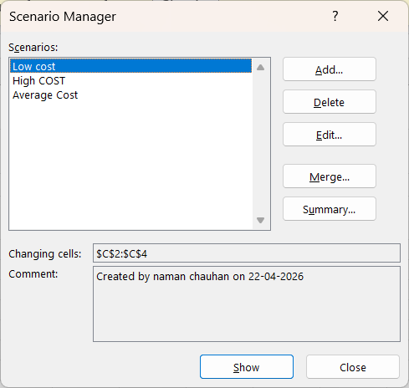

Result: | Scenario Manager successfully created three scenarios (Low, High, Average Cost). The summary report clearly compares the Total Cost under each scenario, aiding in financial decision-making.

PRACTICAL- 5
OBJECTIVE- To perform the data validation criteria by whole number range in between 1-99 in MS excel.
Sample Data:
Student Name | Age (18-25 only) | Course
Amit Kumar |  | MBA
Priya Sharma |  | BCA
Ravi Verma |  | BBA
Steps to Perform:
Step 1: Open MS Excel and enter the above table with column headers in Row 1.
Step 2: Select the cells in the Age column where data will be entered (e.g., B2:B10).
Step 3: Go to Data tab → Data Validation → Data Validation.
Step 4: In the Settings tab: Allow = 'Whole Number', Data = 'between', Minimum = 18, Maximum = 25.
Step 5: Go to Input Message tab: Title = 'Age Input', Message = 'Enter age between 18 and 25'.
Step 6: Go to Error Alert tab: Style = 'Stop', Title = 'Invalid Age', Error message = 'Please enter a whole number between 18 and 25'.
Step 7: Click OK. Now try entering a value outside the range (e.g., 30) to see the error.
Step 8: Enter valid values (e.g., 21, 23) and confirm they are accepted. Take a screenshot.
Output / Screenshot:
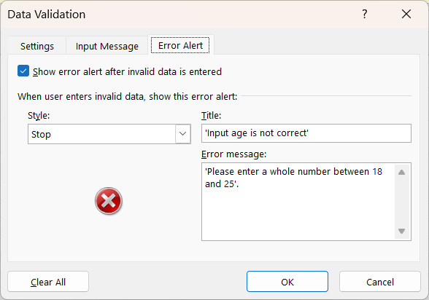
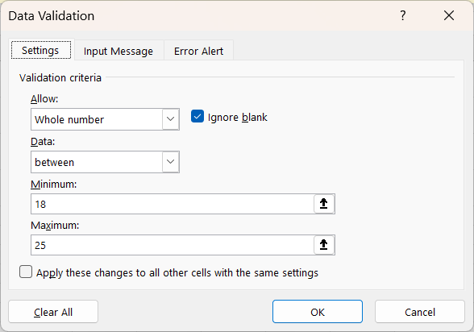


Result: | Data validation for Whole Number range (18-25) was successfully applied. The cells accept only integer values between 18 and 25 and display an error for any invalid entry.

PRACTICAL- 6
OBJECTIVE- To perform the data validation criteria by Decimal number range in between 50.5 - 100.2 in MS Excel.
Sample Data:
Student Name | Score (50.5-100.2) | Grade
Amit |  | A
Priya |  | B
Ravi |  | A+
Steps to Perform:
Step 1: Open MS Excel and create the above table.
Step 2: Select the Score column cells (e.g., B2:B10).
Step 3: Go to Data tab → Data Validation.
Step 4: In Settings: Allow = 'Decimal', Data = 'between', Minimum = 50.5, Maximum = 100.2.
Step 5: Set Input Message: 'Enter score between 50.5 and 100.2'.
Step 6: Set Error Alert: Stop type, message = 'Score must be a decimal between 50.5 and 100.2'.
Step 7: Click OK. Test by entering 45.5 (invalid) and 75.8 (valid).
Step 8: Confirm error shows for invalid input and valid input is accepted. Take screenshot.
Output / Screenshot:
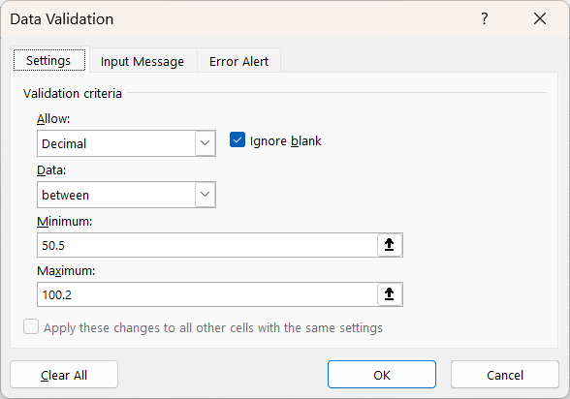
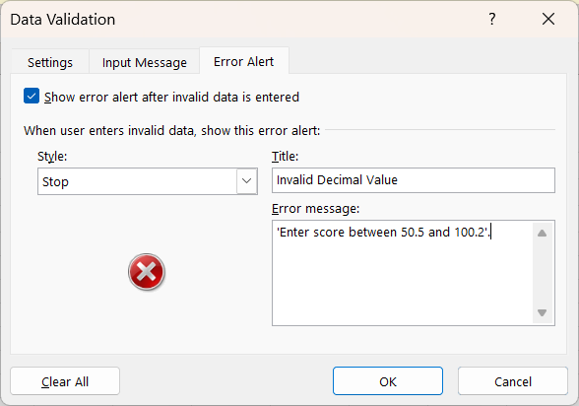

Result: | Data validation for Decimal range (50.5 to 100.2) was successfully applied. Only decimal numbers within the specified range are accepted; all other values trigger the error alert.

PRACTICAL- 7
OBJECTIVE- To perform the data validation criteria by List in MS Excel.
Sample Data:
Employee Name | Department | City
Amit Kumar |  | Delhi
Priya Sharma |  | Mumbai
Ravi Verma |  | Pune
Steps to Perform:
Step 1: In a separate area (e.g., F1:F5), enter the list values: HR, Finance, IT, Marketing, Operations.
Step 2: Select the Department column cells (e.g., B2:B10).
Step 3: Go to Data tab → Data Validation.
Step 4: In Settings: Allow = 'List', Source = $F$1:$F$5 (or type HR, Finance,IT,Marketing,Operations).
Step 5: Check 'In-cell dropdown' option.
Step 6: Set Input Message: 'Select department from the list'.
Step 7: Click OK. A dropdown arrow will appear in each selected cell.
Step 8: Click on a cell and select from the dropdown. Take a screenshot showing the dropdown list.

Output / Screenshot:
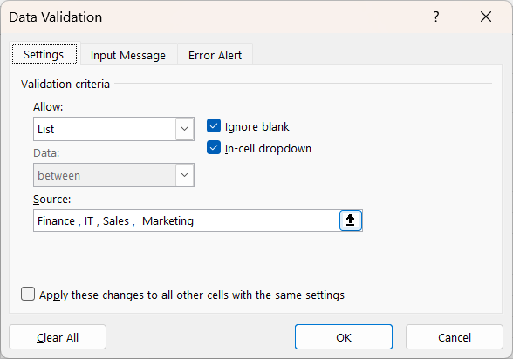

Result: | List validation was successfully applied. A dropdown menu appears in the Department column allowing users to select only from the predefined list of departments, ensuring consistent data entry.

PRACTICAL- 8
OBJECTIVE - To perform the data validation criteria by Date in MS Excel.
Sample Data:
Employee | Joining Date | Project Start Date
Amit
Priya
Ravi
Steps to Perform:
Step 1: Open MS Excel and create the above table.
Step 2: Select the Joining Date cells (e.g., B2:B10).
Step 3: Go to Data tab → Data Validation.
Step 4: In Settings: Allow = 'Date', Data = 'between', Start Date = 01/01/2020, End Date = 31/12/2025.
Step 5: Set Input Message: 'Enter joining date between 2020 and 2025'.
Step 6: Set Error Alert: 'Date must be between 01-Jan-2020 and 31-Dec-2025'.
Step 7: Click OK. Format the cells as Date (dd/mm/yyyy) using Format Cells.
Step 8: Test with a date outside range (e.g., 2019-01-01) and a valid date. Take screenshot.
Output / Screenshot:
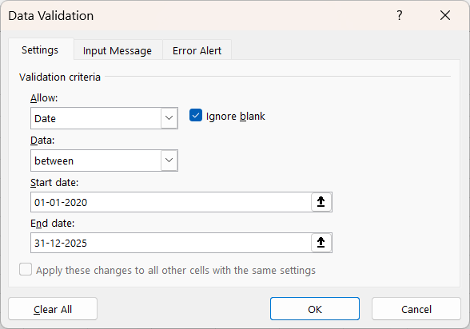

Result: | Date validation was successfully applied. The cells accept only dates within the specified range (01/01/2020 to 31/12/2025) and display an appropriate error message for invalid dates.

PRACTICAL-9
OBJECTIVE- To perform the data validation criteria by Text Length in MS Excel.
Sample Data:
Name | Mobile Number (10 digits) | PIN Code (6 digits)
Amit
Priya
Ravi
Steps to Perform:
Step 1: Open MS Excel and create the table with the headers above.
Step 2: Select the Mobile Number cells (e.g., B2:B10).
Step 3: Go to Data tab → Data Validation.
Step 4: In Settings: Allow = 'Text Length', Data = 'equal to', Length = 10.
Step 5: Set Input Message: 'Enter a 10-digit mobile number'.
Step 6: Set Error Alert: 'Mobile number must be exactly 10 digits'.
Step 7: Click OK. Similarly apply Text Length = 6 for PIN Code column (C2:C10).
Step 8: Test with numbers of wrong length to confirm error. Enter valid values. Take screenshot.
Output / Screenshot:
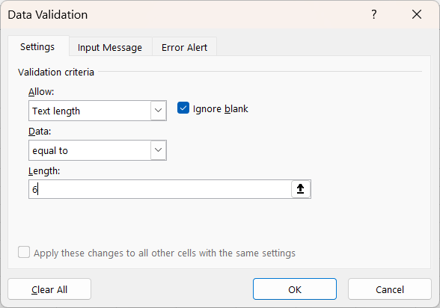
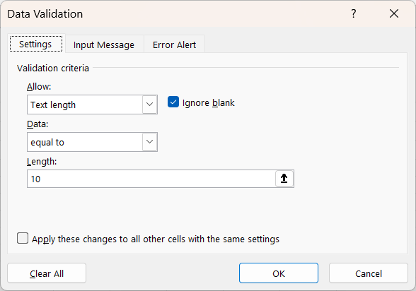

Result: | Text Length validation was successfully applied. The Mobile Number column accepts only 10-character entries, and the PIN Code column accepts only 6-character entries, with errors for all other lengths.

PRACTICAL-10
OBJECTIVE- To perform the data validation criteria by Time in MS Excel.
Sample Data:
Employee | Check-In Time | Check-Out Time
Amit
Priya
Ravi

Steps to Perform:
Step 1: Open MS Excel and create the table as shown above.
Step 2: Select the Check-In Time cells (e.g., B2:B10).
Step 3: Go to Data tab → Data Validation.
Step 4: In Settings: Allow = 'Time', Data = 'between', Start time = 8:00 hr, End time = 18:00 hr.
Step 5: Set Input Message: 'Office check-in must be between 8:00 hr and 18:00 hr'.
Step 6: Set Error Alert: 'Check-in time must be between 8:00 hr and 18:00 hr '.
Step 7: Format the cells as Time (hh:mm) using Format Cells (Ctrl+1).
Step 8: Click OK. Test with 7:00 hr (invalid) and 19:00 hr (valid). Take screenshot.

Output / Screenshot:
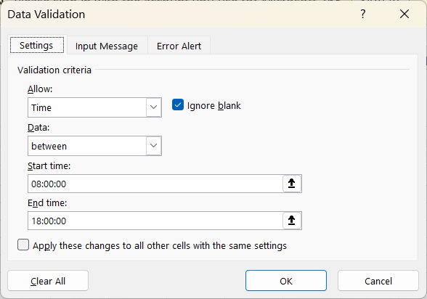

Result: | Time validation was successfully applied. The Check-In Time column accepts only times between 8:00 hr and 18:00 hr and shows an error for any time outside this range.

PRACTICAL-11
OBJECTIVE- To perform the data validation criteria by custom formula in MS Excel.
Sample Data:
Employee ID | Salary | Bonus (must be <= 20% of Salary)
E001 | 50000
E002 | 40000
E003 | 60000
Steps to Perform:
Step 1: Enter the data above in Excel with Salary in column B and Bonus in column C.
Step 2: Select the Bonus cells (e.g., C2:C10).
Step 3: Go to Data tab → Data Validation.
Step 4: In Settings: Allow = 'Custom', Formula =C2<=B2*0.2 (Bonus must be ≤ 20% of Salary).
Step 5: Set Input Message: 'Bonus cannot exceed 20% of the salary'.
Step 6: Set Error Alert: Stop, 'Bonus exceeds the allowed limit of 20% of salary'.
Step 7: Click OK. Test with a bonus of 15000 for salary 50000 (valid: 15000 ≤ 10000? No—use 8000 as invalid and 5000 as valid).
Step 8: Confirm validation behaviour and take screenshot.
Output / Screenshot:
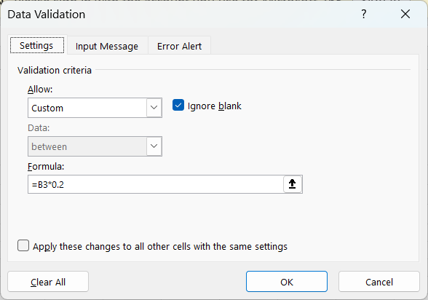

Result: | Custom validation using a formula was successfully applied. The Bonus column only accepts values that are within 20% of the corresponding Salary and displays a Stop error for any excess amount.

PRACTICAL-12
OBJECTIVE- To calculate the Mean of the following table in MS Excel.
Sample Data:
Student | Math | Science | English | Total
Amit | 85 | 90 | 78 | 253
Priya | 92 | 88 | 95 | 275
Ravi | 76 | 82 | 80 | 238
Neha | 88 | 91 | 85 | 264
Suresh | 70 | 75 | 72 | 217
Steps to Perform:
Step 1: Enter the above student marks data in Excel (A1:E6).
Step 2: In cell B8, type the label 'Mean:'.
Step 3: In cell C8, enter the formula: =AVERAGE (B2:B6) to find the mean of Math scores.
Step 4: Copy the formula to D8 and E8 for Science and English means.
Step 5: In F8, calculate the mean of Total: =AVERAGE (E2:E6).
Step 6: Format the mean cells to 2 decimal places using Format Cells → Number.
Step 7: Optionally, use conditional formatting to highlight the highest and lowest scores.
Step 8: Take a screenshot showing the data and the calculated mean values.
Output / Screenshot:
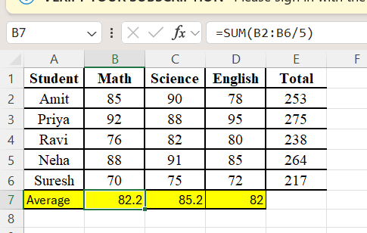

Result: | The Mean was successfully calculated using the AVERAGE function. Math Mean ≈ 82.2, Science Mean ≈ 85.2, English Mean ≈ 82.0, confirming accurate statistical computation.

PRACTICAL-13
OBJECTIVE- To calculate the Median of the following table in MS Excel.
Sample Data:
Month | Sales (Units) | Revenue (Rs.)
January | 120 | 60000
February | 95 | 47500
March | 150 | 75000
April | 88 | 44000
May | 200 | 100000
June | 110 | 55000
Steps to Perform:
Step 1: Enter the monthly sales data in Excel as shown above.
Step 2: In cell A9, type 'Median:'.
Step 3: In cell B9, enter: =MEDIAN (B2:B7) to find the median of Sales Units.
Step 4: In cell C9, enter: =MEDIAN (C2:C7) to find the median of Revenue.
Step 5: Observe that the median (115 units) differs from the mean due to the outlier (200 in May).
Step 6: Also calculate Mean in A10 using AVERAGE for comparison: =AVERAGE (B2:B7).
Step 7: Sort the data in ascending order to manually verify the median.
Step 8: Take a screenshot showing data, median, and mean for comparison.
Output / Screenshot:
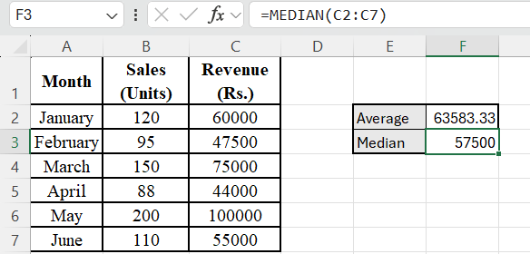

Result: | The Median was successfully calculated. Median Sales = 115 units, Median Revenue = Rs. 57,500. The comparison with Mean demonstrates the Median's robustness against outliers.

PRACTICAL-14
OBJECTIVE- To calculate the Mode of the following table in MS Excel.
Sample Data:
Survey No. | Rating (1-5) | Category
1 | 4 | Good
2 | 3 | Average
3 | 5 | Excellent
4 | 4 | Good
5 | 2 | Poor
6 | 4 | Good
7 | 5 | Excellent
8 | 3 | Average
9 | 4 | Good
Steps to Perform:
Step 1: Enter the survey data as shown in the table above.
Step 2: In cell A12, type 'Mode (Rating):'.
Step 3: In cell B12, enter: =MODE.SNGL(B2:B10) to find the most frequent rating.
Step 4: The result should be 4 (appears 4 times).
Step 5: For multiple modes, in B13 use array formula: =MODE.MULT(B2:B10) with Ctrl+Shift+Enter.
Step 6: Create a frequency count: in E2 use =COUNTIF($B$2:$B$10, D2) for each rating 1 to 5.
Step 7: This confirms that rating '4' is the mode (highest frequency).
Step 8: Take a screenshot showing the mode calculation and frequency distribution.
Output / Screenshot:
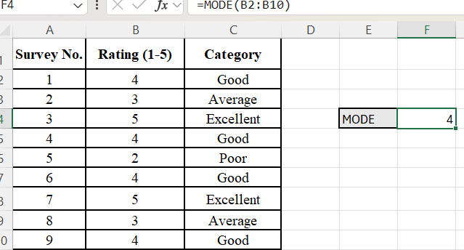

Result: | The Mode was successfully calculated as 4 (appears 4 times out of 9 responses). The MODE.SNGL function confirmed the result, and COUNTIF verified the frequency distribution.

PRACTICAL-15
OBJECTIVE: To perform the data Analysis criteria by Anova Single Factor in MS Excel.
Sample Data:
Group A (Method 1) | Group B (Method 2) | Group C (Method 3)
78 | 82 | 88
85 | 79 | 91
80 | 84 | 87
88 | 81 | 93
76 | 83 | 89
Steps to Perform:
Step 1: Enable the Analysis ToolPak: File → Options → Add-ins → Analysis ToolPak → Go → Check → OK.
Step 2: Enter the data with Group A in column A, Group B in column B, Group C in column C (with headers in row 1).
Step 3: Go to Data tab → Data Analysis.
Step 4: Select 'Anova: Single Factor' and click OK.
Step 5: Input Range: A1:C6 (including headers). Check 'Labels in First Row'.
Step 6: Alpha = 0.05. Output Range: select an empty cell (e.g., E1).
Step 7: Click OK to generate the ANOVA table.
Step 8: Compare the F value with F critical. If F > F critical, means differ significantly. Take screenshot.
Output / Screenshot:
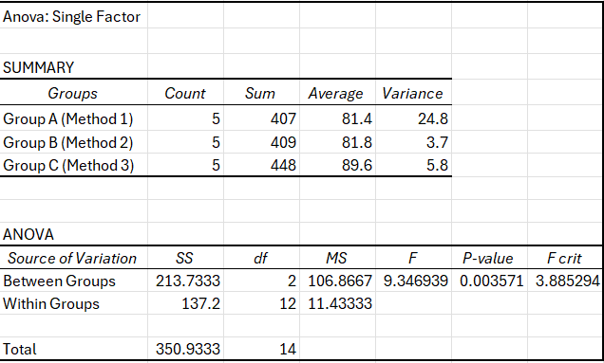

Result: | Anova Single Factor analysis was performed successfully. The output table shows SS, MS, F statistic, and F-critical values, confirming whether the teaching methods produce significantly different test scores.

PRACTICAL-16
OBJECTIVE: To perform the Data Analysis criteria by Anova: Two-Factor Without replication in MS Excel.
Sample Data:
Plant Type | Fertilizer A | Fertilizer B | Fertilizer C
Tomato | 15 | 18 | 22
Pepper | 12 | 14 | 20
Basil | 10 | 11 | 15
Cucumber | 18 | 20 | 25
Steps to Perform:
Step 1: Enter data: Rows represent two groups (Group 1 to Group 4), Columns represent Fertilizer A, Fertilizer B And Fertilizer C.
Step 2: Each group has 3 replications (rows per group).
Step 3: Go to Data tab → Data Analysis → Anova: Two-Factor with Replication.
Step 4: Input Range: A1:C7 (include all data with labels).
Step 5: Rows per sample: 3 (number of replications per group).
Step 6: Alpha = 0.05. Set output range to an empty cell.
Step 7: Click OK to generate the ANOVA output table.
Step 8: Review Sample, Column, and Interaction rows. Compare F vs F critical. Take screenshot.
Output / Screenshot:
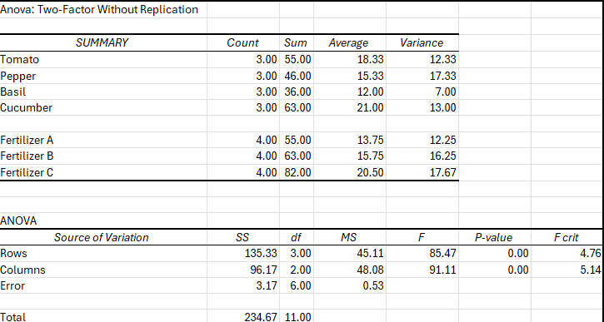

Result: | Two-Factor ANOVA Without Replication was completed. The analysis identifies whether the treatment effect (columns) or block effect (rows) is statistically significant at the 0.05 significance level.

PRACTICAL-17
OBJECTIVE: To perform the Data Analysis criteria by Anova: Two-Factor With replication in MS Excel.
Sample Data:
Sub | Class B | Class C | Class D
math 1 | 20.00 | 30.00 | 32.00
math 2 | 22.00 | 32.00 | 33.00
science 1 | 24.00 | 34.00 | 45.00
science 2 | 26.00 | 36.00 | 28.00
Steps to Perform:
Step 1: Enter the data as shown: rows are blocks (subjects), columns are treatments.
Step 2: Go to Data tab → Data Analysis → Anova: Two-Factor With Replication.
Step 3: Set Input Range to include all data with labels (A1:D5).
Step 4: Check 'Labels' checkbox. Set Alpha = 0.05.
Step 5: Choose output range (empty cell, e.g., F1).
Step 6: Click OK to run the analysis.
Step 7: Review the output: check Rows F and Columns F against their respective F-critical values.
Step 8: If F > F-critical for Columns, the treatment effect is significant. Take screenshot.
Output / Screenshot:
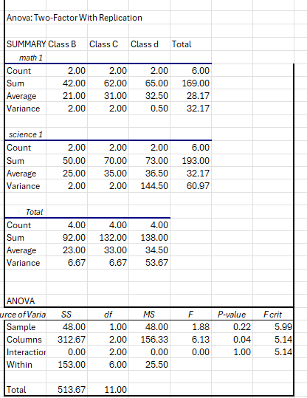

Result: | Two-Factor ANOVA Without Replication was completed. The analysis identifies whether the treatment effect (columns) or block effect (rows) is statistically significant at the 0.05 significance level.

PRACTICAL-18
OBJECTIVE: To perform the Data Analysis criteria by correlation in MS Excel.
Sample Data:
Dosage (mg) - X | Recovery Time (Days) - Y
10 | 12
20 | 10
30 | 8
40 | 5
50 | 4
60 | 2
Steps to Perform:
Step 1: Enter the data above in Excel with Patients, Dosage (mg) - X, Recovery Time (Days) - Y.
Step 2: Go to Data tab → Data Analysis → Correlation.
Step 3: Set Input Range: B1:C7 (including headers for Dosage (mg) - X, Recovery Time (Days) - Y).
Step 4: Check 'Labels in First Row'. Set output range (e.g., E1).
Step 5: Click OK. A 2x2 correlation matrix is generated.
Step 6: The correlation value between, Dosage (mg) - X, Recovery Time (Days) - Y Should be close to 1 (strong positive).
Step 7: Alternatively, use formula: =CORREL (B2:B7, C2:C7) to verify.
Step 8: Interpret the result: r > 0.8 indicates a strong positive correlation. Take screenshot.
Output / Screenshot:
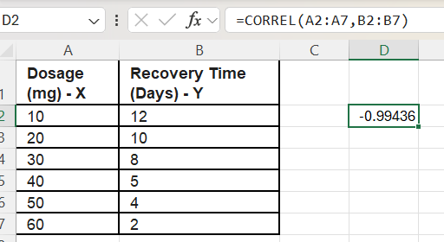

Result: | Correlation analysis was performed successfully. The correlation coefficient between, Dosage (mg) - X, Recovery Time (Days) - Y is approximately -0.994, indicating a very strong negative linear relationship.

PRACTICAL-19
OBJECTIVE: To perform the Data Analysis criteria by covariance in MS Excel.
Sample Data:
Year | Stock A Return (%) | Stock B Return (%)
2019 | 12 | 8
2020 | 15 | 10
2021 | 8 | 6
2022 | 20 | 14
2023 | 10 | 7
2024 | 18 | 12
Steps to Perform:
Step 1: Enter the stock return data in Excel as shown above.
Step 2: Go to Data tab → Data Analysis → Covariance.
Step 3: Set Input Range: B1:C7 (Stock A and Stock B returns with headers).
Step 4: Check 'Labels in First Row'. Set output range (e.g., E1).
Step 5: Click OK to generate the covariance matrix.
Step 6: The diagonal shows variance for each stock; off-diagonal shows covariance between them.
Step 7: Verify manually: =COVARIANCE.P(B2:B7, C2:C7) in any empty cell.
Step 8: Compare covariance with correlation to understand the standardized vs. unstandardized measures. Take screenshot.
Output / Screenshot:
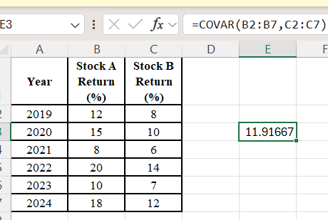

Result: | Covariance analysis was successfully performed. The covariance matrix shows positive covariance between Stock A and Stock B returns, indicating they tend to move in the same direction.

PRACTICAL-20
OBJECTIVE: To perform the Data Analysis criteria by Descriptive Statistics in MS Excel.
Sample Data:
Student | Marks (out of 100)
1 | 78
2 | 85
3 | 92
4 | 65
5 | 88
6 | 70
7 | 95
8 | 55
9 | 82
10 | 76
Steps to Perform:
Step 1: Enter the 10 student marks in column B (B1 = 'Marks', B2:B11 = values).
Step 2: Go to Data tab → Data Analysis → Descriptive Statistics.
Step 3: Set Input Range: B1:B11 (including header).
Step 4: Check 'Labels in First Row'. Set Output Range (e.g., D1).
Step 5: Check boxes for: 'Summary statistics', 'Confidence Level for Mean' (95%), 'Kth Largest' (1), 'Kth Smallest' (1).
Step 6: Click OK. Excel generates a full statistical summary.
Step 7: Review: Mean, Standard Error, Median, Mode, Std Deviation, Variance, Kurtosis, Skewness, Range, Min, Max, Sum, Count.
Output / Screenshot:
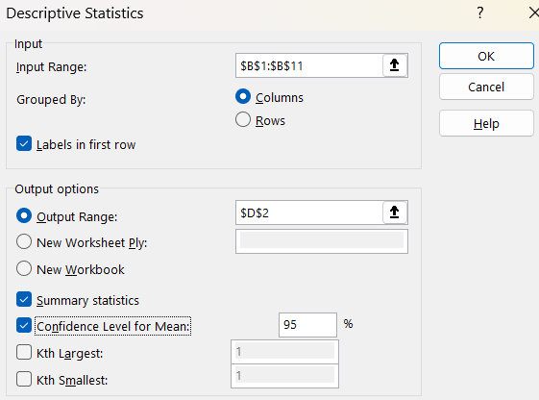
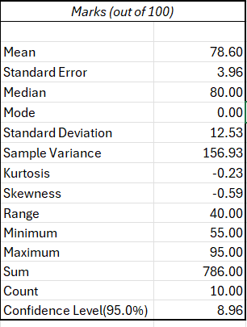

Result: | Descriptive Statistics were successfully generated. The output shows all key statistical measures including Mean ≈ 78.6, Standard Deviation ≈ 12.3, Median = 80, confirming comprehensive data analysis.

PRACTICAL-21
OBJECTIVE: To perform the Data Analysis criteria by Exponential Smoothing in MS Excel.
Sample Data:
Month | Actual Sales | Smoothed Value
Jan | 200
Feb | 220
Mar | 210
Apr | 240
May | 230
Jun | 260
Jul | 250
Aug | 280
Steps to Perform:
Step 1: Enter the monthly actual sales data in column B (B1 = 'Actual Sales', B2:B9 = values).
Step 2: Go to Data tab → Data Analysis → Exponential Smoothing.
Step 3: Set Input Range: B1:B9 (with label). Set Damping Factor: 0.3 (α = 1 - 0.3 = 0.7).
Step 4: Check 'Labels'. Set Output Range (e.g., C2).
Step 5: Check 'Chart Output' to automatically create a comparison chart.
Step 6: Check 'Standard Errors' for additional statistical output.
Step 7: Click OK. Column C will show the smoothed/forecast values.
Step 8: Compare actual vs. smoothed values and analyse the trend. Take screenshot of table and chart.
Output / Screenshot:
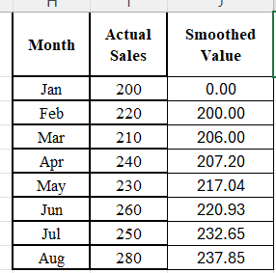
...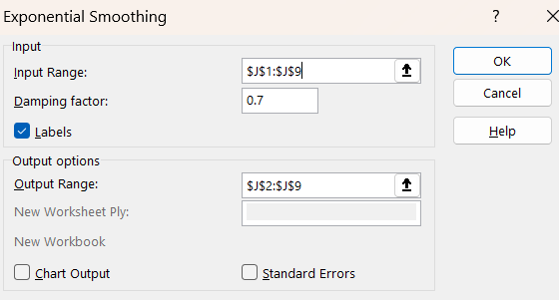

Result: | Exponential Smoothing was successfully applied with damping factor 0.3. The smoothed values closely follow the actual sales trend, and the chart shows reduced volatility in the forecast series.

PRACTICAL-22

OBJECTIVE: To perform the Data Analysis criteria by F-test two sample for variance in MS Excel.

Sample Data:

Student |  | Before | After
Ananya |  | 72 | 85
Rohit |  | 65 | 78
Priya |  | 80 | 88
Deepak |  | 58 | 70
Kavya |  | 75 | 82
Suresh |  | 68 | 74
Meenal |  | 82 | 90
Arjun |  | 70 | 80
Steps to Perform:
Step 1: Enter the two sample datasets in columns A and B with headers.
Step 2: Go to Data tab → Data Analysis → F-Test Two-Sample for Variances.
Step 3: Variable 1 Range: A1:A8, Variable 2 Range: B1:B8 (including headers).
Step 4: Check 'Labels'. Alpha = 0.05. Set output range (e.g., D1).
Step 5: Click OK to run the test.
Step 6: Review output: Mean, Variance, Observations, def., F statistic, P(F<=f) one-tail, F Critical one-tail.
Step 7: If F < F-critical: variances are not significantly different (use equal variance t-test). Otherwise, use unequal variance t-test.
Step 8: Take screenshot of the F-test output table.
Output / Screenshot:
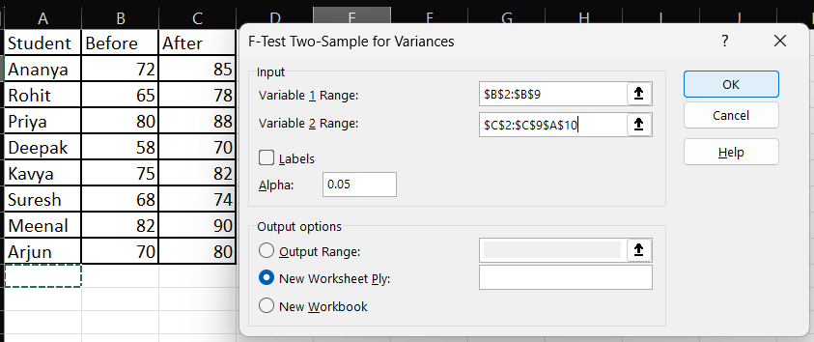
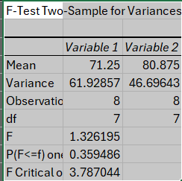



Result: | F-test for Two Sample Variances was successfully performed. The F statistic and P-value were computed. Based on the result, a conclusion about the equality of variances was made, guiding the choice of t-test type.

PRACTICAL-23
OBJECTIVE: To perform the Data Analysis criteria by Fourier Analysis in MS Excel.
Sample Data:
t | Signal Value
1 | 3
2 | 8
3 | 5
4 | 2
5 | 9
6 | 6
7 | 4
8 | 7
Steps to Perform:
Step 1: Enter exactly 8 data points (power of 2) in column B (B1 = 'Signal', B2:B9 = values).
Step 2: Go to Data tab → Data Analysis → Fourier Analysis.
Step 3: Set Input Range: B2:B9 (no label for this tool). Set Output Range: D2.
Step 4: Leave 'Inverse' unchecked for forward FFT.
Step 5: Click OK. The output will be 8 complex numbers in column D.
Step 6: To find magnitude: in E2 type =IMABS(D2) and drag down to E9.
Step 7: The magnitude values represent the strength of each frequency component.
Step 8: Plot the magnitude values as a bar chart to see the frequency spectrum. Take screenshot.
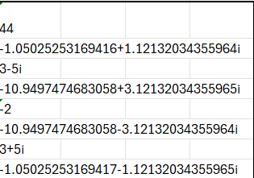
Output / Screenshot:
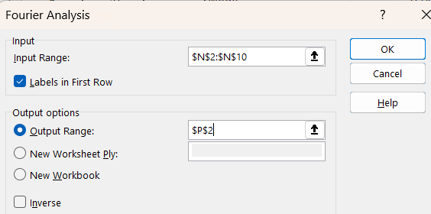

Result: | Fourier Analysis was successfully performed. The FFT output shows frequency components of the signal, and the magnitude chart reveals the dominant frequencies present in the time series data.

PRACTICAL-24
OBJECTIVE: To perform the Data Analysis criteria by Histogram in MS Excel.
Sample Data:
Student No. | Score | Bin Range
1 | 55 | 40
2 | 72 | 50
3 | 88 | 60
4 | 45 | 70
5 | 91 | 80
6 | 63 | 90
7 | 78 | 100
8 | 50
9 | 84
10 | 67
Steps to Perform:
Step 1: Enter student scores in column B (B1 = 'Score', B2:B11 = 10 scores).
Step 2: Enter bin ranges in column D (D1 = 'Bins', D2:D8 = 40,50,60,70,80,90,100).
Step 3: Go to Data tab → Data Analysis → Histogram.
Step 4: Input Range: B1:B11 (with label). Bin Range: D1:D8 (with label).
Step 5: Check 'Labels'. Check 'Chart Output'. Set output range (e.g., F1).
Step 6: Optionally check 'Cumulative Percentage' and 'Pareto'.
Step 7: Click OK. A frequency table and histogram chart will be generated.
Step 8: Review the distribution shape (normal, skewed, etc.). Take screenshot.
Output / Screenshot:
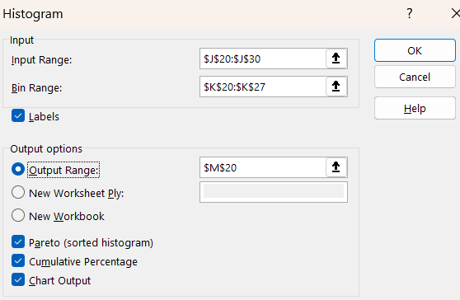


Result: | Histogram was successfully created. The frequency table and chart show the distribution of student scores across the defined bin ranges, revealing the shape and spread of the score distribution.

PRACTICAL-25
OBJECTIVE: To perform the Data Analysis criteria by Moving Average in MS Excel.
Sample Data:
Week | Sales | 3-Week MA
1 | 120
2 | 135
3 | 128
4 | 142
5 | 138
6 | 155
7 | 148
8 | 162
Steps to Perform:
Step 1: Enter weekly sales data in column B (B1 = 'Sales', B2:B9 = values).
Step 2: Go to Data tab → Data Analysis → Moving Average.
Step 3: Input Range: B1:B9 (with label). Check 'Labels in First Row'.
Step 4: Interval: 3 (3-week moving average). Output Range: C2.
Step 5: Check 'Chart Output' to generate a comparison chart.
Step 6: Check 'Standard Errors' to display the prediction standard errors.
Step 7: Click OK. Column C will show the 3-period moving averages (first 2 cells will be #N/A).
Step 8: Observe how the moving average smooths out weekly fluctuations. Take screenshot.

Output / Screenshot:
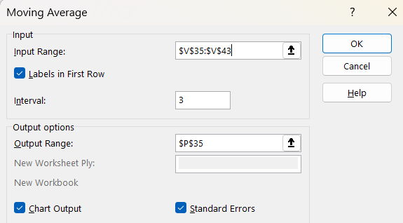
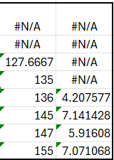

Result: | Moving Average (3-period) was successfully calculated. The smoothed values follow the upward sales trend while eliminating week-to-week fluctuations, and the chart clearly shows the trend line.

PRACTICAL-26
OBJECTIVE: To perform the Data Analysis criteria by Random Number Generation in MS Excel.
Sample Data:
Distribution Type | Parameters | Use Case
Uniform | Min=1, Max=100 | Lottery, Sampling
Normal | Mean=50, StdDev=10 | Test scores
Binomial | p=0.5, Trials=10 | Coin flips
Poisson | Lambda=5 | Call centre arrivals
Steps to Perform:
Step 1: Go to Data tab → Data Analysis → Random Number Generation.
Step 2: Number of Variables: 2, Number of Random Numbers: 20.
Step 3: Distribution: Normal. Parameters: Mean = 50, Standard deviation = 10.
Step 4: Set Random Seed: 12345 (for reproducibility).
Step 5: Output Range: A1.
Step 6: Click OK. 20 random numbers following a normal distribution are generated in columns A and B.
Step 7: Repeat with Uniform distribution (between 1 and 100) in a new range.
Step 8: Calculate mean and std dev of generated numbers to verify they match the parameters. Take screenshot.
Output / Screenshot:
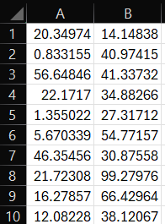
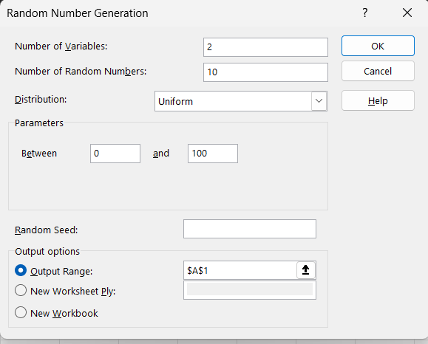

.

Result: | Random Number Generation was successfully performed. 20 random numbers following a normal distribution (mean ≈ 50, std ≈ 10) were generated, and a second set was generated using Uniform distribution.

PRACTICAL-27
OBJECTIVE: To perform the Data Analysis criteria by Rank and Percentile in MS Excel.
Sample Data:
Student | Score
Amit | 85
Priya | 92
Ravi | 78
Neha | 88
Suresh | 72
Kavita | 95
Mohit | 82
Anita | 68
Steps to Perform:
Step 1: Enter student names in column A and scores in column B.
Step 2: Go to Data tab → Data Analysis → Rank and Percentile.
Step 3: Input Range: B1:B9 (including header 'Score'). Check 'Labels in First Row'.
Step 4: Set Output Range: D1.
Step 5: Click OK. The output table shows: Point (row number), Score value, Rank, and Percent.
Step 6: Observe that Kavita (95) has Rank 1 and 100% percentile; Anita (68) has Rank 8 and 0% percentile.
Step 7: Compare with RANK.EQ formula: =RANK.EQ(B2,$B$2:$B$9,0) to verify.
Step 8: Take screenshot of the rank and percentile output table.
Output / Screenshot:
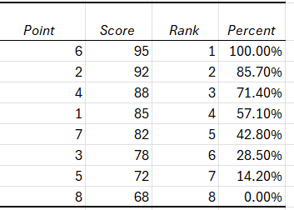
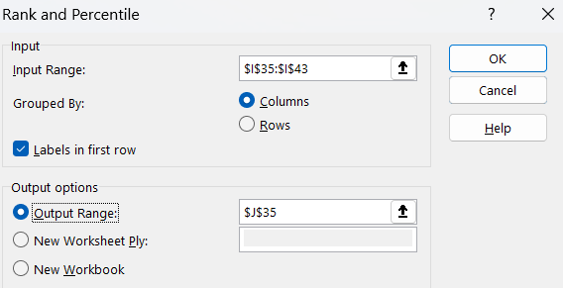


Result: | Rank and Percentile analysis was successfully completed. The output correctly assigns ranks and percentile positions to all students based on their scores, with Kavita ranking 1st at the 100th percentile.

PRACTICAL-28
OBJECTIVE: To perform the Data Analysis criteria by Regression in MS Excel.
Sample Data:
Advertising (X) Rs. | Sales (Y) Rs. | Month
5000 | 30000 | Jan
7000 | 38000 | Feb
8000 | 42000 | Mar
6000 | 34000 | Apr
10000 | 50000 | May
12000 | 58000 | Jun
Steps to Perform:
Step 1: Enter Advertising (independent) in column B and Sales (dependent) in column C.
Step 2: Go to Data tab → Data Analysis → Regression.
Step 3: Y Input Range: C1:C7 (Sales with header). X Input Range: B1:B7 (Advertising with header).
Step 4: Check 'Labels'. Set Confidence Level: 95%. Check 'Residuals', 'Residual Plots', 'Line Fit Plot'.
Step 5: Set Output Range: E1.
Step 6: Click OK to generate the regression output.
Step 7: Review: R Square (>0.9 = strong fit), Coefficients (intercept and slope), P-value (<0.05 = significant).
Step 8: Read the regression equation: Sales = Intercept + Slope × Advertising. Take screenshot.
Output / Screenshot:
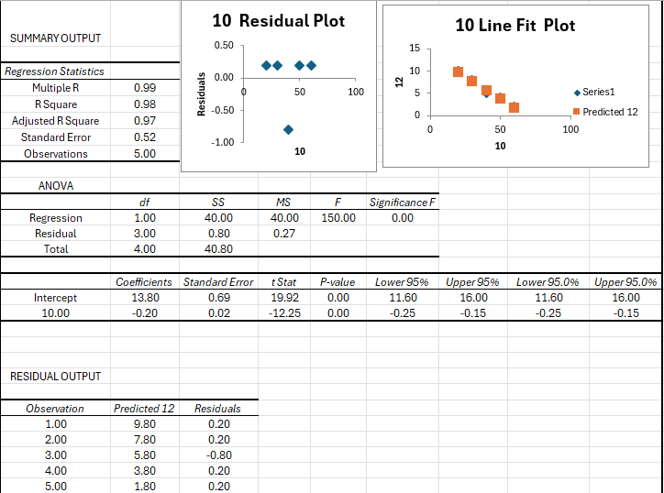

Result: | Regression analysis was successfully completed. The R-squared value is approximately 0.997, indicating a near-perfect linear relationship between advertising spend and sales revenue.

PRACTICAL-29

OBJECTIVE: To perform the Data Analysis criteria by Sampling in MS Excel.
Sample Data:
Data Point No. | Value
1 | 45
2 | 78
3 | 32
4 | 91
5 | 56
Steps to Perform:
Step 1: Enter 15 data points in column B (B1 = 'Value', B2:B6 = data).
Step 2: Go to Data tab → Data Analysis → Sampling.
Step 3: Input Range: B1:B6 (including header). Check 'Labels'.
Step 4: For Periodic Sampling: Select 'Periodic', Period = 3 (select every 3rd item).
Step 5: Set Output Range: D1. Click OK to see 5 sampled values.
Step 6: Repeat: Go to Sampling again, select 'Random', Number of Samples = 5, output to F1.
Step 7: Compare the two sampling methods — periodic is systematic; random is probabilistic.
Step 8: Count and verify the output. Take screenshot of both sampling outputs.

Output / Screenshot:
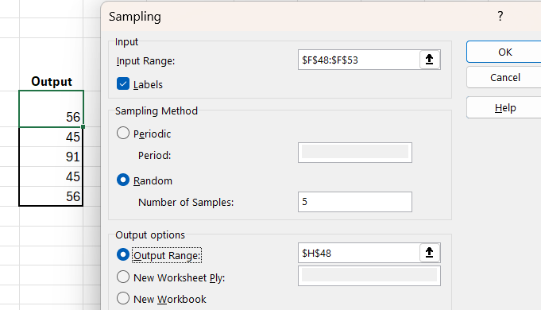

Result: | Sampling was successfully performed using both Periodic (every 3rd item) and Random (5 samples) methods. The tool correctly extracted subsets from the 15-item dataset for further analysis.

PRACTICAL-30
OBJECTIVE: To perform the Data Analysis criteria by t-Test: Paired two sample for means in MS Excel.
Sample Data:
Student | Score Before Training | Score After Training
1 | 65 | 72
2 | 70 | 78
3 | 58 | 65
4 | 75 | 80
5 | 68 | 74
6 | 72 | 79
7 | 60 | 68
8 | 80 | 85
Steps to Perform:
Step 1: Enter the Before and After scores in columns B and C respectively.
Step 2: Go to Data tab → Data Analysis → t-Test: Paired Two Sample for Means.
Step 3: Variable 1 Range: B1:B9 (Before scores, with header). Variable 2 Range: C1:C9 (After scores, with header).
Step 4: Hypothesized Mean Difference: 0. Check 'Labels'. Alpha: 0.05.
Step 5: Set Output Range: E1. Click OK.
Step 6: Review: t-Stat, t Critical (one-tail and two-tail), P-value.
Step 7: If |t Stat| > t Critical OR P-value < 0.05: training significantly improved scores.
Step 8: Take screenshot of the t-test output table.
Output / Screenshot:
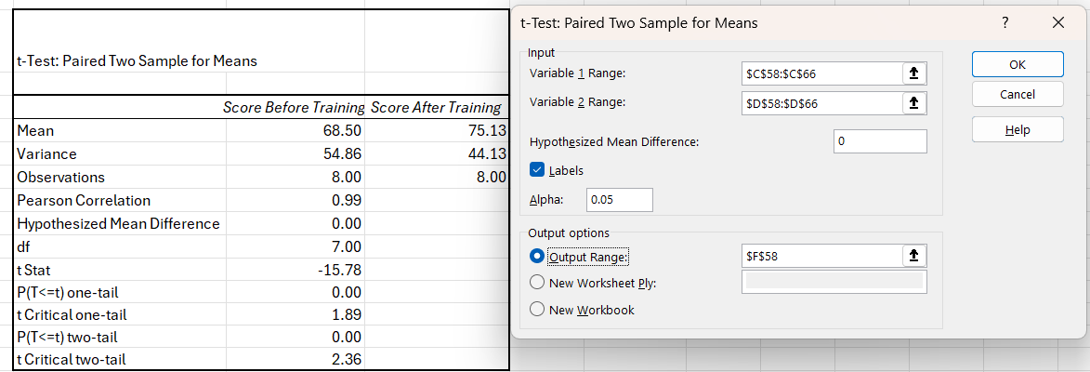

Result: | Paired t-Test was successfully conducted. The P-value < 0.05 and |t Stat| > t Critical confirm that the training significantly improved student scores (mean improvement ≈ 6.8 points).

PRACTICAL-31
OBJECTIVE: To perform the Data Analysis criteria by t-Test: two sample assuming equal variance in MS Excel.
Sample Data:
Group A (Method 1) | Group B (Method 2)
78 | 82
85 | 79
80 | 84
88 | 81
76 | 85
82 | 80
84 | 83
Steps to Perform:
Step 1: Enter Group A scores in column A and Group B scores in column B.
Step 2: First confirm equal variances using F-test (refer to Practical 22).
Step 3: Go to Data tab → Data Analysis → t-Test: Two-Sample Assuming Equal Variances.
Step 4: Variable 1 Range: A1:A8, Variable 2 Range: B1:B8 (with headers). Check 'Labels'.
Step 5: Hypothesized Mean Difference: 0. Alpha: 0.05. Set Output Range: D1.
Step 6: Click OK.
Step 7: Review output: Mean for each group, Pooled Variance, df, t Stat, P-value (one-tail & two-tail), t Critical.
Step 8: If P-value < 0.05: means are significantly different. Take screenshot.
Output / Screenshot:
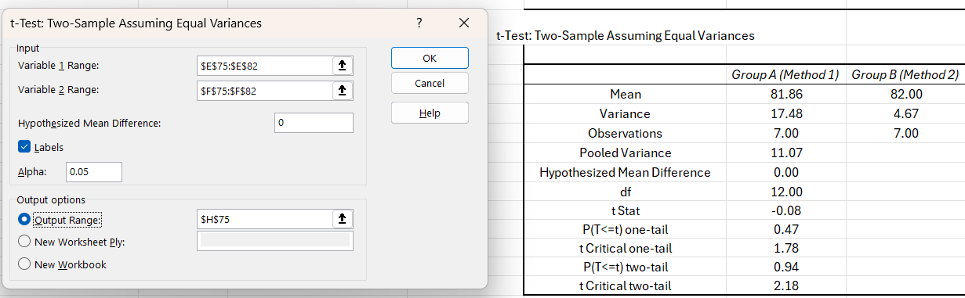

Result: | Two-sample t-Test (equal variances) was successfully performed. The analysis determined whether Method 1 and Method 2 produce significantly different results at the 5% significance level.

PRACTICAL-32
OBJECTIVE: To perform the Data Analysis criteria by t-Test: two sample assuming unequal variance in MS Excel.
Sample Data:
Group X | Group Y
45 | 72
52 | 68
48 | 80
55 | 65
50 | 75
47 | 70
53 | 78
Steps to Perform:
Step 1: Enter Group X in column A and Group Y in column B (data shows high variance difference).
Step 2: Verify unequal variances: =VAR(A2:A8) vs =VAR(B2:B8) — they should differ significantly.
Step 3: Go to Data tab → Data Analysis → t-Test: Two-Sample Assuming Unequal Variances.
Step 4: Variable 1 Range: A1:A8, Variable 2 Range: B1:B8. Check 'Labels'. Hypothesized Diff = 0.
Step 5: Alpha = 0.05. Set Output Range: D1.
Step 6: Click OK.
Step 7: Compare with the equal-variance version: Welch's test uses Satterthwaite approximation for df.
Step 8: Check P-value to determine significance. Take screenshot.
Output / Screenshot:
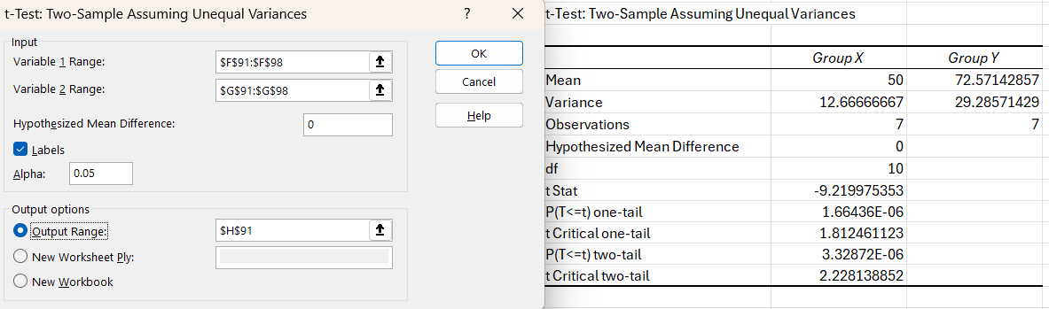

Result: | Two-sample t-Test (Unequal Variances / Welch's t-Test) was successfully performed. The adjusted degrees of freedom and separate variance estimates gave a valid comparison between the two groups.

PRACTICAL-33
OBJECTIVE: To perform the Data Analysis criteria by z-test two sample for means in MS Excel.
Sample Data:
Student | Before | After
Ananya | 72 | 85
Rohit | 65 | 78
Priya | 80 | 88
Deepak | 58 | 70
Kavya | 75 | 82
Suresh | 68 | 74
Meenal | 82 | 90
Arjun | 70 | 80
Steps to Perform:
Step 1: Enter Factory A output in column A (10 observations) and Factory B in column B.
Step 2: Known Population Variance: Factory A = 9, Factory B = 4 (assumed known).
Step 3: Go to Data tab → Data Analysis → z-Test: Two Sample for Means.
Step 4: Variable 1 Range: A1:A11, Variable 2 Range: B1:B11. Check 'Labels'.
Step 5: Hypothesized Mean Difference: 0. Variable 1 Variance (known): 9. Variable 2 Variance (known): 4.
Step 6: Alpha: 0.05. Set Output Range: D1.
Step 7: Click OK.
Step 8: Review: z Stat, P(Z<=z) one-tail, z Critical, P(Z<=z) two-tail. If P < 0.05: means differ. Take screenshot.
Output / Screenshot:
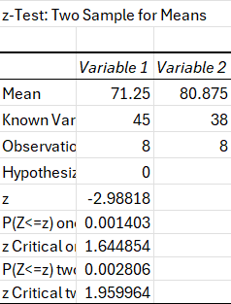
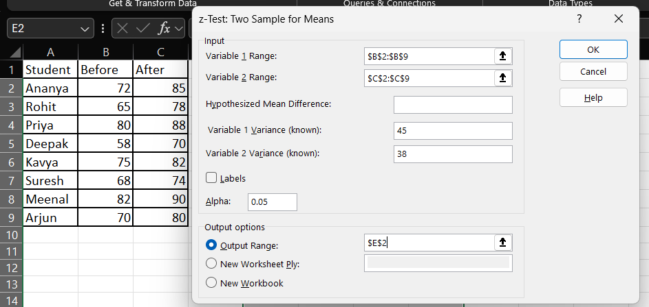

Result: | Z-test for Two Sample Means was successfully performed using known population variances. The z-statistic and p-value indicate whether the output means of Factory A and Factory B are significantly different.

PRACTICAL-34
OBJECTIVE- To perform the trace precedent cell for the given table in MS Excel
Sample Data:
Item | Qty | Price
Laptop | 5 | 45000
Mobile | 10 | 15000
Tablet | 8 | 25000
Steps to Perform:
Step 1: Enter the above table in Excel. In column E, enter the Total formulas as shown.
Step 2: In cell F2, enter: =SUM(E2:E4) for Grand Total.
Step 3: Click on cell E2 (which contains =B2*C2*(1-D2)).
Step 4: Go to Formulas tab → Formula Auditing group → click 'Trace Precedents'.
Step 5: Blue arrows will appear pointing from B2, C2, and D2 to E2 — these are the precedents.
Step 6: Click 'Trace Precedents' again to show indirect precedents (second level).
Step 7: Click on F2 and Trace Precedents to show E2:E4 as its precedents.
Step 8: To remove arrows: Formulas → Remove Arrows. Take screenshot showing the arrows.
Output / Screenshot:
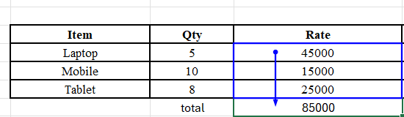

Result: | Trace Precedents was successfully performed. Blue arrows clearly show which input cells (Qty, Price, Discount) feed into the Total formula, confirming correct formula dependencies in the spreadsheet.

PRACTICAL-35
OBJECTIVE- To perform the trace dependent cell for the given table in MS Excel.

Sample Data:
Item | Qty | Price | Total | Tax (18%) | Grand Total
Laptop | 5 | 45000 | =B2*C2 | =D2*0.18 | =D2+E2
Mobile | 10 | 15000 | =B3*C3 | =D3*0.18 | =D3+E3
Steps to Perform:
Step 1: Enter the table in Excel with formulas in D, E, and F columns as shown.
Step 2: Click on cell C2 (Price of Laptop = 45000).
Step 3: Go to Formulas tab → Formula Auditing → click 'Trace Dependents'.
Step 4: Blue arrows will appear from C2 pointing to D2 (Total = Qty × Price).
Step 5: Click 'Trace Dependents' again — arrows extend further to E2 (Tax) and F2 (Grand Total).
Step 6: This shows the cascade effect: changing Price affects Total, Tax, and Grand Total.
Step 7: Now click on D2 and Trace Dependents to see E2 and F2 are dependent on it.
Step 8: Remove arrows using Formulas → Remove Arrows. Take screenshot with arrows visible.
Output / Screenshot:

Result: | Trace Dependents was successfully performed. The arrows show that changing the Price (C2) impacts Total (D2), Tax (E2), and Grand Total (F2), demonstrating the downstream dependency chain.

PRACTICAL-36
OBJECTIVE: For the given table perform the macros function in MS Excel.

Sample Data:
Employee ID | Name | Salary | Department
E001 | Amit Kumar | 50000 | IT
E002 | Priya Sharma | 45000 | HR
E003 | Ravi Verma | 55000 | Finance
E004 | Neha Singh | 48000 | IT
Steps to Perform:
Step 1: Go to View tab → Macros → Record Macro (or Developer tab → Record Macro).
Step 2: Name the macro 'Format Table', assign shortcut Ctrl+Shift+F, store in 'This Workbook'. Click OK.
Step 3: Now perform actions: Select A1:D1, make them Bold, fill background with Blue (Home → Fill Colour), change font colour to White.
Step 4: Select A2:D5, apply alternating row colours (light blue for even rows).
Step 5: Auto fit all column widths (Home → Format → AutoFit Column Width).
Step 6: Stop recording: View → Macros → Stop Recording.
Step 7: Delete the formatting, then press Ctrl+Shift+F to replay the macro and re-apply formatting.
Step 8: To view the VBA code: Alt+F11 → Module → Format Table. Take screenshot of table and VBA editor.
Output / Screenshot:
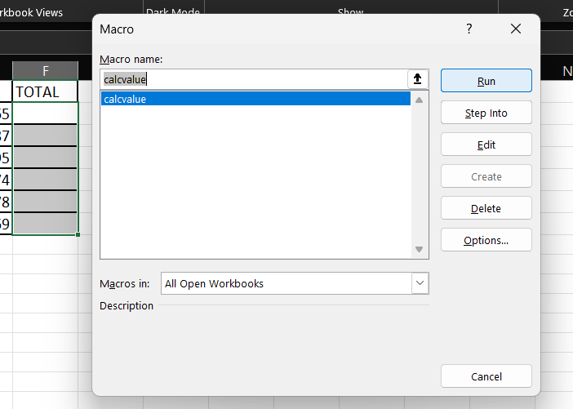
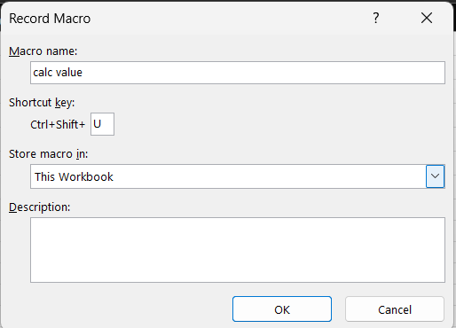

Result: | Macro 'Format Table' was successfully recorded and executed. The macro automatically applies professional formatting (bold headers, alternating colours, auto-fit columns) to the employee table in one keypress.

PRACTICAL-37
OBJECTIVE: To demonstrate the given table in line chart by using MS Excel.
Sample Data:
Month | Product A | Product B
Jan | 120 | 90
Feb | 135 | 105
Mar | 150 | 120
Apr | 145 | 115
May | 160 | 130
Jun | 175 | 145
Steps to Perform:
Step 1: Open MS Excel and enter the sample data table provided above in cells A1 onwards.
Step 2: Select the entire data range including headers (e.g., A1:C7).
Step 3: Go to the Insert tab on the ribbon.
Step 4: Click on 'Insert Line or Area Chart' → Select '2-D Line' → 'Line with Markers'.
Step 5: The line chart will appear on the worksheet showing trends for both products.
Step 6: Right-click the chart → 'Add Chart Title' → Type 'Monthly Sales Trend'.
Step 7: Go to Chart Design tab → 'Add Chart Element' → 'Data Labels' → 'Above'.
Step 8: Format the chart: Right-click each series → Format Data Series to change colours.
Step 9: Take a screenshot of the completed line chart.
Output / Screenshot:
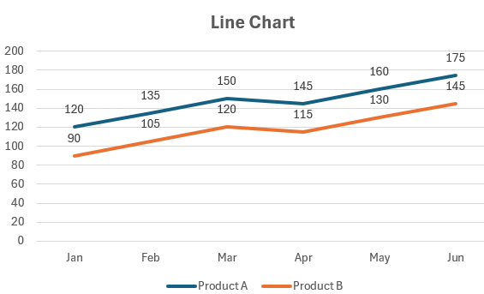

Result: | The Line chart was successfully created in MS Excel. The chart accurately represents the given data, with proper titles, labels, and formatting applied, demonstrating effective use of Excel's charting capabilities.
PRACTICAL-38
OBJECTIVE: To demonstrate the given table in area chart by using MS.
Sample Data:
Quarter | North | South | East | West
Q1 | 50 | 40 | 35 | 45
Q2 | 60 | 55 | 40 | 50
Q3 | 70 | 60 | 55 | 65
Q4 | 80 | 70 | 65 | 75
Steps to Perform:
Step 1: Open MS Excel and enter the sample data table provided above in cells A1 onwards.
Step 2: Select the entire data range including headers (e.g., A1:C7).
Step 3: Go to the Insert tab on the ribbon.
Step 4: Click on 'Insert Line or Area Chart' → Select '3-D Area'.
Step 5: The area chart will show cumulative sales across regions.
Step 6: Add Chart Title: 'Regional Quarterly Sales'. Add axis titles.
Step 7: Apply a color theme: Chart Design → Change Colours.
Step 8: Right-click the plot area → Format Plot Area → Add gradient fill.
Step 9: Take a screenshot of the area chart.
Output / Screenshot:

Result: | The Area chart was successfully created in MS Excel. The chart accurately represents the given data, with proper titles, labels, and formatting applied, demonstrating effective use of Excel's charting capabilities.

PRACTICAL-39
OBJECTIVE: To demonstrate the given table in bar chart by using MS Excel.
Sample Data:
Department | Budget (Lakhs) | Spent (Lakhs)
IT | 50 | 42
HR | 30 | 28
Finance | 40 | 38
Marketing | 35 | 30
Operations | 45 | 40
Steps to Perform:
Step 1: Open MS Excel and enter the sample data table provided above in cells A1 onwards.
Step 2: Select the entire data range including headers (e.g., A1:C7).
Step 3: Go to the Insert tab on the ribbon.
Step 4: Click 'Insert Bar Chart' → Select '2-D Clustered Bar'.
Step 5: The horizontal bars will compare Budget vs Spent per Department.
Step 6: Add Chart Title: 'Department Budget vs Spending'. Add data labels.
Step 7: Sort bars in descending order for better readability.
Step 8: Format bar colors: Budget = Blue, Spent = Orange.
Step 9: Take a screenshot of the bar chart.
Output / Screenshot:

Result: | The Bar chart was successfully created in MS Excel. The chart accurately represents the given data, with proper titles, labels, and formatting applied, demonstrating effective use of Excel's charting capabilities.

PRACTICAL-40

OBJECTIVE: To demonstrate the given table in column chart by using MS Excel.
Sample Data:
Year | Sales | Target
2020 | 150 | 180
2021 | 200 | 190
2022 | 220 | 210
2023 | 250 | 240
2024 | 280 | 270
Steps to Perform:
Step 1: Open MS Excel and enter the sample data table provided above in cells A1 onwards.
Step 2: Select the entire data range including headers (e.g., A1:C7).
Step 3: Go to the Insert tab on the ribbon.
Step 4: Click 'Insert Column or Bar Chart' → Select '2-D Clustered Column'.
Step 5: The column chart shows Sales vs Target per Year.
Step 6: Add title 'Annual Sales vs Target'. Add data labels on top of each column.
Step 7: Apply chart style: Chart Design → Chart Styles → Style 8.
Step 8: Add a trendline: right-click Sales series → Add Trendline → Linear.
Step 9: Take a screenshot of the column chart.
Output / Screenshot:

Result: | The Column chart was successfully created in MS Excel. The chart accurately represents the given data, with proper titles, labels, and formatting applied, demonstrating effective use of Excel's charting capabilities.

PRACTICAL-41
OBJECTIVE: To demonstrate the given table in tree map chart by using MS Excel.
Sample Data:
Category | Sub-Category | Value
Electronics | Mobile | 40
Electronics | Laptop | 30
Clothing | Men | 20
Clothing | Women | 25
Food | Grocery | 15
Steps to Perform:
Step 1: Open MS Excel and enter the sample data table provided above in cells A1 onwards.
Step 2: Select the entire data range including headers (e.g., A1:C7).
Step 3: Go to the Insert tab on the ribbon.
Step 4: Click Insert → Charts group → click 'Insert Hierarchy Chart' → Select 'Treemap'.
Step 5: The treemap shows category sizes proportionally as nested rectangles.
Step 6: Add title 'Product Sales Treemap'.
Step 7: Adjust colors: right-click each category label → Format Data Point.
Step 8: Hover over rectangles to see tooltips with values.
Step 9: Take a screenshot of the treemap chart.
Output / Screenshot:

Result: | The Tree map chart was successfully created in MS Excel. The chart accurately represents the given data, with proper titles, labels, and formatting applied, demonstrating effective use of Excel's charting capabilities.

PRACTICAL-42
OBJECTIVE: To demonstrate the given table in sunburst chart by using MS Excel.

Sample Data:
Division | Department | Revenue
Tech | Dev | 500
Tech | QA | 200
Sales | B2B | 400
Sales | B2C | 300
HR | Recruit | 100
Steps to Perform:
Step 1: Open MS Excel and enter the sample data table provided above in cells A1 onwards.
Step 2: Select the entire data range including headers (e.g., A1:C7).
Step 3: Go to the Insert tab on the ribbon.
Step 4: Click Insert → 'Insert Hierarchy Chart' → Select 'Sunburst'.
Step 5: The sunburst chart displays hierarchical revenue data in concentric rings.
Step 6: Add chart title 'Revenue by Division and Department'.
Step 7: Right-click the chart → 'Format Data Series' to change ring separation.
Step 8: Click on individual segments to see values in the formula bar.
Step 9: Take a screenshot of the sunburst chart.
Output / Screenshot:

Result: | The Sunburst chart was successfully created in MS Excel. The chart accurately represents the given data, with proper titles, labels, and formatting applied, demonstrating effective use of Excel's charting capabilities.

PRACTICAL-43
OBJECTIVE: To demonstrate the given table in pie chart by using MS Excel.
Sample Data:
Product | Market Share (%)
Product A | 35
Product B | 25
Product C | 20
Product D | 12
Product E | 8
Steps to Perform:
Step 1: Open MS Excel and enter the sample data table provided above in cells A1 onwards.
Step 2: Select the entire data range including headers (e.g., A1:C7).
Step 3: Go to the Insert tab on the ribbon.
Step 4: Click Insert → 'Insert Pie or Doughnut Chart' → Select '2-D Pie'.
Step 5: The pie chart shows market share proportions for each product.
Step 6: Right-click chart → 'Add Data Labels' → 'More Data Label Options' → check 'Percentage'.
Step 7: Click on the largest slice → drag slightly outward to 'explode' it for emphasis.
Step 8: Add title 'Product Market Share (%)'.
Step 9: Take a screenshot of the pie chart.
Output / Screenshot:

Result: | The Pie chart was successfully created in MS Excel. The chart accurately represents the given data, with proper titles, labels, and formatting applied, demonstrating effective use of Excel's charting capabilities.

PRACTICAL-44
OBJECTIVE: To demonstrate the given table in doughnut chart by using MS Excel.
Sample Data:
Region | Sales (Rs. Lakh)
North | 45
South | 30
East | 25
West | 35
Central | 20
Steps to Perform:
Step 1: Open MS Excel and enter the sample data table provided above in cells A1 onwards.
Step 2: Select the entire data range including headers (e.g., A1:C7).
Step 3: Go to the Insert tab on the ribbon.
Step 4: Click Insert → 'Insert Pie or Doughnut Chart' → Select 'Doughnut'.
Step 5: The doughnut chart shows regional sales with a hollow center.
Step 6: Right-click → Format Data Series → Doughnut Hole Size = 50%.
Step 7: Add data labels showing both value and percentage.
Step 8: Add title 'Regional Sales Distribution'.
Step 9: Take a screenshot of the doughnut chart.

Output / Screenshot:

Result: | The Doughnut chart was successfully created in MS Excel. The chart accurately represents the given data, with proper titles, labels, and formatting applied, demonstrating effective use of Excel's charting capabilities.

PRACTICAL-45
OBJECTIVE: To demonstrate the given table in histogram chart by using MS Excel.
Sample Data:
Student | Score
1 | 55
2 | 72
3 | 88
4 | 45
5 | 91
6 | 63
7 | 78
8 | 50
9 | 84
10 | 67
Steps to Perform:
Step 1: Open MS Excel and enter the sample data table provided above in cells A1 onwards.
Step 2: Select the entire data range including headers (e.g., A1:C7).
Step 3: Go to the Insert tab on the ribbon.
Step 4: Click Insert → Charts group → 'Insert Statistic Chart' → Select 'Histogram'.
Step 5: Excel automatically calculates bins and frequency.
Step 6: Right-click the horizontal axis → 'Format Axis' to adjust bin width manually (e.g., 10).
Step 7: Add title 'Student Score Distribution'.
Step 8: Observe the distribution shape (bell curve, skewed, etc.).
Step 9: Take a screenshot of the histogram chart.
Output / Screenshot:

Result: | The Histogram chart was successfully created in MS Excel. The chart accurately represents the given data, with proper titles, labels, and formatting applied, demonstrating effective use of Excel's charting capabilities.

PRACTICAL-46
OBJECTIVE: To demonstrate the given table in box and whisker chart by using MS Excel.
Sample Data:
Group | Values
A | 45
A | 55
A | 60
A | 70
A | 52
B | 80
B | 85
B | 90
B | 78
B | 88
Steps to Perform:
Step 1: Open MS Excel and enter the sample data table provided above in cells A1 onwards.
Step 2: Select the entire data range including headers (e.g., A1:C7).
Step 3: Go to the Insert tab on the ribbon.
Step 4: Click Insert → 'Insert Statistic Chart' → Select 'Box and Whisker'.
Step 5: Excel plots the five-number summary (Min, Q1, Median, Q3, Max) for each group.
Step 6: Right-click a box → 'Format Data Series' → show inner points (outliers).
Step 7: Add title 'Score Distribution by Group'.
Step 8: Hover over different parts of the box plot to see Q1, Median, Q3 values.
Step 9: Take a screenshot of the box and whisker chart.
Output / Screenshot:

Result: | The Box and whisker chart was successfully created in MS Excel. The chart accurately represents the given data, with proper titles, labels, and formatting applied, demonstrating effective use of Excel’s charting capabilities.
PRACTICAL-47
OBJECTIVE: To demonstrate the given table in scatter chart by using MS Excel.
Sample Data:
Study Hours | Exam Score
2 | 55
3 | 62
4 | 70
5 | 75
6 | 82
7 | 88
8 | 91
9 | 95
Steps to Perform:
Step 1: Open MS Excel and enter the sample data table provided above in cells A1 onwards.
Step 2: Select the entire data range including headers (e.g., A1:C7).
Step 3: Go to the Insert tab on the ribbon.
Step 4: Click Insert → 'Insert Scatter (X,Y) or Bubble Chart' → Select 'Scatter'.
Step 5: Each point shows Study Hours (X) vs Exam Score (Y).
Step 6: Right-click a data point → 'Add Trendline' → Linear → check 'Display R-squared'.
Step 7: Add axis titles: X = 'Study Hours per Day', Y = 'Exam Score'.
Step 8: Add title 'Study Hours vs Exam Performance'.
Step 9: Take a screenshot of the scatter chart with trendline.
Output / Screenshot:
...

Result: | The Scatter chart was successfully created in MS Excel. The chart accurately represents the given data, with proper titles, labels, and formatting applied, demonstrating effective use of Excel's charting capabilities.

PRACTICAL-48
OBJECTIVE: To demonstrate the given table in bubble chart by using MS Excel.

Sample Data:
Product | Price | Sales | Market Size
A | 500 | 200 | 8
B | 1200 | 150 | 12
C | 800 | 300 | 10
D | 400 | 400 | 6
E | 1500 | 100 | 15
Steps to Perform:
Step 1: Open MS Excel and enter the sample data table provided above in cells A1 onwards.
Step 2: Select the entire data range including headers (e.g., A1:C7).
Step 3: Go to the Insert tab on the ribbon.
Step 4: Click Insert → 'Insert Scatter or Bubble Chart' → Select '3-D Bubble'.
Step 5: The three variables (Price, Sales, Market Size) are mapped to X, Y, and bubble size.
Step 6: Right-click → 'Select Data' → Edit series to map correct columns to X, Y, and Size.
Step 7: Add data labels showing product names.
Step 8: Add title 'Product: Price vs Sales vs Market Size'.
Step 9: Take a screenshot of the bubble chart.
Output / Screenshot:

Result: | The Bubble chart was successfully created in MS Excel. The chart accurately represents the given data, with proper titles, labels, and formatting applied, demonstrating effective use of Excel's charting capabilities.

PRACTICAL-49
OBJECTIVE: To demonstrate the given table in waterfall chart by using MS Excel.
Sample Data:
Item | Amount (Rs.)
Opening Balance | 100000
Sales Revenue | 50000
COGS | -30000
Operating Expense | -15000
Tax | -8000
Net Profit | 97000
Steps to Perform:
Step 1: Open MS Excel and enter the sample data table provided above in cells A1 onwards.
Step 2: Select the entire data range including headers (e.g., A1:C7).
Step 3: Go to the Insert tab on the ribbon.
Step 4: Click Insert → Charts → 'Insert Waterfall, Funnel, Stock, Surface, or Radar Chart' → Waterfall.
Step 5: The chart shows positive increases (blue) and negative decreases (orange) from the base.
Step 6: Right-click 'Net Profit' bar → 'Set as Total' so it starts from zero.
Step 7: Add data labels → 'Outside End' for clarity.
Step 8: Add title 'Profit & Loss Waterfall Analysis'.
Step 9: Take a screenshot of the waterfall chart.
Output / Screenshot:
📸

Result: | The Waterfall chart was successfully created in MS Excel. The chart accurately represents the given data, with proper titles, labels, and formatting applied, demonstrating effective use of Excel's charting capabilities.

PRACTICAL-50
OBJECTIVE: To demonstrate the given table in funnel chart by using MS Excel.

Sample Data:
Stage | Count
Leads | 1000
Prospects | 750
Qualified | 500
Proposals | 300
Negotiations | 150
Closed Deals | 80
Steps to Perform:
Step 1: Open MS Excel and enter the sample data table provided above in cells A1 onwards.
Step 2: Select the entire data range including headers (e.g., A1:C7).
Step 3: Go to the Insert tab on the ribbon.
Step 4: Click Insert → 'Insert Waterfall, Funnel, Stock, Surface, or Radar Chart' → Funnel.
Step 5: The funnel chart shows the narrowing sales pipeline from Leads to Closed Deals.
Step 6: Add data labels showing count values.
Step 7: Apply a gradient color: darker at top (wide) to lighter at bottom (narrow).
Step 8: Add title 'Sales Pipeline Funnel'.
Step 9: Take a screenshot of the funnel chart.
Output / Screenshot:

Result: | The Funnel chart was successfully created in MS Excel. The chart accurately represents the given data, with proper titles, labels, and formatting applied, demonstrating effective use of Excel's charting capabilities.

PRACTICAL-51
OBJECTIVE: To demonstrate the given table in stock chart by using MS Excel.
Sample Data:
Date | Open | High | Low | Close
01-Apr | 450 | 480 | 440 | 475
02-Apr | 475 | 490 | 460 | 485
03-Apr | 485 | 500 | 470 | 495
04-Apr | 495 | 510 | 480 | 505
05-Apr | 505 | 520 | 490 | 515
Steps to Perform:
Step 1: Open MS Excel and enter the sample data table provided above in cells A1 onwards.
Step 2: Select the entire data range including headers (e.g., A1:C7).
Step 3: Go to the Insert tab on the ribbon.
Step 4: Arrange data in order: Date, Open, High, Low, Close (Excel requires this specific order for OHLC).
Step 5: Click Insert → 'Insert Waterfall, Funnel, Stock, Surface, or Radar Chart' → 'Open-High-Low-Close'.
Step 6: The chart shows candlestick-style stock movements.
Step 7: Format: up days = hollow/green bars, down days = solid/red bars.
Step 8: Add title 'Daily Stock Price Movement'.
Step 9: Take a screenshot of the stock chart.
Output / Screenshot:

Result: | The Stock chart was successfully created in MS Excel. The chart accurately represents the given data, with proper titles, labels, and formatting applied, demonstrating effective use of Excel's charting capabilities.

PRACTICAL-52
OBJECTIVE: To demonstrate the given table in surface chart by using MS Excel.
Sample Data:
X\Y | 1 | 2 | 3 | 4
1 | 2 | 4 | 6 | 8
2 | 3 | 6 | 9 | 12
3 | 4 | 8 | 12 | 16
4 | 5 | 10 | 15 | 20

Steps to Perform:
Step 1: Open MS Excel and enter the sample data table provided above in cells A1 onwards.
Step 2: Select the entire data range including headers (e.g., A1:C7).
Step 3: Go to the Insert tab on the ribbon.
Step 4: Select the entire data range A1:E5 (including X and Y axis labels).
Step 5: Click Insert → 'Insert Waterfall... or Radar Chart' → Surface → '3-D Surface'.
Step 6: The 3D surface chart renders automatically with color gradients by value range.
Step 7: Rotate the chart: right-click → '3-D Rotation' → adjust X and Y rotation angles.
Step 8: Add title '3D Surface Plot of Data'.
Step 9: Take a screenshot of the 3D surface chart.
Output / Screenshot:

Result: | The Surface chart was successfully created in MS Excel. The chart accurately represents the given data, with proper titles, labels, and formatting applied, demonstrating effective use of Excel's charting capabilities.

PRACTICAL-53
OBJECTIVE: To demonstrate the given table in radar chart by using MS Excel.
Sample Data:
Skill | Employee A | Employee B | Employee C
Technical | 8 | 6 | 7
Communication | 6 | 9 | 8
Leadership | 7 | 8 | 6
Teamwork | 9 | 7 | 8
Creativity | 7 | 8 | 9
Steps to Perform:
Step 1: Open MS Excel and enter the sample data table provided above in cells A1 onwards.
Step 2: Select the entire data range including headers (e.g., A1:C7).
Step 3: Go to the Insert tab on the ribbon.
Step 4: Click Insert → 'Insert Waterfall... or Radar Chart' → Radar → 'Radar with Markers'.
Step 5: The chart plots each employee's scores on 5 skill axes.
Step 6: Add a legend to differentiate Employee A, B, and C.
Step 7: Format each data series with different colours and marker styles.
Step 8: Add title 'Employee Skill Comparison Radar Chart'.
Step 9: Take a screenshot of the radar chart.
Output / Screenshot:

Result: | The Radar chart was successfully created in MS Excel. The chart accurately represents the given data, with proper titles, labels, and formatting applied, demonstrating effective use of Excel's charting capabilities.

PRACTICAL-54
OBJECTIVE: To demonstrate the given table in combo chart by using MS.
Sample Data:
Month | Units Sold | Revenue (Rs.)
Jan | 120 | 60000
Feb | 150 | 75000
Mar | 130 | 65000
Apr | 180 | 90000
May | 160 | 80000
Jun | 200 | 100000
Steps to Perform:
Step 1: Open MS Excel and enter the sample data table provided above in cells A1 onwards.
Step 2: Select the entire data range including headers (e.g., A1:C7).
Step 3: Go to the Insert tab on the ribbon.
Step 4: Select A1:C7 (Month, Units Sold, Revenue).
Step 5: Click Insert → Charts → 'Recommended Charts' → 'All Charts' → Combo.
Step 6: Set 'Units Sold' as Clustered Column on Primary Axis; 'Revenue' as Line on Secondary Axis.
Step 7: Check 'Secondary Axis' for Revenue to handle the scale difference.
Step 8: Add title 'Monthly Sales Volume and Revenue Combo Chart'.
Step 9: Take a screenshot of the combo chart showing both chart types.
Output / Screenshot:

Result: | The Combo chart was successfully created in MS Excel. The chart accurately represents the given data, with proper titles, labels, and formatting applied, demonstrating effective use of Excel's charting capabilities.

PRACTICAL-55
OBJECTIVE: To demonstrate the given table in filled map chart by using MS Excel.
Sample Data:
State | Sales (Rs. Lakh)
Maharashtra | 150
Karnataka | 120
Tamil Nadu | 110
Uttar Pradesh | 90
Gujarat | 100
Delhi | 130
Steps to Perform:
Step 1: Open MS Excel and enter the sample data table provided above in cells A1 onwards.
Step 2: Select the entire data range including headers (e.g., A1:C7).
Step 3: Go to the Insert tab on the ribbon.
Step 4: Ensure state names are spelled correctly as Excel/Bing Maps recognizes them.
Step 5: Click Insert → Charts → Maps → 'Filled Map'.
Step 6: Excel will connect to Bing Maps and shade each state based on Sales value.
Step 7: Right-click chart → 'Format Data Series' → change color scheme to a heat map.
Step 8: Add title 'State-wise Sales Revenue Map'.
Step 9: Take a screenshot of the filled map chart with geographic shading.
Output / Screenshot:

Result: | The Filled map chart was successfully created in MS Excel. The chart accurately represents the given data, with proper titles, labels, and formatting applied, demonstrating effective use of Excel's charting capabilities.

