

GL BAJAJ INSTITUTE OF TECHNOLOGY AND MANAGEMENT, GREATER NOIDA

“ASSIGNMENT-1”
ON
IT-SKILLS 1
TOWARDS THE PARTIAL FULLFILLMENT FOR THE AWARD OF DEGREE OF
MASTER OF BUSINESS ADMINISTRATION (BA)

(Dr. A.P.J. Abdul Kalam Technical University, Lucknow, Uttar Pradesh)

By
NAMAN SINGH CHAUHAN
SEC-J
Admission No.-25162CN108
Session 2025-26

Under the Supervision of

Mr. Vijay Kumar Singh
COLUMN CHART
Uses rectangular bar in vertical to compare quantities and across categories tracking changes over a discrete period.

Key observations derived from the chart would be:
- Dominance of Silk and Cotton: Silk maintained the highest or near-highest value in three out of the four years (2020, 2021, 2023), confirming its consistent high performance. However, Cotton's value more than doubled from 2022 (202) to 2023 (488), demonstrating the most accelerated increase across the dataset.
- Wool Volatility: Wool showed the most varied performance, reaching a peak in 2021 (156) before experiencing a notable It then recovered sharply in 2023 (400), indicating a volatile market or production cycle compared to the steady rise of Cotton and Silk.
- Overall Market Growth: The combined total value of all three materials increased steadily, especially in 2023, which saw the largest year-over-year increase, signalling a robust market expansion.
CONCULSION:
- The most striking feature of the dataset is the volatility of Wool and the exponential growth of Cotton. Wool's sharp drop in 2022 suggests it was highly sensitive to market factors that year, while Cotton's steady, strong increase positioned it to almost match Silk's peak performance in 2023 (488 vs. 500).

Uses rectangular bar in vertical to compare quantities and across categories tracking changes over a discrete period.

Key Observations from the Bar Graph:
- Sharpest Decline (2022-2023): The columns for Banana (from 5,975 to 2,133) and Orange (from 4,988 to 2,246) would show the most dramatic visual drop, indicating severe market contraction or supply issues for these two fruits in 2023.
- Contrasting Resilience: Blueberry is the only fruit whose column height increases from 2022 to 2023 (5,315 to 5,689), demonstrating resilience and growth during a challenging year for the other fruits.
- 2024 Performance: In 2024, Banana saw a significant recovery (from 2,133 to 4,869), while Grape continued its steady, year-over-year decline, shifting the relative market share among the fruits. The Orange bar for 2024 would be identical to 2023, indicating stagnation.
Overall Conclusion: The market is highly segmented and volatile. While Grape was the volume leader in 2022, it faces persistent decline. Banana and Orange are susceptible to massive annual swings, while Blueberry shows consistent performance but cannot compete with the peak volumes of the other.
SURFACE CHART
Used to plot three-dimensional data, often in geological, topographical, or complex statistical modelling, to show the relationship between three variables

Key Elements of the Chart:
- X-Axis (Horizontal): Represents time — from Nov 2021 to Mar 2022.
- Y-Axis (Depth): Represents different Tata car models — Harrier, Nexon, Tiago, Altroz, Tiger, Safari, Punch.
- Z-Axis (Vertical): Represents Sales Units of each model.
- Colour Bands:
  - Blue (0–5000) → Low sales range
  - Orange (5000–10000) → Medium sales range
  - Green (10000–15000) → High sales range
- Purpose: To visually compare how each model’s sales changed over five months and identify high- and low-performing models.
Conclusion:
The Surface Chart shows a clear variation in sales performance across Tata’s car models from November 2021 to March 2022.
- Nexon consistently dominates the sales figures, staying in the 10,000–15,000 range, showing strong customer demand.
- Punch follows closely behind, maintaining steady growth since launch.
- Tiago and Altroz perform moderately, fluctuating between 4,000–6,000 units per month.
- Harrier, Tigor, and Safari remain in the lower sales band, showing potential areas for marketing or model improvement.
- Overall, sales across most models show a slight upward trend toward March 2022, indicating healthy performance recovery post-winter season.

LINE CHART
- The best way to visualize the relationship (correlation or lack thereof) between two numerical variables.

Key Observations
Profit Margin (%) (Blue Line - Left Axis)
- Starting High: Profit Margin begins at its peak in January (approx. 15%).
- Trough in March: It declines consistently to its lowest point in March (approx. 8%).
- Recovery and End Peak: The margin then rises sharply through April, reaching its peak again in May (approx. 16%).
- Overall Trend: The margin follows a V-shaped pattern over the five months.
Sales Volume (Units) (Orange Line - Right Axis)
- Starting Low: Sales Volume begins low in January (approx. 10,000 units).
- Peak in March: It rises consistently to its highest point in March (approx. 25,000 units).
- Decline to Trough: The volume then decreases sharply through April, hitting its lowest point in May (approx. 12,000 units).
- Overall Trend: The volume follows an inverted V-shaped pattern over the five months.
Conclusion The chart clearly demonstrates a strong inverse (negative) correlation between Profit Margin (%) and Sales Volume (Units). Peak Divergence (March): The two metrics are mirror images of each other and cross paths in March. The month of highest Sales Volume (25,000 units) coincides precisely with the month of lowest Profit Margin (8%).
- Strategic Trade-Off: This inverse relationship implies that strategies used to drive high sales volume (like price reductions, promotions, or heavy discounts) are effectively reducing the profit generated per unit. Conversely, when the company maintains a high margin (January and May), its sales volume is significantly lower
- Net Profit Consideration: To fully evaluate performance, an analysis of Total Net Profit (Volume × Margin) would be necessary to determine which strategy (high volume/low margin in March vs. low volume/high margin in May) yielded the best financial result.

Used to show the proportion of categories within a whole, but it is generally best for a very small number of categories (2 to 5).

Key Observations:
- Fixed Costs Dominate: Rent is the single largest expenditure, accounting for 50% of the total amount.
- Essential Spending: Food is the second largest expense at 30%.
- Minimal Allocation to Growth/Discretion: The combined allocation for both Travel and Savings is only 20% (10% each), indicating a highly constrained budget where discretionary spending and future financial security (savings) take a lower priority compared to immediate necessities.
Overall Conclusion:
The current spending pattern is heavily weighted towards immediate living costs (80%), suggesting a limited capacity for financial flexibility, investment, or significant discretionary spending.

AREA CHART
- Like a Line Chart, but the area beneath the line is filled, which emphasizes the magnitude or accumulated total over time.

Key Observations:
- Total Market Expansion: The overall market size (represented by the top line of the stack) shows consistent growth from November 2021 (approx.29,000) to a peak in January 2022 (approx.41,000), followed by a slight dip in February 2022 (approx40,000).
- Nexon's Core Contribution: Nexon (the largest orange area at the base of the stack) is the single biggest driver of the total volume. Its massive base determines the overall shape and trend of the chart.
- Harrier's Minimal Impact: Harrier (the dark blue area at the very bottom) has a proportionally minimal contribution to the total sales volume, despite being a separate model.
- Mid-Tier Stability: The stacked layers representing the mid-tier models (Tiago, Altroz, Tigor, Safari, and Punch) show relatively stable contribution levels, without any one model dramatically overtaking the others' market share within the total volume.
Overall Conclusion: While the total sales volume expanded significantly up to January 2022, this growth was fundamentally powered by the high-volume sales of the Nexon. The market's success is highly dependent on the continued performance of this one key model.

HISTOGRAM
- Specifically designed to show the distribution of a single continuous variable. The bars represent the frequency count within predefined ranges (bins).

Key Observations:
- Dominant Concentration: Most of the data points fall within the lower range of values (30 to 220), with a frequency of 4.0 (or 80% of the visible total).
- Rapid Drop-off: The frequency drops drastically when moving to the next range, (220 to 410], which has a frequency of only 1.0 (or 20% of the visible total).
- Low Spread: The data suggests that values are tightly clustered around the lower end of the total measured range, with very few observations extending into the higher values.
Overall Conclusion: The process or metric being measured is inherently weighted toward lower outcomes. High values (above 220) are rare events, and the typical outcome is significantly lower than the maximum observed value of 410.

XY SCATTER CHART
The best way to visualize the relationship (correlation or lack thereof) between two numerical variables.

Key Observations:
- Sales Volatility (Y): Weekly Sales (Orange dots) show extreme swings, ranging from a low of 10,000$ (Observation 3) to a high of 25,000$(Observation 4). This indicates that the revenue stream is highly unpredictable and heavily influenced by factors outside of the primary spending shown.
- Stable, Low Marketing Spend (X): Marketing Spend (Blue dots) remains relatively stable and low, hovering between 500$ and 3,500$ across all five observations.
- Lack of Direct Causation: There is no apparent visual correlation where a high spike in Marketing Spend immediately precedes or coincides with a high spike in Sales. For instance, the highest Sales (25,000$ in Obst 4) corresponds to a moderate Spend, while the lowest Sales (10,000$ in Obst 3) corresponds to the lowest Spend (0$).
Overall Conclusion: The business is currently operating with a minimal and steady marketing budget. The high volatility in sales suggests that the primary drivers of revenue are likely external (e.g., seasonality, competitor actions, or economic trends) or internal operational factors (e.g., inventory, distribution) rather than the current low-level marketing efforts.

TREEMAP
A Treemap is a data visualization method used to display hierarchical data (tree-structured data) using nested rectangles.
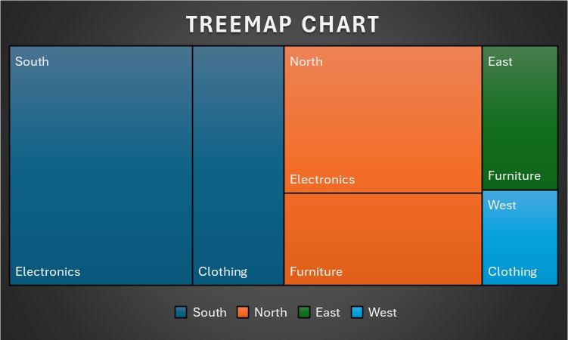
Key Observations:
- Dominance of the South Region: The South region is the single largest contributor to the total value, consuming over half of the entire chart area.
- Category Focus in the South: Most of the South's value comes from Electronics, with a much smaller adjacent block for Clothing and no visible contribution from Furniture.
- North Region's Diverse Contribution: The North region is the second largest contributor and demonstrates a more balanced internal breakdown, with significant portions allocated to Electronics and Furniture.
- Minimal Impact of East and West: The East and West regions contribute only a small fraction to the total value, confirming that the business is primarily driven by the South and North markets.
Overall Conclusion: The success of the business is overwhelmingly reliant on the South Region's sales of Electronics. This concentration represents both a strength (high focus) and a significant risk (vulnerability to localized market disruption).

COMBO CHART
- A Combo Chart, short for Combination Chart, is a data visualization that uses two or more different chart types (like a bar and a line chart) in a single visualization.
- It is particularly useful for comparing two different datasets that share the same X-axis but may have very different scales or represent different types of measures.

Key Observations
- Sales Volume (Units) - Column Chart (Right Axis):
  - Sales volume shows a clear peak in March, reaching approximately 25,000 units.
  - The lowest sales volume occurred in January, at about 10,000 units.
  - Sales volumes show a trend of increasing from Jan to Mar and then decreasing from Mar to May, ending at around 12,000-13,000 units in May.
- Profit Margin (%) - Line Chart (Left Axis):
  - Profit Margin is generally high, with the highest points in January and May, both reaching around 15%.
  - The lowest profit margin was in March, at only 8%.
  - The margin decreases sharply from Jan (15%) to Mar (8%) and then increases sharply to May (16%).
- Relationship Between Metrics:
  - There is a noticeable inverse relationship between the two metrics:
    - The month with the highest Sales Volume (March) corresponds to the month with the lowest Profit Margin (8%).
    - The months with lower Sales Volumes (January and May) correspond to the months with the highest Profit Margins (15-16%).
Conclusion
The data suggests a strong trade-off or inverse correlation between sales volume and profit margin over the five-month period. The company appears to achieve its highest sales volume (in March) at the expense of significantly lower profit margins. Conversely, when profit margins are highest (in January and May), sales volume tends to be lower. This pattern suggests that high sales volumes might be driven by strategies like price reductions or promotions, which inherently decrease the profit margin per unit
COMBO CHART(AREA+COLUMN)

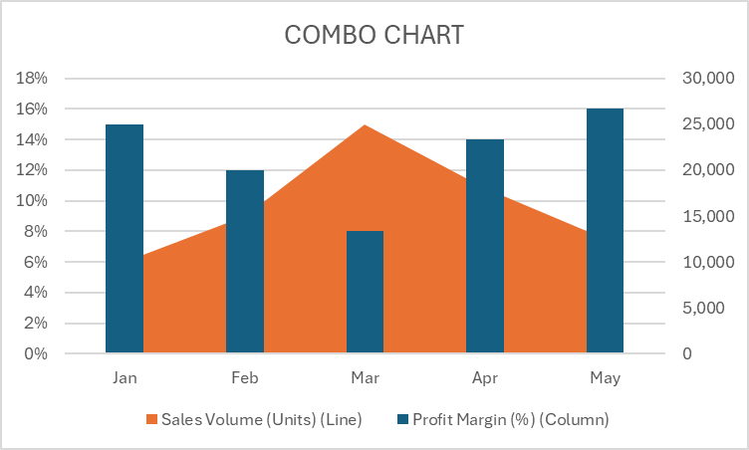
Key Observations
- Inverse Relationship: The chart displays a strong inverse (negative) correlation between the two metrics: when the Sales Volume Area expands (March), the Profit Margin Column contracts, and vice versa.
- Sales Volume (Area Chart - Right Axis):
  - Peak Volume occurred in March (approx. 25,000 units), forming the highest point of the orange shaded area.
  - Lowest Volume was recorded in January (approx. 10,000 units) and remained low in May (approx. 12,500 units).
- Profit Margin (%) (Column Chart - Left Axis):
  - Lowest Margin was in March (8%), which is the shortest column.
  - Highest Margins were achieved in May (approx. 16%) and January (approx. 15%), represented by the tallest columns.
- Coincidence of Extremes: The month with the absolute highest sales volume (March) is also the month with the absolute lowest profit margin (8%).
Conclusion: The combined Column and Area Chart powerfully confirms the fundamental strategic trade-off between volume and profitability in this five-month period.
The business appears to be leveraging aggressive pricing or promotions to maximize unit sales, as evidenced by the peak Sales Volume in March (25,000 units) occurring at the expense of the minimum Profit Margin (8%). Conversely, when the company prioritizes high margins (15-16% in January and May), unit sales volume significantly drops.
This structure suggests two distinct business cycles or strategies are at play, and management must evaluate which approach (high-volume/low-margin vs. low-volume/high-margin) ultimately generates the greatest Total Net Profit for the organization.

