IN-DEPTH STATISTICAL ANALYSIS
AND PREDICTIVE MODELING USING R
Project Report

Programming Language: R
Software: R / RGui
Dataset: mtcars
Project Type: Statistical Analysis and Predictive Modeling
Submitted By: Naman Tiwari
College/Institution: GL Bajaj Group of Institutions, Mathura
Internship Program: [Add program name]
Submission Date: [Add submission date]

Abstract
This project performs statistical analysis and predictive modeling using R and the built-in mtcars dataset. The analysis includes dataset exploration, Pearson correlation, a Welch two-sample t-test, multiple linear regression, model evaluation, five-fold cross-validation, regression diagnostics, and a Shapiro-Wilk normality test. Vehicle weight has a strong negative association with MPG. Four-cylinder cars have higher average MPG than eight-cylinder cars in this sample. The multiple regression model using weight and horsepower has an R-squared of approximately 0.827. The captured cross-validation results show a lower mean RMSE for the model using both predictors than for the weight-only model. The residual normality test is significant at the 5% level, so results require cautious interpretation.

1. Introduction
Statistical analysis helps identify patterns and relationships in data, while predictive modeling estimates numerical outcomes from observed features. R provides built-in functions for statistical tests, regression, visualization, and model diagnostics. This project uses the mtcars dataset to examine vehicle fuel efficiency and evaluate models predicting miles per gallon (MPG).

2. Objectives
- Explore and summarize the mtcars dataset.
- Analyze the relationship between vehicle weight and MPG.
- Compare average MPG for four-cylinder and eight-cylinder cars.
- Build a multiple linear regression model using weight and horsepower.
- Evaluate model performance using RMSE and MAE.
- Compare models with five-fold cross-validation.
- Inspect regression diagnostics and residual normality.

3. Tools and Technologies
Tool / Method | Purpose
R and RGui | Statistical analysis and script execution
mtcars dataset | Vehicle data included with R
Pearson correlation | Measure linear association between weight and MPG
Welch two-sample t-test | Compare two group means
Multiple linear regression | Predict MPG using weight and horsepower
Five-fold cross-validation | Compare predictive performance
Diagnostic plots and Shapiro-Wilk test | Inspect model assumptions

4. Dataset Description
The built-in mtcars dataset contains 32 observations of automobiles from the 1973–1974 model years.
Variable | Description | Role
mpg | Miles per US gallon | Target
wt | Weight in 1,000 pounds | Predictor
hp | Gross horsepower | Predictor
cyl | Number of cylinders | Grouping variable

The first six rows and dataset structure were inspected in R using head(mtcars), str(mtcars), and summary(mtcars).

5. Research Questions
- Is vehicle weight significantly related to fuel efficiency?
- Do four-cylinder and eight-cylinder cars have different average MPG?
- Can weight and horsepower predict MPG?
- Does adding horsepower improve predictive performance over weight alone?
- Do model residuals appear normally distributed?

6. Statistical Analysis and Hypothesis Testing

6.1 Pearson Correlation Analysis
H₀: The population linear correlation between weight and MPG is zero. H₁: The population linear correlation is not zero.
Measure | Result
Pearson correlation coefficient | -0.8676594
t-statistic | -9.559
Degrees of freedom | 30
p-value | 1.294 × 10⁻¹⁰
95% confidence interval | [-0.9338264, -0.7440872]

The correlation is strongly negative and the p-value is far below 0.05. The null hypothesis is rejected. In this dataset, heavier cars tend to have lower MPG. This is an association and does not establish causation.

6.2 Welch Two-Sample t-Test
H₀: Mean MPG is equal for four-cylinder and eight-cylinder cars. H₁: The means differ.
Measure | Result
t-statistic | 7.5967
Degrees of freedom | 14.967
p-value | 1.641 × 10⁻⁶
95% confidence interval for mean difference | [8.318518, 14.808755]
Mean MPG, four-cylinder cars | 26.66364
Mean MPG, eight-cylinder cars | 15.10000

The p-value is below 0.05, so the null hypothesis is rejected. Four-cylinder cars have higher average MPG than eight-cylinder cars in this sample. Cylinder count alone cannot be concluded to cause the difference.

7. Multiple Linear Regression
The model predicts mpg from wt and hp using the formula mpg = β₀ + β₁(wt) + β₂(hp) + error.
Fitted equation:
MPG = 37.22727 − 3.87783(wt) − 0.03177(hp)
Term | Estimate | Standard Error | t-value | p-value
Intercept | 37.22727 | 1.59879 | 23.285 | < 2e-16
wt | -3.87783 | 0.63273 | -6.129 | 1.12 × 10⁻⁶
hp | -0.03177 | 0.00903 | -3.519 | 0.00145

Model measure | Result
Residual standard error | 2.593 on 29 df
Multiple R-squared | 0.8268
Adjusted R-squared | 0.8148
F-statistic | 69.21 on 2 and 29 df
Overall model p-value | 9.109 × 10⁻¹²

The model explains approximately 82.68% of the variation in MPG in the observed dataset. Holding horsepower constant, an increase of 1,000 pounds in weight is associated with an estimated decrease of about 3.88 MPG. Holding weight constant, each additional horsepower is associated with an estimated decrease of about 0.0318 MPG. Both predictor coefficients are statistically significant at the 5% level.

8. Model Evaluation
Metric | Result | Meaning
RMSE | 2.468854 MPG | Penalizes larger prediction errors more heavily
MAE | 1.901484 MPG | Average absolute prediction error
Squared correlation | 0.8267855 | Squared correlation between actual and fitted values

These are in-sample results because predictions were generated for the same observations used to fit the model. They should not be interpreted as independent estimates of performance on unseen vehicles.

9. Five-Fold Cross-Validation
Five-fold cross-validation trains each model on four folds and evaluates it on the remaining fold, repeating until each fold has served as the test fold.
Fold | Weight-only RMSE | Weight + horsepower RMSE
1 | 3.013442 | 2.129026
2 | 5.258100 | 4.434302
3 | 4.038115 | 3.380510
4 | 2.286050 | 2.232420
5 | 1.138557 | 2.064354
Mean | 3.146853 | 2.848123

The model using weight and horsepower has the lower mean RMSE in the captured analysis, suggesting that horsepower adds predictive information. The dataset is small, and fold assignment can affect the results; repeated cross-validation would provide a more robust comparison.

10. Regression Diagnostic Analysis
The standard diagnostic plots from plot(model) include residuals versus fitted values, a normal Q-Q plot, a scale-location plot, and residuals versus leverage. These help assess non-linearity, residual distribution, changing variance, and potentially influential observations. The plots should be considered together rather than relying on any single graph.

11. Shapiro-Wilk Normality Test
H₀: Regression residuals follow a normal distribution. H₁: Regression residuals do not follow a normal distribution.
Measure | Result
W statistic | 0.92792
p-value | 0.03427
Significance level | 0.05

Because p = 0.03427 is below 0.05, the null hypothesis is rejected. The test indicates evidence of a departure from normality. This does not automatically make the model unusable, but small-sample inference should be interpreted cautiously and diagnostic plots should be reviewed.

12. Limitations
- The dataset contains only 32 observations.
- The cars are historical and may not represent modern vehicles.
- Only weight and horsepower are used as regression predictors.
- Correlation and regression do not establish causation.
- Cross-validation results can vary with fold assignment.
- The reported RMSE and MAE are in-sample metrics.
- The residual normality test is significant at the 5% level.

13. Future Improvements
- Use a larger, more recent vehicle dataset.
- Add predictors such as cylinder count, displacement, and transmission type.
- Repeat cross-validation with different fold assignments.
- Investigate outliers and influential observations.
- Consider nonlinear or robust methods if diagnostics justify them.
- Evaluate the model on a separate test dataset.

14. Conclusion
The project demonstrates a statistical workflow in R, including exploratory analysis, hypothesis testing, regression, cross-validation, and diagnostics. Weight has a strong negative association with MPG. Four-cylinder cars in this dataset have significantly higher average MPG than eight-cylinder cars. The regression model using weight and horsepower achieves an in-sample R-squared of about 0.827. The captured cross-validation results favor the model with both predictors, while the Shapiro-Wilk test indicates a departure from residual normality. Findings should be interpreted cautiously because the dataset is small and historical.

Appendix A. R Source Code
The complete executable R script is provided as analysis.R in the accompanying GitHub-ready project folder.

Appendix B. Screenshot Evidence
The accompanying screenshots folder contains the R Console outputs supplied for this report. The images are supporting evidence; ensure each screenshot is readable and corresponds to the stated analysis.

Dataset exploration
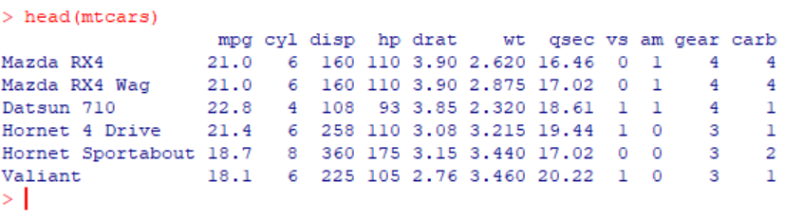

Pearson correlation test
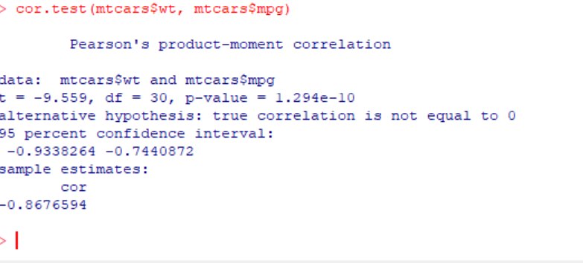

Welch two-sample t-test
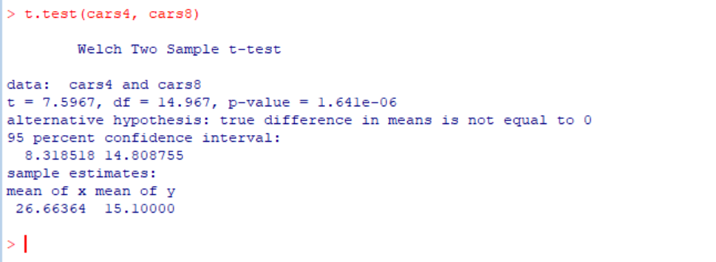

Multiple regression summary
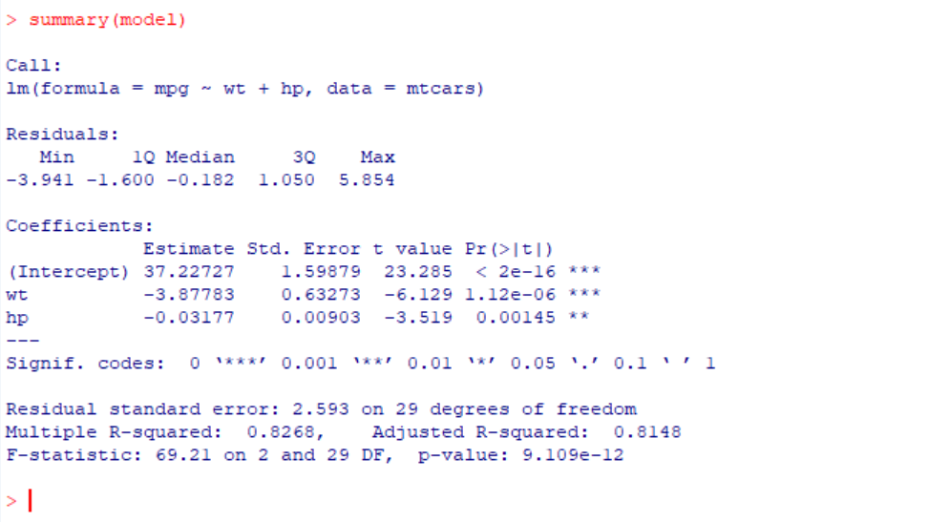

Five-fold cross-validation
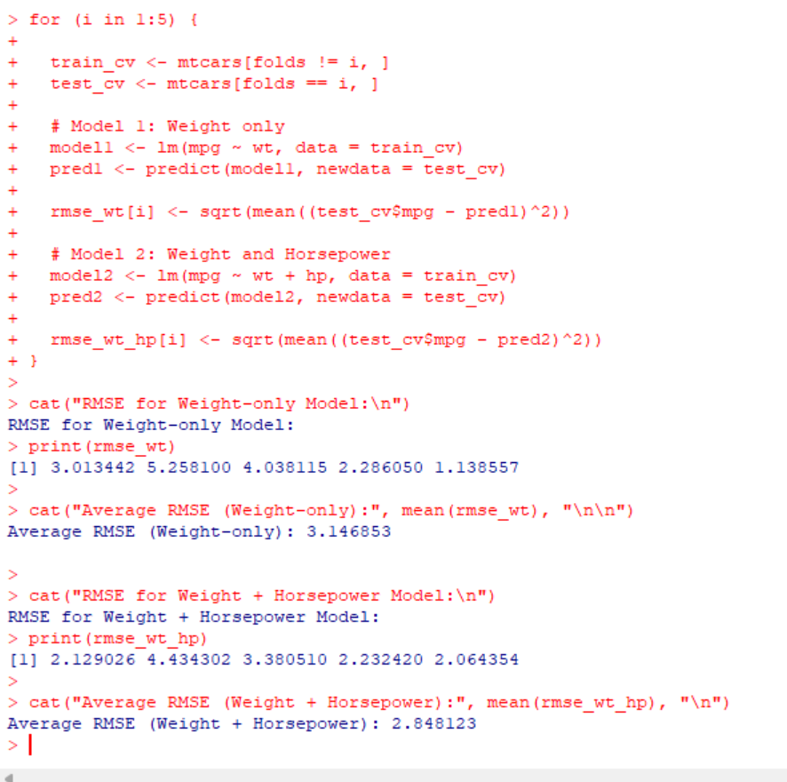

Model evaluation and diagnostic plots
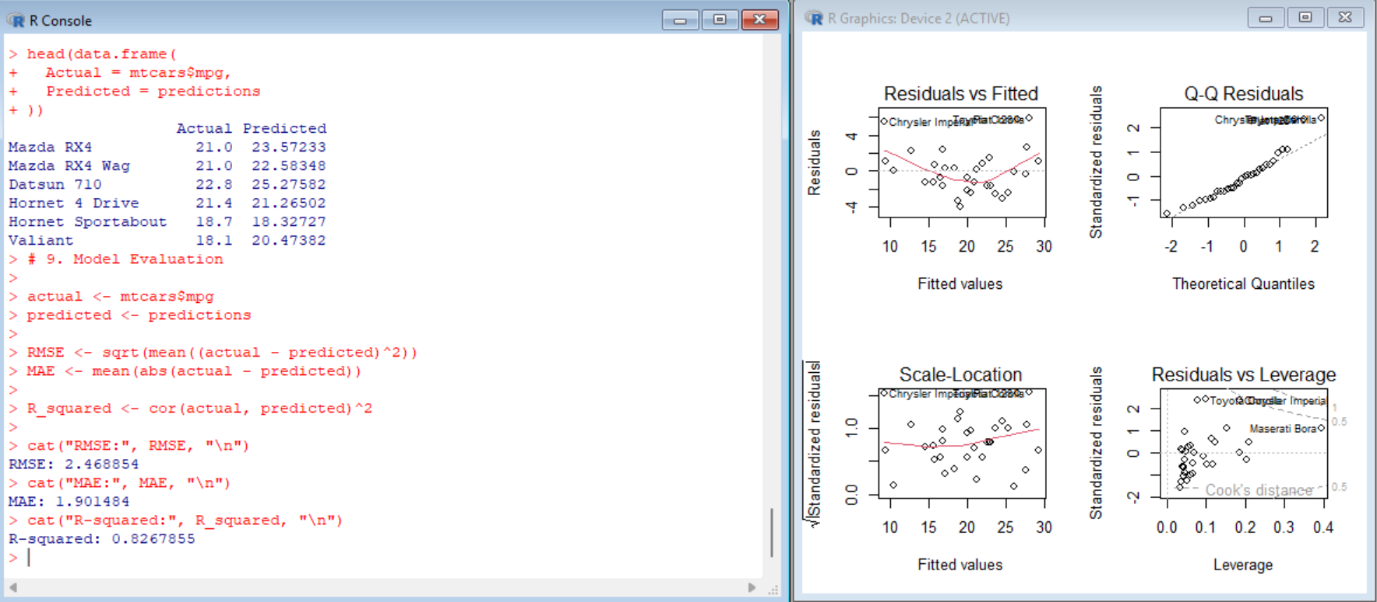

Shapiro-Wilk residual normality test
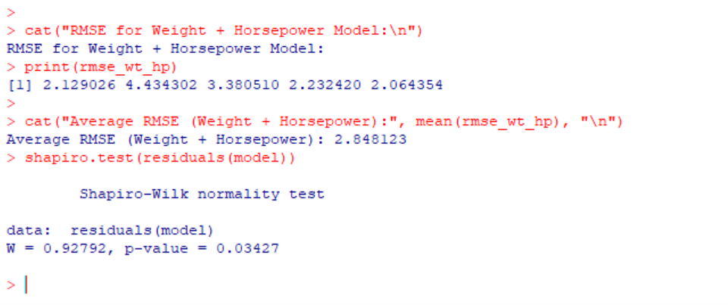

Appendix C. GitHub Submission Checklist
- Repository name: r-statistical-analysis-predictive-modeling
- Repository description: Statistical analysis and predictive modeling in R using the mtcars dataset. Includes Pearson correlation, Welch t-test, multiple linear regression, model evaluation, five-fold cross-validation, residual diagnostics, and Shapiro-Wilk normality testing.
- Upload analysis.R and README.md.
- Upload the final report and screenshots if permitted by the internship instructions.
- Copy the real repository URL after publishing; do not submit a placeholder URL.

