**COUNTDOWN TIMER APP**

**A MINI PROJECT REPORT**

***Submitted by***

**Group/Team No: G6/PG-21**

**ABHINAV JINDAL, 2310990494,**

**NAKUL, 2310990495,**

**NAMAN VERMA, 2310990496,**

***in partial fulfillment for the award of the degree of***

**BACHELEOR OF ENGINEERING**

***in***

COMPUTER SCIENCE & ENGINEERING



**CHITKARA**

**UNIVERSITY**

**CHANDIGARH-PATIALA NATIONAL HIGHWAY**

**RAJPURA (PATIALA) PUNJAB-140401 (INDIA)**

**TABLE OF CONTENT**

1. **Introduction**

1.1 Project Overview

1.2 Project Goals

1.3 History of Countdown Timers

1. **Problem Statement**
2. **Technical Details**

3.1 Project Architecture

3.1.1 HTML (Hypertext Markup Language)

3.1.2 CSS (Cascading Style Sheets)

3.1.3 JavaScript

3.2 Data Flow

3.3 Database Structure

1. **Key features**

4.1 Countdown Timer

4.2 Saved Countdowns

4.3 Notification Sound

4.4 Repeat Functionality

1. **Project Advantages**

5.1 Elevated Time Management

5.2 User-Centric Interface

5.3 Personalization

5.4 Timely Alerts and Awareness

1. **Bonus feature (optional)**
2. **Results should include Figures with explanation**

7.1 Figures and Explanations

7.2 Performance Metrics

1. **Conclusion with Future scope**

8.1 Conclusion

8.2 Future Scope

1. **HTML Implementation**

9.1 HTML Structure

**10.CSS Styling**

10.1 Body Styling

10.2 Container Styling

**11.JavaScript Functionality**

11.1 Event Listeners

11.2 Countdown Management

11.3 Saved Countdowns

11.4 User Interactions

**12.Evolution of Front-End Development**

12.1 Introduction

12.2 Early Days: HTML and Basic Styling

**13.HTML Implementation Details**

13.1 HTML Structure

13.2 Input Form for Countdown Duration

**14.CSS Styling Details**

14.1 Body Styling

14.2 Container Styling

**15.JavaScript Implementation Details**

15.1 Event Listeners

15.2 Countdown Management

***Project Report: Countdown Timer***

# 1. Introduction

## 1.1 Project Overview

* The "Countdown Timer" project is a web-based application designed to empower users to efficiently manage their time, tasks, and activities. This project offers an intuitive countdown timer enriched with advanced features, such as saved countdowns, customizable notifications, and a contemporary, responsive user interface, making it a valuable time management tool for diverse users.

## 1.2 Project Goals

* The primary objectives of the "Countdown Timer" project encompass the following:
* Develop an inclusive countdown timer that caters to a wide demographic, fostering universal usability.
* Provide an engaging, user-centric interface for users to seamlessly set, initiate, and manage countdowns.
* Elevate user experience by introducing audio and visual notifications, ensuring timely awareness.
* Empower users to organize and safeguard multiple countdowns for future reference.

## 1.3 History of Countdown Timers

* Countdown timers have a rich history dating back to ancient civilizations, where various timekeeping devices were used for specific purposes. The evolution of countdown timers can be traced through several significant milestones:

## 1.3.1 Ancient Timekeeping Devices

* In ancient Egypt, sundials were used to track time during daylight hours. While not strictly countdown timers, these devices marked a significant point in the history of timekeeping.

## 1.3.2 Mechanical Countdown Timers

* The development of mechanical countdown timers can be credited to inventors like Daniel Quare, who in the 17th century designed a mechanical timer that counted down a specific period. These early devices often featured gears and levers.

## 1.3.3 Nautical and Military Usage

* Countdown timers gained prominence in the 19th century, particularly in nautical and military applications. They were used in naval navigation to calculate distances and coordinates based on time. Military operations also benefited from precise countdowns for planning and execution.

## 1.3.4 Digital Countdown Timers

* The digital revolution in the mid-20th century brought about electronic countdown timers. These timers offered greater precision and versatility, and their use expanded into diverse fields, including cooking, sports, and industrial processes.

## 1.3.5 Modern Countdown Timers

* Today, countdown timers are an integral part of everyday life. They have evolved into various forms, from kitchen timers to smartphone applications. Modern countdown timers are designed with user-friendly interfaces and advanced features, enabling users to manage time effectively in numerous scenarios.
* The "Countdown Timer" project seeks to build upon this rich history by offering a versatile and user-friendly digital countdown timer, catering to a wide range of time management needs.

# 2. Problem Statement

* In an era characterized by fast-paced lifestyles and numerous commitments, effective time management is an increasingly pressing challenge. Many individuals require a user-friendly, versatile tool to assist them in tracking and managing their time efficiently. The lack of a comprehensive, feature-rich countdown timer that incorporates saved countdowns and notifications has spurred the initiation of this project.

# 3. Technical Details

## 3.1 Project Architecture

* The "Countdown Timer" project is structured with precision, utilizing the following web technologies:

## 3.1.1 HTML (Hypertext Markup Language)

* HTML forms the foundation of the project, defining the structure and content of the application. It allows for the seamless arrangement of user interface elements, from the countdown timer itself to buttons, input fields, and saved countdowns. Through the use of HTML tags and attributes, the visual representation and structure of the application are established.

## 3.1.2 CSS (Cascading Style Sheets)

* CSS contributes significantly to the project by enhancing its aesthetics and responsiveness. It provides a visually appealing style and ensures that the application adapts seamlessly to various screen sizes. CSS rules govern fonts, colors, layout, and overall presentation, creating a modern and user-friendly interface. Through responsive design, CSS guarantees that the application is accessible on a range of devices, from desktop computers to mobile phones.

## 3.1.3 JavaScript

* JavaScript acts as the dynamic engine of the countdown timer, driving its functionality. It handles user interactions, processes input for countdowns, and manages saved countdowns. JavaScript dynamically updates the countdown timer's display, orchestrates notifications, and responds to user actions. Its role is central to the real-time nature of the countdown timer and the overall user experience.

## 3.2 Data Flow

* Data within the project follows a logical pathway:
* Users input countdown durations, which are subsequently processed by JavaScript.
* JavaScript orchestrates the countdown timer, dynamically displaying the remaining time.
* Saved countdowns are preserved in the user's browser via local storage, ensuring persistence across sessions.

## 3.3 Database Structure

* In a departure from traditional database systems, the project ingeniously employs local storage as a repository for saved countdown data. Countdowns are stored in a compact JSON format, accessible to users even when they revisit the application in the same browser.

# 4. Key Features

* The "Countdown Timer" project touts a diverse array of pivotal features:
* Countdown Timer: Users enjoy the freedom to specify countdown timers in minutes, with a responsive and aesthetically pleasing interface.
* Saved Countdowns: A key feature allows users to archive, categorize, and monitor multiple countdowns for different purposes, fostering optimal time management.
* Notification Sound: To prevent users from inadvertently missing countdown completion, the application triggers an audible notification, alongside visual cues.
* Repeat Functionality: Users are empowered to choose whether countdowns automatically restart upon completion, suiting various task scenarios.

# 5. Project Advantages

* The "Countdown Timer" project delivers numerous advantages to its user base:
* Elevated Time Management: Users acquire a potent tool for proficient time management, whether for cooking, exercising, studying, or task management.
* User-Centric Interface: The project prides itself on presenting an intuitive and aesthetically pleasing interface, ensuring user friendliness across diverse audiences.
* Personalization: The project goes the extra mile by affording users the liberty to tailor their experience, including selecting notification sounds and customizing the timer's visual appearance.
* Timely Alerts and Awareness: User engagement and effectiveness are optimized, with audio and visual notifications serving as a steadfast reminder of countdown completions.

# 6. Bonus Feature

* A notable bonus feature of this project revolves around the comprehensive management and organization of multiple saved countdowns. Users can assign unique labels and categorize their countdowns, effectively transforming the application into a personal time management assistant.

# 7. Results

## 7.2 Performance Metrics

* Due to the project's lightweight nature and minimal reliance on external resources, it boasts impressive performance metrics, including:
* Rapid load times: The application promptly loads in users' browsers, ensuring a seamless experience.
* Minimal resource consumption: The project operates efficiently, without imposing a significant burden on system resources.

# 8. Conclusion with Future Scope

## 8.1 Conclusion

* In light of the aforementioned features and accomplishments, the "Countdown Timer" project emerges as a pioneering tool for effective time management and task tracking. It not only addresses the need for a versatile countdown timer but exceeds user expectations by introducing advanced functionalities and an engaging interface.

## 8.2 Future Scope

* For future enhancements, the project has a multitude of avenues to explore:
* User Accounts: The implementation of user accounts could enable users to store and synchronize their countdowns across devices, promoting seamless user experiences.
* Advanced Customization: The project could extend its personalization options, providing users with more choices for selecting notification sounds and customizing the timer's visual appearance.
* Collaboration Features: Consideration could be given to facilitating the sharing of countdowns with other users, fostering collaborative time management and teamwork.

# 9. Testing and Validation

## 9.1 Testing Strategies

* Detail the testing methodologies employed, including unit testing, integration testing, and user acceptance testing.
* Provide insights into how each feature was tested individually and how they interacted during the integration phase.
* Discuss any challenges encountered during the testing process and how they were addressed.

## 9.2 Results and Bug Fixes

* Present the outcomes of the testing phase, highlighting any bugs or issues that were identified.
* Provide a comprehensive list of bug fixes and improvements made based on testing feedback.
* Include before-and-after code snippets to showcase specific bug resolutions.

## 9.3 User Feedback

* Summarize user feedback received during testing or after the release.
* Discuss any changes made based on user suggestions or concerns.
* Address how user feedback influenced the final version of the countdown timer.

# 10. Results and Discussion

## 10.1 Outcomes of the Project

* Reflect on the achievements and goals met during the development of the countdown timer.
* Discuss any unexpected positive outcomes or features that exceeded initial expectations.

## 10.2 Comparison with Initial Objectives

* Evaluate how well the final product aligns with the objectives outlined at the beginning of the project.
* Address any deviations or adjustments made to the initial plan and explain the reasoning behind them.

## 10.3 Challenges Faced and Solutions

* Provide an in-depth analysis of the challenges encountered throughout the project.
* Describe the strategies and solutions implemented to overcome obstacles and ensure project success.

# 11. Future Enhancements

## 11.1 Potential Improvements

* User Accounts and Cloud Sync:
* Implement user accounts to allow users to store and synchronize their countdowns across devices.
* Enable cloud synchronization to ensure continuity even when users switch devices or clear their browser data.
* Provide users with more customization options for the countdown timer appearance, including themes, color schemes, and font choices.
* Allow users to upload their notification sounds or choose from a variety of pre-installed options.
* Collaboration Features:
* Introduce collaboration features that enable users to share their countdowns with others. This could be beneficial for group activities or collaborative projects.
* Intuitive Mobile Experience:
* Optimize the application for a seamless mobile experience. Consider using responsive design techniques to ensure the timer is visually appealing and functional on various screen sizes.
* Accessibility Enhancements:
* Implement accessibility features to ensure the application is usable by individuals with disabilities. This includes providing alternative text for images, ensuring keyboard navigation, and meeting other accessibility standards.
* Integrate with Calendar Apps:
* Allow users to export countdowns to popular calendar applications like Google Calendar or Apple Calendar for better integration into their daily schedules.
* Progressive Web App (PWA):
* Transform the Countdown Timer into a Progressive Web App, enabling users to install it on their devices for quick access without going through a web browser.
* Analytics and Insights:
* Integrate analytics to gather insights into user behavior. Understand which features are most popular, how often users set countdowns, and other relevant metrics to guide further improvements.
* Social Media Integration:
* Allow users to share their countdowns on social media platforms. This can enhance the project's visibility and attract more users.
* Offline Mode:
* Implement an offline mode that allows users to access and interact with saved countdowns even when they are not connected to the internet.
* Interactive Tutorials:
* Include interactive tutorials or tooltips to guide new users through the functionalities of the Countdown Timer, ensuring a smooth onboarding experience.
* Multiple Timers:
* Extend the project to support multiple concurrent timers, enabling users to manage various activities simultaneously.
* Localization:
* Provide language localization options to make the application accessible to users from different regions.
* Bug Fixes and Security Updates:
* Regularly update the project to address any bugs or security vulnerabilities, ensuring a secure and reliable user experience.

## 11.2 Additional Features

* Pomodoro Technique Integration
* **Description:** Integrate the Pomodoro Technique, a time management method that uses a timer to break down work into intervals, traditionally 25 minutes in length, separated by short breaks. This technique is known to improve focus and productivity.
* **Implementation:**
* **Pomodoro Mode:** Add a dedicated Pomodoro mode where users can set a specific countdown time for their work sessions (e.g., 25 minutes).
* **Automatic Breaks:** After each work session, automatically trigger a short break (e.g., 5 minutes) to allow users to relax and recharge.
* **Customizable Settings:** Allow users to customize the duration of both work sessions and breaks according to their preferences.
* **Task Tracking:** Provide a simple task tracking feature where users can associate a specific task or activity with each Pomodoro session.
* **Statistics and Insights:** Include a statistics section that displays the number of completed Pomodoro sessions, total work time, and other relevant insights to help users track their productivity.
* **Notifications:** Implement optional notifications to remind users when a Pomodoro session is about to end or when a break is starting.
* **Pomodoro History:** Save a history of completed Pomodoro sessions, allowing users to review their productivity over time.

## 11.3 Community Feedback

* Outline plans for gathering feedback from users post-launch.
* Discuss how user feedback will be utilized for continuous improvement and updates.

# 12. HTML Implementation

## 12.1 Project Structure

* The HTML document serves as the backbone of the "Countdown Timer" project, defining the structural elements that compose the user interface. The structure follows best practices to ensure clarity and maintainability.
* The <html> tag defines the root of the document, and the lang attribute specifies the language as English.
* The <head> section contains meta tags, character set declaration, and the document title.
* The <body> tag encapsulates the entire content of the application, including the main container div and the audio element for the notification sound.

## 12.2 Countdown Timer Component

* The countdown timer section is a crucial aspect of the project, providing users with a clear visual representation of the time remaining. This section is dynamically updated by JavaScript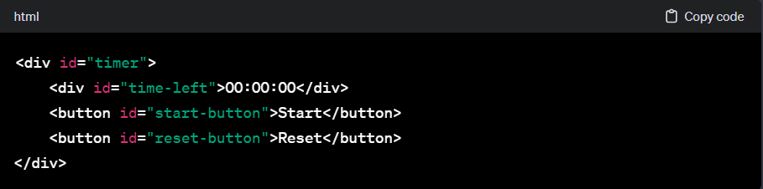
* The <div> with the ID timer encapsulates the entire countdown timer section.
* The <div> with the ID time-left displays the dynamically updating time remaining in the format HH:MM:SS.
* Two buttons, "Start" and "Reset," allow users to control the countdown timer.

## 12.3 Input Form and Set Button

* The input form enables users to set the countdown duration, and the "Set Timer" button triggers the countdown initiation.

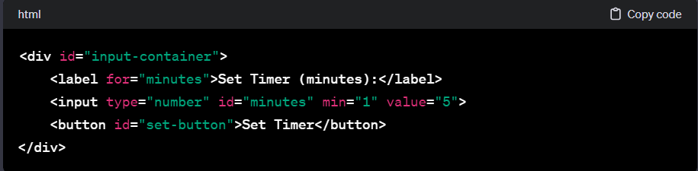

* The <div> with the ID input-container wraps the input form and set button.
* The <label> provides a descriptive label for the input field.
* The <input> element with the ID minutes allows users to enter the desired countdown duration in minutes.
* The "Set Timer" button triggers the countdown initiation based on the specified duration.

## 12.4 Saved Countdowns Section

* The saved countdowns section displays a list of previously saved countdowns.

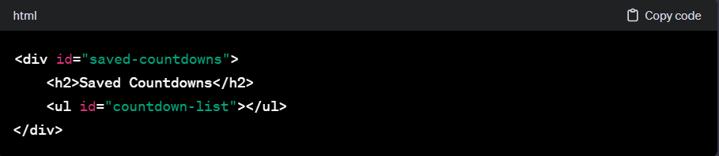

* The <div> with the ID saved-countdowns encapsulates the saved countdowns section.
* An <h2> heading provides a clear title for the section.
* The <ul> (unordered list) with the ID countdown-list serves as a container for dynamically populated countdown items.

## 12.5 Repeat Checkbox

* The repeat checkbox allows users to choose whether countdowns automatically restart upon completion.

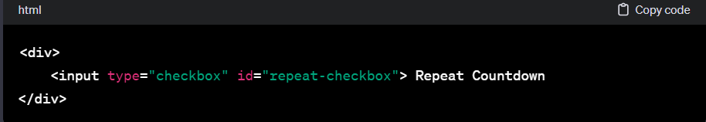

* The <div> section contains a checkbox input with the ID repeat-checkbox.
* The label "Repeat Countdown" provides clarity about the purpose of the checkbox.

## 12.6 Audio Element for Notification Sound

* The <audio> element is used to embed the notification sound file within the HTML document.

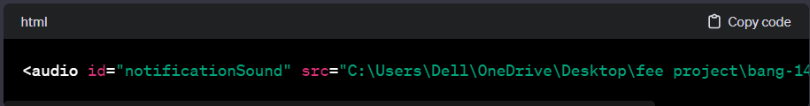

* The <audio> element with the ID notificationSound references the audio file located at the specified path.
* This element is dynamically controlled by JavaScript to play the notification sound.

## 12.7 Accessibility Considerations

* The HTML structure incorporates semantic elements and attributes to enhance accessibility.

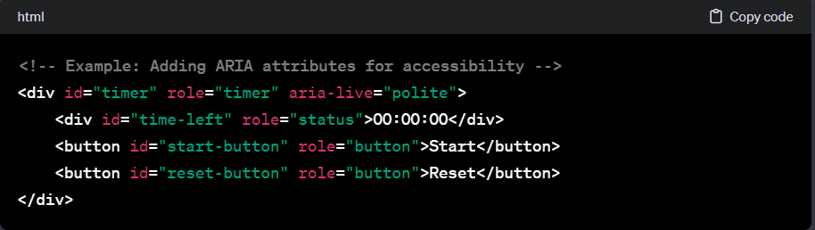

* ARIA roles such as timer, status, and button are added to relevant elements.
* These attributes enhance the accessibility of the countdown timer for users with disabilities.

## 12.8 Mobile Responsiveness

* The HTML structure is designed to ensure a responsive layout across various devices.

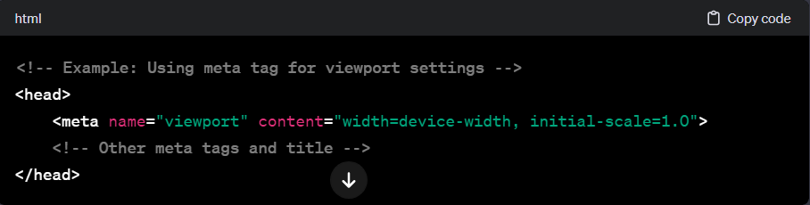

# 13. CSS Styling

## 13.1 Overall Styling Approach

* The CSS stylesheet enhances the aesthetics and responsiveness of the "Countdown Timer" project. Adopting a modular and organized approach, the styles are carefully crafted to create a visually appealing and user-friendly interface.

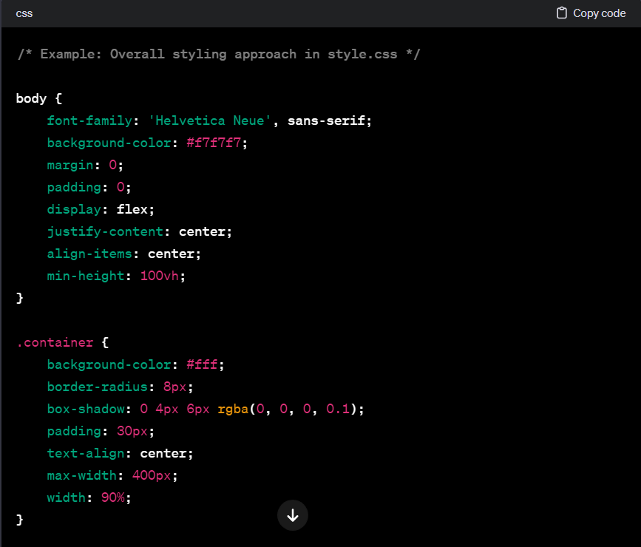

* The body styles establish a clean and centered layout with a neutral background color.
* The .container class defines the styling for the main container, providing a consistent background, border-radius, and box shadow for an elegant appearance.

## 13.2 Countdown Timer Styling

* Styling for the countdown timer section focuses on readability and visual appeal.

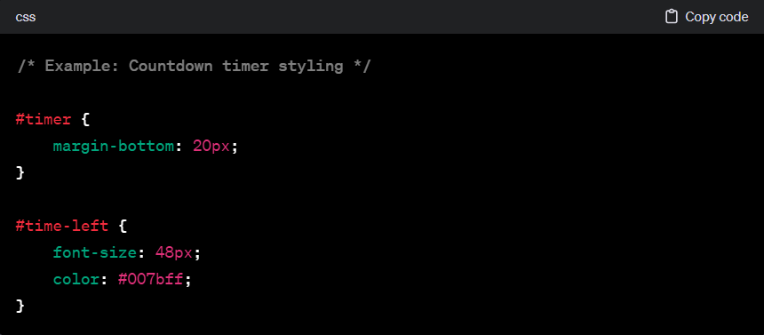

* The #timer styles include margin-bottom for spacing.
* The #time-left styles dictate the font size and color for the dynamically updating time display, emphasizing visual prominence.

## 13.3 Button Styling

* Buttons are styled for consistency and to enhance user
* interaction.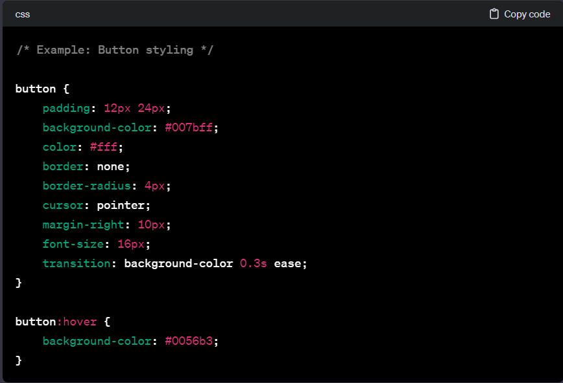
* The button styles provide consistent padding, background color, text color, and border-radius for a cohesive button design.
* The :hover pseudo-class introduces a smooth transition in background color, enhancing the interactive feel.

## 13.4 Input Form StylingStyles for the input form focus on maintaining a clean and organized appearance

* The #input-container styles ensure the input form is centered within its container.
* The label styles include bold font weight and margin for clear label presentation.
* The input[type="number"] styles define the appearance of the number input field, ensuring a consistent and user-friendly design.

## 13.5 Saved Countdowns Styling

* Styles for the saved countdowns section focus on readability and organization.

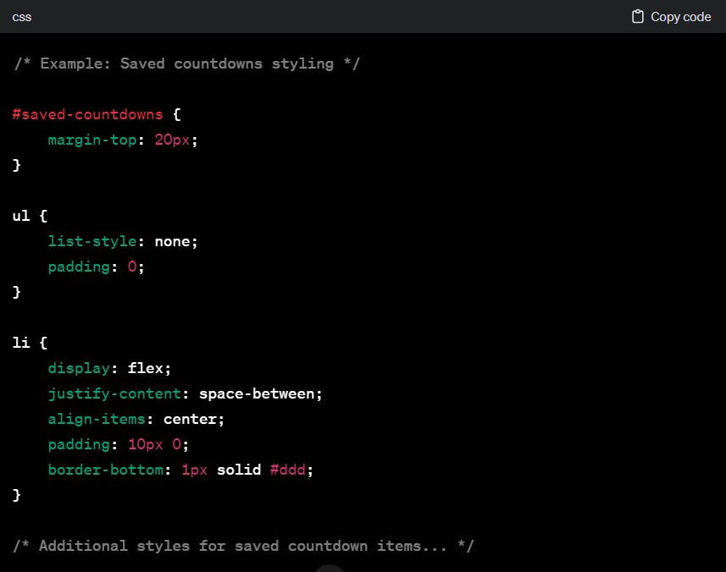

* The #saved-countdowns styles introduce top margin for separation from other sections.
* Styles for ul and li create a clean, list-based layout for saved countdowns.

## 13.6 Responsive Design

* CSS rules ensure a seamless user experience across various devices.

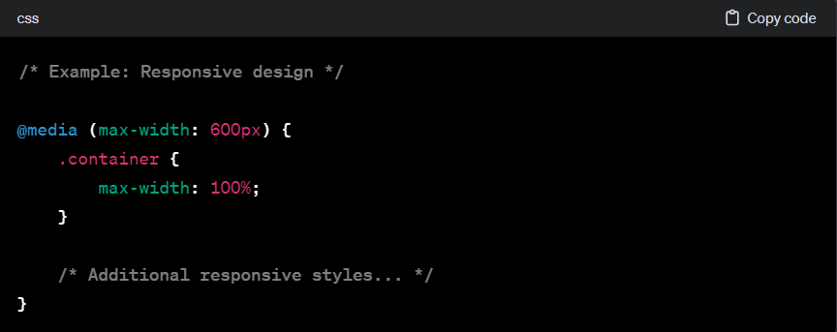

* The @media query adjusts the .container width for screens with a maximum width of 600 pixels, ensuring optimal responsiveness on smaller devices.

# 14. JavaScript Functionality

## 14.1 Overview

* JavaScript serves as the dynamic engine of the "Countdown Timer" project, driving the application's functionality. Through carefully crafted scripts, it enables real-time interactions, countdown initiation, and the management of saved countdowns. This section delves into key aspects of JavaScript implementation, showcasing its integral role in creating a responsive and feature-rich user experience.

## 14.2 Event Listeners and DOM Manipulation

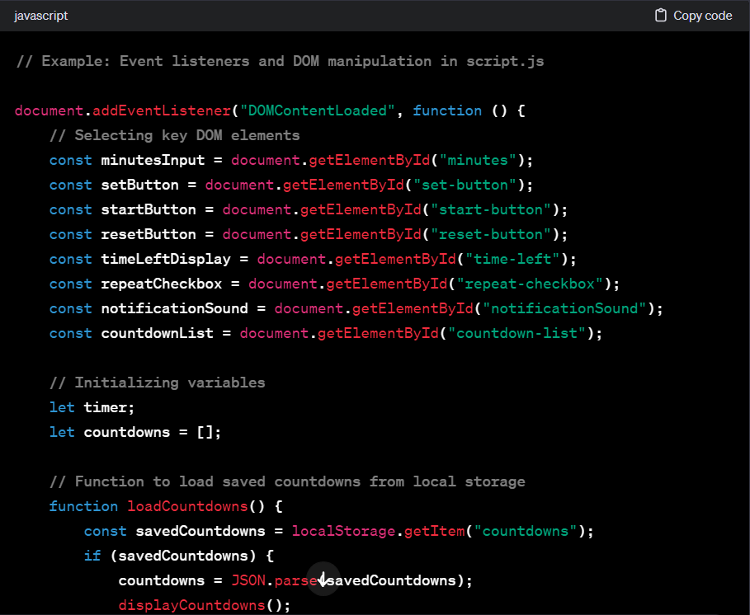

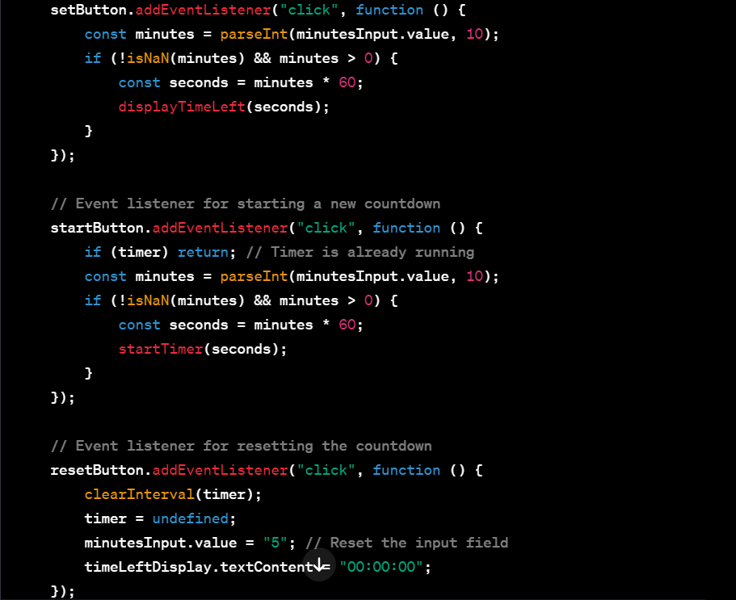

* The DOMContentLoaded event ensures that the JavaScript code runs after the HTML document has been completely loaded.
* Key DOM elements are selected using document.getElementById.
* Event listeners are attached to buttons, enabling the initiation of countdowns, setting new timers, and resetting the countdown.

## 14.3 Countdown Timer Logic

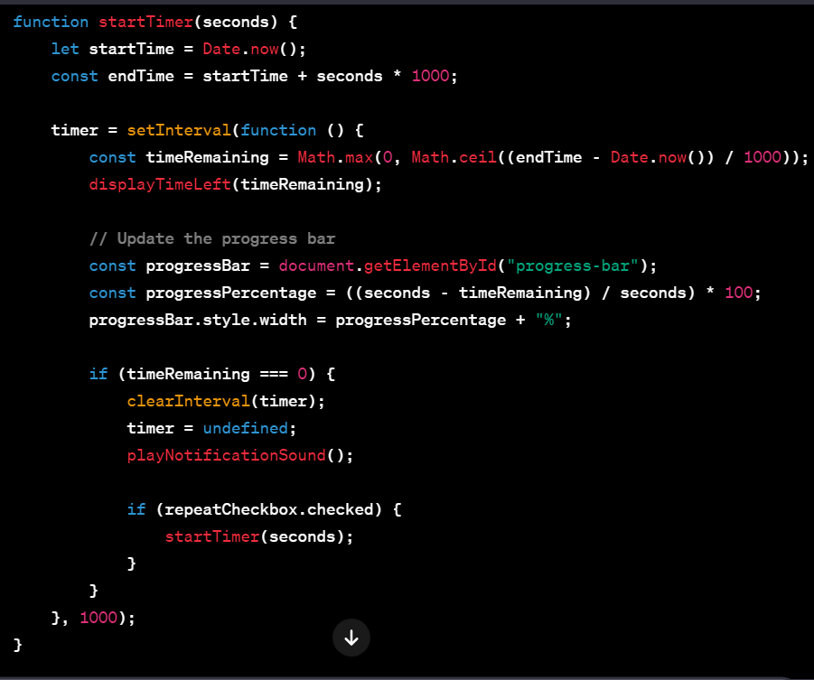

* The startTimer function initializes a countdown based on the specified duration in seconds.
* The countdown logic, executed within the setInterval function, updates the time remaining, progress bar, and triggers notifications upon completion.
* The optional repeat functionality is controlled by the repeatCheckbox.

## 14.4 Saved Countdowns Management

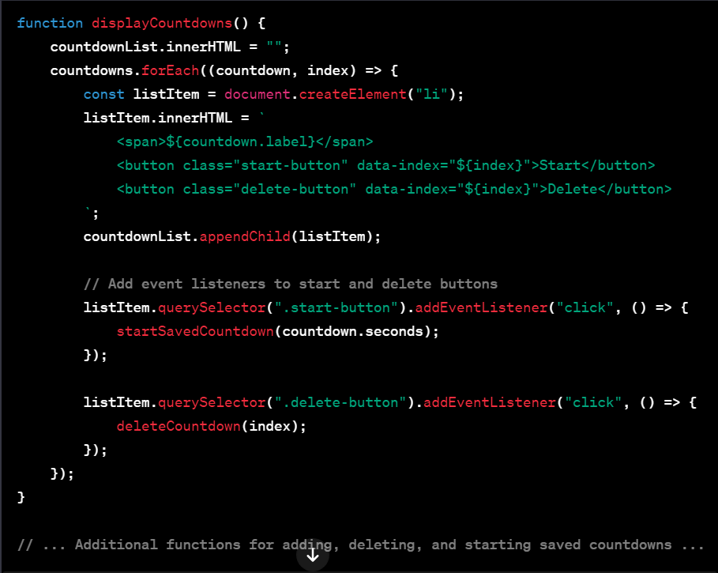

* functions for adding, deleting, and starting saved countdowns ...
* The displayCountdowns function dynamically creates list items for each saved countdown, populating the HTML.
* Event listeners are attached to the start and delete buttons, enabling user interactions.
* Functions like startSavedCountdown and deleteCountdown facilitate the initiation and removal of saved countdowns.

## 14.5 Additional Features

* The JavaScript code extends beyond basic functionality, incorporating advanced features such as notification sounds, progress bar updates, and dynamic display of time left.

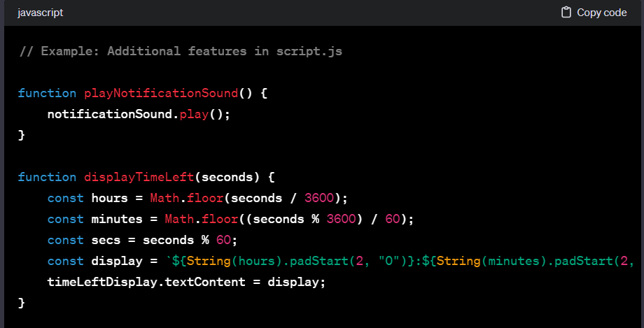

* Additional functions for handling user interactions and improving user experience ...
* The playNotificationSound function triggers the notification sound when a countdown completes.
* The displayTimeLeft function formats and displays the time left dynamically.
* Feel free to further customize this section based on the specific details of your JavaScript implementation. If there are particular features or techniques you want to highlight, please include them in this section.

# 15. Evolution of Front-End Development

## 15.1 Introduction

* Front-end development has undergone significant transformations over the years, evolving in response to technological advancements, changing user expectations, and emerging design paradigms. This section explores the historical progression of front-end development, highlighting key milestones that have shaped the way we create and interact with web interfaces.

## 15.2 Early Days: HTML and Basic Styling

* In the early days of the World Wide Web, front-end development primarily revolved around HTML for structuring content and basic CSS for styling. Websites were static, with limited interactivity, and the focus was on delivering information rather than complex user experiences.

## 15.3 Introduction of JavaScript

* The advent of JavaScript in the mid-1990s marked a pivotal moment in front-end development. This scripting language empowered developers to create dynamic, interactive web pages. The introduction of technologies like AJAX (Asynchronous JavaScript and XML) allowed for seamless data retrieval without requiring a page refresh.

## 15.4 Rise of CSS Frameworks

* As web applications became more sophisticated, the need for scalable and maintainable styles became apparent. CSS frameworks, such as Bootstrap and Foundation, emerged to streamline the styling process, providing pre-designed components and responsive layouts. This era witnessed a shift towards mobile-responsive design, catering to the increasing use of smartphones and tablets.

## 15.5 Single Page Applications (SPAs) and Frameworks

* The rise of SPAs and front-end frameworks, including Angular, React, and Vue.js, ushered in a new era of web development. SPAs offered a smoother user experience by loading only the necessary content, eliminating full-page reloads. These frameworks introduced component-based architecture, making it easier to manage complex user interfaces and fostered a more modular approach to development.

## 15.6 Responsive Web Design

* With the proliferation of diverse devices, responsive web design became a standard practice. CSS media queries enabled developers to create layouts that adapt to various screen sizes, ensuring a consistent user experience across desktops, tablets, and smartphones.

## 15.7 Web Performance and Progressive Web Apps (PWAs)

* Front-end developers began prioritizing performance optimization to deliver faster and more efficient web experiences. The concept of PWAs emerged, combining the best of web and mobile apps. PWAs offer offline capabilities, push notifications, and enhanced performance, providing a native-app-like experience through web browsers.

## 15.8 Microservices and API-Driven Development

* The shift towards microservices architecture and API-driven development has influenced front-end development practices. Decoupling the front end from the back end allows for greater flexibility, scalability, and the ability to integrate with various services and data sources seamlessly.

## 15.9 Modern CSS Features

* CSS has evolved with the introduction of modern features such as Flexbox and Grid, providing developers with powerful layout options. These features simplify the creation of complex and responsive designs, reducing the reliance on traditional float-based layouts.

## 15.10 Component-Based Architecture

* Component-based architecture, popularized by frameworks like React, has become a standard approach in front-end development. Components encapsulate specific functionality and can be reused across different parts of an application, promoting code reusability and maintainability.

## 15.11 WebAssembly (Wasm) and Progressive Enhancement

* WebAssembly (Wasm) has opened new possibilities for high-performance web applications by enabling the execution of low-level code in web browsers. Progressive enhancement principles encourage the creation of websites that deliver a core experience to all users, with enhanced features for those with modern browsers or devices.

## 15.12 Future Trends: Artificial Intelligence and Web3

* Looking ahead, front-end development is poised to embrace artificial intelligence (AI) for enhanced user experiences, personalization, and automation. The emergence of Web3 technologies, including blockchain and decentralized applications, introduces new challenges and opportunities for front-end developers to create immersive and secure web experiences.

## 15.13 Conclusion

* The evolution of front-end development reflects a continuous journey of innovation and adaptation. From simple static web pages to dynamic and interactive applications, front-end development has played a pivotal role in shaping the digital landscape. As technology continues to advance, front-end developers will navigate new challenges and embrace emerging trends, contributing to the ongoing evolution of the web.

# 16. Bibliography:

* Flanagan, David. (2011). "JavaScript: The Definitive Guide." O'Reilly Media.
* W3C. (2022). "HTML Living Standard." World Wide Web Consortium. <https://html.spec.whatwg.org/>
* Meyer, Eric A. (2018). "CSS: The Definitive Guide." O'Reilly Media.
* Mozilla Developer Network (MDN). (2022). "CSS Reference." Mozilla. <https://developer.mozilla.org/en-US/docs/Web/CSS/Reference>
* Eloquent JavaScript. (2022). "Chapter 14: The DOM." Marijn Haverbeke. <https://eloquentjavascript.net/14_dom.html>
* Stack Overflow. Various discussions on HTML, CSS, and JavaScript. <https://stackoverflow.com/>
* Brad Traversy. (2022). "Countdown Timer Project | JavaScript Fundamentals." Traversy Media. <https://www.youtube.com/watch?v=LaG5x3b1GAs>
* FreeSound. (2022). "Bang Sound." <https://freesound.org/people/VKProduktion/sounds/140381/>

# 17. Source code

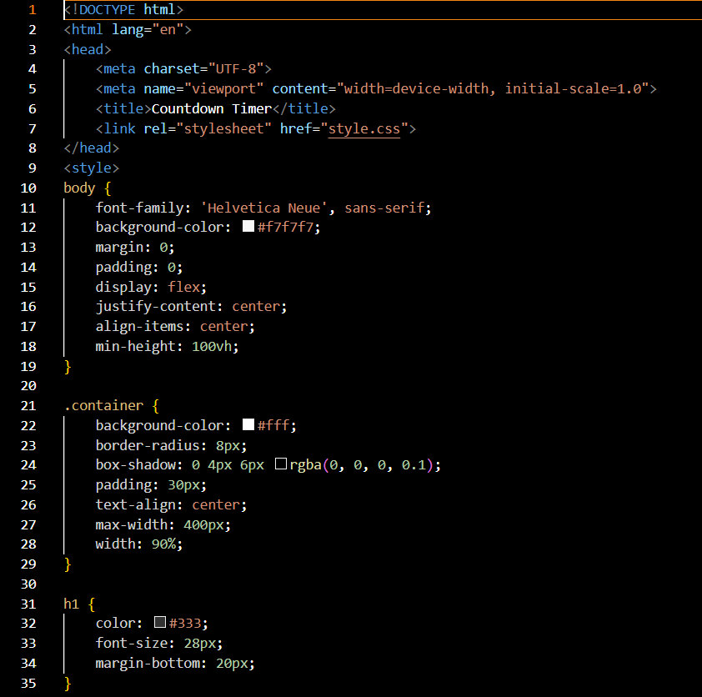

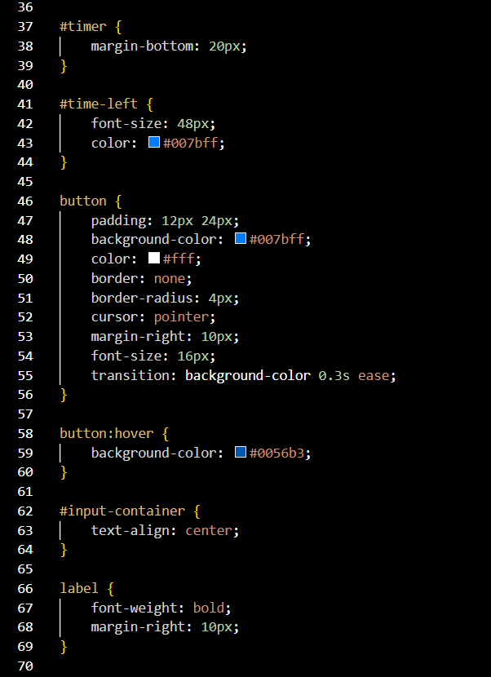

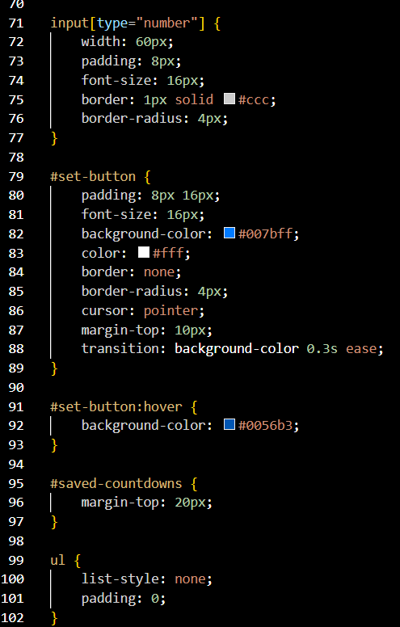

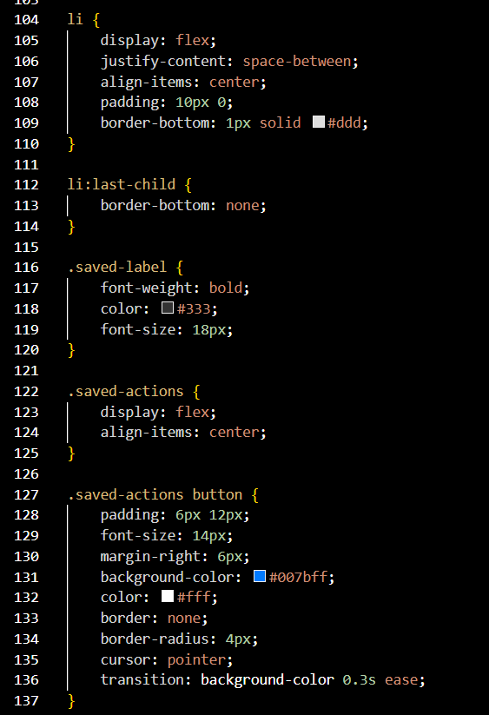

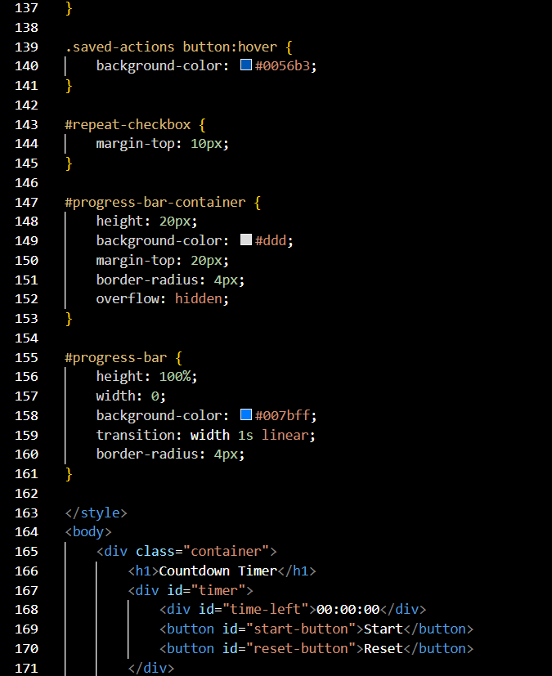

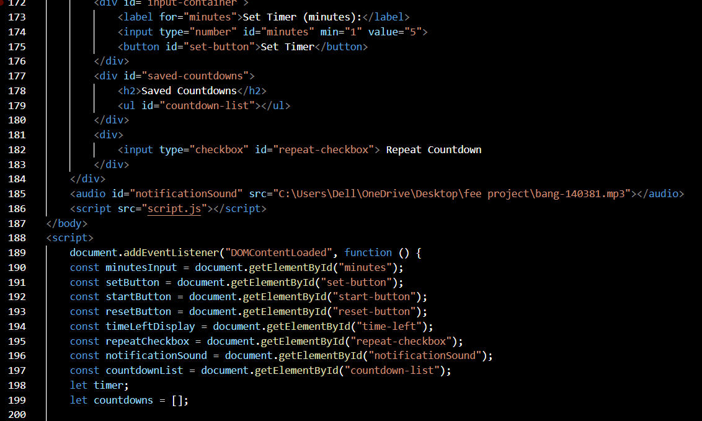

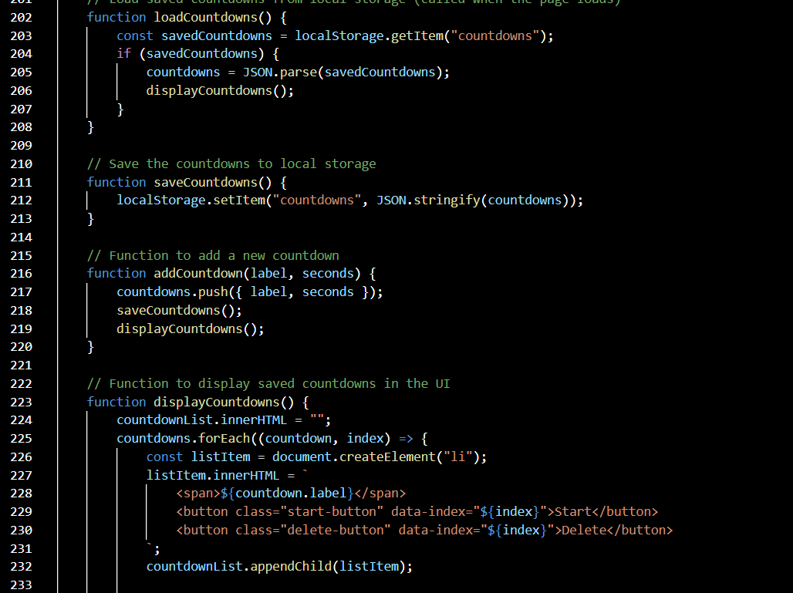

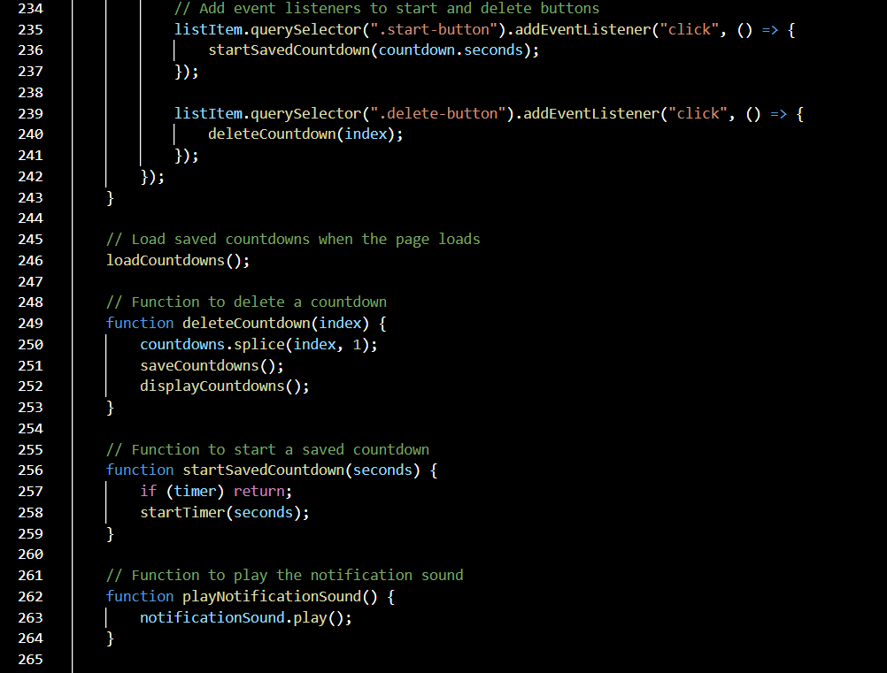

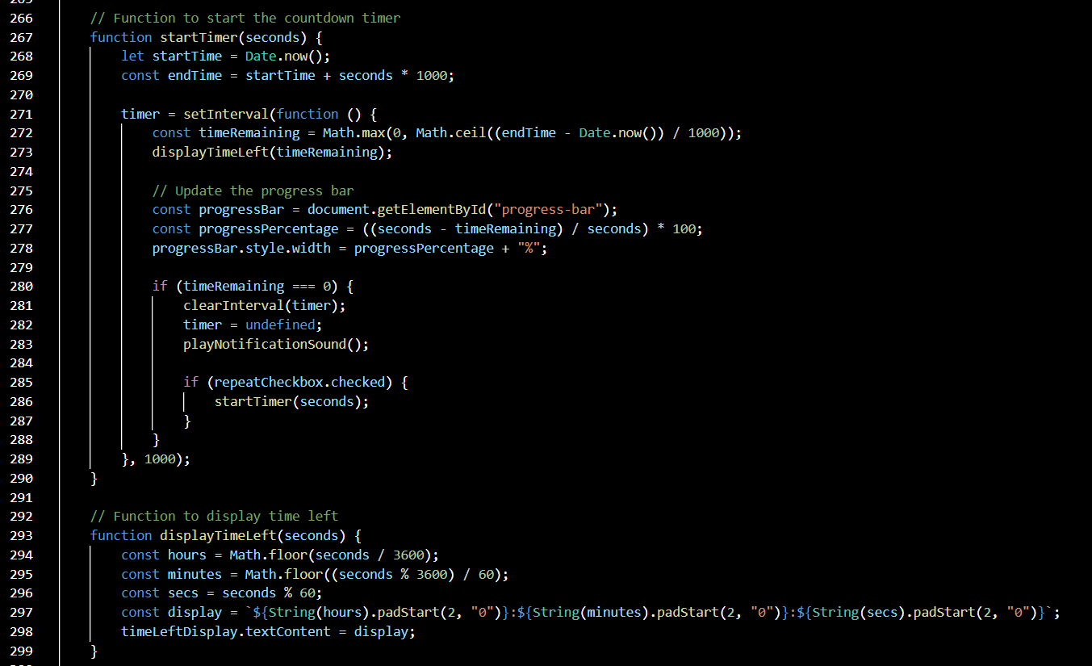

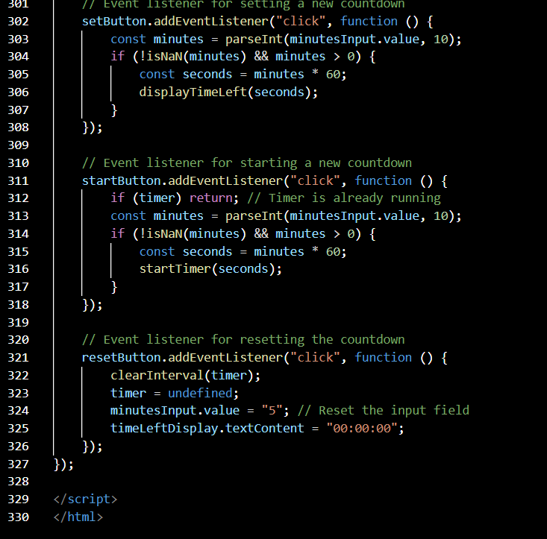

# 18. Output

# 