Image Classification for Fashion-MNIST
Aim

To investigate the performance of different models (with a focus on neural networks) to classify the images in the Fashion-MNIST dataset.

Visualising the Data
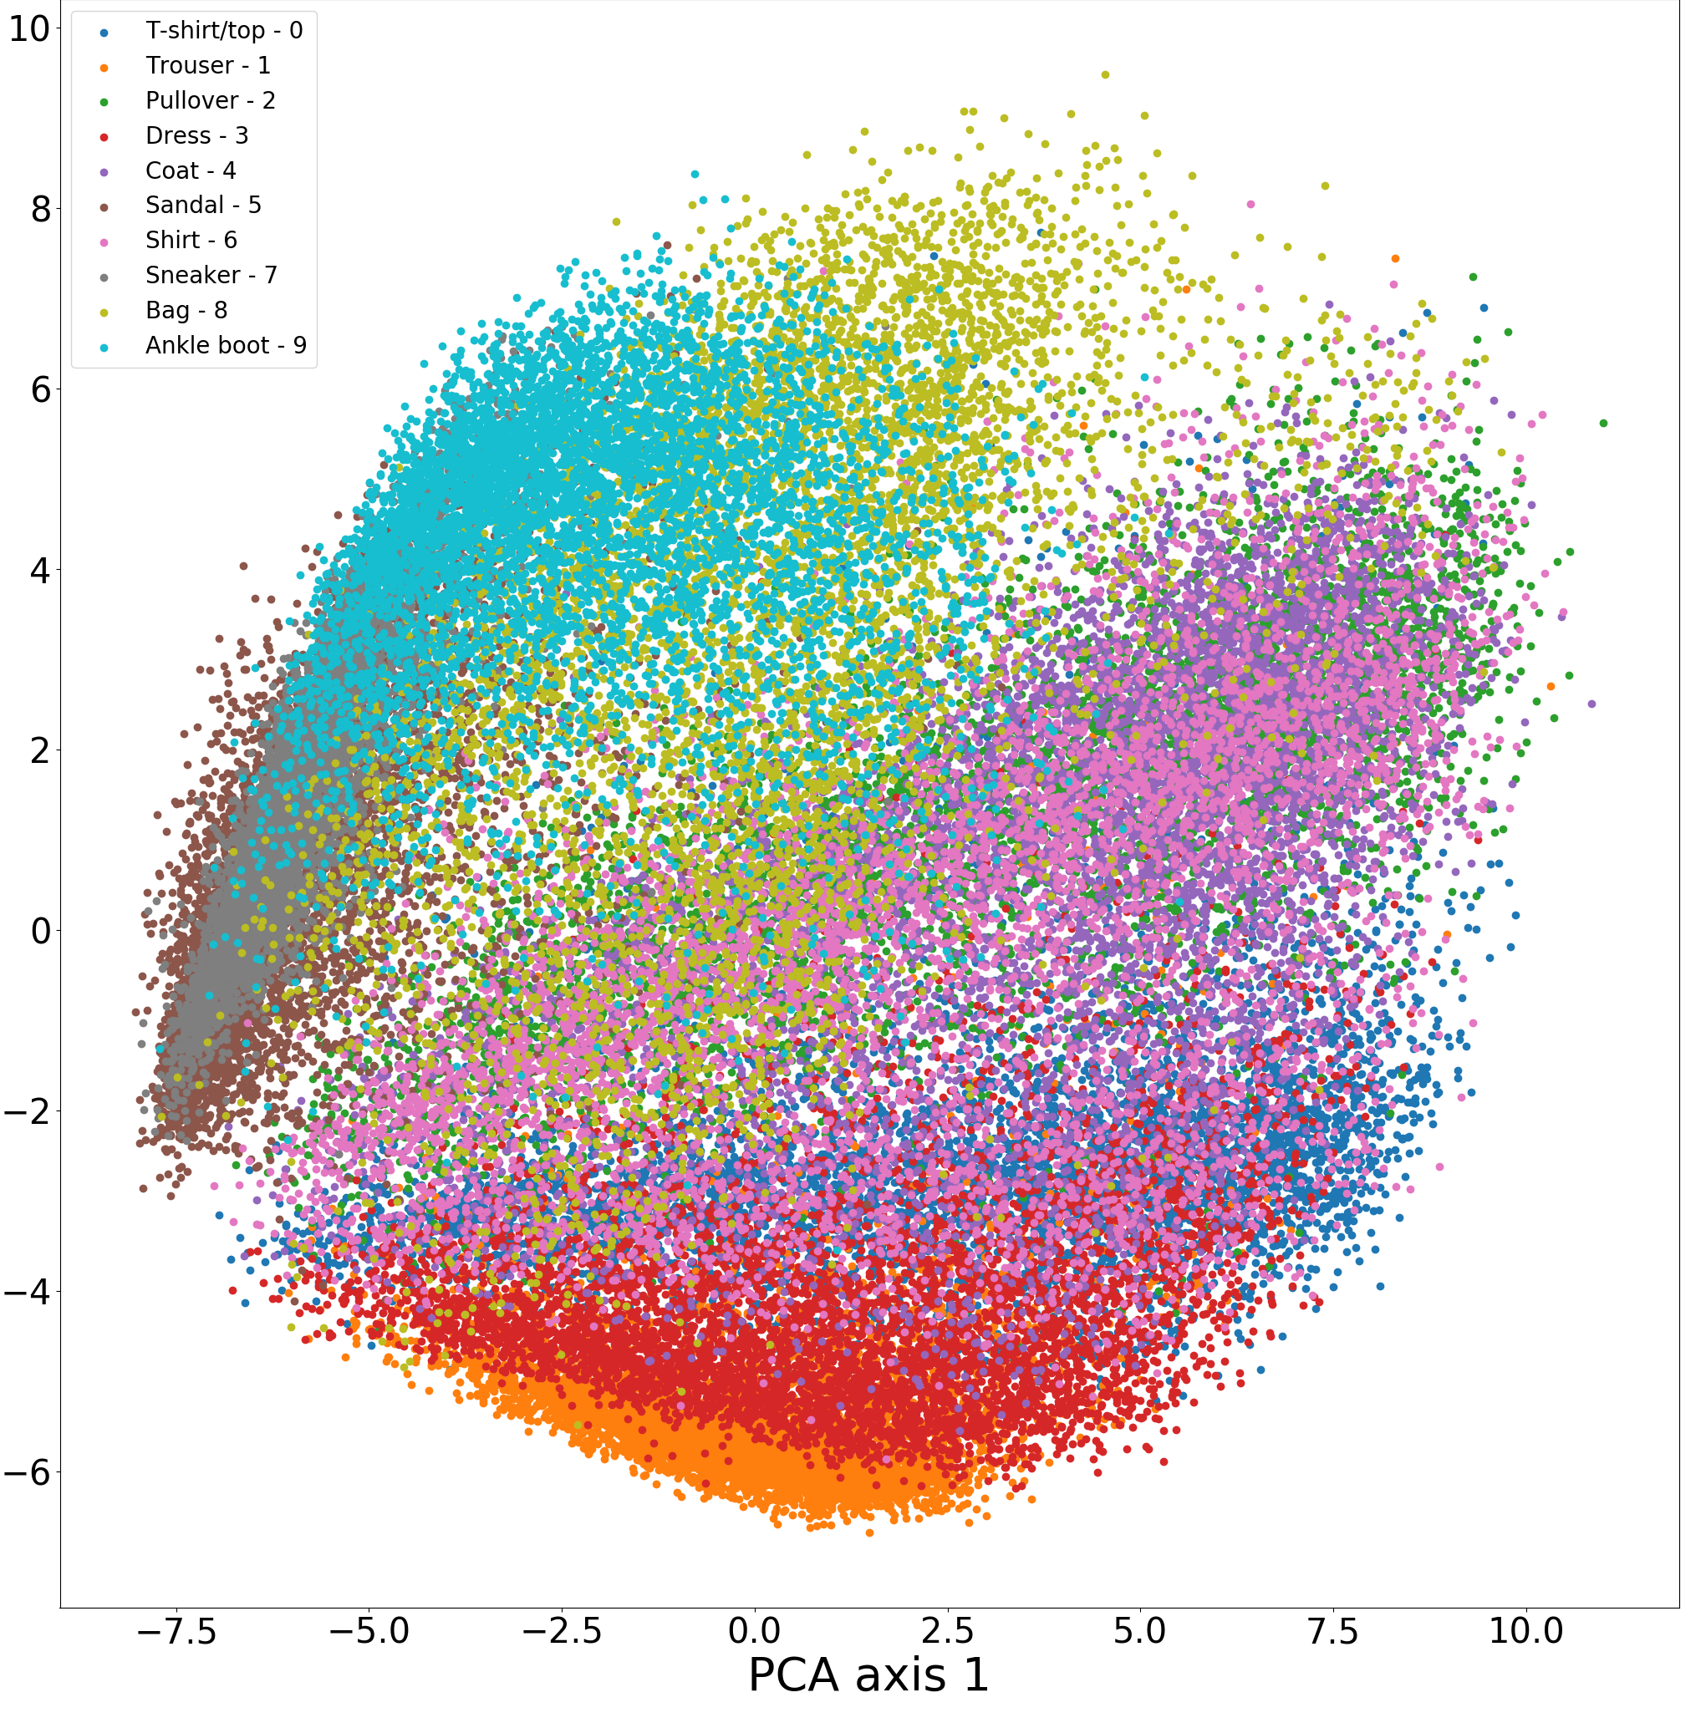
Figure 1: PCA of training data after preprocessing
In order to visualise the data, we can use the dimensionality reduction technique, principal component analysis, to present the data on a scatter diagram. This is shown in Figure 1 which was generated using dataVisualisation.py.

We can see that the most distinct class is trousers. This makes sense because it is the only item of legwear so it will not have many common features with the other classes. From the top left of Figure 1, we can see a lot of overlap between ankle boots, sneakers and sandals. This is most likely because they are all items of footwear and will have similar features as a result. The same can be said for the classes for t-shirts, shirts, and coats which are all upper-body items of clothing. These two sets of classes are therefore likely to be harder to classify.

Preprocessing the data

The gray-scale pixel values are in the range [0, 255]. This is a relatively small range so normalisation is not strictly necessary.^{[1]} However, the pixel values will be all initially divided by 255 so that they will all be in the range [0, 1]. This will help with numerical stability when using exponentiating with large numbers.

The next step will be zero-centering of the data. This can be done using mean subtraction. This is done by first calculating the mean image which consists of the mean pixel value for each pixel position for every image in the training data. This mean image is saved and is subtracted from each training and test image.

Preprocessing the data makes classification less sensitive to changing the parameters of the model, as shown by Figure 2.

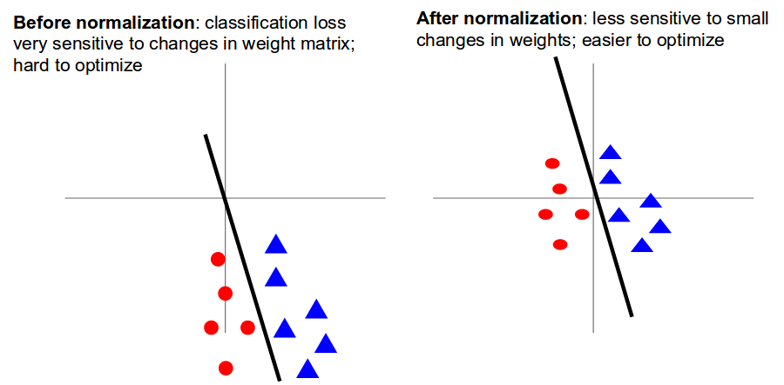
Figure 2: Classifying data before and after zero-centering^{[2]}

The code for the data preprocessing can be found in dataPreprocessing.py.

Experimenting with different Models

Model 1: Linear Model

We will start by first training a linear model adapted from the Imperial College Data Science workshop on neural networks^{[3]}. For input image x. The linear model f will attempt to classify the image using:
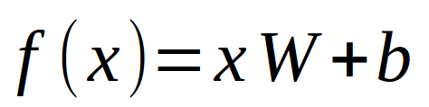

Where W is the matrix of the weights of the model and b is the bias vector.

Initially the weights will be initialised to small random values and biases to zero. The model’s performance will be evaluated using the cross entropy loss function and will be trained using backpropagation and batch gradient descent.

After the loss function has been minimised, we can now test the model on the test data.

The results of the testing are as follows:

Overall Accuracy: 83.36%

Table 1: Performance of the linear model by class

Figure 3: Performance of the linear model class by class (graph)
The trained linear model was most successful in classifying the trouser class. This falls in line with our previous observations when visualising the training dataset. The model is particularly struggling to classify T-shirts, pullovers, coats and shirts. This is to be expected given their overlap on the principal component analysis scatter graph.

The training and testing of this model can be found in linearModel.py.

Model 2: Single Hidden Layer Feedforward Neural Network

For input image x. The model f will attempt to classify the image using:
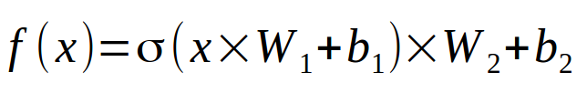
Where W₁,W₂ are the matrices of the weights and b₁, b₂ are the bias vectors. σ is the non-linear activation function ReLU. This is an artificial neural network with a single hidden layer. The idea is that the introduction of the non-linear function will assist in classifying the data.

This models performance will be evaluated using the cross entropy loss function. As this model is more computationally expensive than the linear model, we will use mini batch gradient descent for a faster convergence when minimising the loss. The weights will be updated using the Adam optimizer. The training process can be seen in the function train_NN in singleHiddenLayerFeedforwardTraining.py.

There are many hyperparameters we can choose including: initial learning_rate, hidden layer neurons, training epochs and batch size. For this demonstration we will tune the hyperparameters hidden layer neurons and the initial learning rate.

We will tune these two hyperparameters using a random search method as opposed to a grid search method as argued by James Bergstra and Yoshua Bengio.^{[4]}

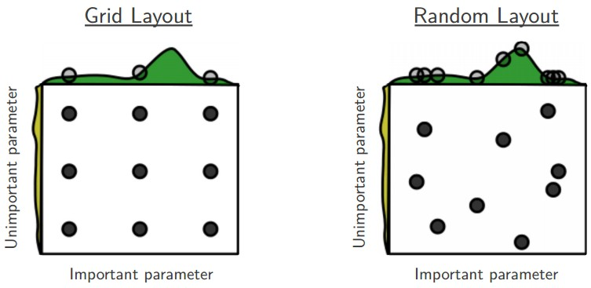
Figure 4: Grid search compared to random search for hyperparameters^{[5]}

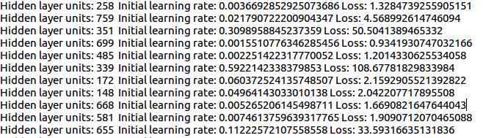
Figure 5: Sample of entries in the hyperparameter search log
The test data should not be used to test the hyperparameter configurations. This could lead to overfitting the test data. Hence, we will use 1000 elements from the training data to test the hyperparameters. This is called the validation set.^{[6]} Over time we can narrow the search on the range of hyperparameters for a more fine tuning. The implementation of this hyperparameter search can be found in the function hyperparameter_search in singleHiddenLayerFeedforwardTraining.py.

The results of the testing are as follows:

Overall Accuracy: 89.28%
Table 2: Accuracy of single hidden layer neural network by class

Figure 6: Comparison of accuracy per class between two models by class
The code used to test this model can be found in singleHiddenLayerFeedforwardTesting.py.

Model 3: Convolutional Neural Network

The next model we will try is a convolutional neural network. Although single hidden layer neural network can be used for image classification, CNNs are typically more common because they scale better for a greater input size.^{[7]}
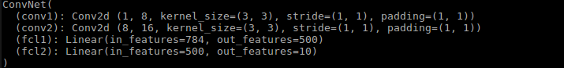
Figure 7: PyTorch ConvNet class in CNNClasses.py
After tuning the hyperparameters, we end up with a CNN with the structure shown in Figure 7. This has two convolutional layers (both followed by max pooling layers) and two fully connected layers. It should be noted that a CNN has many more hyperparameters- such as stride, zero-padding and kernel size)- and can have many architecture configurations. This made it hard to perform the hyperparameter search. Additionally, larger (possibly better) architectures were too computationally expensive to train.

The results of testing this model are as follows:

Overall Accuracy 89.34%
Table 3: Accuracy of CNN by class

The training can be found in convolutionalNeuralNetworkTraining.py and the testing can be found in convolutionalNeuralNetworkTesting.py.
Figure 8: Comparison of the three models
The overall accuracy of the convolutional neural network is similar to the single hidden layer neural network. The performance across each class is also similar as seen in Figure 8, with a noticeable increase in performance when classifying sneakers.

Reflections/Model improvements

Given more time/resources, here is how we could potentially improve the performance of the convolutional neural network:

- Use more filters in the convolutional layers to recognise more features
- Use Xavier initialisation for the weights in the network
- Add batch normalization layers^{[8]}
- Using an existing convolutional neural network that classifies similar data for transfer learning^{[9]}
- Use regularization such as dropout to prevent overfitting the training data^{[10]}
- Perform a more in depth random search for other hyperparameters

References

[1], [2], [5], [6], [8], [9], [10]. Andrej Kaparthy. CS231n: Convolutional Neural Networks for Visual Recognition. Available from: cs231n.stanford.edu. [Accessed 28th December 2017]
[3]. Imperial College Data Science Society. Neural Networks. Available from: https://github.com/Imperial-College-Data-Science-Society/Neural-Networks. [Accessed 25th December 2017]
[4]. Bergstra J, Bengio Y. Random Search for Hyper-Parameter Optimization. Journal of Machine Learning Research 13. 2012. p302.
[7]. Wikipedia contributors. Convolutional neural network. Available from: https://en.wikipedia.org/w/index.php?title=Convolutional_neural_network&oldid=817260146 . [Accessed 28th December 2017]

