**Progress Report**

**Group:**

Initially, we consulted with our unit coordinator, and formed a group of three students then we selected the project topic from the listed topics in our module: Drone based data collection from ground IOT nodes: Simulation Study in MATLAB. Before starting our project, we planned to do the zoom meeting and MS Team meeting weekly with our Tutor, mentors, and supervisor so that we can get detailed information about our project, so we did the first meeting and started the project. For the technical report we divided the task equally among all of us and did the task doing the communication and meeting within ourselves.

The report is done on a several weeks’ basis, so we made the schedule timetable and the task done throughout the time frame. The detailed information on how we did the project task up to now and how we are planning to complete the detail final report is shown in the chart. The below chart shows the details of the project progress.

**Gantt Chart**

**Chart of Completed Tasks**

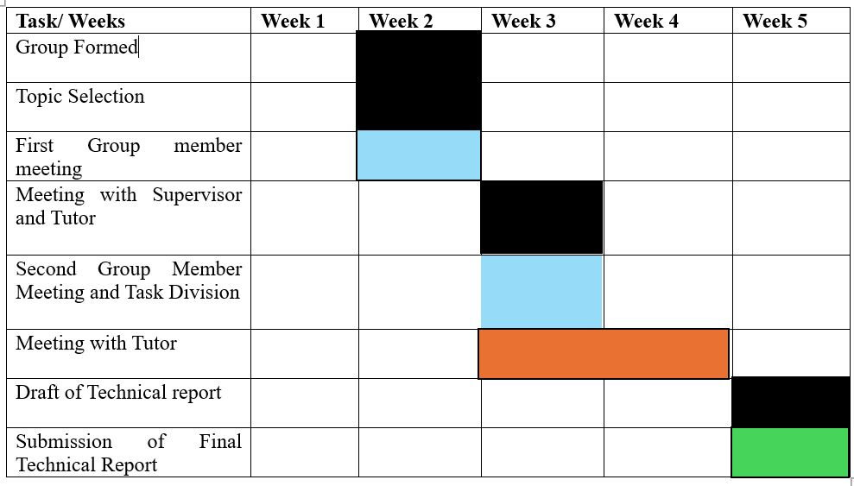

Table 1: Weekly Completed task

**Chart of Planned Tasks for next phase**

Table 2: Weekly Next phase task

**Notation/ Index**:

Table 3: Index of the task

We faced various issues and challenges during the project time. Some of the issues and the challenges that we faces are listed below:

* Initially, we faced difficulties in understanding the project specification.

Here we have the topic as drone-based data collection from IoT nodes and we need to do the simulation using MATLAB. Also, in the specification it’s given collect data and store and do the simulation, but our tutor and supervisor explained not to do the data collection. So, in this specification we got the confusion that without data collection how we can do the simulation. In order to find the path, we also need the distance measurements for the simulation.

* Issues with MATLAB installation

We are having problems with the MATLAB software. We didn’t find MATLAB software available in our UNI Microsoft azure websites, even though we mailed we didn’t receive any response from the university for the license for MATLAB.

* Communication issues, technical complexities and so on

So, to address those issues and to solve we attempted and still trying to do the following steps for unfinished task:

* Regular meeting with the tutor and supervisor to get detailed information and ideas about the project.
* Meeting with the unit coordinator for feedback and to be clear about the unclear task.
* Regular research on the online resources to get more information and ideas from the similar types of report.
* We divided the task equally among all the members of the group so that we could do the task in time and easily.
* We also make the schedule timetable/ Gantt chart of task done and to be done to make easier.