Afkaterns Exercise DAy2

- Pascal’s Triangle
C program to print Pascal triangle which you might have studied while studying Binomial Theorem in Mathematics. A user will enter how many numbers of rows to print.
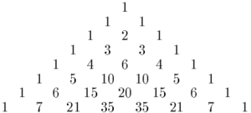

Program to check Palindrome
Palindrome number in C language: A palindrome number is a which remains the same on reversal. For example, some palindrome numbers are 8, 121, 212, 12321, -454. To check whether a number is a palindrome or not first we reverse it and then compare the number obtained with the original number, if both are same then the number is palindrome otherwise not

To check palindrome number algorithm
To test if a number is palindrome or not, do the following steps:
1. Get the number from a user.
2. Reverse it.Palindrome number in C
3. Compare it with the number entered by the user.
4. If both are the same then print palindrome number else print not a palindrome number.

