NIDAQmx
https://www.ni.com/en/support/downloads/drivers/download.ni-daq-mx.html?srsltid=AfmBOooQRrVFY1AyhZ1WgRz5YIS8JAoWZCXbvF5h4vp_-TUu0tP-5VII#494676
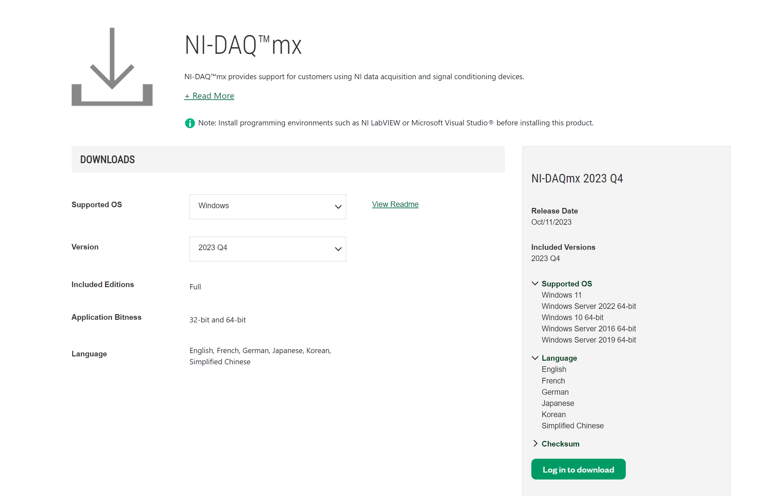
Python Lib
pyDaqmx
https://pypi.org/project/PyDAQmx/

PyQt5
https://pypi.org/project/PyQt5/

pyqtgraph
https://pypi.org/project/pyqtgraph/

Cautions:
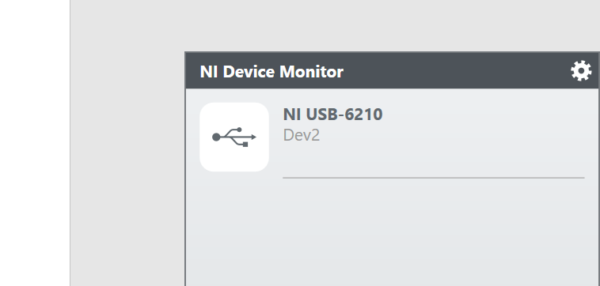
Name of NI USB is: “Dev2”. It might be change. If you want to change the name in code corresponding to your device name
Program
TestDaq.py
- Output: Print data Fx, Fy, Fz
TestDAQpyqtgraph
- Output:
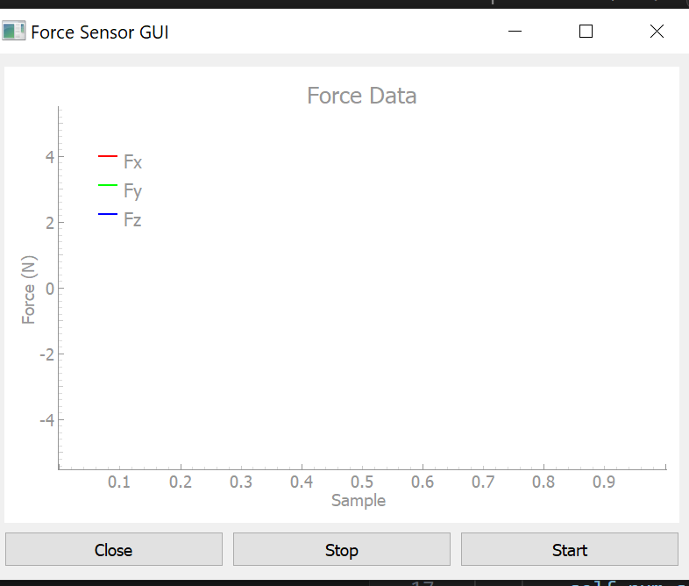
Press “Start” to start thread running
Press “Stop” to stop thread running

