

Airbnb New User Bookings



Prepared by
Nam Pham
Sudip Baral,
Dibakar Barua,
Ruturaj Joshi,
Jiajun Du

November 26, 2017

Project Description:
In this project, we are given a training dataset of 213451 users along with 16 features including their demographics, web session record, and some summary statistics. A testing dataset of 62096 users with 15 features except country_destination feature. We are required to predict which country a new user’s first booking destination. All the users in this dataset are from the USA.
The training and test sets are split by dates. In the test set, you will predict all the new users with first activities after 7/1/2014.
Approach:
- We thought that it is essential to explore the data sets before going to built the model to make sure there are no missing data unprocessed.
- Processing the data so that it would be able to used by variety classifier.
- Applying variety classifier to predict, comparing the result, then choosing the best classifier.

DATA EXPLORATION
The goals of this step is to figure out and solve the following problem:
- is there any mistakes in the data?
- fixing the data so that it could look more realistic.
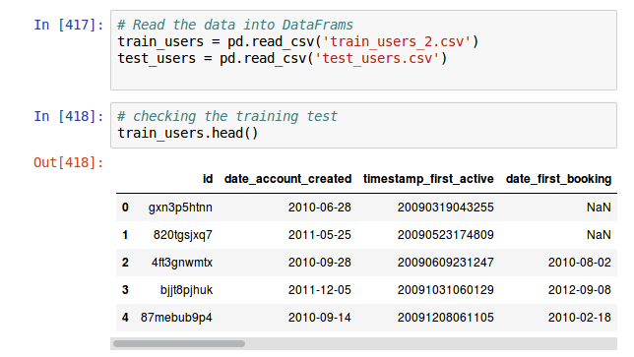
The data seems to be included missing data and unusable format.

MISSING DATA
In the gender column some values being -unknown- . We need to transform it to NaN so that later on we could use pandas built in function to process the data.
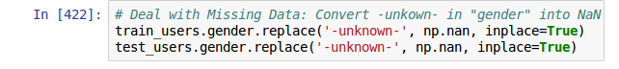
Compute the percentage of missing data in each column in order to exclude those column with maximum missing data rate.
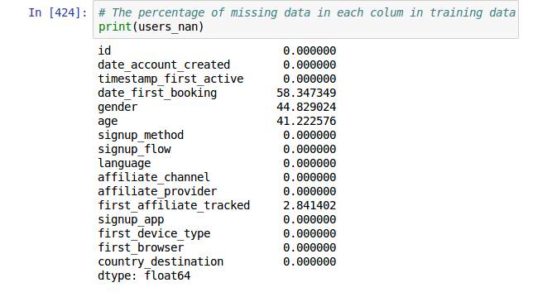
The feature date_first_booking has 58.35% of NaN or missing data, so to maximine our performing of our classifiers we will build we better not include this feature at the modeling part.
According to the statistics, the other features we could explore more are gender and age.
AGE:
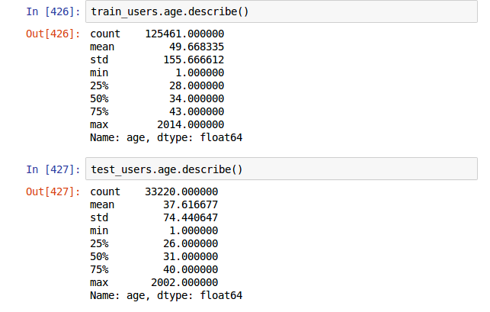
The statictis in both data sets shows the inconsistency in the age of the users.
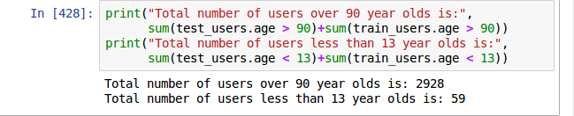
So, we need to fix the data look like more realistic by set all the users whose age are over 90 and less than 13 to NaN.
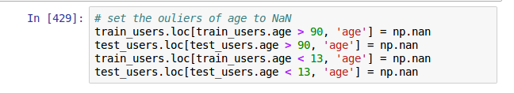

From now we could able to merge both data set into one 'users' dataset in other to visualizing the data.
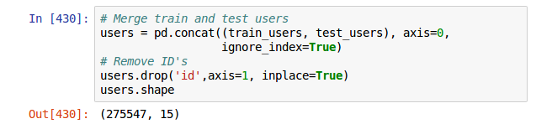

VISUALIZING THE DATA
Visualization able us to see the outliers and error immediately.
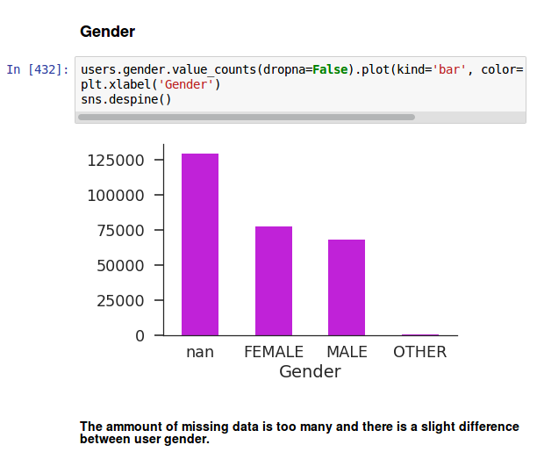

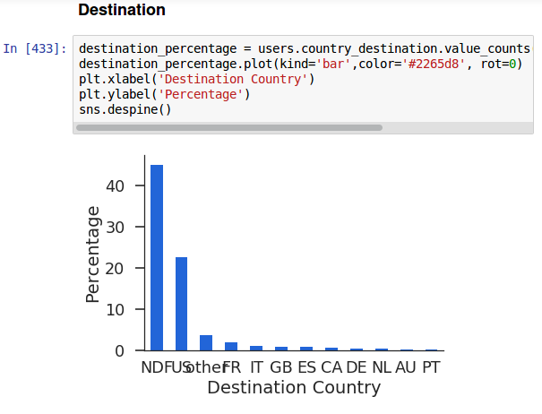
Looking at the bar graph we see that more than 40% users not booking. For those who booked via airbnb the US is the most chose, more than sum of other destinations.
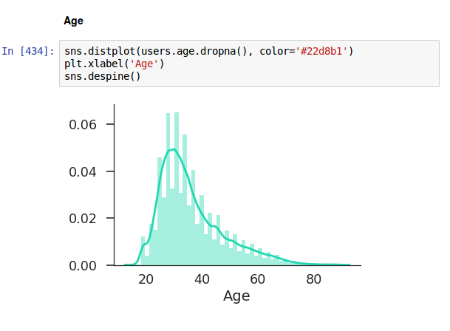
Based on the graph, the common age to travel is between 25 and 40.

DATE:
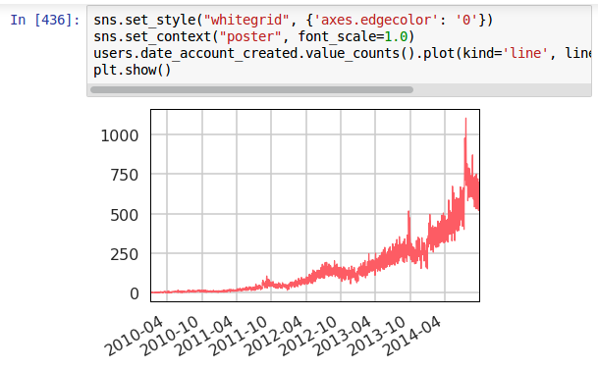

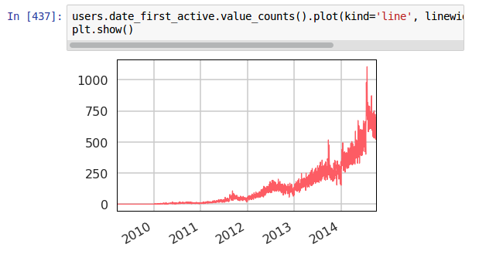
As usual, users who create accounts and activate the accounts almost at the same time.
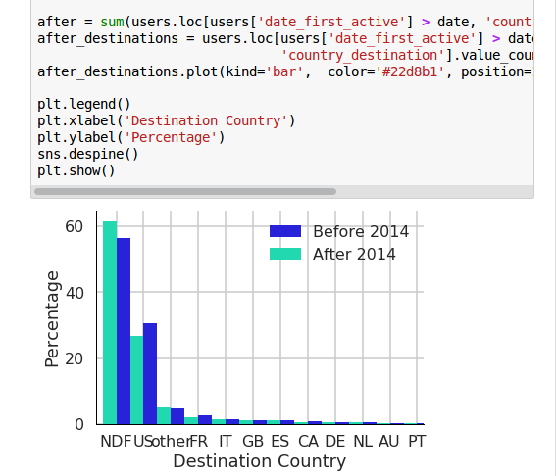
Look at the graph we see that more new users after 2014 but they booked less than the previous.
PREDICTION:
Our approaches are to use different classifier to built the predict model and to make prediction. After comparing the accuracy will we chose the best classifier that provide the most accuracy.
Before building our predict model we need to drop some column features that have peculiar behavior or those will make the predict model less accuracy.
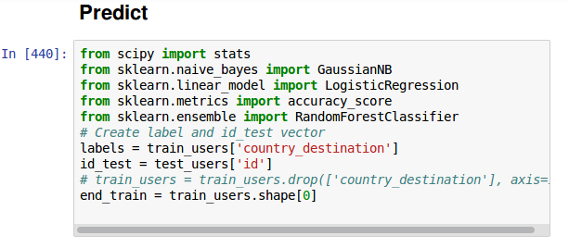
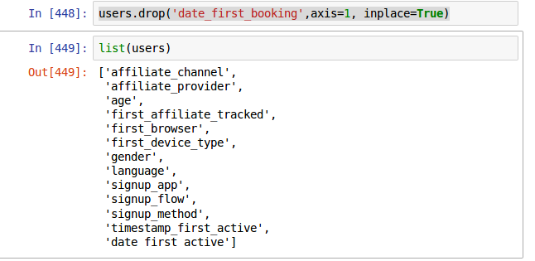
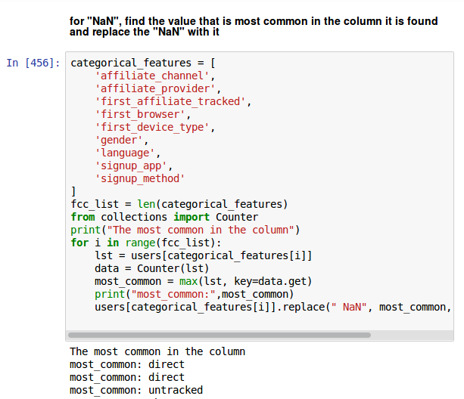
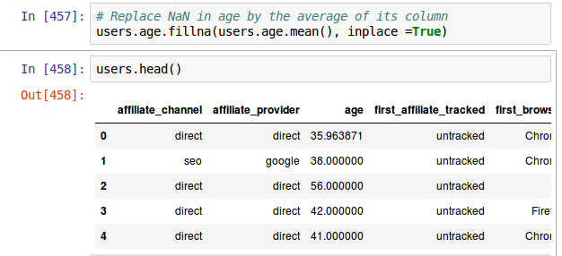

Using One-hot-encoding to transform categorical features in to dummy data so that we could able to use the data for many classifiers.
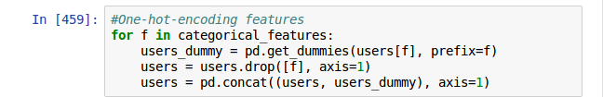
Divide the training data into a training and testing set
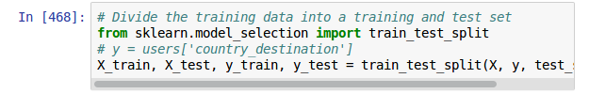
From now we apply different classifier to build the predict model and make prediction.
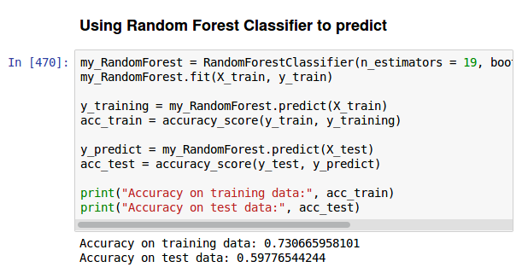
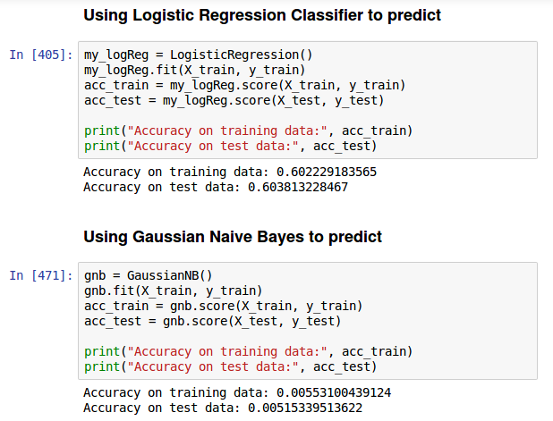
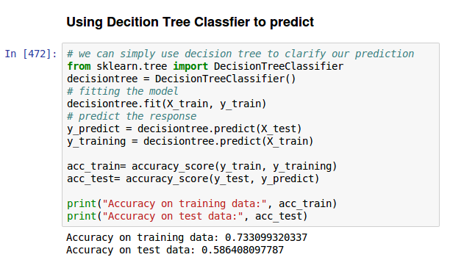

Using Gradient Boosting Algorithms
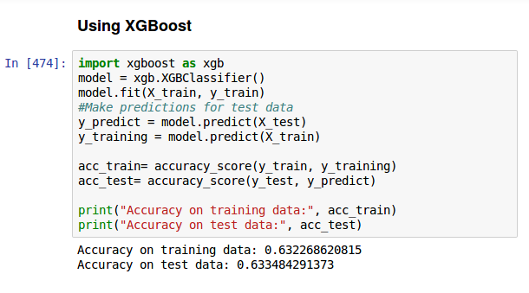
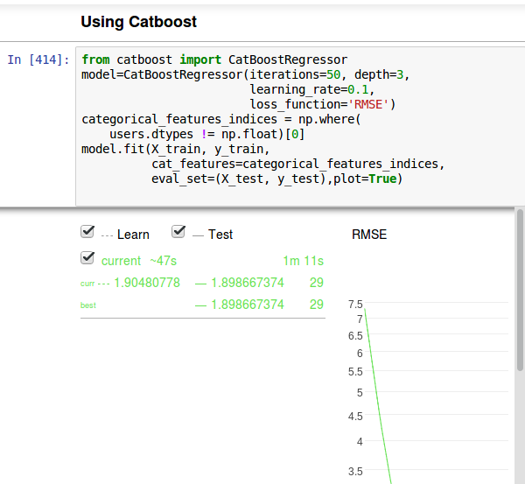
Out of the classifiers we have used, Catboost Classifier give us the most accuracy: 100 – rmse*rmse = 100 – 1.898667374* 1.898667374 = 96.39506220291

