Practical – 7 : Cloud Front Distribution

Name : Nikita Nandkumar Burgute.
Batch : CCF1
Roll No : CCF-16
PRN : 202301040057
__________________________________________________

Step 1 : Create an S3 Bucket & Upload Content

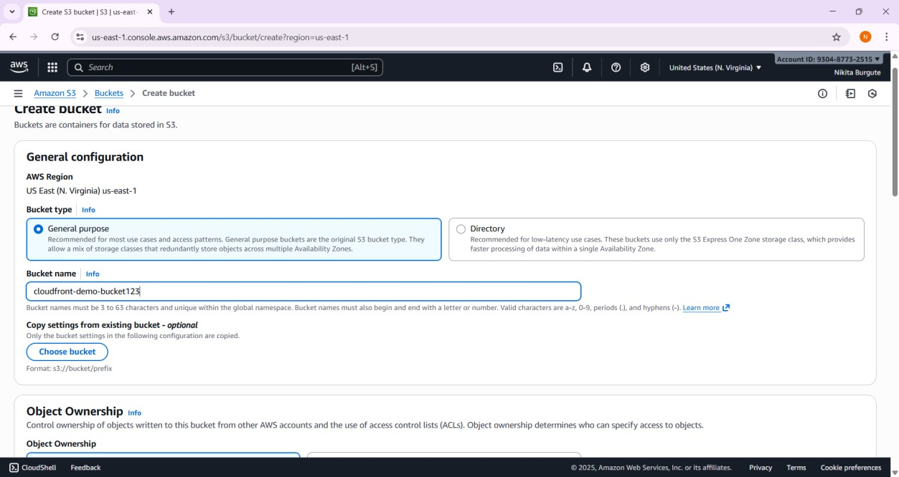

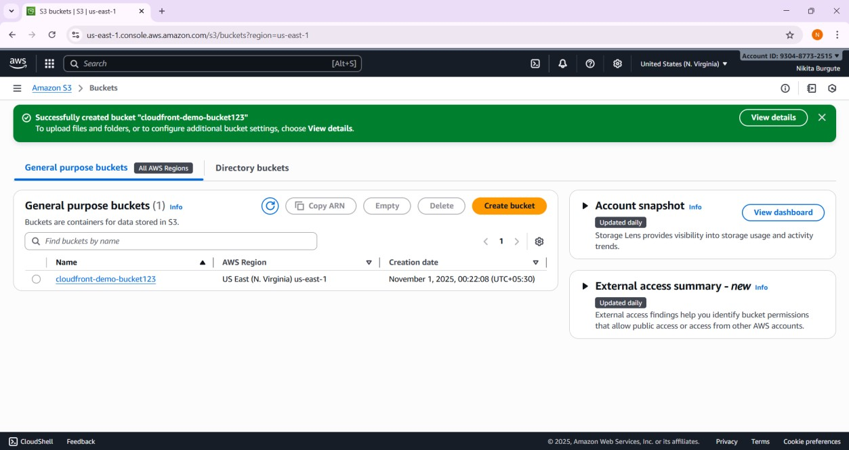

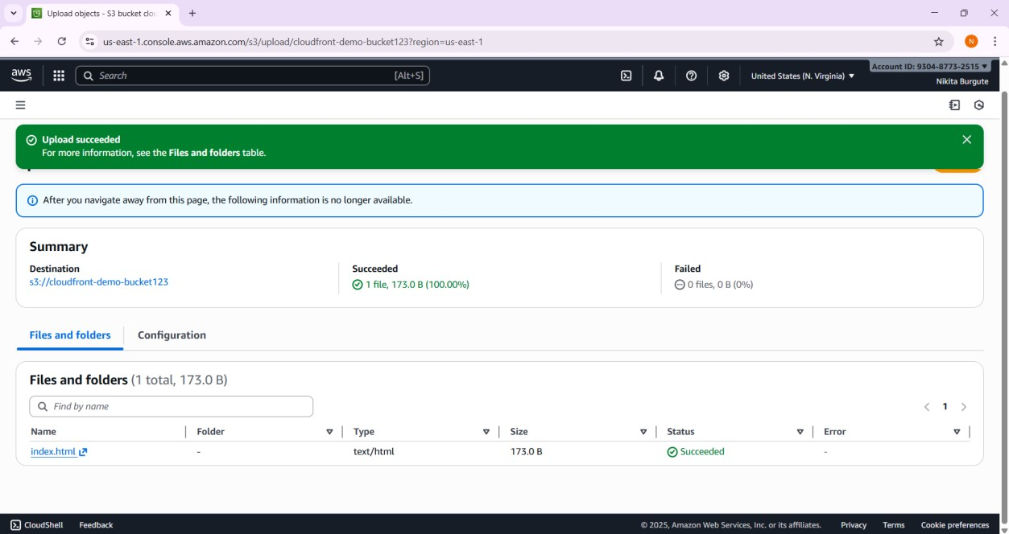

Step 2 : Create an Origin Access Control (OAC)

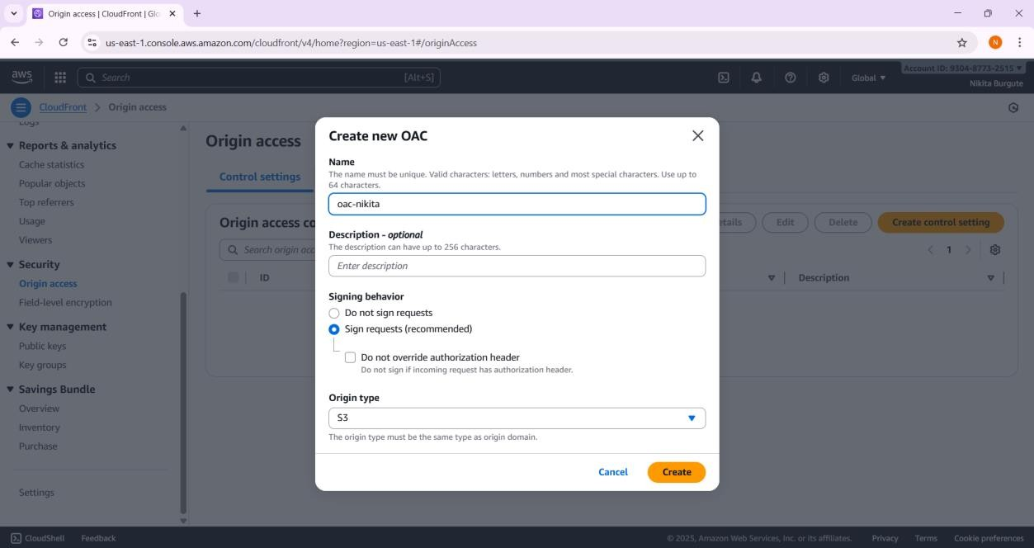

Step 3 : Update the S3 Bucket Policy

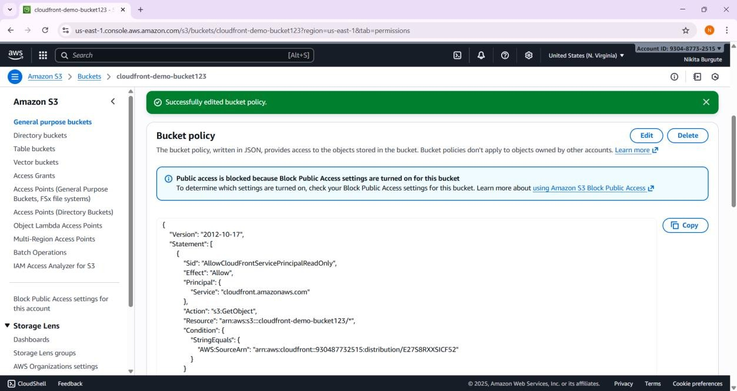

Step 4 : Create a CloudFront Distribution

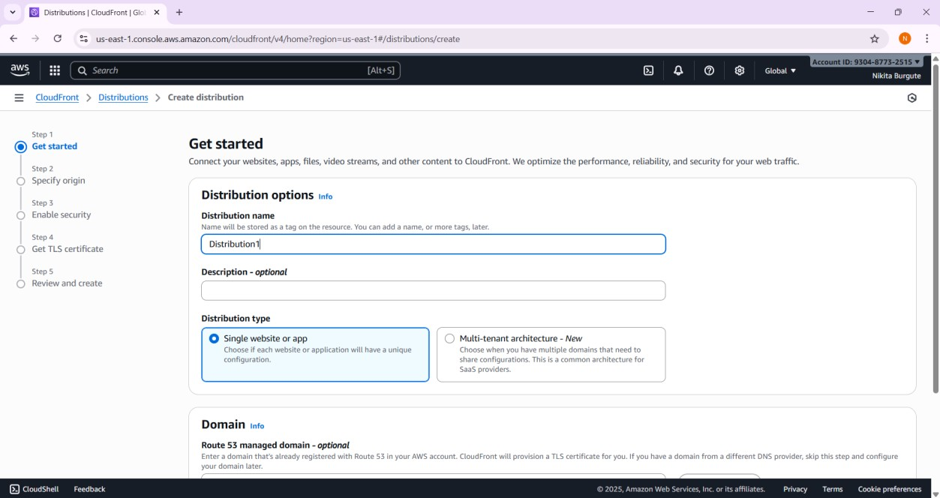

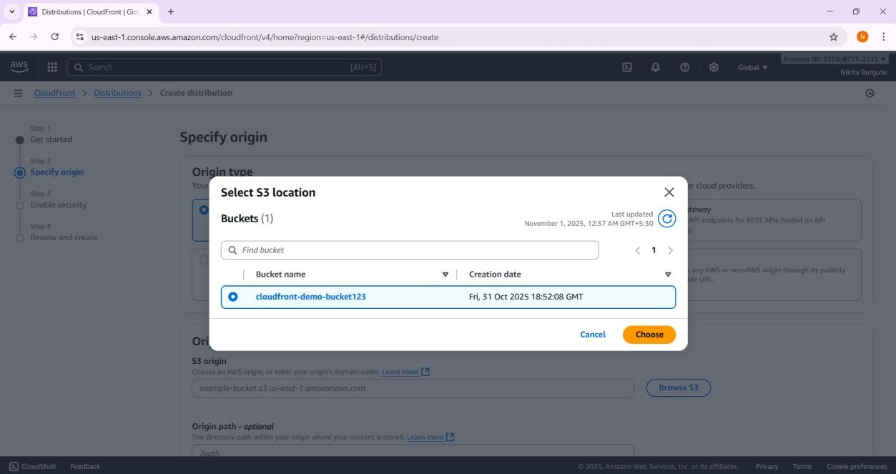

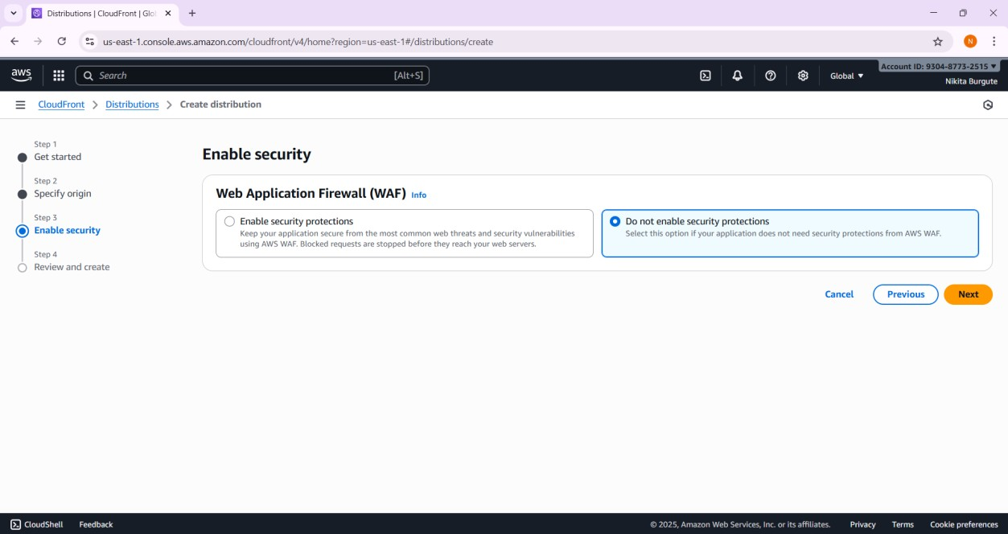

Step 5 : Test Access via CloudFront

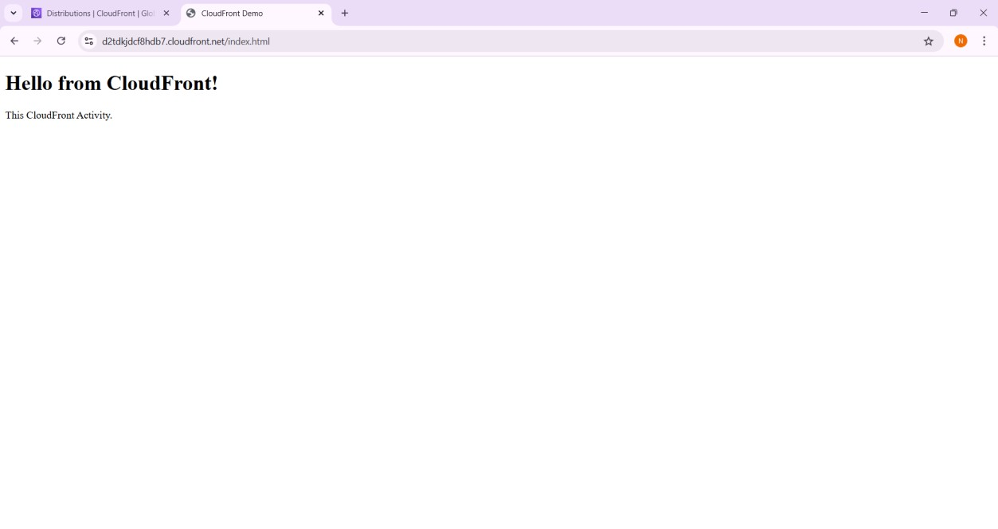

Step 6 : Verify CloudFront Response Headers

