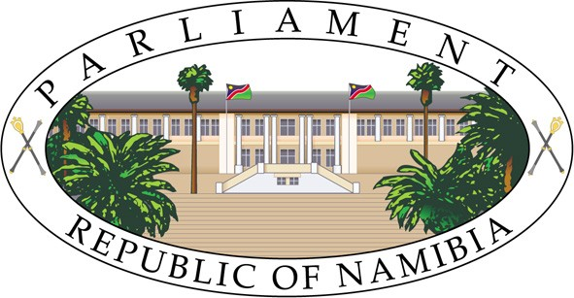

ELEVENTH SESSION, FIFTH NATIONAL COUNCIL
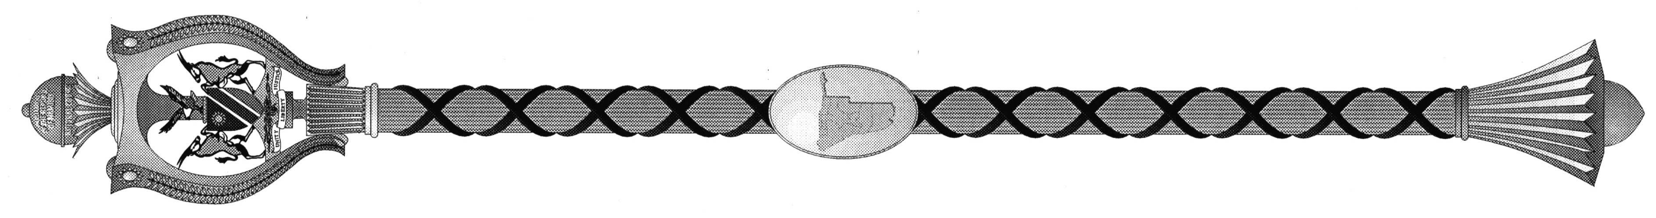

MINUTES OF PROCEEDINGS

Monday, 18 December 2017 No.28 - 2017

The Council met pursuant to adjournment.

- The Chairperson took the Chair.

- The Chairperson recited the Prayer and Affirmation.

- OPENING STATEMENT BY THE CHAIPERSON

Hon. Mensah-Williams, Chairperson of the National Council made a Statement to the House at the opening of the Eleventh Session of the 5th National Council on 18 December 2017.

The Statement is reproduced hereunder:

“HONOURABLE BERNARD SONGA SIBALATANI, VICE-CHAIRPERSON OF THE NATIONAL COUNCIL;
HONOURABLE LEBBIUS TOBIAS, CHIEF WHIP OF THE RULING PARTY IN THE NATIONAL COUNCIL;
HONOURABLE HILMA NICANOR, DEPUTY MINISTER OF VETERANS AFFAIRS & MEMBER OF THE NATIONAL COUNCIL;
HONOURABLES WHIPS OF THE OPPOSITION PARTIES IN THE NATIONAL COUNCIL;

HONOURABLE MEMBERS;
SECRETARY TO THE NATIONAL COUNCIL AND STAFF MEMBERS;
MEDIA REPRESENTATIVES.
Welcome back to Parliament Honourable Members from your constituencies.
All praise be to the Almighty God for protecting us on our journeys to the capital city.
We have gathered once again in this august House to fulfill our constitutional mandate.
Over the next four days, the National Council will review the following bills as passed to it by the National Assembly:
- Urban and Regional Planning Bill (Bill Number 13 of 2017)
- Combating of Trafficking in Persons Bill (Bill Number 14 of 2017)
- Education Amendment Bill (Bill Number 15 of 2017)
Furthermore, this House will also consider a number of reports that have emanated from standing committees in accordance with the National Council’s Standing Rules and Order.
Honourable Members
Ladies and Gentlemen,
I would like to draw your attention to the Combating of Trafficking in Persons Bill.
According to the International Labour Organisation, there are over 40,3 million people worldwide who have been trafficked into various forms of modern slavery.
Human trafficking is a reality that affects many of women, children and men in Namibia.
People get trafficked for a variety of reasons, among others:
- For sexual exploitation
- Criminal activities such street crimes and begging
- Domestic servitude
- Exploitative labour in beauty salons, restaurants, agriculture and so on
- Illegal private fostering for benefit from state grants
- Illegal adoption
- Forced marriage
- Removal of organs
- Child soldiers

Our country is both a destination and an exporter of victims of trafficking in persons. As a matter of fact, a local television station recently aired the heartbreaking story of a Kenyan woman who was trafficked into Namibia for sexual exploitation.

Last week I also learned about the story of a Namibian woman who was sold by her uncle to traffickers in the United Kingdom a few years ago. She is still in the UK right now fighting for her life. I was heartbroken when I was told that she had contracted HIV/AIDS as a result of sexual exploitation.

These two stories are only the tip of the iceberg because many cases of human trafficking cases remain unreported.
Victims of modern slavery are unable to leave their situation of exploitation because they are controlled by threats of punishment, violence, coercion and deception.
Parliament has an important role to play in ending this shameful practice. Through the review and passing of this bill, we will give Government the tools it needs to protect and prosecute the criminals who profit from exploiting others.
Furthermore, when this bill comes into force, it will serve as a deterrent to perpetrators and make citizens more alert to the problem.
Honourable Members,
I believe that the proposed sentences in the current bill are too lenient. I also think that that there should not be an option of a fine upon the conviction of a human trafficker.
Namibia has an obligation to tackle the evil of human trafficking under the United Nations Convention Against Transnational Organised Crime.
We need to end this despicable industry and protect especially the most vulnerable in society.
Urge all members to create awareness of the dangers of human trafficking in their constituencies. Furthermore, the National Council will, early next year, embark upon creating public awareness on the issue through its programmes.
With these few words, I thank you for your kind attention more!’
- NOTICE OF MOTION(S)
Hon. Katamelo gave notice: That on Wednesday, 20 December 2017, he shall move the Report of the Inter-Parliamentary Union (IPU) National Group to the High-Level Political Forum on Sustainable Development Goals (SDGs) held at the UN Headquarters in New York, USA from 10-19 July 2017.

- MESSAGE FROM THE NATIONAL ASSEMBLY
The Chairperson announced to the National Council that the National Assembly has passed and referred the following Bills to the National Council for review in accordance with Article 75(1) of the Namibian Constitution:

- Urban and Regional Planning Bill [B.13 – 2017];

- Combating of Trafficking in Persons Bill [B.14 – 2017]; and

4) Education Amendment Bill [B.15 – 2017].

The Chairperson then called upon the Secretary to read the Bills a First Time.
The Secretary read the Bills a First Time.
The Bills stood referred to a Second Reading.
- Hon. Tobias seconded by Hon. Van Neel adjourned the Council at 09:50 until Tuesday, December 19, 2017 at 09:30.

Emilia Mkusa
Secretary of the National Council

______________________________________________

