* Sequence Diagram – UC Login  
  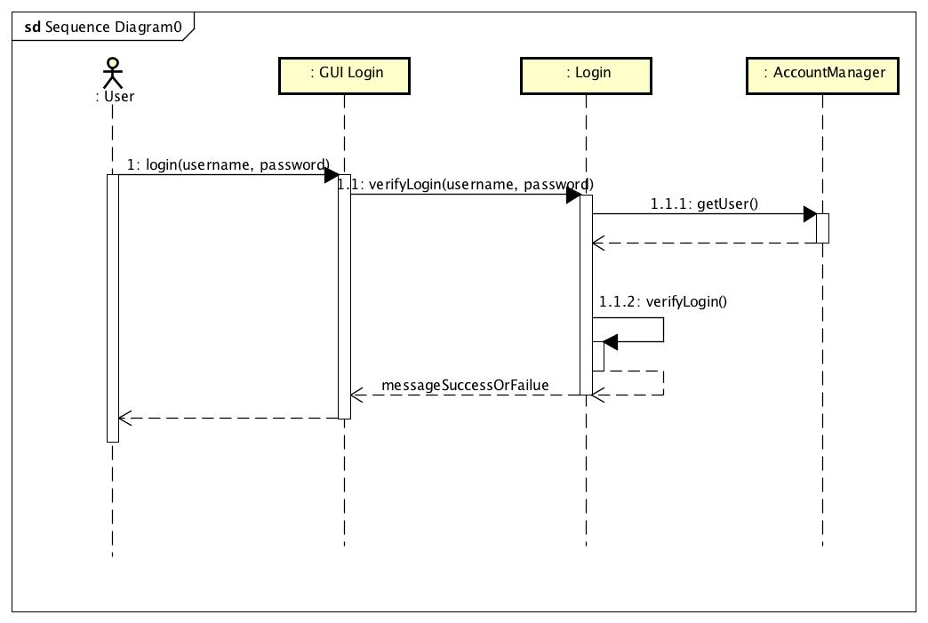
* Sequence Diagram – search book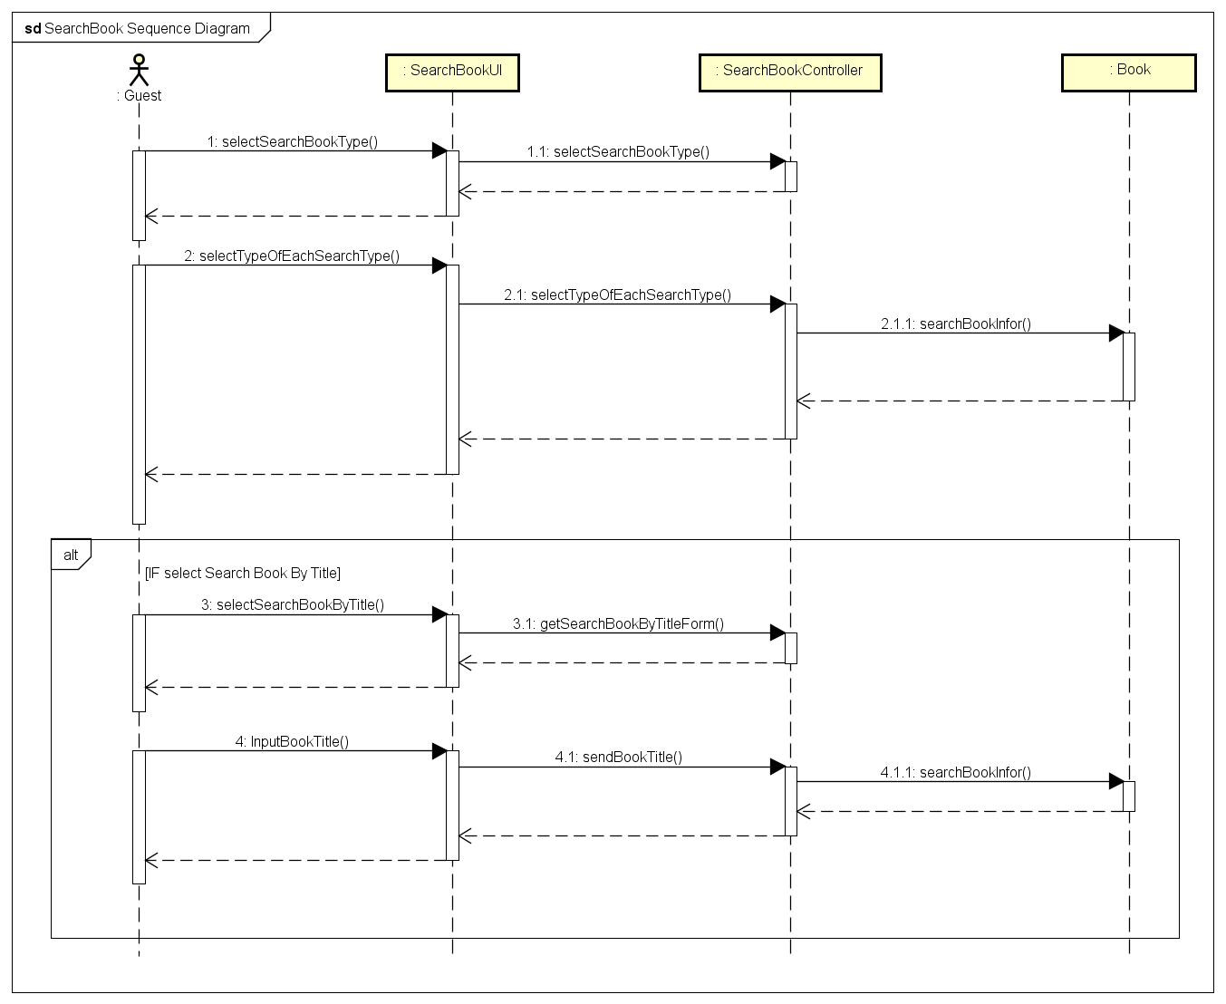
* Communication Diagram– Register To Borrow Book.  
  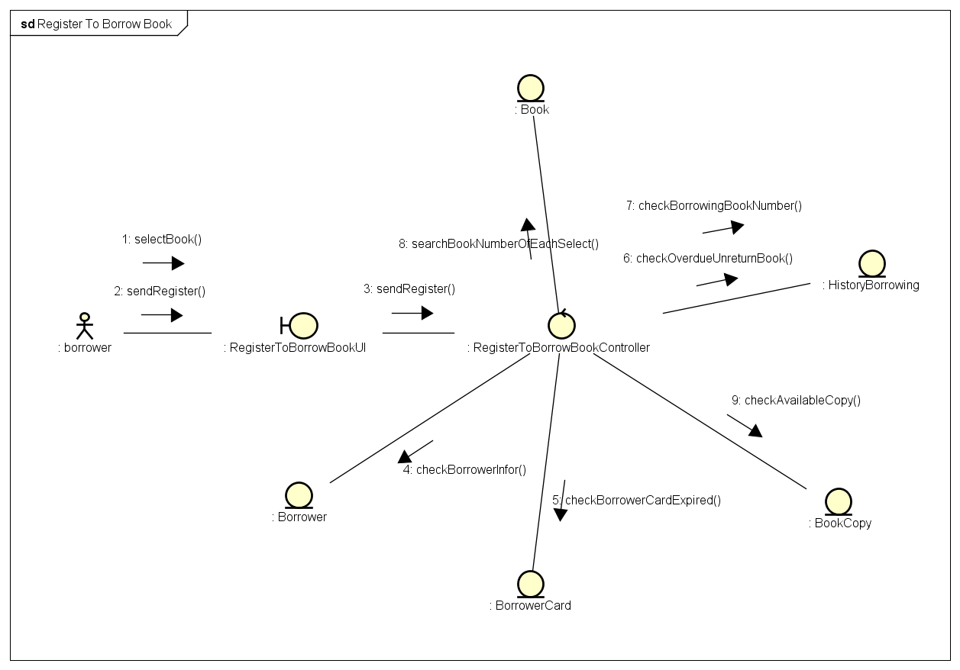
* Communication Diagram– Brower borrow book.  
  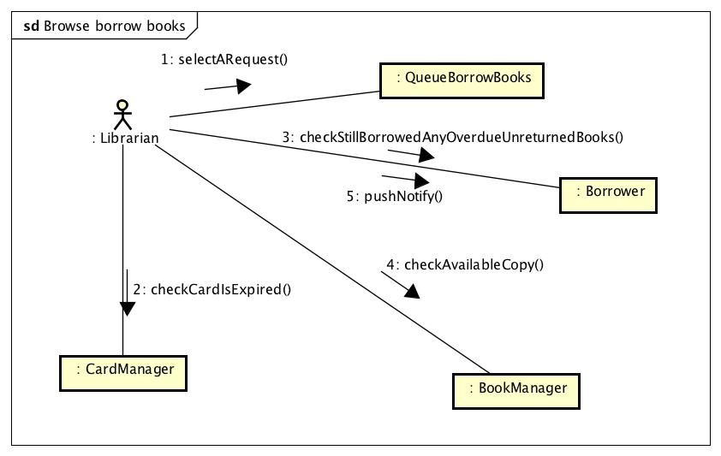
* 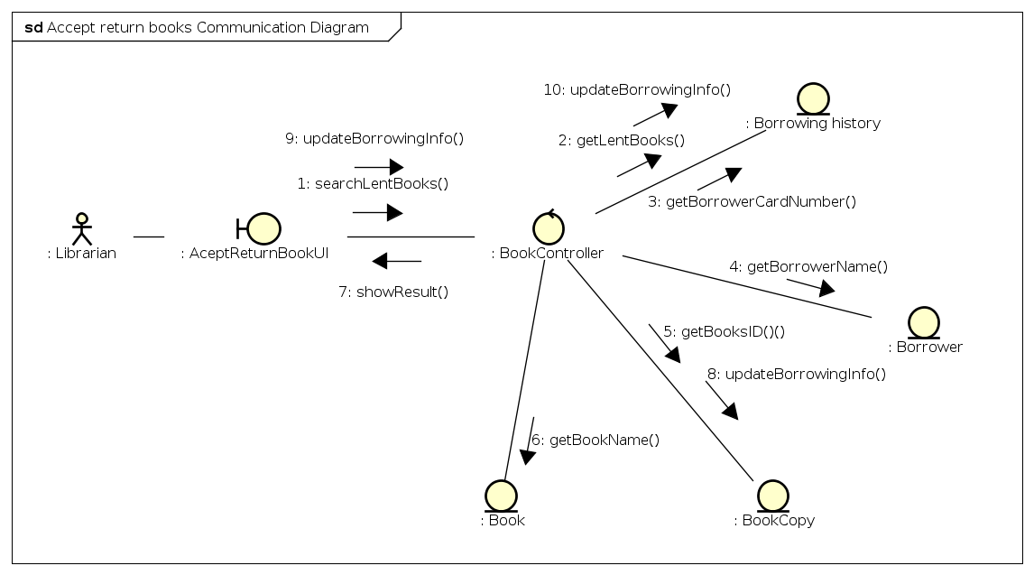Communication Diagram– Accept return book.
* Add new copy

