## Fractal Architecture as a Foundational Design Principle in Biomimetic Materials Engineering

## -Introducing Bio-Fractal Mimetics-

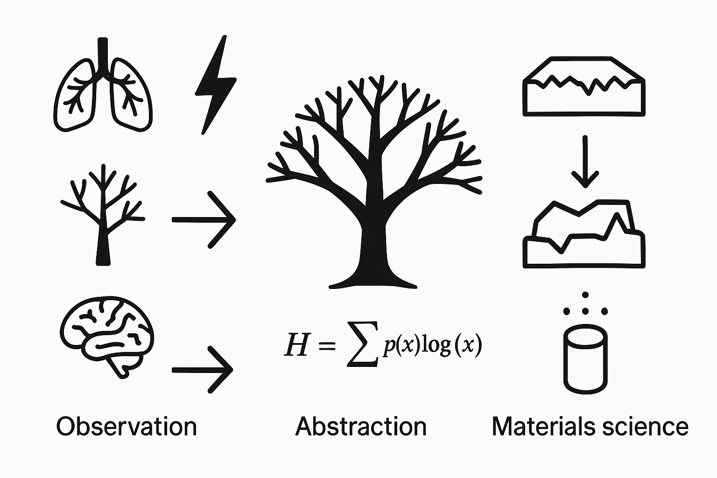

### 1. Background and Problem Statement

While studying biomimetics, I noticed a recurring limitation: much of the field is based on mimicking specific biological forms without generalizing underlying structural principles. Through extensive review, I observed that many natural systems—especially those demonstrating efficiency, resilience, and scalability—share a common structural property: **fractality**. This led to a question: could fractal geometry itself serve as a universal and abstract design principle in materials science and engineering?

### 2. Empirical Review of Fractal-Based Biomimetic Materials

I conducted a detailed review of approximately ~~150~~ 200 (2025.04.02 update) research papers covering nanowires, mesoporous materials, catalysts, electrodes, supercapacitors, dendrimers, dendrites, and batteries. Across these studies, fractal-inspired designs were frequently used to increase surface area, distribute stress evenly, and enhance overall efficiency. This empirical trend **supports the hypothesis that fractal organization is not coincidental but rather a strategic design choice in biomimicry**.

### 3. Observed Optimal Fractal Dimensions

Based on both empirical data and theoretical assumptions, two ranges of optimal fractal dimensions emerged:  
- 1.6–1.8: Between linear and planar structures, typically seen in nanowire and catalyst networks.  
- 2.4–2.6: Between planar and volumetric forms, such as in bulk porous media or dendritic assemblies.  
These intervals appear to optimize trade-offs between robustness, surface area, and diffusion behavior.

### 4. Structural Unification: Fractals, Hierarchy, Branching

Upon closer examination, I found that various terminologies—‘fractal,’ ‘hierarchical,’ ‘branch-like,’ and ‘root-inspired’—often describe structures sharing **self-similarity**. Below is a simplified conceptual mapping of these terms:

- Fractal: Mathematical pattern with scale invariance.  
- Hierarchical, multi-scale structure: Layered structures with distinct functional levels.  
- Branching, tree structure: Often seen in biological and fluidic systems.  
- Root-like: Describes dense, distributed capture systems (e.g., vascular or rhizome models).   
- Self-organized structure, scale-free structure: Usually used in complex network, complex network theory and physics to explain the hub-node and fractal structural exist in our world such as airport etc.

These terms often overlap conceptually and structurally, hinting at a unifying principle across disciplines.

### 5. Planned Simulation Using Python

To strengthen the theoretical foundation of my hypothesis, I plan to implement a mathematical simulation using Python libraries such as numpy, matplotlib, and fractal-specific tools. My goal is to simulate efficiency metrics across a range of fractal dimensions and determine if the empirically observed optima emerge from theoretical modeling. As I’m relatively new to computational modeling, this stage may take additional time.

2025.04.02 update

Recent studies have provided strong theoretical support for the existence of optimal fractal dimensions in nature and engineered systems. The paper "Universal fractality of morphological transitions in stochastic growth processes" demonstrates that a wide range of natural growth phenomena converge toward a fractal dimension of approximately **1.71**, suggesting a universal tendency toward this efficient configuration. Complementing this, "Fractal approach to mechanical and electrical properties of graphenesic composites" reports simulation results indicating that a fractal dimension around **2.5** leads to optimal mechanical and electrical performance in graphene-based materials. Interestingly, these independently derived theoretical findings align closely with the experimental tendencies I have observed, further reinforcing the validity and universality of optimal fractal dimension ranges across diverse domains.

## 6. Theoretical Generalization and Mathematical Modeling

In addition to empirical review and planned simulations, a key theoretical breakthrough emerged during the modeling process. Upon fitting various empirical performance metrics (e.g., electrical conductivity, surface area efficiency, diffusion rate) to functions of fractal dimension, I discovered that they consistently follow a two-dimensional parabolic trend. This implies that for every material or functional purpose, there exists at least one optimal fractal dimension—a global or local extremum—governed by a smooth curve.

To go further, these functions are not limited to a single variable. When considering multiple design parameters (e.g., porosity, rigidity, diffusion length), the structure-performance relationship expands into a multi-variable function, effectively forming a three-dimensional curved surface. This opens the door for multivariate optimization strategies that are both mathematically tractable and physically meaningful.

For instance, nanowires may exhibit optimal conductivity around D ≈ 1.7, dendritic polymers at D ≈ 2.5, and biological lungs at D ≈ 2.8—all corresponding to minima or maxima on these parabolic or hyperbolic curves. This suggests a unified mathematical framework that can predict the most efficient fractal architecture for each functional role.

This theoretical development not only supports the observed empirical trends but elevates the paradigm from design heuristics to quantitative predictive science, aligning with the original vision of proposing fractality as a universal design principle in biomimetics.

Representative formula for structure-performance prediction (single-variable case):

f(D) = a*(D - D_opt)^2 + C

Where D is the fractal dimension, D_opt is the optimal dimension for a given property, and C is a constant offset related to baseline performance. In multivariable scenarios, the function can take the form:

f(D, x, y, ...) = a*(D - D_opt)^2 + b*x + c*y + ... + C

2025.04.03update

### 7. Fractal Dimension as a Potential Biomarker

As an extension of the design principle framework, I have explored the possibility that fractal dimension may also serve as a quantitative biomarker in biological systems. Across various studies, I observed that many healthy organs and tissues—such as the lung, brain cortex, and vascular systems—tend to exhibit fractal dimensions within a specific optimal range. Intriguingly, multiple medical papers report that certain diseases (e.g., schizophrenia, emphysema, and neurodegenerative disorders) are correlated with a collapse or distortion of these natural fractal patterns.

Although it remains unclear whether these fractal irregularities are causes or consequences of the disease, their consistent association suggests a valuable role as a **diagnostic biomarker**. Rather than asserting a causal relationship at this stage, I propose that fractal geometry could offer a neutral, quantifiable indicator of physiological integrity. This hypothesis has also received support from a neuroscience professor engaged in connectome research, who noted that disruptions in structural self-similarity often parallel functional breakdowns in brain networks.

By framing fractal dimension as a biomarker, this work opens a pathway for future interdisciplinary studies at the intersection of materials science, biology, and medicine.

### 8. Personal Note

Thank you very much for reviewing this document.

My name is Jeong-Mo Yang, an undergraduate student at Dongguk University in South Korea. This project is part of my bachelor’s thesis in the Department of Energy and New Materials Engineering. I hope this research will contribute to a new paradigm in engineering design, one that draws inspiration from the deep structures of nature.

nambooki72@naver.com

+82) 10 – 3184 – 8921

<https://blog.naver.com/cognitasapiens>

<https://www.linkedin.com/in/jeong-mo-yang-048b94249/>