**==========================================================**

**WPF Application**

**Assignment 2 (week 4 and 5)**

=====================================================================================

**Goals:**

The goal of Assignment 2 is to develop a WPF Application .NET core named “Music Store” described in document “List of sample projects”.

**System description:**

Your system must have the following main functions:

1. Buy albums (view albums, add/remove an album to/from cart, and checkout)
2. Add/Edit/Delete an album (only for Administrator).

**Your program output may be look like:**

# Flow of windows

Logout Message

Click menu “Logout”

AlbumWindow

ShoppingWindow

Click button “Delete”

Click menu “Shopping”

Click menu “Albums”

Confirm Delete Message?

Click menu “Login”

LoginWindow

MainWindow

CartWindow

Click menu “Cart”

Click button “Checkout”

CheckoutWindow

# MainWindow

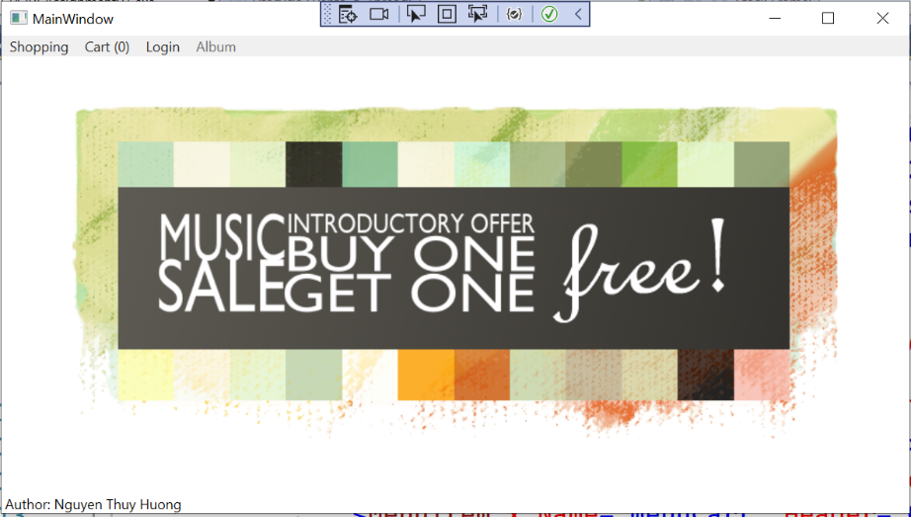

Requirements:

* Display menus: Shopping, Cart(0), Login, and Album (is enabled when the user is logged in as Administrator)
* Display Class ID and Group number and all members in the status bar (in the bottom of window).

# LoginWindow

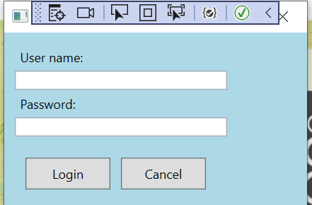

Requirements:

* Enter user name and password.
* Click the button “Login” and system will search this member in Database:
  + If it is not found, the following message will be displayed

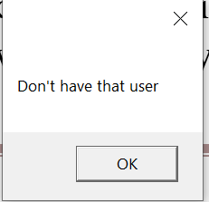

* + If that member is found, and his/her role is administrator, the MainWindow form will be displayed as below

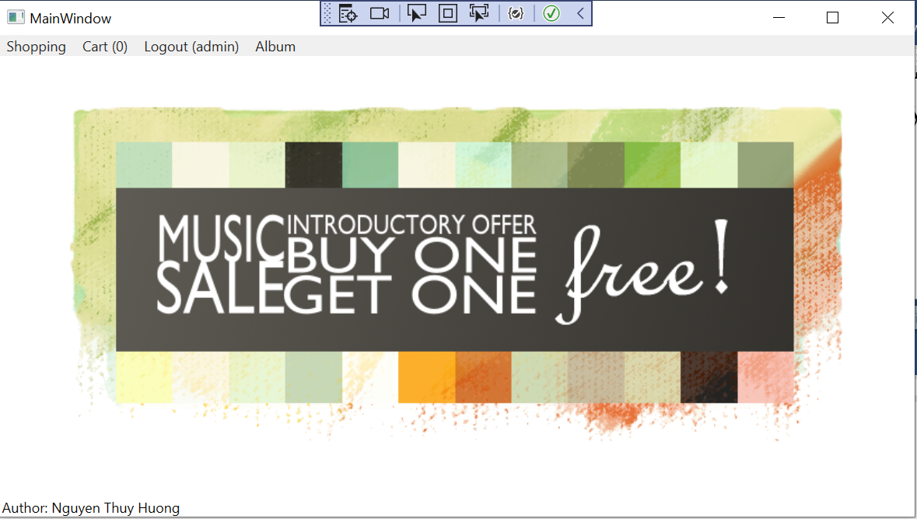

# ShoppingWindow

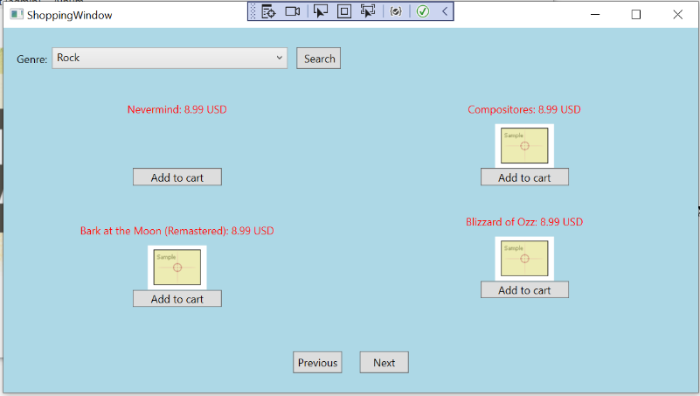

Requirements:

* List all albums for the selected genre. Each time only one page (maximum 4 albums) is displayed. Click button ‘Previous’/’Next’ to move to the previous/next page.
* Click button “Add to cart” to add that album to cart, then CartWindow will be displayed.

# CartWindow

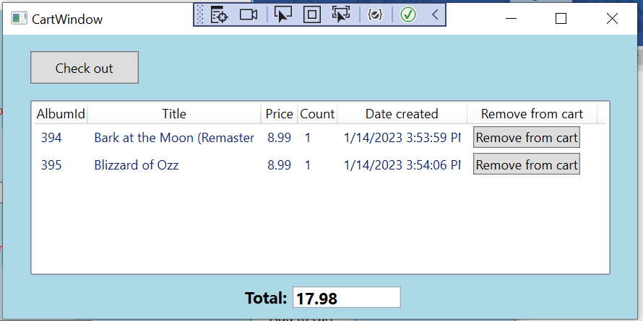

Requirements:

* Click the button “Remove from cart” to remove the given album from cart (Count will be decreased by 1 if count > 1, or that album will be remove from cart if Count = 1).
* Click the button “Checkout” (if you are already logged in and total value of Cart is greater than 0) to display “CheckoutWindow”.

# CheckoutWindow

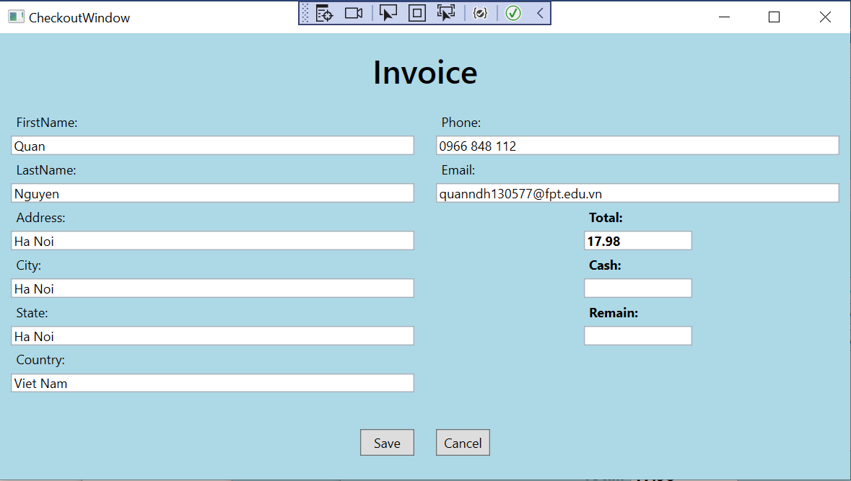

Requirements:

* Information of user logged in will be filled, and current system date will be considered as order date, the user can enter information as he/she wants.
* Click the button “Save” to save that order into Database, the following message will be displayed

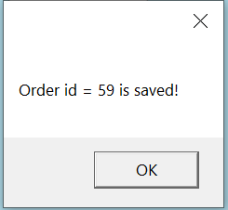

# AlbumWindow

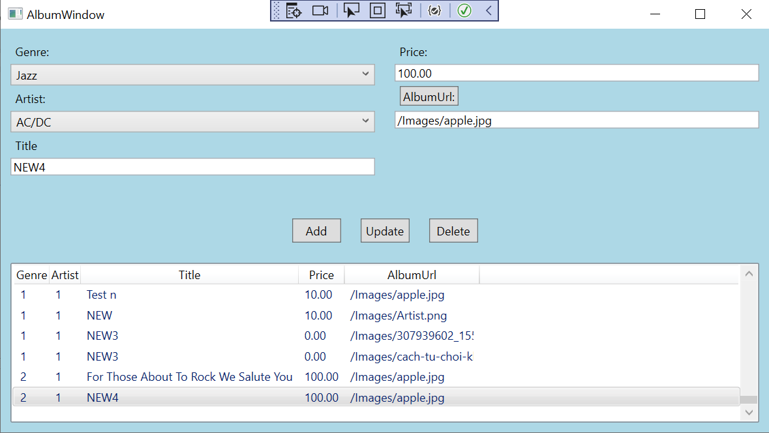

Requirements:

* List all albums in the ListView.
* If an album is selected, the information of that album will be displayed in the textboxes.
* Click the button “Delete”, then the following message will be displayed

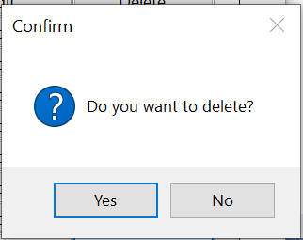

Then click the button “Yes” to delete that album from Database, and the following message will be displayed

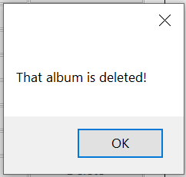

* Click the button “Add” to add that album to Database, then the following message will be displayed

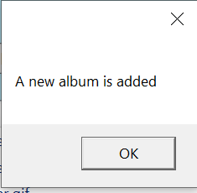

* Click the button “Update” to update that album in Database, then the following message will be displayed

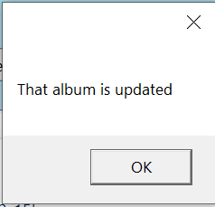

**General Requirements:**

* Your system must follow all rules described in Music Store system (in document “List of sample projects”.
* Your system must check input data and allow the user to enter again.
* Use Database “MusicStore” given in site “cms” and must use “localhost” for the name of DB server computer .
* Your solution name: ClassID_GroupN_A2.sln, and file name: ClassID_GroupN_A2.rar