**Lab 01 Report**

**Trần Đức Nam – 20215228**

1. **How to run.**

* Run the following commands on terminal



1. **Execution result of 3 examples**
   1. **Example 1**

Input:

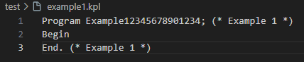

Output:

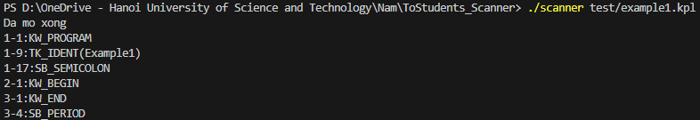

* 1. **Example 2**

Input:

Output:

* 1. **Example 3**

Input:

Output:

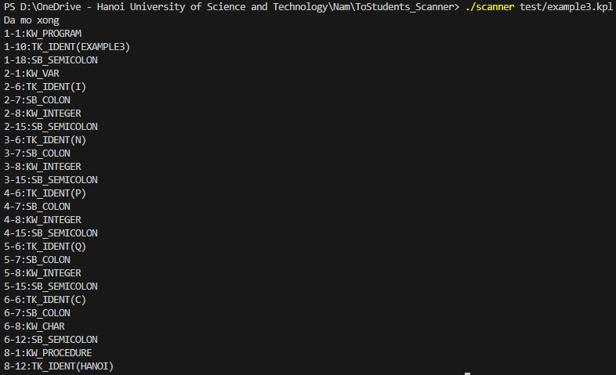

1. **Error detection**
   1. **Comment Unclosed**

Input:

Output:

* 1. **Identifier Too Long**

Input:

Output:

* 1. **Invalid Constant Char**

Input:

Output:

* 1. **Invalid Symbol**

Input:

Output:

* 1. **Number too long**

Input:

Output:

