**Lab 02 Report**

**Trần Đức Nam – 20215228**

1. **How to run.**

* Run the following commands on terminal

1. **Execution result of 4 examples**
   1. **Example 1**

Input:

Output:

* 1. **Example 2**

Input:

Output:

|  |  |  |
| --- | --- | --- |
|  |  |  |

* 1. **Example 3**

Input:

|  |  |
| --- | --- |
|  |  |

Output:

* 1. **Example 4**

Input:

Output:

1. **Error detection**
   1. **Invalid constant**

* 1. **Invalid type**

* 1. **Invalid basic type**

* 1. **Invalid parameter**

* 1. **Invalid statement**

* 1. **Invalid arguments**

* 1. **Invalid comparator**

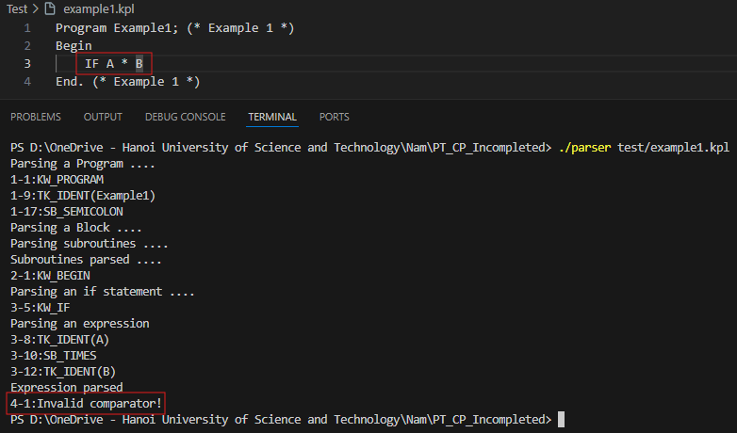

* 1. **Invalid term**

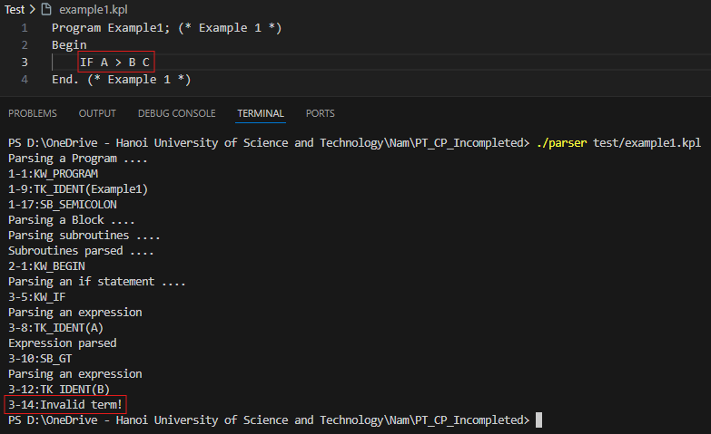

* 1. **Invalid factor**

