**Lab 03 Report**

**Trần Đức Nam – 20215228**

1. **How to run.**

* Run the following commands on terminal

1. **Execution result of one of given files**

Input:

Output:

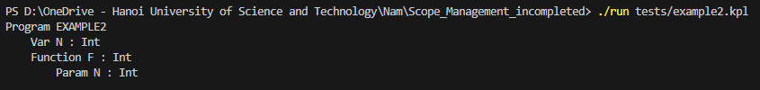

|  |  |  |
| --- | --- | --- |
|  |  |  |

1. **Error detection**
   1. **Undeclared procedure**

* 1. **Undeclared identifier**

* 1. **Undeclared type**

* 1. **Type inconsistency**

* 1. **Parameters arguments inconsistency**

* 1. **Duplicate identifier**

* 1. **Undeclared variable**

* 1. **Undeclared constant**

* 1. **Invalid procedure**

* 1. **Invalid indentifier**

