# scription of the Application

A large number of participants take part in programming courses every year. Participants need continuous programming practice in order to be able to correctly implement the concepts taught in programming classes. The programming assignments have to be evaluated by the instructors quickly, to help participants progress well. As a result, instructors will have high workload of grading each program. Moreover, the only way to assess a program is to run it against several sets of test data to verify its correctness. This is time consuming when done manually.

An automatic evaluation tool will reduce this workload. The web application developed by us is an automated system for assessment of solutions to programming assignments. It allows instructors to specify programming exercises for a group of participants. Participants can view the problem statements assigned to them, and work on the programs. They can also test their solution against a set of public test cases, available along with each problem statement. Once the participant uploads the solution, the system automatically grades the program based on the complete set of test cases. Instructors and students can see statistics about each programming assignment. Various kinds of reports can be generated from the system.

# Users and Use Cases

This web application will have two categories of users:

* Administrators
* Test Takers

A short list of use-cases (features) of the system is given below:

Use cases common to both users

* Login
* Logout

Use cases for Administrators

* Create a group of candidates
* Create a candidate
* Associate a group with a candidate
* Add an assessment
* Add a test case to an assessment
* Schedule an assessment - for a group or a test taker
* Update an assessment - activate, deactivate
* View assessment reports for a group or a test taker

Use cases for Test Takers

* View assigned assessments
* Start an assessment
* Compile and execute a solution
* View compilation & runtime results
* Submit a solution
* View reports

# Software Technologies Used

The web application has been developed using the following technologies:

* Java Development Kit
* Java Enterprise Edition
* Spring Framework
* Hibernate Framework
* MySQL Database Server
* Apache Tomcat Web Server

# System Design

We have followed the typical 3-tier architecture using the software technologies listed above. The components of each tier are given below.

# Database Design

An entity-relationship diagram depicting the database tables is given below:

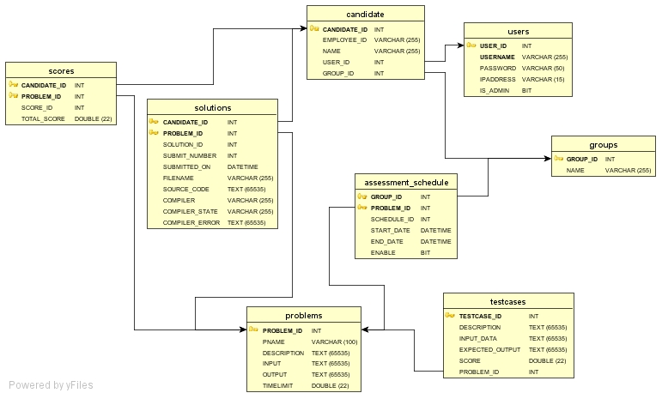

# User Manual

The following screenshots describe the usage of the system.

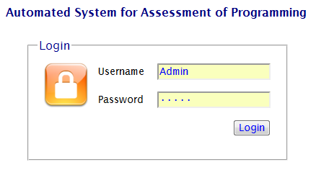

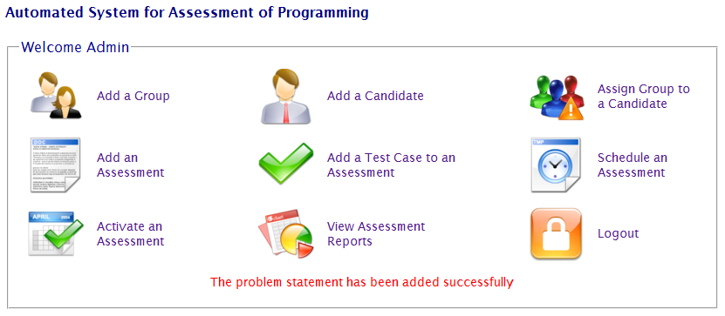

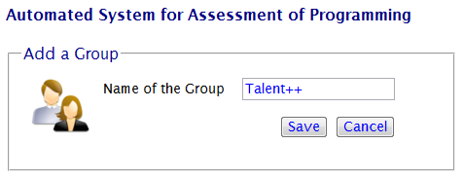

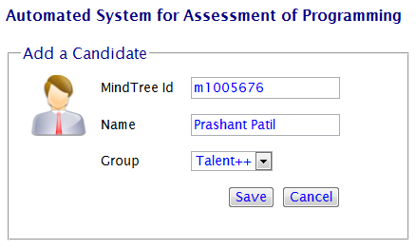

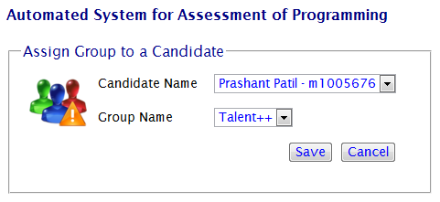

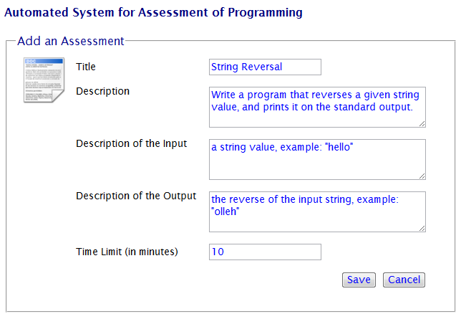

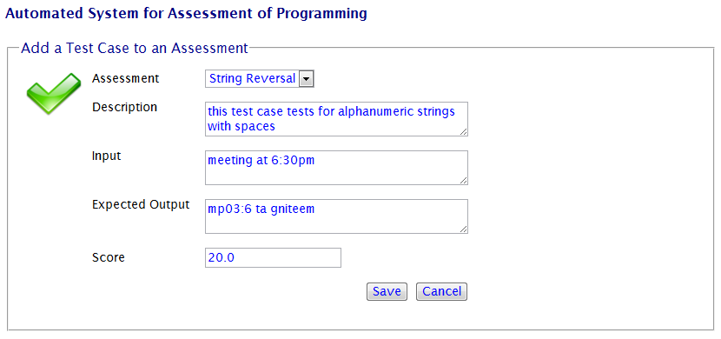

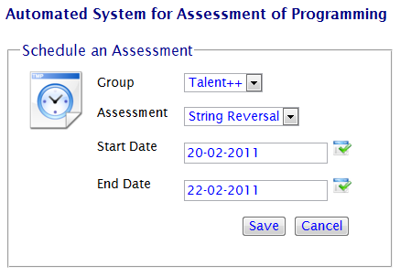

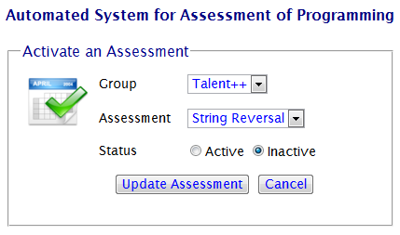

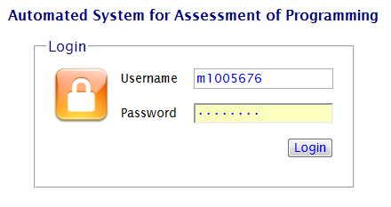

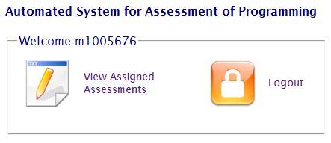

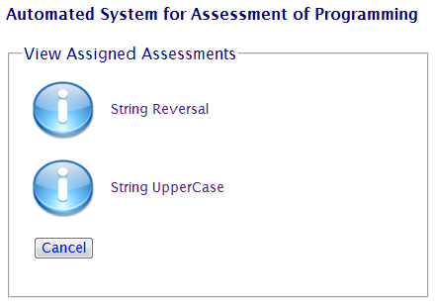

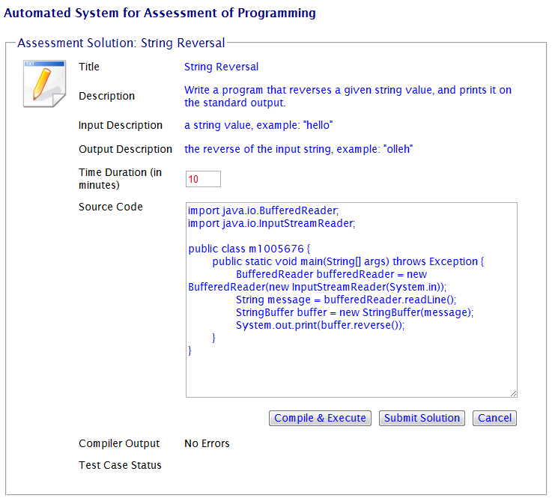

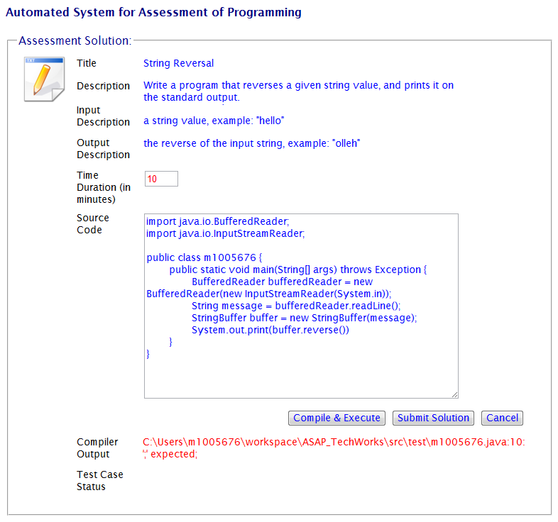

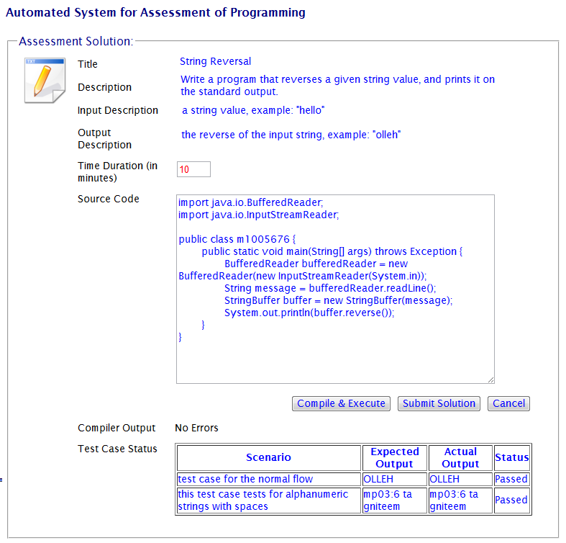

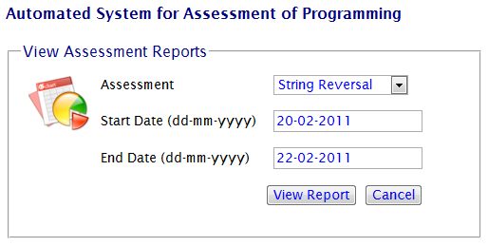

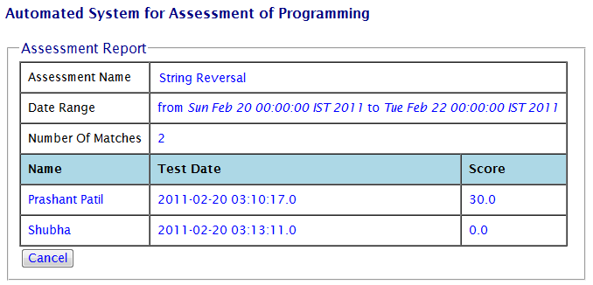

# Future Enhancements

The following enhancements are planned for the current system:

* Support for multi-file programs
* Support for web and database applications
* Enhanced security
* Plagiarism detection
* Code quality reports
* Generation of various other reports