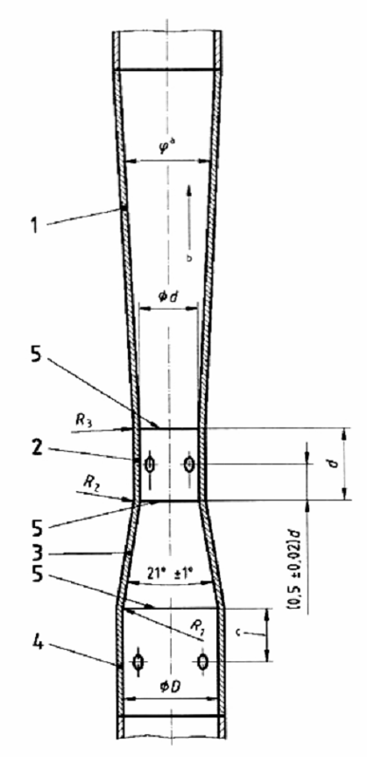

CHÚ DẪN:
1 Phần côn phân kỳ E
2 Cổ đo hình trụ, C
3 Phần côn hội tụ B
4 Đầu vào hình trụ A
5 Mặt phẳng nối
ª 7° ≤ ϕ ≤ 15°
^{b} Hướng dòng chảy
^{c} Xem 5.4.7

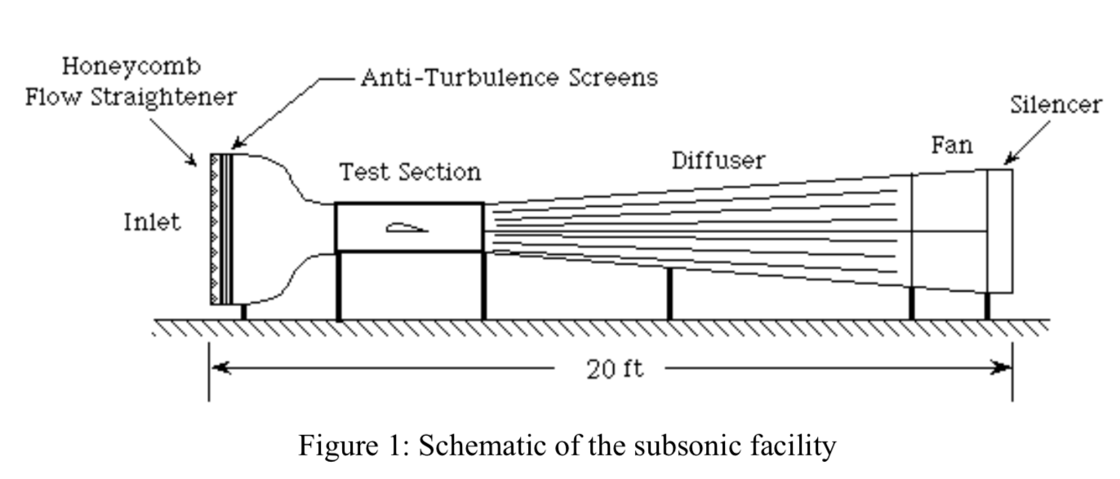

I. Cấu trúc của hệ thống chuẩn gió
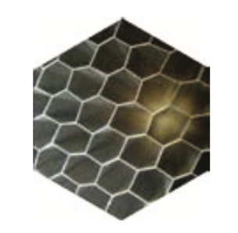
1. Thiết bị nắn dòng dạng tổ ong (Honeycomb Flow Straightener)
- Aluminum
- 4-inch deep hexagonal cells
- Removable for cleaning
- Turbulence-reducing Screens
• Two 20 x 20 (mesh) screens made of 0.009” (0.23mm) diameter stainless steel wire Contraction (bell mouth) Contour
- Proprietary design used on all AEROLAB wind tunnels
- 9.5:1 contraction ratio Static Pressure Ring
- Access to test section static pressure for non-intrusive q/V measurements
- Consists of four pressure ports – one on each wall just prior to test section entrance w/ manifold Test Section
- Hard anodized aluminum structure
- Two top-hinged Acrylic side windows and one top window
- Integrated yaw table w/ engraved scale and prepared for optional model positioning system Diffuser Design
• Increases wind tunnel efficiency and overall flow quality Motor
• High-efficiency 10 hp (7.5 KW) electric motor Fan/Propeller
• High-efficiency
• 9-blade
• Balanced
Noise Attenuator
• Reduces noise w/ 2 layers of acoustic insulation Speed Controller
- Solid state Variable Frequency Drive (VFD)
- Accepts analog or digital remote control signals
- Built-in display is selectable for Hz, RPM, % power and Amps
- Adaptable to 208-240VAC, 380-480VAC and 50/60Hz Excellent Flow Quality
• Less than 0.2% turbulence
Functionality
• Easy to use
Mobility
• Four high-quality steel casters with polyurethane wheels

