TEST 2
(Time: 40 minute)

Question: (10 points)
You are given a database script, execute the script to get the database as shown in below figure:
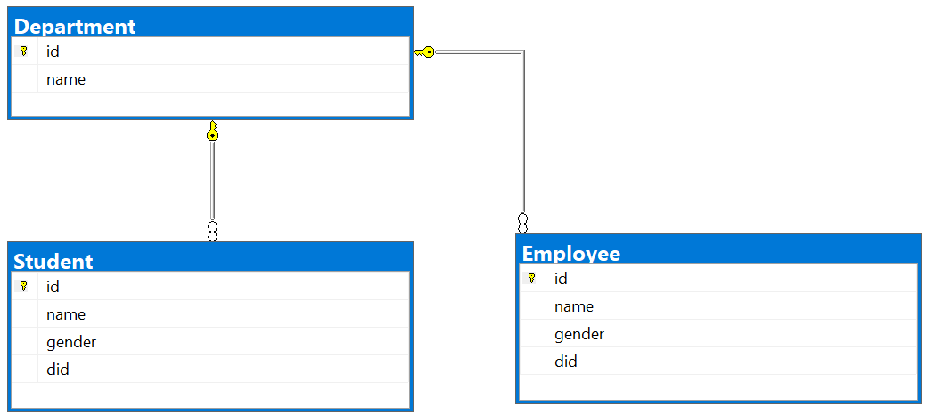
Note: Use given DbContext class to access the database, ONLY MODIFY the url, username, and password inside the DbContext. 0 will be given to the work that tries to restructured the DbContext.
Your task is to create a web page to allow users adding new Students:
- Url to access your page: /add (0 given for a wrong URL)
- The page should be displayed as follows:
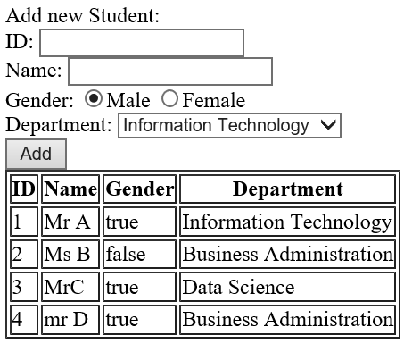
Existing students
New student info
- Departments are loaded from [Department] table (2 point)
- All existing Student are loaded to the table (3 points)
- When a user clicks [add] button, if the user enters to all field of new student info, the system inserts new student to the database (3 points)
- If new student added to database successful, it immediately is shown to the table (current page still be kept, DO NOT CHANGE PAGE URL) (2 point)

