1. Consider the results are stored in following format:

EmpID Name Subject Marks(/50)

E001 Nilesh Unix 30

E002 Suresh DSA 20



Like these you have 10 records ( 5 of DSA and 5 of Unix)

1. Display First 5 records.



1. Display Employees who belongs to subject Unix



1. Display employee names that got less than 30 marks in DSA subject.

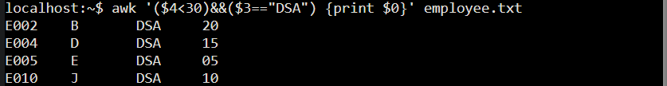

1. Display only even numbered records



1. Display Employee id of records whose name start with N.

+++++ (Used B here)+++++

