1.

a.

b.localhost:~$ sed -n '1,5p' employee.txt

c.localhost:~$ sed 's/Chennai/Pune/g' employee.txt

d.localhost:~$ sed -e 's/e/UNIX/' employee.txt

e.localhost:~$ sed '/^$d' employee.txt

f.localhost:~$ sed '3,5d' employee.txt

Using SED Commands

1.Create a file “Employee.dat” with text as follows.

James 76382 PACE Chennai

John 34228 GRIT Hyderabad

Peter 22321 GE Bangalore

Albert 32342 GRIT Pune

Mathew 23222 PACE Mumbai

Richard 23232 ACS Pune



a) Write a sed command to print only the lines starting at line 2 and

ending with the letters “Pune”



b) Write a sed command that will display the top 5 lines from the file



c) Write a sed command that will substitute the word “Chennai” for "Pune" used

in all instance of the word



d) Write a sed command that will replace occurrence of the character e

with the string UNIX in all lines. (Use –e option)

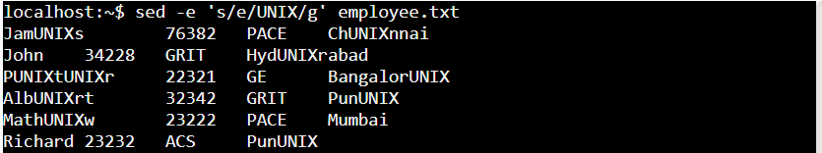

e) Write a sed command to delete blank lines



f) Write a sed command to delete lines from 3 to 5



2: Create a new file “PACE.dat which has only the lines that contain the word “PACE” from Employee.dat

