Name:Ma Shaoxuan
Student ID:1155251596

Work process
When customer upload a picture,the ai agenr will identify all the elements in this picture and output result in a fixed format,like:
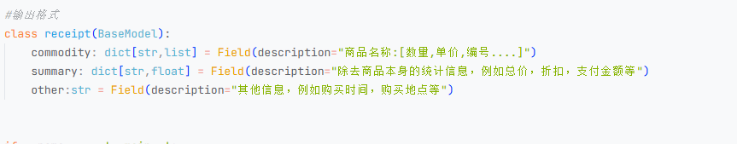
The result will be record and use for the next step.Users can pose a question like: How much money did I spend in total for these bills ,then the agent will answer it based on the data from the picture.
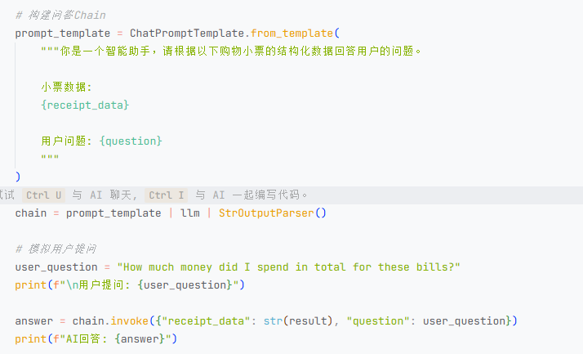

Results:
Query 1: How much money did I spend in total for these bills?
Picture:
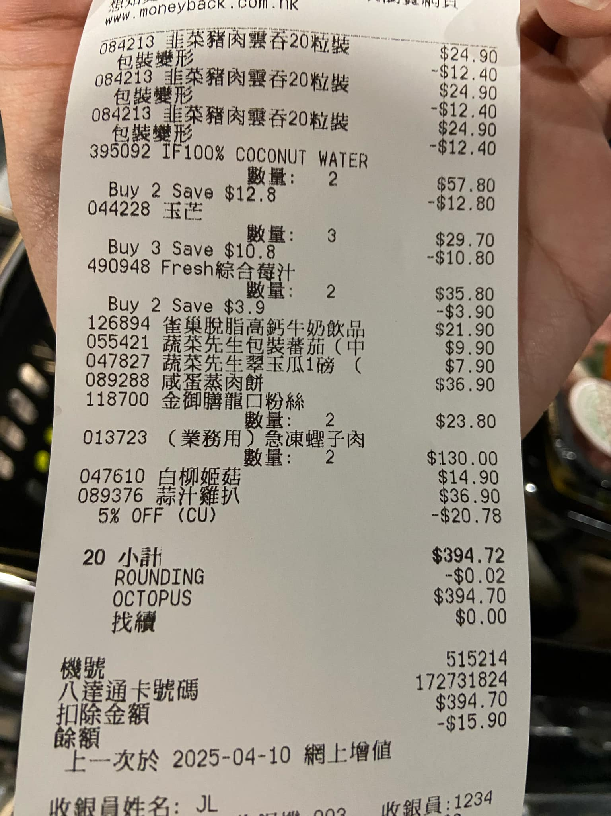
Data from the receipt:
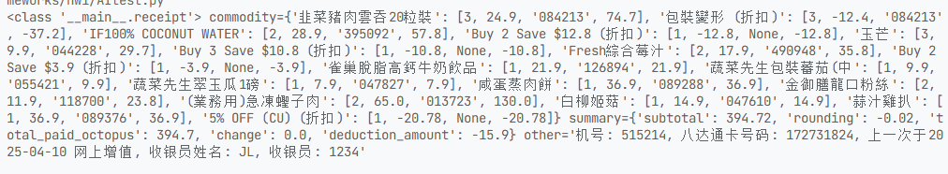
Answer:

Query 2: How much would I have had to pay without the discount?
Data from the receipt:
Answer:
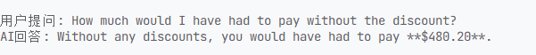
Ask for the calculation process:
