

***Dealer Fire Honda Compliant Images***

***DB Application***

Installation of required software

(for Windows only)

1.1 Install Python 2.7

1.1.1 Go to [*www.python.org*](http://www.python.org)

1.1.2 Click the download tab

1.1.3 Click *Python 2.7.4 Windows Installer x86 MSI Installer* (see Figure 1)

**Note: It is important that you install the 32-bit version of Python to ensure the application will run correctly**

**Figure 1**

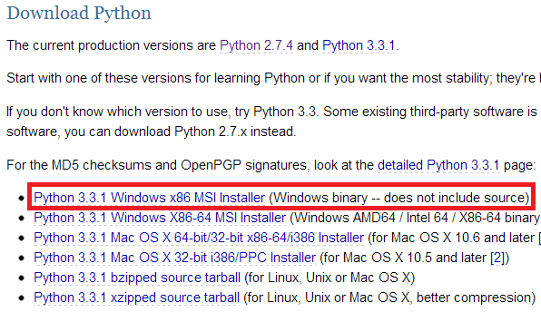

1.1.2 Run the downloaded file to install Python 2.7

1.2 Install cx_Oracle

1.2.1 Go to [*cx-oracle.sourceforge.net*](cx-oracle.sourceforge.net)

1.2.2 Click *Windows x86 Installer (Oracle 10g, Python 2.7)* (see Figure 2)

**Note: In order for the application to work, you must use the version for Python 2.7**

**Figure 2**

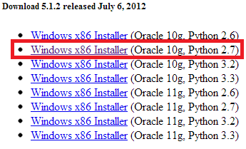

1.2.3 Run the downloaded file to install cx_Oracle

1.3 Install wxpython

1.3.1 Go to [www.wxpython.org](http://www.wxpython.org)

1.3.2 Click the *Stable* link under *Download* (see Figure 3)

1.3.3 Click *wxPython2.8-win32-unicode-py27* (see Figure 4)

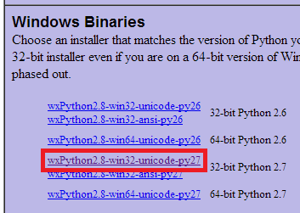 **Figure 4**

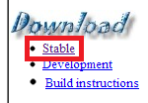**Figure 3**

1.3.4 Run the downloaded file to install wxpython

Setting up the environment

2.1 Setting up Oracle

2.1.1 To ensure you are able to use the database, you must use the correct logon and connection for Oracle

2.1.1.1 On most systems, the username is *system* and the password is *system.* If yours is not, make sure you find out what it is before continuing

2.1.1.2 Once you find out what your username and password is, open the python application file, *project app.py*, and put in the correct username and password in the connect function

2.1.2 Next, once you’re sure you know what the username and password is, go to your *Oracle SQL Developer* application to set up a new connection

2.1.2.1 When the *New / Select Database* dialog pops up, choose any connection name then put in your username and password

2.1.2.2 Test your connection and click *Save*

2.1.3 Finally, open *db.sql* and run the script. This will create all of the tables and import all of the values

2.2 Setting up the file system

2.2.1 The point of our application is to have pictures so we need to make sure the pictures are in the right location

2.2.2 If it is not labeled as such already, make sure the folder containing the compliant images is labeled *2012HondaComplianceImages*

2.2.3 Next, move the folder to the C: drive so the application is able to access them

Running the application

3.1 Open the application by double-clicking *project app.py*

Application features

4.1 Dropdown menus

4.1.1 The application has several dropdown menus, each of which is used as a filter. The dropdown menus and their descriptions are as follows:

4.1.1.1 Year: the year of the model of car

4.1.1.2 Make: the manufacturer of the car, e.g. Honda, Ford, Chevy, etc. (this application only uses Honda compliant images)

4.1.1.3 Model: the model of the car, e.g. Civic, Corvette, Focus, Challenger, Prius, etc. (this application only uses Honda models)

4.1.1.4 Type: the type of car, e.g. Sedan, Coupe, Crossover SUV, Hybrid, Large SUV

4.1.1.5 Trim: the specific type of model, eg. SE, DX, etc.

4.1.1.6 Color: the color of the car

4.1.2 In order to use the filter, simply select the desired filter from the dropdown menus and the result will be listed in the results area in the bottom half of the screen

4.1.3 To view the picture, double click the desired result

**Note: If you wish to reset the filter, you must restart the application**