

**Functional Requirements & Design (FRD) Document**

(Version 1.0)

***Document Overview***

|  |  |  |  |
| --- | --- | --- | --- |
| Title | FRD_GFTN_V1.0.docx | Version | V1.0 |
| Project | GFTN | Status | Released |
| Client | Mr. Samuel | Type | Internal / External |
| Author | Mr. Rajendra | Last Save | Apr, 03 2018 |
| Reviewed By | Mr. Keerthi Venkatesh | | |  |
| Comments: | | | |
|  | | | |

***Revision History***

|  |  |  |  |  |
| --- | --- | --- | --- | --- |
| **Ver. #** | **Rev Date** | **Author** | **Dist. Date** | **Brief Description** |
|  |  |  |  |  |
|  |  |  |  |  |
|  |  |  |  |  |

***Distribution List***

1. ***Baryons Stakeholders***
2. ***Delivery Team***

***Approved By***

|  |  |  |
| --- | --- | --- |
| **Name** | **Role** | **Version** |
|  |  |  |
|  |  |  |
|  |  |  |
|  |  |  |

Contents

1. Context: 6

2. GFTN Screens & User Stories 7

2.1 User Story: Admin Login and Logout 7

2.2 User Story: Home Page 7

3. User Management 9

3.1 Add User 9

3.2 Edit User 9

3.3 List User - With Filters 9

4. Company Management 10

4.1 Edit List Company - Group by Country - User Access Oriented 10

4.2 List Company - Browse by Company 11

4.3 List Company - Browse by Country 12

5. Add Company 13

5.1 Add Legal Entity 13

5.2 Add Logo 13

5.3 Add / Edit Documents - Legal Entity 14

6. Company - Legal Entity – View 16

6.1 View Company - Legal Entity 16

6.2 View Company - Sidebar - Legal Entity 16

6.3 View Documents - Legal Entity 16

7. Company - Trade View 17

7.1 View Company – Trade 17

7.2 View Progress Report – Trade 18

8. Company - Forestry View 19

8.1 View Company – Forest 19

8.2 View Progress Report – Trade 21

9. View/Edit Due Diligence 22

9.1 Strategic Rating – Forest 22

9.2 Screening Documents 23

9.3 Strategic Rating – Trade 23

10. Company - Legal Entity – Edit 24

10.1 Edit - Legal Entity 24

10.2 Edit – Documents 24

11. Company - Trade – Edit 25

11.1 Edit – Trade 25

11.2 Edit - Documents 25

11.3 Edit - Progress Report 25

12. Company - Forest -Edit 28

12.1 Edit – Forest 28

12.2 Edit – Documents 30

12.3 Edit - Progress Report 30

13. Products 31

13.1 Add Products 31

13.2 Add Species 31

14. Global Statistics 33

15. Country Wise Statistics 33

16. Monitoring Tools 34

Table of Contents of User Stories

|  |  |
| --- | --- |
| **SL No** | **User Stories** |
| 1 | Home |
| 2 | User Login / Logout |
| 3 | User Management |
| 4 | Company Management |
| 5 | Add Company |
| 6 | Company - Legal Entity - View |
| 7 | Company - Trade View |
| 8 | Company - Forestry View |
| 9 | View/Edit Due Diligence |
| 10 | Company - Legal Entity - Edit |
| 11 | Company - Trade - Edit |
| 12 | Company - Trade - Forest -Edit |
| 13 | Products |
| 14 | Global Statistics |
| 15 | Country Wise Statistics |
| 16 | Monitoring Tools |
|  |  |
|  |  |
|  |  |
|  |  |

# Context:

WWF team was having an Tender management application. The application Frontend was done in ColdFusion and backend database was Oracle. Now WWF team need to revamp the Frontend application. For that they have migrated the backend database from Oracle to MSSQL and provided a MSSQL backup file to Baryons, shared the details and high-level understanding of DB and provided the application mockups in a document ‘GFTN Web Migration.docx’

Baryons must create the frontend application which will use MSSQL as backend. Baryons will develop the frontend using PHP MVC Framework (CodeIgniter)and other web technologies like HTML 5, CSS (Bootstrap framework), jQuery.

# GFTN Screens & User Stories

# User Story: Admin Login and Logout

Admin should access the GFTN URL to Login to the application and should logout from the application.

# User Story: Home Page

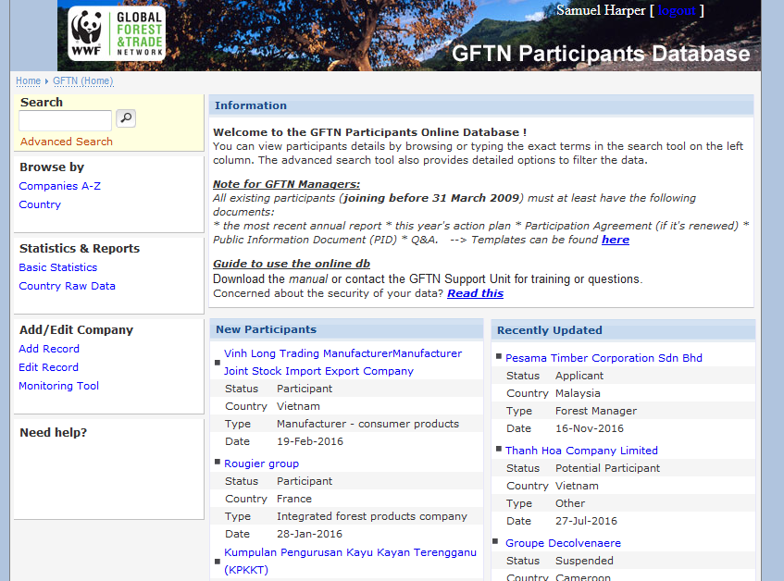

Header:

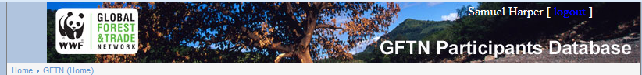

Footer:



Sidebar:

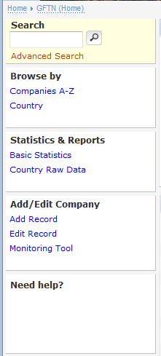

After Login, home page should be shown with Header, Footer and Side bar. Also new participants list and recently updated participants list should be shown.

# User Management

# Add User

As a admin, need to add the user to the system

# Edit User

As a admin, need to Edit the user details

# List User - With Filters

As a admin, need to get the list of users

# Company Management

# Edit List Company - Group by Country - User Access Oriented

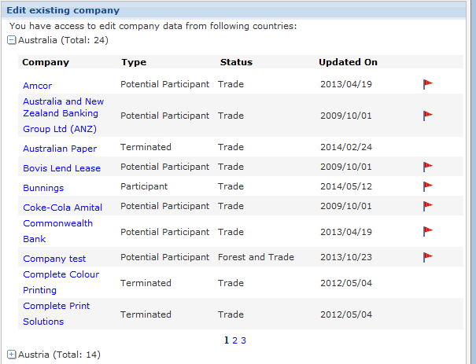

As a admin, need to edit the company details

# List Company - Browse by Company

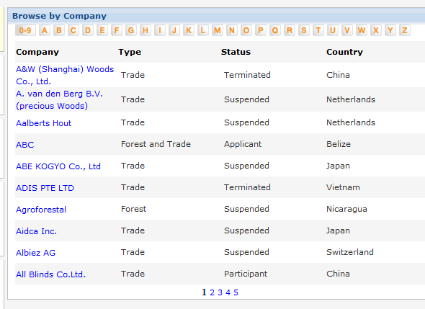

As a admin, need to search the company using company name as search filter

# List Company - Browse by Country

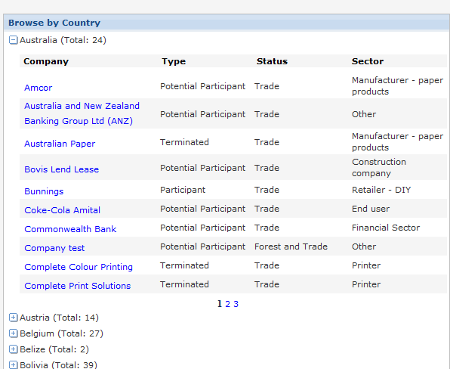

As a admin, need to browse the company using Country name as search filter

# Add Company

# Add Legal Entity

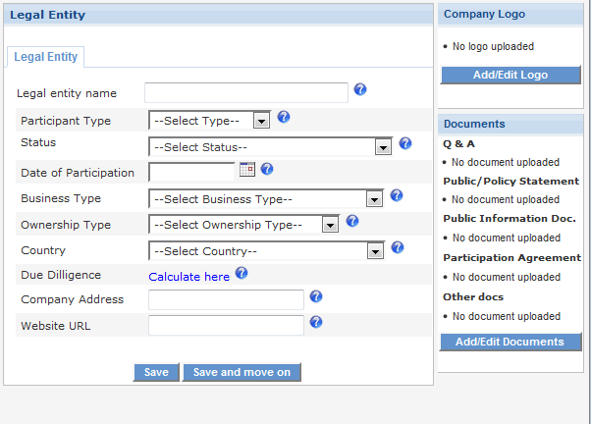

As a admin, need to Add Company details.

# Add Logo

As a admin need to Add Logo of the company while creation of company details

# Add / Edit Documents - Legal Entity

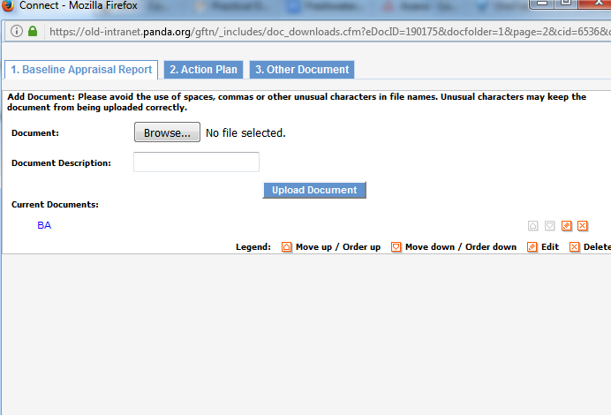

Action Plan:

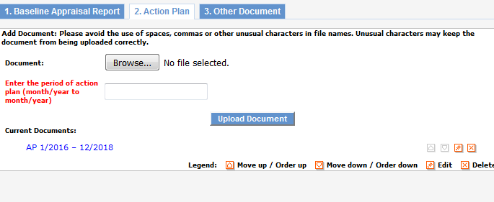

Other:

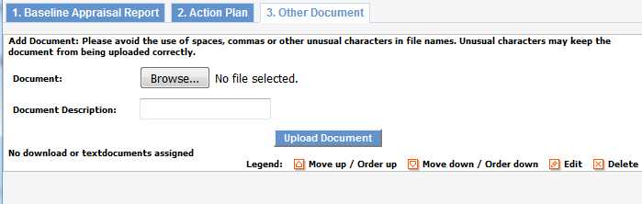

As a admin, need Documents should be uploaded for,

1. Baseline Appraisal Report
2. Action Plan
3. Other Document

# Company - Legal Entity – View

# View Company - Legal Entity

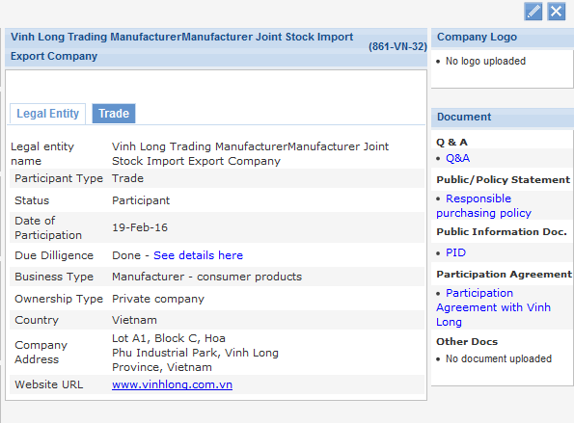

As a admin, need to view the Company details

# View Company - Sidebar - Legal Entity

As a admin, need to view the right-side bar as shown

# View Documents - Legal Entity

As a admin, need to view the Documents uploaded for the company- legal entity in the right-side bar as shown

# Company - Trade View

# View Company – Trade

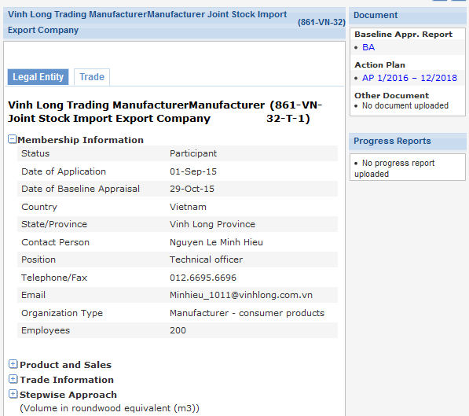

As admin, need to view the Trade details of the company

Expanded:

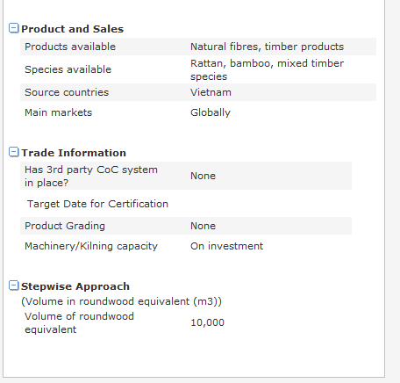

# View Progress Report – Trade

# Company - Forestry View

# View Company – Forest

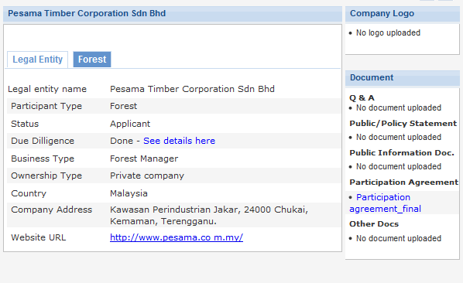

As a admin, need to view the Forest details of the company

Forest details:

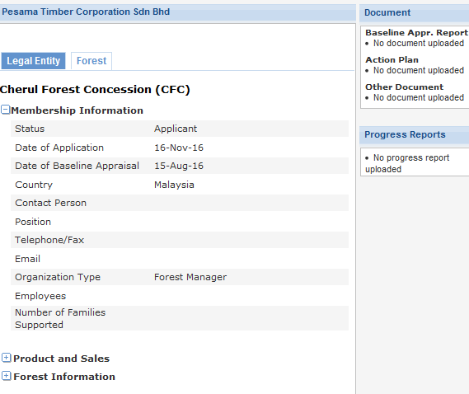

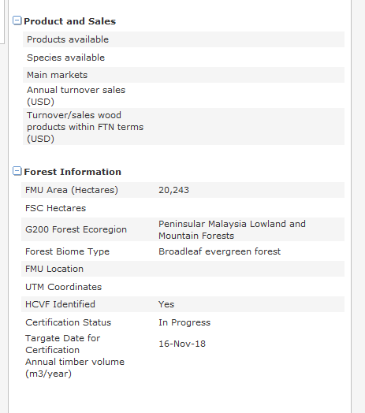

# View Progress Report – Trade

# View/Edit Due Diligence

# Strategic Rating – Forest

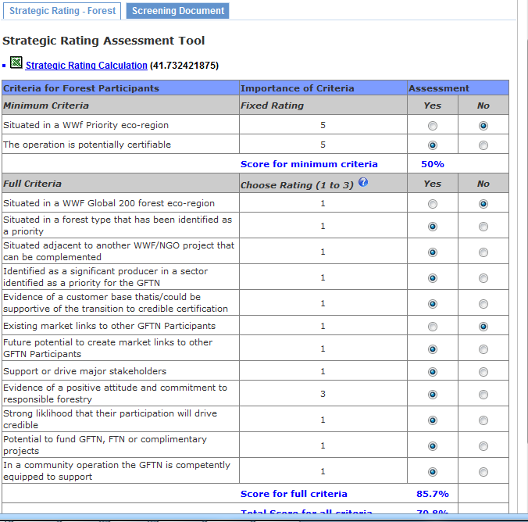

# Screening Documents

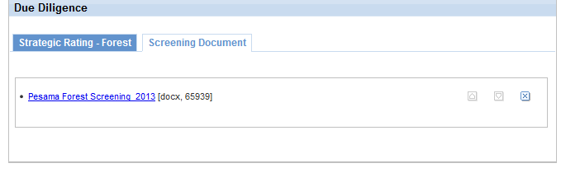

# Strategic Rating – Trade

# Company - Legal Entity – Edit

# Edit - Legal Entity

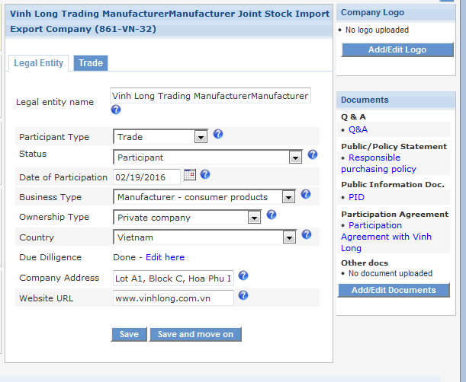

As a admin need to edit the company legal entity details

# Edit – Documents

As a admin need to edit the company legal entity documents

# Company - Trade – Edit

# Edit – Trade

# Edit - Documents

# Edit - Progress Report

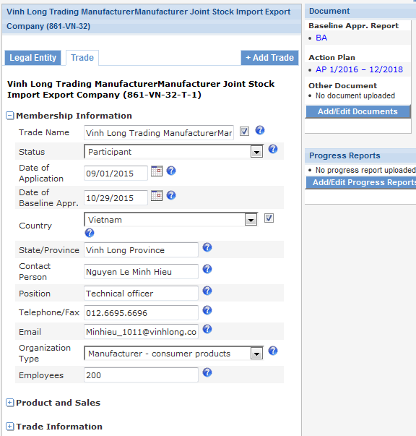

More info:

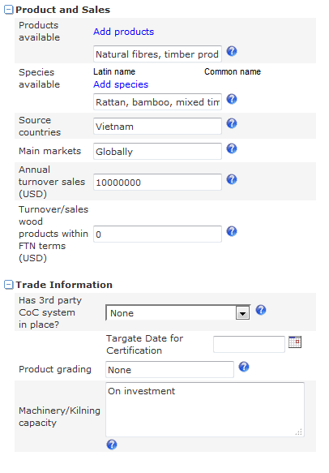

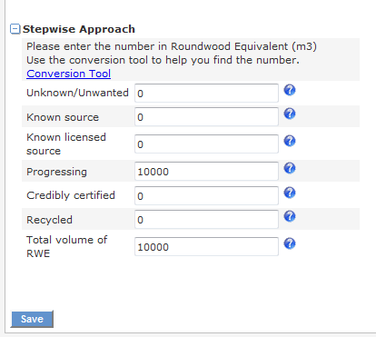

As a admin need to edit the company trade details

# 12. Company - Forest -Edit

# Edit – Forest

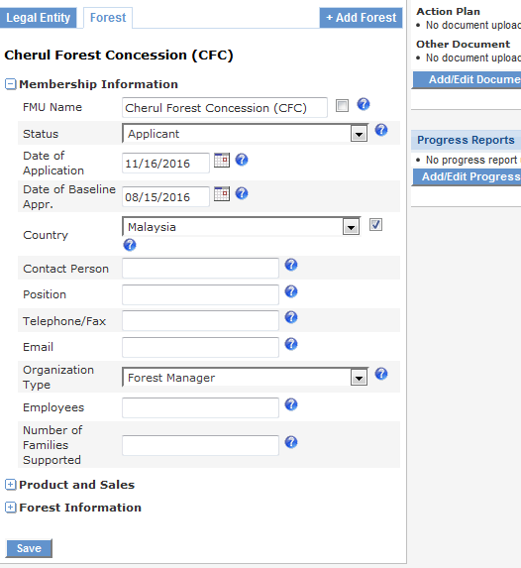

As a admin need to edit the company Forest details

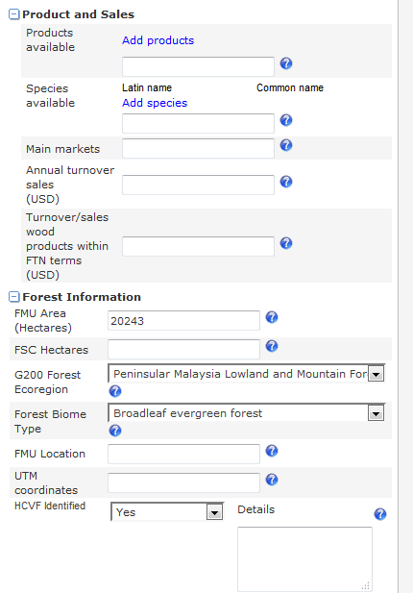

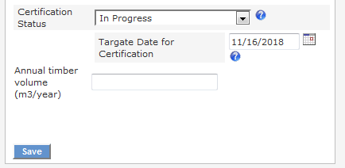

# Edit – Documents

As a admin need to edit the company Forest documents

# Edit - Progress Report

# Products

# Add Products

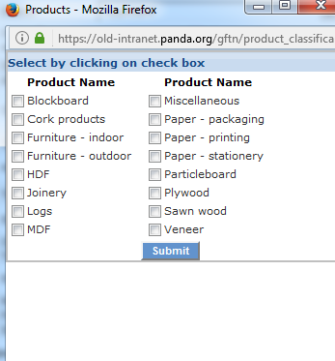

As a Admin need to add the Products

# Add Species

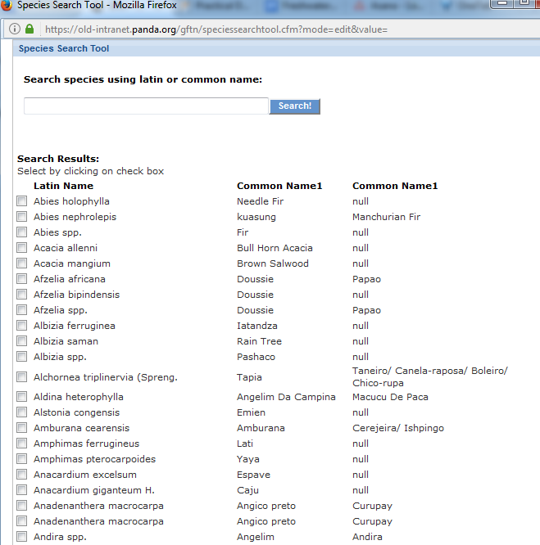

As a Admin need to add the Species

# Global Statistics

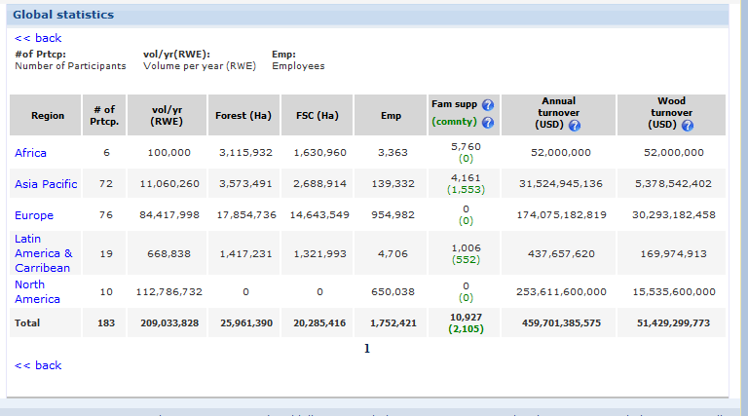

# Country Wise Statistics

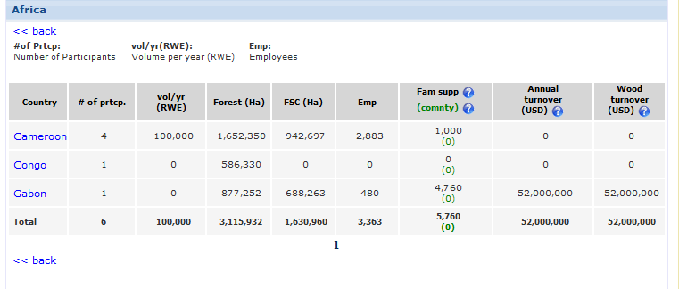

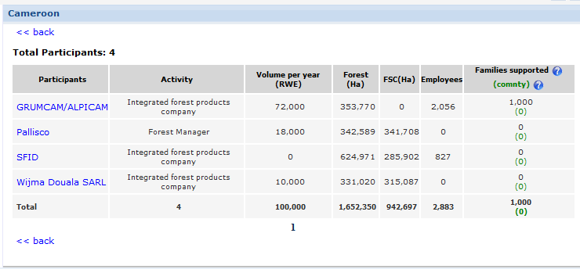

# Monitoring Tools

