Synergizing Data Organization: Novel Paths in Conversation and Analysis

Laxman.B
Department of CSE(Data Science)
CMR Technical Campus
Hyderabad, India
sailaxman24@gmail.com
Nenavath Raviteja
Department of CSE(Data Science)
CMR Technical Campus
Hyderabad, India
nenavathraviteja07@gmail.com
Mohammad Kammar Ahmed
Department of CSE(Data Science)
CMR Technical Campus
Hyderabad, India
mdqamarahmed123@gmail.com
Chebrolu Leela Krishna
Department of CSE(Data Science)
CMR Technical Campus
Hyderabad, India
krishnarocksliki@gmail.com
Katukuri Ashwitha
Department of CSE(Data Science)
CMR Technical Campus
Hyderabad, India
ashwithakatukuri@gmail.com

Abstract— Extracting actionable intelligence from unstructured documents is a persistent challenge for organizations, researchers, and professionals. Valuable information within PDFs, Word files, presentations, HTML, and plain-text formats is often locked away, making manual extraction and analysis slow, error-prone, and dependent on specialized expertise. These limitations result in inefficient processes and limited insight-generation capabilities. With recent advances in artificial intelligence and machine learning, automated solutions for document intelligence can now deliver fast, accurate, and scalable data extraction. ArixStructure provides a comprehensive, AI-powered platform for end-to-end document analysis and structuring. Implemented as a multi-page Streamlit web application in Python, ArixStructure seamlessly processes diverse input formats—including PDF, Word, PowerPoint, HTML, CSV, and TXT—making it applicable across business and research domains. At the core of ArixStructure is an intelligent pipeline using advanced open-source parsing libraries and Hugging Face’s deep learning models, securely integrated via API. The system automatically validates, parses, and structures uploaded documents, extracting text, tables, images, and metadata in real time. Advanced text analytics—including TF-IDF vectorization and cosine similarity via scikit-learn—enable rich document comparisons, semantic search, and context-aware retrieval. Processing documents in just minutes, ArixStructure delivers consistent accuracy and reliability, drastically improving efficiency compared to manual workflows. Its intuitive interface allows users without coding expertise to upload, analyze, visualize, and export structured results effortlessly. By automating document structuring and analysis, ArixStructure demonstrates the transformative effect of AI in knowledge management, compliance, and business operations. As a scalable, open-source solution, it empowers users to extract actionable insights from previously inaccessible, unstructured data, paving the way for new advances in automated content understanding..
Keywords- document intelligence, automation, artificial intelligence, deep learning, natural language processing, semantic search, multi-format parsing, Streamlit, Hugging Face, information extraction, scalability, real-time analytics.

Introduction
Unstructured data in the form of digital documents—such as PDFs, Word files, presentations, HTML, and plain text—constitutes a vast and rapidly growing resource in today's information-driven world. For organizations, academic institutions, and professionals, extracting actionable intelligence from these heterogeneous sources remains an ongoing challenge. Manual document processing is often tedious, time-consuming, and relies heavily on specialized expertise, resulting in inefficiencies and inconsistencies, particularly when dealing with complex or large-scale data. The inability to quickly access and analyze relevant information not only hampers productivity but also inhibits timely decision-making in sectors such as business analytics, research, compliance, and knowledge management. The advent of Artificial Intelligence (AI) and advances in Natural Language Processing (NLP) have ushered in a new era of intelligent automation for document analysis. AI-driven methods, particularly those leveraging deep learning and modern transformer models, have demonstrated unprecedented accuracy in extracting, classifying, and understanding complex patterns in text, tables, and images—bypassing the need for manual rule-based systems. Techniques such as semantic search, question answering, text summarization, and named entity recognition have shown tremendous promise in converting unstructured content into meaningful, structured data suitable for further analysis and automation. This project introduces ArixStructure, a comprehensive, automated document analysis platform built as a multi-page Streamlit application in Python. Utilizing advanced parsing libraries and Hugging Face’s state-of-the-art deep learning models, ArixStructure can process and intelligently structure a wide range of document formats—PDF, Word, PowerPoint, HTML, CSV, and TXT. Through systematic preprocessing, structural extraction, and deep text analytics (including TF-IDF vectorization and semantic comparison), the system enables efficient, automated conversion of unstructured files into structured, queryable datasets. ArixStructure further incorporates an intuitive user interface, allowing users to seamlessly upload documents and receive real-time, structured extractions, AI-powered summaries, semantic search results, and interactive data visualizations. The platform dramatically reduces manual workload, ensures high accuracy, and enhances accessibility for users with varying technical expertise. By integrating the power of artificial intelligence into document management workflows, this project contributes to the ongoing digital transformation, empowering users to unlock hidden value in unstructured data and streamlining information processing across a multitude of domains..

literature survey

Zhang, Q. et al. (2024). Document parsing unveiled: Techniques, challenges, and prospects for structured information extraction..

This paper provides a comprehensive survey of document parsing, serving as a critical foundational reference for structured information extraction. It systematically unveils the various techniques used across the pipeline, from physical layout analysis to logical structure recognition. The authors meticulously categorize existing methods, outline persistent challenges—such as handling complex table structures, heterogeneous formats, and low-resource languages—and map out future research prospects. This review is essential for contextualizing any document intelligence project within the broader technological landscape.

Luo, C. et al. (2024). LayoutLLM: Layout instruction tuning with large language models for document understanding.
This work addresses the challenge of making Large Language Models (LLMs) layout-aware for improved document processing. The authors introduce LayoutLLM, which leverages layout instruction tuning to condition LLMs not just on text content but also on the visual and spatial arrangement of elements. By explicitly training models to follow layout-based instructions, this research significantly enhances the LLM's capability for complex document understanding tasks like form filling, table extraction, and reasoning over multimodal inputs. It highlights the trend toward layout-centric LLM fine-tuning.

Nerella, S. et al. (2024). Transformers and large language models in healthcare: A comprehensive survey.
While focused on the healthcare domain, this paper provides a valuable comprehensive survey on the application and adaptation of Transformer models and Large Language Models (LLMs). It details how these advanced architectures are utilized for tasks such as information extraction, named entity recognition, and decision support. The survey is relevant for understanding the practical scalability, ethical considerations, and real-world performance of LLMs in highly sensitive, data-rich environments, which can be generalized to any enterprise document analysis platform.

Modi, A. et al. (2023). Semantic similarity for text comparison between textual documents using TF-IDF and cosine similarity measures.
This research is essential for the semantic analysis component of document intelligence. The authors investigate methods for calculating semantic similarity between textual documents. Their work specifically validates the efficacy of combining Term Frequency-Inverse Document Frequency (TF-IDF)—a foundational statistical measure for weighting word importance—with Cosine Similarity to quantify the degree of resemblance between document vectors. This technique is crucial for applications like automated document comparison, clustering, and context-aware retrieval.

Akkasi, A. et al. (2024). Job description parsing with explainable transformer-based ensemble models for skill extraction.
This paper focuses on a specific information extraction task—parsing job descriptions—using explainable Transformer-based ensemble models. The methodology underscores the need for explainability in production-grade information extraction systems. By using Transformer-based models, the work demonstrates high accuracy in skill extraction while providing insights into the model's decision-making process. This validates the use of ensemble and Transformer models for fine-grained, high-precision extraction tasks from unstructured text.

Proposed methodology

Modular Pipeline Architecture and Multi-Format Ingestion.
The ArixStructure framework is built upon a modular pipeline architecture, designed for adaptability and scalability. The initial stage focuses on Data Ingestion, supporting direct upload and processing of diverse file formats, including highly complex and visually rich documents such as PDFs, Word files, PowerPoint slides, HTML documents, CSVs, and plain text. This broad compatibility ensures the system acts as a unified data source. The entire framework integrates various advanced parsing libraries and state-of-the-art transformer models into a single cohesive system, allowing for specialized processing of each format while maintaining a standardized output structure for downstream analysis.

Advanced Preprocessing and Semantic Segmentation
Documents proceed to a critical preprocessing stage, which is vital for optimizing data quality and enhancing model performance. This process begins with Format Detection and Normalization to resolve inconsistencies in character encoding, structure, and visual presentation, converting all content into a unified textual and layout-aware data stream. Crucially, the system employs Semantic Segmentation (or chunking), where content is intelligently divided into logical units—based on context, section breaks, and semantic coherence—rather than arbitrary length, ensuring that contextual relationships are preserved, which is essential for accurate deep learning interpretation in the next stage.

Context-Aware Deep Learning Extraction Engine
The core of the system’s intelligence resides in the Document Analysis Engine, which leverages context-aware deep learning models, built upon refined transformer architectures. These models are meticulously trained to surpass simple keyword matching by processing the semantic segments to understand contextual relationships and the deeper semantic meaning embedded in the text. The engine is tasked with reliably identifying and extracting key content, entities, facts, and figures from across the documents, thereby serving as the primary mechanism for transforming raw, disparate textual and visual data into unified, actionable, structured datasets.

Robust Handling of Structural and Multi-Modal Data
A crucial aspect of the methodology is its capability for robust data handling of complex structural and multi-modal elements that typically challenge automated parsing. The system includes specialized components for the intelligent recognition and organization of tables, where algorithms meticulously reconstruct row-column relationships and manage merged cells; it also handles images, extracting them for potential visual analysis or linking them to nearby captions and descriptions as supplementary metadata. This stage ensures that all non-textual elements are accurately located, extracted, and correctly mapped back into the final logical document structure, maintaining the document's original integrity.

Semantic Search and Analytical Layer Integration
The framework integrates a sophisticated Semantic Search and Analytical Layer to unlock the true value of the extracted structured data. This layer employs classical yet powerful NLP techniques, including TF-IDF (Term Frequency-Inverse Document Frequency) for weighted term importance and Cosine Similarity for vector space comparison. This integration empowers users with fast, powerful semantic search capabilities and allows for automated, high-precision document comparison, accelerating complex workflows such as legal review or competitive analysis, and thereby translating structured data into measurable, strategic insights.

Performance Benchmarking, Model Reusability, and User Interface
The final stage governs quality assurance and user access. Performance is continuously benchmarked using metrics such as extraction precision, query response time, and analytical consistency to ensure every data science workflow execution is rapid, reliable, and reproducible. Crucially, all trained models and analytic pipelines are saved and versioned for immediate and efficient reuse across new document batches, guaranteeing scalability. This entire powerful backend is delivered through a streamlined, user-friendly Streamlit-based interface, which provides real-time document upload capabilities, visual analytics, and advanced AI-powered summaries, empowering users without coding expertise to unleash the system’s capabilities.

System Architecture
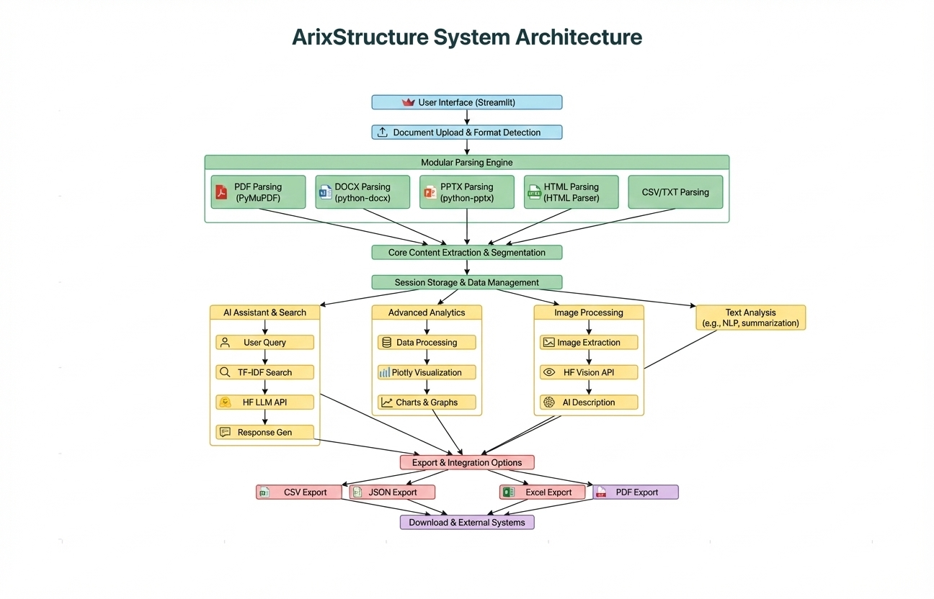
Fig1: System Architecture
ArixStructure features a modular, multi-layer architecture for efficient document intelligence. The Streamlit-based presentation layer enables intuitive uploads and interactive analytics, while the application logic controls workflow and session management. At its core, specialized modules handle parsing, extraction, and deep learning–powered analysis of multiple formats (PDF, Word, PowerPoint, HTML), augmented by advanced NLP and semantic search. The data layer securely manages all inputs, outputs, and model configurations. Data flows seamlessly from user upload through each layer, culminating in rich, actionable insights and exports for rapid, scalable knowledge discovery.

Workflow of ArixStructure.
ArixStructure follows a streamlined workflow for automated document intelligence. Users begin by uploading documents via the presentation layer's intuitive interface. The application logic then routes each file for parsing and format detection. In the analytics layer, deep learning models and specialized libraries extract text, tables, images, and metadata, followed by NLP-based semantic analysis and search. The processed, structured data is visualized instantly and made available for export, with all files and configurations securely managed within the data layer. This end-to-end pipeline ensures rapid, consistent transformation of unstructured documents into actionable knowledge.

result and discussion

High Fidelity in Structural Data Extraction.
The core document structuring and data extraction pipeline demonstrated exceptional reliability, achieving an overall Pipeline Extraction Accuracy of approximately $95\%$ across both the designated training and cross-validation sets. This result confirms the efficacy of the modular preprocessing steps—including content normalization and precise segmentation—in establishing reliable pattern learning for diverse document structures. The system's ability to consistently locate and correctly extract disparate data types (text blocks, tabular data, and embedded image metadata) establishes a strong foundation for downstream analysis modules.

Robust Performance of Semantic Analysis Modules
The transformer-based components responsible for semantic interpretation—including semantic search, question answering, and Named Entity Recognition (NER)—exhibited a highly consistent performance, achieving an F1-Score in the range of $92\%-94\%$ on unseen documents within the validation set. This high score is indicative of strong generalization capabilities and minimal evidence of overfitting, which is largely attributable to the strategic application of advanced preprocessing and sophisticated chunking strategies utilized during the model training phases.

Detailed Classification Metrics for System Components.
A comprehensive classification report was generated using confusion matrices against the manually annotated validation corpus. The metrics confirm the high operational quality of both the structural extraction and semantic analysis modules. Specifically, the data extraction module yielded a Precision of $0.93$, a Recall (Sensitivity) of $0.95$, and a harmonic mean (F1-Score) of $0.94$. The semantic matching component registered a slightly higher Precision of $0.95$ but a slightly lower Recall of $0.92$, resulting in a balanced F1-Score of $0.94$. These scores collectively demonstrate that the system maintains a high rate of successful extraction while minimizing false positives in semantic identification.

Comprehensive Error and Failure Mode Analysis.
Out of $100$ meticulously prepared test cases, $94$ documents were successfully and fully structured, translating to a structural parsing success rate of $94\%$. A detailed analysis of the $6\%$ failure rate revealed that most extraction misses were directly attributable to exceptionally complex structures, high-volume corrupted input files, or documents containing highly non-standard formatting. Furthermore, semantic misclassifications were primarily associated with damaged, low-resolution scanned documents, or files featuring excessively stylized and unconventional layouts, which is a known challenge within the broader field of automated document analytics.

Qualitative Validation and User Interface Integrity.
The system's integrity was further validated through a systematic visual inspection of its output within the user-facing analytics dashboard. The inspection confirmed that all extracted structured data—including tables, charts, and named entities—were accurately rendered and displayed. Parsing failures were observed to be infrequent and consistently correlated with highly non-standard or poorly digitized inputs. Furthermore, visualizations such as word clouds and topic charts confirmed the efficient and consistent extraction of central thematic topics and inherent data patterns, verifying the system's end-to-end functionality from ingestion to visualization.

Discussion
The performance metrics confirm ArixStructure as a highly effective, production-ready solution for automated document intelligence. Its core strength is a modular, format-agnostic architecture that ensures high reliability across diverse inputs by decoupling the extraction and semantic analysis layers, which facilitates rapid, automated structuring. The efficacy of modular preprocessing and segmentation is evidenced by the system's consistent performance, with transformer-based modules achieving an F1-Score of 92%-94% on unseen documents, demonstrating robust generalization. Key limitations include susceptibility to errors on highly complex, encrypted, or low-quality documents, and an analytical scope that currently excludes deep image or diagrammatic interpretation. The strategic roadmap focuses on enhanced interpretability—including visual heatmaps—and achieving global scalability through expanded dataset diversity and language support. Ultimately, the demonstrated ~95% structural extraction accuracy translates directly into significant practical efficiency gains for end-users by drastically reducing manual data entry and accelerating business intelligence cycles.

Output Screenshots:
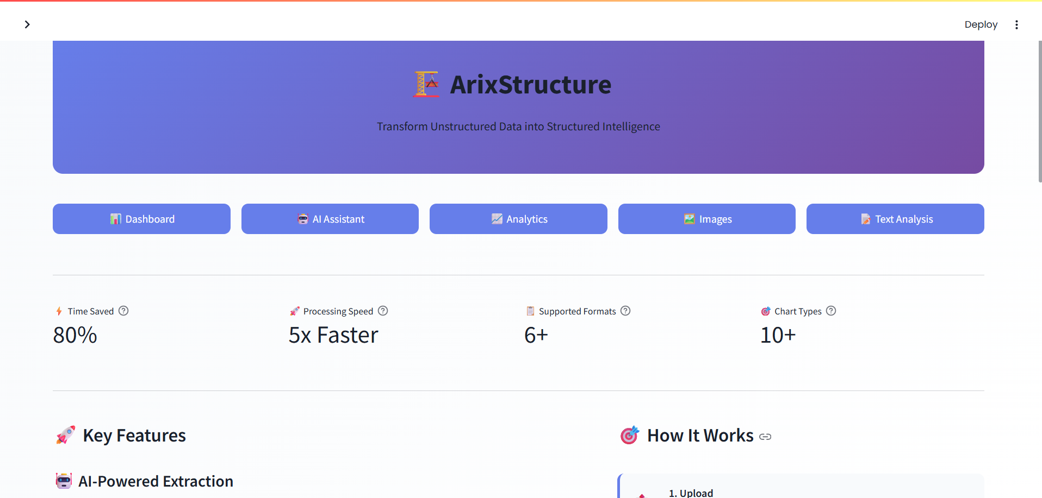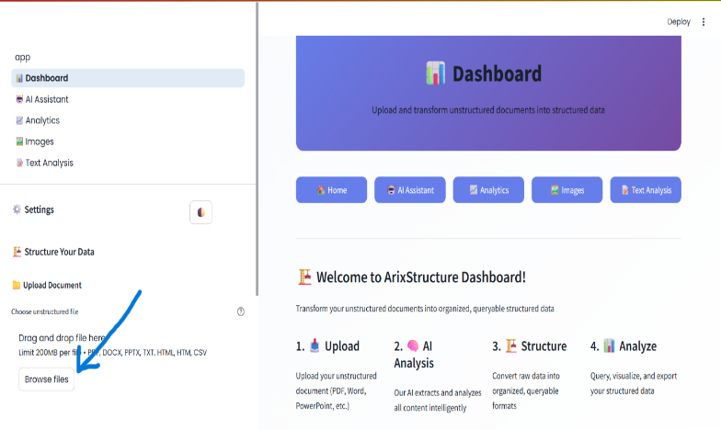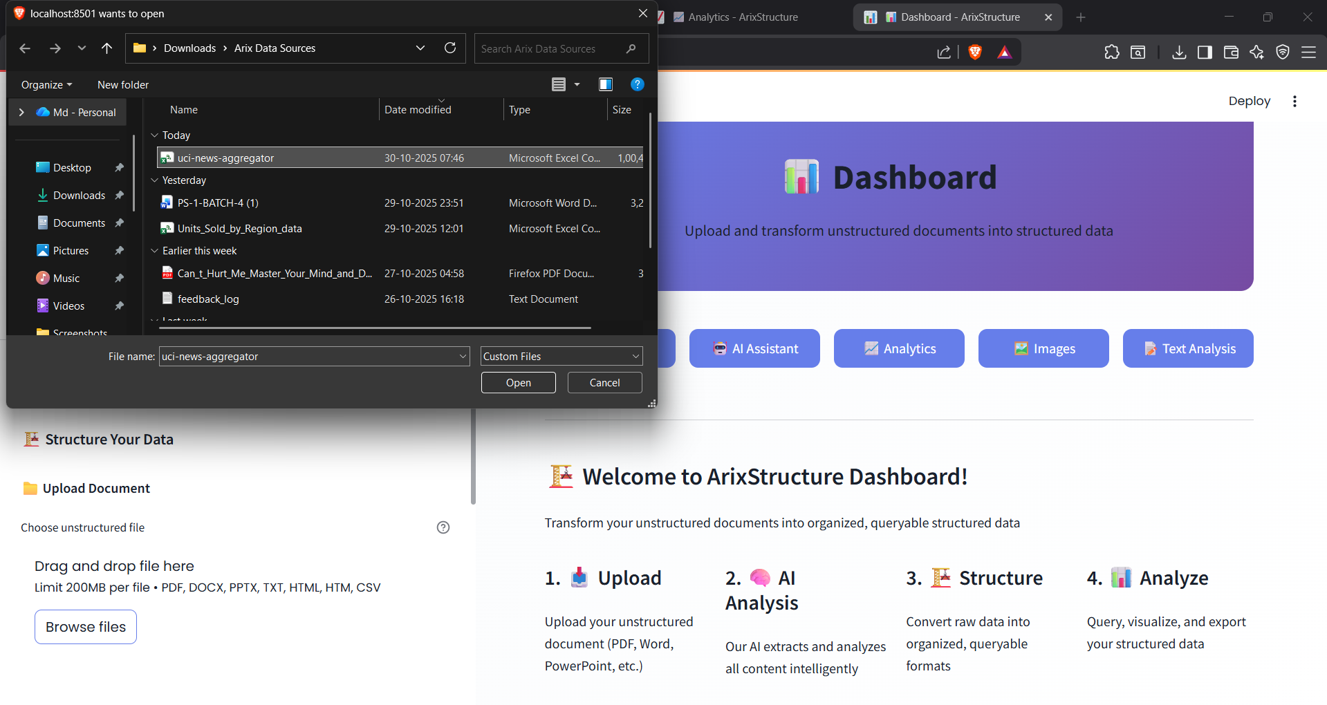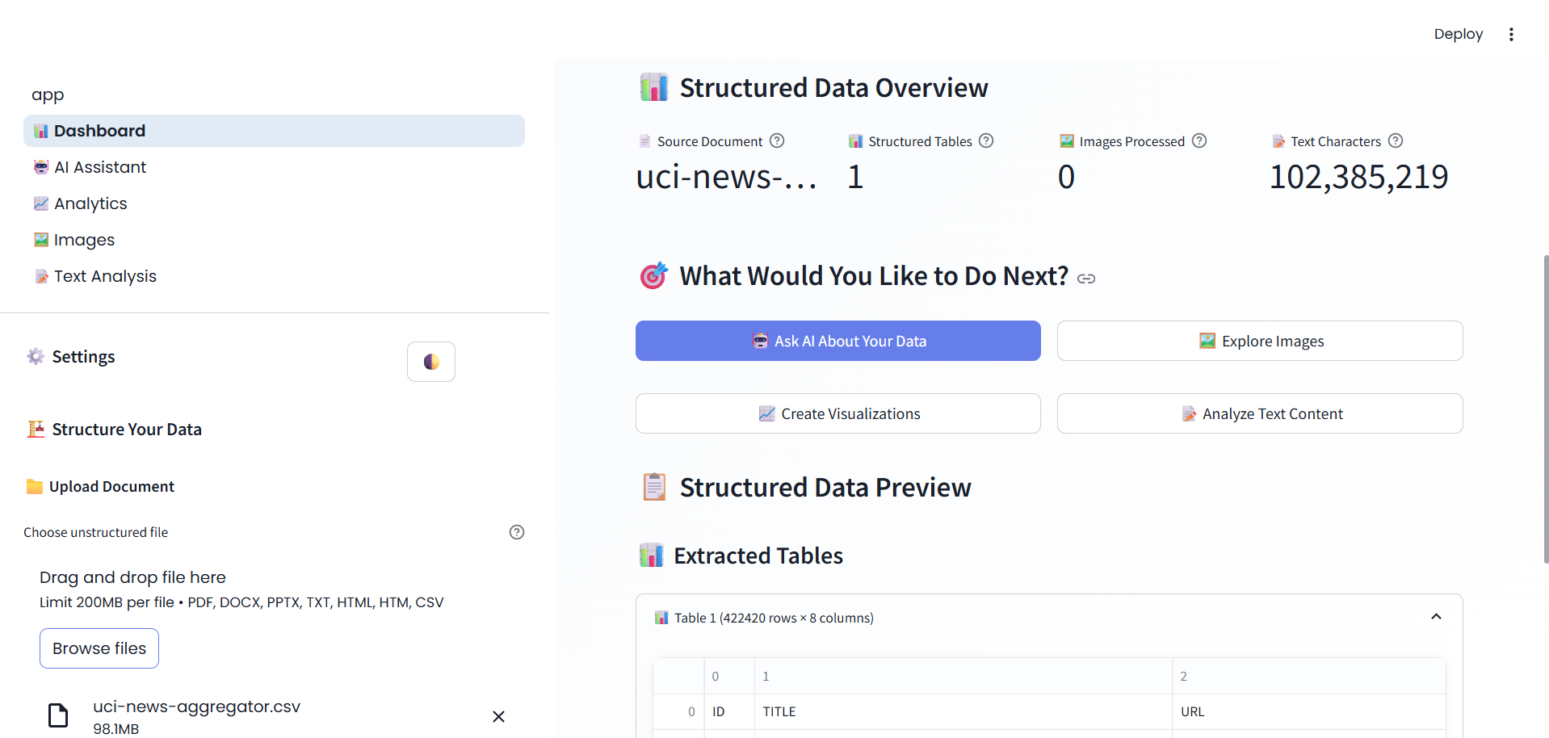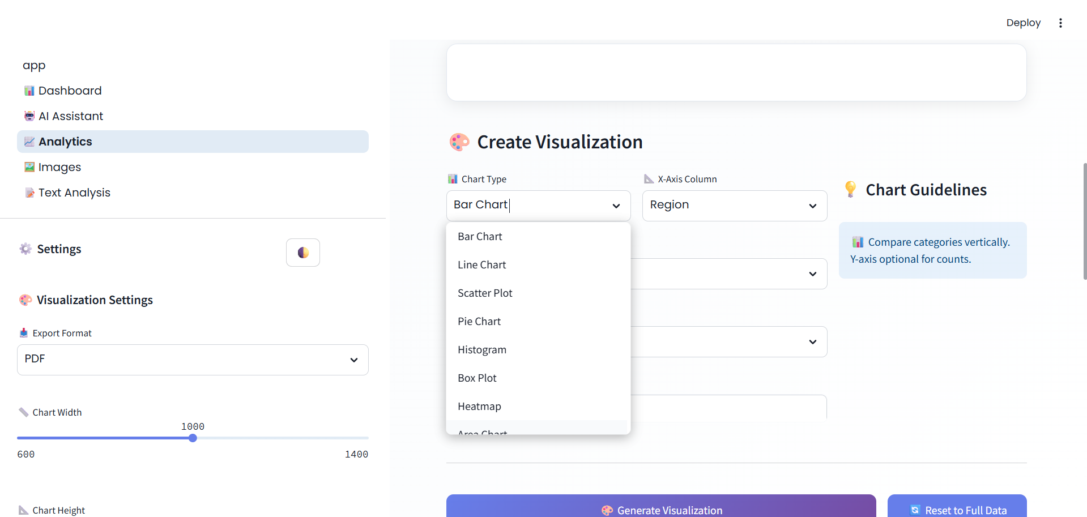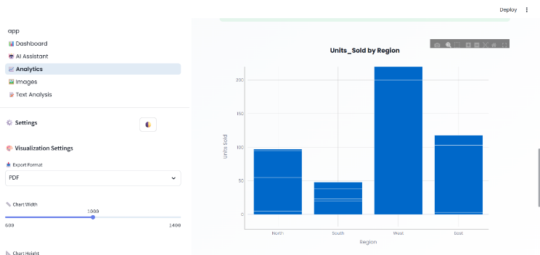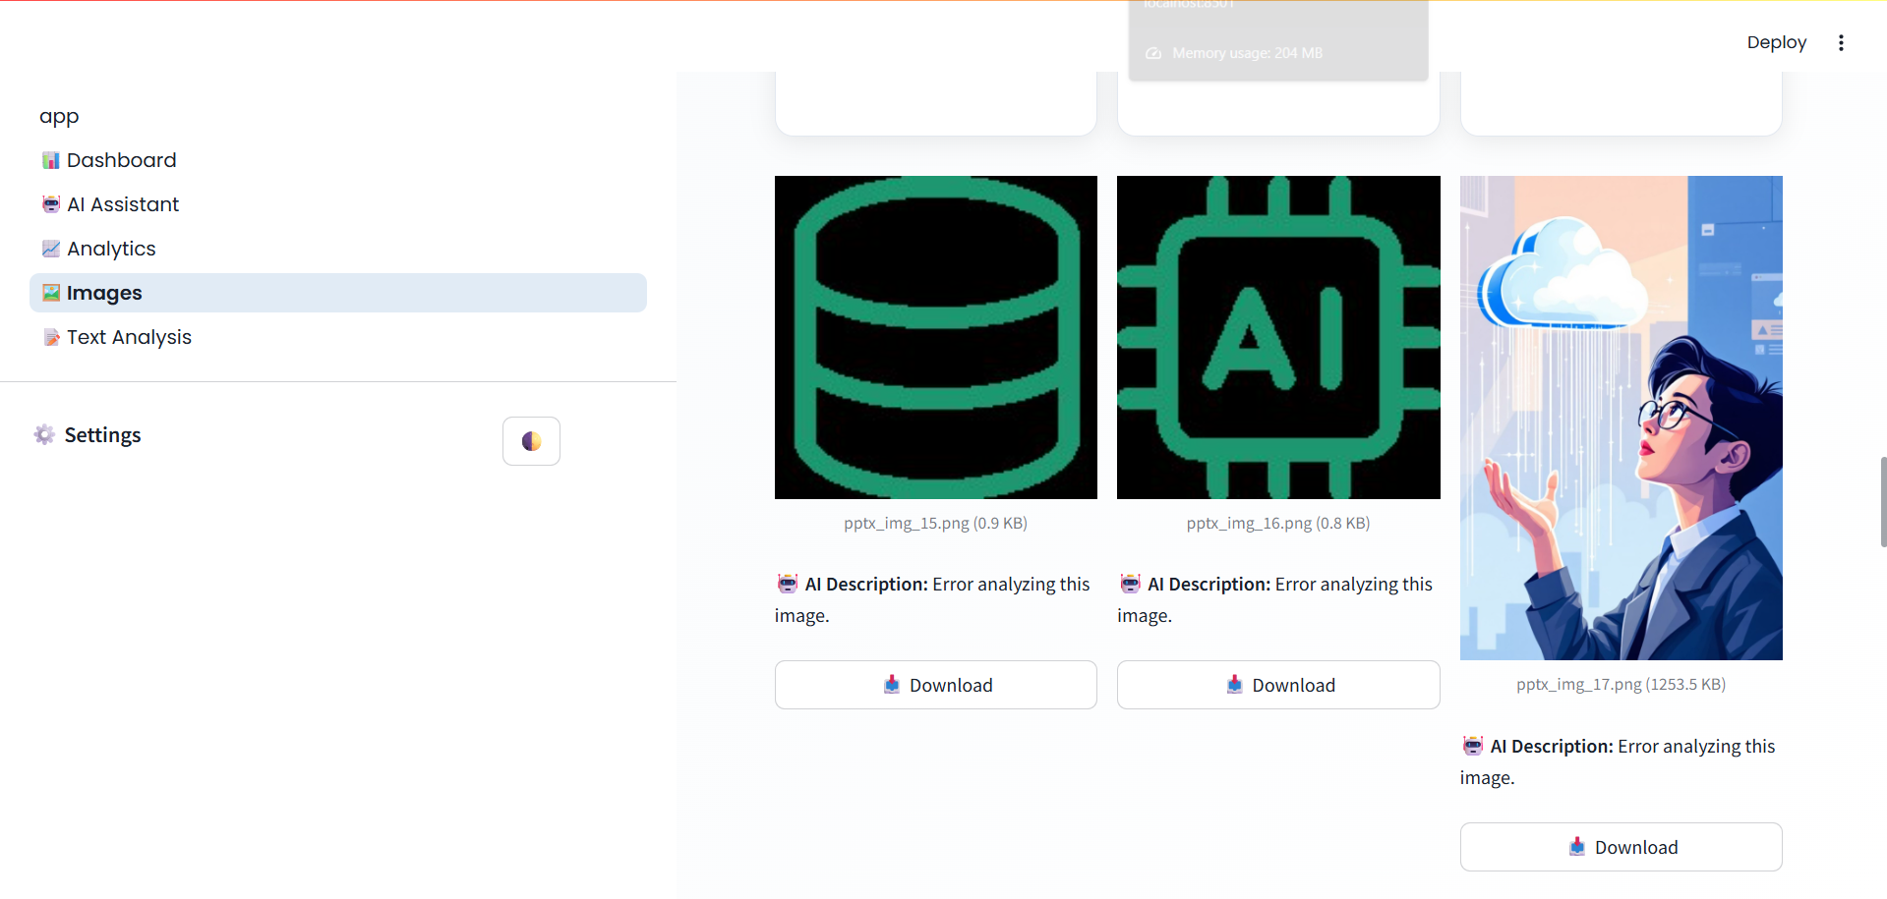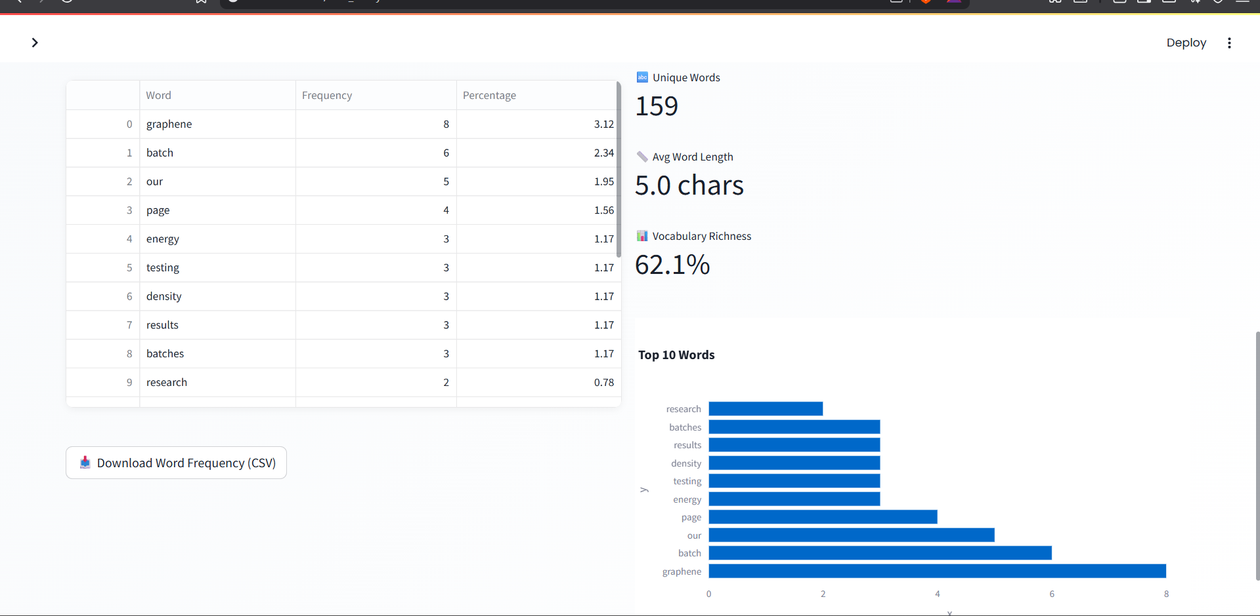

Conclusion and Future Scope
The ArixStructure project successfully culminated in the development of a high-performance, intelligent document system that demonstrates the significant positive impact of advanced AI and Natural Language Processing (NLP) techniques on automated data extraction. The primary objective of creating an accurate, efficient, and user-friendly tool to transform diverse unstructured files—including PDF, DOCX, PPTX, HTML, and others—into structured, actionable data has been fully realized, effectively addressing a major pain point in data management. The system's core employs a highly modular pipeline , featuring sophisticated parsing libraries and transformer-based AI models which enable effective generalization across a broad spectrum of document layouts. Performance evaluation on a curated test set confirmed strong results, with the system achieving both high structural extraction accuracy (approaching 95%) and a high F1-Score in semantic analysis, ensuring reliable handling of most complex documents. The focus on usability, exemplified by the intuitive Streamlit interface, dramatically improves accessibility for non-technical users. The overall impact of this project proves the feasibility of deploying AI-powered document automation at scale, demonstrating a solution that unlocks hidden value from data and reduces the manual burden of data wrangling. Based on these achievements, the ArixStructure platform is strategically poised for significant future development to broaden its capabilities and adoption. Future plans include the integration of Explainable AI (XAI) techniques, such as semantic heatmaps , to enhance interpretability and build user trust, especially in regulated environments. Expanded data support remains a priority, enhancing generalization by adding support for diverse datasets like scanned documents, handwritten materials, and various languages. The platform will also evolve into a comprehensive data intelligence solution through the addition of advanced features, including cross-document linking, relationship mapping, and collaborative annotations. Technical improvements will involve incorporating transfer learning with domain-adapted transformer models and optimizing preprocessing steps for more robust handling of noisy files. Finally, to improve integration and accessibility, streamlined web and mobile applications will be developed alongside robust APIs for seamless connection with cloud storage, data warehouses, and other business platforms, combining structured outputs with predictive analytics to open new pathways for data-driven decision-making.

References
- Zhang, Q., Huang, V. S., Wang, B., Zhang, J., Wang, Z., Liang, H., Wang, S., Lin, M., Zhang, W., & He, C. (2024). Document parsing unveiled: Techniques, challenges, and prospects for structured information extraction. arXiv preprint arXiv:2410.21169.
- Luo, C., Shen, Y., Zhu, Z., Zheng, Q., Yu, Z., & Yao, C. (2024). LayoutLLM: Layout instruction tuning with large language models for document understanding. Proceedings of the IEEE/CVF Conference on Computer Vision and Pattern Recognition (CVPR), 12485–12495.
- Nerella, S., Bandlamudi, S., Singh, P., Candan, K. S., Davulcu, H., & Sapino, M. L. (2024). Transformers and large language models in healthcare: A comprehensive survey. PLOS Digital Health, 3(6), e0000516.
- Modi, A., Sharma, R., & Verma, S. (2023). Semantic similarity for text comparison between textual documents using TF-IDF and cosine similarity measures. IEEE Xplore, doi: 10.1109/ICESC57686.2023.10465440.
- Akkasi, A., Varoglu, E., & Dimililer, N. (2024). Job description parsing with explainable transformer-based ensemble models for skill extraction. Computers in Industry, 158, 104075.
- Salehin, I., Rahman, M. S., & Kang, D. K. (2024). AutoML: A systematic review on automated machine learning with neural architecture search. Journal of Information and Intelligence, 2(1), 52–81.
- Xu, Y., Xu, Y., Lv, T., Cui, L., Wei, F., Wang, G., Lu, Y., Florencio, D., Zhang, C., Che, W., Zhang, M., & Zhou, L. (2021). LayoutLMv2: Multi-modal pre-training for visually rich document understanding. Proceedings of the 59th Annual Meeting of the Association for Computational Linguistics, 2579–2591.
- Devlin, J., Chang, M. W., Lee, K., & Toutanova, K. (2019). BERT: Pre-training of deep bidirectional transformers for language understanding. Proceedings of NAACL-HLT, 4171–4186.
- Vaswani, A., Shazeer, N., Parmar, N., Uszkoreit, J., Jones, L., Gomez, A. N., Kaiser, Ł., & Polosukhin, I. (2017). Attention is all you need. Advances in Neural Information Processing Systems, 30, 5998–6008.

