Problem statement- assignment 2
- Where would you rate yourself on (LLM, Deep Learning, AI, ML). A, B, C [A = can code independently; B = can code under supervision; C = have little or no understanding]
- What are the key architectural components to create a chatbot based on LLM? Please explain the approach on a high-level
- Please explain vector databases. If you were to select a vector database for a hypothetical problem (you may define the problem) which one will you choose, and why?

PS-1: Self Rating on LLM, Deep Learning, AI, and Machine Learning
I am rating myself based on practical project experience, real system implementations, and my ability to design and deploy AI pipelines using Python and modern AI tools.

Machine Learning — Level A (Can Code Independently)
Machine Learning is my strongest skill area. I have independently built end-to-end ML pipelines and deployed production-style applications.
In my Arix Stroke Prediction System, I implemented the complete ML workflow including:
- Data preprocessing (cleaning, encoding, scaling)
- Feature selection using Chi-Square (SelectKBest)
- Class imbalance handling using SMOTE
- Training and benchmarking 7 ML algorithms (Random Forest, XGBoost, CatBoost, SVM, KNN, Logistic Regression, Naive Bayes)
- Model evaluation using accuracy, confusion matrix, precision, recall, and F1-score
- Model persistence using .pkl files and API-based deployment using Flask and Gunicorn
I also built the Iris Flower Classification System, where I trained multiple models, created inference APIs, added confidence scoring, and integrated frontend with backend ML services.
I can independently design ML pipelines, tune models, evaluate performance, and deploy them into real applications. That is why I rate myself as A in Machine Learning.

LLM (Large Language Models) — Level B (Can Code With Guidance)
I have strong hands-on experience working with LLMs, especially in building Retrieval-Augmented Generation (RAG) pipelines and AI-powered applications.
LLM Platforms and Models I Have Used
I have experimented with and integrated:
- OpenAI Models (text generation and embeddings)
- Ollama (Local LLMs) — Llama 3.2, Qwen 2.5
- Groq (high-speed inference testing)
- Perplexity Sonar (cloud LLM integration)
- Gemini (Google LLM)
- OpenCode (code-focused LLMs)
RAG and LLM Project Experience
In my RAG-Based Teaching Assistant, I built a system that:
- Converts video audio to text using Whisper
- Chunks subtitles and generates embeddings
- Performs semantic search using vector databases
- Injects retrieved context into LLM prompts
- Produces timestamp-based, grounded answers
In my RAG In-Depth Project, I experimented with:
- LangChain and LangGraph pipelines
- OpenAI and HuggingFace embeddings
- ChromaDB and FAISS vector stores
- Multi-format data ingestion (PDF, CSV, JSON, SQL)
In my ArixAI Resume Analyzer, I integrated Perplexity API to perform ATS scoring, resume feedback generation, and structured AI analysis.
I can build LLM-based applications and RAG systems, but I am still learning advanced topics like model fine-tuning, training custom LLMs, and inference optimization. Therefore, I rate myself as B in LLMs.

Artificial Intelligence (AI) — Level B (Can Code With Guidance)
I have built AI systems that combine machine learning, LLMs, retrieval pipelines, and backend services.
My AI experience includes:
- Resume analysis systems
- Educational AI assistants
- Healthcare prediction platforms
- RAG-based knowledge systems
I understand how AI systems work end-to-end including:
- Data ingestion
- Model integration
- API-based inference
- Pipeline orchestration
- Frontend and backend connectivity
I can design and implement intelligent systems, but I am still improving deeper research-level AI concepts and large-scale system optimization. Hence, I rate myself as B in AI.

Deep Learning — Level B (Foundational Understanding)
I currently have a foundational understanding of deep learning concepts.
I understand:
- Neural networks
- Perceptrons
- Forward and backward propagation
- Activation functions
- Loss functions
I have also used Whisper (deep learning-based speech-to-text model) in my RAG project for converting video content into transcripts.
At present, I mainly use pre-trained deep learning models and basic TensorFlow concepts. I am actively learning advanced architectures such as CNNs and Transformers. Therefore, I rate myself as B in Deep Learning.

Machine Learning Projects
- Stroke Prediction System
https://github.com/nameisahmedh/strokeprediction
- Iris Flower Classification
https://github.com/nameisahmedh/iris-classification
LLM & RAG Projects
- RAG-Based Machine Learning Teaching Assistant
https://github.com/nameisahmedh/RAG-based-ML-teaching-Assistant
- RAG In-Depth (LangChain + LangGraph + Vector DB Experiments)
https://github.com/nameisahmedh/RAG-indepth
AI Application Project
- ArixAI Resume Analyzer
https://github.com/nameisahmedh/arixai_resume_analyzer

PS-2: Key Architectural Components of an LLM-Based Chatbot (High-Level Approach)
From my experience working on RAG systems and AI chatbot projects, I learned that an LLM-based chatbot is not just about calling a model API. It is a complete pipeline that prepares data, retrieves relevant information, builds proper prompts, and then generates responses in a controlled way.
Below is how I usually design and think about the architecture at a high level.

1) User Interface Layer
This is the part where users interact with the chatbot.
It is responsible for:
- Taking user questions or messages
- Sending requests to the backend
- Showing chatbot responses
- Managing chat history or session state
In my projects, this is usually a web interface or a simple API client. I keep this layer lightweight so it only handles interaction and not heavy processing.

2) Backend API Layer
This is the main control layer of the chatbot.
It handles:
- Receiving user requests
- Validating inputs
- Managing request flow
- Connecting different components like embeddings, vector database, and LLM
I usually build this layer using Python APIs such as Flask or FastAPI. This layer works like a central controller that connects all parts of the system together.

3) Data Ingestion and Knowledge Preparation Layer
Before a chatbot can answer questions, the data must be prepared.
In this step, I process different types of content such as:
- PDFs
- Videos
- CSV and Excel files
- JSON and database records
What happens here:
- Text is extracted
- Unwanted data is cleaned
- Large content is broken into smaller chunks
- Metadata like source name and timestamps is added
In my RAG projects, I used Whisper to convert video audio into text and created structured pipelines to prepare knowledge data. This step is usually done offline or in background jobs.

4) Embedding Generation Layer
After preparing the data, I convert the text into embeddings.
Embeddings are numerical representations of text that help the system understand meaning instead of just keywords.
I used:
- HuggingFace embedding models
- OpenAI embedding APIs
This step allows the chatbot to perform semantic search instead of simple word matching.

5) Vector Database and Retrieval Layer
This layer acts as the memory of the chatbot.
It is responsible for:
- Storing embeddings
- Searching similar vectors
- Retrieving relevant content
I worked with vector databases like:
- ChromaDB
- FAISS
When a user asks a question:
- The query is converted into an embedding
- Similar vectors are searched
- The most relevant content chunks are selected
This step is very important because it helps reduce hallucinations and ensures answers come from real data.

6) Prompt Building and Context Assembly Layer
Before sending data to the LLM, I prepare a structured prompt.
This includes:
- User question
- Retrieved context
- Instructions on how the model should respond
This step helps control the output and ensures that the model only uses the provided information.
In my teaching assistant project, this step helped generate timestamp-based and topic-focused answers.

7) LLM Inference Layer
This is where the response is actually generated.
I have worked with different LLM platforms such as:
- OpenAI models
- Ollama local models (Llama, Qwen)
- Perplexity Sonar
- Groq
- Gemini
This layer takes the final prompt and generates a human-readable response. Depending on the setup, it can run locally or through cloud APIs.

8) Post-Processing and Response Layer
After the LLM generates the output, I process the response before sending it to the user.
This includes:
- Formatting the output
- Adding references or timestamps
- Cleaning unwanted text
- Logging responses
This step improves reliability and user experience.

9) Monitoring and Security Layer
For real applications, it is important to track system behavior.
This layer handles:
- Request logging
- Error tracking
- Performance monitoring
- API access control
- Rate limiting
This helps keep the chatbot stable and secure.

High-Level Flow Summary
User Question
→ Backend API
→ Embedding Generation
→ Vector Search
→ Context Retrieval
→ Prompt Construction
→ LLM Response
→ Post-Processing
→ Final Answer to User

Why This Architecture Works Well
This design works well because:
- It reduces hallucinations using retrieval
- It scales easily by separating components
- It supports cloud and local deployment
- It allows switching models without changing the whole system
- It keeps the system organized and maintainable
This is the approach I followed in my RAG and chatbot projects.

I have also attached a simple hand-drawn style diagram below to visually explain the architectural components and data flow of the LLM-based chatbot system that I followed in my projects and which is commonly used in real-world RAG-based chatbot implementations.

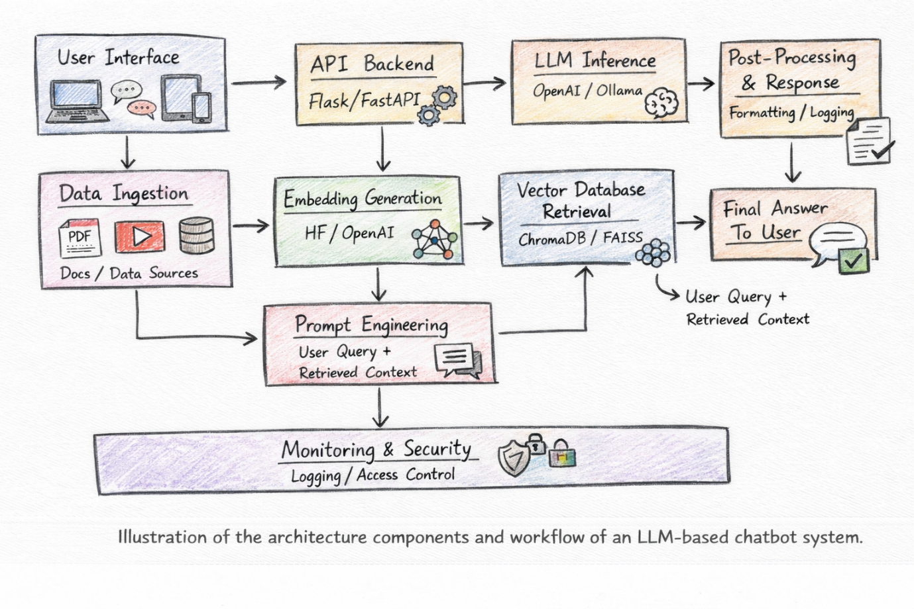

PS-3: Vector Databases – Explanation and Selection
From my work on RAG and semantic search projects, I understood that a vector database is mainly used to store embeddings and perform similarity-based search. Unlike traditional databases that depend on exact keywords, vector databases help find information based on meaning.

What Is a Vector Database?
A vector database stores data in the form of vectors. These vectors are created using embedding models that convert text into numbers that represent the meaning of the content.
When a user asks a question:
- The question is converted into an embedding
- The system compares it with stored embeddings
- The most similar content is retrieved
This makes searching smarter and more accurate than normal keyword search.
For example, if someone asks:
“Where is Bayes theorem explained?”
The system can find related content even if the exact words are not present in the document.

How I Used Vector Databases in My Projects
In my RAG projects, I used vector databases to build the retrieval layer.
My usual workflow was:
- Split documents into small chunks
- Generate embeddings using HuggingFace or OpenAI
- Store embeddings in a vector database
- Convert user query into embedding
- Perform similarity search
- Retrieve top relevant chunks
- Send them to the LLM for answer generation
I worked practically with:
- ChromaDB
- FAISS
Both helped me build fast and accurate retrieval systems.
Refer to this ->
RAG In-Depth (LangChain + LangGraph + Vector DB Experiments)
https://github.com/nameisahmedh/RAG-indepth

Hypothetical Problem Example
Suppose I want to build a college study assistant chatbot.
This chatbot should:
- Answer questions from lecture notes and PDFs
- Support thousands of documents
- Return fast responses
- Filter results based on subject or topic
- Work locally or on cloud

Which Vector Database I Would Choose
For this type of application, I would choose ChromaDB.

Why I Would Choose ChromaDB
1) Easy to Use
ChromaDB is simple to set up and easy to connect with Python and LangChain. This makes development faster.

2) Good for RAG Applications
It works very well with embedding-based search, which is exactly what RAG chatbots need.

3) Metadata Filtering Support
It allows filtering based on document type, topic, or source. This helps improve search accuracy.

4) Works Well for Medium-Scale Systems
For projects with thousands to hundreds of thousands of records, ChromaDB provides good performance and stable results.

When I Would Choose FAISS Instead
If the system needs to handle very large datasets with millions of embeddings and very fast search speed, I would prefer FAISS.
FAISS is optimized for high-performance similarity search but requires more manual setup compared to ChromaDB.

Why Vector Databases Are Important
Vector databases are important because they:
- Enable semantic search
- Reduce hallucinations in chatbots
- Improve answer accuracy
- Allow AI systems to use real data
- Make RAG systems practical

