Technical Report for Web Retail Revenue Data System and Visualization
Name: Rohit Yadav
Student No: 20051855

Name: Sahana Gurav
Student No: 20058426

Name: Sruthi Saila
Student No: 20062013

By
Contents
1. Introduction 2
1.2. Reasons for selecting the subject area AND DATA 3
1.3. Vision and Goals 4
1.4. Key StakeHolders 4
1.5. Business requirements 5
2. SCHEMA 6
3. ETL 9
4. VISUALIZATIONS AND REPORTS 14
4.1. Visualizations 14
4.2. Reports 15
5. Graph Databases 19
5.1. COMAPRISON to realtional databases 23
6. Conclusions 25
7. Bibliography 26
Appendix A – VISUALIZATIONS Code 26
Appendix B – Neo 4J code 27

1. Introduction
In the modern world, the retail business is growing fast, and competition is also increasing. To survive in the market, companies need to make smart decisions. One of the best ways to do this is by using data properly. Every day, online retail companies collect large amounts of sales data. But this data is not useful unless it is stored, managed, and studied in the right way. This project is focused on building a system that works like a data warehouse, where all retail sales information can be collected and organised.
The system will also have tools for visualization, which means it can show data in charts, graphs, and reports. This helps business owners, managers, and other users understand the data easily without needing technical skills. For example, they can see which products are selling more, which times are best for sales, and which customers buy more often. These insights can help them plan marketing strategies, manage stock better, and increase profits.
This kind of system also saves time and reduces errors in reporting. The goal of this project is to create a simple but powerful solution that turns raw data into meaningful insights. This will help retail businesses grow faster, improve customer satisfaction, and stay ahead in the market.

Dataset link for Warehouse:
https://www.kaggle.com/datasets/tanushagarwal01/online-retail-sales-analysis?select=prod_cat_info.csv
Dataset link for SQL and CQL: https://www.kaggle.com/datasets/dorcasdavid/adventureworks-sales
In this project, we used modern tools to change complex sales data into simple and useful information. We followed a step-by-step process to build a strong system that helps understand retail performance in a better way.
• Data Modeling: First, we used a Star Schema to arrange the data in a proper format. We created fact and dimension tables such as Sales, Customers, Products, and Stores. This helped to make the data easy to manage and fast to use for analysis.
• ETL using SSIS: Then, we used SQL Server Integration Services (SSIS) to collect data from different sources. We cleaned and changed the data to remove mistakes and then stored it in one central place. This step helped to improve the quality of the data.
• Reports using SSRS: We used SQL Server Reporting Services (SSRS) to make reports that are easy to understand. These reports helped the team to make quick and good decisions in daily work.
• Dashboards in Tableau: Finally, we used Tableau to show the data in charts and graphs. The dashboard includes things like sales trends, top products, and store-wise comparisons. It gives clear and live updates to the management team.
All these steps together helped to build a strong system that connects raw data with real business needs. This solution helps in many areas like stock control, customer understanding, and checking which sales channels are doing well. With the help of SSIS, SSRS, and Tableau, we created a smart and future-ready platform that helps in making faster and better business decisions.

1.2. Reasons for selecting the subject area AND DATA
This project mainly looks at how customers buy products and how those products are grouped into different categories. In today’s world, where data is very important, this topic is useful for many businesses. Companies use this kind of information to make better plans for marketing, customer service, and daily operations (Subramaniam, 2025).
There are a few main reasons why we selected this topic and dataset:
- Real-World and Detailed Data:
The dataset has many useful details like customer information, past purchases, and types of products. Because of this variety, we can study many things such as how different customers shop, which product groups are doing well, and what new sales trends are coming up.
- High Business Usefulness:
If a company knows who is buying which product and how often, it can create better marketing offers, control stock in a smarter way, and build strong customer connections. These insights are very important for running a business with the help of data (Davtyan, 2024).
- Good for ETL Learning:
The dataset is also great for practising ETL (Extract, Transform, Load) processes using tools like SSIS. Since the data comes from different places and needs cleaning, it is a good example of real-life data handling.

1.3. Vision and Goals
Vision
The main aim of this project is to create a system where data can be used in a better way to understand how customers behave and how products are performing. By collecting, changing, and studying the data properly, businesses can take smarter and more useful decisions. This idea is focused on using customer and sales data to make plans that care more about the customer — like sending personal offers or managing products more wisely.

Goals
1. Combine All the Data
Bring together customer information, past sales, and product details in one place. This gives a full view of what is happening in the business.
2. Create Smart ETL Workflows
Use tools like SSIS inside Visual Studio to take out data from different places, clean it, change it into the right format, and then load it for analysis and reports.
3. Know Your Customers
Study the age, location, and shopping habits of customers. This helps to group them and find out which customers are most valuable for the business.
4. Track Product and Sales Trends
Look at how well different product types are doing, how often customers are buying, and find any seasonal changes. This helps in better planning for stock and marketing.
5. Help in Business Decisions
Make clear and useful reports and dashboards so that company managers can take smart decisions based on the data.

1.4. Key StakeHolders
• Business Executives – They will use the system to make better long-term plans and take smart business decisions based on data.
• IT and Data Engineering Teams – These teams will handle the technical side, like building the star schema and creating ETL processes to manage the data (Storm, 2025).
• Sales and Marketing Teams – They can use the data to divide customers into groups, check how well marketing campaigns are working, and study product sales trends

1.5. Business requirements
To make sure this project gives real value to the business and stays focused on its main goals, we have listed some important requirements below:
1. Combine All Data in One Place
We need to collect data from three main files Customer.csv, Transactions.csv, and prod_cat_info.csv. These must be joined together in a proper way to show who the customers are, what they have bought, and which product category those items belong to. This will help in creating one complete and clear model for analysis.
2. Group Customers Based on Behaviour
Customers should be divided into groups based on their age, gender, and how they shop. This includes how often they buy, how recently they made a purchase, and how much they usually spend. By doing this, we can find out who our best customers are and what makes each group different from others.
3. Study Sales and Product Performance
We will look at the sales data from many sides:
- By product category and sub-category
- By time (monthly, quarterly, yearly)
- By different customer groups
This will help us know which products are selling the most, which ones are not doing well, and how we can improve our marketing and stock planning.

2. SCHEMA

This data warehouse is built using a star schema, which is a popular and effective method for organizing data, especially in retail businesses (M Kirmani, 2017). In this design, there is one main fact table in the center that stores the sales data. Around it, there are four dimension tables that give extra information. These dimension tables help us study the sales data from different sides, like customer details, product categories, and more. This setup makes it easier to run reports and find useful insights quickly.

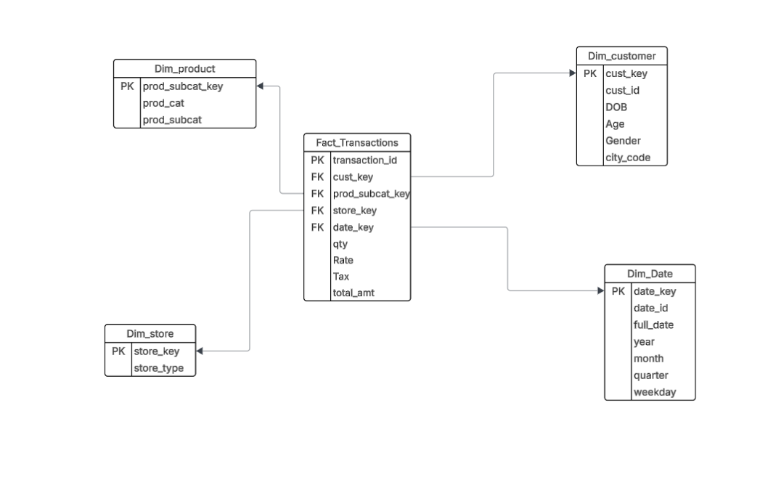
Figure 1: Star Schema

Star Schema Code:
USE [20051855_DW];
GO
-- Creating Dimension Tables
CREATE TABLE Dim_Product (
prod_subcat_key INT NOT NULL IDENTITY,
prod_cat VARCHAR(50),
prod_subcat VARCHAR(50),
PRIMARY KEY (prod_subcat_key)
);
GO

CREATE TABLE Dim_Customer (
cust_key INT NOT NULL IDENTITY,
cust_id INT,
DOB DATE,
Age INT,
Gender VARCHAR(50),
city_code INT,
PRIMARY KEY (cust_key)
);
GO

CREATE TABLE Dim_Store (
store_key INT IDENTITY(1,1),
store_type VARCHAR(50) UNIQUE,
PRIMARY KEY (store_key)
);
GO

CREATE TABLE Dim_Date (
date_key INT NOT NULL IDENTITY,
full_date DATE,
year INT,
month INT,
quarter VARCHAR(10),
weekday VARCHAR(20),
PRIMARY KEY (date_key)
);
GO

-- Creating Fact Table
CREATE TABLE Fact_Transactions (
transaction_key INT NOT NULL IDENTITY,
transaction_id NUMERIC(18,0),
cust_key INT NOT NULL,
prod_subcat_key INT NOT NULL,
store_key INT NOT NULL,
date_key INT NOT NULL,
Qty INT,
Rate INT,
Tax FLOAT,
total_amt FLOAT,
FOREIGN KEY (cust_key) REFERENCES Dim_Customer(cust_key),
FOREIGN KEY (prod_subcat_key) REFERENCES Dim_Product(prod_subcat_key),
FOREIGN KEY (store_key) REFERENCES Dim_Store(store_key),
FOREIGN KEY (date_key) REFERENCES Dim_Date(date_key),
PRIMARY KEY (transaction_key)
);
GO

3. ETL
Explain the procedure. Include screen shots (if any). Include code.
1. Dim_Customer:
This ETL package is made to handle customer data completely from raw data to final loading. The process starts by extracting the customer data from the source file, which contains basic details like customer ID, name, gender, date of birth, and more.
Next, the data goes through a transformation stage. Here, the data types are converted properly so that all the values are in the correct format, which is very important to avoid errors during loading. During this stage, we also add some new columns to make the data more useful. One important column is Age, which we calculate using the customer's date of birth. This helps later in customer segmentation and understanding customer behaviour based on age groups.
We also check the data for missing values or errors, and correct them wherever possible. This step is necessary to keep the data clean and ready for analysis.
Once the data is cleaned, improved, and well-structured, we load it into the Dim_Customer table in our SQL Server data warehouse. This table acts as a main source for all customer-related information in reports and dashboards. It plays a big role in helping businesses understand who their customers are and how they behave.

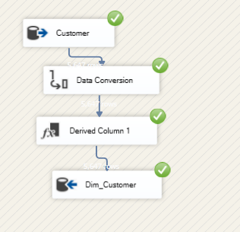
Figure 2: Customer Dimension

2. Dim_Date:
This ETL package handles the date-related data needed for time-based analysis. It begins by sorting the date values and removing any duplicate entries to keep the data clean and correct. After that, it makes sure all the dates follow the same format, so there is no confusion or mismatch.
The next step is to create new columns based on each date. These include the year, quarter, month, and day of the week. These extra fields make it easier to study sales and customer behaviour over time.
After all the cleaning and transformations are done, the final data is loaded into the Dim_Date table in the data warehouse. This table is useful for doing time-based analysis like monthly trends, yearly comparisons, and seasonal performance.

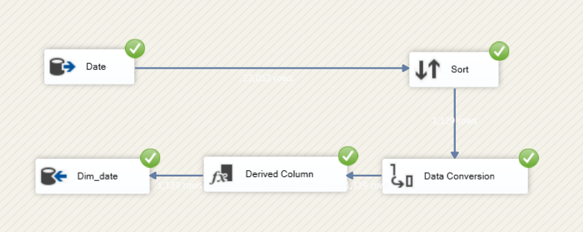
Figure 3: Date Dimension
3. Dim_Product:
This ETL package works with product-related data. It directly extracts the data from the prod_cat_info.csv file and loads it into the Dim_Product table in the data warehouse.
The file contains information about product categories and sub-categories, which helps in grouping and analysing product performance. The data is checked for any duplicates or format issues before loading, to make sure the table is clean and ready for reporting.The Dim_Product table supports product-level analysis and helps businesses understand which product categories are doing well.
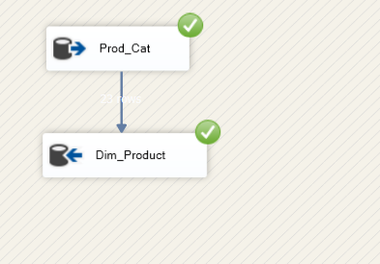
Figure 4: Prodcut Dimension

4. Dim_Store:
This ETL package is used to handle store-related data. It first extracts the raw data, then sorts it properly, and removes any duplicate records to keep the data clean and accurate.
After the data is processed, it is loaded into the Dim_Store table in the data warehouse. This table helps in identifying and analysing performance at the store level.

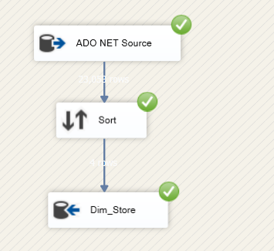
Figure 4: Store Dimension

5. Fact_Transaction:
This ETL package starts by extracting data from the Transactions.csv file, which contains all the sales transactions. After that, it performs lookups on the related dimension tables (like customer, product, store, and date) to get the correct foreign key values for each record.
It also applies the necessary data conversions to make sure all the fields are in the correct format for loading. Once everything is ready, the final data is loaded into the Fact_Transactions table in the data warehouse.
This table is the main source for all sales and transaction analysis, and it connects with all the dimension tables to give a full picture of the business.

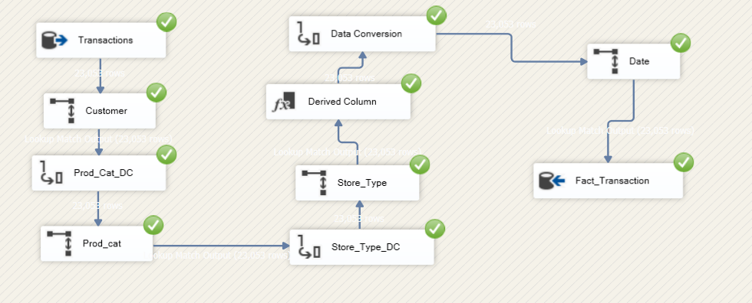
Figure 5: Fact Transaction

4. VISUALIZATIONS AND REPORTS

4.1. Visualizations
As part of our analysis, we created an interactive dashboard using Tableau, which is directly connected to our Transaction Data Warehouse. This live connection helps us fetch updated and accurate data for analysis. The dashboard includes four main visualizations, each designed to highlight important patterns and key business information. It also allows users to filter by store type, product category, age group, and gender to explore different insights.

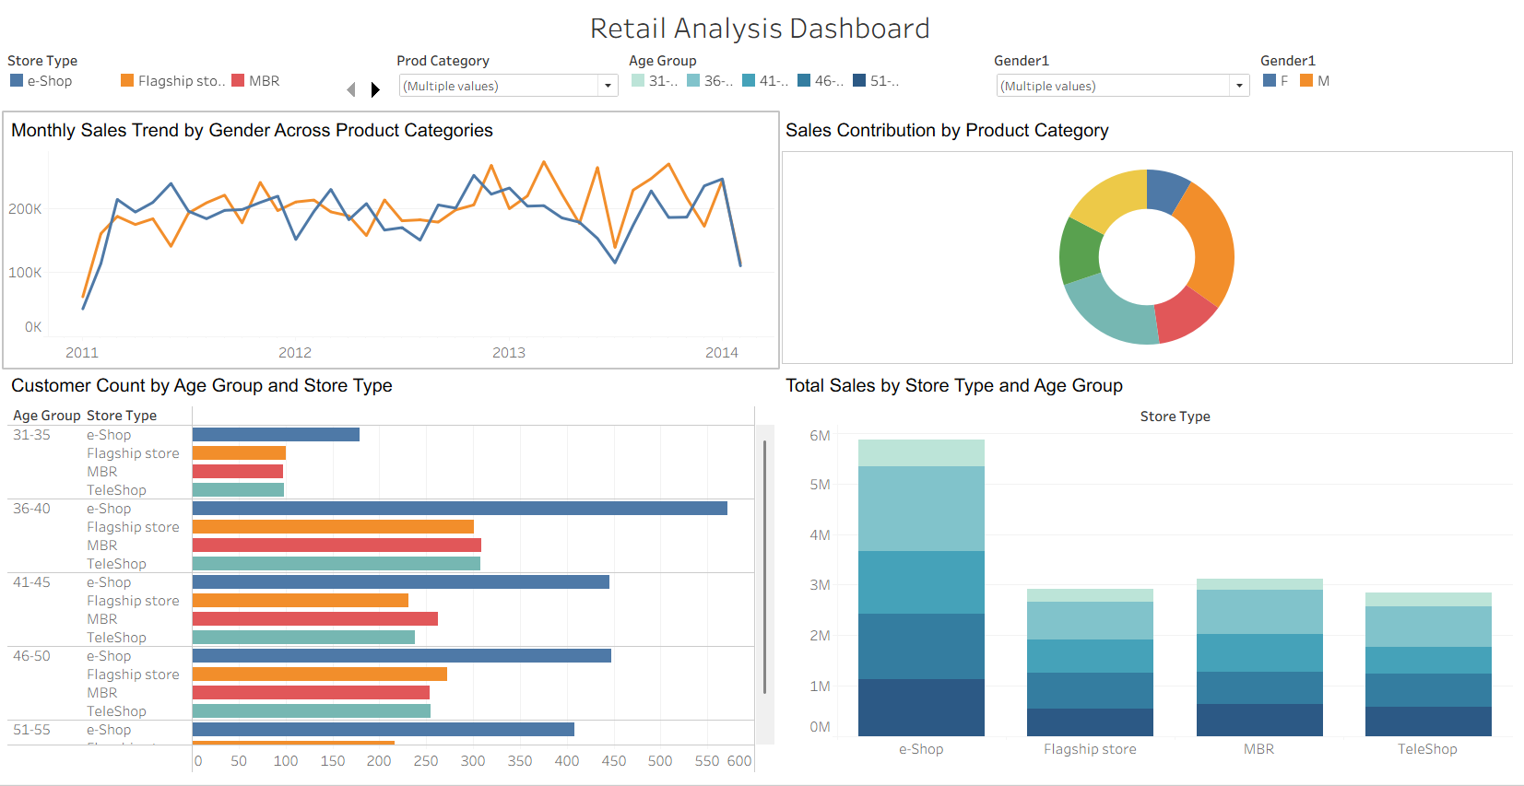
Figure 6: Tableau dashboard
Dashboard Visualizations and Insights:
• Monthly Sales Trend by Gender Across Product Categories
This line chart shows monthly sales trends from 2011 to 2015, divided by gender (Male/Female) and product category. It helps us understand how sales changed over time and whether there are any differences in buying patterns between male and female customers.
• Sales Contribution by Product Category
This donut chart displays how much each product category added to the total sales. It is useful for identifying which product groups are doing well and which may need attention.
• Customer Count by Age Group and Store Type
This horizontal bar chart shows how many customers belong to each age group, broken down by store type. It gives a clear view of customer distribution and preferences.
• Total Sales by Store Type and Age Group
This clustered vertical bar chart compares total sales across store types and age groups. It helps us see which age group spends the most and where.
By connecting the dashboard to our transaction data warehouse, we are able to create dynamic, real-time visualizations that support faster and more informed decision-making.

4.2. Reports

1. Total Tax by Store Type and Product Category
This table shows the total tax collected, grouped by store type and product category. It uses the transactional sales data from the data warehouse to calculate the total tax values. This helps in understanding how much tax is being generated by different product categories in each store type. It can also be useful for financial planning and tax reporting.

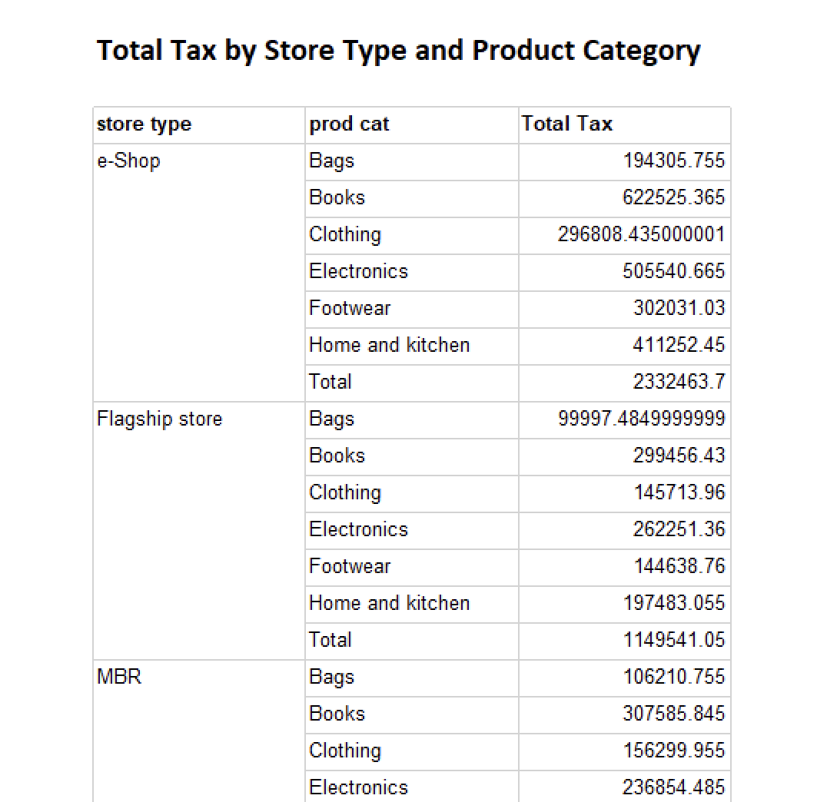

Figure 7: Total Tax by Store Type and Prodcut Category

2. Customer Purchase Summary Report
This table gives a summary of each customer's shopping behaviour. It shows how many purchases they have made, how many items they bought, and how much money they spent in total. The data is also divided by gender, which helps in finding top spenders and understanding the difference in buying patterns between male and female customers.
This report is useful for spotting trends, making better marketing plans, and creating targeted sales offers for different customer groups.
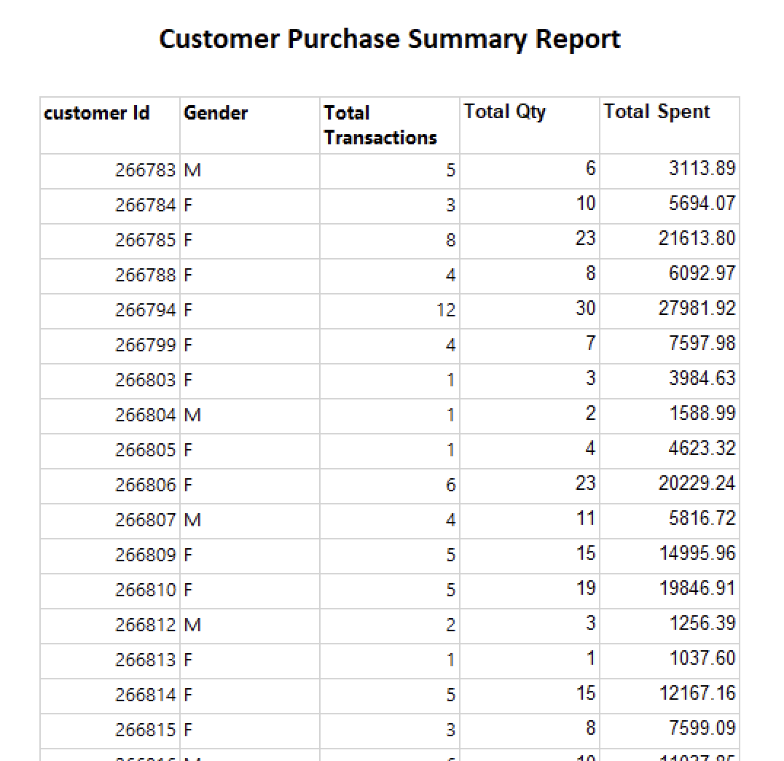
Figure 8: Customer Purchase Summary Report

3. Product Category Performance Report
This table shows the sales performance for each product category and subcategory. It includes the total quantity of items sold (Total Qty) and the total revenue earned from each group. By looking at this data, we can easily find out which subcategories are performing the best and how much each category is contributing to the overall sales.
This report is helpful for product planning, inventory management, and deciding where to focus marketing efforts.

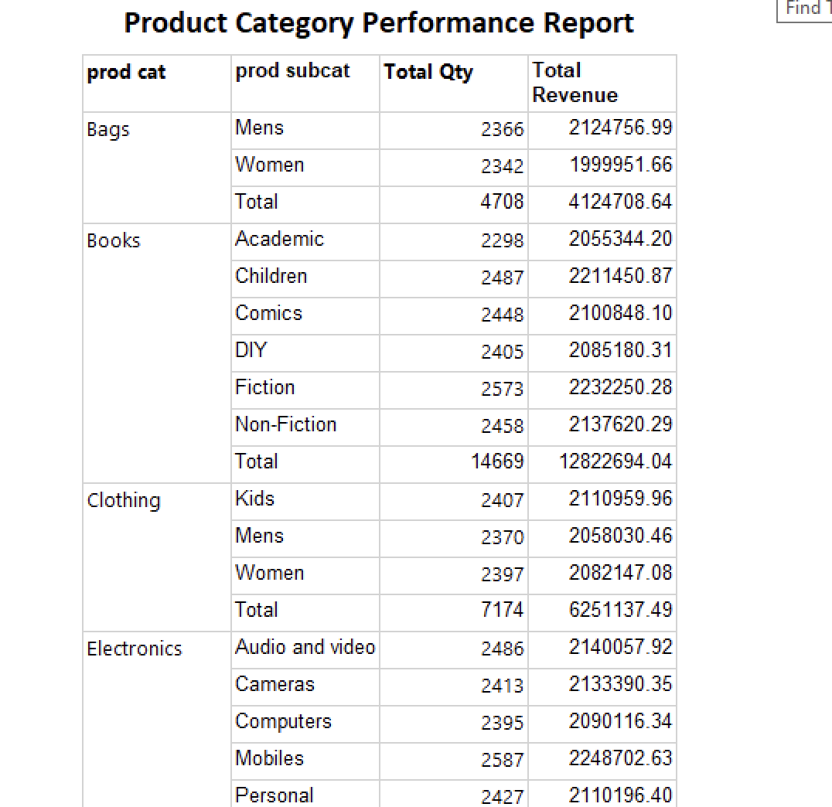
Figure 9: Prodcut Category Performance Report

4. Store Type Sales Comparison Report
This table compares the sales performance of different store types. It shows the total number of items sold (Total Qty) and the total revenue generated by each store type. From the report, we can see that the e-Shop is the top-performing sales channel, with the highest sales and revenue.
This report helps in understanding which store types are doing well and where the business is getting the most profit.

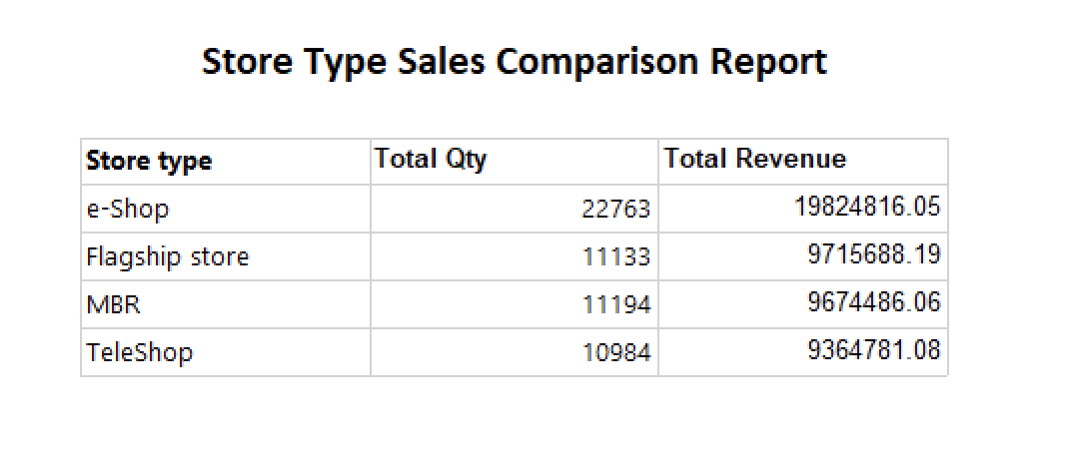
Figure 10: Store Type Sales Comparison Report

5. Graph Databases
Graph data analysis is becoming more popular in many areas of computer science. In the past, researchers often started with MySQL databases to store, access, and test their data. MySQL is widely used because it is simple and easy to set up for testing. It stores data in the form of rows and columns, and users can perform different tasks using SQL queries (Johnpaul and Mathew, 2017).On the other hand, graph databases are a type of NoSQL database where data is stored as graphs with nodes and edges. In this model, nodes represent data objects or entities, and edges show the relationships between them. Both nodes and edges can have properties and labels that give more details. Graph databases are useful for showing complex relationships and help make data easier to understand. In this system, nodes can have one or more labels, and the relationships between them can carry extra information too (Rusu and Huang, 2019).
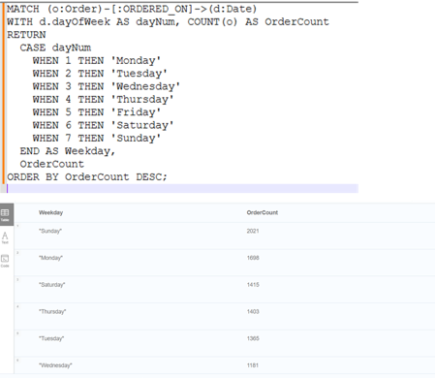

Figure 11: Peak Order Day of the Week

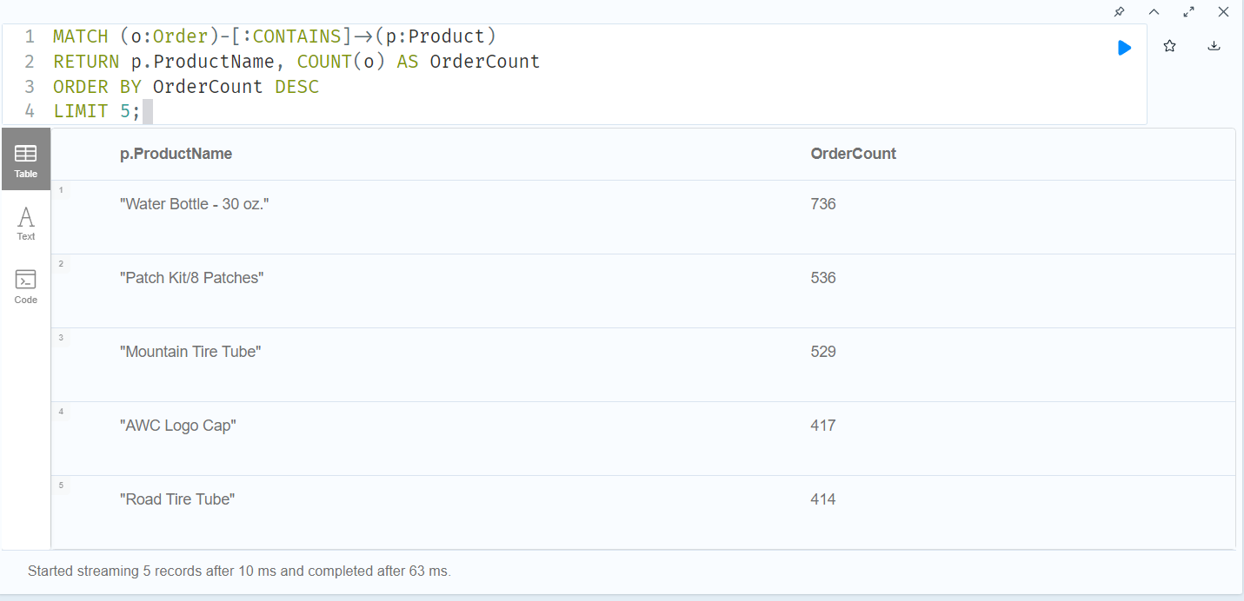

Figure 12: Top 5 popular products

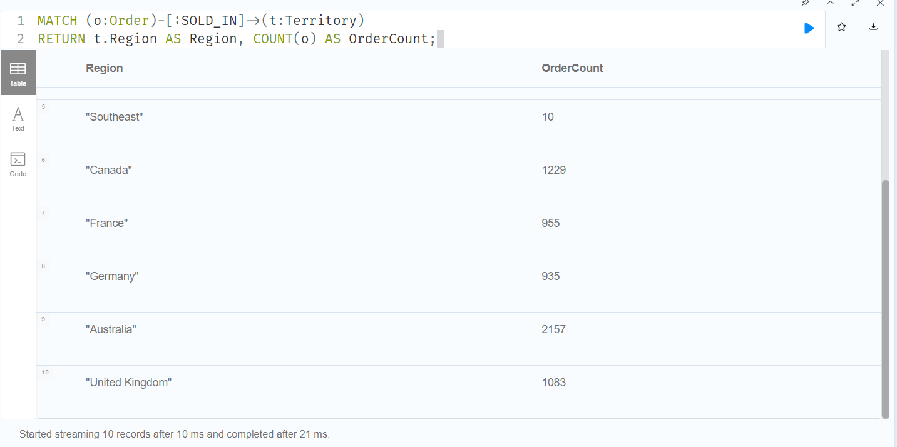

Figure – 13: Number of orders per region

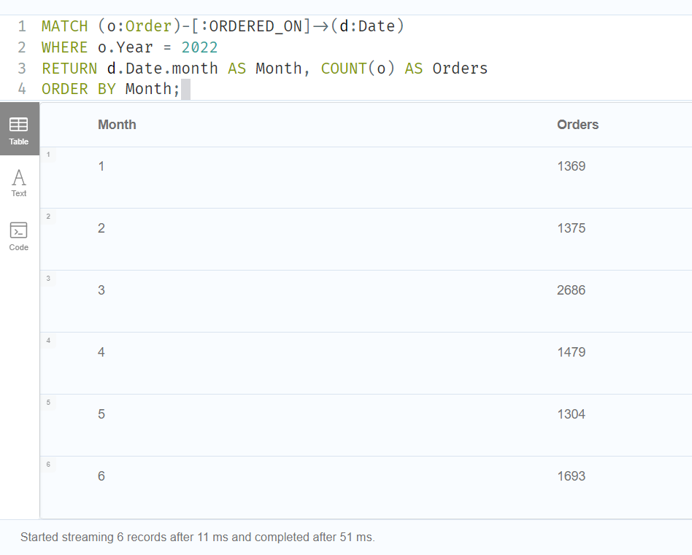

Figure – 14: Order count per month in 2022
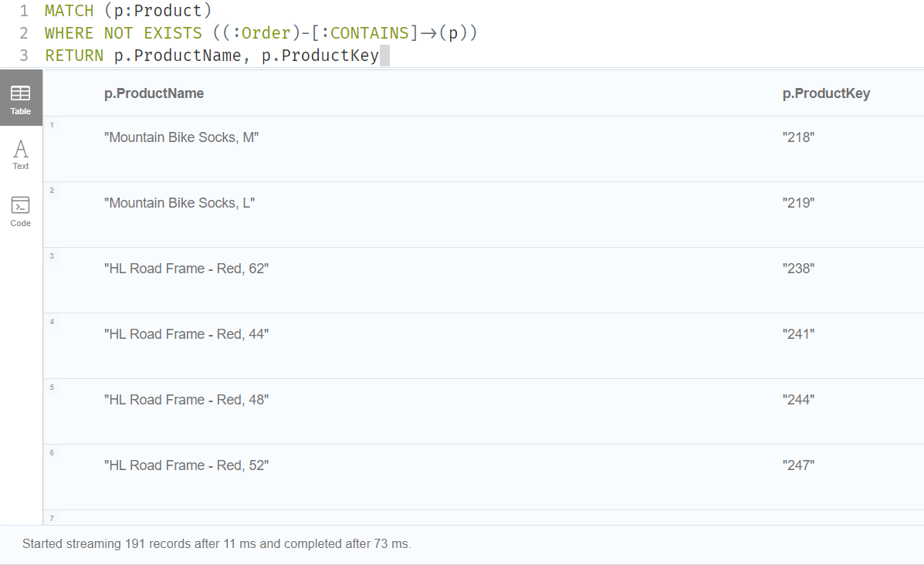
Figure 15: Products never ordered

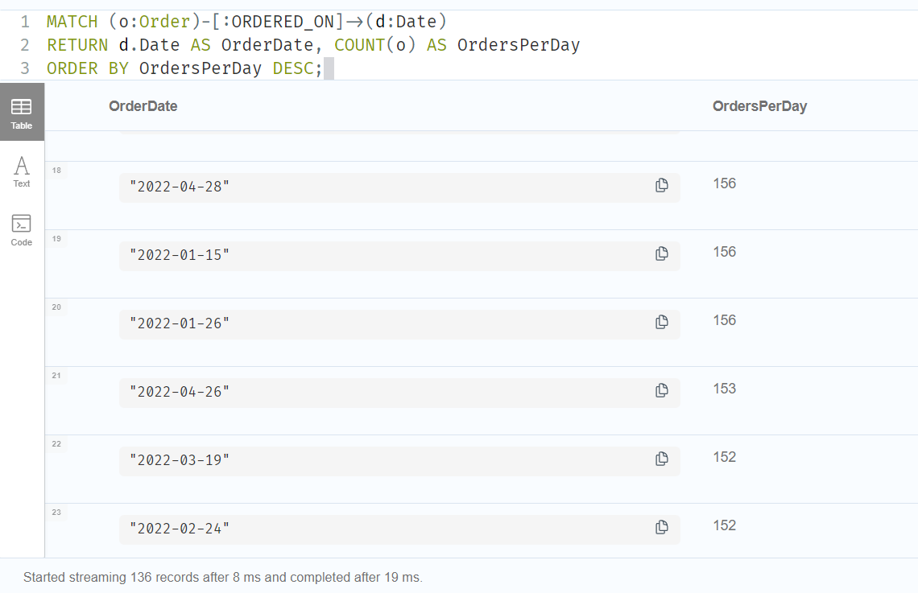

Figure – 16: Number of Orders Per Day

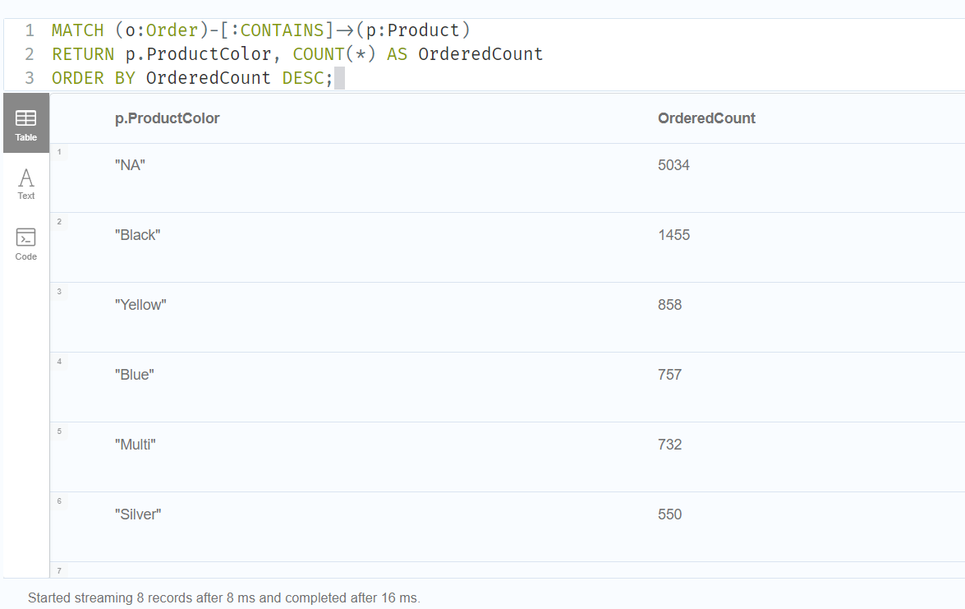
Figure 17: Sales order by color

5.1. COMAPRISON to realtional databases
To better understand the benefits of graph databases, we created and tested seven similar queries using both Cypher Query Language (CQL) for Neo4j and SQL for a traditional relational database. This side-by-side comparison helped us see the main differences in how each method handles data and relationships.
In the relational model, SQL queries often need multiple JOIN operations to connect different tables for example, linking customers to orders, and then to products. While this works well, the queries can become long and complex, especially when there are many connected tables. This also makes it harder to maintain and understand the queries.

On the other hand, using CQL with a graph database made the queries simpler and easier to read. Since graph databases store direct relationships between nodes, we could easily move from one item to another like from a customer to their orders, and then to the products they bought. This made the process of querying connected data feel more natural and efficient, especially when the data had deep or multiple levels of relationships.

SQL Code:
Use Adventure;

SELECT DATENAME(WEEKDAY, OrderDate) AS Weekday, COUNT(*) AS OrderCount
FROM Sales_2022
GROUP BY DATENAME(WEEKDAY, OrderDate)
ORDER BY OrderCount DESC;

SELECT TOP 5 p.ProductName, COUNT(o.OrderNumber) AS OrderCount
FROM Sales_2022 o
JOIN [Product] p ON o.ProductKey = p.ProductKey
GROUP BY p.ProductName
ORDER BY OrderCount DESC;

SELECT t.Region, COUNT(*) AS OrderCount
FROM Sales_2022 o
JOIN Territory t ON o.TerritoryKey = t.SalesTerritoryKey
GROUP BY t.Region;

SELECT MONTH(OrderDate) AS Month, COUNT(*) AS OrderCount
FROM Sales_2022
WHERE YEAR(OrderDate) = 2022
GROUP BY MONTH(OrderDate)
ORDER BY Month;

SELECT p.ProductName, p.ProductKey
FROM [Product] p
LEFT JOIN Sales_2022 o ON p.ProductKey = o.ProductKey
WHERE o.OrderNumber IS NULL;

SELECT o.OrderDate, COUNT(o.OrderNumber) AS OrdersPerDay
FROM Sales_2022 o
GROUP BY o.OrderDate
ORDER BY OrdersPerDay DESC;

SELECT ProductColor, COUNT(*) AS OrderedCount
FROM Sales_2022 od
JOIN Product p ON od.ProductKey = p.ProductKey
GROUP BY ProductColor
ORDER BY OrderedCount DESC;

6. Conclusions

This project connects raw sales data with smart business decisions by creating a full Business Intelligence (BI) pipeline. It combines technical tools with real business needs to give useful insights. We used a star schema for data modelling, SSIS for smooth ETL processes, SSRS for creating detailed reports, and Tableau for building dashboards that are easy to read and understand.

This system helps stakeholders in many important ways:

• Improving Operations: It becomes easier to see which store types perform best (for example, the strong results from e-Shops), manage inventory based on product trends, and reduce return rates through better planning.

• Better Customer Engagement: The system uses customer data like age and gender to help create more targeted marketing campaigns and improve customer loyalty.
.
• Promoting Data Understanding: It allows both technical teams and business users (like Sales and Marketing) to work together by using easy-to-use reports and dashboards, making data more clear and useful for everyone.

7. Bibliography
Use Harvard style of referencing.
- Davtyan, N. (2024) ‘AI in Consumer Behavior Analysis and Digital Marketing: A Strategic Approach’. DOI: 10.70301/CONF.SBS.
- M Kirmani, M. (2017) ‘Dimensional Modeling Using Star Schema for Data Warehouse Creation’. Oriental Journal of Computer Science and Technology, 10(04), pp. 745–754. DOI: 10.13005/OJCST/10.04.07.
- Storm, A. (2025) Data Analytics Team Structure: A Practical Guide to Building a Data-Dr. Available at: https://marketerhire.com/blog/data-analytics-team-structure (Accessed: 13 April 2025).
- Subramaniam, S. (2025) Predicting Customer Behavior: The Key to Smarter Business Decisions. Available at: https://www.entropik.io/blogs/predicting-customer-behavior-the-key-to-smarter-business-decisions #Marketing-Experience (Accessed: 13 April 2025).

Appendix A – VISUALIZATIONS Code
All visualizations queries.

ORDER BY Customers.CustomerID;

Appendix B – Neo 4J code
CQL Code:
LOAD CSV WITH HEADERS FROM 'file:///Product_Categories.csv' AS row
CREATE (:ProductCategory {
ProductCategoryKey: row.ProductCategoryKey,
CategoryName: row.CategoryName
});

LOAD CSV WITH HEADERS FROM 'file:///Product_Subcategories.csv' AS row
CREATE (:ProductSubcategory {
ProductSubcategoryKey: row.ProductSubcategoryKey,
SubcategoryName: row.SubcategoryName,
ProductCategoryKey: row.ProductCategoryKey
});

LOAD CSV WITH HEADERS FROM 'file:///Product.csv' AS row
CREATE (:Product {
ProductKey: row.ProductKey,
ProductSubcategoryKey: row.ProductSubcategoryKey,
ProductName: row.ProductName,
ModelName: row.ModelName,
ProductDescription: row.ProductDescription,
ProductColor: row.ProductColor,
ProductSize: row.ProductSize,
ProductStyle: row.ProductStyle,
ProductCost: toFloat(row.ProductCost),
ProductPrice: toFloat(row.ProductPrice)
});

LOAD CSV WITH HEADERS FROM 'file:///Customer.csv' AS row
WITH row, split(row.BirthDate, "-") AS dateParts
WHERE size(dateParts) = 3
AND toInteger(dateParts[0]) >= 1 AND toInteger(dateParts[0]) <= 12
AND toInteger(dateParts[1]) >= 1 AND toInteger(dateParts[1]) <= 31
AND toInteger(dateParts[2]) >= 1900 AND toInteger(dateParts[2]) <= 2100
WITH row, date(dateParts[2] + "-" + dateParts[0] + "-" + dateParts[1]) AS parsedBirthDate
CREATE (:Customer {
CustomerKey: row.CustomerKey,
Prefix: row.Prefix,
FirstName: row.FirstName,
LastName: row.LastName,
BirthDate: parsedBirthDate,
MaritalStatus: row.MaritalStatus,
Gender: row.Gender,
EmailAddress: row.EmailAddress,
AnnualIncome: toFloat(row.AnnualIncome),
TotalChildren: toInteger(row.TotalChildren),
EducationLevel: row.EducationLevel,
Occupation: row.Occupation,
HomeOwner: toBoolean(row.HomeOwner)
});

LOAD CSV WITH HEADERS FROM 'file:///Territory.csv' AS row
CREATE (:Territory {
SalesTerritoryKey: row.SalesTerritoryKey,
Region: row.Region,
Country: row.Country,
Continent: row.Continent
});

LOAD CSV WITH HEADERS FROM 'file:///Sales_2022.csv' AS row
WITH row,
split(row.OrderDate, "/") AS OrderParts,
split(row.StockDate, "/") AS StockParts
WHERE size(OrderParts) = 3 AND size(StockParts) = 3
AND toInteger(OrderParts[0]) >= 1 AND toInteger(OrderParts[0]) <= 31
AND toInteger(OrderParts[1]) >= 1 AND toInteger(OrderParts[1]) <= 12
AND toInteger(OrderParts[2]) >= 1900 AND toInteger(OrderParts[2]) <= 2100
AND toInteger(StockParts[0]) >= 1 AND toInteger(StockParts[0]) <= 31
AND toInteger(StockParts[1]) >= 1 AND toInteger(StockParts[1]) <= 12
AND toInteger(StockParts[2]) >= 1900 AND toInteger(StockParts[2]) <= 2100
WITH row,
date(OrderParts[2] + "-" + OrderParts[1] + "-" + OrderParts[0]) AS parsedOrderDate,
date(StockParts[2] + "-" + StockParts[1] + "-" + StockParts[0]) AS parsedStockDate
CREATE (:Order {
OrderDate: parsedOrderDate,
StockDate: parsedStockDate,
OrderNumber: toString(row.OrderNumber),
ProductKey: row.ProductKey,
CustomerKey: row.CustomerKey,
TerritoryKey: row.TerritoryKey,
OrderLineItem: toInteger(row.OrderLineItem),
OrderQuantity: toInteger(row.OrderQuantity),
Year: 2022
});

CREATE CONSTRAINT FOR (p:Product) REQUIRE p.ProductKey IS UNIQUE;
CREATE CONSTRAINT FOR (c:Customer) REQUIRE c.CustomerKey IS UNIQUE;
CREATE CONSTRAINT FOR (t:Territory) REQUIRE t.SalesTerritoryKey IS UNIQUE;
CREATE INDEX FOR (o:Order) ON (o.OrderNumber);
CREATE INDEX FOR (d:Date) ON (d.Date);

// Create relationships between Order and stockdate
MATCH (o:Order)
WITH o, o.StockDate AS stockDate
MERGE (d:Date {Date: stockDate})
CREATE (o)-[:STOCKED_ON]->(d);

// Create date relationships (optimized)
MATCH (o:Order)
WITH o, o.OrderDate AS orderDate
MERGE (d:Date {Date: orderDate})
CREATE (o)-[:ORDERED_ON]->(d);

// Create relationships between Subcategories and Categories (optimized)
MATCH (s:ProductSubcategory)
MATCH (c:ProductCategory {ProductCategoryKey: s.ProductCategoryKey})
CREATE (s)-[:BELONGS_TO_CATEGORY]->(c);

// Create relationships between Products and Subcategories (optimized)
MATCH (p:Product)
MATCH (s:ProductSubcategory {ProductSubcategoryKey: p.ProductSubcategoryKey})
CREATE (p)-[:BELONGS_TO_SUBCATEGORY]->(s);

// Create relationships between Orders and Territories (optimized)
MATCH (o:Order)
MATCH (t:Territory {SalesTerritoryKey: o.TerritoryKey})
CREATE (o)-[:SOLD_IN]->(t);

// Create relationships between Orders and Customers (optimized)
MATCH (o:Order)
MATCH (c:Customer {CustomerKey: o.CustomerKey})
CREATE (o)-[:PLACED_BY]->(c);

// Create relationships between Orders and Products (optimized)
MATCH (o:Order)
MATCH (p:Product {ProductKey: o.ProductKey})
CREATE (o)-[:CONTAINS]->(p);

MATCH (o:Order)-[:ORDERED_ON]->(d:Date)
WITH date(d.Date).dayOfWeek AS dayNum, COUNT(o) AS OrderCount
RETURN
CASE dayNum
WHEN 1 THEN 'Monday'
WHEN 2 THEN 'Tuesday'
WHEN 3 THEN 'Wednesday'
WHEN 4 THEN 'Thursday'
WHEN 5 THEN 'Friday'
WHEN 6 THEN 'Saturday'
WHEN 7 THEN 'Sunday'
END AS Weekday,
OrderCount
ORDER BY OrderCount DESC;

//Find the most popular products (top 5 by order count)
MATCH (o:Order)-[:CONTAINS]->(p:Product)
RETURN p.ProductName, COUNT(o) AS OrderCount
ORDER BY OrderCount DESC
LIMIT 5;

//Number of orders per region:
MATCH (o:Order)-[:SOLD_IN]->(t:Territory)
RETURN t.Region AS Region, COUNT(o) AS OrderCount;

//Order count per month in 2022:
MATCH (o:Order)-[:ORDERED_ON]->(d:Date)
WHERE o.Year = 2022
RETURN d.Date.month AS Month, COUNT(o) AS Orders
ORDER BY Month;

//Products never ordered:
MATCH (p:Product)
WHERE NOT EXISTS ((:Order)-[:CONTAINS]->(p))
RETURN p.ProductName, p.ProductKey

//Number of Orders Per Day (Based on Order Date):
MATCH (o:Order)-[:ORDERED_ON]->(d:Date)
RETURN d.Date AS OrderDate, COUNT(o) AS OrdersPerDay
ORDER BY OrdersPerDay DESC;

//Sales order by color
MATCH (o:Order)-[:CONTAINS]->(p:Product)
RETURN p.ProductColor, Count(*) AS OrderCount
ORDER BY OrderCount DESC;

