Name: Nam Jun Lee

WSU ID: 011606459

Assignment: Assignment #1

Class number: 2021 Fall-MIS-325-ONLIN-2217-H72-01-10356-LEC

Date: October 19th, 2021

<https://cb-ot-devst06.ad.wsu.edu/MF13namjun.lee/Assignment1/Assignment1.aspx>

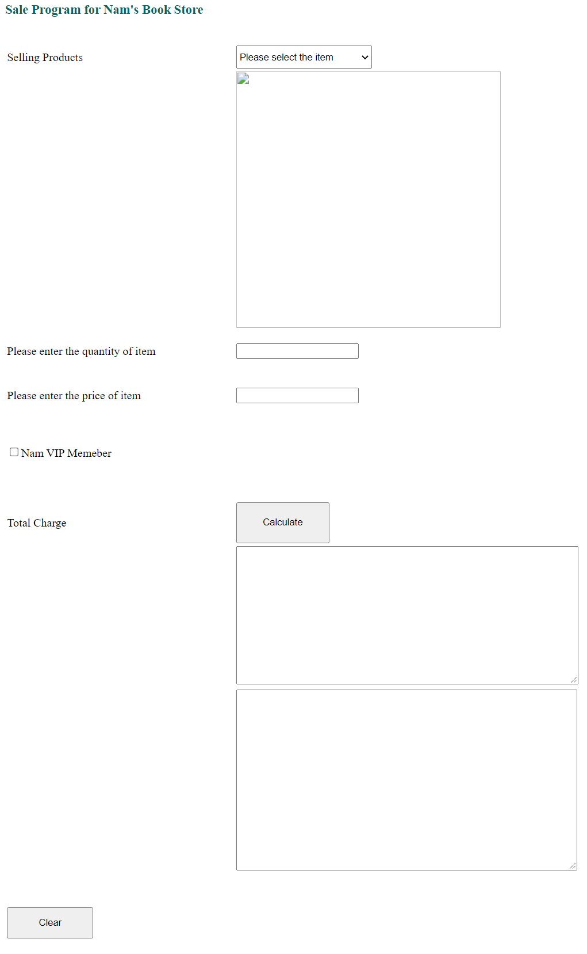

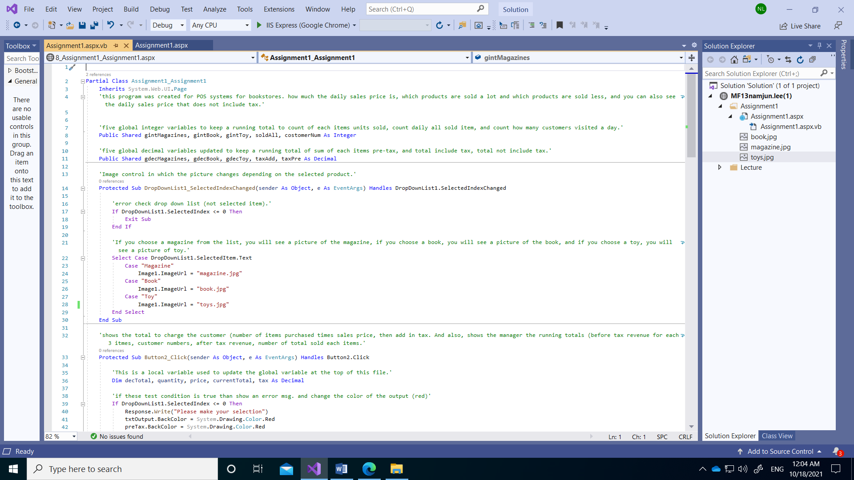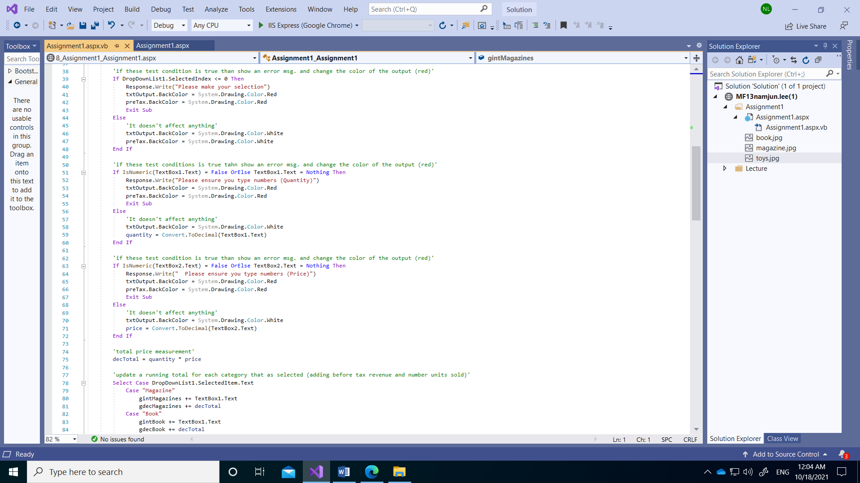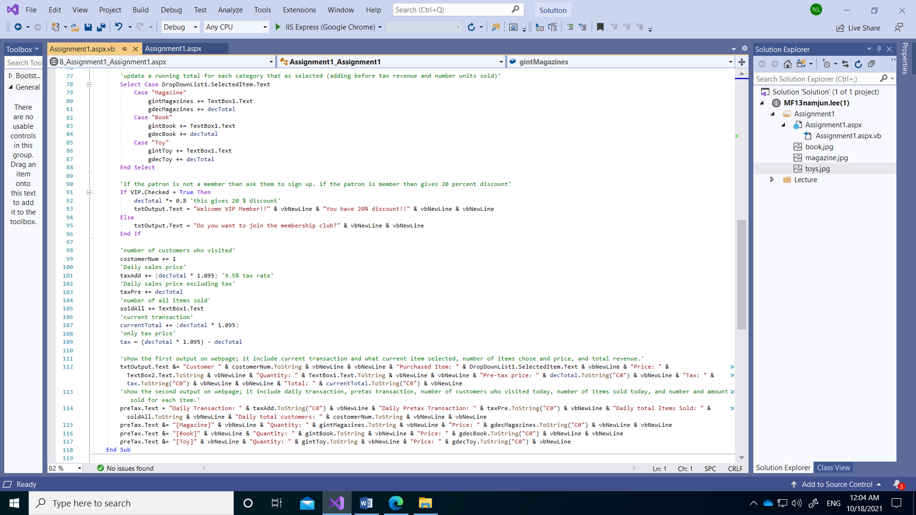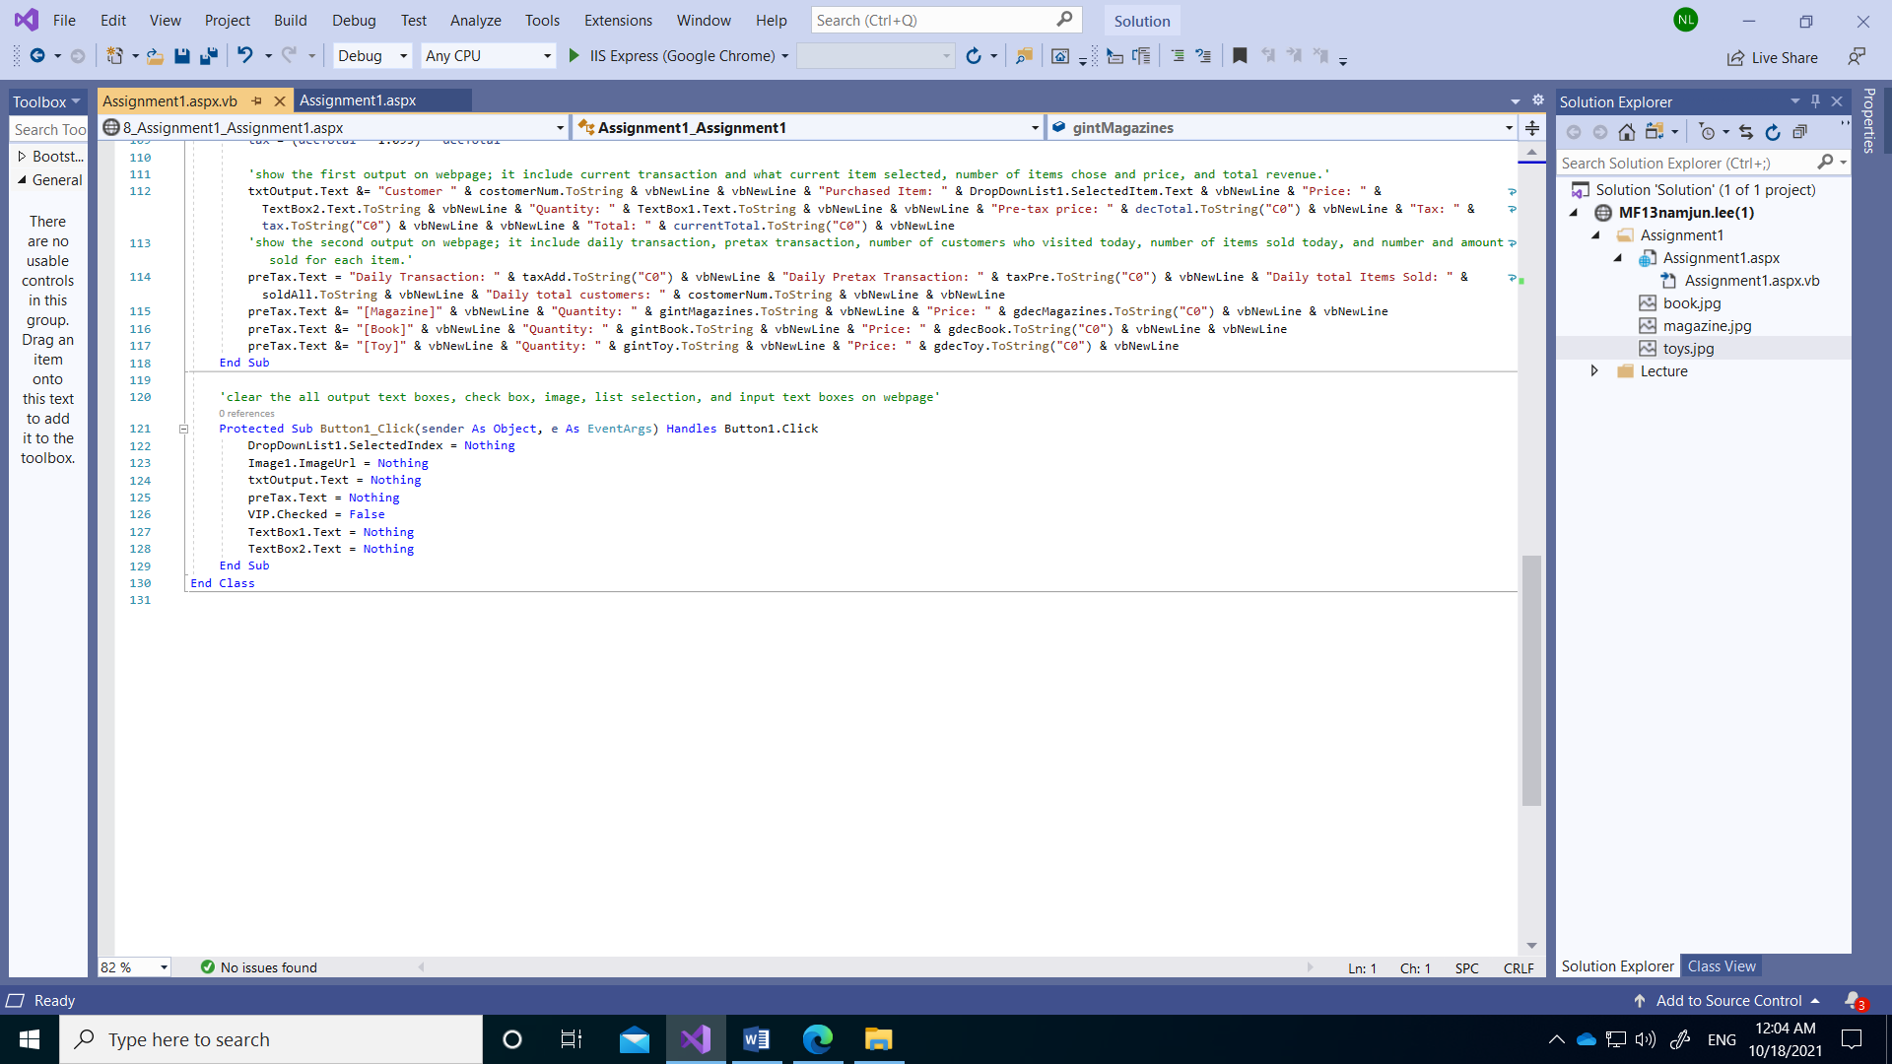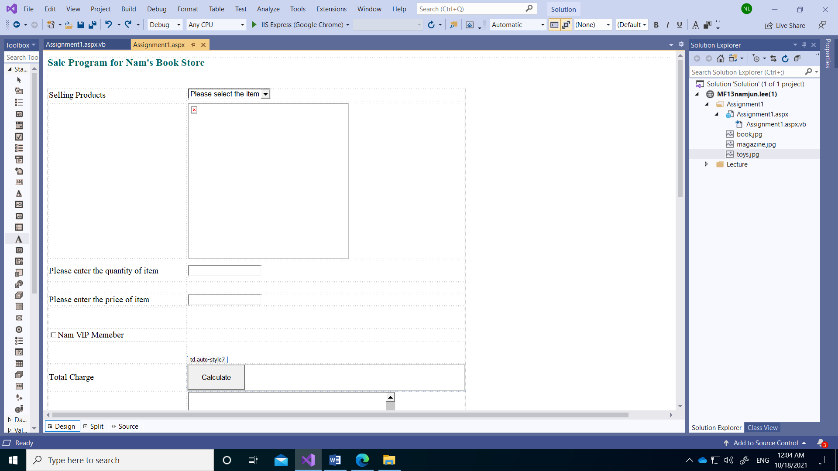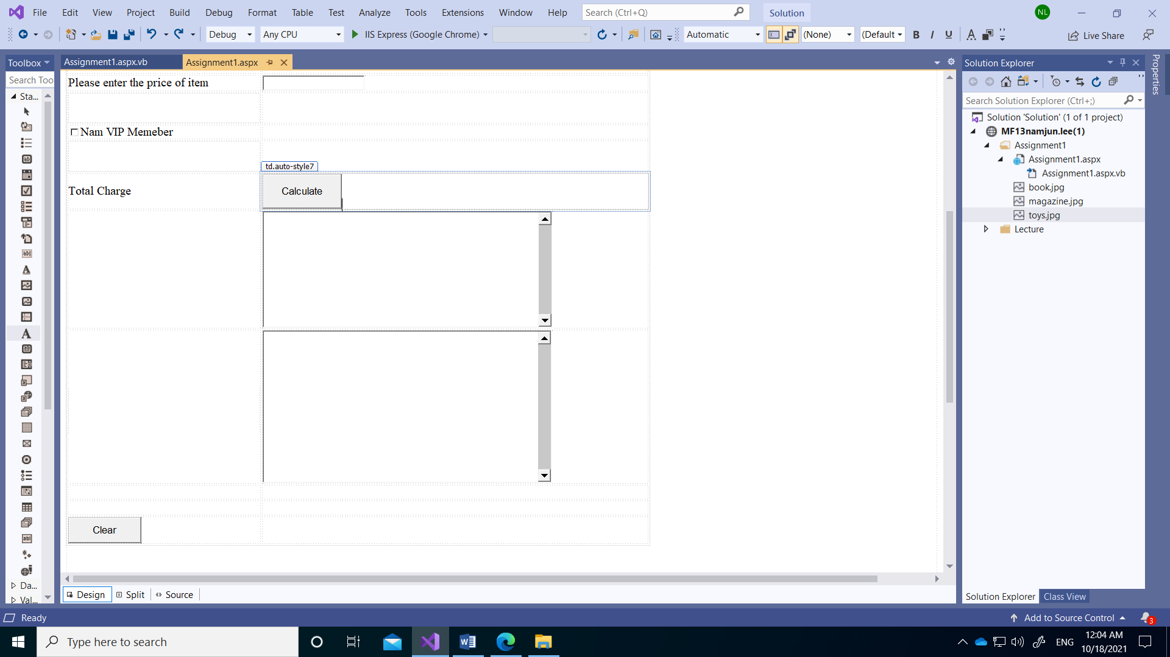

**Aspx.vb code:**

Partial Class Assignment1_Assignment1

Inherits System.Web.UI.Page

'this program was created for POS systems for bookstores. how much the daily sales price is, which products are sold a lot and which products are sold less, and you can also see the daily sales price that does not include tax.'

'five global integer variables to keep a running total to count of each items units sold, count daily all sold item, and count how many customers visited a day.'

Public Shared gintMagazines, gintBook, gintToy, soldAll, costomerNum As Integer

'five global decimal variables updated to keep a running total of sum of each items pre-tax, and total include tax, total not include tax.'

Public Shared gdecMagazines, gdecBook, gdecToy, taxAdd, taxPre As Decimal

'Image control in which the picture changes depending on the selected product.'

Protected Sub DropDownList1_SelectedIndexChanged(sender As Object, e As EventArgs) Handles DropDownList1.SelectedIndexChanged

'error check drop down list (not selected item).'

If DropDownList1.SelectedIndex <= 0 Then

Exit Sub

End If

'If you choose a magazine from the list, you will see a picture of the magazine, if you choose a book, you will see a picture of the book, and if you choose a toy, you will see a picture of toy.'

Select Case DropDownList1.SelectedItem.Text

Case "Magazine"

Image1.ImageUrl = "magazine.jpg"

Case "Book"

Image1.ImageUrl = "book.jpg"

Case "Toy"

Image1.ImageUrl = "toy.jpg"

End Select

End Sub

'shows the total to charge the customer (number of items purchased times sales price, then add in tax. And also, shows the manager the running totals (before tax revenue for each 3 itmes, customer numbers, after tax revenue, number of total sold each items.'

Protected Sub Button2_Click(sender As Object, e As EventArgs) Handles Button2.Click

'This is a local variable used to update the global variable at the top of this file.'

Dim decTotal, quantity, price, currentTotal, tax As Decimal

'if these test condition is true than show an error msg. and change the color of the output (red)'

If DropDownList1.SelectedIndex <= 0 Then

Response.Write("Please make your selection")

txtOutput.BackColor = System.Drawing.Color.Red

preTax.BackColor = System.Drawing.Color.Red

Exit Sub

Else

'It doesn't affect anything'

txtOutput.BackColor = System.Drawing.Color.White

preTax.BackColor = System.Drawing.Color.White

End If

'if these test conditions is true tahn show an error msg. and change the color of the output (red)'

If IsNumeric(TextBox1.Text) = False OrElse TextBox1.Text = Nothing Then

Response.Write("Please ensure you type numbers (Quantity)")

txtOutput.BackColor = System.Drawing.Color.Red

preTax.BackColor = System.Drawing.Color.Red

Exit Sub

Else

'It doesn't affect anything'

txtOutput.BackColor = System.Drawing.Color.White

quantity = Convert.ToDecimal(TextBox1.Text)

End If

'if these test condition is true than show an error msg. and change the color of the output (red)'

If IsNumeric(TextBox2.Text) = False OrElse TextBox2.Text = Nothing Then

Response.Write(" Please ensure you type numbers (Price)")

txtOutput.BackColor = System.Drawing.Color.Red

preTax.BackColor = System.Drawing.Color.Red

Exit Sub

Else

'It doesn't affect anything'

txtOutput.BackColor = System.Drawing.Color.White

price = Convert.ToDecimal(TextBox2.Text)

End If

'total price measurement'

decTotal = quantity * price

'update a running total for each category that as selected (adding before tax revenue and number units sold)'

Select Case DropDownList1.SelectedItem.Text

Case "Magazine"

gintMagazines += TextBox1.Text

gdecMagazines += decTotal

Case "Book"

gintBook += TextBox1.Text

gdecBook += decTotal

Case "Toy"

gintToy += TextBox1.Text

gdecToy += decTotal

End Select

'if the patron is not a member than ask them to sign up. if the patron is member than gives 20 percent discount'

If VIP.Checked = True Then

decTotal *= 0.8 'this gives 20 % discount'

txtOutput.Text = "Welcome VIP Member!!" & vbNewLine & "You have 20% discount!!" & vbNewLine & vbNewLine

Else

txtOutput.Text = "Do you want to join the membership club?" & vbNewLine & vbNewLine

End If

'number of customers who visited'

costomerNum += 1

'Daily sales price'

taxAdd += (decTotal * 1.095) '9.5% tax rate'

'Daily sales price excluding tax'

taxPre += decTotal

'number of all items sold'

soldAll += TextBox1.Text

'current transaction'

currentTotal += (decTotal * 1.095)

'only tax price'

tax = (decTotal * 1.095) - decTotal

'show the first output on webpage; it include current transaction and what current item selected, number of items chose and price, and total revenue.'

txtOutput.Text &= "Customer " & costomerNum.ToString & vbNewLine & vbNewLine & "Purchased Item: " & DropDownList1.SelectedItem.Text & vbNewLine & "Price: " & TextBox2.Text.ToString & vbNewLine & "Quantity: " & TextBox1.Text.ToString & vbNewLine & vbNewLine & "Pre-tax price: " & decTotal.ToString("C0") & vbNewLine & "Tax: " & tax.ToString("C0") & vbNewLine & vbNewLine & "Total: " & currentTotal.ToString("C0") & vbNewLine

'show the second output on webpage; it include daily transaction, pretax transaction, number of customers who visited today, number of items sold today, and number and amount sold for each item.'

preTax.Text = "Daily Transaction: " & taxAdd.ToString("C0") & vbNewLine & "Daily Pretax Transaction: " & taxPre.ToString("C0") & vbNewLine & "Daily total Items Sold: " & soldAll.ToString & vbNewLine & "Daily total customers: " & costomerNum.ToString & vbNewLine & vbNewLine

preTax.Text &= "[Magazine]" & vbNewLine & "Quantity: " & gintMagazines.ToString & vbNewLine & "Price: " & gdecMagazines.ToString("C0") & vbNewLine & vbNewLine

preTax.Text &= "[Book]" & vbNewLine & "Quantity: " & gintBook.ToString & vbNewLine & "Price: " & gdecBook.ToString("C0") & vbNewLine & vbNewLine

preTax.Text &= "[Toy]" & vbNewLine & "Quantity: " & gintToy.ToString & vbNewLine & "Price: " & gdecToy.ToString("C0") & vbNewLine

End Sub

'clear the all output text boxes, check box, image, list selection, and input text boxes on webpage'

Protected Sub Button1_Click(sender As Object, e As EventArgs) Handles Button1.Click

DropDownList1.SelectedIndex = Nothing

Image1.ImageUrl = Nothing

txtOutput.Text = Nothing

preTax.Text = Nothing

VIP.Checked = False

TextBox1.Text = Nothing

TextBox2.Text = Nothing

End Sub

End Class

Run my webpage

