**Problem 1**

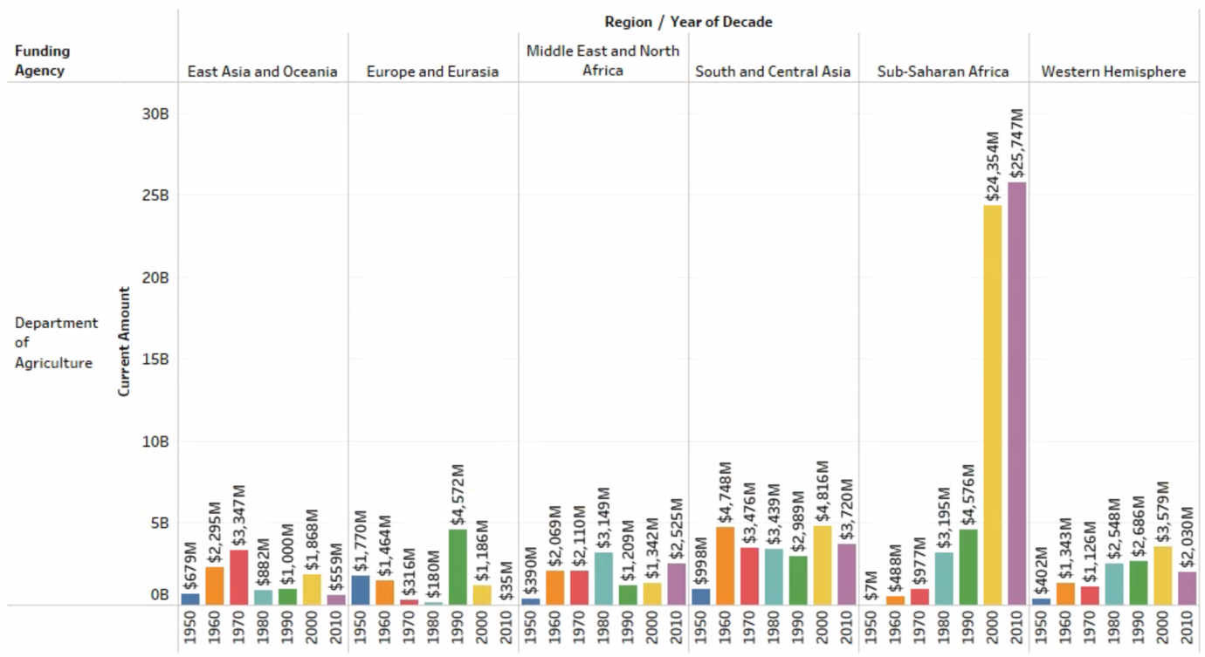

Figure: Problem 1

The graph above shows the amount of aid received by each region from the Department of Agriculture every 10 years. Between 1950 and 1980, South and Central Asia received more aid than other regions, while from 2000 to 2019, Sub-Saharan Africa received $24,354 million and $25,757 million from the Department of Agriculture.

**Problem 2**

Figure: Problem 2

The above graph illustrates the allocation of defense spending from 1950 to 2019. It can be observed that there was a decrease of $7,923,000,000 in defense spending in 1960 compared to 1950, and the amount of expenditure gradually increased thereafter. Furthermore, there was a sharp rise in defense spending between 1990 and 2000.

Figure: Problem 2-1

To provide more information, I analyzed the regions with the highest levels of defense support from 1970 to 2019. The analysis showed that the Middle East and North Africa received relatively more defense funding than other regions. In addition, aid has been observed to be used primarily for military purposes rather than economic development.

As a result, the graphs of Problem 2 and Problem 2-1 show that the increase in defense spending is strongly influenced by the Middle East and North Africa. In addition, given that these areas have received a considerable level of defense support from the 1950s to the present, it can be said that there is still a national security problem within the area.

**Problem 3**

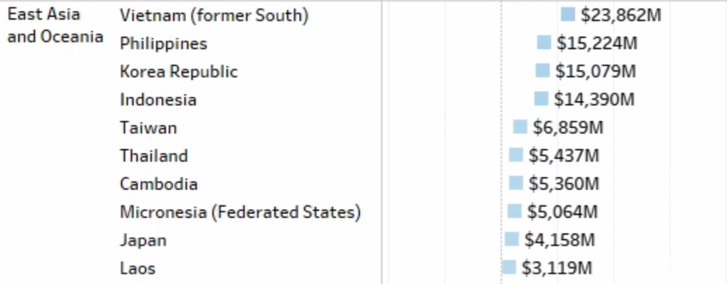

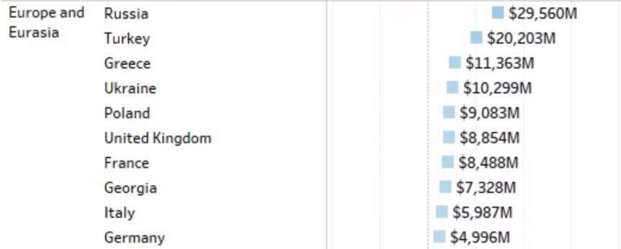

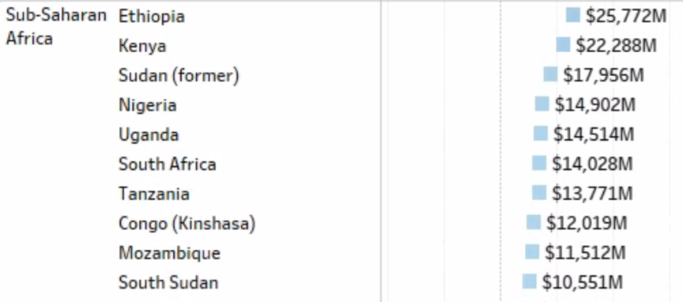

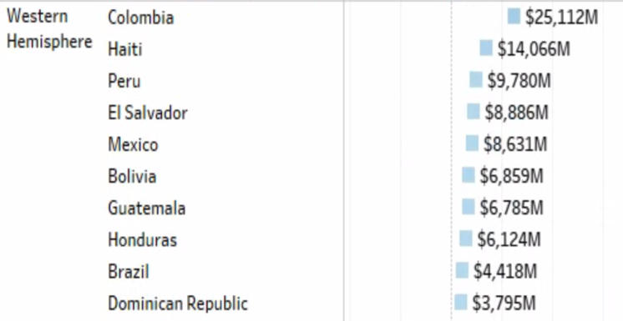

Figure: Problem 3

The data presented in Problem 3 shows the distribution of US aid among different countries in each region, with only the top 10 countries for each region displayed due to the large volume of data. The table indicates that Afghanistan in South and Central Asia receives a significant amount of aid, totaling $201,463,000,000, compared to other countries in the region. In the Middle East and North Africa, Israel, Iraq, and Egypt receive over $100,000,000,000 in aid, indicating that they receive more aid than other countries in the region. In East Asia and Oceania, Vietnam, the Philippines, and South Korea are the top recipients, while Russia and Turkey receive the most aid in Europe and Eurasia. In Sub-Saharan Africa, Ethiopia and Kenya receive the most aid, while Colombia receives the most aid in the Western Hemisphere. Overall, the data highlights that Afghanistan, Israel, Iraq, and Egypt receive a relatively higher amount of aid from the US compared to other countries in their respective regions, particularly in terms of defense and energy aid.

Figure: Problem 3-1

Based on the graph shown in Problem 3-1, it can be concluded that the primary types of aid received by the countries that receive the most aid from the United States in each region are as follows: Afghanistan receives the majority of its aid in the form of military aid, while Colombia receives primarily regional aid, and Ethiopia receives cultural aid. In addition, Israel receives most of its aid in the form of defense assistance, Russia receives energy aid, and Vietnam receives historical aid, which make up the majority of their respective aid packages.

**Problem 4**

Figure: Problem 4

The graph of Problem 4 illustrates the primary purpose of aid for each decade. It reveals that from 1940 to 1980, the main objective was to provide assistance in multiple sectors, while in the 1990s, food aid became the most significant purpose. Subsequently, after 2000, operating expenses emerged as the most crucial aim.

**Problem 5**

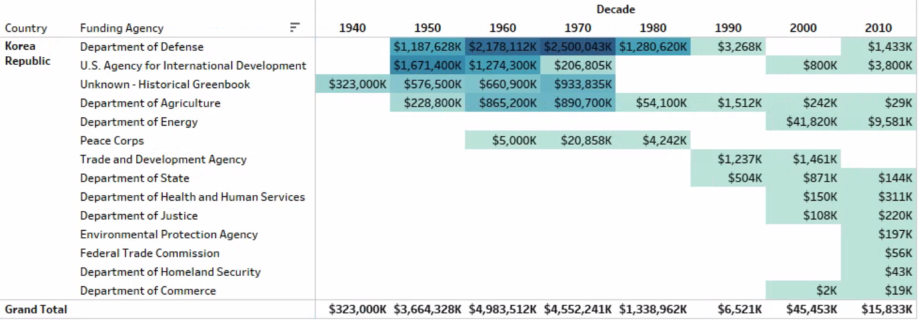

Figure: Problem 5

The graph of Problem 5 depicts the aid received by Korea over a period of 10 years. It is apparent that the country received a substantial amount of defense aid from the United States from 1950 to 1980. However, since the 1990s, the amount of defense aid received by Korea has decreased, and it has been receiving a considerable amount of energy aid since 2000.

**Problem 6**

I am interested in the purpose of food assistance, so I decided to research which regions receive the most food aid and to understand the level of food aid in those regions. Additionally, I plan to examine how the level of aid has changed over the years.

Figure: Problem 6

As a result, the Problem 6 graph above shows that Sub-Saharan Africa received a lot of food assistance at $13,607,000,000, 43.81% of the total six regions, and South and Central Asia and Western Hemisphere regions received a lot of food assistance at 18.93% and 17.03%, respectively. On the other hand, the Middle East and North region received the least food aid among the 6 regions.

Figure: Problem 6-1

The graph of Problem 6-1 above shows the level of food aid from 1992 to 2019. This shows that the U.S. provided the most food aid with $2,426 million in 1999, and since then, it has gradually decreased, providing $127 million food aid in 2019.

**Problem 7**

One of the objectives of the support was to identify initiatives related to water supply and sanitation management. Through this process, it was discovered that the United States had initiated a project in India aimed at increasing access to safe water and sanitation services to improve overall health. USAID collaborated with the private sector to address water supply issues in Indian cities and worked alongside the Indian government's flagship programs to enable over 178,000 individuals to access safe drinking water in 2020 (USAID).

This successful initiative confirms that the United States has helped India through water supply and sanitation assistance. To verify the effectiveness of this aid, the OEC website was consulted. The OEC reported that India exported $49.6 billion to the United States in 2020 and $71.2 billion in 2021 (OEC). This indicates that the infrastructure development related to water supply and sanitation had a positive impact on the overall trade between India and the United States, as India exported $20.6 billion more after the aid was implemented.

In conclusion, the United States' assistance in the water supply and sanitation sector has been instrumental in promoting healthy living and increasing trade between India and the United States. It highlights the potential for aid in infrastructure development to benefit both the recipient country and the donor country's economy.

**References**

*Partnership for water, sanitation, and hygiene (WASH): India*. U.S. Agency for International Development. (2022, August 5). Retrieved April 11, 2023, from https://www.usaid.gov/india/water-and-sanitation

*United States (USA) and India (IND) trade*. OEC. (n.d.). Retrieved April 11, 2023, from https://oec.world/en/psrofile/bilateral-country/usa/partner/ind